28 February 2025

GDP increased by 1.0% in 2024

## GDP resources and uses – the fourth quarter of 2024

According to the refined estimate, the gross domestic product (GDP) increased by 0.7%, quarter-on-quarter, and by 1.8%, year-on-year, in the Q4 2024. The GDP for the whole year 2024 increased by 1.0%.

The **gross domestic product** (GDP)adjusted for price effects and seasonally adjusted[1] **in the Q4 2024** **was by 0.7% higher compared to the previous quarter. Compared to the corresponding quarter of 2023, it increased by 1.8%.**

**GDP development (%)**

|  |  |  |  |  |  |
| --- | --- | --- | --- | --- | --- |
|  | Q1 | Q2 | Q3 | **Q4** | **Year 2024** |
| compared to the previous quarter | +0.3 | +0.3 | +0.6 | **+0.7** | **+1.0** |
| compared to the corresponding quarter of 2023 | +0.3 | +0.5 | +1.4 | **+1.8** |

**GVA development (%)**

|  |  |  |  |  |  |
| --- | --- | --- | --- | --- | --- |
|  | Q1 | Q2 | Q3 | **Q4** | **Year 2024** |
| compared to the previous quarter | -0.1 | +0.3 | +0.8 | **+0.0** | **+0.3** |
| compared to the corresponding quarter of 2023 | -0.6 | -0.1 | +1.0 | **+1.1** |

The **gross value added** (GVA) **stagnated** in the Q4 2024**,** **quarter-on-quarter** **(q-o-q), and increased by 1.1%, year-on-year (y-o-y)**. In the q-o-q comparison, especially the following were successful: economic activities of manufacturing (+1.0%), a group of economic activities of trade, transportation, accommodation and food service activities (+0.4%), and also real estate activities (+2.2%).

The following were contributing the most to the **y-o-y increase of the GVA** (+1.1%): a group of economic activities of trade, transportation, accommodation and food service activities +0.5 percentage point (p. p.; an increase by 3.0%) and real estate activities +0.3 p. p. (+2.1%). Other service activities were also successful. Construction increased by 2.4%, y-o-y. On the other hand, industry had a negative influence of -0.6 p. p. (-2.2%).

***On the demand side****, higher final consumption expenditure of households and a change in inventories were the key factors of the q-o-q GDP increase in the Q4 2024. A negative influence came from gross fixed capital formation and a decreasing external demand,”* Vladimír Kermiet, Director of the National Accounts Department of the Czech Statistical Office (CZSO), comments on the data.

The following had a positive influence on the year-on-year GDP growth (+1.8%): final consumption expenditure of households +1.9 p. p. [2], final consumption expenditure of general government +0.6 p. p., and a change in inventories +1.6 p. p. On the other hand, a negative influence came from the gross fixed capital formation -0.7 p. p. and external demand -1.7 p. p.

**Final consumption expenditure of households** increased by 1.5%, q-o-q. In the y-o-y comparison, they increased by 3.2%, while especially purchases of non-durables increased.

**Final consumption expenditure of general government** decreased by 0.3%, q-o-q, and in the y-o-y comparison they increased by 3.2%.

**Gross fixed capital formation** decreased by 1.5%, q-o-q, and by 2.4%, y-o-y. A y-o-y increase occurred in investments to other buildings and structures and to transport equipment. Investments to all other assets were decreasing. The **change in inventories**[3] amounted to CZK -79.5 billion, which was, however, by CZK 10.5 billion more compared to the corresponding quarter of the previous year.

The **international trade balance of goods and services** at current prices reached the value of CZK 129.2 bn; thus it was by CZK 5.1 bn higher than in the corresponding period of the previous year. Exports decreased in real terms by 1.5%, q-o-q, and in the y-o-y comparison it increased by 1.3%. The development was influenced the most by an increase in exports of electronic and optical products and electrical equipment. On the other hand, exports of machinery and equipment and of motor vehicles were decreasing. Imports decreased by 1.8%, q-o-q, and in the y-o-y comparison it increased by 3.1%.

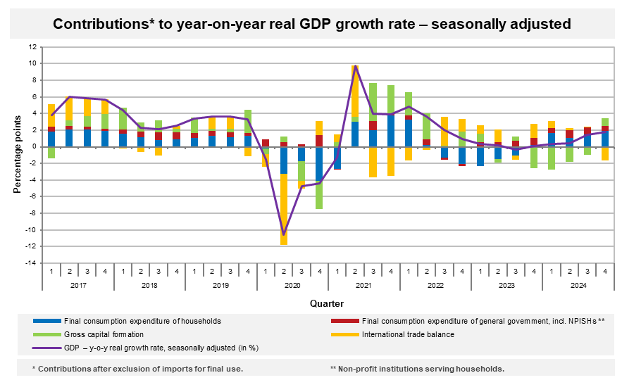

As for the price development in the Q4 2024, the total GDP deflator increased by 0.3%, q-o-q, and by 3.7%, y-o-y.

The volume of labour costs[4] increased by 6.6%, y-o-y, in the Q4 2024.

**Total employment**[5] decreased by 0.1% compared to the previous quarter and in the y-o-y comparison it increased by 0.2%. The number of hours worked in total remained unchanged, quarter-on-quarter, and in the y-o-y comparison it increased by 0.5%.

GDP resources and uses in 2024

The **GDP for 2024** was **by 1.0%** higher compared to the year 2023. The year-round increase was positively influenced especially by the final consumption expenditure of households +1.5 p. p. and by final consumption expenditure of general government (+0.7 p. p.). The following had a negative influence: gross capital formation expenditure (-1.1 p. p.) and external demand (-0.1 p. p.).

Final consumption expenditure of households increased by 2.0%. Final consumption expenditure of general government increased by 3.8%. Gross fixed capital formation was by 1.3% lower. Theinternational trade balance increased at current prices by CZK 141.2 bn, y‑o‑y, to CZK +525.6 bn.

The **GVA in 2024** **increased** **by 0.3%** compared to the previous year. The GVA growth was the most significantly contributed to by a group of economic activities of trade, transportation, and accommodation and food service activities (+0.3 p. p.). A negative influence came mainly from industry (-0.5 p. p.).

**Total employment** increased by 0.3%, y-o-y, to 5 404 thousand persons. However, in total, there were by 0.2% less hours worked than in the year 2023.

Notes:

Responsible head at the CZSO: Vladimír Kermiet, Director of the National Accounts Department, phone number (+420) 274 054 247, e‑mail: [vladimir.kermiet@csu.gov.cz](mailto:vladimir.kermiet@csu.gov.cz)

Contact person: Jan Benedikt, Quarterly Estimates Unit, phone number (+420) 274 052 750, e-mail: [jan.benedikt@csu.gov.cz](mailto:jan.benedikt@csu.gov.cz)

Used data sources updated as at: 26 February 2025

Time series: [Quarterly national accounts](https://apl.czso.cz/pll/rocenka/rocenka.indexnu_kvart?mylang=EN&co=Q_HDP_ZAM)

The news release web page: [Quarterly GDP estimates | Statistics (gov.cz)](https://csu.gov.cz/quarterly-gdp-estimates?pocet=10&start=0&podskupiny=051&razeni=-datumVydani)

*The next news release will be published on: 30 April 2025*

*(GDP preliminary estimate for the first quarter of 2025)*

1. *Unless otherwise stated, all data presented in this news release are adjusted for price, seasonal, and calendar effects.* 
2. *contributions to the GDP growth (imports for final use excluded, unless otherwise stated)*
3. *at current prices, not adjusted for seasonal effects*
4. *at current prices, not adjusted for seasonal effects*
5. *the number of persons in terms of national accounts* 