10 April 2025

The 2024 birth cohort is the least numerous in history

Population change – year 2024
The population of the Czech Republic grew by 8.9 thousand to 10,909,500 in 2024. The increase due to international migration (36.8 thousand) was suppressed by a natural decrease (−27.9 thousand) resulting from the prevalence of deaths over live births. The number of deaths (112.2 thousand) fell slightly year-on-year. The number of live births (84.3 thousand) was the lowest ever. The number of marriages also declined significantly for the second year in a row. On the other hand, the number of divorces was up year-on-year.
The population growth of 8.9 thousand raised the population of the Czech Republic to 10,909,500 as of 31 December 2024. This was the highest number since the end of World War II. By natural change, the population of the Czech Republic decreased for the sixth year in a row. The natural decrease of 27.9 thousand was similar to that in 2021 when the record number of deaths was registered. However, the large natural decrease in 2024 was primarily driven by a low number of births.
Figure Population change in 2023 and 2024
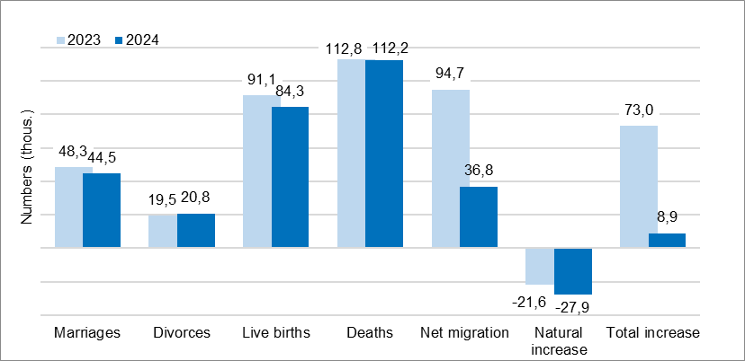

The annual total number of live births of 84.3 thousand was down by 6.8 thousand, or 8% year-on-year. "The number of live births in 2024 fell significantly for the third year in a row. The annual total of 84,311 represents a new historical low, surpassing the previous figure of 89,471 from 1999," says Michaela Němečková from the Demographic Statistics Unit of the CZSO. Both the number of first-born children (by 9%) and the number of second-born children (by 7%) were lower year-on-year, as was the number of children born in the third or higher order (by 5%). According to preliminary data, there were 1.37 children per woman and the total fertility rate was 0.1 lower than in 2023. A total of 47.0% of children were born outside marriage, 0.1 p.p. less than a year before.

In 2024, a total of 112.2 thousand inhabitants of the Czech Republic died, of which 57.7 thousand were men and 54.5 thousand were women. This was 0.6 thousand (1%) less compared to 2023. The highest number of deaths was recorded in January and December, the lowest in June. Within the five-year age groups, the largest groups of deceased were those aged 80–84 years (19.2 thousand) and 75–79 years (19.0 thousand). According to preliminary estimates, the decline in deaths was associated with a further increase in life expectancy for both men and women (by about a quarter of a year).

A total of 44.5 thousand couples entered into marriage, which was 3.8 thousand, or 8%, fewer than in 2023. Year-on-year, there were fewer brides and grooms in all five-year age groups from 25 to 50. The largest number of fiancés (2.5 thousand brides as well as grooms) belonged to the generation born in 1993. A total of 20.8 thousand marriages ended in divorce, up by 1.3 thousand (7%) year-on-year. The total divorce rate was also slightly higher (40% compared to 37% in 2023). Divorces were most frequent after 4 to 7 years of marriage. A total of 58% of divorced couples had minor children. A total of 19.3 thousand minor children were affected by divorce.

The Czech Republic has gained 36.8 thousand inhabitants through international migration. Compared to 2023, this was significantly less (by 57.8 thousand). The number of immigrants from abroad to the Czech Republic decreased year-on-year (by 19.4 thousand) to 121.8 thousand, but still remained significantly higher compared to the years before the outbreak of the war in Ukraine. Almost 85.0 thousand emigrants abroad were registered (38.4 thousand more year-on-year). About three-quarters of the emigrants were persons with terminated temporary protection.
Notes:
All data refer to citizens of the Czech Republic and foreigners with permanent residence in the Czech Republic, third-country nationals with temporary residence in the territory of the Czech Republic based on a long-term visa (over 90 days) or a permanent residence permit, nationals of the EU Member States, Norway, Switzerland, Iceland, Liechtenstein and their dependants with notified temporary residence in the territory of the Czech Republic and foreigners with granted international protection in the Czech Republic. Since 2022, the population has included persons granted temporary protection in the Czech Republic with usual residence in the Czech Republic. The data contain also information on events (marriages, births, and deaths) of Czech citizens with the permanent residence in the Czech Republic that occurred abroad and were registered by the special registry office in Brno.
All data for 2024 are preliminary.

Responsible manager: Mgr. Robert Šanda, director of Population Statistics Department,
tel. 274 052 160, e-mail: robert.sanda@csu.gov.cz
Contact person: Mgr. Michaela Němečková, Demographic Statistics Unit,
tel. 274 052 184, e-mail: michaela.nemeckova@csu.gov.cz
Data source: Demographic statistics – results of processing statistical reports of Obyv series and data from Census Information System of the CZSO
Divorces – Information system of the Ministry of Justice of the CR
Migration data – Information System of Inhabitants Records (Ministry of the Interior of the CR) and Alien Information System (Directorate of Alien Police)
End of data collection: 27 March 2025
Related publication: 130062-24 Population of the Czech Republic – year 2024
https://vdb.czso.cz/vdbvo2/faces/en/index.jsf?page=statistiky&katalog=30845#katalog=34275
Related time series: https://vdb.czso.cz/vdbvo2/faces/en/index.jsf?page=statistiky&katalog=33157
Next News Release: 11 September 2025

Text is not edited for language.

Annexes:
Table 1 Population (absolute and relative figures, year-to-year changes)
Chart 1 Population, quarterly data (numbers)
Chart 2 Population change, 1st - 4th quarter (numbers)
Chart 3 Live births, quarterly data (numbers)
Chart 4 Deaths, quarterly data (numbers)
Chart 5 Marriages, quarterly data (numbers)
Chart 6 Divorces, quarterly data (numbers)

