September 24, 2025

Overall confidence in the economy increased slightly

Business cycle survey – September 2025

The composite confidence indicator (economic sentiment indicator), in the basic index form – increased by 0.8 points to 101.9 m-o-m, with the same development of its components. The business confidence indicator slightly increased by 0.1 point to 101.6, while the consumer confidence indicator rose by 4.5 point to 103.5.
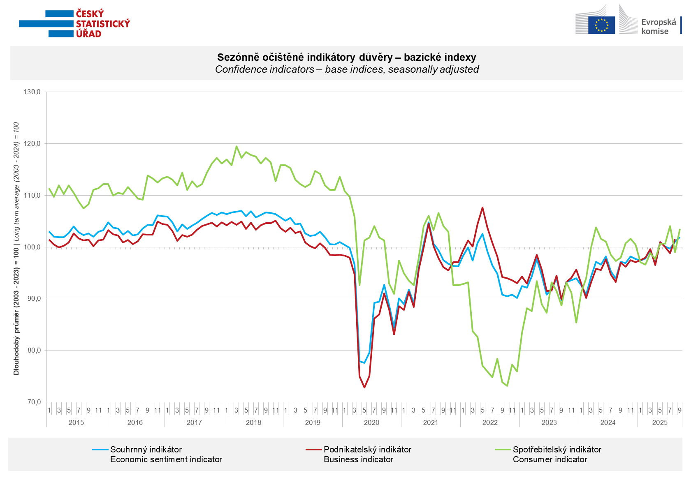

Business confidence in the economy increased in September in industry (+2.0 points), construction (+3.0 points), and trade (+1.2 points). In selected service sectors, however, it decreased by 2.3 points.

Consumer confidence rose m-o-m in September. The confidence indicator rose by 4.5 points to 103.5. Compared to August, the share of consumers expecting the overall economic situation in the Czech Republic to deteriorate over the next twelve months declined. The share of households expecting their financial situation to deteriorate over the next twelve months also decreased slightly. In addition, the number of households assessing their current financial situation as better than in the previous twelve months increased m-o-m. The number of respondents who do not plan to make any major purchases in the next twelve months remained almost unchanged.
***
More detailed information on the development of business and consumer confidence can be found in the supplementary information to the RI business surveys.

Notes:

Responsible manager: Juraj Lojka, Director of Business Statistics Coordination and Business Cycle Surveys Department, tel. +420731439291, e-mail: juraj.lojka@csu.gov.cz
Contact person: Jiri Obst, Head of Business Cycle Surveys Unit, tel. +420604815440, e-mail: jiri.obst@csu.gov.cz
Data source: CZSO business survey, Data Collect consumer survey (https://www.datacollect.cz)
Data collection date: Business part: September 18, 2025
Consumer part: September 15, 2025
Next News Release: October 24, 2025

This press release wasn´t edited for language.

Detailed time series of Balances and basic
indices of confidence indicators: https://csu.gov.cz/produkty/kpr_ts
Business and Consumers Surveys are co-financed by grant agreements of the European Commission DG ECFIN.
https://ec.europa.eu/info/business-economy-euro/indicators-statistics/economic-databases/business-and-consumer-surveys_en
Link to European database: https://ec.europa.eu/eurostat/web/euro-indicators/database

Annex:
Additional information to NR Business cycle survey
Table Confidence Indicators – basic indices
Graph 1 Confidence indicators – base indices, seasonally adjusted (2003–2025)
Graph 2.1 Confidence Indicators for industry, construction, trade, and in selected services – base indices, seasonally adjusted (2003–2025)
Graph 2.2 Balances of seasonally adjusted confidence indicators for industry, construction, trade, and in selected services (2003–2025)
Graph 3 Economic Sentiment Indicators – international comparison, seasonally adjusted (2007-2025)

