November 24, 2025

Consumer confidence in the economy continues to grow, while business confidence declined m-o-m

Business cycle survey – November 2025

The composite confidence indicator (economic sentiment indicator), expressed as a basic index, fell by 2.1 points m-o-m to 101.9, with its two components developing differently. The business confidence indicator fell by 3.5 points to 99.9, while the consumer confidence indicator rose by 4.3 points to 111.7.
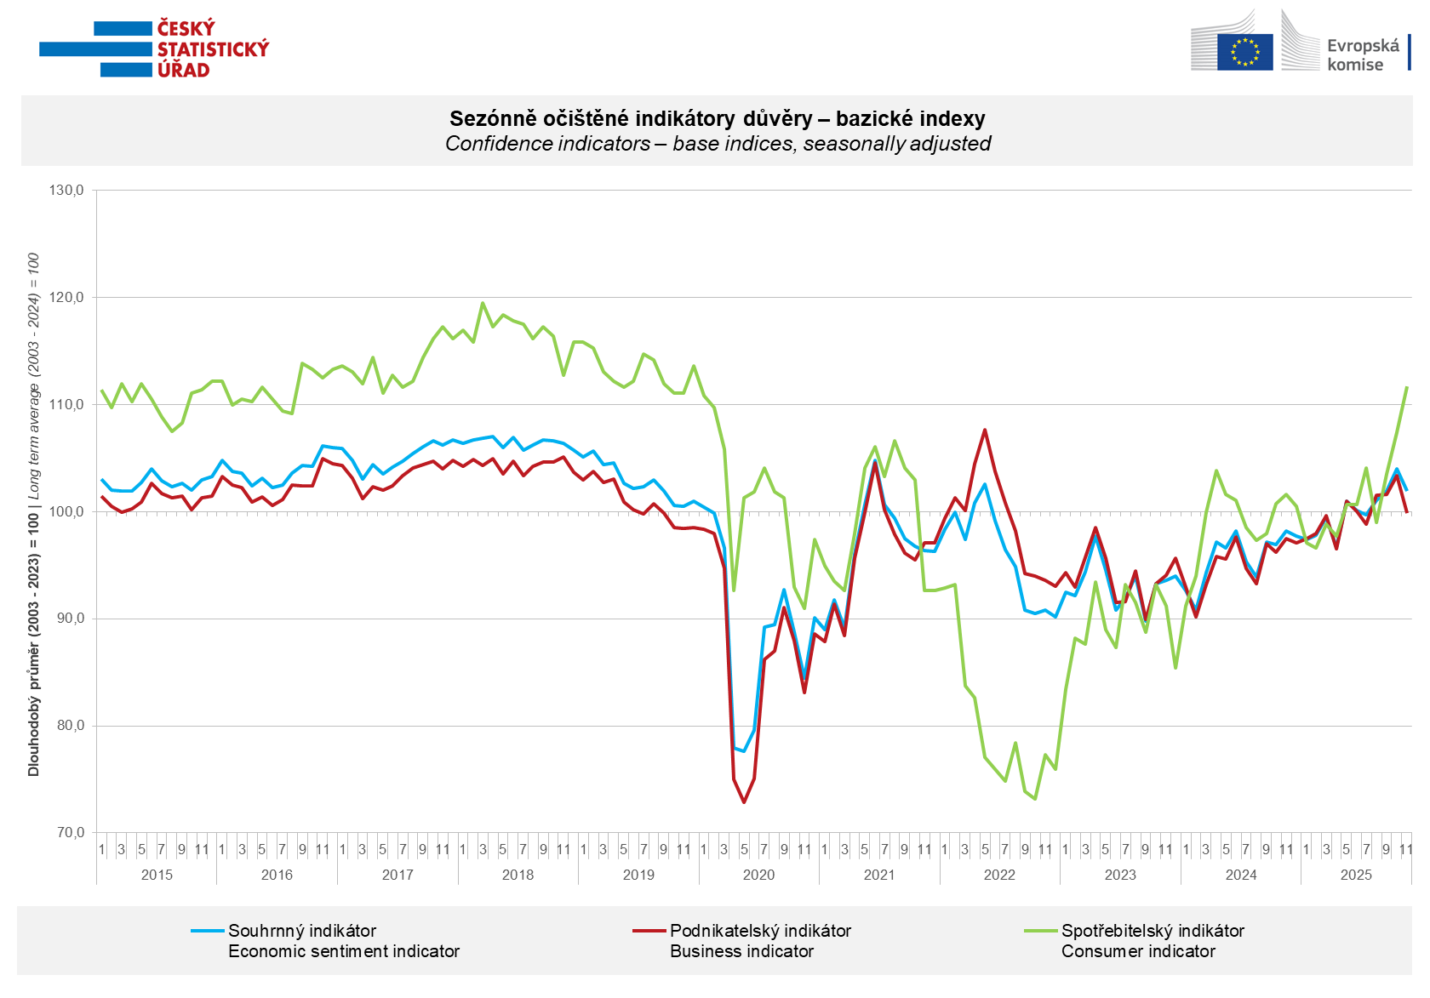

In November, confidence in the economy increased only in trade (+1.4 points). In contrast, it declined month-on-month in construction (-7.7 points), industry (-6.6 points), and slightly in selected service sectors (-0.6 points).

Consumer confidence increased m-o-m. The confidence indicator rose by 4.3 points to 111.7. In November, most consumers expected the overall economic situation in Czechia to improve over the next twelve months. In a m-o-m comparison, the share of households expecting an improvement in their financial situation over the next twelve months increased. At the same time, the share of respondents who assess their current financial situation as worse than in the previous twelve months decreased. The number of respondents who do not plan to make any major purchases in the next twelve months decreased slightly.
***
More detailed information on the development of business and consumer confidence can be found in the supplementary information to the RI business surveys.

Notes:

Responsible manager: Juraj Lojka, Director of Business Statistics Coordination and Business Cycle Surveys Department, tel. +420731439291, e-mail: juraj.lojka@csu.gov.cz
Contact person: Jiri Obst, Head of Business Cycle Surveys Unit, tel. +420604815440, e-mail: jiri.obst@csu.gov.cz
Data source: CZSO business survey, Data Collect consumer survey (https://www.datacollect.cz)
Data collection date: Business part: November 18, 2025
Consumer part: November 14, 2025
Next News Release: December 23, 2025

This press release wasn´t edited for language.

Detailed time series of Balances and basic
indices of confidence indicators: https://csu.gov.cz/produkty/kpr_ts
Business and Consumers Surveys are co-financed by grant agreements of the European Commission DG ECFIN.
https://ec.europa.eu/info/business-economy-euro/indicators-statistics/economic-databases/business-and-consumer-surveys_en
Link to European database: https://ec.europa.eu/eurostat/web/euro-indicators/database

Annex:
Additional information to NR Business cycle survey
Table Confidence Indicators – basic indices
Graph 1 Confidence indicators – base indices, seasonally adjusted (2003–2025)
Graph 2.1 Confidence Indicators for industry, construction, trade, and in selected services – base indices, seasonally adjusted (2003–2025)
Graph 2.2 Balances of seasonally adjusted confidence indicators for industry, construction, trade, and in selected services (2003–2025)
Graph 3 Economic Sentiment Indicators – international comparison, seasonally adjusted (2007-2025)

