12 December 2023

Year-on-year decline in marriages and births was more than 10%

Population change – 1st – 3rd quarter of 2023
The population of the Czech Republic increased by 54.7 thousand to 10.88 million in the first nine months of this year. The net migration reached 68.0 thousand, while the balance of the natural change was negative, and amounted to −13.3 thousand. There were significantly fewer live births and marriages compared to the same period last year. There were also fewer deaths and divorces year-on-year.
According to the population balance, the population of the Czech Republic was 10.88 million as of 30 September 2023. It was 54.7 thousand more than at the beginning of the year. The whole increase was due to net migration of 68 thousand. A total of 116.7 thousand people immigrated to the Czech Republic from abroad during the first three quarters, while 48.6 thousand people moved out of the Czech Republic. Two-fifths of those who emigrated were registered in September – this reflected the expiration of temporary protection for people who did not come to collect the visa sticker into the passport within the set deadline. By natural change, the population of the Czech Republic decreased by 13.3 thousand, by 2.8 thousand more than in the first three quarters of 2022.
From January to September this year, 69.2 thousand children were born alive; a year-on-year decrease of 8.6 thousand, or 11%. The decline in the birth rate occurred in all age groups of women under 45 years. The number of deaths was 82.6 thousand. It was by 5.8 thousand, or 7% fewer than in the same period last year.
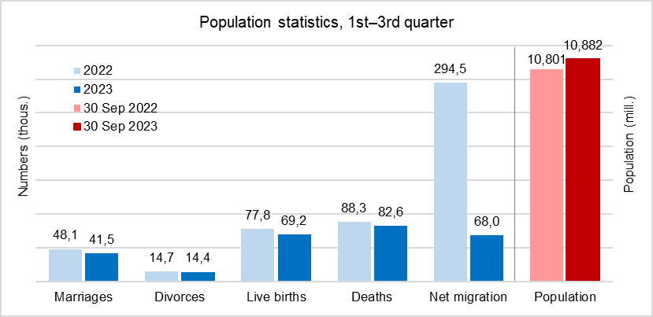
"During the first three quarters of this year, 41.5 thousand couples got married. This was 14% less compared to the same part of 2022. The decline in marriages occurred in both single and divorced persons and at a similar rate," says Michaela Němečková from the Demographic Statistics Unit of the Czech Statistical Office. The number of divorces decreased by 0.3 thousand year-on-year to 14.4 thousand.

Notes:
All data refer to citizens of the Czech Republic and foreigners with permanent residence in the Czech Republic, third-country nationals with temporary residence in the territory of the Czech Republic based on a long-term visa (over 90 days) or a permanent residence permit, nationals of the EU Member States, Norway, Switzerland, Iceland, Liechtenstein and their dependants with notified temporary residence in the territory of the Czech Republic and foreigners with valid asylum status in the Czech Republic. As of 2022, the population includes persons granted temporary protection in the Czech Republic with usual residence in the Czech Republic. The data contain also information on events (marriages, births, and deaths) of Czech citizens with the permanent residence in the Czech Republic that occurred abroad and were registered by the special registry office in Brno.
All data for 2023 are preliminary.

Responsible manager: Mgr. Robert Šanda, director of Population Statistics Department,
tel. +420 274 052 160, e-mail: robert.sanda@czso.cz
Contact person: Mgr. Michaela Němečková, Demographic Statistics Unit,
tel. +420 274 052 184, e-mail: michaela.nemeckova@czso.cz
Data source: Demographic statistics – results of processing statistical reports of Obyv series
Divorces – Information system of the Ministry of Justice of the CR
Migration data – Information System of Inhabitants Records (Ministry of the Interior of the CR) and Alien Information System (Directorate of Alien Police)
End of data collection: 7 December 2023
Related publication: 130062-22 Population of the Czech Republic – 1st–3rd quarter of 2023
https://www.czso.cz/current-product/41180
Related time series: https://www.czso.cz/csu/czso/oby_ts
Next News Release: 20 March 2024

Annexes:
Tab. 1 Population (absolute and relative figures, year-to-year changes)
Chart 1 Population, quarterly data (numbers)
Chart 2 Population change, 1st – 3rd quarter (numbers)
Chart 3 Live births, quarterly data (numbers)
Chart 4 Deaths, quarterly data (numbers)
Chart 5 Marriages, quarterly data (numbers)
Chart 6 Divorces, quarterly data (numbers)

