6 February 2026

Industrial production increased by 1.5% in 2025

Supplementary information to the news release on industry –December 2025
Industry in the year 2025
Industrial production was by 1.5% higher, year-on-year (y-o-y), in 2025. The year 2025 had by one working day less than the year 2024. The following contributed the most to the year-on-year growth: manufacture of fabricated metal products (a contribution of +0.44 percentage point (p. p.), an increase by 4.4%), followed by electricity, gas, steam and air conditioning supply (a contribution of +0.35 p. p., an increase by 4.1%), and manufacture of rubber and plastic products (a contribution of +0.22 p. p., an increase by 3.6%). The highest negative contributions were recorded in the following: manufacture of computer, electronic and optical products (a contribution of -0.11 p. p., a decrease by 3.2%), mining and quarrying (a contribution of -0.08 p. p., a decrease by 4.6%), and manufacture of beverages (a contribution of -0.07 p. p., a decrease by 3.8%).

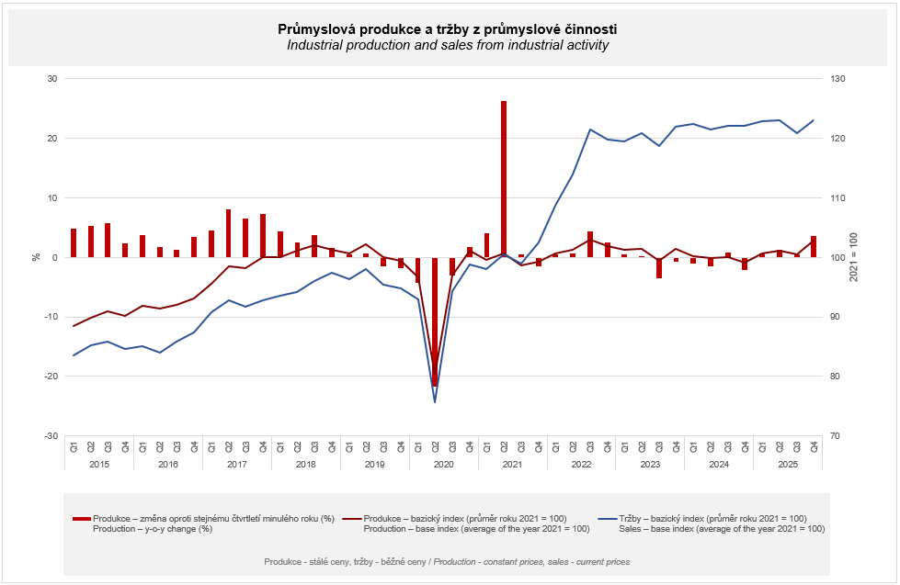

In the first quarter, the industrial production increased by 0.7%, y-o-y. In the second quarter, the growth rate moderately accelerated: compared to the Q2 2024, the industrial production increased by 1.3%. Production in the third quarter was, de facto, on the same level as in the previous year, when it increased by 0.4%. In the fourth quarter of 2025, the industrial production increased by 3.5%, y-o-y.

Sales from industrial activity at current prices increased by 0.3%, y-o-y, in 2025. Direct export sales of industrial enterprises increased at current prices by 1.6%. Domestic sales, which also include indirect export via non-industrial enterprises, decreased at current prices by 1.2%.
The following contributed the most to the growth: manufacture of fabricated metal products (a contribution of +0.41 p. p., an increase by 5.3%), manufacture of food products (a contribution of +0.34 p. p., an increase by 5.0%), and repair and installation of machinery and equipment (a contribution of +0.19 p. p., an increase by 6.5%).
On the other hand, sales from industrial activity decreased the most in manufacture of computer, electronic and optical products (a contribution of -0.30 p. p., a decrease by 5.5%), manufacture of chemicals and chemical products (a contribution of -0.17 p. p., a decrease by 5.3%), and in mining and quarrying (a contribution of -0.17 p. p., a decrease by 14.8%).

The value of new orders at current prices in surveyed industrial CZ-NACE activities in 2025 increased by 3.4%, year-on-year. Non-domestic new orders increased by 4.7%. Domestic new orders increased by 1.0%.
The following contributed the most to the increase of the value of new orders: manufacture of other transport equipment (a contribution of +1.60 p. p., an increase by 53.6%), manufacture of fabricated metal products (a contribution of +0.99 p. p., an increase by 8.1%), and manufacture of motor vehicles, trailers and semi-trailers (a contribution of +0.80 p. p., an increase by 2.1%).
Negative contributions were recorded by manufacture of computer, electronic and optical products (a contribution of -0.47 p. p., a decrease by 5.5%), manufacture of chemicals and chemical products (a contribution of -0.23 p. p., a decrease by 4.3%), and manufacture of paper and paper products (a contribution of -0.05 p. p., a decrease by 1.7%).

In the first quarter, the value of new orders was by 0.6% lower than in the first quarter of 2024. In the second quarter, the value of new orders already increased by 2.7%, year-on-year. In the third quarter, it increased by 1.9%. In the fourth quarter of 2025, the value of new orders increased by 9.8%, y-o-y, namely thanks to concurrence of several long-term orders in manufacture of other transport equipment and in manufacture of electrical equipment. In the end of the year, more new orders were made, for example, in manufacture of fabricated metal products and in manufacture of motor vehicles, trailers and semi-trailers.

The average registered number of employees in industry in 2025 was by 1.8% lower than the one in the corresponding period of the previous year and their average gross monthly nominal wage increased by 5.8%.

Notes:

Contact person: Veronika Doležalová, Head of the Industrial Statistics Unit, phone number (+420) 734 352 291, e-mail: veronika.dolezalova@csu.gov.cz

Related outputs: time series in the Public database, the Industry chapter

