6 November 2025

Industrial production increased by 0.8%, year-on-year, in the Q1 through Q3

Supplementary information to the news release on industry –September 2025
Industry in the Q1 through Q3 2025
Industrial production was by 0.8% higher, year-on-year, in the Q1 through Q3 of 2025.

Electricity, gas, steam and air conditioning supply contributed the most to the year-on-year increase (a contribution of +0.5 percentage point (p. p.), an increase by 5.4%). The following also contributed: manufacture of fabricated metal products (a contribution of +0.24 p. p., an increase by 2.3%), manufacture of rubber and plastic products (a contribution of +0.15 p. p., an increase by 2.4%), and manufacture of other non-metallic mineral products (a contribution of +0.14 p. p., an increase by 3.4%).
The highest negative contributions were recorded by manufacture of computer, electronic and optical products (a contribution of -0.17 p. p., a decrease by 4.9%), manufacture of motor vehicles, trailers and semi-trailers (a contribution of -0.12 p. p., a decrease by 0.6%), and manufacture of machinery and equipment (a contribution of -0.09 p. p., a decrease by 1.2%).

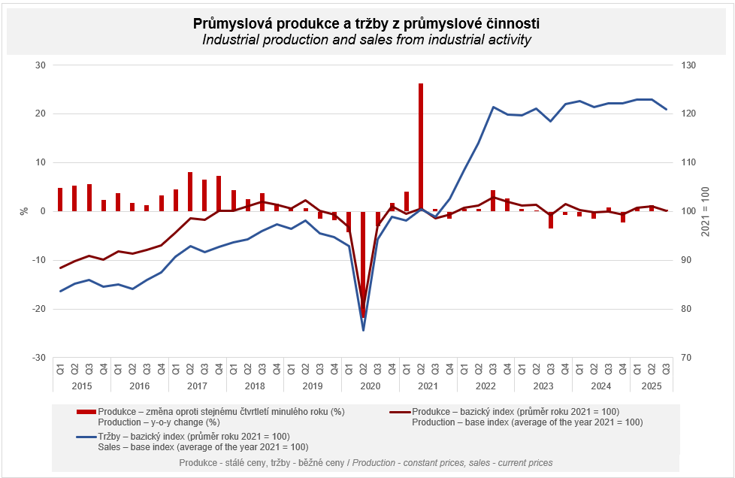

Sales from industrial activity at current prices increased by 0.1%, year-on-year, in the Q1 through Q3 of 2025. Direct export sales of industrial enterprises increased at current prices by 1.6%. Domestic sales, which also include indirect export via non-industrial enterprises, decreased at current prices by 1.6%.
The following contributed the most to the growth: manufacture of food products (a contribution of +0.37 p. p., an increase by 5.5%), manufacture of fabricated metal products (a contribution of +0.29 p. p., an increase by 3.7%), and repair and installation of machinery and equipment (a contribution of +0.20 p. p., an increase by 7.6%).

On the other hand, sales from industrial activity decreased the most in manufacture of computer, electronic and optical products (a contribution of -0.33 p. p., a decrease by 6.3%), manufacture of chemicals and chemical products (a contribution of -0.19 p. p., a decrease by 5.9%), and mining and quarrying (a contribution of -0.15 p. p., a decrease by 13.1%).

The value of new orders at current prices in surveyed industrial CZ-NACE activities in the Q1 through Q3 of 2025 increased by 1.4%, year-on-year. Non-domestic new orders increased by 1.3%. Domestic new orders increased by 1.6%.
The following contributed the most to the increase of the value of new orders in the Q1 through Q3: manufacture of fabricated metal products (a contribution of +0.87 p. p., an increase by 7.0%), manufacture of motor vehicles, trailers and semi-trailers (a contribution of +0.66 p. p., an increase by 1.7%), and manufacture of machinery and equipment (a contribution of +0.31 p. p., an increase by 3.1%).
The highest negative contributions were recorded by manufacture of computer, electronic and optical products (a contribution of -0.48 p. p., a decrease by 5.6%), manufacture of chemicals and chemical products (a contribution of -0.28 p. p., a decrease by 5.4%), and manufacture of basic metals (a contribution of -0.06 p. p., a decrease by 1.2%).

The average registered number of employees in industry in the Q1 through Q3 of 2025 was by 2.0% lower than in the corresponding period of the previous year.

Notes:

Contact person: Veronika Doležalová, Head of Industrial Statistics Unit, phone number (+420) 734 352 291, e-mail: veronika.dolezalova@csu.gov.cz

Related outputs: time series in the Public database, the Industry chapter

