July 24, 2024

**Overall confidence in the economy has decreased**

**Business cycle survey – July 2024**

**The composite confidence indicator (economic sentiment indicator), in the basic index form – decreased by 2.9 points to a value of 95.1, m-o-m, reflecting different developments in its components. The business confidence indicator decreased by 2.9 points to a value of 94.5, and the consumer confidence indicator decreased by 2.6 points to a value of 98.4.**

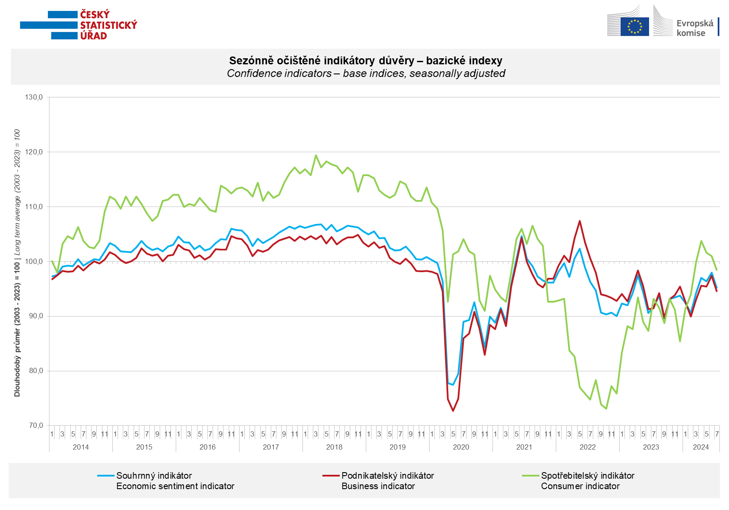

Confidence in the economy among **entrepreneurs** decreased in the industry (-4.9 points) and the selected services (-2.3 points). According to the previous month, the confidence among entrepreneurs increased in trade (+1.7 points) and the construction (+4.2 points).

**Consumer** confidence decreased three times in the row. The confidence indicator decreased by 2.6 points to a value of 98.4. The number of respondents expecting a deterioration in the overall economic situation in the next twelve months slightly decreased. The number of consumers assessing their current financial situation worse than in the previous twelve months has significantly increased. The number of respondents expecting a deterioration in their financial situation in the next twelve months is slightly decreased. The share of consumers who believe that the current time is not suitable for making major purchases has increased compared to the previous month.

***

More detailed information on the development of business and consumer confidence can be found in [*the supplementary information to the RI business surveys*](https://csu.gov.cz/docs/107532/ce9a8fed-9a73-f35b-bcac-9f515f13de01/akpr072424_komentar.pdf)*.*

Notes:

Responsible manager: Juraj Lojka, Director of Business Statistics Coordination and Business Cycle Surveys Department, tel. +420731439291, e-mail: juraj.lojka@czso.cz

Contact person: Jiri Obst, Head of Business Cycle Surveys Unit, tel. +420604815440, e-mail: [jiri.obst@czso.cz](mailto:jiri.obst@czso.cz)

Data source: CZSO business survey, Data Collect consumer survey (https://www.datacollect.cz)

Data collection date: Business part: July 17, 2024

Consumer part: July 15, 2024

Next News Release: August 26, 2024

This press release wasn´t edited for language.

Detailed time series of Balances and basic

indices of confidence indicators: <https://www.czso.cz/csu/czso/kpr_ts>

*Business and Consumers Surveys are co-financed by grant agreements of the European Commission DG ECFIN.*

[*https://ec.europa.eu/info/business-economy-euro/indicators-statistics/economic-databases/business-and-consumer-surveys_en*](https://ec.europa.eu/info/business-economy-euro/indicators-statistics/economic-databases/business-and-consumer-surveys_en)

*Link to European database:* [*https://ec.europa.eu/eurostat/web/euro-indicators/database*](https://ec.europa.eu/eurostat/web/euro-indicators/database)

Annex:

Additional information to NR Business cycle survey

Table Confidence Indicators – basic indices

Graph 1 Confidence indicators – base indices, seasonally adjusted (2003–2024)

Graph 2.1 Confidence Indicators for industry, construction, trade, and in selected services – base indices, seasonally adjusted (2003–2024)

Graph 2.2 Balances of seasonally adjusted confidence indicators for industry, construction, trade, and in selected services (2003–2024)

Graph 3 Economic Sentiment Indicators – international comparison, seasonally adjusted (2007-2024)

Graph 4 Production Capacity Utilisation in Manufacturing Industry (2003-2024)

Graph 5 Limits of Production in Industry (2005-2024)

Graph 6 Limits of Production in Construction (2005-2024)

Graph 7 Limits of Production in Selected Services (2005-2024)