June 24, 2024

Business confidence indicator increased, but consumer confidence indicator has decreased slightly

Business cycle survey – June 2024
The composite confidence indicator (economic sentiment indicator), in the basic index form – increased by 1.6 points to a value of 98.0, m-o-m, reflecting different developments in its components. The business confidence indicator rose by 2.0 points to a value of 97.4, and the consumer confidence indicator slightly decreased by 0.6 points to a value of 101.0.

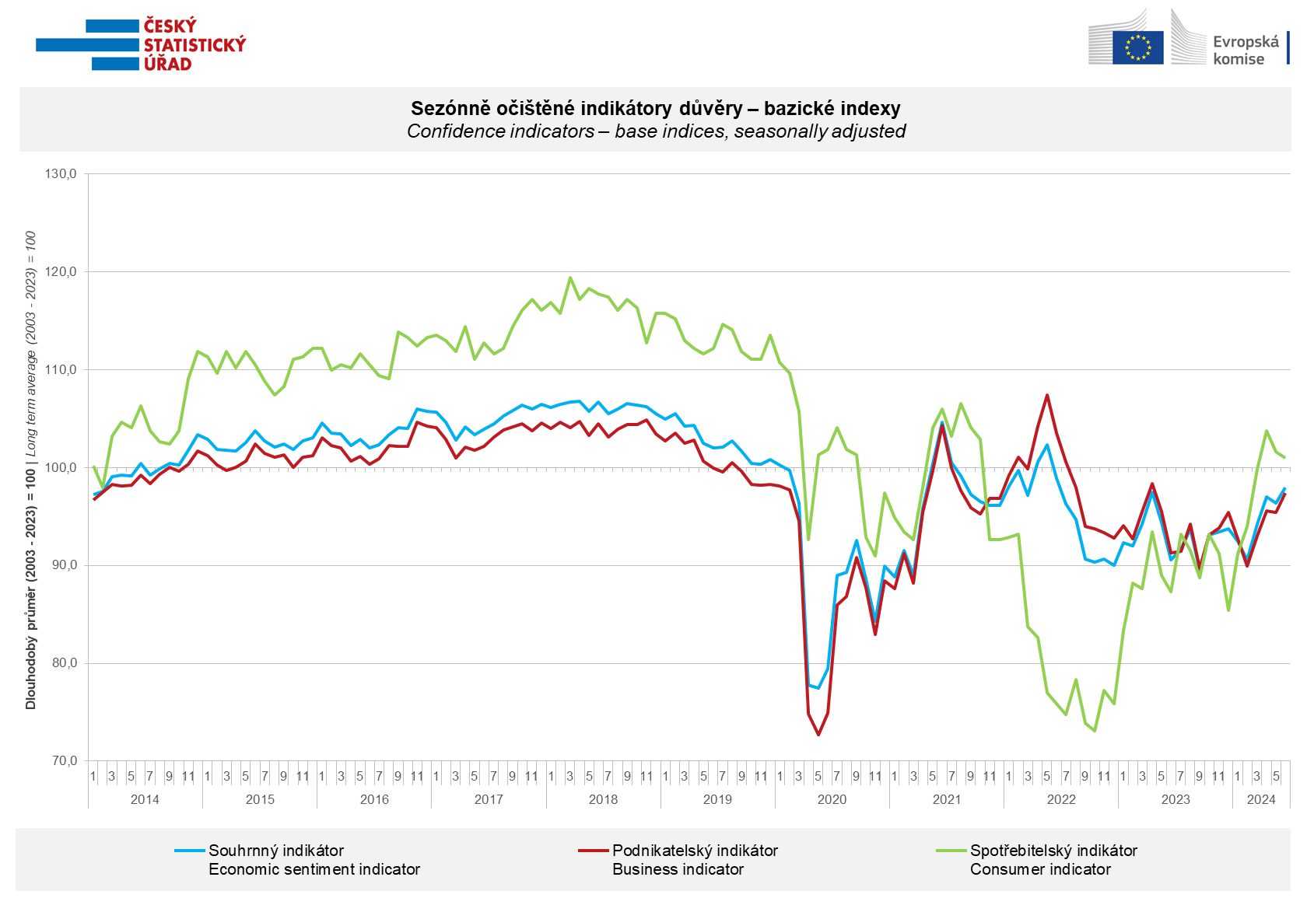

Confidence in the economy among entrepreneurs increased in the industry (+4.3 points) and the slightly increase is in the construction sector (+ 0.6 points) and the selected services (+ 0.1 points). The decrease is monitored in the trade (- 0.8 points).

Consumer confidence decreased again. The confidence indicator slightly decreased by 0.6 points to a value of 101.0. The number of respondents expecting a deterioration in the overall economic situation in the next twelve months significantly increased again. The number of consumers assessing their current financial situation worse than in the previous twelve months has decreased. But the number of respondents expecting a deterioration in their financial situation in the next twelve months is unchanged. The share of consumers who believe that the current time is not suitable for making major purchases has not changed compared to the previous month.

***
More detailed information on the development of business and consumer confidence can be found in the supplementary information to the RI business surveys.

Notes:

Responsible manager: Juraj Lojka, Director of Business Statistics Coordination and Business Cycle Surveys Department, tel. +420731439291, e-mail: juraj.lojka@csu.gov.cz
Contact person: Jiri Obst, Head of Business Cycle Surveys Unit, tel. +420604815440, e-mail: jiri.obst@csu.gov.cz
Data source: CZSO business survey, Data Collect consumer survey (https://www.datacollect.cz)
Data collection date: Business part: June 17, 2024
Consumer part: June 17, 2024
Next News Release: July 24, 2024

This press release wasn´t edited for language.

Detailed time series of Balances and basic
indices of confidence indicators: https://csu.gov.cz/produkty/kpr_ts
Business and Consumers Surveys are co-financed by grant agreements of the European Commission DG ECFIN.
https://ec.europa.eu/info/business-economy-euro/indicators-statistics/economic-databases/business-and-consumer-surveys_en
Link to European database: https://ec.europa.eu/eurostat/web/euro-indicators/database

Annex:
Additional information to NR Business cycle survey
Table Confidence Indicators – basic indices
Graph 1 Confidence indicators – base indices, seasonally adjusted (2003–2024)
Graph 2.1 Confidence Indicators for industry, construction, trade, and in selected services – base indices, seasonally adjusted (2003–2024)
Graph 2.2 Balances of seasonally adjusted confidence indicators for industry, construction, trade, and in selected services (2003–2024)
Graph 3 Economic Sentiment Indicators – international comparison, seasonally adjusted (2007-2024)

