1 April 2026

Balance of the general government sector for 2025 ended up in deficit

Notification of government deficit and debt – 2025

For the year 2025, the balance of the general government sector ended up with a deficit corresponding to 2.1% of the GDP, which was by 0.1 percentage point (p. p.) more than in the year 2024. The general government sector debt in the end of the year 2025 reached 44.3% of the GDP while the y-o-y increase was by 1.0 p. p.

“The balance of the general government sector for the year 2025 ended up with a deficit in the amount of CZK 183.7 billion (bn), which in the year-on-year comparison means worsening by CZK 20.4 billion. The government debt ratio increased to the level of 44.3% of the GDP,” Helena Houžvičková, Director of the Macroeconomic Statistics Section of the Czech Statistical Office (CZSO), stated.

The largest part of the deficit results from the balance of the central government sub-sector that ended up with the deficit of CZK 197.8 bn. The local government sector balance ended up with a surplus of CZK 29.4 bn and the social security funds sub-sector (of health insurance companies) ended up with a deficit of CZK 15.3 bn.

Tab. 1.1: Notification table of government deficit and debt, Czech Republic
 | Unit | 2022 | 2023 | 2024 | 2025
Net borrowing/lending of general government | CZK mil. | -216 345 | -286 066 | -163 345 | -183 744
General government consolidated gross debt | CZK mil. | 2 997 632 | 3 234 102 | 3 488 500 | 3 786 250
Net borrowing/lending of general government as % of GDP | % | -3.1 | -3.7 | -2.0 | -2.1
General government consolidated gross debt as % of GDP | % | 42.5 | 42.2 | 43.3 | 44.3

The total general government sector revenue increased in 2025 by 5.9%, y-o-y; in absolute terms, it was an increase by CZK 194.6 bn. Received social contributions, revenue from income taxes and from taxes on production and imports were increasing the most.

The total general government sector expenditure increased in 2025 by 6.2%, y-o-y, or by CZK 215.0 bn. The biggest increase was recorded for gross fixed capital formation, compensation of employees paid, and social benefits paid.

In the end of 2025, the relative debt of the general government reached 44.3% of the GDP. In the year-on-year comparison, the relative debt increased by 1.0 p. p. An increase in the nominal GDP contributed to the decrease of the relative amount of the debt (-2.5 p. p.), whereas the nominal growth of the debt contributed in relation to the GDP to an increase by 3.5 p. p.

Chart 1.1 Year-on-year relative changes in government debt
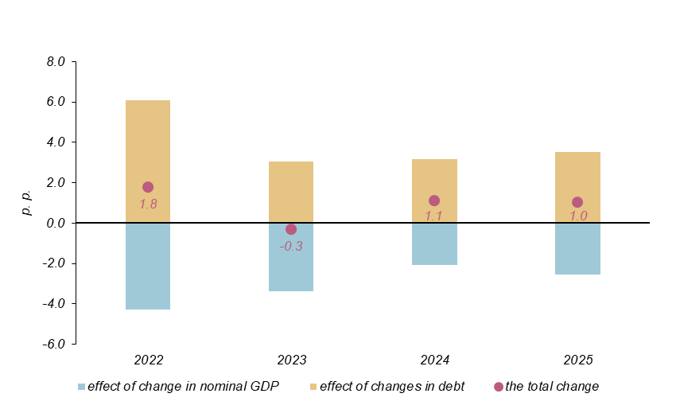

In the end of 2025, the general government debt increased by CZK 297.8 bn, y-o-y, and reached CZK 3 786.3 bn. A major part of the y-o-y change is due to the issued debt securities (CZK 276.0 bn).

In 2025, the year-on-year change in the debt (the increase by CZK 297.8 bn) was markedly different from the general government sector balance (a deficit of CZK 183.7 bn); it means that the general government sector borrowed by CZK 114.1 bn more than its need to be financed was. This fact was reflected on the assets side by an increase in the value of financial assets held, especially of transferable deposits.

Indicators presented in the Tab. 1.1 were transmitted to Eurostat on 31 March 2026.

Notes: Notification of government deficit and debt is compiled always for the past four years and submitted to the European Commission by each Member State of the European Union always at the end of March and September each year, including a projection for the current year. The projection for the current year is compiled and published by the Ministry of Finance of the Czech Republic. Quantification of fiscal indicators is based on the ESA 2010 methodology and serves the assessment of how the Maastricht convergence criteria are complied with. Pursuant to the Maastricht criteria, the government deficit must not exceed 3% of the GDP and the level of the accumulated government debt must not exceed 60% of the GDP.

Government surplus/deficit is represented by the item B.9 “net borrowing (−) or net lending (+)” in the system of national accounts. The indicator refers to the ability of the general government sector in the given year to finance other sectors of the economy (+) or the need of the general government sector to be financed (−) by other sectors.

The government debt consists of consolidated liabilities of the general government sector in the form of currency and deposits, issued debt securities, and received loans. In case of foreign exchange debt instruments hedged against currency risk, value in CZK is obtained by means of a contractual exchange rate.

Responsible head at the CZSO: | Helena Houžvičková, Director of the Macroeconomic Statistics Section, phone: (+420) 704 688 734, e-mail: helena.houzvickova@csu.gov.cz
Contact person: | Jaroslav Kahoun, Head of the Government Accounts Unit, phone: (+420) 274 054 232, e-mail: jaroslav.kahoun@csu.gov.cz
Next news release will be published on: | 22 April 2026

