September 25, 2023

Overall confidence in the economy decreased
Business cycle survey – September 2023

The composite confidence indicator (economic sentiment indicator) – in the basis index form – decreased by 4.2 points to 89.2 m-o-m, with the same developments of its components. The business confidence indicator decreased by 4.5 percentage points to 89.4 and the consumer confidence indicator decreased by 2.7 points to 88.3. 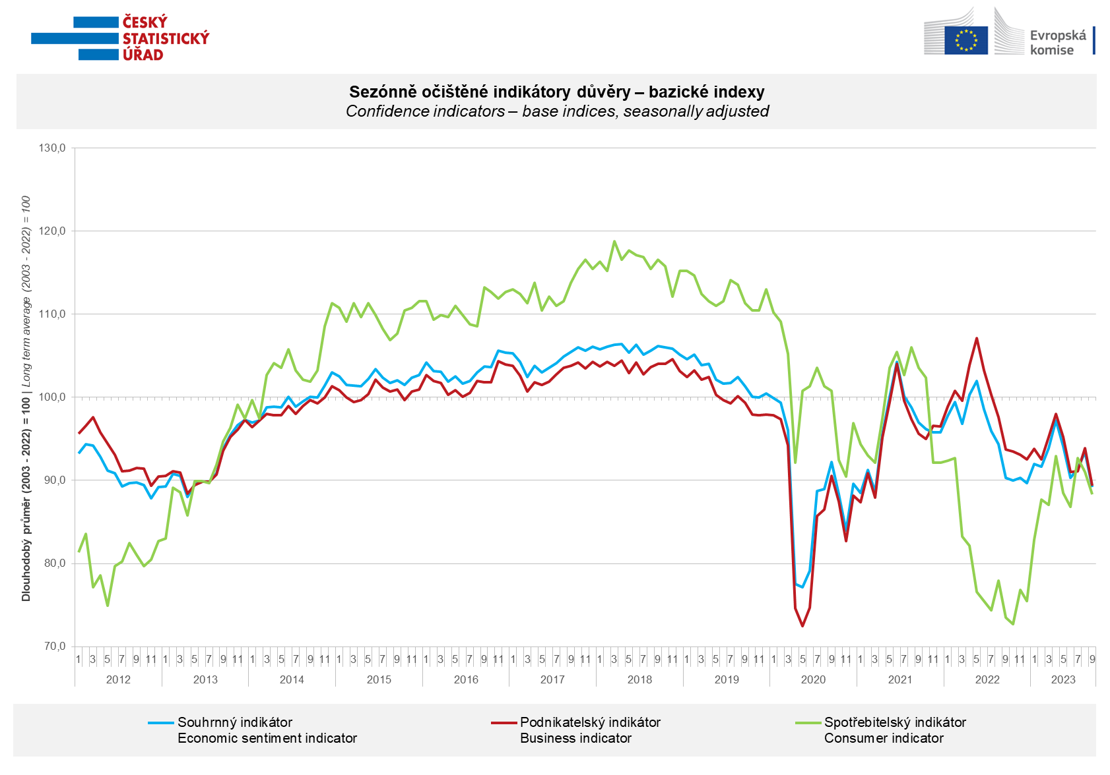

The September decrease in economic sentiment among entrepreneurs is mainly due to a significant drop in confidence in the industry sector (-7.6 points). Confidence also fell in selected services (-2.2 points) and in trade (-1.2 points), slightly increased only in construction (+0.6 points).

Consumer confidence in the economy decreased m-o-m. The number of respondents expecting a deterioration of the overall economic situation in the Czech Republic in the next twelve months increased significantly in September. The number of households rating their current financial situation worse compared to the previous twelve months has hardly changed compared to August. The share of respondents who believe that the current time is not suitable for making large also remained approximately the same.

***
More detailed information on the development of business and consumer confidence can be found in the supplementary information to the RI business surveys.

Notes:

Responsible manager: Juraj Lojka, Director of Business Statistics Coordination and Business Cycle Surveys Department, tel. +420731439291, e-mail: juraj.lojka@czso.cz
Contact person: Jiri Obst, Head of Business Cycle Surveys Unit, tel. +420604815440, e-mail: jiri.obst@czso.cz
Data source: CZSO business survey, Data Collect consumer survey (https://www.datacollect.cz)
Data collection date: Business part: September 18, 2023
Consumer part: September 15, 2023
Next News Release: October 24, 2023

This press release wasn´t edited for language.

Detailed time series of Balances and basic
indices of confidence indicators: https://www.czso.cz/csu/czso/kpr_ts
Business and Consumers Surveys are co-financed by grant agreements of the European Commission DG ECFIN.
https://ec.europa.eu/info/business-economy-euro/indicators-statistics/economic-databases/business-and-consumer-surveys_en
Link to European database: https://ec.europa.eu/eurostat/web/euro-indicators/database

Annex:
Additional information to NR Business cycle survey
Table Confidence Indicators – basic indices
Graph 1 Confidence indicators – base indices, seasonally adjusted (2003–2023)
Graph 2.1 Confidence Indicators for industry, construction, trade, and in selected services – base indices, seasonally adjusted (2003–2023)
Graph 2.2 Balances of seasonally adjusted confidence indicators for industry, construction, trade, and in selected services (2003–2023)
Graph 3 Economic Sentiment Indicators – international comparison, seasonally adjusted (2007-2023)

