General government debt reached 43.8% of the GDP
1 October 2026

Government deficit and debt – the second quarter of 2026
In the Q2 2026, the general government sector balance ended up with a deficit corresponding to 1.5% of the GDP. The government debt ratio reached 43.8% of the GDP.
General government sector balance
In the Q2 2026, the general government sector deficit reached CZK 33.3 billion (bn), which means that it worsened by CZK 42.6 billion in the year-on-year comparison. The central government ended up with a deficit of CZK 107.1 billion that increased by CZK 74.7 billion, y-o-y. Performance of the local government sector ended up with a surplus in the amount of CZK 60.7 billion, which means, in a year-on-year comparison, improvement by CZK 19.6 billion. Performance of social security funds (of health insurance companies) ended up with a surplus of CZK 13.1 billion, by CZK 12.5 billion higher, year-on-year.
“In the second quarter of 2026, the general government sector ended up with a deficit of CZK 33.3 billion, which is in relative terms 1.5% of the GDP. The government debt ratio increased to 43.8% of the GDP, year-on-year,” Petr Musil, Director of the Government and Financial Accounts Department of the Czech Statistical Office (CZSO), stated.
Table: The general government sector balance
 | Q2 2024 | Q3 2024 | Q4 2024 | Q1 2025 | Q2 2025 | Q3 2025 | Q4 2025 | Q1 2026 | Q2 2026
CZK bn | 5.3 | -30.1 | -75.5 | -70.0 | 9.4 | -24.5 | -100.4 | -73.2 | -33.3
% of the GDP | 0.3 | -1.5 | -3.6 | -3.6 | 0.4 | -1.1 | -4.5 | -3.6 | -1.5
Data in the table are not seasonally adjusted; they cannot be compared quarter-on-quarter
The total government revenues increased by 4.8%, y-o-y, and reached 43.1% of the GDP. Especially received social contributions (+CZK 32.9 bn) contributed to the y-o-y increase in revenues. The total government expenditure increased by 9.5%, y-o-y, and reached 44.6% of the GDP. The highest growth in terms of volume was mainly recorded in social benefits payable (+CZK 27.5 bn), compensation of employees paid (+CZK 19.2 bn), and gross fixed capital formation (+CZK 17.8 bn).

Debt
The nominal debt of the general government increased, year-on-year, by CZK 215.1 bn to CZK 3 842.4 bn. The government debt ratio increased from 43.7% to 43.8% of the GDP, y-o-y; the influence of the nominal change of the debt was +2.4 p. p. while the increasing nominal GDP reduced the debt ratio by –2.3 p. p. In the quarter-on-quarter comparison, the debt increased by CZK 14.9 bn, the nominal change of the debt was 0.1 p. p., whereas an increase in the nominal GDP contributed to a decrease in the indebtedness by –0.4 p. p., which resulted in a decrease in the debt ratio by 0.3 p. p., quarter-on-quarter.

Chart 1: Debt of the general government sector
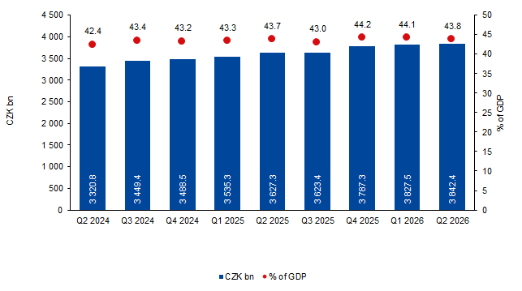
Chart 2: Year-on-year relative changes in government debt
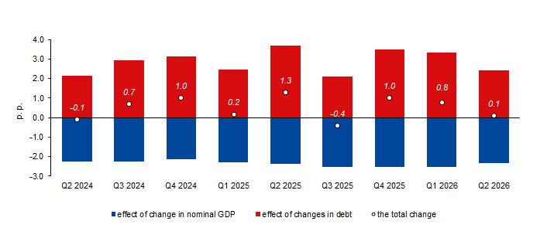

Seasonally adjusted general government sector balance
The general government sector balance after seasonal adjustment as well as adjustment for calendar effects ended up with a deficit of CZK 72.5 bn, which corresponded to 3.3% of the GDP. The general government sector balance worsened by CZK 16.3 bn., q-o-q. The development of the general government sector balance adjusted by seasonal and calendar effects is shown in the chart below.

Chart 3: Seasonally adjusted general government sector balance (% of GDP)

Notes: Quantification of fiscal indicators of government deficit and debt mentioned above is based on the ESA2010 methodology. Data published in this news release are methodologically consistent with the data used for the statistics of the excessive deficit procedure (EDP) purposes and for the assessment of how Maastricht convergence criteria are met.
The government surplus/deficit is represented by the item B.9 “net borrowing (−) or net lending (+)” in the system of national accounts. It refers to the ability of the general government sector to finance other sectors of the economy (+) or the need of the general government sector to be financed (−) by other sectors of the economy in the given period.
The general government debt is the amount of consolidated liabilities of the general government sector comprising the following items: received deposits, issued debt securities, and received loans. In case of foreign exchange debt instruments hedged against the currency risk, the value in CZK is obtained by means of the contractual exchange rate.
The general government sector balance is compared with the amount of the GDP in the given quarter at current prices. The amount of the consolidated general government debt is compared with the sum of quarterly GDP for the last four quarters at current prices. Unless otherwise stated, data are not seasonally adjusted as well as they are not adjusted for calendar effects.

Responsible head at the CZSO: | Petr Musil, Director of the Government and Financial Accounts Department, T: +420 734 352 286, E: petr.musil@csu.gov.cz
Contact person:  Related information: | Jaroslav Kahoun, Head of the Government Accounts Unit,  T: +420 274 054 232, E: jaroslav.kahoun@csu.gov.cz  https://csu.gov.cz/government-finance-statistics
The next news release will be published on: | 6 January 2027

