31 March 2026

The year 2025 rewrote historical records

Population change – year 2025
During 2025, the population of Czechia increased by 6.3 thousand and exceeded 10.915 million. International migration raised the population by 42.0 thousand, while natural change resulted in a decrease of 35.7 thousand. The number of live births (77.6 thousand) and marriages (42.5 thousand) declined year-on-year again. On the other hand, the number of deaths (113.3 thousand) and divorces (21.2 thousand) increased slightly year-on-year.
As of 31 December 2025, Czechia had a population of 10,915,839 inhabitants, 6.3 thousand more than on 1 January 2025. The population of Czechia has been recording positive total increases continuously since 2014. However, over the past seven years, this growth has been driven solely by foreign migration, as natural change has remained negative. The excess of deaths over live births by 35.7 thousand people in 2025 was the largest ever since 1919.

In 2025, the natality continued to decline for the fourth year. A total of 77.6 thousand children were born alive, 6.7 thousand (8%) fewer year-on-year. This was the lowest number in the history of statistical surveys. The number of births decreased across all birth orders. A total of 46.8% of children were born outside marriage, slightly lower than a year earlier, due to a decline in the share among first-born children. In absolute numbers, the most children were born to women aged 31, or 30–32.

Figure Population change in 2024 and 2025
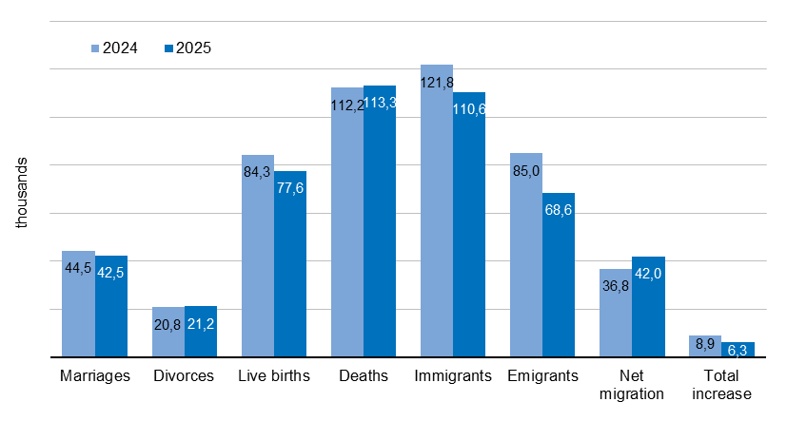

In 2025, a total of 113.3 thousand inhabitants of Czechia died, which was 1.1 thousand (1%) more year-on-year. Almost all the increase in deaths was attributable to women (an increase by 1.0 thousand to 55.6 thousand), while the number of male deaths increased only slightly (by 0.1 thousand to 57.8 thousand). Among the deceased men, the majority were aged 75–79, and among the deceased women, the majority were aged 80–84. A total of 39.3 thousand people died in the age group 75–84, accounting for nearly 35% of all deaths.

"In 2025, the number of marriages decreased for the third year in a row. A total of 42.5 thousand couples entered into marriage, which was 1.9 thousand less than a year earlier and the lowest since the end of World War I. The previous minimum of 43.5 thousand recorded in 2013 was thus surpassed," says Michaela Němečková from the Demographic Statistics Unit of the CZSO. Three out of four engaged couples entered marriage for the first time.

A total of 21.2 thousand marriages ended in divorce, which was 0.4 thousand (2%) more than in the previous year. One quarter of all divorces occurred after 5–9 years of marriage, most of them after six years of marriage. Among the divorced, people aged 45–49 predominated. Divorces affected at least 20.3 thousand children, as 59.0% of divorced couples had at least one common minor child.

In 2025, 110.6 thousand people immigrated to Czechia from abroad. This was 11.2 thousand fewer than in 2024, but still significantly higher compared to the years before the outbreak of the war in Ukraine. In the opposite direction, 68.6 thousand inhabitants emigrated from Czechia, which was 16.4 thousand fewer than in the previous year. The net migration reached 42.0 thousand and increased by 5.2 thousand compared to 2024. The net migration was significantly higher for men (33.7 thousand) than for women (8.3 thousand). From the perspective of five-year age groups, the highest net migration was recorded among those aged 20–24, reflecting a significant increase in immigrants aged 21 and 22. As in 2024, the largest share of net migration was attributable to citizens of Ukraine (23.1 thousand), Slovakia (5.9 thousand) and the Philippines (3.9 thousand).

Notes:
All data refer to citizens of the Czech Republic and foreigners with permanent residence in the Czech Republic, third-country nationals with temporary residence in the territory of the Czech Republic based on a long-term visa (over 90 days) or a permanent residence permit, nationals of the EU Member States, Norway, Switzerland, Iceland, Liechtenstein and their dependants with notified temporary residence in the territory of the Czech Republic and foreigners with granted international protection in the Czech Republic. Since 2022, the population has included persons granted temporary protection in the Czech Republic with usual residence in the Czech Republic. The data contain also information on events (marriages, births, and deaths) of Czech citizens with the permanent residence in the Czech Republic that occurred abroad and were registered by the special registry office in Brno.
All data for 2025 are preliminary.

Responsible manager: Mgr. Robert Šanda, director of Population Statistics Department,
tel. 274 052 160, e-mail: robert.sanda@csu.gov.cz
Contact person: Mgr. Michaela Němečková, Demographic Statistics Unit,
tel. 274 052 184, e-mail: michaela.nemeckova@csu.gov.cz
Data source: Demographic statistics – results of processing statistical reports of Obyv series and data from Census Information System of the CZSO
Divorces – Information system of the Ministry of Justice of the CR
Migration data – Information System of Inhabitants Records (Ministry of the Interior of the CR) and Alien Information System (Directorate of Alien Police)
End of data collection: 20 March 2026
Related publication: 130062-25 Population of the Czech Republic – year 2025
https://vdb.czso.cz/vdbvo2/faces/en/index.jsf?page=statistiky&katalog=30845#katalog=34275
Related time series: https://csu.gov.cz/produkty/oby_ts
Next News Release: 12 June 2026

Text is not edited for language.

Annexes:
Table 1 Population and population change in the 1st–4th quarter
Chart 1 Population (quarterly data)
Chart 2 Population in the 1st–4th quarter
Chart 3 Live births (quarterly data)
Chart 4 Deaths (quarterly data)
Chart 5 Marriages (quarterly data)
Chart 6 Divorces (quarterly data)

