Real and nominal convergence

The ability of a country to near by the rate of growth of performance of its economy to the level of economic and currency union in Europe, i.e. converge in real terms to this level, is in this chapter examined through the development of shifts in the relative position of the Czech republic economy according to GDP per capita in purchasing power parity (in PPS) to the EU average, resp. in some cases to the average of their most developed countries, which consist of so called old EU countries, that is the EU 15 group (does not include states, which became a member of the Union in the accession wage from May 2004 and later). Fulfilment of the Maastricht criteria is then assessed further as a nominal convergence.

Changes in the relative position of the CR in the economic development compared to the EU
Economic advancement of a country gauged by the gross domestic product per one inhabitant expressed in the purchasing power parity (units of PPS) in case of the Czech Republic from year 2010 in relation to the average level of economic and currency union in Europe worsens. Real convergence thus switched to a mild real divergence.

GDP per capita in PPS fell in the CR in 2012 to 79 % of the EU 27 average… |  |  |  |  | Mostly due to the fall of GDP of the CR in 2012 compared to 2011 by 1.2 %, which was – after five European countries with the highest debt of the government sector and also Hungary – the seventh deepest drop in the EU 27, eventuated further worsening of the relative position of the CR in measuring the economic advancement. GDP per capita in purchasing power parity (PPS) fell according to Eurostat data to 79 % of the EU 27 average. In years 2010 and 2011 arrived according to this source at 80 % of the average level of the union (chart 69).
… and 72.5 % of the „old“ Union countries level |  |  |  |  | If we however relate this development to the idea, that convergence is a desirable especially towards the very advanced European countries, this view shows the intensity of approaching mostly to the EU 15 group, which involves so called „old“ EU countries, i.e. the union before the May 2004 accession wave.  Convergence of the CR to the EU 15 groups halted similarly as in the relation to the average of EU 27 in 2009, when GDP per capita amounted to 75.5 % of the economic level of these old EU countries. In 2012 fell this ratio to 72.5 %. Worsening, i.e. a divergence relative to the average level of the EU 15 group (chart 69) was thus more marked than the worsening towards the average of the whole union (EU 27).
Chart 69 | Gross Domestic Product per capita v PPS (constant prices, seasonally adjusted, y/y in %) |  |  |  |  | Chart 70 | GDP (in cur.p., y/y in %) and confidence indicators based on CZSO Business Cycle Surveys
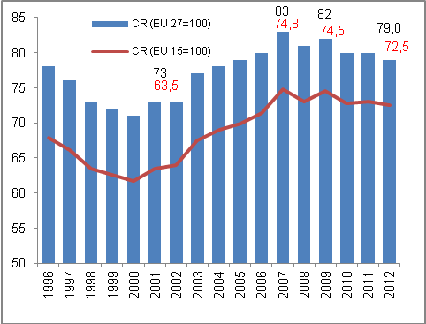 |  |  |  |  |  | 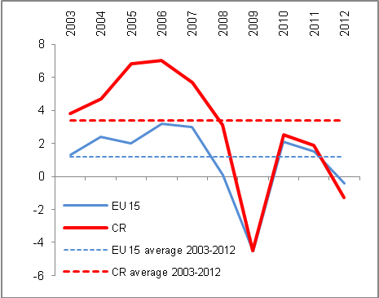
 |  |  |  |  |  | Source: Eurostat, own calculations
Effect of the GDP drop by 1.2 % in 2012, but also in years 2010 and 2011 was the GDP growth of the CR against the usually compared neighbour central European countries weaker  Despite the fall of relative position of GDP per capita in PPS for Greece and Portugal the Czech Republic in 2012 in the ranking of countries sustained its position… |  |  |  | Significant effect on worsening of this relative position of the Czech Republic had the adverse development of GDP in 2012, since in the post crisis year 2010 GDP in the CR increased in real terms year-on-year by 2.5 %, which was mildly more than for EU 27 (+2.1 %) and in this view was relatively favourable also year 2011 (+1.8 % against 1.6 % in the EU 27). For comparison, Slovakian economy however in these years grew year-on-year by 4.4 % and 3.2 % resp., Polish by 3.9 % and 4.5 % resp., Austrian by 2.1 % and 2.7 % resp.  If in years of boom and when including the crisis year 2009 (i.e. period 2004-2009) grew the CR economy on average by 3.8 % annually and the EU 27 economy by 1.2 % and the strength of convergence of the CR towards the average economic level of the union was with this more than triple growth very high, then in the post crisis period, i.e. 2010 till 2012 presented weak, but still a divergence – GDP in the CR grew for that period on average annually by 1 %, while the economy of the EU 27 by 1.1 %. Development of GDP of „old“ EU countries against the CR presents the chart 69.  In the ranking of countries based on GDP per capita in PPS did not occur in 2012 from the point of view of the Czech Republic any substantial changes. Its position (16th place in the ranking of EU countries) did not affect nor the marked worsening of the relative position of Portugal to 75 % of the EU 27 average from 78 % in 2011, neither the worsening in case of Greece (according to preliminary data also to 75 % of the EU 27 average from 79 % in 2011), since these countries were behind the CR already in 2011.
… on the 16th place in the EU 27 and when including the European countries outside union then on the 20th place |  |  |  | If we include also the European countries standing outside the EU, i.e. states with a very high GDP per capita in PPS, the Czech Republic shifts to the 20th position in Europe (this indicator amounted to in 2012 in case of Iceland to 110% of the EU average, Switzerland 160 % and in Norway the GDP per capita in PPS was in comparison to the EU 27 average even nearly double with 195 % of the union level.
GDP per capita in PPS fell in the CR in year 2012 to 79 % of the EU 27 average and 72.5% of „old“ Union countries average |  |  |  | Mostly due to the effect of GDP fall in the Czech Republic in 2012 in comparison to 2011 by 1.2 %, which was – after five European countries with the highest debt of the government sector and also Hungary – the seventh deepest decrease in the EU 27, eventuated a further worsening of the relative position of the CR in the measurement of the economic development. GDP per capita in the purchasing power parity (PPS) fell according to the Eurostat data to 79 % of the EU 27 average. In years 2010 and 2011 it amounted to 80 % of the average Union level according to this data source. Relative position of the CR on the scale of European countries can be discerned from chart 71.
Chart 71 Ranking of countries in GDP per capita in PPS in year 2012 (EU 15=100)
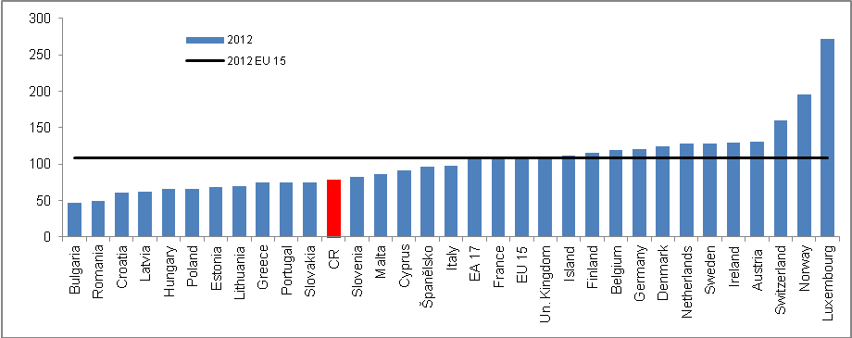
Source: Eurostat

Significant influence of the rate of growth of economies on the size of GDP per capita |  |  | Worsening of the indicator GDP per capita in PPS in case of the CR was caused mostly by the loss of the pace of performance of its economy (a role in this complex indicator however play also other factors). As can be seen from chart 72, countries where was this indicator improving in time, i.e. mostly Slovakia and Poland (but also very mildly Hungary) recorded especially after crisis a significantly higher growth of economy compared to the Czech Republic. Mainly due to the fall of GDP of the Czech Republic in 2012 against year 2011 by 1.2 %, 2011 totalled according to this source 79 % of average union level.
Very low growth of GDP per capita in PPS in the CR for years 2003-2012 |  |  | Even though in comparing the GDP per capita in PPS level against its change for selected countries (chart 73) plays a role the methodological change in case of the CR, which can distort the position, the fact remains, that the growth of this indicator for the whole decade of 2003-2012 is in case of the CR only very mild.
Three out of four largest European economies recorded a fall of GDP per capita in PPS in 2012 against year 2003 - Italy under European average, strengthening of prosperity in Germany |  |  | Debt crisis in large European economies, such as for example Italy, affected likely indirectly also the decrease of its economic level according to GDP per capita in PPS in 2012 in comparison to the level of year 2003 – from 112 % of the EU 27 average to 98 % in 2012, which means that this fourth largest European economy got with respect to advancement according to the monitored indicator, below the EU level.  Worsening was recorded among four largest European economies also in France (from 116 % in 2003 to 108 % EU 27 average in 2012), whose government sector also worsened its budget. In losses was also the United Kingdom (from 120 % to 110 % of average GDP per capita in the EU 27).  As the only one from large economies manage to increase its economic prosperity according to GDP per capita in PPS Germany (from 115 % to 121 % of the EU 27 average). It thus reaffirms the role it plays in the European economy also for economically connected countries via the imports of their goods and services, resp. capital interconnectedness via subsidiaries in these countries. Its prosperity is for them from the view of development of their economies very important.
Norwegian GDP per capita increased from very high 145 % against the EU 27 average in 2003 to 195 % in 2012… |  |  | From other European economies accelerated the most the prosperity of Norway standing outside the EU – its very high level of GDP per capita in 2003 (155 % of the EU 27 average) further markedly increased to 195 % in 2012. It is a country very little hit by the crisis in 2009 (GDP fell in real terms year-on-year by less than two percent) and in 2012 was its growth against other Scandinavian countries the highest.
…Slovakia also strengthened significantly its prosperity from 55 % to 75 % in 2012 compared to the CR, where GDP per capita rose from 77 % of the Union average in 2003 in ten years to 79 % |  |  | Among small European countries managed to increase during years 2003-2012 it’s GDP per capita in PPS Slovakia (from 55 % to 75 % of the EU 27 average). It thus neared relatively close the level of the Czech Republic (79 %). Its negligible increase of this indicator for the decade of 2003-2012 had comparison only with the development of Hungary (from 63 % to 66 % of the EU 27 average). Lower GDP per capita in PPS shown for the monitored years Slovenia, which used to have traditionally the best result among the usually compared countries of the accession wave of year 2004. Worsening of this indicator to 82 % in 2012 from 84 % in 2003 was in the percentage points lower compared to case of Portugal, which was till year 2004 according to this prosperity measure in front of the Czech Republic. After the relatively long and strong boom of the Czech economy however Portugal moved below the level of the CR.
Chart 72 | GDP per capita in PPS, selected countries in the decade 2003-2012 (EU 27=100) |  |  | Chart 73 | GDP per capita in PPS in year 2003 and 2012 (selected countries, EU 27=100)
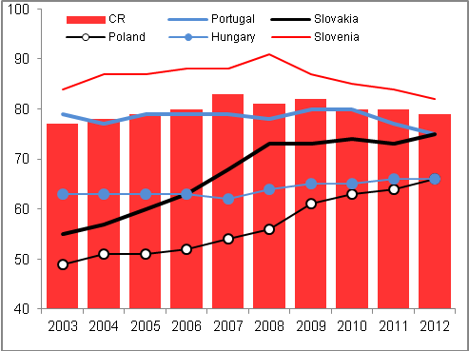 |  |  |  | 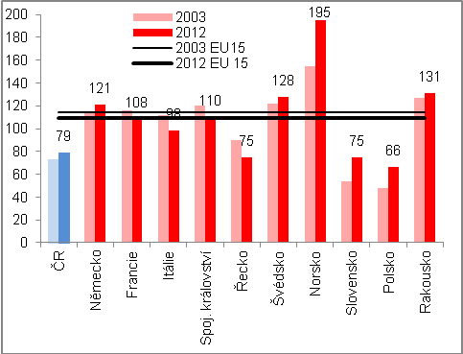
Source: Eurostat, own calculations

Comparison of the CR and EU 27 in years 2003-2007 and post crisis in the basic structure of GDP… |  | Structure of growth according to the development of individual expenditure components of GDP in the CR compared to the EU 27 and also the development of the supply side of economies (tab. 4) depicts in more detail, how in the periods – most interesting in the economic view – of decade 2003-2011 differed the dynamics of these components in the Union economy as a whole against the Czech Republic.
… confirmed for one thing markedly better development of most components in the CR during period 2003-2007 (but stagnation of consumption of government sector in the CR compared to its growth in the EU), on the contrary for years 2010-2012 worse development apart from foreign trade |  | While for years 2003-2007, when the European economy as well as economy of the CR enjoyed the boom phase, increased in comparison to the EU 27 more significantly the Czech foreign trade, investment as well as household consumption – however not the expenditure on final consumption of the government sector – in the post-crisis year 2010-2012 this was already valid only for foreign trade. Other components fared in the CR worse.  The year 2012 then only confirmed the significantly worse development of final consumption expenditure of both households and government sector against their development in the European Union as a whole. The slump of investment was in this comparison smaller, however the fall of gross value added more than triple compared to EU 27.
Table 4 Increments/reductions of basic GDP components in the medium- and long term horizon (in real terms, in %, year 2012 year-on-year in %)

 | 2003-2007 |  | 2010-2012 |  | 2012/2011
 | CR | EU 27 | CR | EU 27 | CR | EU 27
Household consumption | 17.5 | 8.3 | -2.2 | -0.5* | -2.7 | -0.8
Government consumption | -0.5 | 13.5 | -3.9 | 0.0** | -1.2 | 0.1
Investment | 17.4 | -0.2 | -3.4 | -3.1 | -4.1 | -5.5
Exports of goods and services | 95.5 | 43.2 | 14.0 | 8.9 | 4.0 | 2.4
Imports of goods and services | 66.0 | 34.9 | 9.4 | 3.8 | 2.3 | 0.3
Domestic demand | 13.4 | 7.6 | -2.8 | -0.9 | -2.7 | -1.5
Gross value added | 30.6 | 11.6 | 0.8 | 1.6 | -1.0 | -0.3
Gross domestic product | 28l4 | 10.8 | 0.6 | 1.3 | -1.2 | -0.4
* E.g. Germany +2.5 %, Slovakia -1.1 %, Poland +3.5 %, Estonia +8.3 %.
** E.g. Germany +2.2 %, France +1.9 %, Greece -9.2 %, Slovakia -4.9 %. Source: Eurostat

Factors influencing the loss of performance of the Czech economy

Domestic demand
Strongly worked also the domestic influences, especially falls of final consumption expenditures and even more also the lack of investment |  |  | Internal economic development of the CR stood for the prevailing part of year 2012 behind its weaker performance compared to the results of the EU 27 economy (chart 74). Significant was especially the factor of household consumption, which in both the nominal and real expression shared roughly by one half on total expenditures on GDP in the CR.  While till year 2009 increased the household final consumption expenditures in the CR in real terms markedly faster than for households for EU 27 average (e.g. in 2003 by 5.3 % year-on-year against +1 % in EU 27), and after crisis their year-on-year increase was in 2010 approximately the same, i.e. +1 % in the CR against +1.1 % in the EU), year 2012 already showed a notable imbalance to the detriment of the CR (-2.7 % year-on-year against -0.7 % in the EU).
Chart 74 | GDP dynamics (real, y/y in %) |  |  | Chart 75 | Domestic demand (real, y/y in %)
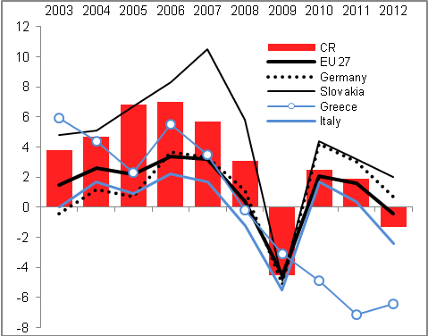
Source: Eurostat, own calculations

Development of domestic demand in the CR was thus in years 2011 and 2012 compared to the EU 27 development unfavourable |  | In years 2011 and 2012 was already significantly falling also the rate of growth of imports in reaction to the weak domestic market, even though a fall below the level of the preceding year did not eventuate, in contrast to the development of investment (gross fixed capital formation), as can be seen from chart 75. Domestic demand in the CR in total decreased in 2012 year-on-year by 2.7 %, while in the EU by 1.5 %. Difference to the detriment of the CR was apparent already in year 2011 (-0.1 % against +0.7 % in the EU) and especially in 2009 (-5.4 % against  -4.4 %). In all other years of the period 2003-2012 increased the domestic demand in the CR faster compared to the EU 27.

Foreign demand
Countries of the largest business partners such as Slovakia and Germany as well as the EU as a whole did not record significant slump of GDP, resp. its decline until Q4 2012 |  | The unfavourable change for the CR on foreign markets, lying in the decline of demand after exported goods and services due to the fall of GDP (chart 76), did not start to appear in 2012 until approximately Q3 (mostly in August and September). However, it strengthened significantly only in the last quarter of the year. Result of the foreign business exchange, as the only factor working from the half of year 2011 in the positive direction on the GDP development thus also started to lose dynamics (in Q4 2012 was its effect however null, for the whole year 2012 arrived the contribution of the foreign trade with goods and services balance +1.4 p.p. thanks to high contributions in Q1 and Q3).
Decline of the rate of growth of exports of goods and services from the CR in real expression from +6.3 % year-on-year in Q1 to +2.4 % in Q4 2012; comparably for imports from +3.6 % to + 2.6 % |  | For the whole year 2012 was sustained both the imports and exports expressed in the nominal terms (according to CZ-CPA in the national conception) in year-on-year growths (chart 77).  In real terms then increased the total exports of goods and services compared to year 2011 by 4.2 % (exports of goods by 4.6 %, exports of services by 2.2 %). In individual quarters the decrease was recorded only in Q2 for exports of services (year-on-year by -2 %). Comparably the total imports of goods and services in 2012 increased by 2.5 % (imports of goods by 1.7 %, imports of services by 7.3 %), the fall eventuated in Q3 for imports of services.  Also these proportions of the rates of growth of imports and exports reflect in the annual view a weaker domestic demand compared to foreign demand.

Chart 76 | GDP dynamics in countries of largest business partners (real terms, y/y in %) | Chart 77 | Foreign trade (according to CZ-CPA data in national conception, y/y in %)
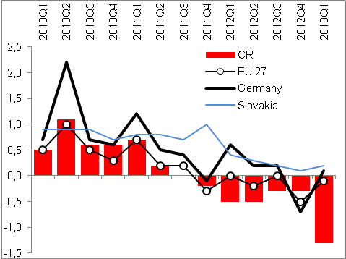 |  | 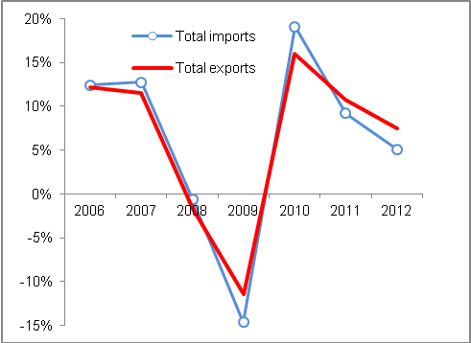
Source: Eurostat Source: CZSO

Exports of motor vehicles out of the CR after year-on-year growth by strong 17.6 % in Q1 2012 in the last quarter fell by 1.6 % and thus set also the lowering of rate of growth of total CZ exports; in Q1 2013 already sharp year-on-year fall of motor vehicle exports by -11.6 % |  | Cyclical industries producing main export items of goods from the CR suffered in 2012 by a gradual loss of pace of these exports (chart 78). In data related to foreign trade based on national conception (CZ-CPA) is apparent a very sharp year-on-year fall of exports of motor vehicle out of the CR in individual quarters – from +17.6 % in Q1 to -1.6 % in the last quarter of year 2012. This development was for the dynamics of the total exports of goods from the CR determining.  In Q1 2013 already occurred a sharp fall of the motor vehicle exports from the Czech Republic by 11.6 % against the same period of 2012, which was however partially influenced also by the statistical basis.
Following a weak year-on-year growth of exports of computers and electrical appliances from the CR by 1.5 %, their exports fell in Q1 2013 by 12 % |  | Also another significant item, exports of computers and electronic appliances, which in years of boom similarly to the case of motor vehicles put dynamics into the total exports from the CR, progressed in 2012 unfavourably with respect to the year-on-year dynamics quarter by quarter – after year-on-year addition in Q1 2012 by +7.7 % their export fell in the last three months by 0.9 %.  In Q1 2013 the exports of computers and electronic appliances from the CR lowered compared to the same period of 2012 by strong 12 %.
Chart 78 Exports of selected commodities (motor vehicles, computers and electronic appliances) and aggregate exports from the CR (y/y in %, CZ CPA, national conception)

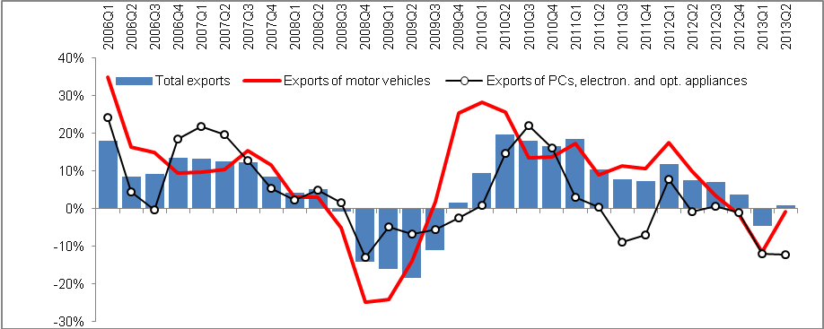
Source: CZSO

Positive outlook only for two countries in Europe, for „countries at risk“ identified Germany and Slovakia, the largest business partners of the CR – for the whole remaining part of the EU 27 indicated for 2013 a recession |  |  | Outlook for 2013 does not bring from the point of view of foreign demand for the CR for now a turn for better, this is expected as far as 2014. As can be seen from chart 79 (a map) processed by the rating agency Moody´s in May 2013, recession is anticipated for year 2013 in the majority of monitored countries (red field). Recovery is predicted by the Moody´s agency in Austria, as economies „at risk“ are according to this source marked Germany and Slovakia, i.e. the largest customers for goods from the CR. In this view is this way identified development for the exports from the Czech Republic more favourable, than in the majority of other European destinations.  Prediction of „expansion“, or economic growth limited the Moody´s agency in their prediction from May 2013 to only two countries of Europe – Norway and Poland.
Eurostat is also positive regarding Germany and Slovakia; recession for year 2013 predicts apart from seven countries of south Europe only to Netherlands, Slovenia and the Czech Republic |  |  | Also the prediction of Eurostat for years 2013 and 2014 counts with the recovery only in 2014. GDP of the EU 27 in real terms according to this estimate shall in 2013 in fact stagnate (-0.1 %), drop of 0.2 % is indicated for old union countries (EU 15), deeper for the euro area as a whole (-0.4 %). Also Eurostat is in case of Germany and Slovakia more optimistic and forecasts the growth of their GDP in 2013. It again suggests from the view of Czech exports a favourable anticipations.
Apart from seven countries of south Europe predict Eurostat recession in 2013 already only to Netherlands, Slovenia and the CR  GDP per capita in PPS fell in the CR in “Union country“  Relatively fast diversification of the Czech exports on markets outside EU 27 – fall of share of union on total exports from the CR from 87.3 % in 2003 to 83 % in 2011 and 80.8 % in 2012 |  |  | From other EU 27 countries Eurostat forecasts for year 2013 a recession to seven states of South Europe (Greece, Spain, France, Italy, Cyprus, Croatia and Portugal) and apart from them only to Netherlands, Slovenia and the Czech Republic.  In the global outlook processed in May 2013 by Moody´s Analytics the growth is anticipated only in Russia, China, several countries of southeast Asia, in Australia and the Pacific region and smaller countries of central and South America. As economies at risk signs this outlook the economies of USA, India, Argentina, Bolivia and South Africa. From largest fast growing economies labelled as the BRIC group thus apart from growth in Russia and China shall revive the Brazilian economy and somewhat lower outlook has India.  Czech exports is still more and more diversified with respect to group of countries BRIC, especially in the direction of Russia, where the dynamics increases year-on-year the fastest. Still in year 2012 represented the exports into these four large countries only 5.7 % of total exports from the CR, while into the EU 27 countries headed 80.8 % of aggregate exports.  With respect to the European recession is thus favourable, that the share of EU 27 countries falls 87.3 % in 2003 via 83 % in 2011 until the mentioned approximately four fifths in 2012.
Chart 79 | Outlook for the European economy (Moody´s, prepared in May 2013) |  |  | Chart 80 | Eurostat Expectations for years 2013 and 2014 (real GDP, y/y in %)
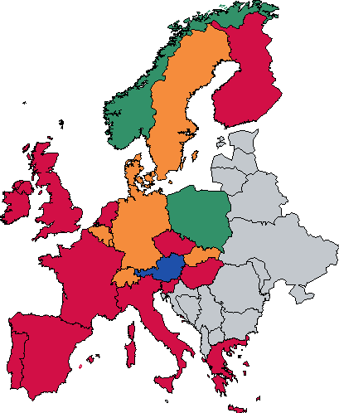 |  |  |  | 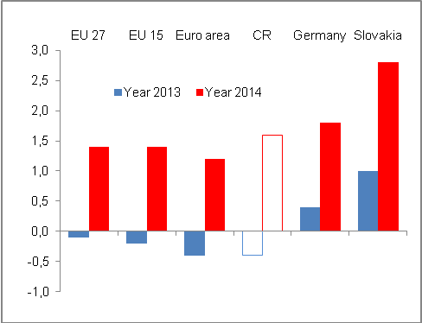
Source: Moody´s Analytics Source: Eurostat
Note to coloured fields of the map:
Green „expansion“, blue „recovery“, yellow „economy at risk“, red „recession“

Chart 81 Outlook for the world economy (prepared in May 2013)
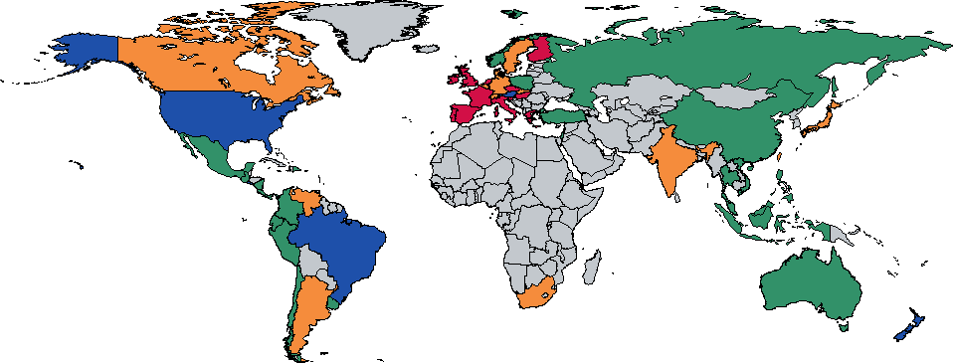
Source: Moody´s Analytics
Note to coloured fields of the map:
Green „expansion“, blue „recovery“, yellow „economy at risk“, red „recession“

Fulfilment of the Maastricht criteria of nominal convergence
Even after the 2009 crisis the CR fulfilled the given convergence criteria with the exception of government sector deficit to nominal GDP |  | Maastricht agreement criteria regarding the nominal convergence of countries to the average level of currency and economic union in Europe, the CR filled through the prevailing part of the last decade without relatively large troubles (in years 2004 and 2006-2007 it was possible thanks to strong growth of economy also to reach the prescribed government sector deficit in relation to nominal GDP). Not even after the crisis of year 2009 did this fulfilment not worsen somehow more significantly – from year 2009 till year 2011 the CR fulfilled the convergion criteria with the exception of the limit for the size of the government sector deficit in relation to nominal GDP, where its relative size did not fall below 3 % of GDP. However the criterion of gross consolidated debt of the CR to GDP with limit of 60 % was filled with reserve (more to the fiscal criterion in the analysis in chapter 5 about imbalances).  Criterion prescribed above of long-term nominal interest rates of the government bonds denominated in the national currency the Czech Republic fulfils in the long-term similarly with a marked reserve. Last prescribed condition of a convergence, the criterion of exchange rate stability of the national currency, is not possible from the point of view of the CR without the membership in the ER II system to assess. Volatility of the crown exchange rate according to the development on the exchange rate market is not however a significant issue of the Czech crown.
In 2012 were not kept two of the limits, apart from prescribed relation of the government sector deficit to GDP also the inflation criterion – it meant the least favourable result of the criteria of nominal convergence fulfilment in the last five years |  | Not very positive post-crisis development, which halted in years 2010-2012 the real convergence, but until year 2011 did not worsen the fulfilment of Maastricht criteria, impacted in 2012 the ability of the CR to keep the inflation criterion. Growth of harmonised index of consumer prices (HICP) by 3.5 % was above the limit of 2.8 % valid for year 2012.  The CR thus in 2012 did not meet two of the convergence criteria, which was the least favourable result in the last five years.

Table 5 Nominal convergence of the CR – fulfilment of the Maastricht criteria (values in %)

 | 2008 | 2009 | 2010 | 2011 | 2012
Inflation criterion (HICP) in % | 6,3 | 0,6 | 1,2 | 2,1 | 3,5
Inflation criterion (HICP) in % | No | Yes | Yes | Yes | No
Fiscal criteria
deficit  (< 3 % GDP in cur.p.) | -2,2 | -5,8 | -4,8 | -3,3 | -4,4
deficit  (< 3 % GDP in cur.p.) | Yes | No | No | No | No
debt  (< 60 % GDP in cur.p.) | 28,7 | 34,2 | 37,8 | 40,8 | 45,8
debt  (< 60 % GDP in cur.p.) | Yes | Yes | Yes | Yes | Yes
Stability criteria
Interest rates in % | 4,6 | 4,8 | 3,9 | 3,7 | 2,8
Interest rates in % | Yes | Yes | Yes | Yes | Yes
Exchange rate | CR is not part of the ERM II system.

Source: Eurostat, own calculations

Imbalance between the Eurostat and CZSO data is given by the methodology. Following the extraordinary revision of the national accounts arose the increase of the GDP level of the Czech Republic from year 2008 (mostly due to the inclusion of the imputed rents). Eurostat recognises this methodology, however given the inconsistence of the time series of coefficients of purchasing power parities until year 2007 (Eurostat did not recalculate this series retrospectively even after a repeated request from CZSO). On the contrary, national accounting of the CZSO keeps a consistent time series of these parities, however on the other hand does not consider the change given by the extraordinary revision. According to the opinion of employees from the section of CZSO macroeconomic analyse, this version provides a more precise picture of the development in contrast to the Eurostat version.
This takes into account, whether its price development in the sphere of consumer prices does not divert to a significant extent from the price development according to the quantified data for the EU 27 development. It further considers, whether country in similar comparison does not show a marked imbalance in the government sector deficit and its gross consolidated debt in relation to nominal GDP. Maastricht stability criteria determine also the limits for the development of long-term nominal interest rates and volatility of the exchange rate.

