Trends in producer price indices in Q3 2026
16. 10. 2026
In Q3 2026, compared to Q2 2026, agricultural producer prices went down by 1.9% and were lower by 10.5% year-on-year (y-o-y) in Q3 2026. In Q3 2026, compared to Q2 2026, industrial producer prices were higher by 0.7 % and increased by 2.4% y-o-y in Q3 2026. Construction work prices rose by 0.8% in Q3 2026 compared to Q2 2026 and were 4.3% higher y-o-y in Q3 2026. Service producer prices in the business sphere fell by 0.6% in Q3 2026 compared to Q2 2026 and rose by 2.8% y-o-y in Q3 2026.
In Q3 2026, compared to Q2 2026, agricultural producer prices were lower by 1.9%. Falling were prices of milk (-2.4%), pigs for slaughter (-6.8%), cattle for slaughter (-9.2%) and eggs (-20.3%). Growth was recorded in prices of poultry (+0.4%), oilseeds (+2.0%) and cereals (+2.9%). Agricultural producer prices decreased by 10.5%, y-o-y, in Q3 2026. Prices in crop production fell by 2.2% due to lower prices of cereals (-7.2%) and fruit (-4.1%). Prices rose for oilseeds (+1.6%), vegetables (+6.0%) and potatoes (+7.6%). Prices in animal production decreased by 19.4%. Falling were prices of eggs (-7.1%), cattle for slaughter (-9.5%), pigs for slaughter (-25.6%) and milk (-27.1%). Increase was observed in prices of poultry (+2.2%).
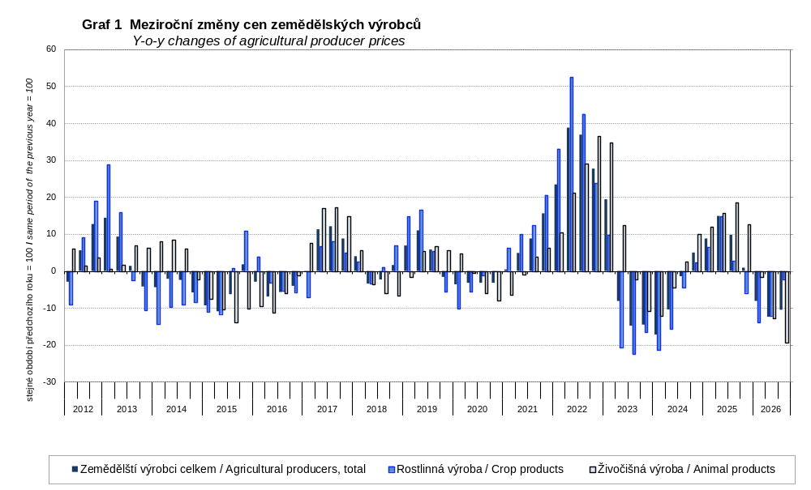
In Q3 2026, compared to Q2 2026, industrial producer prices were higher by 0.7%. Prices rose markedly in ‘coke, refined petroleum products’. Higher were prices in ‘textiles’ (+4.2%), ‘basic metals’ (+2.5%) and ‘wood and products of wood and cork, except furniture’ (+2.4%). Prices increased in ‘electricity, gas, steam and air conditioning’ (+1.6%). Prices decreased in ‘food products’ (-0.8%), thereof ‘preserved meat and meat products’ (-2.0%).
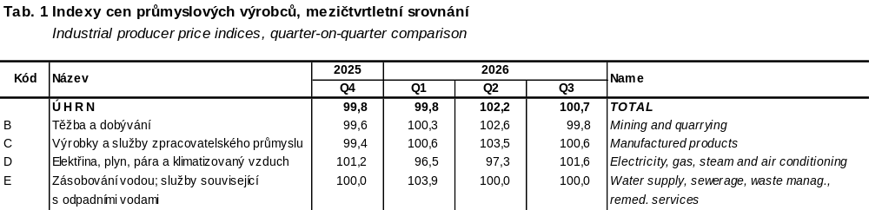
In Q3 2026, industrial producer prices were higher by 2.4% y-o-y (+1.3% in Q2 2026). Prices went up significantly in ‘coke, refined petroleum products’. Prices were higher in ‘chemicals and chemical products’ (+13.9%), ‘wood and products of wood and cork, except furniture’ (+11.4%), ‘printing and recording services’ (+7.1%) and ‘basic metals’ (+5.5%). Prices decreased in ‘electricity, gas, steam and air conditioning’ (-3.5%) and ‘paper and paper products’ (-1.1%). Prices went down in ‘food products’ (-5.3%), thereof ‘dairy products’ (-14.9%) and ‘preserved meat and meat products’ (-6.7%).
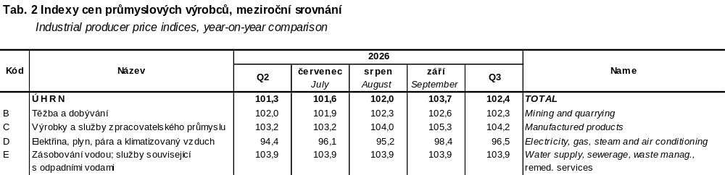
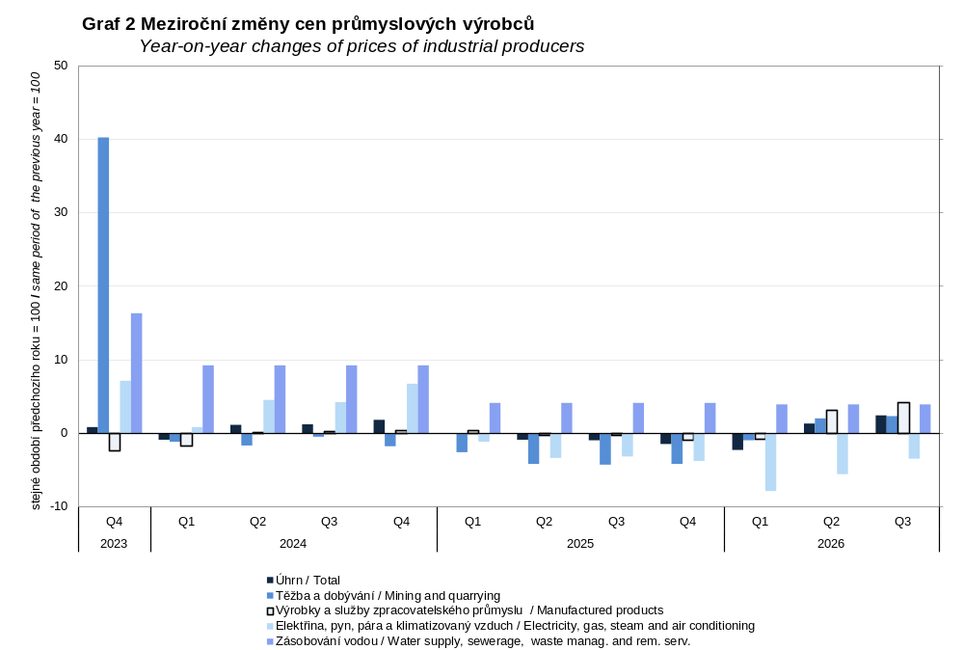
In Q3 2026, according to the estimate, construction work prices compared to Q2 2026 (after updating) rose by 0.8%. Prices of construction materials and products input also rose by 0.8%. Construction work prices, as estimated, grew by 4.3% in Q3 2026 compared to Q3 2025 (after updating). Prices of construction materials and products input increased by 6.9%, y-o-y.
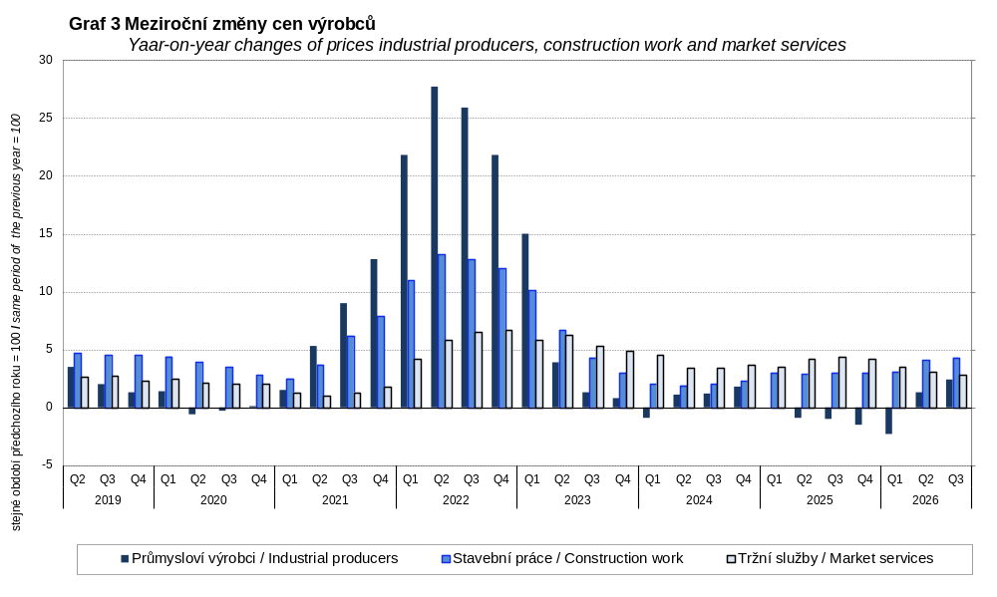
In Q3 2026, compared to Q2 2026, service producer prices in the business sphere fell by 0.6%. On the decrease were prices for 'programming and broadcasting services' (-11.1%), ‘advertising and market research services’ (-9.8%) and 'motion picture, video and television programme production services, sound recording and music publishing' (-1.4%). Rising were prices of ‘employment services’ (+1.8%) and ‘publishing services’ (+1.0%). Service producer prices in the business sphere, excluding advertising services, went up by 0.3%. Service producer prices in the business sphere grew in total by 2.8%, y-o-y, in Q3 2026. Increasing were prices of ‘advertising and market research services’ (+11.8%), ‘employment services’ (+11.2%), ‘security and investigation services’ (+6.3%) ‘information services’ (+4.8%) and 'motion picture, video and television programme production services, sound recording and music publishing' (+5.6%). Prices of ‘architectural and engineering services’ (-2.3%) were lower. Service producer prices in the business sphere, excluding advertising services, grew by 2.2%.

Note: For internal reasons, the Czech decimal comma is used instead of the English decimal point as a decimal separator in tables of this analysis.
Contact:
Ing. Miloslav Beránek
Industrial and International Trade Price Statistics Unit
T: +420 274 052 665
E: miloslav.beranek@csu.gov.cz

