18 August 2025

Employment in the tertiary sector was increasing

Employment and unemployment in the Czech Republic as measured by the Labour Force Sample Survey – 2nd quarter of 2025
The number of the employed persons was by 76.2 thousand higher, year-on-year (y-o-y); the total employment was thus moderately increasing. According to the methodology of the International Labour Organization (ILO), the number of the unemployed was by 12.0 thousand higher, y-o-y. The number of the economically inactive aged 15+ years decreased by 42.9 thousand during the same period.

Employment
In the Q2 2025, the seasonally adjusted average number of employed persons decreased by 4.7 thousand persons, compared to the Q1 2025.
The number of working persons aged 15+ years moderately increased, year-on-year. In the Q2 2025, an increase by 76.2 thousand persons (i.e. by 1.5%) to the total of 5 243.5 thousand employed persons was recorded. The increase was mainly owing to an increase in the number of working females who were up by 122.6 thousand, year-on-year, whereas the number of working males dropped by 46.5 thousand persons. The most marked increment was recorded as for working persons aged 60+ years, whose number grew by 52.2 thousand (i.e. by 9.4%). An increase was also recorded in the youngest age category of 15–24 years, in which there were by 11.0 thousand persons more (i.e. by 4.2%). The number of working persons aged 45–59 years also increased, namely by 28.2 thousand persons (i.e. by 1.3%) and in the age group of 25–29 years by 4.3 thousand persons (i.e. by 1.1%). Conversely, there was a year-on-year decrease in the age category of 30–44 years, in which the number of working persons dropped by 19.6 thousand (i.e. by 1.1%). The year-on-year changes in the number of working persons in individual age groups are to a considerable extent influenced by the demographic structure of the population and by transfers of persons to higher age groups.
Chart 1: The number of working persons in the national economy and their structure by age group (thousand)
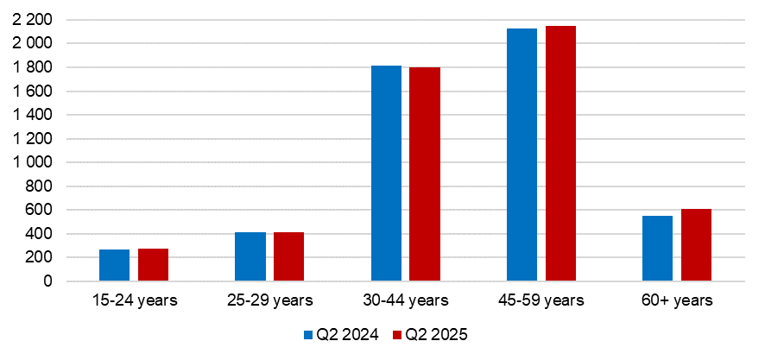Source: CZSO, LFSS

In terms of sex, the most marked decrease in the number of working persons was recorded in males aged 30–44 years, among whom the number decreased by 61.6 thousand persons (i.e. by 5.9%). Conversely, the biggest increase was among females aged 60+ years, the number of whom increased by 23.7 thousand persons (i.e. by 9.6%).
The number of employees increased by 75.9 thousand persons, i.e. by 1.7%, to 4 426.7 thousand. The number of the self-employed (without unpaid contributing family workers) remained almost the same; a y-o-y increment of 0.5 thousand persons was recorded there. The number of the self-employed without employees (own-account workers) was by 1.9 thousand higher (i.e. by 0.3%), whereas the number of the self-employed with employees (employers) was by 1.3 thousand lower, year-on-year (i.e. by 1.1%). In concrete numbers, the number of the self-employed without employees was 690.4 thousand and the number of the self-employed with employees was 115.1 thousand. In the Q2 2025, the share of the self-employed in the total employment was 15.4%.
Males were doing business more than females (66.4% of all the self-employed); their activities were mainly in the CZ-NACE sections of ‘construction,’ ‘wholesale and retail trade; repair of motor vehicles and motorcycles,’ and ‘manufacturing’. Females were doing business most in the sections of ‘professional, scientific and technical activities’, ‘arts, entertainment and recreation,’ and ‘other service activities’ (the section includes, among others, hairdressing and other beauty treatment). The highest share of entrepreneurs (the self-employed) was in skilled agricultural, forestry and fishery workers (48.3%); however, the number of all workers in these jobs is not large, in the Q2 2025 it was only 1.3% of the total employment in the national economy. A high share of entrepreneurs was also among craft and related trades workers (27.4%) and in service and sales workers (19.0%). The self-employed had the lowest proportion in clerical and support workers (3.9%) and in elementary occupations (4.3%). The lowest share of entrepreneurs was among working persons with primary education (14.4%), however, as for education that is higher, there was not a big difference in the proportion of entrepreneurs. The highest share of the self-employed was in working persons with secondary education without A-level examination (those with secondary vocational education) and in university graduates – it was the same for both (15.6%); among working persons with A-level examination the share of entrepreneurs was 15.1%.
According to data for the Q2 2025, the development of employment in individual economic activities (CZ-NACE sections) in the Czech Republic was different⁾. In the primary sector of agriculture, forestry and fishing, the number of working persons decreased, year-on-year, by 2.2 thousand to 141.5 thousand persons. Employment in the secondary sector of industry and construction also moderately decreased; a decrease in the number of working persons by 9.7 thousand to 1 817.2 thousand was recorded. In the tertiary sector of services, the total employment increased, y-o-y, by 88.0 thousand to 3 284.7 thousand persons. In this sector, the biggest relative increment of working persons was in the section of ‘arts, entertainment and recreation,’ namely by 20.1 thousand persons, i.e. by 24.3%; also the following sections were considerably increasing: ‘other service activities’ (by 10.2 thousand persons, i.e. by 11.3%) and ‘information and communication’ (by 17.5 thousand persons, i.e. by 9.1%). A decrease in employment was recorded, for example, in the section of ‘financial and insurance activities,’ in which the number of persons decreased by 11.9 thousand (i.e. by 8.6%) and in ‘professional, scientific and technical activities’, in which there was a decrease by 17.9 thousand persons (i.e. by 6.6%).
Over the last five years, the number of working persons in the tertiary sector increased by almost 285 thousand (i.e. by 9.5%); therefore, during the last reference period, 3 284.7 thousand persons were employed in the sector of services. The highest growth was recorded by the section of ‘public administration and defence; compulsory social security,’ in which, over the last five-year period, there was an increase by almost 86 thousand working persons and by the section of ‘education’, in which there was an increase by almost 71 thousand working persons. In both the sections, the increment was mainly in working females. A marked increment was also recorded in the section of ‘information and communication’ (by 40.9 thousand), in which males were prevailing.
Chart 2: The number of working persons in the national economy by economic activity (thousand)

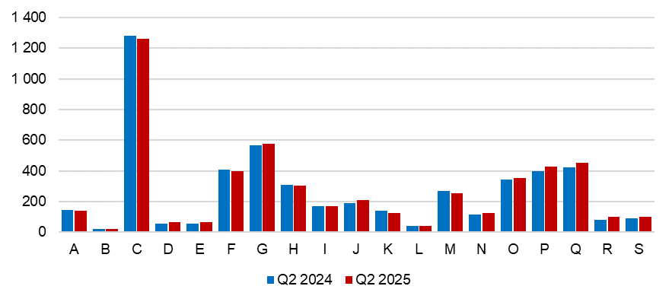A – Agriculture, forestry and fishing; B – Mining and quarrying; C – Manufacturing; D – Electricity, gas, steam and air conditioning supply; E – Water supply; sewerage, waste management and remediation activities; F – Construction; G – Wholesale and retail trade; repair of motor vehicles and motorcycles; H –Transportation and storage; I – Accommodation and food service activities; J – Information and communication; K – Financial and insurance activities; L – Real estate activities; M – Professional, scientific and technical activities; N – Administrative and support service activities; O – Public administration and defence; compulsory social security; P – Education; Q – Human health and social work activities; R – Arts, entertainment and recreation; S – Other service activities.
Source: CZSO, LFSS

Along with changes in the structure by economic activity (CZ-NACE section), changes in the structure of working persons by occupation also occurred. According to the Classification of Occupations (CZ-ISCO), the number of working persons increased relatively the most in the major group of skilled agricultural, forestry and fishery workers (by 5.2 thousand persons, which is an increment by 7.9%) and in the group of clerical support workers (by 27.0 thousand persons, i.e. by 7.7%).
Chart 3: The number of working persons in the national economy by Classification of Occupations (thousand)
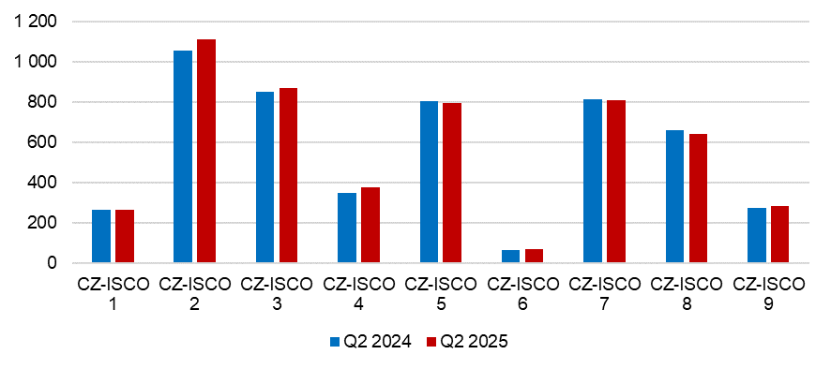
CZ-ISCO 1 – Managers; CZ-ISCO 2 – Professionals; CZ-ISCO 3 – Technicians and associate professionals; CZ-ISCO 4 – Clerical support workers; CZ-ISCO 5 – Service and sales workers; CZ-ISCO 6 – Skilled agricultural, forestry and fishery workers; CZ-ISCO 7 – Craft and related trades workers; CZ-ISCO 8 – Plant and machine operators, and assemblers; CZ-ISCO 9 – Elementary occupations.
Source: CZSO, LFSS

The development trend in the number of working persons according to the educational attainment is also related to the mentioned changes in the employment structure. The number of working persons with primary education increased by 2.0 thousand to 241.0 thousand. The number of working persons with secondary education without A-level examination decreased by 42.3 thousand to 1 577.4 thousand persons. On the other hand, the number of working persons with secondary education with A-level examination was higher, year-on-year, by 41.5 thousand. The biggest increase occurred in employed persons with tertiary education the number of whom increased by 75.2 thousand to 1 495.5 thousand. This increase mainly applied to working females with tertiary education the number of whom increased by 73.5 thousand, year-on-year.
The employment rate (the percentage of working persons in the age group of 15–64 years old) increased in the Q2 2025 compared to the corresponding period of the previous year by 0.4 percentage point (p. p.) to 75.7%. The development among males and females was opposing. The male employment rate decreased by 0.9 p. p., y-o-y, to 80.1% and the female one increased by 1.9 p. p. to 71.2%.
Development of part-time jobs also had an influence on the growth of the total employment. They have been increasing in number during the last years. In 2018, 387.9 thousand persons were working part-time; their number increased during the last seven years by 112.2 thousand (i.e. by 28.9%).
In the Q2 2025, 500.1 thousand persons were working part-time, which is by 24.2 thousand more, year-on-year (an increase by 5.1%). The increment in females was 26.4 thousand and most of those newly working females had higher education (25.3 thousand).
During the reference period, 355.6 thousand females were working part-time, i.e. 71.1% of all part-time jobs in main job. A part-time job enabled them to be more flexible, mainly when carrying their caring responsibilities. Females were working part-time most often in ‘public administration and defence; compulsory social security,’ ‘education,’ and ‘wholesale and retail trade; repair of motor vehicles and motorcycles’. Of the total number of all working females, 14.5% worked part-time.
Females gave most often the following reasons for working part-time: childcare or care for an adult person in need of care (68.5 thousand), other personal reasons (65.8 thousand), or that only a part-time job was available (54.9 thousand). The highest number of females working part-time was in the age of 30–44 years (127.6 thousand, i.e. 35.9%).
Males used part-time work significantly less. 144.5 thousand males worked part-time, which is only 5.2% of all working males. They worked mainly in ‘wholesale and retail trade; repair of motor vehicles and motorcycles’, in ‘public administration and defence; compulsory social security,’ but also in ‘manufacturing’. Males worked part-time mainly due to “other personal reasons” (42.1 thousand). Most of males working part-time were in the age of 60+ years (63.3 thousand, i.e. 43.8%).
Chart 4: The number of part-time workers and their age structure (thousand)
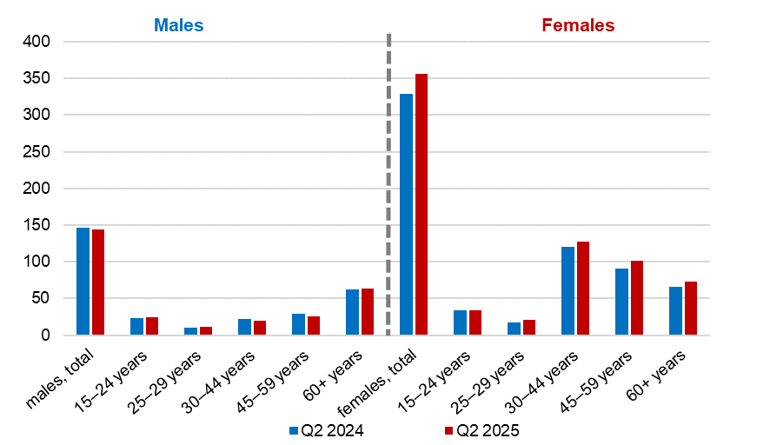

Source: CZSO, LFSS

Unemployment
The seasonally adjusted average number of unemployed persons according to the ILO methodology⁾ increased in the Q2 2025 by 13.5 thousand persons, compared to that in the Q1 2025.

Chart 5: The number of the unemployed in Regions of the Czech Republic (thousand)
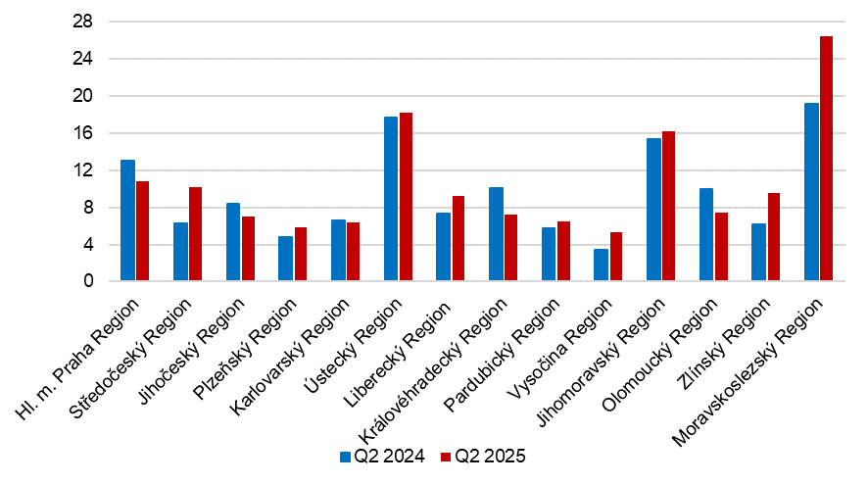 Source: CZSO, LFSS

The total number of the unemployed aged 15+ years increased, year-on-year, by 12.0 thousand to 146.1 thousand persons. The number of the unemployed females increased by 7.3 thousand to 74.5 thousand and the number of the unemployed males by 4.7 thousand to 71.5 thousand. The highest number of unemployed males were in the age of 45–59 years (29.8 thousand), whereas in females the age group of 30–44 years was prevailing (35.2 thousand). In males, unemployment thus affects most often middle-age persons whereas in females it is more often after their return from parental leave.
The most marked relative year-on-year increase of the unemployment was recorded in the Středočeský Region (by 4.0 thousand, i.e. by 63.8%), in the Vysočina Region (by 1.9 thousand, i.e. by 54.4%), and in the Zlínský Region (by 3.3 thousand, i.e. by 53.1%).
The number of persons unemployed for one year and longer (the long-term unemployed) has also increased; it was by 4.9 thousand, y-o-y, to 44.8 thousand persons. The number of the long-term unemployed males decreased by 0.9 thousand, whereas in females it was higher by 5.8 thousand in the Q2 2025 compared to the corresponding period of 2024.
The number of the long-term unemployed males was 21.0 thousand in total; most of them were in the age of 45–59 years (7.1 thousand). In females, the number was 23.8 thousand, while most of them were in the age group of 30–44 years (8.9 thousand). The highest relative year-on-year increment of the long-term unemployed was recorded in the age group of 60+ years (an increase by 92.5 p. p. from 2.7 thousand in the Q2 2024 to 5.3 thousand in the Q2 2025). The increment was higher in females.

Chart 6: The number of persons unemployed for one year and longer and their age structure (thousand)

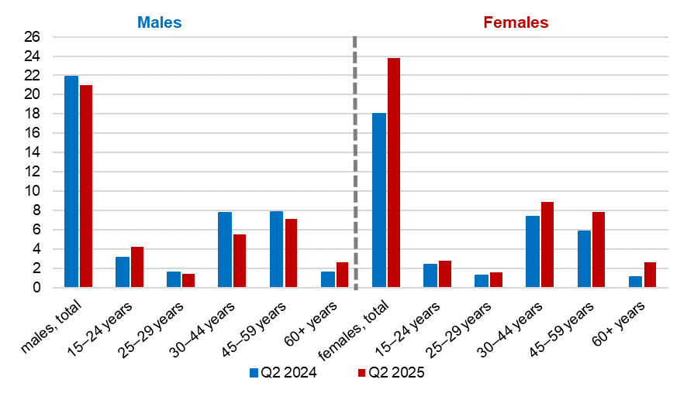
Source: CZSO, LFSS

The general unemployment rate according to the ILO definition in the age group of
15–64 years old (the percentage of the unemployed in the labour force, i.e. in the sum of the employed and the unemployed) increased by 0.2 p. p., year-on-year, and in the Q2 2025 it was 2.8%.

Chart 7: Unemployment rate of the 15–64 years old in Regions of the Czech Republic (%)
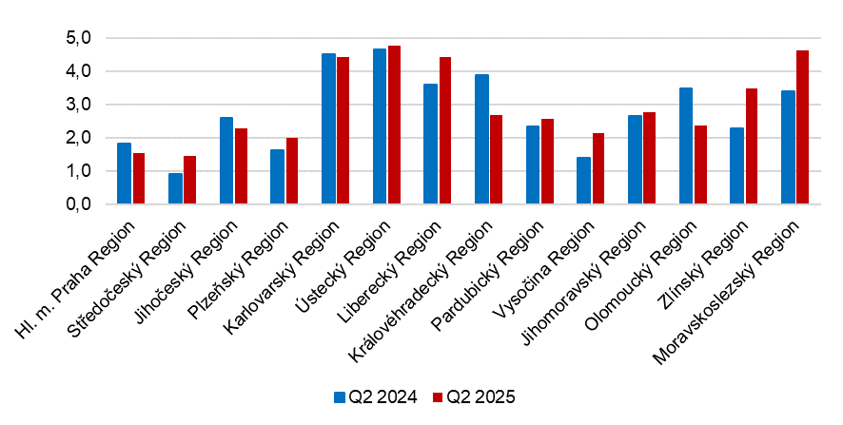Source: CZSO, LFSS

In terms of a regional comparison, the general unemployment rate of the 15–64 years old was the highest in the Ústecký Region (4.8%), in the Moravskoslezský Region (4.6%), and further in the Liberecký Region and in the Karlovarský Region (both 4.4%). The lowest figures were reported by the Středočeský Region and by the Hl. m. Praha Region (both 1.5%) and by the Plzeňský Region (2.0%). The biggest y-o-y decreases in the unemployment rate were in the Královéhradecký Region (by 1.2 p. p. to 2.7%) and in the Olomoucký Region (by 1.1 p. p. to 2.4%). The biggest year-on-year increases were, on the other hand, in the Moravskoslezský Region (by 1.2 p. p. to 4.6%) and in the Zlínský Region (by 1.2 p. p. to 3.5%).

Economic inactivity
The number of economically inactive persons aged 15+ years was by 42.9 thousand lower, year-on-year, and amounted to 3 457.5 thousand. The number of economically inactive males increased by 48.5 thousand to 1 423.4 thousand, whereas the number of economically inactive females was by 91.4 thousand lower than a year ago and their number thus was 2 034.0 thousand.
In the sample survey, data are also collected on persons who do not work and do not seek a job in an active manner and therefore do not comply with the ILO conditions for the unemployed, however, they state that they would like to work. In the Q2 2025, the number of such persons was 82.8 thousand, i.e. by 1.2 thousand persons more than in the corresponding period of 2024. The number of persons who are willing to work, yet they are not able to start in a potential job immediately, is relatively high. Only 16.7 thousand persons are able to start in a job within a fortnight, at the latest.

Note:
Data in the analysis have not been seasonally adjusted unless otherwise stated.
Recalculation to the same population structure
The Labour Force Sample Survey (LFSS) is carried out in selected dwelling households. Collective accommodation establishments are not included in the survey. The data found were weighted to the population of the Czech Republic based on the results of the population (demographic) statistics as at the beginning of the reference quarter; estimates of the number of persons living outside private households were subtracted from the population totals of the demographic statistics.

Authors:
Marta Petráňová, phone number: (+420) 274 054 357, e-mail: marta.petranova@csu.gov.cz
Gabriela Strašilová, phone number: (+420) 567 109 071, e-mail: gabriela.strasilova@csu.gov.cz
Labour Force Statistics Unit

⁾ Data for economic activities (CZ-NACE sections) may be influenced by the employed methodology of the Labour Force Sample Survey (LFSS). The survey only covers persons living in dwellings (flats), i.e. private households. Data on persons living in collective accommodation establishments are not measured; these establishments often give accommodation to foreign nationals.
⁾ The ILO methodology defines the unemployed as persons who during the reference period were without a job, did not work an hour for pay or remuneration, and were in an active manner seeking a job they would be able to join within fortnight at the latest. This methodology is uniform for all EU Member States and provides internationally comparable data. It has to be taken into consideration that the definition of “the unemployed” by the ILO differs from the definition of “job applicants kept in the register of the labour offices” of the Ministry of Labour and Social Affairs.

