***1. Comparison of IFS 2020 and Agrocensus 2000 results***

***Agricultural holdings and their legal forms***

*The Integrated Farm Survey 2020 provided updated data on the agricultural sector in the Czech Republic. In total 28 909 agricultural holdings met the thresholds for inclusion in the survey; out of them, there were 85.3% of natural persons and 14.7% of legal persons. Out of 24 648 natural persons, there were 18 667 (75.7%) agricultural entrepreneurs. Among legal persons (4 261 holdings in total) the greatest share was represented by limited liability companies (2 875 holdings; 65.7%) followed by joint stock companies (664 holdings; 15.6%) and cooperatives (492 holdings; 11.5%).*

*The total number of agricultural holdings declined by one quarter since the year 2000 (−26.0%). The number of natural persons decreased almost by a third (−31.9%) while the number of legal persons went up nearly by one half (+47.7%). A significant growth was recorded in the number of limited liability companies (+112.8%) while the number of cooperatives went down (−33.7%).*

***Table 1: Agricultural holdings and their utilised agricultural area***

|  |  |  |  |  |  |  |
| --- | --- | --- | --- | --- | --- | --- |
|  | | ***AGC 2000*** | | ***IFS 2020*** | | ***Index 2020/2000 (%)*** |
| ***abs.*** | ***share (%)*** | ***abs.*** | ***share (%)*** |
| *Agricultural holdings, total* | *Agricultural holdings* | *39 082* | *100.0* | *28 909* | *100.0* | *74.0* |
| *Utilised agricultural area (ha)* | *3 623 929* | *100.0* | *3 493 609* | *100.0* | *96.4* |
| *Average area (ha)* | *93* | *x* | *121* | *x* | *130.3* |
| *Holdings of natural persons* | *Agricultural holdings* | *36 198* | *92.6* | *24 648* | *85.3* | *68.1* |
| *Utilised agricultural area (ha)* | *943 182* | *26.0* | *1 042 605* | *29.8* | *110.5* |
| *Average area (ha)* | *26* | *x* | *42* | *x* | *162.3* |
| *Holdings of legal persons* | *Agricultural holdings* | *2 884* | *7.4* | *4 261* | *14.7* | *147.7* |
| *Utilised agricultural area (ha)* | *2 680 746* | *74.0* | *2 451 004* | *70.2* | *91.4* |
| *Average area (ha)* | *930* | *x* | *575* | *x* | *61.9* |
| *Business companies & partnerships* | *Agricultural holdings* | *1 998* | *5.1* | *3 571* | *12.4* | *178.7* |
| *Utilised agricultural area (ha)* | *1 578 943* | *43.6* | *1 793 127* | *51.3* | *113.6* |
| *Average area (ha)* | *790* | *x* | *502* | *x* | *63.5* |
| *Limited liability companies* | *Agricultural holdings* | *1 351* | *3.5* | *2 875* | *9.9* | *212.8* |
| *Utilised agricultural area (ha)* | *783 769* | *21.6* | *934 466* | *26.7* | *119.2* |
| *Average area (ha)* | *580* | *x* | *325* | *x* | *56.0* |
| *Joint stock companies* | *Agricultural holdings* | *608* | *1.6* | *664* | *2.3* | *109.2* |
| *Utilised agricultural area (ha)* | *779 710* | *21.5* | *843 675* | *24.1* | *108.2* |
| *Average area (ha)* | *1 282* | *x* | *1 271* | *x* | *99.1* |
| *Cooperatives* | *Agricultural holdings* | *742* | *1.9* | *492* | *1.7* | *66.3* |
| *Utilised agricultural area (ha)* | *1 059 451* | *29.2* | *627 717* | *18.0* | *59.2* |
| *Average area (ha)* | *1 428* | *x* | *1 276* | *x* | *89.4* |

***Size structure of agricultural holdings***

*The utilised agricultural area was concentrated in holdings of legal persons (70.2%); this share decreased since 2000 to the benefit of holdings of natural persons by 3.8 percentage points.*

*Holdings with 10 to 50 ha of utilised agricultural area prevailed (31.8% of the total number of holdings), while the smallest share belonged to holdings with more than 2 000 ha of UAA (1.0%) and, on the other side, to holdings without UAA (1.6%). Holdings with more than 500 ha comprised only 6.0%; however, they shared 66.1% of the total agricultural area. On the contrary, holdings with less than 50 ha (72.2%) utilised only 7.4% of the UAA.*

*Holdings of natural persons utilised usually smaller areas than holdings of legal persons. For example, among holdings with less than 50 ha of UAA, natural persons shared 93.2% of the total number of holdings, whereas legal persons only 6.8% in 2020. On the contrary, category above 500 ha of UAA was dominated by holdings of legal persons (87.0%). Since 2000, the number of holdings decreased in the category with less than 50 ha of UAA (−13.1 p. p.) while the number of holdings above 500 ha rose (+1.2 p. p.).*

***Graph 1: Structure of agricultural holdings***

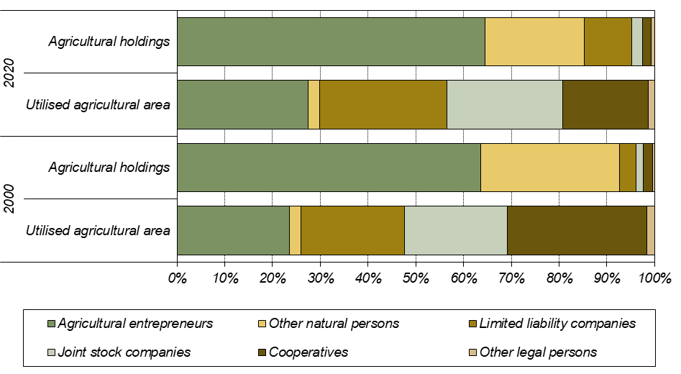

***Average agricultural area per holding***

*The average utilised agricultural area per holding in the period 2000–2020 increased from 93 ha to 121 ha. It grew by 62.3% (from 26 ha to 42 ha) in holdings of natural persons and decreased by 38.1% (from 930 ha to 575 ha) in holdings of legal persons. The most distinct decrease occurred in limited liability companies (−44.0%) but it stayed almost the same in joint stock companies (−0.9%).*

***Organic farming***

*In total 4 534 agricultural holdings dealt with organic farming in 2020. Organic production methods were applied on 528 424 ha of the utilised agricultural area (15.1% of the total UAA). In 2000, there were only 418 holdings involved in organic production and 132 254 ha of the UAA under organic farming. Therefore, the number of holdings dealing with organic farming grew almost eleven times and the utilised agricultural area under organic farming rose fourfold.*

***Table 2: Agricultural holdings involved in organic farming and their utilised agricultural area***

|  |  |  |  |  |  |
| --- | --- | --- | --- | --- | --- |
|  | ***AGC 2000*** | | ***IFS 2020*** | | ***Index***  ***2020/2000***  ***(%)*** |
| ***abs.*** | ***share (%)*** | ***abs.*** | ***share (%)*** |
| *Agricultural holdings, total* | *39 082* | *100.0* | *28 909* | *100.0* | *74.0* |
| *of which holdings applying organic methods (certified*  *or in conversion period)* | *418* | *1.1* | *4 534* | *15.7* | *1 084.7* |
| *Utilised agricultural area, total (ha)* | *3 623 929* | *100.0* | *3 493 609* | *100.0* | *96.4* |
| *of which organically utilised area (certified*  *or in conversion period) (ha)* | *132 254* | *3.6* | *528 424* | *15.1* | *399.6* |

***Agricultural land hired and owned***

*In total 465 agricultural holdings (1.6%) did not possess any agricultural land in 2020. Most holdings with agricultural land farmed on hired land (72.7%), only 27.3% of the utilised agricultural area was owned by holdings. The share of own land decreased with the increasing total UAA: holdings with less than three ha of the UAA kept 81.5% of own land whereas holdings with more than 2 000 ha owned only 20.6% of their UAA.*

*Since 2000, the share of own land in holdings rose; at that time it only achieved 8.0% of the total UAA. The most distinct growth – by 22.0 percentage points – was recorded in the size group 100*–*500 ha.*

*Own land in holdings of natural persons represented almost half of their total UAA (44.8%). The smallest share was 30.8% for the size group above 2 000 ha, while in holdings up to 50 ha it was 55.9% and in the smallest holdings up to 10 ha even three quarters of their UAA (71.1%). On the contrary, holdings of legal persons preferred hiring the agricultural land: their own land represented only 19.8%. Holdings up to 10 ha owned 45.0% of the UAA while holdings with more than 500 ha only 19.3% of the UAA.*

***Graph 2: Hired and owned land, by legal form***

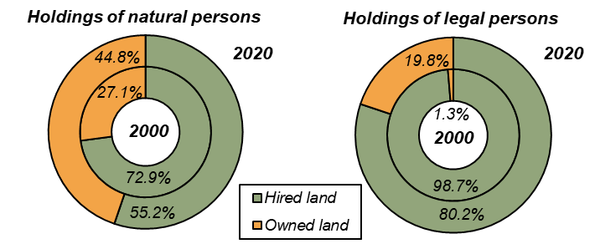

*The percentage of hired land distinctly decreased in holdings of both natural and legal persons during the period 2000–2020. This decrease accounted for 17.7 p. p. in natural persons and for 18.5 p. p. for legal persons. The greatest increment of owned land was recorded in holdings of natural persons with 500 to 2 000 ha (+41.2 p. p) and holdings of legal persons with 2 000 ha of UAA and more (+19.2 p. p.).*

***Graph 3: Hired and owned land, by size of holding***

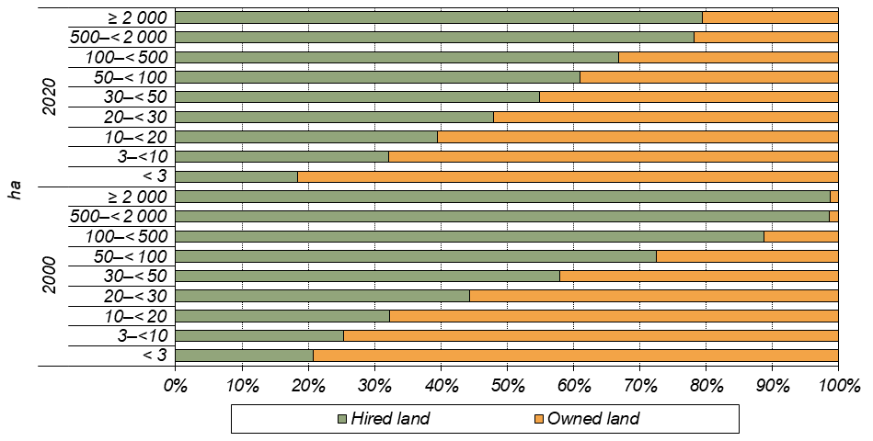

***Agricultural land use***

*In 2020, the utilised agricultural land covered 3 493 609* *ha, i.e. 44.3% of the area of the Czech Republic. A loss of 1.7 percentage point occurred since 2000 to the benefit of artificial area or wooded land. Utilised agricultural area went down by 3.6% (i.e. by 130 320 ha) and arable land even by 10.1% (i.e. by 277 888 ha). The share of arable land decreased during the period 2000–2020 by 5.1 p. p. A certain part of arable land was grassed as a result of subsidies provided by the European Union and for this reason the area of permanent grasslands rose since 2000 by 18.4%, i.e. by 151 811* *ha. Vineyard area increased by 49.3% while area of orchards decreased by 27.3%.*

*Arable land covered 70.8% of the total utilised agricultural area and permanent grasslands further 28.0%. Other permanent crops (hop-gardens, vineyards, orchards, kitchen gardens, other permanent crops as e.g. short rotation coppices on UAA) represented only 1.2% share in the UAA. In holdings of natural persons, the share of arable land (59.2%) was distinctly lower than in holdings of legal persons (75.7%), especially in joint stock companies and cooperatives (81.6% in both cases). Holdings of natural persons utilised exactly one quarter (25.0%) of arable land in Czechia in 2020; in 2000, it was by 1.5 p. p. less.*

*Graph 4: Share of arable land, permanent grasslands and permanent crops, by size group*

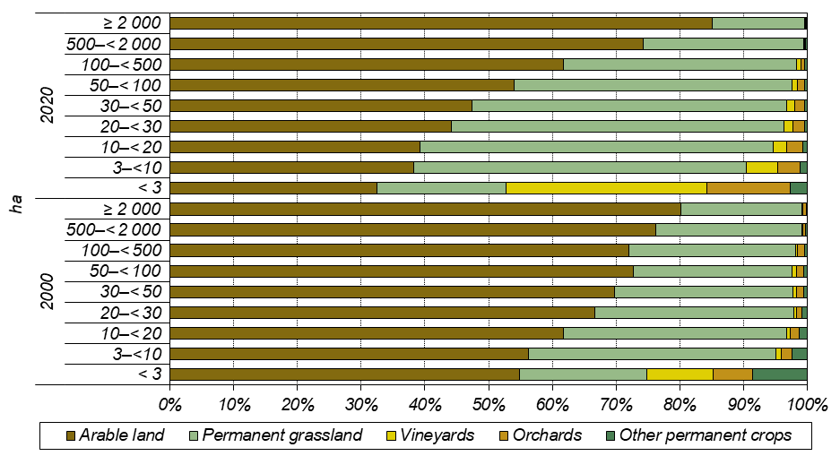

*Although permanent crops cover only small portion of arable land, they form a considerable part of the crop production in small-size holdings. In agricultural holdings with less than three ha of the UAA, vineyards comprised 31.6% and orchards 13.1% of their area. The shares of both types of crops increased significantly compared to 2020, by 21.1 p. p. for vineyards and 7.0 p. p. for orchards.*

*On the contrary, large agricultural holdings focused mainly on arable land crops: in the size group of 500 ha of the UAA and more, their arable land covered 78.2% of the UAA in 2020. There has been no significant change here since 2000, when the share was 77.9%. The share of arable land decreased mainly in holdings with their area of up to 50 ha from 63.5% to 43.1%.*

*The share of permanent grassland increased the most in the size category of 30 to 50 ha during the past 20 years, from 28.0% to 49.3%. The size category of holdings with 2 000 ha and more, which recorded a decrease by 4.4 p. p., was out of the general trend.*

*Table 3: Agricultural land use, by legal form*

|  |  |  |  |  |  |  |  |  |  |
| --- | --- | --- | --- | --- | --- | --- | --- | --- | --- |
|  | ***Year*** | ***Agricultural holdings,***  ***total*** | ***by legal form*** | | | | | | |
| ***Natural***  ***persons,***  ***total*** | ***of which agricultural entrepre-neur***  ***– natural person*** | ***Legal***  ***persons,***  ***total*** | ***of which*** | | | |
| ***Business companies & partner- ships*** | ***of which*** | | ***Coopera- tive*** |
| ***Limited***  ***liability company*** | ***Joint stock company*** |
| *Agricultural holdings* | *2020* | *28 909* | *24 648* | *18 667* | *4 261* | *3 571* | *2 875* | *664* | *492* |
| *2000* | *39 082* | *36 198* | *24 880* | *2 884* | *1 998* | *1 351* | *608* | *742* |
| *Utilised agricultural  area (ha)* | *2020* | *3 493 609* | *1 042 605* | *957 216* | *2 451 004* | *1 793 127* | *934 466* | *843 675* | *627 717* |
| *2000* | *3 623 929* | *943 182* | *853 440* | *2 680 746* | *1 578 943* | *783 769* | *779 710* | *1 059 451* |
| *Arable land (ha)* | *2020* | *2 473 239* | *617 642* | *567 036* | *1 855 597* | *1 325 969* | *626 473* | *688 555* | *512 526* |
| *2000* | *2 751 127* | *646 084* | *589 635* | *2 105 044* | *1 211 140* | *560 624* | *639 891* | *863 287* |
| *Hop-gardens (ha)* | *2020* | *5 348* | *635* | *635* | *4 713* | *3 610* | *2 592* | *1 018* | *1 075* |
| *2000* | *6 966* | *1 246* | *1 048* | *5 721* | *3 853* | *2 717* | *977* | *1 788* |
| *Vineyards, total (ha)* | *2020* | *16 782* | *6 249* | *5 079* | *10 533* | *9 469* | *5 993* | *3 413* | *832* |
| *2000* | *11 240* | *3 510* | *2 234* | *7 729* | *6 031* | *2 518* | *3 267* | *1 349* |
| *Kitchen gardens (ha)* | *2020* | *140* | *120* | *76* | *19* | *7* | *4* | *3* | *1* |
| *2000* | *5 831* | *4 198* | *2 902* | *1 633* | *744* | *402* | *333* | *515* |
| *Orchards (ha)* | *2020* | *16 354* | *7 176* | *6 122* | *9 178* | *7 921* | *6 435* | *1 414* | *1 138* |
| *2000* | *22 489* | *6 419* | *5 479* | *16 070* | *11 156* | *5 317* | *5 707* | *4 581* |
| *Permanent grassland, total (ha)* | *2020* | *978 087* | *409 006* | *376 754* | *569 081* | *444 651* | *291 805* | *148 938* | *111 936* |
| *2000* | *826 276* | *281 726* | *252 141* | *544 550* | *346 019* | *212 192* | *129 535* | *187 930* |

*Organic production methods were applied predominantly on permanent grasslands, which formed 81.8% of the total acreage of organically utilised agricultural area. Out of the total permanent grasslands area, 44.2% were utilised organically. Organic production methods were practised also in fruit orchards (23.7% of their area) while for vineyards it represented only 6.3% of their total area and for arable land even only 3.6% of the total area.*

*Graph 5: Share of cultures in organically utilised agricultural area*

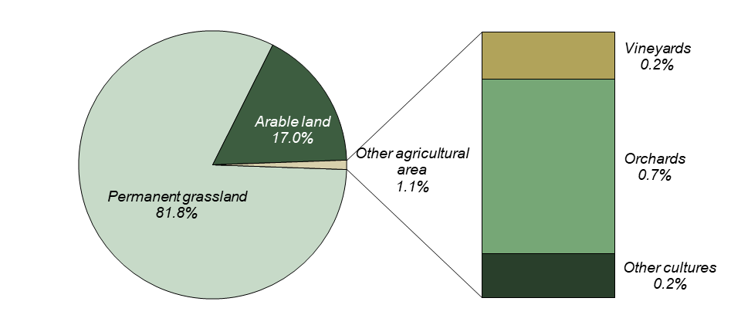

***Areas under crops***

*In 2020, agricultural holdings utilised 2 473 239* *ha of arable land. Cereals comprised the largest share (53.9%), especially wheat with more than one half (59.9%) of cereals’ area. Another one quarter (24.7%) was sown with barley. In comparison with 2000, the most remarkable finding is that areas of maize for grain distinctly grew (+78.2%) while barley areas declined by 26.5%.*

*Compared to 2000, areas of industrial crops grew by 33 thousand ha (+7.7%). Planting of rape contributed the most to this increase as its areas grew by 42 thousand ha (+12.7%); in 2000 the rape shared 11.9% of arable land and its share grew by 2020 by 3.0 percentage points. This situation was influenced by a growing demand for rape seed for the production of fatty acid methyl ester – a basic compound of biofuels. Areas of soya grew seven times (+606.8%) since 2000.*

*On the contrary, potatoes are an example of a crop whose acreages declined by two fifth (−41.1%) due to combination of lower consumption and increased import. Distinct declines were recorded also for green fodder on arable land (−11.1%) affected by a decline in cattle numbers.*

*Shares of arable land crops in particular legal forms were similar with rare exceptions. On the other hand, there are distinct dissimilarities among size groups of holdings. In all types of holdings, growing of cereals is the most frequent production type. However, in holdings of natural persons utilising less than 3 ha of the UAA there was only 49.1% of arable land used for cereals. In size group 3 to 10 ha, it was 61.9% and for larger holdings, it continually slightly decreased from 64.3% for holdings in size group 10 to 20 ha to 56.5% for holdings with more than 500 ha. Holdings of legal persons up to three ha planted cereals even on only 21.7% of arable land and in higher categories the share rose to more than one half (the largest proportion was 54.1% for the group with 100*–*500 ha).*

*Graph 6: Shares of selected crops in arable land*

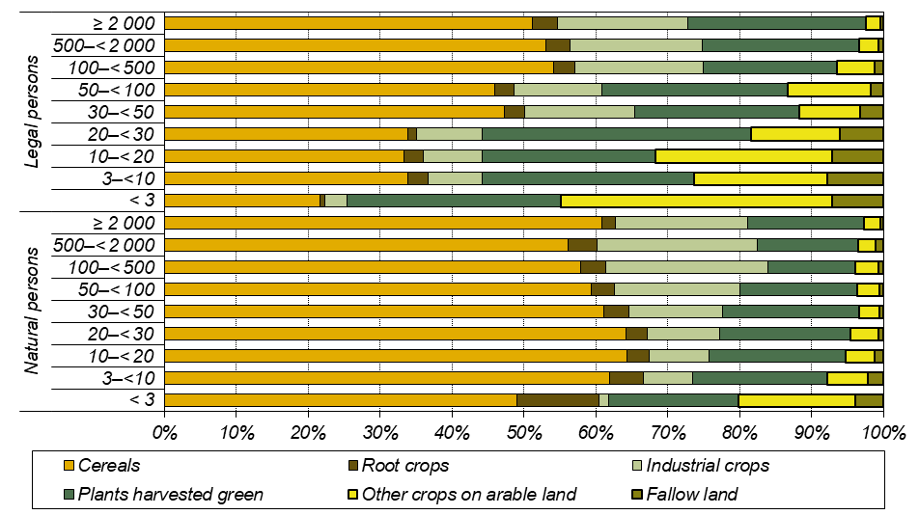

***Fertiliser management***

*The Integrated Farm Survey 2020 covered a range of questions on fertiliser management on farms. It was found that 21 499 agricultural holdings, i.e. 74.4%, fertilise a total of 2 978 thousand ha of utilised agricultural area, i.e. 85.2%. Natural persons use fertilisers slightly less (73.8% of holdings and 72.6% of agricultural area) than legal persons (77.5% of holdings and 90.6% of area).*

*Mineral fertilisers are applied by holdings of legal persons on 64.0 % of their UAA, and by holdings of natural persons on only 45.8 % of their UAA. There is almost no difference in the extent to which manure of animal origin is used (25.6% of UAA in holdings of natural persons and 25.3% of UAA in holdings of legal persons), but the amount of manure used per hectare of UAA fertilised is twice as high in holdings of legal persons (26.0 t/ha) as in holdings of natural persons (12.8 t/ha).*

*The most common way of applying manure to agricultural area is broadcast spraying or spreading, which does not require sophisticated technical equipment. It was used by 56.9% of natural persons and 63.7% of legal persons. Band application of fertiliser was used by 8.1% of legal persons and injection by 2.3% of legal persons, while the proportion of natural persons using these techniques was less than 0.5% in both cases.*

***Agricultural holdings without agricultural land***

*A little group of agricultural holdings (343 holdings of natural persons, i.e. 1.4%; and 122 holdings of legal persons, i.e. 2.9%) did not utilise any agricultural land and specialised in animal production. Compared to 2000, the number of such holdings decreased by a half (−51.4%); the number of holdings of natural persons went down by 53.1% and the number of legal persons by 46.0%.*

***Table 4: Agricultural holdings without agricultural land***

|  |  |  |  |  |  |  |  |
| --- | --- | --- | --- | --- | --- | --- | --- |
|  | ***Agricultural holdings,***  ***total*** | ***by legal form*** | | | | | |
| ***Natural***  ***persons,***  ***total*** | ***of which***  ***agricultural entrepre-neur***  ***– natural person*** | ***Legal***  ***persons,***  ***total*** | ***of which*** | | |
| ***Business companies & partner- ships*** | ***of which*** | |
| ***Limited***  ***liability***  ***company*** | ***Joint stock company*** |
| *Agricultural holdings* | *465* | *343* | *150* | *122* | *110* | *82* | *27* |
| *Cattle (head)* | *7 077* | *1 964* | *920* | *5 113* | *5 080* | *4 556* | *524* |
| *Pigs (head)* | *567 226* | *8 992* | *8 234* | *558 234* | *557 068* | *44 906* | *496 437* |
| *Poultry (head)* | *12 995 705* | *875 454* | *785 231* | *12 120 251* | *11 926 947* | *6 772 659* | *5 154 288* |
| *Average number of head per holding without agricultural land* | | | | | | | |
| *Cattle (head)* | *15* | *6* | *6* | *42* | *46* | *56* | *19* |
| *Pigs (head)* | *1 220* | *26* | *55* | *4 576* | *5 064* | *548* | *18 387* |
| *Poultry (head)* | *27 948* | *2 552* | *5 235* | *99 346* | *108 427* | *82 593* | *190 900* |
| *Share of legal forms on agricultural holdings without agricultural land (%)* | | | | | | | |
| *Agricultural holdings* | *100.0* | *73.8* | *32.3* | *26.2* | *23.7* | *17.6* | *5.8* |
| *Cattle (head)* | *100.0* | *27.8* | *13.0* | *72.2* | *71.8* | *64.4* | *7.4* |
| *Pigs (head)* | *100.0* | *1.6* | *1.5* | *98.4* | *98.2* | *7.9* | *87.5* |
| *Poultry (head)* | *100.0* | *6.7* | *6.0* | *93.3* | *91.8* | *52.1* | *39.7* |
| *Share on total number of agricultural holdings (%)* | | | | | | | |
| *Agricultural holdings* | *1.6* | *1.4* | *0.8* | *2.9* | *3.1* | *2.9* | *4.1* |
| *Cattle (head)* | *0.5* | *0.5* | *0.3* | *0.5* | *0.7* | *1.5* | *0.1* |
| *Pigs (head)* | *37.6* | *11.9* | *13.9* | *38.9* | *45.3* | *21.5* | *49.4* |
| *Poultry (head)* | *50.7* | *51.2* | *50.2* | *50.7* | *52.4* | *52.9* | *51.8* |

*Although agricultural holdings without agricultural land represent only a negligible group of holdings, they share an important part of animal production. In 2020, these holdings raised one half (50.7%) of all poultry numbers and more than a third (37.6%) of all pig numbers.*

*The largest proportion of livestock belonged to holdings of legal persons that kept 98.4% of pigs, 93.3% of poultry and 72.2% of cattle. In total 87.5% of pigs were raised in joint stock companies without agricultural land. Limited liability companies shared 64.4% of cattle and 52.1% of poultry. Agricultural entrepreneurs without agricultural land kept 13.0% of cattle, 6.0% of poultry and only 1.5% of pigs.*

***Graph 7: Share of legal forms in agricultural holdings without agricultural land***

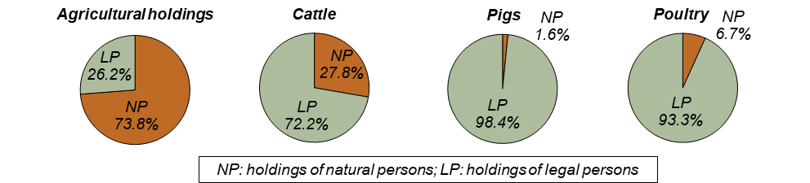

*In comparison with 2000, the concentration of pigs in holdings without agricultural land rose from 758 head per holding to 1 220 head per holding and the concentration of poultry from 13 197 head per holding to 27 948 head per holding; on the contrary, the concentration of cattle decreased from 20 head per holding to 15 head per holding. As for holdings raising pigs, the share of joint stock companies went up (from 67.7% to 87.5%) while the share of limited liability companies fell (from 21.5% to 7.9%). Limited liability companies focused on raising of cattle and poultry: the share of such holdings grew from z 25.0% to 64.4% and 37.8% to 52.1%, respectively.*

***Livestock numbers***

*During the period 2000–2020, the number of livestock declined in all principal categories except sheep and goats. The sharpest plummet was recorded for pigs (−56.2%) and less distinct ones for poultry (−14.5%) and cattle (−9.3%). Raising of pigs ceased in 81.9% of holdings, poultry raising in 72.2% of holdings, and cattle raisin g in 40.6% of holdings. This fact led to increased concentrations of livestock in particular agricultural holdings. On the contrary, increments were recorded during the abovementioned period for sheep by 164.3% and for goats by 142.0%.*

*However, there were exceptions from abovementioned trends for each livestock category in particular legal forms: they were recorded, for example, for cattle in holdings of natural persons (+17.5), for poultry in limited liability companies (+63.9%), or for sheep and goats in cooperatives (−41.9% and −40.9%, respectively).*

***Table 5: Basic characteristics of animal production, by legal form***

|  |  |  |  |  |  |  |  |  |  |
| --- | --- | --- | --- | --- | --- | --- | --- | --- | --- |
|  | ***Year*** | ***Agricultural holdings,***  ***total*** | ***by legal form*** | | | | | | |
| ***Natural***  ***persons,***  ***total*** | ***of which***  ***agricultural entrepre-neur***  ***– natural person*** | ***Legal***  ***persons,***  ***total*** | ***of which*** | | | |
| ***Business companies & partner- ships*** | ***of which*** | | ***Coopera- tive*** |
| ***Limited***  ***liability***  ***company*** | ***Joint stock company*** |
| *Agricultural holdings* | *2020* | *28 909* | *24 648* | *18 667* | *4 261* | *3 571* | *2 875* | *664* | *492* |
| *2000* | *39 082* | *36 198* | *24 880* | *2 884* | *1 998* | *1 351* | *608* | *742* |
| *Cattle (head)* | *2020* | *1 412 348* | *359 085* | *330 326* | *1 053 263* | *695 402* | *294 242* | *398 599* | *345 408* |
| *2000* | *1 557 408* | *305 619* | *276 333* | *1 251 789* | *658 773* | *263 431* | *389 710* | *574 480* |
| *Pigs (head)* | *2020* | *1 509 915* | *75 647* | *59 132* | *1 434 268* | *1 230 710* | *209 212* | *1 005 771* | *194 557* |
| *2000* | *3 445 908* | *368 908* | *336 644* | *3 077 000* | *2 116 385* | *611 518* | *1 498 837* | *931 276* |
| *Poultry (head)* | *2020* | *25 629 496* | *1 708 525* | *1 565 450* | *23 920 971* | *22 762 125* | *12 809 841* | *9 952 243* | *1 120 685* |
| *2000* | *29 988 411* | *4 852 839* | *4 170 330* | *25 135 572* | *21 392 765* | *7 817 851* | *13 574 914* | *3 609 453* |
| *Sheep (head)* | *2020* | *172 731* | *144 851* | *127 324* | *27 880* | *24 150* | *21 693* | *2 170* | *1 798* |
| *2000* | *65 365* | *50 274* | *41 959* | *15 091* | *11 851* | *9 587* | *2 046* | *3 094* |
| *Goats (head)* | *2020* | *24 374* | *18 431* | *14 393* | *5 943* | *5 267* | *4 761* | *501* | *217* |
| *2000* | *10 073* | *9 293* | *6 875* | *780* | *313* | *302* | *5* | *367* |

***Graph 8:* *Share of holdings in livestock totals, by legal form***

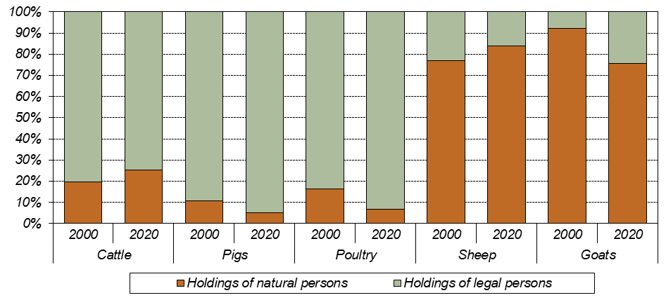

*Organic production methods were applied mainly in raising of sheep (35.6% of their total number), and goats (29.6%). In total 16.6% of cattle were ecologically reared; however, it is 46.4% of cows other than dairy ones. Raising of poultry and pigs using organic production methods is negligible (0.2% for both).*

***Raising of cattle***

*In 2020, there were 1 412 348* *head of cattle reared in 12 005 agricultural holdings. Compared to 2000, the cattle number went down by 9.3% and the number of their breeders by 40.6%. This resulted in increased average number of cattle per holding from 77 head to 118 head. Cattle density declined from 43 head per 100 ha of the UAA to 40 head per 100 ha of the UAA.*

*Three quarters (74.6%) of cattle were kept in holdings of legal persons; this share in 2000 was 80.4%. In holdings of natural persons the number of cattle increased by 17.5% and the average number per holding went up from 17 head to 36 head, while in holdings of legal persons the number of cattle declined by 15.9% and the average number per holding went down from 702 head to 521 head.*

*The largest share in the number of cattle in holdings of legal persons was represented by joint stock companies (28.2%), where the cattle numbers increased by 2.3% since 2000. The overall decline in cattle breeding was caused mainly by the plummet of cattle numbers in cooperatives (−39.9%); as the share of cooperatives in all cattle breeders was 24.5%, this represents a decline by almost 230 thousand head.*

*Three fifths (61.2%) of cattle were concentrated in large holdings with more than 500 head. However, there were distinct differences between particular legal forms: Holdings of natural persons reared typically small herds; only 18.7% of them reared more than 50 head. Nevertheless, this share was only 6.0% in 2000. On the contrary, in holdings of legal persons the most typical size category was 101–500 head, recorded in 35.6% of cattle farms. Compared to 2000, the share of holdings of legal persons having herds up to 100 heads distinctly rose from 10.1% to 27.1%.*

*In comparison with 2000, the number of cows decreased by 8 081 head to 588 998* *head; their share in the total number of cattle rose from 38.3% in 2000 to 41.7% in 2020. Three fifths (60.9%) of cows kept in agricultural holdings in 2020 were dairy cows. In comparison with 2000, the share of dairy cows went down by 22.7 p. p. Raising of dairy cows is influenced by long-term trends in farmers’ milk prices which were not favourable during the period 2000–2020. On the contrary, raising of beef cows was supported by subsidies from both national and European Union sources.*

***Graph 9:* *Shares of holdings by legal form in categories by cattle number per holding***

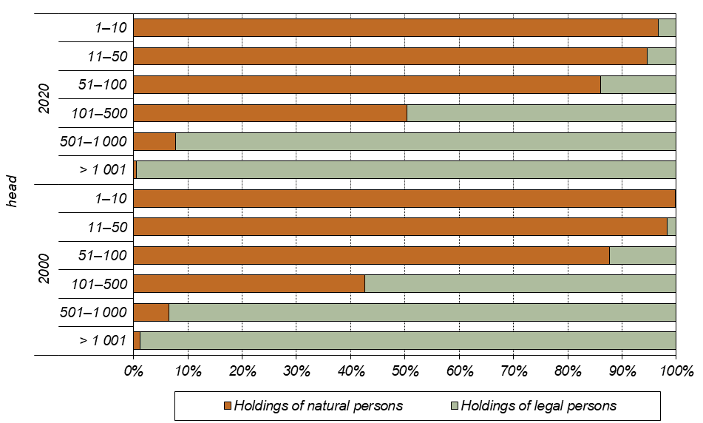

***Raising of pigs***

*In total 1 509 915* *pigs were kept in agricultural holdings in 2020; compared with 2000 their number dropped to less than a half (−56.2%). The number of pig farms declined even by 81.9% to 3 104 holdings. The number of head per one holding increased (from 201 head to 486 head) while their livestock density went down since 2000 to one half: from 125 head per 100 ha of arable land to only 61 head per 100 ha of arable land.*

*There were 392 holdings of legal persons raising pigs; since 2000 their number decreased nearly to one quarter (26.6%). They reared 95.0% of all pigs. One holding of legal person reared on average 3 659 head; i.e. by 1 568 head more than in 2000.*

*Out of 15 681 holdings of natural persons in 2000, only 2 712 did not ceased their activity until 2020. Number of their pigs declined by almost four fifths (−79.5%) to 75.6 thous. head. Due to a huge plummet in the number of pig farmers, the average number of pigs per one holding rose as well from 24 head to 28 head.*

*The prevailing way of pig rearing were large piggeries with more than 1 000 head (93.1% of the total number); only 2.0% of pigs were kept in groups of less than 100 head. Groups up to 10 head prevailed (71.1% of farms) among holdings of natural persons while the most frequent size category of holdings of legal persons was that with more than 1 000 head (44.1%). Since 2000, the number of small farms up to 10 pigs declined by 7.9 p. p., the shares of other size categories changed only insignificantly.*

***Graph 10: Shares of holdings by legal form in categories by number of pigs per holding***

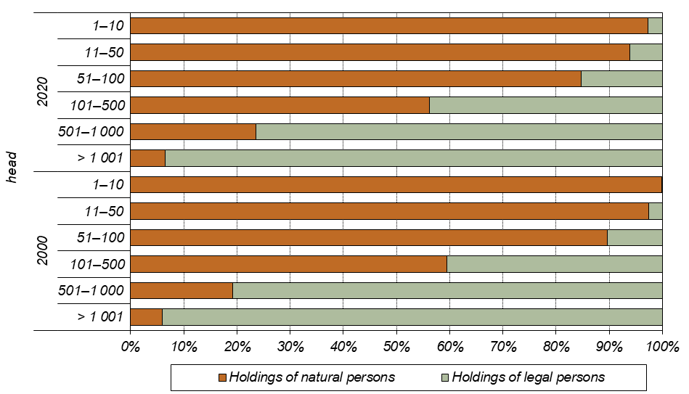

***Raising of poultry***

*In total 4 960 holdings raised more than 25 million head of poultry in the Czech Republic in 2020. One half (50.7%) of poultry were kept in agricultural holdings without utilised agricultural land. Holdings of natural persons prevailed (4 694 farms; i.e. 94.6%) but their share on poultry numbers was only 6.7% of the total number of poultry. The remaining 93.3% of poultry were concentrated in 266 holdings of legal persons.*

*During the period 2000–2020, the number of poultry decreased by 14.5% and the number of their breeders dropped by 72.2%. The average number per holding rose almost threefold, from 1 683 head to 5 167 head per holding. Poultry density went down from 1 090 head per 100 ha of arable land to 1 036 head per 100 ha of arable land. This decline was caused mainly by reduced number of broilers (−34.9%), while the number of chicken for breeding increased (+28.1%).*

*In holdings of natural persons, the decline amounted to 64.8% for poultry totals and even 75.6% for hens. In holdings of legal persons, the total poultry numbers went down by 4.8% but the number of hens rose by 39.4%. The number of poultry kept in cooperatives plummeted by two thirds (−69.0%) and a decrement by 26.7% was noted in joint stock companies. Limited liability companies, on the contrary, recorded an increase by 63.9% to 12.8 million head.*

***Graph 11: Raising of chickens, by legal form***

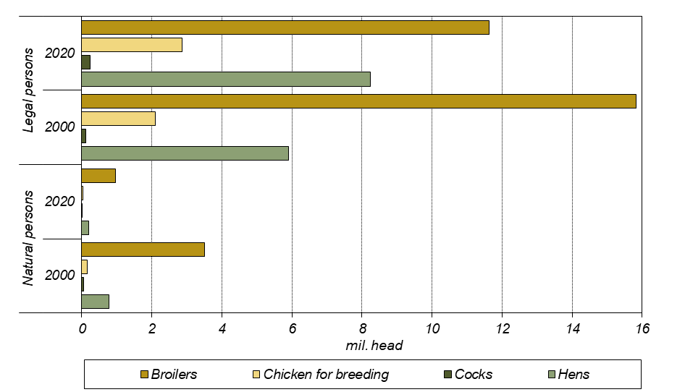

*Out of holdings of natural persons, 95.1% raised less than 100 head of poultry while a half (47.4%) of holdings of legal persons had large farms with more than 10 thous. head. The reduction of poultry farming since 2000 influenced all size categories of holdings of natural persons, mainly those with up to 100 head (−73.7% of holdings) and the category with 5–10 thous. head (−76.8% of poultry numbers). As for holdings of legal persons, a reduction occurred mainly in the size group of 501–1 000 head, where a reduction by 76.2% of poultry numbers and by 75.0% of holdings was recorded. On the contrary, the number of small farms up to 100 head as well as their poultry numbers rose nearly threefold (+196.4% of holdings; +171.1% of poultry). Although only several tens of holdings are involved, it can be interpreted as a sign of growing interest in poultry raising with respect to animal welfare standards.*

*The shares of particular poultry species in the total poultry number did not change much during the period 2000–2020; the share of hens and chicks for breeding rose to the detriment of broilers. Raising of chickens predominated: out of the total poultry number, there were 49.1% of broilers, 32.9% of hens, and 11.3% of chicken for breeding. As for other poultry species, ducks reached 2.5% and turkeys 1.2% of total poultry. In 2000, raising of broilers prevailed as well (64.5%), followed by hens (22.3%) and chicken for breeding (7.5%); out of other species, turkeys shared 2.9% and ducks 1.7% of the total poultry numbers.*

***Raising of sheep and goats***

*Sheep and goats numbers, in opposite to other livestock categories, recorded an increment since 2000. The number of sheep rose by 164.3% to 172 731* *head and the number of goats by 142.0% to 24 374* *head. In 2020, there were 4 145 sheep farmers and 1 563* *holdings raising goats. While number of holdings raising sheep went up by 28.0%, number of goat breeders dropped by 51.1% compared to 2000.*

*Raising of both sheep and goats was concentrated in holdings of natural persons; they involved 89.2% of sheep farmers and 87.8% of goat farmers; they kept 83.9% of sheep and 75.6% of goats. In comparison with 2000, there is a positive trend in number of these species among holdings of legal persons: their sheep numbers rose almost than twofold (from 15 091 to 27 880 head) and goats numbers more than 7.5 times (from 780 to 5 943 head).*

*Sheep are kept mostly in flocks of 11–50 head; this size category involves one half of farmers (49.0%) and one third of sheep (30.1%); this concerns especially holdings of natural persons. Among holdings of legal persons, this size group represented the largest share of the holdings as well (43.9%) but a fifth of sheep (21.6%) was concentrated in flocks of more than 500 head belonging to only 6 holdings (1.3%).*

***Graph 12:* *Raising of sheep, by legal form***

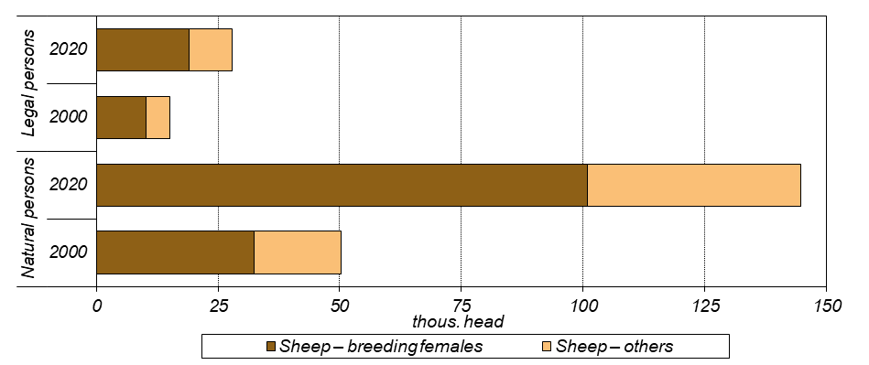

*As for raising of goats, size group up to 10 head per holding prevailed in both holdings of natural persons (69.6%) and legal persons (52.6%). Flocks larger than 50 head belonged to 65 holdings of natural persons (4.7%) and 26 holdings of legal persons (13.7%).*

***Graph 13: Raising of goats, by legal form***

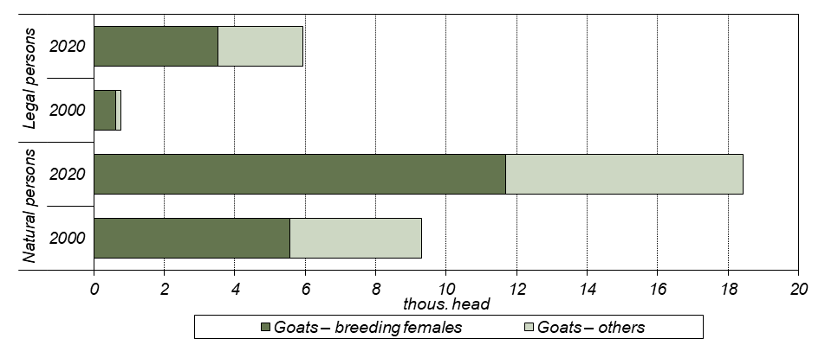

***Animal housing***

*Another topic studied in the Integrated Farm Survey 2020 was animal housing practices. The survey showed differences between holdings of natural and legal persons, mainly due to their financial and technical conditions and also differences in size groups of livestock.*

*As for housing of cattle, both dairy cows and cattle from other categories, solid manure housing prevails over slurry housing. Its share of the total housing capacity for dairy cows is 84.9% for holdings of natural persons and 82.9% for holdings of legal persons; for other cattle, a similar share (81.4%) was found in holdings of legal persons, while it is lower in holdings of natural persons (62.0%). Year-round outdoor rearing of cattle is mainly used for other cattle: it accounts for 35.4% of capacity in natural persons and 11.9% in legal persons. Dairy cows are kept outdoors year-round in holdings of natural persons in 6.9% of cases and in holdings of legal persons in only 0.4% of cases.*

*As for housing of pigs, holdings of legal persons mainly use facilities equipped with slatted floors: for 80.6% of the breeding sows and 86.0% of other categories of pigs. In contrast, natural persons use more often housing on solid floors (35.5% of capacity for breeding sows and 38.2% for other pigs) or deep litter housing (29.2% for breeding sows and 34.2% for other pigs). Outdoor rearing accounts for 6.3% of the capacity for breeding sows and 1.6% of the capacity for other pigs in holdings of natural persons and less than 0.5% in holdings of legal persons.*

*Holdings of natural persons keep hens mainly on deep litter (45.6% of capacity) and only 2.1% in cages, while legal persons use deep litter housing in 32.3% of cases and cage systems in 42.9% of cases. Free-range hen keeping is used in 39.7% of natural persons but only in 1.0% of legal persons.*

***Graph 14: Animal housing***

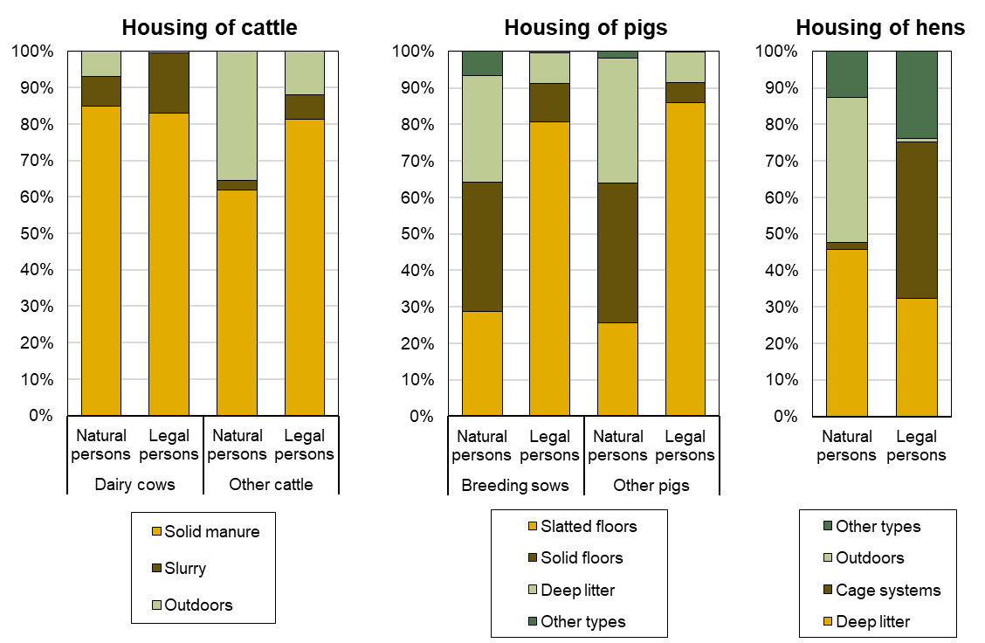

***Labour force in agriculture***

*In 2020, in total 176 815 persons were involved in agricultural work; out of them, 124 501 persons were regularly employed and 48 766 persons irregularly employed (i.e. working on the basis of contract for work or for services). Other 3 548 persons were employed not directly by agricultural holdings; those were either self-employed persons or employed by job agencies. Because of high seasonality of some agricultural work, this type of employment is widely utilised by agricultural holdings during work peaks.*

*Labour force regularly employed in agriculture consisted mainly of employees (including family members of the holder with employment contract), whose share was 58.7%; however, it was 70.9% in 2000. In holdings of natural persons, holders represented 45.5% and members of their families 44.5% of persons regularly employed; in holdings of legal persons, 5.7% were working owners.*

*During the period 2000–2020, the labour force totals decreased by 64 928 persons, i.e. by 26.9%. This decline was observed mainly in holdings dealing with animal production as the consequence of lowered interest in raising of main livestock species.*

*In holdings of natural persons, in total 61 815 persons were working in 2020, i.e. by 24.0% less than in 2000. Compared to 2000, there were more family members involved in the farm work instead of employees and persons working on the basis of contracts. While in 2000 there were 13.2% of employees and 34.6% of holders’ family members, in 2020 these shares were 8.8% for employees and 38.9% for family members. Even more distinct decline of labour force occurred in holdings of legal persons during the period 2000–2020. The number of workers decreased by more than one quarter (−28.3%) to 115 000 persons and the number of workers regularly employed even by 45.8% to 70 380 persons. Agricultural holdings frequently engaged persons working on the basis of contracts or employed by job agencies for short-term activities with high share of manual work (harvest of vegetables, fruits, or potatoes). In 2020, holdings of legal persons engaged 42 138 persons working on the basis of contracts and 2 482 self-employed persons and persons employed by job agencies.*

***Graph 15: Labour force structure in holdings of natural and legal persons***

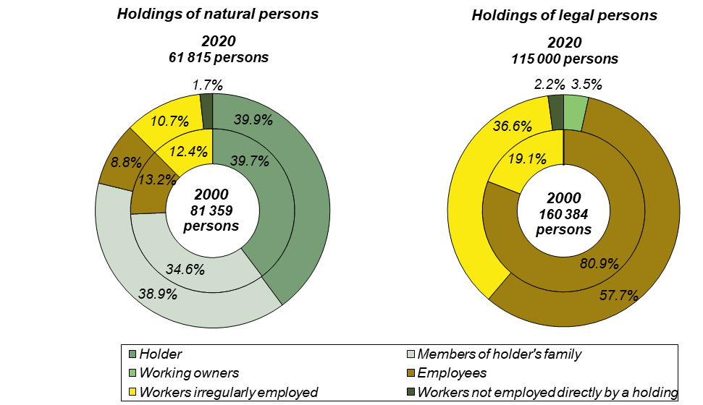

*According to standard EU methodology, data on labour force in agricultural sector is expressed in Annual Work Units (AWU).* *One AWU is the full-time equivalent employment, i.e. the total number of hours worked divided by the average annual number of hours worked in full-time jobs in the country. The annual fund of working hours is set at 1 800 hours in the Czech Republic and is based on the number of working days with 8 working hours a day minus minimum statutory claim for holiday and minus the average number of hours not worked for incapacity for work.*

*Expressed in Annual Work Units, the labour force number in 2020 was 95 372 AWU, i.e. 53.9% share in the total number of working persons. In 2000, this value accounted for 174 262 AWU (i.e. there was a decline by 45.3% in 2020) and 72.1% share in the working persons total. The decrease of the ratio between the number of persons and AWU shows increasing share of utilisation of part-time and temporary jobs in agricultural holdings. It was more frequent in holdings of natural persons, where the share after recalculation was 48.9% (30 205 AWU) while in holdings of legal persons the share was 56.7% (65 167 AWU).*

*The share of women in the total number of labour force regularly employed increased from 27.3% to 32.7%. In 2020, the share of women in holdings of natural persons was slightly lower (32.0%) than in holdings of legal persons (33.2%).*

***Workers per 100 hectares of UAA***

*From 2000 to 2020, the average number of workers per 100 ha of utilised agricultural area (computed only for holdings with UAA) has decreased by almost a quarter (-24.5%) from 6.4 to 4.8 persons per 100 ha. In holdings of natural persons, there was a decrease from 8.5 to 5.9 persons per 100 ha; in holdings of legal persons, it fell from 5.7 to 4.4 persons per 100 ha.*

*The recalculated number of workers per 100 ha of UAA is inversely proportional to the size of the agricultural holding. In holdings with up to 5 ha of UAA, the average number of workers per 100 ha in 2020 was 153.6, which is by 47.6 persons more than in 2000; this category involves mainly holdings dealing with production of highly labour-intensive commodities as vegetables, fruit, or grapes. In holdings with 5 to 10 ha, the numbers were only 31.1 and 32.0 in 2020 and 2000, respectively. For holdings larger than 2 000 ha, 3.6 workers per 100 ha of agricultural land were sufficient, by 1.6 less than in 2000. In 2020, 4.2% of persons worked in entities without agricultural land, compared with 3.6% in 2000. The share of workers in holdings by size group decreased the most from 2000 to 2020 in the largest holdings over 2 000 ha, by 8.1 percentage points to 17.1%, followed by the smallest holdings under 5 ha having a decrease of 2.3 p. p. to 9.9%. The largest increase of this share occurred in holdings with 100-500 ha, by 5.2 p. p. to 13.7%.*

*A similar trend as for absolute numbers of workers can be observed after converting the workforce into Annual Work Units (AWU). A comparison of the ratios between the number of persons and the number of AWU in each size group shows that part-time and occasional employment is more common in smaller holdings. However, in all size categories, there has been a decrease in this ratio, i.e. an increase in the proportion of part-time jobs, from 2000 to 2020, with the smallest decrease in the size group of 5 to 10 ha (-7.9 p.p.) and the largest decrease in the size group of 500 to 1 000 ha (-21.9 p.p.).*

***Table 6: Workers per 100 ha of the utilised agricultural area in agricultural holdings by size group***

|  |  |  |  |  |  |  |  |  |  |
| --- | --- | --- | --- | --- | --- | --- | --- | --- | --- |
|  | ***Total***  ***in holdings with UAA*** | ***size group of the utilised agricultural area (ha)*** | | | | | | | |
| ***>0 –***  ***< 5*** | ***5–***  ***<10*** | ***10–***  ***< 50*** | ***50–***  ***< 100*** | ***100–***  ***< 500*** | ***500–***  ***< 1 000*** | ***1 000–***  ***< 2 000*** | ***≥ 2 000*** |
| *persons* | | | | | | | | | |
| *2020* | *4.8* | *153.6* | *31.1* | *11.9* | *4.9* | *3.4* | *3.2* | *3.8* | *3.6* |
| *2000* | *6.4* | *106.0* | *32.0* | *13.0* | *6.6* | *4.6* | *4.2* | *4.7* | *5.2* |
| *Index 2020/2000 (%)* | *75.5* | *144.9* | *97.2* | *91.7* | *73.4* | *73.5* | *74.7* | *80.3* | *69.1* |
| *AWU* | | | | | | | | | |
| *2020* | *2.6* | *54.8* | *14.0* | *5.9* | *2.7* | *1.8* | *1.8* | *2.3* | *2.4* |
| *2000* | *4.6* | *49.7* | *16.9* | *8.0* | *4.6* | *3.2* | *3.3* | *3.8* | *4.3* |
| *Index 2020/2000 (%)* | *57.3* | *110.3* | *82.6* | *74.0* | *58.1* | *56.3* | *54.0* | *59.8* | *54.6* |
| *AWU/person (%)* | | | | | | | | | |
| *2020* | *54.6* | *35.7* | *44.9* | *49.9* | *55.0* | *52.7* | *57.1* | *60.9* | *65.8* |
| *2000* | *71.9* | *46.9* | *52.8* | *61.8* | *69.4* | *68.8* | *79.0* | *81.7* | *83.3* |
| *Difference (p. p.)* | *-17.2* | *-11.2* | *-7.9* | *-11.9* | *-14.4* | *-16.1* | *-21.9* | *-20.8* | *-17.5* |

***Managers of agricultural holdings***

*Four-fifths (81.9%) of the managers of Czech agricultural holdings are males. There is little difference between legal forms in this respect: females manage 18.3% of holdings of natural persons and 16.8% of holdings of legal persons. In 99.1% of of holdings of natural persons, the manager is the owner of the holding.*

*Holdings of natural and legal persons differ significantly in the educational background of their agricultural managers. While 50.4% of holdings of natural persons are headed by persons with only practical experience (48.6% of males and 58.3% of females), holdings of legal persons are mainly headed by persons with secondary and higher education in agriculture (66.2%; 67.6% of males and 59.4% of females). Less than a third (30.9%) of the managers of natural persons and almost three fifths (57.1%) of the managers of legal persons had received further training in the 12 months prior to the survey date.*

*The age structure of agricultural managers is not very favourable. Only 10.1 % of the heads of natural persons and 8.6 % of the heads of legal persons are under 34 years of age. By contrast, 44.4% of natural persons and 42.1% of legal persons are headed by a person aged 55 or over. The age structure of females is slightly more favourable than that of males: 11.5% of natural persons and 12.6% of legal persons are headed by females aged under 34, while females aged over 55 are in charge of 41.7% of natural persons and 34.9% of legal persons. Males aged 34 and under manage 9.8% and males aged 55 and over 44.9% of natural persons, while in legal persons, the ratio is 7.8% for males aged 34 and under and 43.5% for males aged 55 and over.*

*In holdings of natural person, male managers are most often represented by those who have held their managerial position for 26 years or more (32.7%), while the largest proportion of female managers have held their position for less than 5 years (25.7%). In case of legal persons, the category of persons who have held the position of manager for less than 5 years is dominated both by males (33.8%) and females (39.7%).*

***Graph 16: Age structure of managers***

