CROSS-THEMATIC INFORMATION

 | Year 2013
Comprehensive information |  | Prague, 19th September 2013
Publication code: a-1120-13 |  | Reference No.: 1678/2013–01
Yearly publication number: 2

The Czech Economy Development
in the First half of 2013

Prepared by: | Cross-Thematic Analyses Department
Authors of publication: | Ing. Drahomíra Dubská, CSc., Bc. Jiří Kamenický, Ing. Lukáš Kučera
Contact person: | Ing. Drahomíra Dubská, CSc.
Phone number: | +420 2 7405 4041
E-mail: | drahomira.dubska@czso.cz

Czech Statistical Office
Year 2013

Are you interested in the latest data connected with inflation, GDP, population, average wages and much more? You can find them on the CZSO web page: www.czso.cz

© Czech Statistical Office, Prague 2013
Contents

1. Summary 4
2. Overall Economic Performance 5
3. Industry Performance 7
4. External Economic Relations 10
5. Prices 12
6. Labour Market 14
7. Monetary Conditions 16
8. State Budget 17

Summary

- Decrease of the CR Gross domestic product (GDP) considerably slowed down to -1.3 % year-on-year in Q2 2013 following -2.4 % in Q1. In H1, it was by 1.9 % lower in comparison to the same period of 2012. Despite the aggregate fall of GDP, the Czech economy strengthened its stability especially within the external economic relations, where all the components of balance of payment featured no deficit. State finances depicted improvement in the imbalance as well. Also, the overall employment grew accompanied by the increasing impact of part-time employment.

- Notwithstanding the improvement, the rate of year-on-year fall in the CR in Q2 2013 (-1.3 %) was markedly deeper than the rate in the EU, where the economy stagnated. On the contrary, quarter-on-quarter growth of GDP was more favourable in the CR (+0.6 % compared to 0.4 % in the EU). The CR result was influenced by a rather weak comparative basis of the preceding quarter, which was negatively affected mostly by pre-stocking of tobacco products in the last quarter of year 2012. Also thanks to this displayed the Czech economy quarter-on-quarter growth in Q2 for the first time in six quarters. Only the data for the next quarter can indicate the direction of the subsequent development of the economy.

- Positive shifts in the structure of expenditure items of GDP from Q1 2013, when apart from the inventory formation all items of expenditures on GDP recorded quarter-on-quarter additions – expenditures on final consumption even for two quarters in a row – did not continue in Q2 2013 any longer. The moving force in the direction of positive development of the economy was thus in Q2 2013 only the foreign trade and a milder drop of the stock of inventories. Exports of goods and services rose compared to Q1 by 3.6 %, imports given the lasting weakness of domestic demand by 2.5 %.

- The Czech economy lacks investment. Year-on-year drop in the gross fixed capital formation by 6.2 % in Q2 2013 was the deepest in the last two years, since the investments had been decrrasing constantly. Also the notable reduction in inventories led to a lower gross capital formation by 12.6 %. This fact does not signal any signs of near economic recovery, because companies are most likely not convinced about the strengthening of the demand.

- Final consumption expenditure grew year-on-year for the first time in eight quarters (+ 0.8 %). However, also here worked the effect of the comparative basis, as in Q2 2012 was their year-on-year decrease during the recession so far the deepest (-2.4 %). Foreign trade returned back to a year-on-year growth (exports of goods and services +2 %, imports +0.5%), while the development of prices in both Q1 and Q2 generated a business profit flowing from the terms of trade for the first time since year 2009.

- Development of GDP towards year-on-year growth moved in Q2 the result of foreign trade with a contribution of +1.2 p.p. and final consumption expenditure (+0.6 % p.p.). Nevertheless, decrease of capital formation (-3 p.p.) eliminated these favourable growth influences.

- Gross value added (GVA) in the Czech economy fell year-on-year in Q2 by 1.2 %. It was mainly due to the industry (-0.9 p.p.), further construction, agriculture and with the exception of financial and insurance activities (+0.8 p.p.) also all branches of market services. This list again proves the weakness of demand.

- Overall employment in the economy in the conception of national accounts grew year-on-year (+1.3 %) the strongest since the last quarter of 2008. The ability of economy to absorb new labour force was however connected to a change in the structure of jobs. Real wage in the economy in H1 2013 fell year-on-year by 1.3 % given the growth of average nominal monthly wage by 0.4 %.

- Aggregate price level in the economy was in Q2 2013 year-on-year higher by 1.4 %, similarly to the preceding quarter. The growth of prices for consumers (+1.5 %) slowed down and so did the industrial producer prices (+0.5 %). In construction, the deflation deepened given the fall of production by 12.8 %. Situation of this branch is one of the reasons behind the investment activity in the Czech economy being low in the long-term.

- In H1 2013, exports of motor vehicles increased year-on-year by 5.8 %, traditionally high surplus of this trade on the contrary fell. Direct investment inflow into the CR was above the average of the previous five years.

- Additions to loans to enterprises and households (+2.3 %) was year-on-year the second lowest since September 2010. It is the evidence of the lower need for the operational financing of firms for one thing and their prudence regarding the investment for another, and also a prudence of households (as well as banks) with respect to a new debt. Recovery is apparent in connection to provision of a non-bank credit. Growth of non-term deposits was accompanied by a drop of other deposits already for a third quarter in a row (-4.6 %).

- State budget deficit significantly improved in H1 2013 year-on-year to 31.5 bn. from 71.7 bn crowns (H1 2012), given a notable growth of revenues (+9 %) compared to expenditures (+0.9 %).

Overall Economic Performance

GDP in the CR fell already for the sixth quarter in a row in Q2 2013 year-on-year, the depth of fall was however in comparison to previous three quarters lower… |  | GDP fell in Q1 and Q2 2013 in comparison to the same period of the previous year by 2.4 % and 1.3 %, in total for H1 by 1.9 %. Viewed from the point of year-on-year development, the economic performance was falling already six quarters in a row. If the year-on-year falls of GDP gradually deepened quarter by quarter from -0.4 % in Q1 2012 down to -2.4 % in Q1 2013, in Q2 2013 the GDP fell „only“by mentioned 1.3 %. This corresponded to a milder year-on-year decrease compared to preceding three quarters.
...the GDP thus after six quarters increased for the first time in quarter-on-quarter terms by 0.6 % |  | Milder year-on-year drop of GDP in Q2 2013 was caused by quarter-on-quarter increase of GDP by 0.6 %. If the GDP still decreased in Q1 2013 over the previous quarter by 1.3 %, in Q2 2013 the domestic economy already displayed a growth after a quarter-on-quarter fall lasting six quarters. In total the GDP fell in the period of contraction by 3.1 %, which corresponded approximately to half of the fall occurring in the period of 2008/2009.
Quarter-on-quarter decrease of GDP in the CR in Q1 2013 one of the largest in the EU, while the growth of GDP in Q2 on the contrary one of the highest |  | Position of the CR in the EU based on the quarter-on-quarter rate of growth of GDP markedly improved. Given the quarter-on-quarter decrease of GDP in the CR in Q1 2013 being one of the deepest in the whole EU (GDP in the EU lowered in the same period only by 0.1 %), quarter-on-quarter addition in Q2 2013 in the CR reached an above average rate of growth (GDP in the EU in Q2 2013 rose by 0.4 %). Higher rate of growth compared to the domestic economy occurred in Q2 2013 only in Portugal (+1.1 %) and further in Germany, Great Britain, Latvia, Lithuania, Malta (similarly +0.7 %). Also the last country out of the three largest economies according to GDP (France) reached an above average quarter-on-quarter growth (nevertheless lower compared to the CR) in the amount of 0.5 %.
Behind the quarter-on-quarter recovery stood especially the foreign trade… |  | Quarter-on-quarter increase of GDP in the CR in Q2 2013 was under the direction of foreign trade. In the last quarter of 2012 the exports still fell compared to the previous quarter by 1.9 %, imports did not change and the balance of foreign trade thus contributed to the quarter-on-quarter decrease of GDP. In Q1 2013, the exports fell by further 0.6 %, imports however already by 1.1 % and the positive result of the foreign trade started to soften the fall of GDP. In Q2 2013 the exports quarter-on-quarter even improved (by 3.6 %) and the same was valid for imports (by 2.5 %). Higher growth of imports compared to exports (by 1.1 p.p.) in Q2 2013 led to a more notable increase of the foreign trade surplus than the 0.5 p.p. milder drop of exports in comparison to exports in Q1 2013.
…which recorded a better result in Q2 2013 mainly thanks to the demand from Germany |  | In the growth of domestic exports in Q2 2013 significantly assisted the improved performance of the German economy. GDP in Germany in the last quarter of 2012 fell year-on-year by 0.5 % and in Q1 2013 stagnated, to which corresponded also the changes in the aggregate volume of imports into this country – in the last quarter of 2012 the imports decreased by 0.9 %, in Q1 2013 by further 0.4 %. Quarter-on-quarter expansion of the German GDP in Q2 2013 however again increased the imports by exactly two percent, which benefited also the CR.
The most significant expenditure component of GDP by volume - the final consumption expenditure – in 2Q 2013 in year-on-year terms grew, however they were by half a percentage lower compared to Q1 2013… |  | The most significant expenditure component of GDP by volume, the final consumption expenditure, again grew in Q2 2013 year-on-year (by 0.8 %). This turn occurred after a two-year fall. Positive rate of growth of consumption was however given only by a low comparative basis in Q2 2012, when the consumption year-on-year decreased by 2.4 %, the most across the whole recession. Quarter-on-quarter the consumption grew already in the last quarter of 2012 (by 0.5 %) and in Q1 2013 (by 1.3 %). On the contrary, the final consumption expenditure again decreased in Q2 2013, specifically by 0.5 %.
…which was again the effect of both the weaker consumption of the household sector… |  | Repeated reduction of the consumption of the domestic economy in Q2 2013 was caused by the lowered consumption of households, which was reduced quarter-on-quarter by 0.4 %. Given the fact that the household consumption was already rising in the last quarter of 2012 and Q1 2013 by 0.3 % and 1.5 %, returned slump put further increase to a halt. Despite Business Cycle Surveys signalling relatively long-term improving of the consumer confidence in the future economic development (consumer confidence indicator grew already roughly from the half of year 2012), real data related to consumption did not confirm these findings.
…and the final consumption expenditure of the government institutions |  | To the lowering of the overall consumption in the economy in Q2 2013 in comparison the previous quarter contributed also the repeated drop in the final consumption expenditure of the government institutions. Consolidation of public finances gradually limited the volume of funds provided to public services starting the last quarter of 2010 until Q2 2012 (with the exception of quarter-on-quarter growth by half a percentage in Q1 2012). Beginning the second half of 2012 a gradual ceasing of expenditure restrictions eventuated – consumption of government institutions increased quarter-on-quarter by 0.2 % in Q3 2012 and 1 % in the last quarter. Growth of final consumption expenditure of government institutions continued also in Q1 2013 (by 0.9 %). In Q2 2013 however again the government institutions consumption was restricted by 0.7 % – the consolidation of public finances from the point of view of restrictions on the expenditure side thus was not yet fully completed.
The last main expenditure item, gross capital formation, did not contribute to the quarter-on-quarter growth of GDP either |  | The last main expenditure item, the gross capital formation, did not contribute to the quarter-on-quarter growth of GDP either. If in Q1 2013 the gross capital formation downswinged by 10.7 % in comparison to the last quarter of 2012, in Q2 2013 its volume rather stagnated (-0.1 %).
If the gross capital formation sank in Q1 2013 by more than one tenth as a result of lowering of the volume of inventories in the economy, in Q2 the lowering of stock of inventories slowed down and consequently limited the negative impact of the lower investment on the gross capital formation |  | Causes of the specific quarter-on-quarter shifts in the volume of gross capital formation in H1 is necessary to search for already in the last quarter of 2012, when the gross capital formation increased by 3.2 %, investment (gross fixed capital formation) however decreased by 2.2 %. The source of growth of the gross capital formation was thus in Q4 2012 the increase of inventories in the domestic economy, which was most likely supported by the pre-stocking of tobacco products for the reason of expected increase in the consumption tax at the beginning of year 2013. In Q1 2013 the gross capital formation sank by the above mentioned 10.7 %, investment however increased by modest 0.2 % – what occurred most likely was a significant sell out of inventories prestocked in the preceding quarter. In Q2 2013 the gross capital formation stagnated, but investment again decreased – by 1.5 %. The stock of inventories in the economy continued to fall, however, it can be assumed that by a lower pace compared to Q1 2013.
The long-term low tendency of firms to acquire new investment led to a fact, that the volume of new investment in Q2 2013 reached only 92.8 % of the volume of investment from the end of 2011 |  | Relatively adverse development of the gross capital formation was strongly impacted also by the weak investment activity in the long-term in the CR. Beginning year 2012 the quarter-on-quarter increase in investment eventuated only twice – in Q2 2012 by 0.6 %, in Q1 2013 by mentioned 0.2 %. The volume of the gross fixed capital formation was thus in Q2 2013 by 7.2 % lower compared to the end of 2011. This fact has its root probably in the low investment activity of firms, which can be observed from the long-term weak business confidence in the economic development – the indicator of business confidence has been decreasing already from the start of 2011.
Weakened domestic demand led to only a minimal quarter-on-quarter growth of gross value added in the economy (by 0.2 %) |  | Domestic demand in Q2 2013 fell down, with a contribution apart from a milder reduction of the stock of inventories of all its major components. The source of quarter-on-quarter growth of GDP thus remained in the positive result of the foreign trade. Adverse development in the economy – notable from the expenditure structure of GDP – negatively affected also the supply side (total gross value added increased compared to the previous quarter only by 0.2 %).
Slump of the aggregate gross value added was averted by high performance of the financial and insurance activities together with growth of GVA in industry |  | More signification source of the growth of gross value added in Q2 2013 thus remained financial and insurance activities, which increased its quarter-on-quarter rate of growth of gross value added from 1.2 % in Q1 to 6.2 % in Q2. Also industry (CZ NACE B to E) increased gross value added by 1.7 %, when it was still decreasing in Q1 by 0.8 % – with respect to the reduction in the gross value added formation of the manufacturers in Q1 by 0.2 % and its growth by 0.2 % in the second it can be assumed, that the main role in the dynamics of gross value added as a whole played the energy industry.
… quarter -on-quarter lowering was on the contrary observed for groups of branches significant by volume - trade, transportation, food service activities and accommodation but also for real estate activities |  | The drop of gross value added in Q2 2013 was deepened for groups of branches of trade, transportation, food service activities and accommodation (from quarter-on-quarter -0.1 % to -0.9 %). A slump in Q2 recorded also a branch significant by volume in the area of real estate (-1.5 %) or the group of public governance and defence, education, health and social care (-0.2 %) – all these branches are sensitive to shifts in the domestic demand.

Chart 1 | GDP (constant prices, adjusted for seasonal and calendar effects, in %) | Chart 2 | GDP (constant prices, adjusted for seasonal and calendar effects, y/y in %, r.axis) and confidence indicators (2005=100, l. axis)
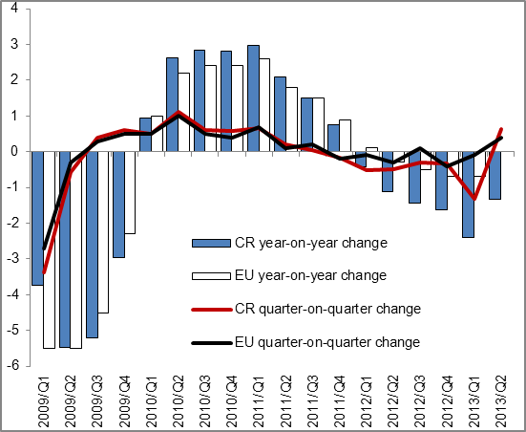 |  | 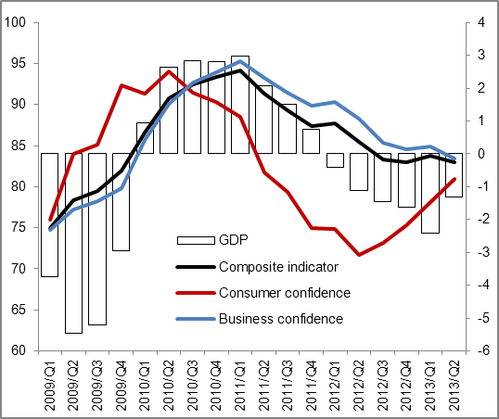
Source: Eurostat, CZSO

Chart 3 | Contributions of expenditure components to variation in GDP (constant prices, y/y in p.p.) | Chart 4 | Contributions of branches to variation in gross value added  (constant prices, y/y in p.p.)
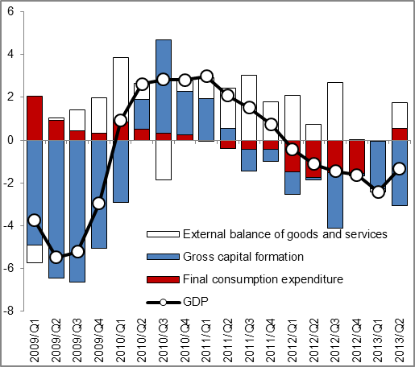 |  | 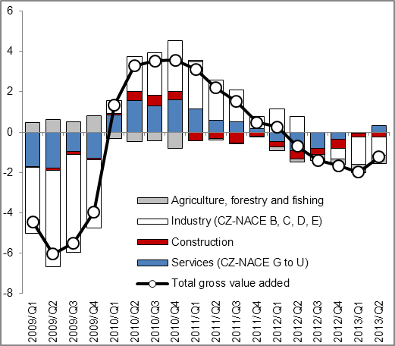
Source: CZSO

Industry Performance

Recovery in the quarter-on-quarter growth of gross value added – especially due to industry and financial sector |  | Performance of the branches of the Czech economy, gauged by the seasonally adjusted volume of gross value added created in these branches, decreased in H1 2013 according to the preliminary data year-on-year in real terms by 1.6 % (it stagnated in the same period of the preceding year). The adverse result was affected mostly by the development at the beginning of year 2013 (Q1 -2.0 %), in Q2 2013 (-1.2 %) the year-on-year fall in the dynamics of the formation of gross value added in the whole economy did not deepened any more after more than two years. A turn in the development of the business cycle can suggest a mild quarter-on-quarter growth (+0.2 %), which occurred in Q2 for the first time after a year and a half, especially by a more favourable development in the whole industry (incl. energy industry) and also in financial activities.
For the first time after four years a more marked year-on-year growth of number of employees, which was however not yet reflected in the growth of hours worked |  | First half of 2013 brought for the first time since the beginning of the deep recession (2008/2009) also a visible growth of employment (year-on-year in the national accounts conception by 1.2 %, in the category of employees by 2.1 %). Lead of the dynamics of jobs of the employee character ahead of other types of employment was in the last decade in the Czech economy typical more for the expansion period. Lasting problem of the inadequate demand indicates on the contrary constant fall in the hours worked, which was in H1 2013 year-on-year even lower than in the previous year (-3.0 % vs. -1.5 %), especially due to the near 10% falls in construction and also in total in agriculture, forestry and fishing.
Deeper fall of the value added in the primary sector, lasting negative tendencies in construction…  Performance in industry as well as financial sector partly affected by a higher last year comparative basis  In most services year-on-year growth of employment given a mild, little differentiated drops of gross value added |  | Given the individual branches, an atypical development was recorded during the year 2013 by the financial sector, high year-on-year growth of value added (in first half year +15 %) can be explained mostly by the low comparative basis of the previous year. In the key industry (manufacturing) the gross value added decreased in H1 year-on-year by 2.8 %, in quarter-on-quarter comparison however the second quarter of 2013 experienced a renewal of a mild growth again after one year. Relatively worse year-on-year dynamics of the industry reflects the fact, that at the beginning of last year, this industry was one of the few still in the relatively good condition supported by a high growth of foreign orders. Negative tendencies are persisting for a long time in construction, where apart from falls of the value added (in H1 2013 year-on-year by -3.4 %) also continues the reduction of employment (with deeper reduction of jobs of the non-employee character). Similar situation occurs in agriculture, where in contrast to the anticipations of good harvest the value added fell in H1 the most among all branches (by one sixth). Within services the dynamics of value added did not differ significantly year-on-year apart from financial activities, more notably (as opposed to industry) grew the employment (in information and communication activities, real estate, but also in public services).
The period of recession affected the creation of gross value added in a very variable ways |  | With respect to the creation of gross value added in branches, the most successful were the financial activities and real estate, the worse situation was in construction and agriculture. The size of real gross value added in the manufacturing industry amounted in H1 2013 to the level of the period of boom (five years ago), in financial and insurance activities it exceeded this level by one quarter (for activities in the real estate area by one seventh), however in construction it was lower by one tenth and in the primary sector even by one quarter.
Year-on-year drop of industrial production did not deepen in Q2 anymore, however it still remained below the level of the previous year 2012 |  | Long-time weaker domestic demand in connection with the so far weak growth of economies of our traditional business partners have a negative effect mostly on the industrial production. Industrial production index in Q2 2013 stayed still visibly below the last year's level (both in Q1 and Q2 2013 after adjusting for calendar variations similarly nearly by 3 %). Following a quarter-on-quarter growth (+1.2 %), which was recorded in Q1 2013 for the first time since 2011, the performance of industry in Q2 2013 again decreased quarter-on-quarter (-0.2 %). Near return on the growth trajectory is however for now very uncertain due to the persisting adverse development of the value of new domestic as well as foreign orders in the whole industry as well as its key branch – manufacturing of motor vehicles.
Drop in the production of motor vehicle industry and its associated productions and also metallurgy… |  | Within the branches of the manufacturing industry, one quarter of branches kept in H1 2013 mild year-on-year growth, except for manufacturing of metal constructions and pharmaceutical industry (profiting from the growth of foreign orders), however these were peripheral branches by performance. On the contrary, the largest drop of production eventuated for the manufacturers of computers, electronic and optical appliances (-15 %), for the past two years even by a whole one third. Long-term weakening of the dynamics of industrial production remained notable in metallurgy, manufacture of plastic and rubber products and manufacture of other non-metallic mineral products (influenced by a prolonged recession in construction), among small branches then in printing or furniture industries.  Substantial fall (-7 %) affected in H1 also from the view of export the key branch of the motor vehicle production, whose growth in the same period of the previous year (+7 %) was in contrast to the majority of other manufacturing branches still sustained by more than 10% growth of new foreign orders.  Among the more significant branches, keeping growth still at the end of the last year, the chemical industry production fell in H1 (-3 %) and also the manufacturing of electrical equipment (- 2 %), flourished only the smaller branches within other manufacturing industries (e.g. the manufacturing of toys or sport equipment). The production in the mining industry keeps falling for nearly two years in a row and it deepened in Q2 2013 (year-on-year weaker by one fifth). On a relatively successful year 2012 built the energy industry in H1 of the following year by 4% decrease in production. In contrast to the preceding years, the aggregate dynamics of the industrial production did not differ in the branches oriented on the short-term, long-term consumption or investment.
...value of new industrial orders with a moderated year-on-year fall compared to a year-on-year fall in the quarter |  | Dynamics of sales of the industrial firms is closely related to the development of their production. Also in Q1 2013 continued the long-term tendency (interrupted only in years 2005 and 2008) of advance of the dynamics of sales from direct export over domestic sales. In Q2 the sales “from exports” even year-on-year grew in current prices by 3 %, while on the “domestic market” they fell by 5 %. The adverse development proceeded in 2013 also for new industrial orders (Q1 -6 %, Q2 -1 %), without more significant differences between domestic and foreign orders. The dynamics of all new orders also notably weakened in the motor vehicle and chemical industries, further the drop of orders deepened for manufacturers of computers and electronic and optical appliances. Year-on-year larger value of foreign orders had on their disposal at the beginning of this year manufacturers of metal constructions, machinery and also clothes, traditionally also textile and pharmaceutical industry. In case of domestic orders it was valid for manufacturers of computers and electronic and optical appliances and electrical equipment.
Drop of construction production in H1 2013 year-on-year by 13 %, in Q2 the manufacturing neared the real level reached twelve years ago |  | Construction carried the adverse tendencies over also into the year 2013. Construction production year-on-year falls already 15 quarters in a row (disregarding Q1 2011, when the mild growth of production was the result of a very low comparative basis of the previous year), last whole year growth was in the branch recorded in 2007. Construction production in H1 2013 decreased by 13 %, given the comparable fall in both quarters (affected by the adversity of weather). Even though both the building and civil engineering construction reached a comparable depth of slump, the result of the whole industry was due to a larger weight nearly by three quarters affected by the building construction. Compared to the period of boom (Q2 2008) the production was in Q2 2013 for civil engineering construction by nearly one fifth lower, for building construction by nearly one third. Real production in Q2 2013 in the whole construction neared the level achieved twelve years ago.
Record low values of new construction orders due to the effect of lack of funds for their financing |  | Long-lasting negative mood in the enterprise sector with connection to the restriction of government investment project into a record low values of new construction orders. These in H1 2013 (for businesses with 50 and more employees) year-on-year decreased by one sixth, in building construction even by one quarter (in absolute terms down to the lowest value in the modern history), in civil engineering by 7 % (absolutely the lowest since year 2001). This year's value of new orders was in both two main branches of construction compared to boom lower by one half. Further continued the trend of shrinking of the average size of order, which fell for the new closed orders in H1 2013 to 3.1 mil crowns, year-on-year by one tenth.  The lack of new orders at the end of Q2 2013 was perceptible also on the total value of all construction orders (in the total amount of 135 bn crowns, year-on-year nearly by one seventh lower). In contrast to the previous years, the deep downswing of the value of public orders (by one fifth) was joined with the year-on-year depth nearly comparable drop of private orders. Lower volume of these orders could not be compensated by a dynamic growth of by weight so far peripheral orders from abroad (+19 %). One half of stock of all orders still represents the public sector, foreign orders form one eight (four years ago their share was 5.5 %). The lack of large orders transforms since year 2009 into the reduction of average number of employees (year-on-year it was in Q2 2013 lower by 7 %, in five years nearly by one fifth).
Construction of commenced flats at the level of middle 90s |  | In H1 2013 the number of commenced flats (11 thousand) year-on-year lowered by one eight and amounted to a level of middle 90s. Less flats was year-on-year commenced in all main types of buildings, the depth of fall was comparable for family and flat houses. The number of completed flats also decreased year-on-year by one tenth (to total 11.8 thousand), in all main categories apart from flats in flat houses, whose numbers year-on-year stagnated.
Sales in services in H1 year-on-year lower by two percent, mild growth in transportation and some services for entrepreneurs |  | Similarly to construction also services has not so far extricated themselves from the year-on-year falls caused by the deep recession (2008/2009). In H1 2013 they continued in the moderate year-on-year decrease of the real sales (-1.9 %). After 12 quarters ceased the continuous growth of sales of job agencies (-0.3 %, in four years they increased by two thirds). Differentiated development continued in the sector of accommodations, food service activities and restaurants, where the growth of sales for accommodation lasts for three years (In H1 +1.6 %). Restaurants and food service activities face long-term difficulties, in spite of the depth of decreases of real sales grew milder (to -1.5 %), for the last six years the sales were lower by more than one quarter.  Among the major branches the sales grew somewhat only in transportation (especially thanks to the warehousing and support activities for transportation), in business services then for activities of head office and management consultancy activities. Businesses on the contrary save on the costs for advertisement and market surveys (sales in this segment year-on-year lowered by one tenth, since the beginning of deep recession they decreased by two fifths).
Sales in retail in Q2 increased year-on-year by 0.3 % due to the higher sales in the motoristic segment and also non-food products |  | Four quarters in a row lasting year-on-year decrease of retail sales was in Q2 2013 halted. In H1 the sales weakened in real terms by 1.3 %. To a more favourable result contributed also the somewhat higher sales of non-food products, partially also in Q2 higher sales in the motoristic segment (both for repair and maintenance). Sales of food (-2.2 %) as well as fuels (-2.7 %) continued falling. The strong long-term growth of sales of internet sellers continued.  Out of specialised shops the internet and delivery sellers fared traditionally the best also in H1, with sales growing year-on-year nearly by one quarter, which represented a return to a high growth dynamics from year 2008. Sales strategies assisted also to computer and communication equipment (+10 %) as well as to sales of clothing and shoes (+4 %). For other types of shops the sales only stagnated (textile, books) or mildly weakened (products predominantly for household; culture and recreation, pharmaceutical and health products, furniture, electrical appliances and electronics).

Chart 5 | Production in industry and selected branches of manufacturing (y/y, in %) | Chart 6 | New orders in motor vehicle manufacturing and industry in total (y/y, in %)
Source: CZSO

Chart 7 | Production in construction and value of new orders (y/y, in %) | Chart 8 | Retail sales incl. motor vehicle segment (in real terms, y/y in %)
Source: CZSO

External Economic Relations

Balance of payment in the first half year without deficits – such a favourable result recorded last in year 2006 |  | Economic relations of the Czech Republic with foreign countries in H1 2013 proceeded favourably, similarly to development in Q1 alone. Revenues exceeded expenditures both on the current account of balance of payments and on the capital and financial accounts. At the same time, surplus current account for a half year was lastly recorded in 2006. Current account surplus in H1 2013 arrived at 0.4 % of nominal GDP, the deficit in the same period of 2012 then -0.5 %. Behind the positive balance of the current account stood in total the improvement of the trade balance with goods as well as balance of services and mild improvement of the surplus of current transfers. In the opposite direction worked the result of the income balance, which year-on-year worsened. Half-year fall of the Czech economy thus did not influence its deviation from balance.
The growth of trade balance surplus, services balance as well as result of current transfers exceeded the deepening income balance deficit |  | Half year surplus on the current account arrived at 8.6 bn crowns against the deficit of 9.1 bn crowns in H1 2012. Trades with goods finished in surplus in the amount of 111.3 bn crowns, which was year-on-year higher by 25.4 bn crowns (half year positive trade balances grow continuously already fifth year in a row regardless the economic crisis in 2009 and recession in 2012). Exports and imports of services surplus rose by 6.8 bn to 32.9 bn crowns and the current transfers balance improved from the deficit of 2.6 bn crowns to a surplus in the same amount. Increase of these surpluses was in total significantly higher compared to the worsening of the income balance, whose deficit deepened to 138.2 bn crowns from 118.4 bn crowns in the same period of 2012.
Half year fall both of exports and imports of goods caused by its marked decrease already in Q1 2013…, |  | Both exports and imports of goods according to data in the national conception of foreign trade – better reflecting from the macroeconomic point of view the economic performance of a country – decreased for H1 2013 in current prices (-1.1 % and -3.2 % resp.), mostly by the influence of adverse development in Q1 (-4.5 % and -5.2 % resp.). In subsequent three months revived both the foreign demand and the interest of the domestic economy in imports.
…while the reduction of goods flows took place simultaneously with strengthening of the trade balance; surplus of the motor vehicle trade however decreased |  | Imports and exports of goods balance in H1 2013 improved – the surplus based on the statistics of foreign trade in the national conception and product classification increased to 75.6 bn crowns from 52 bn crowns in the same period of 2012. Increase of the surplus was notable mostly for the trade with electrical appliances (to 36.9 bn crowns), metal-working products (31.2 bn crowns), furniture (11.5 bn crowns) or for an item machinery and appliances not elsewhere classified (57 bn crowns). Traditionally very high surplus of motor vehicle trade on the contrary fell to 141 bn crowns from 152 bn in half year of 2012. Improvement of deficits recorded mostly the trades with oil and natural gas and also with food.
Exports of food, chemicals and electrical appliances increased, exports of motor vehicles fell |  | More than double digit rate of growth displayed in H1 2013 year-on-year among commodities in the national conception of trade the exports of ores, beverages, mined wood, fishing or creative, artistic and entertainment products. Among the items significant by volume recorded year-on-year increase of exports e.g. food products (+7.7 %), chemicals (+4.9 %) and electrical appliances (+5.4 %). Exports of motor vehicles year-on-year decreased by 5.8 % to 283.2 bn crowns.
Surplus of imports and exports of services grew up |  | Services balance strengthened thanks to the higher dynamics of exports in the item of Other services compared to their imports, revenues from tourism however only stagnated (+0.3 %), while the travels from the CR increased outlays on tourism by 3.3 % (it was however according to the so far available data related mostly to private journeys, since the outlays on business trips fell at that time by 9.4 %).
Twice as higher outflow of dividends compared to the same period of the previous year |  | Half-year result of the income balance (-138.2 bn crowns) was worse in comparison to the average for the last six years (-122 bn crowns), which can reflect the shift in the cycle of foreign direct investment into the phase of prevailing profit repatriation. According to the so far available data was in Q1 2013 the outflow of funds in the form of dividends of foreign owners of firms in the CR (50.3 bn) nearly twice as high as in the same period of 2012 (27.1 bn crowns). Part of profit intended for reinvestment in the CR on the contrary fell to 20 bn from 28.8 bn crowns in Q1 2012 (data for Q2 2013 are not yet available).
Persisted high inflow of foreign direct investment, significantly above the average of preceding five years |  | In the form of foreign direct investment there were in H1 2013 78 bn crowns coming into the CR, which was less than in the same period of 2012 (90 bn crowns), which was however their largest half year volume in the last seven years. The total inflow was impacted by 87.8 bn by direct capital inflows and reinvested profits, item other capital recorded outflow of funds from the CR in the amount of 9.9 bn crowns.
Portfolio investment also strengthened due to the effect of significant purchases of Czech bonds by foreign investors |  | Notably higher was year-on-year also the inflow of funds into the Czech Republic in the form of portfolio investment (66.4 bn crowns). Foreign portfolio investors purchased Czech bonds in net for 62.3 bn crowns, but liquidated their positions in shares (in net by -0.6 bn crowns). On the contrary resident subjects invested significantly abroad on capital markets into shares, given the outflow of money from the country amounted by the end of July 2013 to net 11.5 bn crowns. Result of their trade with bonds with an excess of sales was opposed to this an inflow of funds back into the CR in the value of 16.2 bn crowns.

 | Chart 9 | Balances of items of current account  of the balance of payments  (in mil crowns, half years) | Chart 10 | Inflow of foreign direct investment into the CR (in mil crowns)
Source: CNB, own calculations

Prices

Growth of aggregate price level at the turn of the years 2012 and 2013 led year-on-year to higher prices in the first half of 2013,… |  |  | Aggregate price level in the economy (according to the implicit GDP deflator) in Q1 2013 increased year-on-year by 1.4 %, the same rate of growth of prices was also observed in Q2. On this growth participated the price increases between the last quarter of 2012 and first quarter of 2013 by 1.3 %. In Q2 2013 the price level compared to Q1 2013 remained the same.
…the main role in the price increases played the improvement of terms of trade between last quarter of 2012 and first quarter of 2013 |  |  | To the growth of price level between Q4 2012 and Q1 2013 contributed mostly a higher increase in the prices of exports (1.8 %) compared to imports (0.4 %). Quarter-on-quarter stagnation of the price level in Q2 2013 was given by the mild increase in the prices of final consumption expenditure (by 0.8 %), which was however fully compensated by a price decrease for gross capital formation in connection with the repeated worsening of the terms of trade in the foreign trade.
Prices for consumers in H1 2013 were determined especially by the increase of VAT in January 2013 |  |  | In January 2013 the prices for consumers increased compared to the last month of the previous year by 1.3 %. This relatively high growth was caused especially by the increase of both rates of VAT by one percentage point – total tax impact increased the price level by 0.8 p.p., the other influences consisted of 0.5 p.p. contribution. The price dynamics in the following months nevertheless markedly alleviated – prices for consumers were thus at the end of first half of the year only by 0.4 % higher than in January. Year-on-year the index of consumer prices climbed in Q1 2013 by 1.8 %, in Q2 by 1.5 %. The households of pensioners felt the effect of price increases stronger – their costs of living rose by 0.6 and 0.8 p.p. more notably compared to all households – products and services, affected by the growth of VAT the most, share higher proportion in the households of pensioners a larger part of total expenses compared to all households.
In the consumer basket compared to the same period of previous year the most grew the prices of food and non-alcoholic beverages, the deepest slump was faced by prices of postal services and telecommunications |  |  | Prices of housing, water, energy and fuels – the most significant items of consumer basket by volume – grew year-on-year in Q1 and Q2 2013 by 2.6 % and 2 %. Compared to the growth of prices in the same period of the previous year (by 5.6 % and 5.4 %) it represented a reduction of rates of growth to less than one half. The largest increase in the price level out of all products of the consumer basket was in both quarters visible for food and non-alcoholic beverages – by 4.9 % and 5.4 %, still it represented compared to Q1 and Q2 2012 a milder increase (+7.5 % and +6.8 %). Opposite development eventuated for the prices of transportation, which were falling already for second quarter in a row – by 0.8 % in Q1 with acceleration to 1.2 % in the second. This price development was unusual; year-on-year fall of prices in transportation was not observed as far as half of 2009. The main role represented the lower prices of motor vehicles, motorcycles and bicycles determined by the still weakening consumer demand together with the lower prices of oil on the world market reducing the prices of fuels. Still the largest fall among all products contained in the consumer basket the most fell the prices of postal services and telecommunications (by 4.9 % and 9.5 %), which were set by the massive reduction of prices of the telecommunication services in H1 2013. Competition contest however pushed down these prices already for a sixth year.
Year-on-year rate of growth of industrial producer prices continued weakening. Low domestic demand in Q2 2013 even decreased the prices of manufacturers. |  |  | Year-on-year rates of growth of prices in industry kept further weakening. Given that in the second half of 2012 prices grew year-on-year by 1.7 % and 1.6 %, in the first half of 2013 the rates of growth further weakened to 1.2 % and 0.5 % – lowering of rates of growth was already long-term and lasted since Q3 2011. In the provided rates of growth the main role played the prices of manufacturers – rates of growth of prices in the manufacturing industry gradually fell to 0.8 % in Q1 2013, weakened domestic demand even decreased the prices in Q2 2013 by 0.2 %. „Deflation“ development in the manufacturing industry was not prevented even by the still growing prices of manufacturers of food, beverages and tobacco.
 |  |  | Mild price increase was in Q2 2013 – following four quarters lasting year-on-year fall – apparent in the mining and quarrying (+0.4 %). Compared to first half of 2012 the prices in energy industry also rose by an above average pace, less markedly then in the supply of water.
Year-on-year rate of growth of prices in agriculture in Q2 2013 weakened due to the quarter-on-quarter drop of prices of plant production |  |  | For prices of agricultural producers, the prices grew year-on-year especially at the turn of years 2012/2013 – given the prices in total increased in the last quarter of 2012 approximately by 14 %, the same increase was notable also in Q1 2013 and the rate of growth slackened only in Q2 2013 (9.3 %). Quarter-on-quarter the prices in agriculture presented in Q2 2013 even a decrease (-2.2 %). The halting or prices in agriculture in Q2 2013 was influenced by the decrease of prices of plant production (quarter-on-quarter by 5.2 %) linked to the prices of animal production remaining the same (quarter-on-quarter by -0.4 %).
Prices of construction works kept falling – however they were falling faster compared to costs of construction production and the mark-up of construction companies further fell |  |  | Prices of construction works kept sinking. If in the last quarter of 2012 the prices year-on-year fell by 0.8 %, in Q1 2013 the fall deepened to one percentage point. However, deepening of the falls continued – in Q2 2013 the prices of construction works fell already by 1.3 %. Even though the prices of construction works were decreasing across the whole year 2012, the lowering was always less than one percentage point – thus the year-on-year decreases in first two quarters of 2013 not only continued, but markedly deepened. Only the price development by itself proved the adverse state of the domestic construction. The fact that in Q1 and Q2 2013 occurred a year-on-year stagnation respectively fall of costs of construction production only by 0.6 % (prices of construction works fell by 1 p.p. deeper in Q1 and by 0.7 p.p. more in Q2) was the evidence of continued lowering of construction firms mark-up.
Prices of market services were year-on-year lowered by a significant reduction of prices of telecommunication services but also a weak demand for warehousing and transportation |  |  | Prices of market services accelerated its fall in Q2 2013 from year-on-year 0.5 % to 1.7 %. The already mentioned competition contest on the market of telecommunication services contributed significantly to this fact, leading to a marked deepening of the year-on-year fall of prices from one percentage in Q1 2013 to a marked 14.8 % in the second. Deepening of the decrease of prices of market services as a whole was also caused by prices of warehousing and supportive services in transportation (year-on-year by -3.5 % and -8.8 %) but also prices of ground and pipe transportation (-1.5 % and -2.1 %), which are lowered in the long-term by weaker demand for products to be processed in industry and construction and thus also a lower demand for their warehousing or transportation.
Exports prices continued growing year-on-year, prices of imports were in H1 2013 falling… |  |  | Prices of exports of goods continued in H1 2013 in their year-on-year growth – prices were in Q1 by 0.9 % higher compared to the same period of the previous year, in Q2 by 0.6 %. The growth of export prices was affected also by a weaker crown against euro (year-on-year by 1.9 % and 2.3 %). Opposed to this, the import prices were in H1 2013 year-on-year by 0.3 % and 0.7 % lower – as a consequence of lowered import prices in H2 2012.
…which led to an improvement in the terms of trade |  |  | Lasting year-on-year growth of prices of exports of goods together with the drop of import prices led to an improvement of the terms of trade in comparison to the same period of the preceding year – in Q1 2013 by 1.2 %, in Q2 by 1.3 %.
Year-on-year lowering of the import prices in both quarters of 2013 was determined by a weak demand for raw materials in the world |  |  | On the side of exports eventuated a year-on-year increase in prices of the most significant by volume machinery and transportation vehicles (in both quarters by 1.6 %), on the part of exports then for the same group only by 0.5 % and 0.9 %. Higher growth of export prices of machinery and transportation vehicles then led to a profit from the terms of trade with these goods. Decrease of import prices in both quarters of 2013 was determined by the lowering of import prices of other raw materials (year-on-year by 7.6 % and 6.5 %), especially then by the lower prices of imported mineral fuels and grease (by 4 % and 7.7 %). Decrease of the import prices of these raw materials was given the mild depreciation of crown against the dollar caused by the weakening demand for raw materials to be processed in the world.
Chart 11 | Growth of consumer prices based on individual types of households  (y/y in %) |  |  | Chart 12 | Growth of prices in selected divisions of CPI (y/y in %)
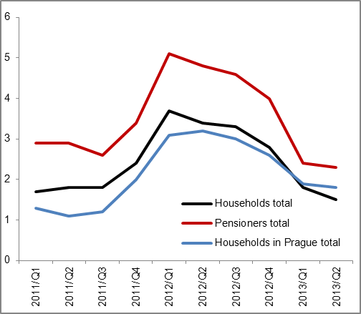 |  |  |  | 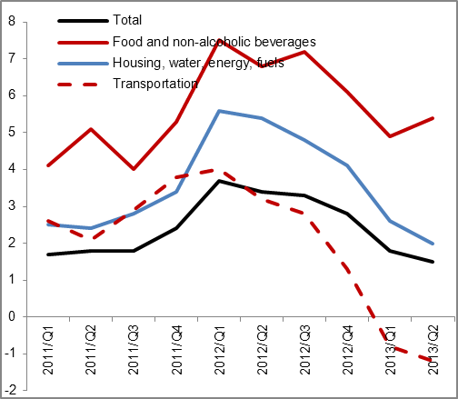
Source: CZSO

Chart 13 | Deflators (y/y in %) | Chart 14 | Producer prices (y/y in %, prices in agriculture on the right axis, others on the left axis)
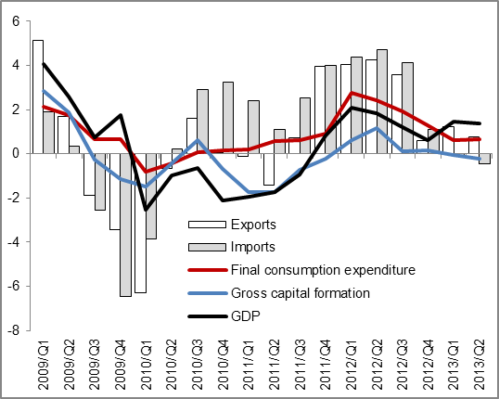 |  | 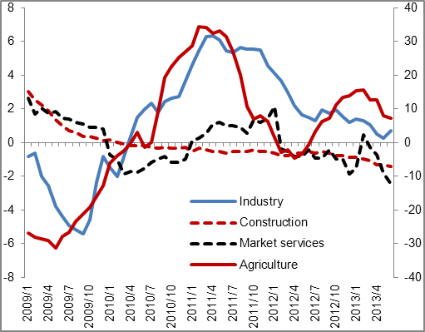
Source: CZSO

Labour Market

Again the acceleration of the growth of aggregate employment |  | In Q2 2013 the Czech economy accelerated „the absorption“ of new employees. Aggregate employment increased year-on-year by 1.3 % to 5 141.4 thousand employed persons (following +1 % in Q1 2013 and +0.8 % in Q4 2012) according to the seasonally adjusted data and in the conception of national accounts. This growth can be most likely partially assigned to the slowing down of the rate of fall of economic downturn, partially then to the growing trend of part-time jobs. It is notable, that the total numbers of employed persons year-on-year grow (+1.3 % in Q2 2013), while the numbers of hours worked fall (-0.9 %).
Decrease of productivity per one employed person and on the contrary, growth of hour productivity |  | More employed with lower hours worked led to the fact, that the labour productivity measured according to the gross value added per one employed person in the Czech economy falls, while the hourly labour productivity rises – in Q2 2013 was however its year-on-year addition (+0.9 %) lower compared to Q1 (+4.1 %). The number of hours worked fell the most in construction (-8 % year-on-year in Q2 2013 on seasonally adjusted data), which proves the slump of production occurring in this period.  On the contrary, branches with the highest year-on-year growth of number of hours worked were information and communication activities (+4.2 %), where however also arose the largest addition to employment (in total by +4.3 %, in number of employees even by +5.1 %). However, the industry still holds only a negligible share (111 thousand persons in Q2 2013) on the total number of persons with a status of employee in the economy of the CR (4 242.6 thousand persons).
Absorption capacity of the public sector |  | Given the increase of numbers of employed persons, it was the largest in the public sector (+26.2 thousand). Market services in branches involving professional, scientific, technical and administrative activities was their addition (+14.1 thousand of persons) practically eliminated by the decrease in construction (15 thousand persons). Employment in the manufacturing industry grew by 14.3 thousand persons, in the whole industry by 16.5 thousand persons. Fewer workers (by one thousand) had by the end of Q2 2013 compared to the same period of 2012 apart from construction also only agriculture incl. forestry and fishing.
Fall of the general rate of unemployment compared to Q1 2013; in year-on-year terms stagnation |  | Labour Force Sample Survey showed in Q2 lowering of the general rate of unemployment in the Czech economy to 6.7 % persons aged above 15 years, which was a lower ratio compared to Q1 (7.4 %) and similar size to the same period of year 2012. Seasonally adjusted, the status of unemployed had in the CR according to the methodology of the International Labour Organization 6.9 % persons older 15 years. Even this is a more favourable result compared to the long-term average of EU. The supply of vacancies has not yet however reflected the effect of moderation of the economic downturn.
Rate of economic activity significantly grows |  | With expansion and usage of part-time employment is also related the fact, that there were 59.4 % of economically active persons in the population above 15 years in Q2 (based on seasonally adjusted data), which was the highest rate of economic activity since Q1 2006. Its growth is noticeable especially since the beginning of 2012. It increased since then by 1.1 p. p.
Real wage in the economy in Q2 decreased year-on-year by 0.3 %, in the non-business sector it started growing after eleven quarters |  | The growth of average gross monthly nominal wage in H1 2013 for the economy as a whole by 0.4 % compared to the same period of the preceding year was impacted by its year-on-year decline in the first three months – in Q2 2013 the year-on-year addition arrived at 1.2 %. The wages grew faster in this quarter in the non-business sector (1.9 %) in comparison to the income of persons the business sector (+1.1 %). Still the wage increased in industry (+1.6 %) by more than the average for the business sector, which was pushed down year-on-year by the lower wages in branches of market services (e.g. professional, scientific and technical activities -2.7 %, activities in the area of real estate -2.6 %). Development of consumer prices in Q2 2013 – despite lowering of their dynamics – led to the fall of purchasing power of the CR population by a drop of real wage by 0.3 %, mainly for persons employed in companies (-0.4 %). On the contrary the real wage of employees in the non-business sector grew for the first time in eleven quarters (+0.4 %).

Chart 15 | Total employment and numbers of employees (y/y in %, seasonally adjusted) | Chart 16 | Nominal and real wage (y/y in %, recalculated numbers, monthly values)
Source: ČZSO

Chart 17 | Labour productivity/1 employed person and hour productivity  (y/y in %, seasonally adjusted data) | Chart 18 | Comparison of gross value added and number of employed persons in branches (y/y in %, seasonally adjusted data)
Source: CZSO, own calculations

Monetary Conditions

Monetary conditions worked towards the growth of the Czech economy |  | Money stock in the economy rose by the balances as of the end of June 2013 year-on-year by 4.3 % given the stagnation of nominal GDP, resulting in the monetary conditions in the Czech economy confirming their expansiveness. The growth of M2 aggregate was affected mostly by the increase of non-term (one day) deposits, on the contrary so called quasi money (other deposits apart from non-term deposits) fell year-on-year (-4.6 %) already for a third quarter in a row. Addition to loans to firms and households (+2.3 %) was year-on-year the second lowest since September 2010 and proves for one thing the lower need for operational financing of companies, for another their prudence regarding investment and also the prudence of households (as well as banks) regarding new indebtedness.
The rate of growth of domestic loans again slowed down |  | The growth of domestic loans (i.e. loans to government and private sectors) decreased its pace to +1.8 % year-on-year in their balances as of the end of June 2013. During the same period of 2012 the domestic loans grew year-on-year by 6.1 % (in Q1 2013 also faster, by 2.7 %). This loss of pace resulted from the lowering of indebtedness of the government sector (-1.1 % compared to the same period of 2012), repeated marked decrease of the rate of loans provided to firms, which grew close to year-on-year stagnation (+0.4 %). This fact proves the uncertainty and weakness of the economy regarding the upcoming recovery. Loans to households rose in H1 year-on-year by 3.9 %, in the same period of 2012 by 5 %.
Housing loans grow year-on-year, loans from banks for consumption fall already seventh quarter in a row |  | Loans to population from banks for housing were according to their balances as of the end of June 2013 year-on-year higher by 4.6 % thanks to a more notable addition to mortgages (+6.3 %) against loans provided to population by the building savings societies. Loans for consumption provided by banks on the contrary decreased by 1.2 % and their balances keep falling continuously already since September 2011. The population again probably tilts towards non-bank borrowing – balances of loans provided by leasing companies and instalment sale companies increased year-on-year for already second quarter in a row (by 3 % as of the end of June 2013). The reason lies most likely in lower requirements on clients solvency of these providers.
Preference to strengthen the balances on current and saving accounts continues, in case of households the dynamics somewhat softened |  | With respect to the deposit deals of banks, their mark-up is positively influenced by the fact, that people further increase their balances on non-term deposits (+6.8 % year-on-year as of the end of June 2013), which less burdens the volume of cost interest of banks. One-day deposits of households thus came to 1 197 bn crowns by the end of H1, current accounts of companies then summed up to 662.3 bn crowns. While additions of these funds in case of households rather fall (+6.8 % year-on-year from +7.4 % in the half of 2012), for companies there is an obvious higher growth (+14.4 %, against +12.1 %) – this phenomenon is most likely a consequence of worsened possibilities of companies to employ these funds either in an investment activity or by financing of the production activity.

Chart 19 |  | Term deposits of households and firms (y/y, in %) | Chart 20 | Loans to firms and households  (without securities, y/y, in %)
 | Source: CNB, own calculations

State Budget

In the half of the year the lowest deficit for the last five years… |  | State budget (according to cash fulfilment) finished at the end of first half of 2013 with the lowest deficit since the beginning of the deep economic recession (-31.5 bn crowns). The development of the last three years confirmed the trend towards a gradual consolidation of public finances. In the last three years (mostly due to the indirect effect of legislative amendments in the tax area) the balance of state budget was always in the second quarter worse compared to the first three months of the year (in 2013: +14 bn crowns vs. -45 bn crowns).
…mostly due to the effect off growing non-tax revenues, partially also thanks to the legislative amendments of indirect taxes |  | Better result of the deficit year-on-year given a mild growth of expenditures (year-on-year +0.9 %) was ensured by a markedly higher dynamics of state budget revenues (+9 %), both in tax, but especially in non-tax area (mainly drawing of European funds). While the drawing of total expenditures occurred (apart from investment) according to the budget anticipations, revenues exceeded in H1 the approved budget anticipations by more than 4 p.p. compared to last year. Year-on-year fall of nominal GDP in the first half of 2013 notably heighten the improvement of state finances balance to -1.7 % GDP (from -3.8 % in H1 2012).
Higher tax revenues were caused mainly by better collection of VAT as a result of January increase in both rates, however partially also by the slowdown of rate of fall of private consumption  The effect of increasing the rate for tobacco products gradually subsided during the first half of year 2013 |  | Year-on-year growth of aggregate revenues was assisted not only by higher tax revenues (+5 bn crowns), but also the non-tax and capital revenues (+40 bn crowns). In addition, state budget revenues could have been by more than 3 bn crowns higher, if there were no changes in the budget determination of taxes, which from the beginning of this year strengthened the preference of regional and municipal budgets. More favourable balance in the tax area was positively impacted by the recovery of collection of taxes significant by volume across the state – mostly VAT (+18 bn crowns) and partially also by the income taxes of physical persons from employment (+3 bn crowns). In both cases, the effect of administrative measures had a large impact – for VAT (January increase of both rates by one p.p.), for physical persons (increase of tax by roughly 2 % for highest income group, but also the mild growth of employment). On the contrary, the effect of increasing the rate for tobacco products, which similarly to last year created their pre-stocking, from the point of view of state budget subsided during the first half of year 2013 (in Q1 year-on-year +5.5 bn crowns, for the whole half year +1.5 bn crowns), its role probably also plays the lowering of tobacco product consumption in the long-term. Collection of consumption tax most significant by weight (on mineral oils) year-on-year weakened by 7 %, due to the effect of weaker retail sales of fuels at the beginning of the year. Collection of this tax should support the lowering of tax returns for so called green diesel. Influence of in the past dynamically growing collections from photovoltaic power plants during 2013 markedly weakened (the state gained below 2 bn crowns for the whole half year).
The decrease of dynamics of physical person income tax collection halted in H1, adverse situation on the contrary lasts for corporate taxes  Compared to planned budget year-on-year better fulfilment only for VAT, consumer tax on tobacco products and property taxes |  | Weakening of dynamics of the physical person income tax collection, typical for the whole year 2012, halted in year 2013, with the statewide collection strengthening year-on-year by 3.0 % and 3.8 % resp. (in Q1 and Q2 resp.). The growth of collection consists of administrative influences (introduction of so called solidarity surcharge of 7 % on income exceeding the fourfold of average wage, increase of the withholding tax from 15 % to 35 % for foreign tax residents) partially also the situation on the labour market (growth of number of employees). On the contrary, the collection of corporate taxes, not influenced by major administrative impacts, in the first half year year-on-year decreased by 2.6 % (nearly 2 bn crowns). In the last two years the year-on-year dynamics of tax collection from companies was in the second half of the year always markedly better year-on-year compared to first half years. Statewide collection of corporate taxes or. physical person income taxes, ended slightly below the level of half year of 2006, compared to boom it was lower by 30 % and 5.5 % resp. In relation to the approved budget, the state finances achieved for the first half of 2013 year-on-year higher percentage fulfilment for indirect taxes significant by volume, lower fulfilment continued for taxes on legal as well as physical person income (despite higher year-on-year collection) and for majority of other more significant tax revenues (apart from property taxes). Year-on-year nearly by two thirds higher non-tax revenues were affected mostly by the revenues from the EU budget (+33 bn crowns). Payments to the EU budget (23 bn crowns) remained in H1 2013 on the contrary nearly at the level of preceding year.
Continuing of long-term fall of investment, their size in H1 at the level of expenditures on state debt |  | Mild year-on-year growth of state budget expenditures (+ 5 bn crowns) ensured in H1 2013 current expenditures (+2 %), while investment year-on-year decreased already for the third time in a row (against the level of half of year 2010 they were lower by more than one third) and shared in the total state expenditures by 6.2 %. Year-on-year lower were especially the transport buildings investments. Expenditures on pensions, most significant by volume, stopped (regardless an anticipated growth in the planned budget) after more than five years its year-on-year growth (-1.6 %), the size of all social benefits stagnated and participated on the total state expenditures by 40.9 % (one year earlier by 41.2 %).
Year-on-year stagnation of aggregate size of social benefit expenditures; opposite to the previous years the expenditures on pensions fell and on the contrary, the funds on state social support and other social benefits increased |  | The decrease of other types of social benefits, typical for previous two years, ceased at the beginning of this year. The effect of more strict requirements for allocation of these benefits became exhausted and on the contrary, the dissatisfying situation on the labour market showed more (continuing growth of unemployment, fall of real income of majority of population). State social benefits increased year-on-year by 3 %, funds on unemployment benefits were in H1 2013 higher by one tenth as were the other social benefits (including among other benefits in poverty, benefits for persons with disabilities, contribution on care and sickness benefits). Expenditures on state debt also grow in the long-term (year-on-year + 6 %), in H1 2013 their size was at the level of all capital expenditures of the state budget.
Year-on-year lower pension account deficit due to the decrease of the pensioners and mild revival of the social insurance collection in Q2 2013 |  | The pension account balance given the year-on-year comparable fall of revenues (social insurance on pensions) and expenditures (paid out pension benefits) in H1 2013 (-21 bn crowns) after more then five years did not deepen. In Q2 2013 the falling dynamics of insurance collection lasting for ten quarters in a row stopped, still these revenues were for the whole half year year-on-year weaker by 1.6 %. The size of paid out insurance affected after a long time mildly falling number of pension recipients (at the end of June 2013 year-on-year by 0.2 %), as well as long-time growing share of recipients with a permanently reduced pension.

Chart 21 | State wide collection of tax revenues and state budget balance development | Chart 22 | Pension account balance and number of pensioners development
Source: MF CR

Chart 23 | Revenues and expenditures of the CR relative to the EU | Chart 24 | Selected types of state budget expenditures in H1 of 2005-2013
 |  | *state contributions
Source: MF CR

Source of data in the whole analysis: CZSO, MF CR, CNB, Eurostat, CZSO calculations.
Latest information from the CZSO and CNB given in this report are dated the 6th September 2013.

Unless stated otherwise, data related to GDP and its components are considered in real terms and adjusted for seasonal and calendar effects.
In real terms, adjusted for seasonal effects and effects of variable number of working days – unless stated otherwise.
EU27
Classification of Products (CZ-CPA)
This consideration corresponds to the fact, that in Q2 the number of employees alone grew faster in comparison to the number of employed persons. This group includes apart from persons with the most common job relationship (i.e. employment contract with eight hour working time) also persons working part-time.

