1 February 2013

dependent children in aLmost one fifth of family households live with solely one parent

The number of incomplete family households with dependent children has been growing since the 1990s. In 2012, according to results of the Labour Force Sample Survey (LFSS), the number of aforementioned families increased by one half compared to their number in 1995 and their share in the total number of family households with dependent children grew by almost 7 percentage points (p.p.). The group is dominated by families in which mothers live together with their children. Mothers in incomplete families have a lower educational attainment and are more frequently unemployed compared to those living in complete families. The share of incomplete families is high namely in Northwest Bohemia and in North Moravia.

Demographic and socio-economic developments in the recent twenty years have brought an important change to the structure of family households in the Czech Republic. According to results of the Labour Force Sample Survey grossed up to the whole population, the number of family households with at least one dependent child aged up to 26 years dropped from over 1.5 million in 1995 to 1.4 million in 2012, that is by 100 000. While the share of complete family households with children decreased by almost 7 p.p.; the number of incomplete families with dependent children conversely increased by almost 7 p.p. in the period of 1995-2012. A similar development has been shown in the group of family households with children aged up to 15 years.

Development in the structure of family households with dependent children and those with children aged up to 15 years
Households | 1995 | 2000 |  | 2005 |  | 2010 |  |  | 2012
 | Households with dependent children aged up to 26 years
Total (thousand) | 1 507.1 | 1 417.7 |  | 1 402.2 |  | 1 418.3 |  |  | 1 406.7
Structure (%)
Complete households | 88.7 | 87.1 |  | 83.5 |  | 82.1 |  |  | 81.8
Incomplete households | 11.3 | 12.9 |  | 16.5 |  | 17.9 |  |  | 18.2
of which:
Female as the head of household | 9.8 | 11.4 |  | 14.9 |  | 15.9 |  |  | 16.2
 | Households with children aged up to 15 years
Total (thousand) | 1 122.3 | 1 018.9 |  | 967.9 |  | 986.1 |  |  | 1 001.3
Structure (%)
Complete households | 90.6 | 88.9 |  | 86.1 |  | 85.5 |  |  | 84.9
Incomplete households | 9.4 | 11.1 |  | 13.9 |  | 14.5 |  |  | 15.1
of which:
Female as the head of household | 8.2 | 10.1 |  | 13.1 |  | 13.5 |  |  | 14.0
Source: CZSO, Labour Force Sample Survey

Methodological Note: Private family households with dependent children shall mean any household, in which there is an economically inactive child aged up to 26 years (which does not work or is not unemployed) living with one of his/her parents, at least. Family households do not include other households, in which there is a dependent child living solely with grandparents, siblings, etc. The sample survey is based on the existence of a partnership of parents, not merely on the relation determined by marriage. This rather broader concept describes conditions in the Czech Republic households, when a significant portion of children are born outside marriage, in a better way. Households are constructed on the basis of family relations among persons who usually live in the selected dwellings.

The graph below demonstrates development in the share of incomplete families with dependent children and of which those with children aged up to 15 years in family households in the recent twelve years. It is clear that since the millennium beginning the share of incomplete families with all dependent children has been growing due to frequent split of partners. On the contrary, the share of incomplete families with children aged up to 15 years has not changed in a significant manner. The growth in the share of incomplete families is shown in the last year.

Development of the share of incomplete family households in the total number of family households with dependent children and those with children aged up to 15 years
in the period 2001 - 2012
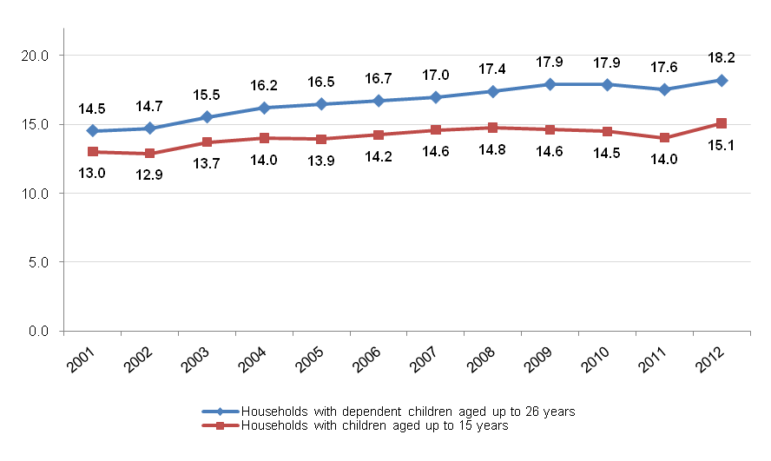


Source: CZSO, Labour Force Sample Survey

Long-term changes are noticeable not only from the point of view of the number of incomplete families yet also from the standpoint of the number of children in such families. If in 1995 ten per cent of all children lived in family households with solely one parent, according to the LFSS results, in 2012 it was already 16.3%. Similarly, the share of children aged up to 15 years living in incomplete families increased from 8.3% to 13.4% in all children living in family households.

The same way as in the case of the number of incomplete family households the share of children in incomplete families in the total number of dependent children has been growing since 2001 yet the number of children aged up to 15 years in incomplete families has been changing in less pronounced manner.

Development of the share of children in incomplete families in the total number
of children in family households with dependent children and those with children
aged up to 15 years in the period 2001 - 2012
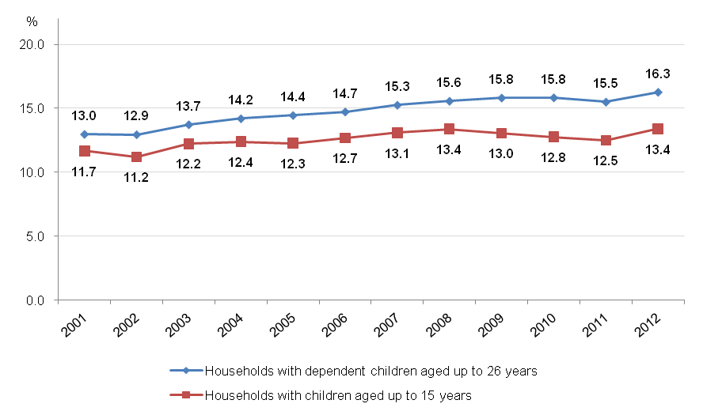

Source: CZSO, Labour Force Sample Survey

The head of household of incomplete families in the Czech Republic is usually mother. It is just mother who lives with dependent children in ninety per cent of incomplete families and this way females essentially affect family environment. Taking a closer look at economic status of mothers great differences in between the groups of complete family households and the incomplete ones are clearly visible. (The differences were assessed on the basis of the average of results of the sample survey in the last five years of 2008-2012.)

Mothers in complete families with children aged up to 15 years are more often economically inactive. This has a logic relation to a high share of females on parental leave taking care of the youngest children. Females in complete family households also more frequently opt for the potential of part-time job.

Conversely, mother s living with children aged up to 15 years much more frequently work full-time, because their income is the decisive revenue for the family. What is also important is the fact that mothers in incomplete families are often unemployed. The share of unemployed mothers in incomplete families is twice as high as that in complete families.

The aforementioned differences in economic status of mothers can also be seen in a wider group of mothers caring for all dependent children up to 26 years of age, i.e. including students at secondary and tertiary education.

Mothers in complete and incomplete families with dependent children by economic status (average for 2008-2012)
 |  |  |  |  |  | Percentage
Economic status of mothers | Families with dependent children aged up to 26 years |  |  | Families with children  aged up to 15 years
Economic status of mothers | Incomplete | Complete |  | Incomplete |  |  | Complete
Total | 100.0 | 100.0 |  | 100.0 |  |  | 100.0
The employed | 73.6 | 67.0 |  | 64.7 |  |  | 58.4
full-time | 68.1 | 60.4 |  | 58.1 |  |  | 50.9
part-time | 5.6 | 6.6 |  | 6.6 |  |  | 7.5
The unemployed | 9.5 | 4.9 |  | 11.7 |  |  | 5.4
Inactive | 16.9 | 28.1 |  | 23.6 |  |  | 36.2
Source: CZSO, Labour Force Sample Survey

Besides the differences in the structure of economic status, there are great differences also in educational attainment of mothers according to the LFSS. The differences can be demonstrated in the group of mothers living with children aged up to 15 years. Almost two thirds of mothers in complete families have secondary education with A-level examination, at least, while in incomplete families they accounted for one half. This, inter alia, reflects that the number of mothers having A-level examination, at least, and especially those having higher educational attainment, has been growing fast. Educational attainment of a higher level is characteristic especially for the group of mothers caring for the youngest children of preschool age.

A level of educational attainment of mothers in complete families higher than that of mothers in incomplete families is also obvious in households with elder dependent children, prevailing portion of which studies at secondary schools and universities.

Educational attainment of mothers with children aged up to 15 years
in family households (average for 2008-2012)
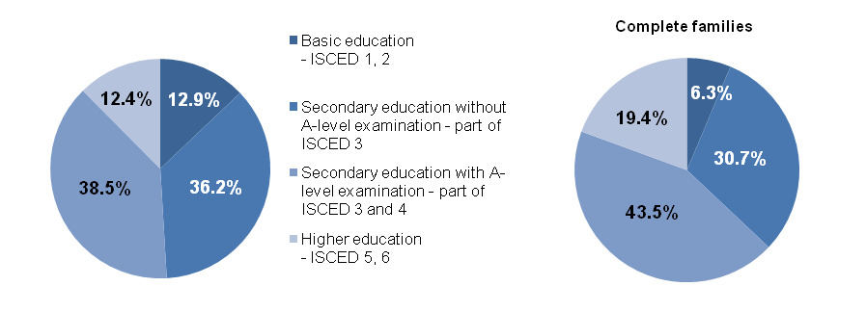


Source: CZSO, Labour Force Sample Survey

Economic conditions of development differ in respective regions of the Czech Republic in very significant manner. This is also reflected in conditions in which there are households in respective regions. The share of incomplete families in the total number of family households with dependent children has fallen within the range from 14.2% in the Vysočina Region to 23.0% in the Ústecký Region in the five latest years. Similarly, the span of the share of incomplete family households with children aged up to 15 let years has been from 12.5% in the Vysočina Region to 21.4% in the Ústecký Region.

The level of the share of incomplete families does not differ much in majority of regions. There is, however, a high share of incomplete family households in three regions - Karlovarský Region, Ústecký Region, and Moravskoslezský Region. Every fourth family household with dependent children in the Karlovarský Region and Ústecký Region is an incomplete one, in which mostly mother lives with her children or child without their father. Both the regions form a part of the Northwest Cohesion Region where socio-economic conditions are more troublesome compared to other regions. It is characteristic this is a region with a high unemployment rate and with under average income of the employees.

Share of incomplete family households with dependent children in the share of the total number of children in these households in respective regions (average for 2008-2012)
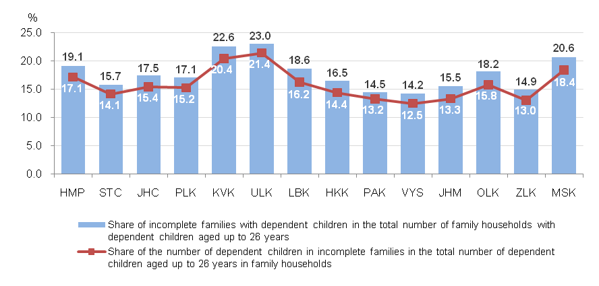

Source: CZSO, Labour Force Sample Survey

It is surprising to a certain extent that an above average share of incomplete households can be found in Prague as well. This is, however, influenced by the fact in the capital city there is, in general, a lower share of family households in the total number of households (including households of individuals and multi-member non-family households). An important portion of young families, usually those which are financially secured, has been moving from the capital city to the surrounding districts, which, on one side, influence in positive manner the demographic composition in parts of the Středočeský Region yet at the same time decreases the number of complete families with dependent children in Prague.

It may be assumed that economic conditions of incomplete households in Prague are not identical with those in the Northern regions of the country. In the capital city, unemployment is very low, there is enough job offers and a higher level of education, which all, with no doubt, essentially affects social conditions of respective families.

