The Czech Economy Development in 2012 March 2013

Monetary Conditions
- High range of depreciation of household and businesses deposits |  | Monetary conditions were characterised by practically zero prices of money, which however did not enhance higher loans given the uncertainties for the business sector in anxiety over weak demand, for consumers then the distrust flowing from the worries related to the possible job losses and an adverse development of wages. Due to the development of the inflation rate and low nominal interest rates, the bank deposits of households and businesses were in 2012 depreciated in the amount of 54.3 bn crowns. The central bank tries to support the growth of not only “money for free”, but also the faster growth of money stock (M2 year-on-year +4.5 %) in comparison to the real stagnation of the growth of nominal GDP (+0.1 %). Expansive monetary conditions thus continued.
- Loans grew the slowest for the past ten years |  | Shrinking of the loan activity on the side of the business sector and further significant limiting of its dynamics of loans to households lead together with the lowering of net credit of the government sector to the result, that the domestic credit grew in 2012 compared to 2011 only by 1.4 %, i.e. by 34 bn crowns. In the preceding two years their additions amounted to 218 and 116 bn crowns. “Freezing” of credit depicts the uncertain situation in the economy and little optimism especially regarding the investment.  Credit to businesses grew year-on-year only by 0.9 % after +5.1 % in 2011, loans to households by 4 % (the least since year 1998). Together the credit to businesses and households increased year-on-year by 2.6 %, which was the lowest increase since year 2003.
- Decline of the balance of consumer credit |  | The balances of consumer credit provided to households have already decreased for the second year (-0.7 %), even though the fall was not that deep as in 2011 (-1.9 %). It is most likely not only the effect of rational behaviour of households with a will not to indebt themselves further this way, but also the stricter assessment of the solvency of clients on the side of banks. Lower indebtedness of households for consumption caused the fall mainly of the consumer nonpursposed-credit (-1.2 %), which form more than three quarters of household consumption debt. On the contrary, the liabilities on credit cards grow (+2.1 %) and somewhat also the debit balances on overdraft accounts, by 0.1 %. The transfer of indebtedness to the sphere outside the official statistics cannot be yet reliably confirmed, however it can be observed from the growth of these most expensive debts.
- Growth of credit for housing only thanks to mortgages, balances on building savings accounts fell again |  | Credit for housing in 2012 further increased (+4.8 %) after 6.1 % in 2011 following the favourable development of prices on the real estate market. It can be presumed, that these loans were applied for mostly highly solvent clients – many of whom were acquiring the real estate for investment purposes - , since the total increase in credit for housing was affected only by mortgages provided (+6.3 %). Balances of loans from building savings societies were year-on-year lower (bridging by 6.8 %, standard credit from building savings by 4.3 %), while these are decreases second year in a row (-17.3 %, resp. -4.3 % in 2011).
- Growing balances on non-term deposits markedly enhance the size of depreciation of overall client deposits |  | In 2012, the aiming of money to nonterm deposits with higher liquidity continued – for households (+8 %) as well as businesses (+12.4 %), with a higher rate of growth compared to 2011 (+7.4 %, resp. +6.5 %). Together the demand deposits grew year-on-year by nearly one tenth (+9.6 %).  It is the concentration of money on the demand deposits that causes, due to the effect of negative real interest rates, its depreciation on a massive scale. In 2012 it took away from households, as a result of higher inflation rate in comparison to the level of nominal interest rates from the size of their non-term deposits – whose balances reached by the end of 2012 1.102 bn crowns – over 26.8 bn crowns. It was more than the sum of depreciation of these deposits for the previous three years together. Further 11.3 bn crowns households lost this way on the term deposits (deposits on maturity and notice period).  Depreciation of deposits of businesses amounted in 2012 a total of 16.2 bn crowns, while the largest share had the depreciation of balances on their current accounts (by 13.6 bn crowns).
- Crown depreciated |  | Crown in 2012 weakened against the main currencies roughly to the level of 2010. The exchange rate against euro was on the yearly average 25.143 CZK/EUR, towards dollar 19.583 CZK/USD. Strong depreciation was obvious especially against dollar (-10.7 %), milder against euro (-2.3 %). The development of the crown exchange rate was probably connected with the worsening of fundamentals of the Czech economy in 2012.
Chart 19 | Deposits of businesses and households (y/y in %) |  | Chart 20 | Czech crown exchange rate (CZK/EUR and CZK/USD)
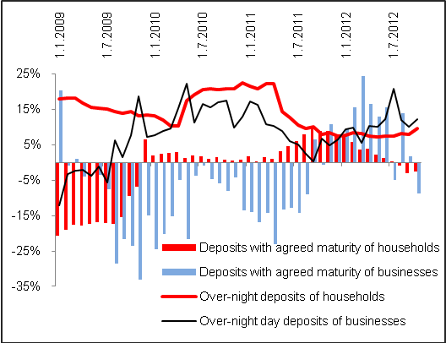 |  |  | 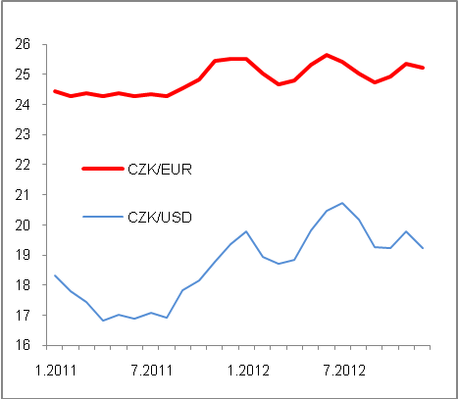

Sourc: CNB

Incl. non-profit institutions serving households

