14 February 2022

International trade price indices development in the Q4 2021 and in the year 2021

In the Q4 2021, compared to the Q3 2021, export prices increased by 2.9%, import prices by 4.5%. The terms of trade reached the value of 98.5%. In the year-on-year (y-o-y) comparison, export prices increased by 9.8%, import prices by 12.2% in the Q4 2021. The terms of trade reached the value of 97.9%.

**In the average for the whole year 2021, compared to the year 2020, export prices increased by 5.8%, import prices by 6.1%, and the terms of trade amounted to 99.7%.**

# Quarter-on-quarter comparison

Export prices increased by 2.9%, quarter-on-quarter (q-o-q), in the Q4 2021 compared to the Q3 2021. The following prices increased the most: prices of ‘mineral fuels, lubricants and related materials’ by 48.5% (especially prices of electric current, coal, and gas), ‘food and live animals’ by 5.3%, and ‘manufactured goods classified chiefly by material’ by 2.6% (mainly prices of manufactures of metals, iron and steel). Only prices of ‘crude materials, inedible, except fuels’ decreased by 1.6% (mainly prices of wood).

Import prices in the Q4 2021, compared to the Q3 2021, increased by 4.5%, q-o-q. The highest increase of prices was in ‘mineral fuels, lubricants and related materials’ by 34.8% (primarily prices of gas, petroleum and petroleum products, and electric current), ‘chemicals and related products’ by 4.1%, and in ‘manufactured goods classified chiefly by material’ by 3.1% (mainly non-ferrous metals and paper). Prices of ‘crude materials, inedible, except fuels’ decreased by 9.5% (mainly metalliferous ores).

The terms of trade in the Q4 2021, compared to the Q3 2021, decreased to the value of 98.5%. The lowest negative value of the terms of trade was recorded by ‘chemicals and related products’ (98.2%) and the highest positive value was reached by ‘mineral fuels, lubricants and related materials’ (110.2%).

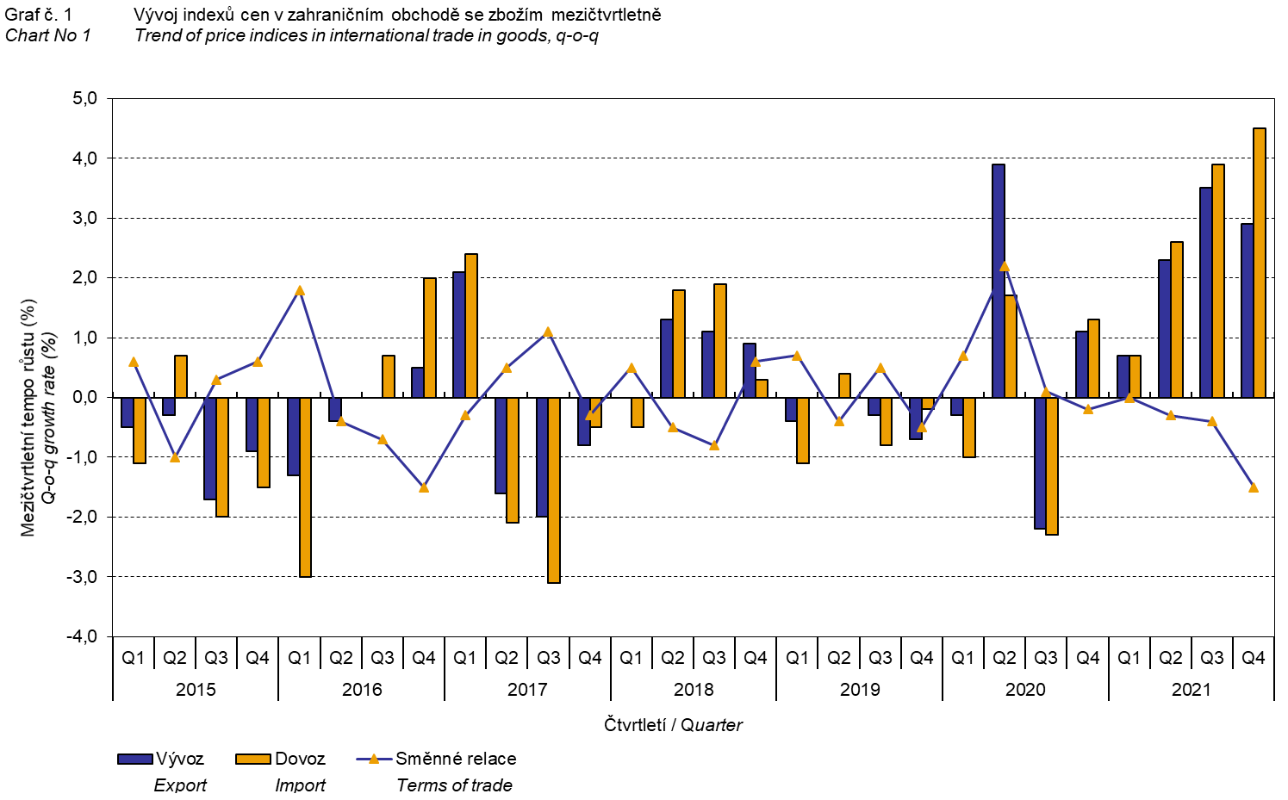

The international trade in goods (change of ownership) price development was also significantly influenced by the CZK exchange rate to the major foreign currencies. The q-o-q exchange rate index includes two most important currencies in terms of the Czech Republic's international trade, i.e. EUR and USD. Q-o-q indices of the CZK exchange rate to these currencies were weighted by the respective weight, which pertains to those foreign currencies in the export price index and in the import price index.

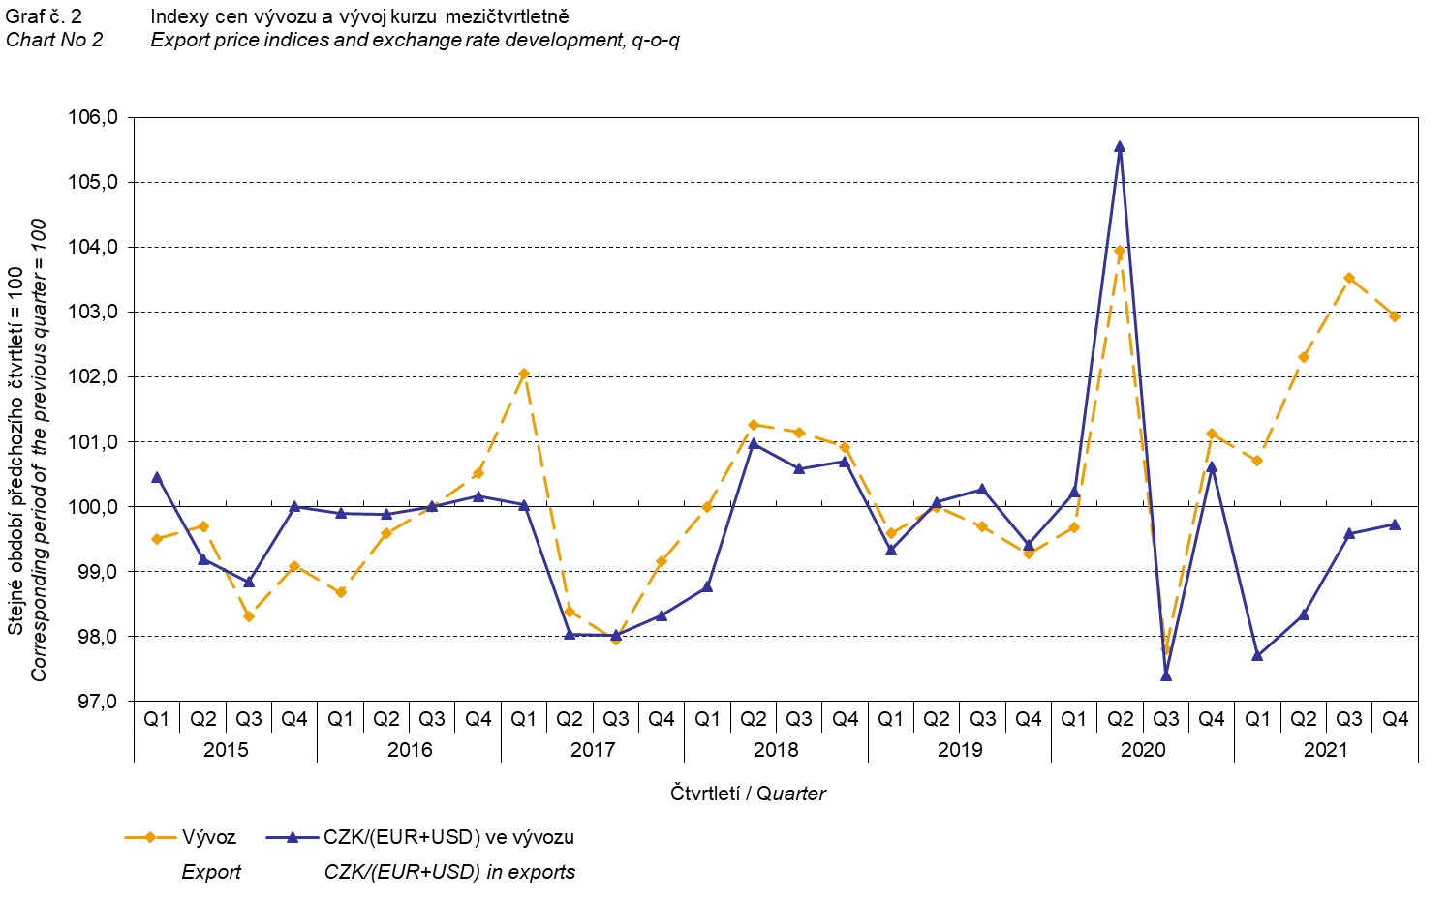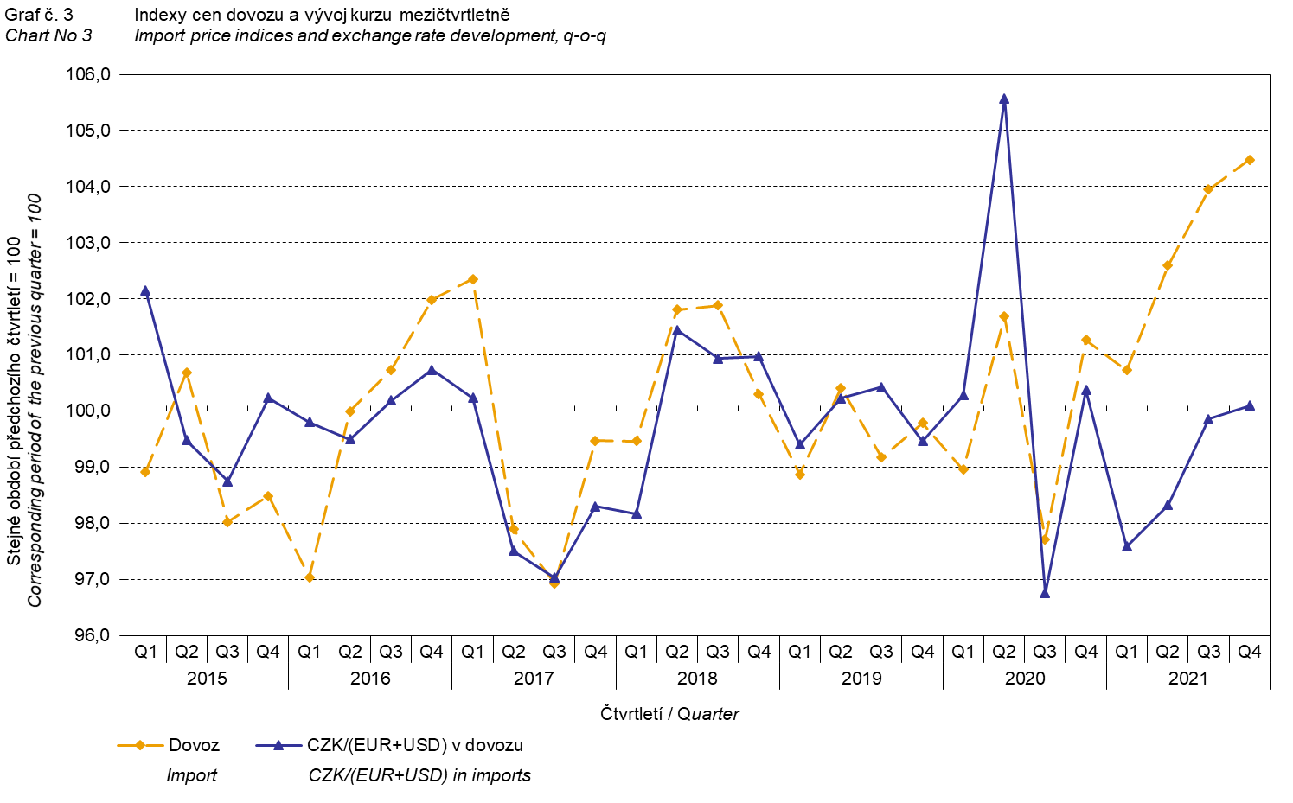

It is apparent from the Chart No 2 and the Chart No 3 above that in both exports and imports, international trade in goods prices have a relation to exchange rate impacts. Contracts with foreign entities are usually concluded for a longer period of time and the longer the contract period is, the stronger the relation to exchange rates is.

# Year-on-year comparison

In the Q4 2021, export prices increased by 9.8%, y-o-y (in the Q3 2021 by 7.9%, y-o-y). Prices of the following were increasing the most: prices of ‘mineral fuels, lubricants and related materials’ by 119.2% (mainly of electric current and petroleum products), ‘crude materials, inedible, except fuels’ by 55.6% (primarily prices of wood and of metal scrap), prices of ‘manufactured goods classified chiefly by material’ by 16.2% (mainly prices of iron and steel and prices of manufactures of metals), and prices of ‘chemicals and related products’ by 15.7%. Only prices of ‘beverages and tobacco’ decreased by 3.6%.

Import prices in the Q4 2021 increased by 12.2%, y-o-y (in the Q3 2021 by 8.7%, y-o-y). Prices of the following increased the most: prices of ‘mineral fuels, lubricants and related materials’ by 123.1% (primarily prices of gas, petroleum and petroleum products, and electric current), ‘crude materials, inedible, except fuels’ by 23.1% (mainly prices of metalliferous ores, metal scrap, and wood), prices of ‘manufactured goods classified chiefly by material’ by 14.6% (mainly prices of iron and steel and prices of non-ferrous metals), and prices of ‘chemicals and related products’ by 14.3%. Prices of ‘miscellaneous manufactured articles’ decreased by 1.4% and prices of ‘machinery and transport equipment’ decreased by 0.1%.

The terms of trade decreased to the value of 97.9%, year-on-year, in the Q4 2021 (in the Q3 2021 they were at the value of 99.3%, y-o-y) and remained in negative values for the third successive quarter – see the Chart No 4 below. The lowest negative value of the terms of trade was reached by ‘beverages and tobacco’ (95.9%) and the highest positive value of the terms of trade was recorded by ‘crude materials, inedible, except fuels’ (126.4%).

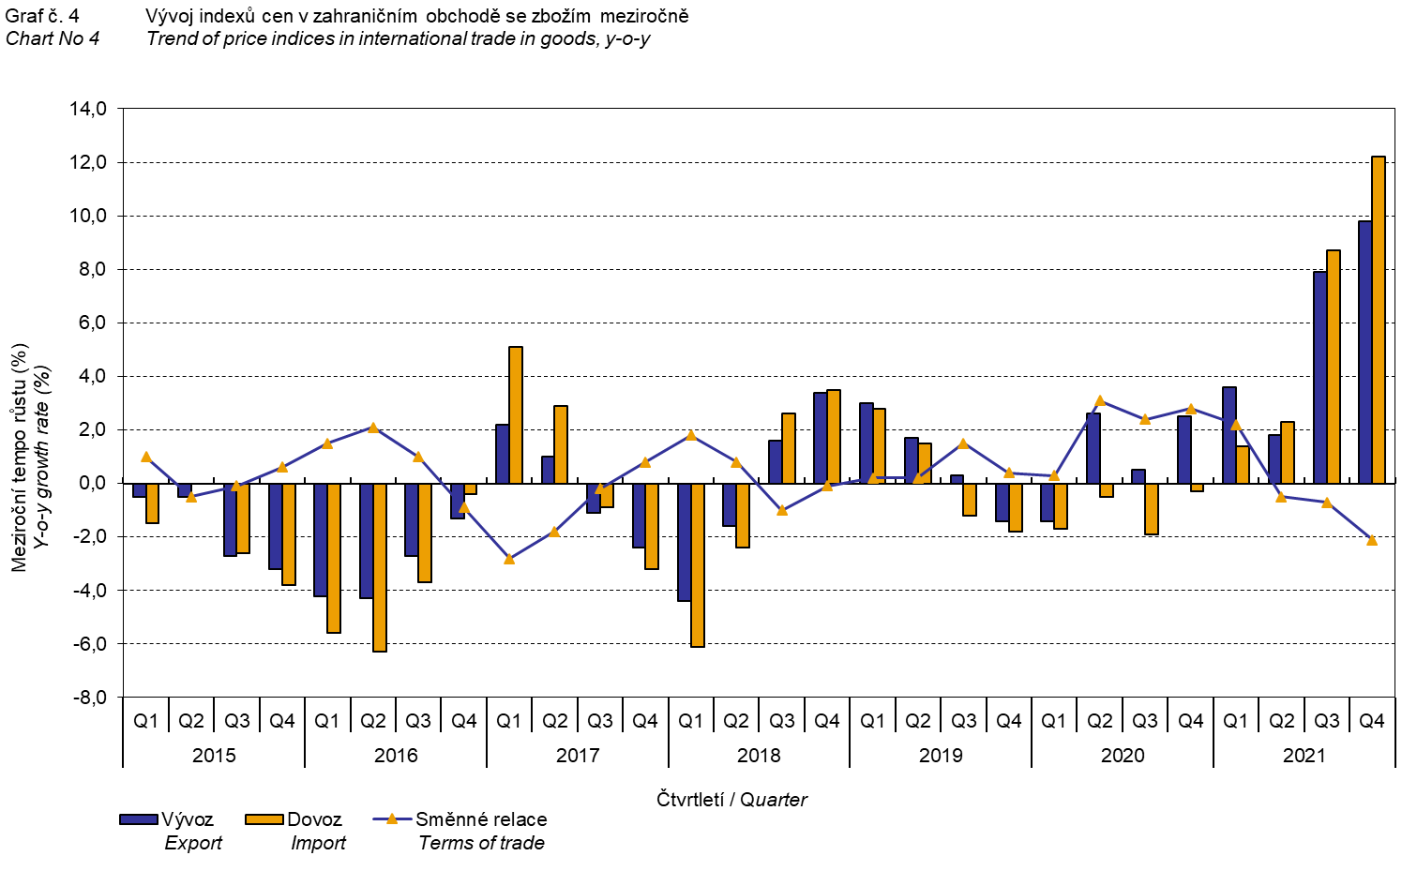

# Development in the year 2021

**In the average for the whole year 2021**, compared to the year 2020, **export prices** increased by 5.8%, y-o-y (in 2020 they increased by 1.1%, y-o-y). **Import prices** increased by 6.1%, y-o-y (in 2020 they decreased by 1.1%, y-o-y).

In**export prices**, prices increased for ‘mineral fuels, lubricants and related materials' by 57.9% (primarily prices of electric current and petroleum products), ‘crude materials, inedible, except fuels’ by 45.2% (mainly prices of wood and metal scrap), and ‘chemicals and related products’ by 10.4%. Only prices of the following decreased: ‘beverages and tobacco’ by 3.2% and ‘miscellaneous manufactured articles’ by 0.5%.

In **import prices**, highest price increases occurred in ‘mineral fuels, lubricants and related materials’ by 68.8% (primarily prices of petroleum and petroleum products, gas, and electric current), in ‘crude materials, inedible, except fuels’ by 24.5% (mainly metalliferous ores and wood), and in ‘manufactured goods classified chiefly by material’ by 9.0% (mainly iron and steel). Prices of ‘machinery and transport equipment’ decreased by 1.6%.

The **terms of trade** reached in total the value of 99.7% in 2021 (in 2020, they amounted to 102.2%).

# International trade in goods price indices, year-on-year, adjusted for exchange rate influence

The Czech Statistical Office also calculates year-on-year international trade in goods price indices adjusted for effects of exchange rate. It is carried out as follows: prices in foreign currencies reported in the current month are **converted** to Czech crowns by the **exchange rate** of the same month **of the previous year**. Then they are used for the weighted mean calculation together with prices reported in CZK. This exchange rate adjusted base price index of a month is related to the non-adjusted base price index of the corresponding month of the previous year and thus the year-on-year adjusted price index for a month is calculated. Adjusted quarter-on-quarter price indices have been calculated similarly since 2017. **Differences between adjusted and non-adjusted price indices may be considerable**; they are obvious in the Chart No 6 and the Chart No 7, for example, in the Q2 2020.

The method employed does not enable to make a 100% exchange rate adjustment because not all trade transactions made in foreign currencies are also reported in foreign currencies; the proportion does not exceed 30%. From the aforementioned it follows that **at the full exchange rate adjustment, differences** between the price indices published and the exchange rate adjusted price indices **would** probably further **increase**.

The exchange rate adjusted indices described above can also be used to make the exchange rate adjusted breakdown of increments of price indices. The Table 1 gives the **published and exchange rate adjusted breakdown of increments** of export and import price indices, supplemented by the most important two-digit code groups of the SITC 7. The breakdown illustrates well how many percentage points each of the groups “exchange rate contributed” to the index.

# In general it is true that the exchange rate effect decreases the value of price indices in international trade in goods if CZK is strengthening to foreign currencies in total. Conversely, the exchange rate effect pushes the price indices up if CZK is weakening to foreign currencies in total.

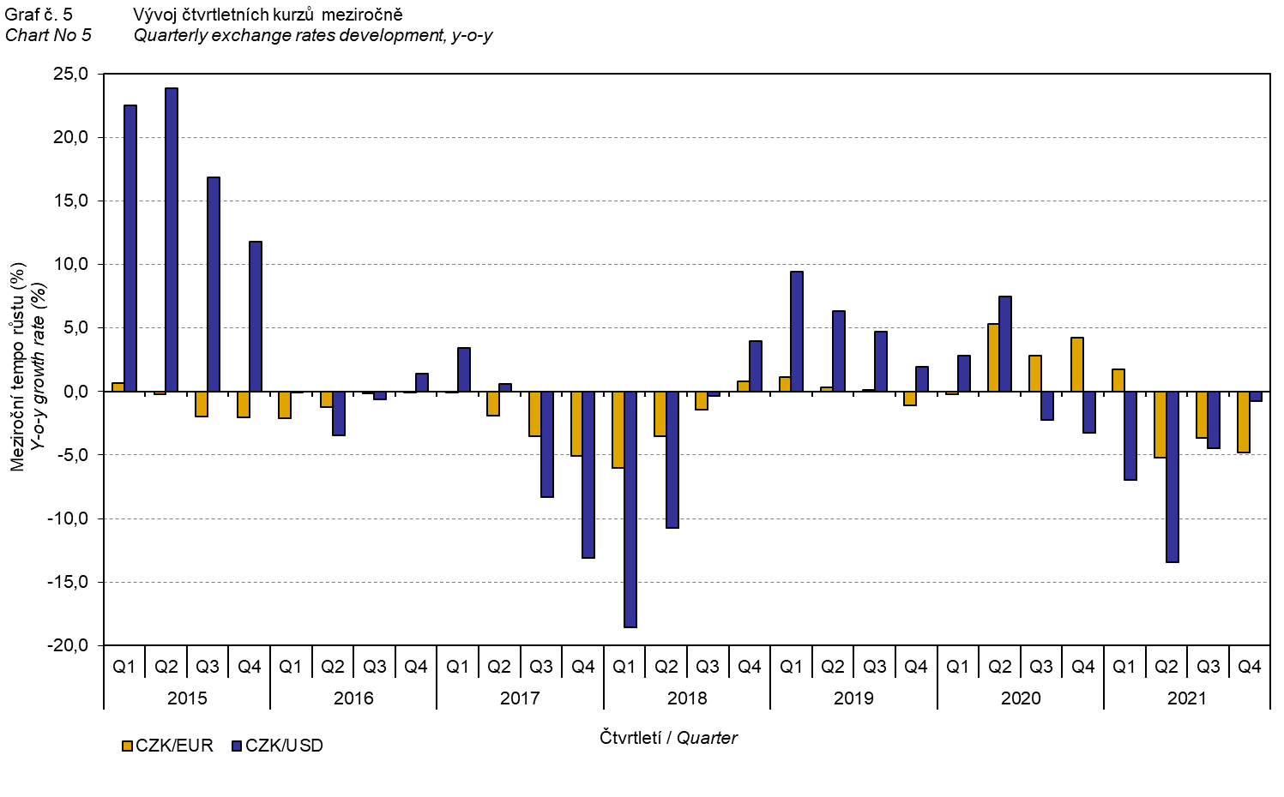

It is apparent from the Chart No 6 and the Chart No 7 below how significant the exchange rate influence on the value of the export and import price indices was.

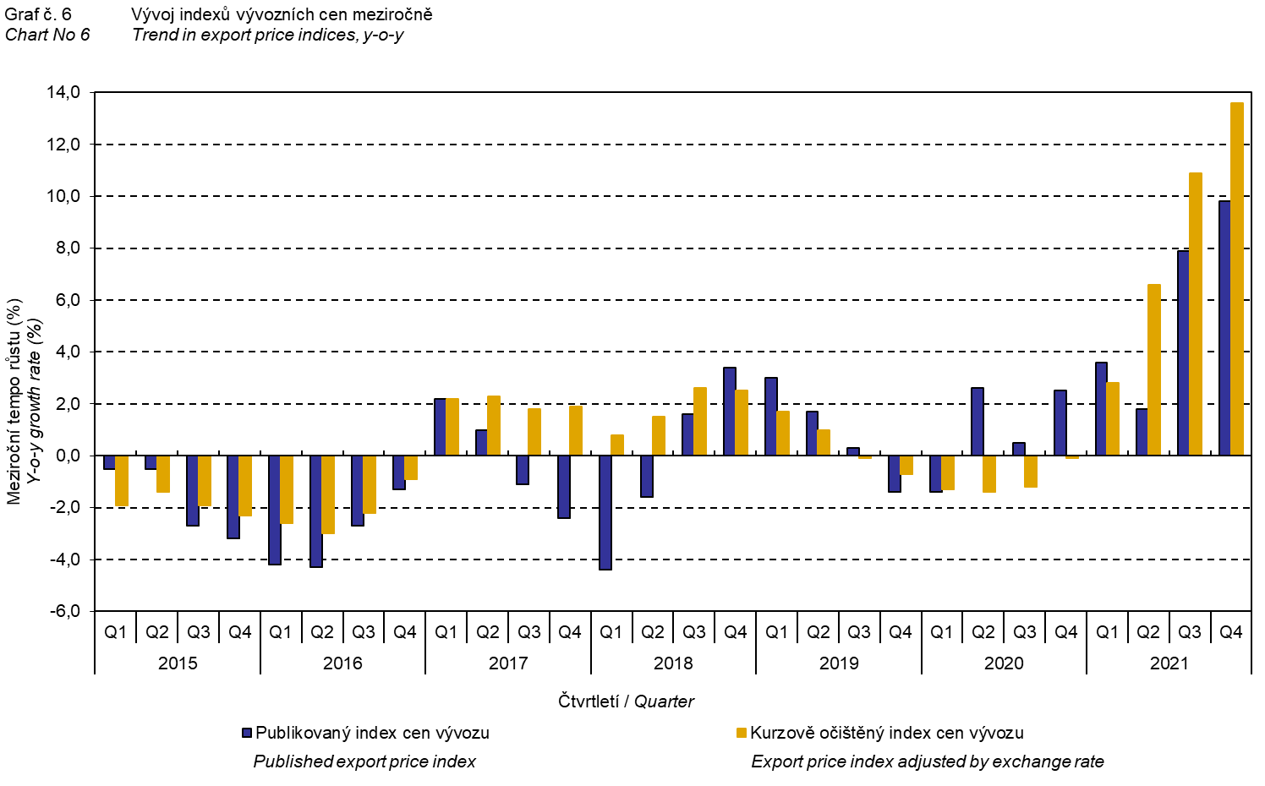

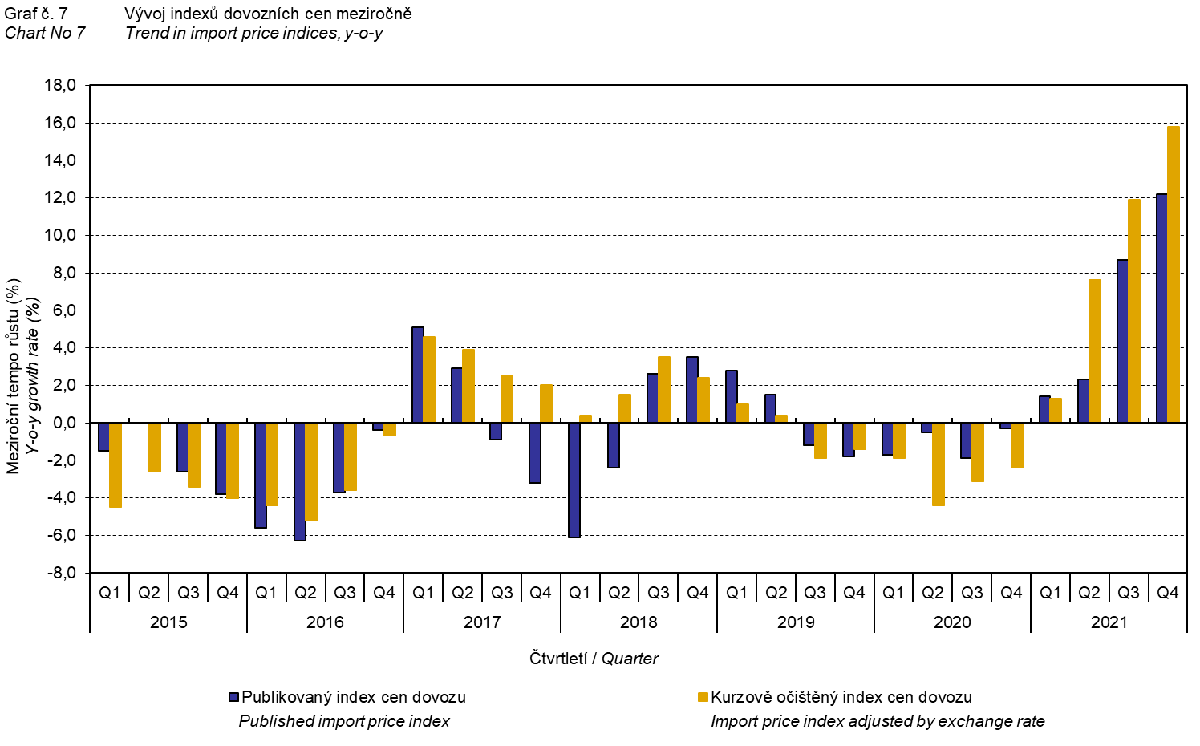

The Chart No 8 shows the exchange rate influence on the value of the year-on-year terms of trade.

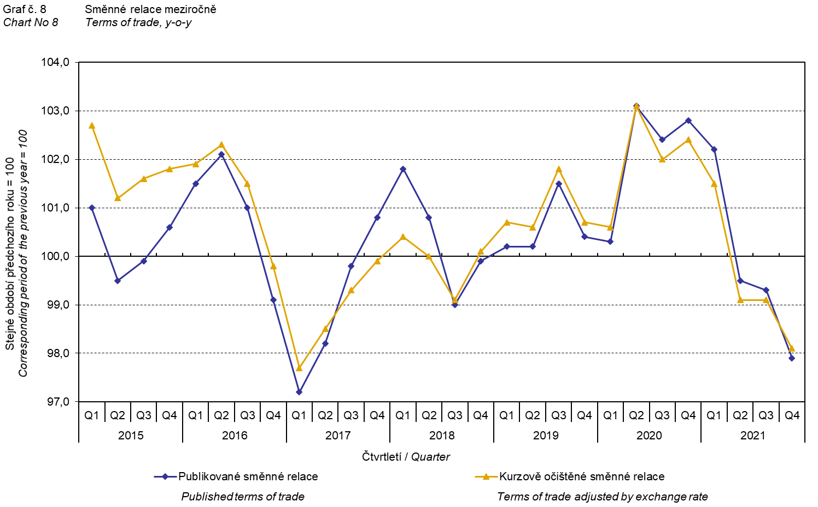

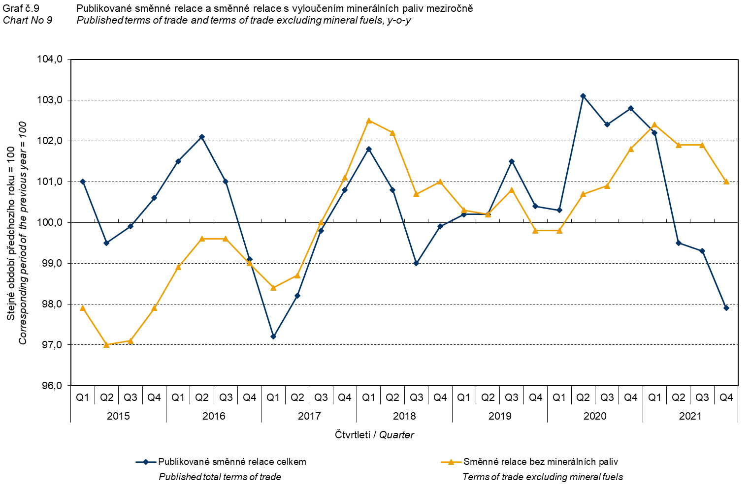

The Chart No 9 shows the development of the value of the terms of trade when the group of ‘mineral fuels, lubricants and related materials’ is excluded. In this chart, the effect of ‘mineral fuels, lubricants and related materials’ can be observed; it has an influence on the total value of the y-o-y terms of trade. Since the Q3 2019, ‘mineral fuels, lubricants and related materials’ were increasing the value of the terms of trade; however, in the Q1 2021 there was a turnabout and ‘mineral fuels, lubricants and related materials’ started to decrease the value of the terms of trade. Naturally, it is related to the world market price development, especially as for petroleum prices. Import prices, which, compared to export prices, have a higher proportion of crude materials, respond in a more sensitive way to price turbulences. Therefore, the terms of trade are usually increasing when prices of crude materials are decreasing, and, vice versa, when prices of crude materials are increasing, the terms of trade are decreasing.

# Final summary

In the Q4 2021, the exchange rate effect considerably decreased both the export price index and the import prices index, year-on-year. Import prices were increasing faster than export prices and therefore the terms of trade reached negative values. After elimination of the exchange rate effect, the terms of trade were higher than the published terms of trade; despite that they remained in negative values. Values free of the exchange rate effect correspond to the exchange rate adjusted indices – see the Charts Nos. 6, 7, and 8.



The closing table gives published **non-adjusted** international trade in goods price indices. 

*Note: For internal reasons, the Czech decimal comma is used instead of the English decimal point as a decimal separator in tables and charts of this analysis.*

**Elaborated by:** Hana Lapáčková, Prices Statistics Department

phone number: (+420) 274 052 709, e-mail: hana.lapackova@czso.cz