Development of consumer price indices in Q3 2026
13. 10. 2026
In Q3 2026, consumer prices rose by 0.6% compared to the Q2 2026. In a year-on-year comparison, consumer prices rose by 2.0% in Q3 2026, which is the same as in Q2 2026.
The quarter-on-quarter development of consumer prices in Q3 2026 was mainly influenced by price increases in ‘recreation, sport and culture‘ and to a lesser extent in 'housing, water, electricity, gas and other fuels', in ‘transport’ and in the most other divisions. The opposite effect was exerted by the decline in prices in ‘food and non-alcoholic beverages’. In ‘recreation, sport and culture’ prices of package holidays rose by 18.6%. In 'housing, water, electricity, gas and other fuels', prices of actual rentals for housing were higher by 1.4%. Prices of solid fuels increased by 1.0% and heat and hot water by 0.4%. Owner occupied housing costs (imputed rentals) increased by 1.6%. On the contrary, there was a decrease in prices of electricity by 0.2% and natural gas by 1.1%. In ‘transport’, prices of fuels and lubricants for personal transport equipment increased by 5.0%, prices of passenger transport services by 2.0% and prices of postal services and other transport services by 2.1%. In ‘food and non-alcoholic beverages’, prices of oils and fats decreased by 6.6%, meat by 0.4%, cereals and cereal products by 0.5%, fruits by 7.1%, coffee by 2.5%. Prices in group ‘milk, dairy products and eggs’ fell by 3.6%. Prices of vegetables were lower by 2.6%, of which prices of potatoes fell by 7.1%. The average month-on-month change in the overall consumer price index in Q3 2026 was 0.3%, in Q2 2026 it was 0.1%.

Consumer price indices (previous quarter = 100)
 | 2025 |  | 2026
DIVISION | Q3 | Q4 | Q1 | Q2 | Q.3
TOTAL | 100.7 | 99.8 | 100.7 | 100.9 | 100.6
Food and non-alcoholic beverages | 99.5 | 99.3 | 100.4 | 98.6 | 98.0
Alcoholic beverages, tobacco | 100.5 | 100.6 | 102.8 | 100.5 | 100.5
Clothing and footwear | 98.8 | 101.3 | 97.3 | 100.1 | 98.5
Housing, water, electricity, gas and other fuels | 100.6 | 100.4 | 99.5 | 100.7 | 101.0
Furnishings. household equipment and routine household maintenance | 100.0 | 100.0 | 100.6 | 100.6 | 100.4
Health | 100.5 | 99.4 | 102.5 | 101.0 | 101.0
Transport | 100.2 | 99.9 | 101.7 | 106.0 | 101.9
Information and communication | 100.8 | 100.2 | 100.6 | 101.0 | 100.5
Recreation, sport and culture | 106.2 | 94.9 | 102.1 | 100.1 | 104.4
Education services | 101.2 | 102.4 | 100.2 | 100.2 | 101.5
Restaurants and accommodation services | 101.1 | 100.8 | 101.1 | 101.4 | 101.0
Insurance and financial services | 100.5 | 101.0 | 102.0 | 100.5 | 100.6
Personal care. social protection and miscellaneous goods and services | 100.1 | 100.3 | 102.4 | 100.6 | 100.5
Consumer prices rose by 2.0%, year-on-year (y-o-y), in the Q3 2026 compared to the Q3 2025, that is, the same as in Q2 2026. The acceleration of price growth in ‘transport’ was offset by a deepening of price decline in ‘food and non-alcoholic‘ and a slowdown in price growth in ‘recreation, sport, and culture‘.
Changes in the development of prices in Q3 2026 were reflected in the year-on-year growth of market prices by 2.7% (also 2.7% growth in Q2 2026). Regulated prices decreased by 1.2% (1.3% drop in Q2 2026).
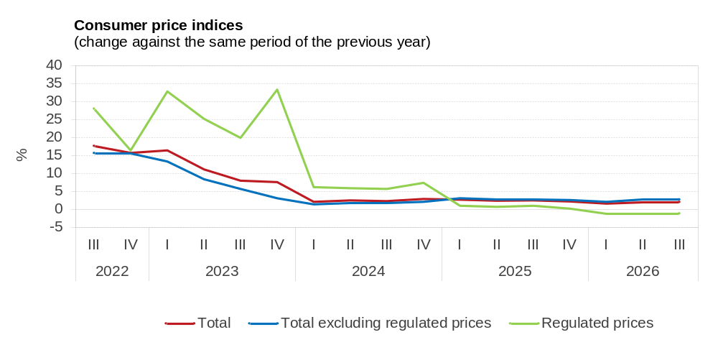

In 'transport', prices of fuels and lubricants for personal transport equipment rose by 26.8% and passenger transport services by 3.1%. Prices of motor cars decreased by 0.3%. The average price of Natural 95 petrol was CZK 44.96 per litre and the price of diesel was CZK 49.21 per litre in September.

In 'food and non-alcoholic beverages', prices of oils and fats decreased by 23.4% year-on-year in Q3 2026, fruits by 3.2%, cereals and cereal products by 1.0%, meat by 5.4%, coffee by 4.9%. Prices in group ‘milk, dairy products and eggs’ were lower by 7.6%. Prices of vegetables increased by 5.6%, of which prices of potatoes were higher by 9.5%.
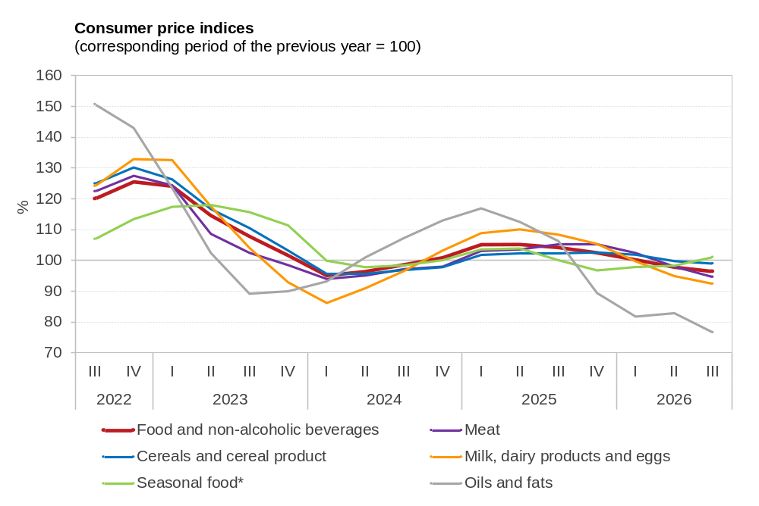
* Seasonal foods include fish and seafood, fruits and vegetables.

In 'housing, water, electricity, gas and other fuels', prices of actual rentals for housing increased by 6.1%, prices of materials and services for the maintenance and repair of the dwelling by 5.3%, water supply by 3.9%, sewage collection by 3.8%, heat and hot water 1.5%, solid fuels by 1.1%. Owner occupied housing costs (imputed rentals) were higher by 5.4%. Prices of electricity went down by 11.1%, natural gas by 4.6%.
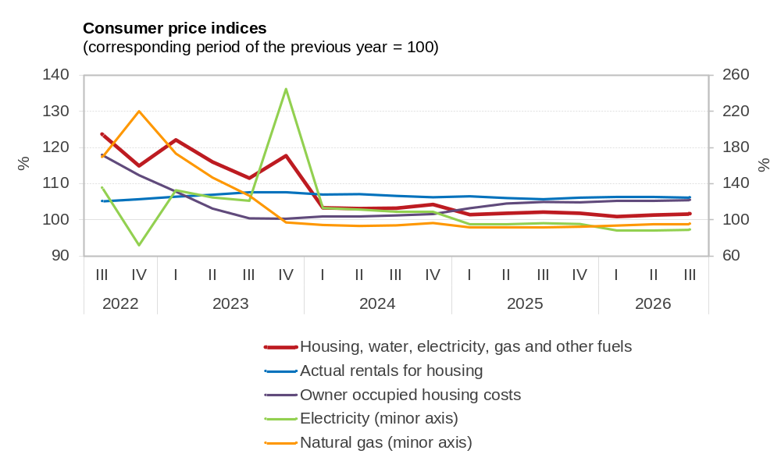

In ‘recreation, sport and culture‘, prices of package holidays increased by 3.4% and recreational services by 5.2%.
In ‘alcoholic beverages, tobacco’, prices of tobacco products increased by 6.7%, beer by 2.4% and spirits and liquors by 2.5%. Prices of wine fell by 1.6%.
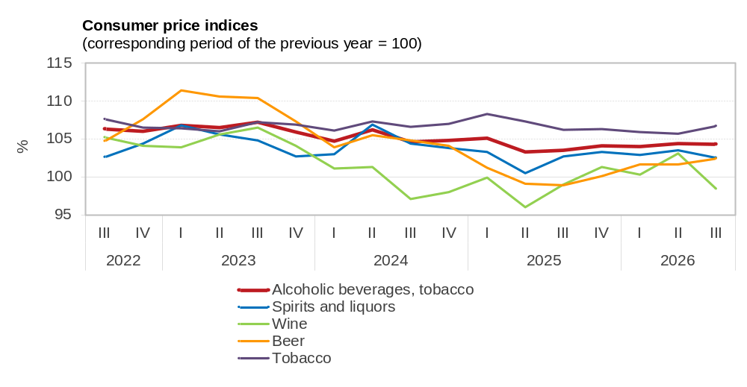

In 'restaurants and accommodation services', prices of food and beverage serving services increased by 3.9% and prices of accommodation services by 6.7%.
In ‘personal care, social protection and miscellaneous goods and services’, prices of goods and services for personal care were higher by 1.1%.
In ‘furnishings, household equipment and routine household maintenance’, prices of furniture and furnishings increased by 2.3%. Prices of non-durable household goods went down by 1.3%.
The aforementioned fluctuations in consumer prices resulted in an increase in prices of goods in total by 0.4% and in prices of services by 4.6%.
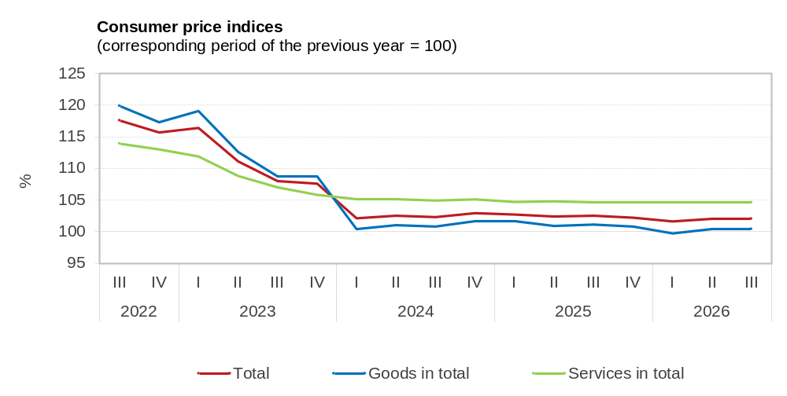

Harmonized index of consumer prices (HICP) ⁾
According to preliminary calculations, the HICP in Czechia in September decreased by 0.1%, month-on-month and increased by 2.2% (1.5% in August), year-on-year. According to flash estimates of Eurostat, the MUICP (Monetary Union Index of Consumer Prices) in September 2026 amounted to 3.8%, year-on-year (3.2% in August), 3.3% in Germany and 3.1% in Slovakia. It was the highest in Lithuania (6.1%) in September and the lowest in Malta (2.4%).
According to preliminary data of Eurostat, the year-on-year change in the average harmonized index of consumer prices (HICP) in the EU27 member states amounted to 3.2% in August, which was 0.2 percentage points more than in July. In August, the rise in prices was the highest in Romania (6.3%) and the lowest in Sweden (0.3%).
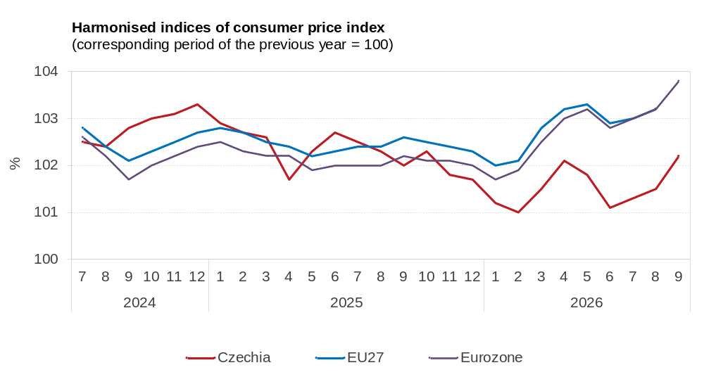

Development of the consumer price index broken down by COICOP divisions
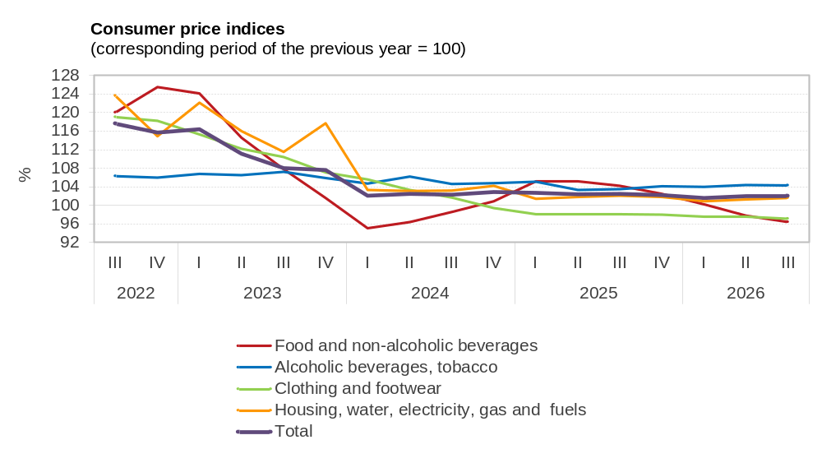
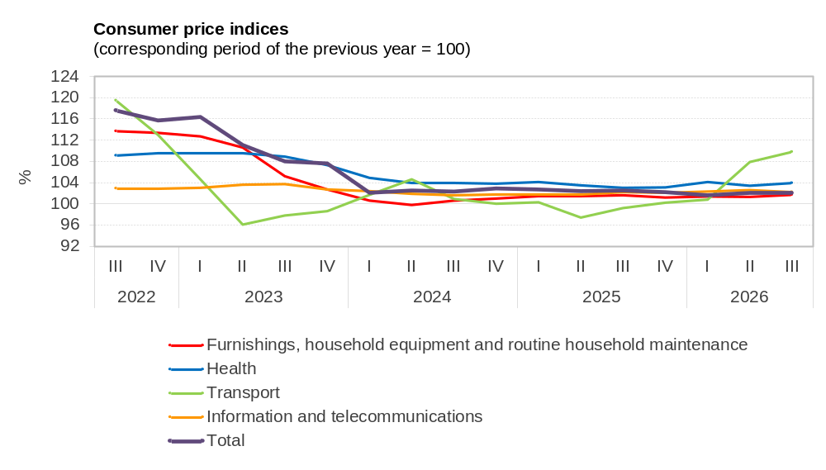

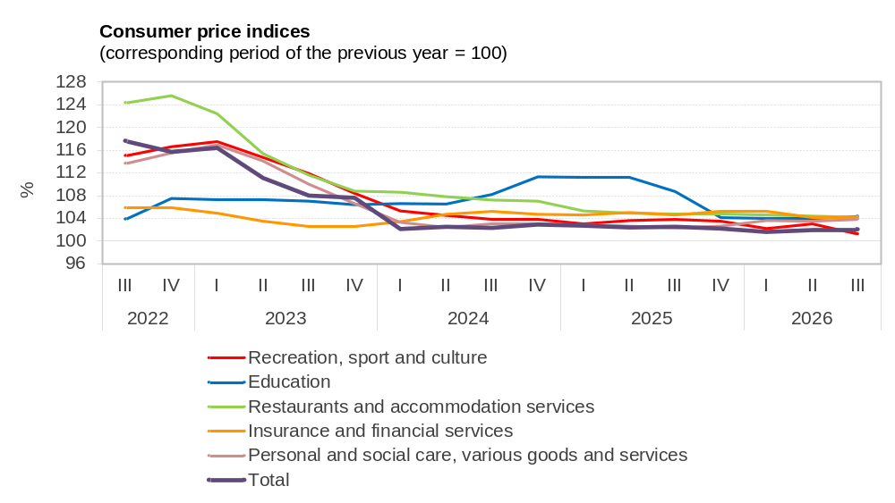

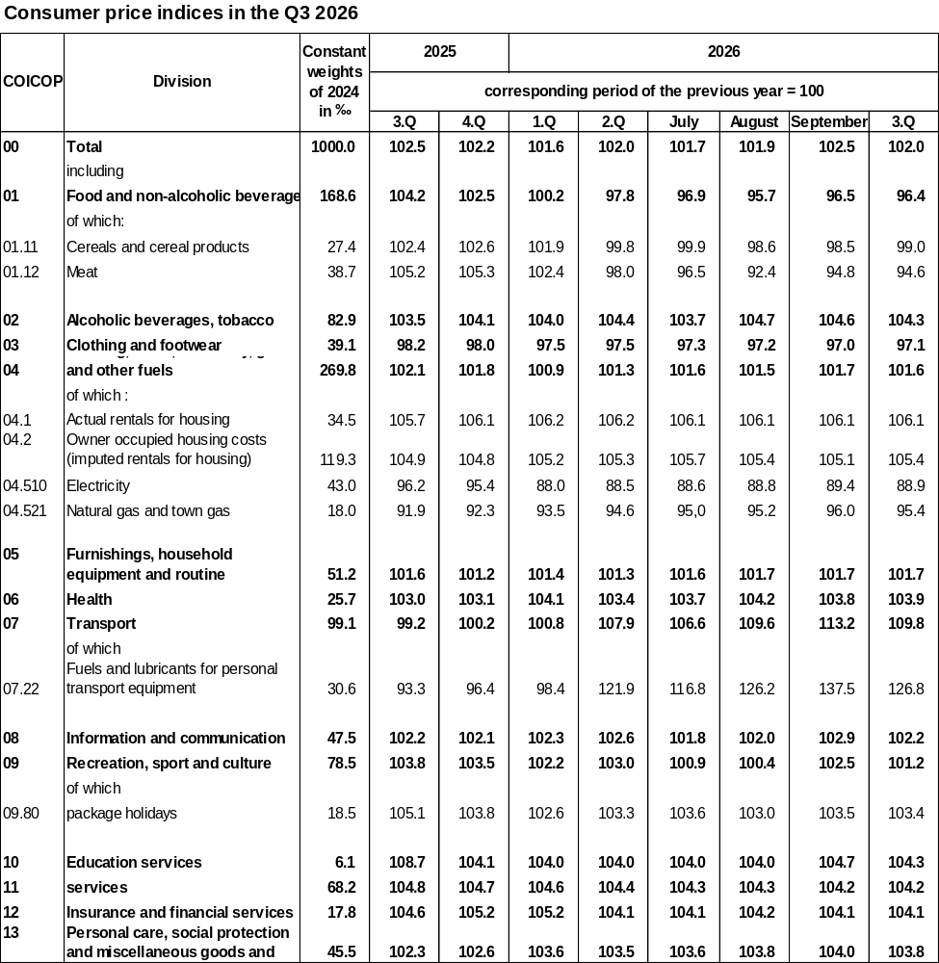
Elaborated by Consumer Prices Statistics Unit of the CZSO
Contact:
Jiří Trexler
Consumer Prices Statistics Unit
E-mail: jiri.trexler@csu.gov.cz
Phone: (+420) 274 054 137

) Imputed rentals are excluded from the HICP.

