Prices

Year-on-year growth of aggregate price level in the economy – gauged by the implicit GDP deflator –accelerated in Q4 2013 |  | Aggregate price level in the economy gauged by the GDP implicit deflator increased by 2.2 % in Q4 2013 in comparison to the same period in the preceding year and exceeded thus the rates of growth from the previous quarters (1.8 %, 1.6 % and 1.6 %). Especially the favourable terms of trade, which followed from the growth of export prices by 3.4 %, while the import prices grew only by 1.5 %, participated on the growth of the price level. Price level of the overall consumption expenditures grew by 0.8 %, investment prices (gross fixed capital formation) by 0.6 %.
Costs of living of the average household based on the inflation rate grew in the CR in 2013 the slowest since 2009 |  | Inflation rate was equal to 1.4 % in 2013, the lowest value since 2009 (1 %). Low price growth was given by the weak overall domestic demand in connection to the „import of deflation“ from abroad, which was reflected in lower prices of inputs (materials, semi-finished products, raw materials) and consequently via the production chain transferred into the prices of final products, which did not have in total a high tendency to grow. If in the average Czech household cost of living increased by 1.4 % in 2013, costs of living of households of pensioners rose by slightly higher 2 %. However also for the households of pensioners, the year 2013 represented the lowest increase in prices since 2009 (1.5 %).
Slowing down of year-on-year growth of prices for consumers lasted in the last quarter of 2013 already the seventh quarter in a row. If it was not for the increase of both rates of VAT in January 2013 by 1 percentage point, the year-on-year growth of prices would be in Q4 2013 already nearly zero |  | Year-on-year growth of prices for consumers was slowing down throughout the whole year 2013. If still in Q1 2013 the prices were year-on-year higher by 1.8 %, the rate of growth gradually weakened via 1.5 % and 1.2 % until final 1.1 % in Q4. The falling year-on-year rate of growth of prices lasted already seven quarters in a row. Such a low increase of prices for consumers in the year-on-year comparison, apparent in the last quarter 2013, has not been observed since the beginning of year 2010 (0.7 %). If it was not for the administrative amendments of the VAT rates at the beginning of year 2013 (both rates were upsized by 1 p.p.), which immediately manifested in January 2013 in the month-on-month rising of prices by 0.8 percentage points (prices grew by total 1.3 % compared to December 2012), the year-on-year increase of prices would be in the last quarter of 2013 already nearly zero.
Slowing down of the price dynamics in the CR was not unique, it occurred across the whole Europe in 2013, some of the European Union countries even faced deflation |  | Slowing down of rising of prices in the CR in 2013 was not at all an isolated occurrence. According to the internationally comparable harmonised index of consumer prices, the prices in the CR rose against the same period of the preceding year in quarters by 1.7 %, 1.5 %, 1.2 % and 1.1 %. The rate of growth of prices decelerated even faster in the EU28 – from the original 2 % in Q1 2013 via 1.6 % and 1.5 % to final 1 % in the last quarter. Weak demand led to the decline of year-on-year growth of prices across the whole Europe, some of the countries even had to face deflation – in Greece the prices were curbed by 2.2 % year-on-year in the last quarter of 2013, in Bulgaria by 1 %, Cyprus by 0.8 % and Latvia by 0.2 %.
During 2013 the year-on-year increase of prices of significant groups of goods in the consumption basket decelerated, prices of transportation were lower throughout the whole year |  | More than half of consumption expenditures of average household in the CR consists of resources on housing, water, energy and fuels together with food and non-alcoholic beverages and transportation. If still at the beginning of year 2013 the prices of housing, water, energy and fuels were by 2.6 % year-on-year higher, in the last quarter especially due to slowing down of prices of energies only by 1.2 %. The same conclusion was also valid for food and non-alcoholic beverages, whose prices increased by 4.9 % in Q1 - and even though the growth gained pace (as a result of temporarily faster growth of prices of bakery products and vegetables) to 5.4 % and 5.3 % during the year – at the end of the year the prices were only by 4.1 % higher. Prices of expenditures on transport were throughout the whole year 2013 – because of year-on-year lower prices of petroleum on the world markets and cheaper transport vehicles – even in the year-on-year decrease.
Only the expenditures on clothing and footwear and expenditures on recreation and culture worked in the direction of higher inflation, which however could not reverse the trend of decline of year-on-year increases |  | To these more significant groups add also the gradual slackening of the year-on-year rate of growth of prices for alcoholic beverages and tobacco, expenditures on health, restaurants and accommodation, but also the year-on-year price reduction in the segment of postal services and telecommunications and household equipment, and gradually we come to a conclusion, that the only groups, which pressed on higher inflation during the year 2013, were the prices of clothing and footwear together with recreation and culture, which broke free from the long-term deflation development in Q3. More favourable price development for these goods however could not in any way reverse the trend of gradual deceleration of growth of prices for the consumers, since in the aggregate these two groups formed in total consumer expenditures only roughly one eighth.
Non-zero growth of prices in industry in 2013 due to the January increase of prices in the energy sector and water supplies |  | Prices in industry in the aggregate rose by 0.8 % in 2013, which corresponded to the lowest price raise since the significant slump in the crisis year 2009. Weak growth of prices in this area was given by the nearly stagnating prices in the manufacturing industry (+0.2 %) - which this way adapted to the overall weak demand – in connection to the deflation development in the segment of mining and quarrying affected by the very low prices of coal on the world market. Only the prices in the energy industry and water supplies pushed in the direction of price raises, which were together already third year in a row adjusted upwards immediately in January.
Weaker exchange rate of crown has not managed to manifest in the prices of industrial producers in Q4 2013 –year-on-year rate of growth of industrial producer prices was only by tenths of percentage point higher in Q4 than in the previous quarters |  | In Q4 2013 the prices in industry increased compared to the same period of the previous year by 0.8 %, which was only by tenths higher growth compared to the preceding two quarters (0.5 % and 0.7 %). At the same time, the rate of growth of prices in the energy industry and water supplies nearly did not change compared to Q3. The same was also valid for the manufacturing industry, which in the prices of the industry as a whole shares the largest weight. If the weaker crown following the intervention on the part of the central bank the most intensively expressed itself in the boosted growth of prices of transportation vehicles (because of higher price dynamics for motor vehicle parts) –the growth of prices by 1.2 % in Q3, already by 3.5 % in Q4 – in other branches of the manufacturing industry on the contrary eventuated the lowering of rates of growth or deepening of falls, which in the aggregate led to the continuing actual stagnation of the prices of manufacturers. A mildly higher growth of prices in the industry as a whole thus occurred only as a result of lower deflation in mining and quarrying in Q4 2013.
Agricultural producer prices were in the aggregate higher by 4.5 % for the whole year 2013, however, growth-rates weakened very fast in individual quarters (in Q4 in deflation) |  | Prices of agricultural producers were raised by 4.5 % in 2013, which was slightly higher growth compared to the preceding year (+3.8 %). If still in Q1 2013 the prices were year-on-year higher by 14.4 % and in Q2 by 9.3 %, in Q3 already only by 1.4 % and the disinflationary development transformed into deflation in the last (year-on-year fall of prices by 4.2 %). This occurred due to the year-on-year reduction of prices of vegetable production in the second half of the year –the prices of vegetable production were curbed by 2.6 % in Q3, already by more than one tenth in the last.
Prices in construction fell by 1.1 % in 2013, the most in last four years, when they were continually lowering, … |  | The prices in construction were reduced by 1.1 % in 2013. The price adjustment downwards thus arrived already fourth year in a row, the cut in 2013 was the deepest. If the prices in construction were in the year-on-year comparison lower by 1 % in Q1 2013, by 1.3 % in Q2 and Q3. In Q4 however the year-on-year fall slowed down to 0.8 % and it is possible to infer from the development of the index, that the trend of falling prices in the construction ceased in the half of year 2013 – the question however remains, whether this occurred as a result of heightened demand for construction in the second half of the year supported by the above-average warm weather in the last quarter or the simple fact, that the long-term reduction of prices in construction hit the limits, signalling the prices of costs, and further potential reduction of prices was not possible any more.
… for the second year the prices of market services were also falling |  | The decline in prices of market services also continued in 2013 (by 1.5 %). They were cut for the second year in a row (in 2012 cut of 0.6 %) and thus completed the overall picture of unfavourable price development in the production chain in the CR. If the prices of market services were year-on-year lower by 0.5 % in Q1 2013, by 1.7 % in Q2 and even by 2.1 % in Q3. Only in the last quarter of 2013 the prices of market services slightly narrowed the reduction in the year-on-year comparison (to 1.9 %), especially due to the milder deflation in transportation and storage, which could be a signal regarding the end of deepening of reduction of prices resulting from the gentle revival of the domestic resp. foreign trade.
For the first time in three years the domestic economy recorded the improvement of terms of trade in 2013 |  | Prices of exported goods went up in total by 1.2 % for year 2013, which was the weakest raise since year 2010 (-1 %). With respect to the reduction of prices of commodities in the world, a deflation was imported from abroad in 2013(-0.2 %), consequently contributing to the lowering of production costs and in the end to the disinflationary process in the CR. Growth of export prices accompanied by the reduction of import prices led to the improvement of the terms of trade by 1.4 %, which has not been apparent in the CR for whole three preceding years.
Still in Q3 2013 the export prices were in the year-on-year comparison higher only by 0.4 %, the weaker crown however contributed to a notable acceleration to 2.9 % |  | Central bank intervention (carried out at the beginning of November 2013) contributed to the crown depreciation against euro in the year-on-year comparison by 5.9 % in the last quarter of 2013, which consequently assisted the growth of export prices by 2.9 %, when they still grew only by mere 0.4 % in Q3. Among significant groups of goods on the side of exports the prices of machinery and transportation vehicles increased notably (by 3.7 %) in the last quarter of 2013 (when the year-on-year growth did not overtake the boundary of 2 % in no previous quarter), the prices of exported beverages and tobacco however increased the most (by more than one fifth, when they still grew by 8.8 % in Q3).
Weaker crown cut the deflation in the year-on-year expression on the side of imports in Q4 2013, still a significant improvement of the terms of trade occurred |  | Weaker crown also assisted the rising of prices of imported goods. In the last quarter of 2013 the import prices increased precisely by one percent in the year-on-year comparison, falling in all the previous quarters of the same year. Still the increase of the year-on-year rate of growth was not as high as on the side of exports – for exports the year-on-year rate of growth rose by 2.5 p.p. in the last quarter, for imports by 1.9 p.p. If the terms of trade thus improved in the year-on-year comparison by 1.2 %, 1.3 % and 1.3 % quarter by quarter in 2013, in the last quarter they increased by 1.9 % and the Czech economy thus expanded the profits from the favourable development of prices in the foreign trade.

Chart 11 | Growth of consumer prices for individual types of households (y/y in %) | Chart 12 | Growth of prices in selected divisions of CPI (y/y in %)
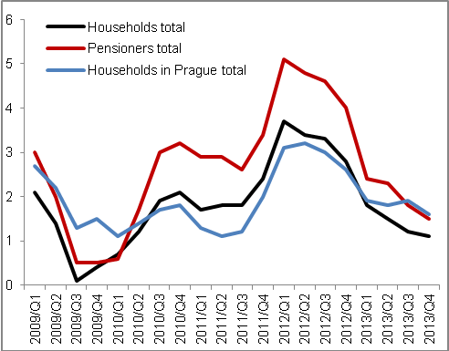 |  | 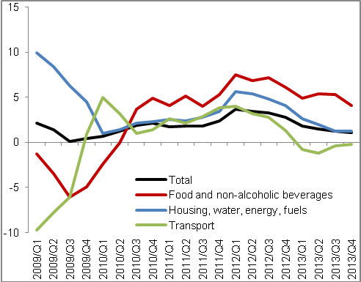
Source: CZSO

Chart 13 | Deflators (adjusted for seasonal and calendar effects, y/y in %) | Chart 14 | Producer prices (y/y in %, prices in agriculture on the right axis, others on the left axis)
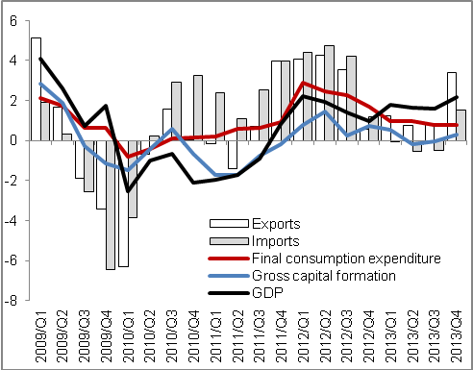 |  | 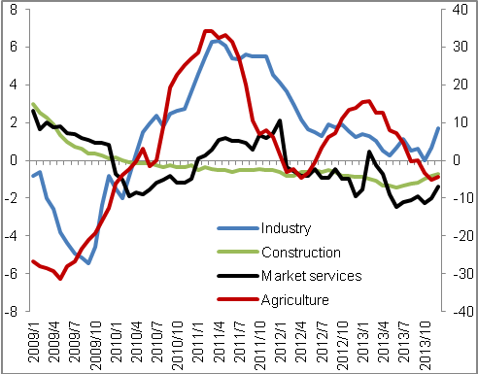
Source: CZSO

Adjusted for seasonal and calendar effects.

