3 September 2025

Development of the Czech labour market in the Q2 2025
The average wage increased, year-on-year, more markedly, both nominally (by 7.8%) as well as in real terms (by 5.3%). An increasing economic activity and female employment are a significant trend on the Czech labour market. The sector of services strengthened again. The unemployment is insignificantly increasing, however, the unemployment rate remains to be one of the lowest in the European area.

Employment, unemployment, and economic inactivity
Results of the Labour Force Sample Survey (LFSS) brought for the Q2 2025 an increase in total numbers of both the employed and the unemployed, and therefore an increase in the economic activity of the population of the Czech Republic. Year-on-year, there were by 122.6 thousand working females more, whereas the number of working males decreased by 46.5 thousand persons. This discrepancy is one of the most striking statements (indicators) about what is going on in the economy; it is also influenced by marked structural changes as well as integration of Ukrainian women, war refugees in the Czech labour market.

In total, the employment increased by 76.2 thousand (1.5%), year-on-year, and reached 5 243.5 thousand persons. As for age groups, the group of the aged 60+ years contributed the most to the increment (52.2 thousand), which is related to extending of working (professional) career to a higher age and to later retirement. The number of working females aged 60+ years even increased by a tenth, year-on-year (9.6%).

As for the status in employment, the increase in the number of working persons was driven by the largest group of employees, in which the number increased by 75.9 thousand persons, i.e. by 1.7% to 4 426.7 thousand. In entrepreneurs (the self-employed), the trends were indistinctive. The share of the self-employed in the total employment was 15.4% in the Q2 2025 with males comprising two thirds of the group (66.4%).

Employment in the primary and the secondary sectors moderately decreased; therefore, it was only the tertiary sector that contributed to the overall increase in employment. An increase by 88 thousand can be found there. The biggest relative increment of working persons according to the LFSS was in the section of ‘arts, entertainment and recreation,’ namely by 20.1 thousand persons, i.e. by 24.3%. Over the last five years, the number of working persons in the tertiary sector increased by almost 285 thousand (i.e. by 9.5%); therefore, during the last reference period, 3 284.7 thousand persons were employed in the sector of services, which is almost 63% of the total employment.

The employment rate (the percentage of working persons in the age group of 15–64 years old) increased compared to the corresponding period of the previous year by 0.4 percentage point (p. p.) to 75.7%. The male employment rate (80.1%) was by 0.9 p. p. lower, y-o-y; the female one increased by 1.9 p. p. to 71.2%, i.e. both the rates got even closer. Related to that is the development trend of part-time jobs that further continued. Currently, their number exceeded the threshold of half a million of persons (500.1 thousand; in the y-o-y comparison, it increased by 24.2 thousand, i.e. by 5.1%). 14.5% of working females worked part-time; in the year-on-year comparison, their number increased by 26.4 thousand. They gave most often childcare as the reason for working part-time. Only 5.2% of males worked part-time and they were most often the elderly.

The unemployment has been increasing especially during the recent period; the number of persons seeking a job increased by 12 thousand, y-o-y, to 146.1 thousand. The increase had an impact on both sexes; the number of unemployed females increased by 7.3 thousand to 74.5 thousand, the number of unemployed males increased by 4.7 thousand to 71.5 thousand. However, in females it is the most related to the age group of 30–44 years in relation to parental care, whereas in males it is the age of 45–59 years.

The number of persons unemployed for one year and longer (the long-term unemployed) has also increased; it increased by 4.9 thousand, y-o-y, to 44.8 thousand persons. This phenomenon newly also occurs in the oldest age group of the aged 60+ years.

The unemployment rate in the age group of 15–64 years increased by 0.2 p. p. to 2.8%. In terms of Regions, the situation continued to be the worst in the Ústecký Region (4.8%) followed by the Moravskoslezský Region (4.6%) and the Karlovarský Region and the Liberecký Region (both the same 4.4%). On the other hand, the lowest unemployment rate was in the Středočeský Region and in the Capital City of Prague (the Hl. m. Praha Region; both the same 1.5%).

Surplus labour (persons who do not work and do not seek a job in an active manner and therefore do not comply with the ILO conditions for the unemployed, however, they state that they would like to work) increased by 1.2 thousand to 82.8 thousand.

Note: The LFSS only covers persons living in dwellings (flats), not those living in hostels and similar collective households. It has a negative influence on the capture of some groups of foreigners who often use such ways of housing. The weighting and grossing up methodology of the LFSS was in 2023 adapted to this type of survey, which affected time series of absolute figures on employment, mainly as for classification by age group. Weights of the LFSS are newly modified according to the results of the demographic statistics for every quarter.

Registered number of employees converted to full-time equivalent employees
Preliminary data of the CZSO’s business statistics confirm the growth trend in the Czech economy. The registered number of employees in full-time equivalent (FTE) increased, y-o-y, in the Q2 2025, by 14.3 thousand; it was by 0.4% in relative terms. (The registered number of employees, headcount, increased by 23 thousand or by 0.5%.)

While the total figure shows a moderate value, in the breakdown by CZ-NACE section, some considerable increases and decreases in the number of employees can be found, which proves that the internal structure of the labour market changes and employees fluctuate.

Also in the Q2 2025, the sector of services and care remained to be a growth area, whereas decreases can be found again in ‘agriculture, forestry and fishing’, ‘mining and quarrying’, ‘manufacturing’, and in ‘transportation and storage’. In those four CZ-NACE sections, the number of employees decreased, year-on-year, by 24 thousand in total. In the remaining fifteen sections, it increased in total by 38.3 thousand. Individual relative increments or decrements ranged widely from -10.9% to 10.2%. These extreme changes, however, were in economic activities that are not important as for their numbers of employees.

The absolute majority of the decrease was due to a decrease in ‘manufacturing’, in which there were by 18.5 thousand employees less, year-on-year. In relative terms, it was a decrease by 1.7%, which was not very dramatic; however, the decrements have been accumulating already for many successive years. Nevertheless, ‘manufacturing’ is still the biggest economic activity in Czechia; also in the Q2 2025, it employed over one million employees (1 040.4 thousand) as the only section. Tab. 1 in the news release on average wages therefore provides CZ-NACE divisions of this section, which were the biggest as for the number of employees. In six of those divisions, we can find decreases in the numbers of employees; the deepest one (both in relative and absolute terms) was in ‘manufacture of motor vehicles, trailers and semi-trailers’ (by 3.7%; 6.3 thousand). The only selected division with an increase in the number of employees was ‘manufacture of food products’ (by 2.6%; 2.2 thousand).

The biggest relative decrease in the number of employees was in the section of ‘mining and quarrying’, already an utterly marginal economic activity, in which the number of employees has now decreased by 10.9%; it was a decrement by 2.0 thousand to 16.0 thousand. In ‘agriculture, forestry and fishing’, in which 89.6 thousand employees were currently employed, a moderate decrease occurred, too (by 1.8%; 1.6 thousand). The last section with a negative value was ‘transportation and storage’, in which a decrease by 0.7% was a decrease by 1.9 thousand to the value of 253.3 thousand.

Two economic activities where the state plays a dominant role contributed the most to the increase in the number of employees: in ‘human health and social work activities’, the year-on-year growth was by 9.1 thousand (or by 2.6%) and in ‘education’ by 6.6 thousand (or by 1.9%). After the last year’s decrease, there was a moderate growth also in the ‘public administration and defence; compulsory social security’ (by 1.2 thousand or 0.4%, which mainly occurred in municipal authorities). In those three economic activities, about one million employees in total thus work now.

Another two CZ-NACE sections that are considerably growing belong to the tertiary sector as follows: recovery in trade (‘wholesale and retail trade; repair of motor vehicles and motorcycles’) entailed an increase in the number of employees by 5.5 thousand to 502.3 thousand (a relative increase by 1.1%). ‘Real estate activities’ recorded the highest relative increase by 10.2%, which in this smaller economic activity was an increase by 4.3 thousand.

The fifth highest absolute increment by 2.3 thousand can be found in ‘other service activities’, which was also the second highest relative increase by 6.2%. An important increase was also in ‘professional, scientific and technical activities’, in which there were by 2.1 thousand employees more (by 1.2%). ‘Construction’ was again better off; the number of employees increased there by 2.0 thousand, year-on-year, or by 0.9%. Also recovery in ‘accommodation and food service activities’ continued; there were by 0.5 thousand employees more, y-o-y, which was an increase by 0.4%.

‘Financial and insurance activities’ recorded a modest increment of 0.3 thousand, which was an increase by 0.4%; it was higher in ‘information and communication’, by 1.4 thousand (by 1.0%). Two smaller industrial economic activites increased, too; the energy sector (‘electricity, gas, steam and air conditioning supply’) less, the number of employees only increased there by 0.1 thousand (by 0.4%), whereas ‘water supply; sewerage, waste management and remediation activities’ increased more, by 1.2 thousand (by 2.3%).

Chart 1: Indices of consumer prices and average wages (seasonally adjusted), 2019=100%
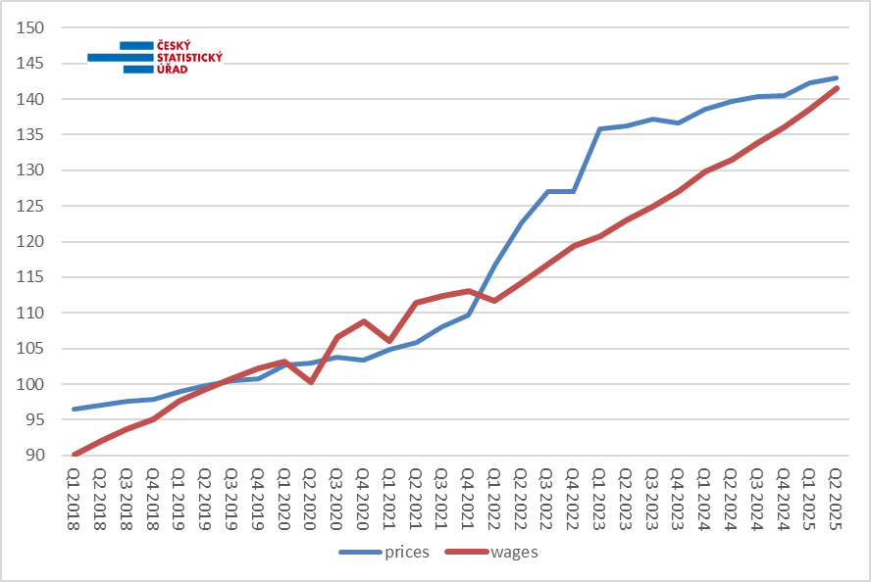 Sources: price statistics of the CZSO, wage statistics of the CZSO

Quarterly average gross monthly wages
The average wage (CZK 49 402) increased nominally by CZK 3 583 in the Q2 2025, compared to the corresponding period of the previous year, i.e. by 7.8%. It is an average of a very diverse development on the level of individual economic activities, enterprises, or organisations.

The year-on-year wage growth thus accelerated its growth rate; the wage level increased like that for the last time in the Q1 2024; afterwards, the values were weaker; in the Q1 2025, the growth was only by 6.6%.

As for the standard of living of employees, the real development was more important; it compares an increase of earnings with the increase in consumer prices (inflation) and thus it shows how many goods and services an employee could buy for his/her wage. The consumer price index reached in the Q2 2025 the value of 2.4%; the real average wage thus increased by 5.3%, y-o-y. It has also been the best result since the Q1 2024 when there was an increase of real wage by 5.6%.

In the long term, the previous real decrease is being caught up when the wage level is gradually catching up with the price level that increased dramatically especially in 2022. The enclosed Chart 1 with basic indices shows that the real average wage in the Q2 2025 still (after seasonal adjustment) has not reached the level from the year 2019; however, when the current fast growth of nominal wages is kept and provided that the inflation is not going to grow faster, the surpassing should take place before the end of the year.

Although the average wages were considerably increasing in all economic activities, their dynamics again varied a lot. Nominal increases ranged from 4.8% to 12.7%. The highest year-on-year increase can currently be found in the section of ‘professional, scientific and technical activities’ where the average wage got to CZK 63 235. Four more sections got above the ten-percent year-on-year nominal growth: ‘construction’ with 11.0%, ‘real estate activities’ with 10.9%, ‘accommodation and food service activities’ with 10.4%, and last ‘administrative and support service activities’ with 10.1%. Just below this threshold, there were also ‘arts, entertainment and recreation’ with 9.8%, ‘transportation and storage’ had an increase by 9.6%, and ‘agriculture, forestry and fishing’ 9.3%.

In all the remaining sections, values below the level of an increase of the total average wage can be found (7.8%). ‘Manufacturing’ got the closest to it with 7.5%. Within this section, a high increase was in the division of ‘manufacture of motor vehicles, trailers and semi-trailers’ (10.3%), while other selected divisions ranged from 6.3% to 7.7%.

‘Information and communication’ recorded an increase by 7.2%, trade (‘wholesale and retail trade; repair of motor vehicles and motorcycles’) by 7.1%, ‘public administration and defence; compulsory social security’ as well as ‘education’ by 7.0%. In the energy sector (‘electricity, gas, steam and air conditioning supply’) wages increased by 6.2% and in ‘water supply; sewerage, waste management and remediation activities’ by 5.9%. This time, the increment was even lower in ‘human health and social work activities’ (5.6%).

Now we are already getting to the area of economic activities with the wage growth strongly below the average, only about five percent. In ‘financial and insurance activities’, the average wage increased by 5.1%, in ‘other service activities’ by 5.0%, and by far the lowest value was recorded by ‘mining and quarrying’ (4.8%).

Employees in the following two economic activities as usual also enjoyed the highest wage level in the Q2 2025: ‘information and communication’, where the average wage got to CZK 87 477 and ‘financial and insurance activities’ with the level at CZK 84 702. With a gap, ‘electricity, gas, steam and air conditioning supply’ ranked third with CZK 69 598 followed by ‘professional, scientific and technical activities’ with CZK 63 235.

The ranking from the opposite side was not surprising, either. In ‘accommodation and food service activities’, the average wage was still the lowest and did not even exceed the thirty-thousand level (CZK 29 270). The second lowest was in ‘administrative and support service activities’ with the average wage of CZK 35 335. ‘Other service activities’ ranked third with CZK 36 325 followed by ‘agriculture, forestry and fishing’, in which it increased to CZK 37 739.

Long-term development of wages in economic activities (CZ-NACE sections) – comparison with the first half-year of 2019
It must be noted that newly published figures for the first half-year of 2025 are preliminary, they come from the task with a smaller sample of enterprises or organisations (“Práce 2-04” that reads in English “Labour 2-04” questionnaire/report). After including results of larger annual tasks (“ÚNP 4-01” on total labour costs and “P 5-01” questionnaires/reports) and after connecting it with administrative data sources (especially from the Czech Social Security Administration) they will be refined in the periods to come. The year 2019 is closed with final results.

In total, the wage level increased in the six-year period in nominal terms by 42.6%. In real terms, however, it decreased by 0.6%, because prices increased in that period by 43.5%. However, this general picture says little about the situation of employees from different fields.

Chart 2: Increment/decrement in real average wages by CZ-NACE section in the first half-year of 2025 to the first half-year of 2019 (%)
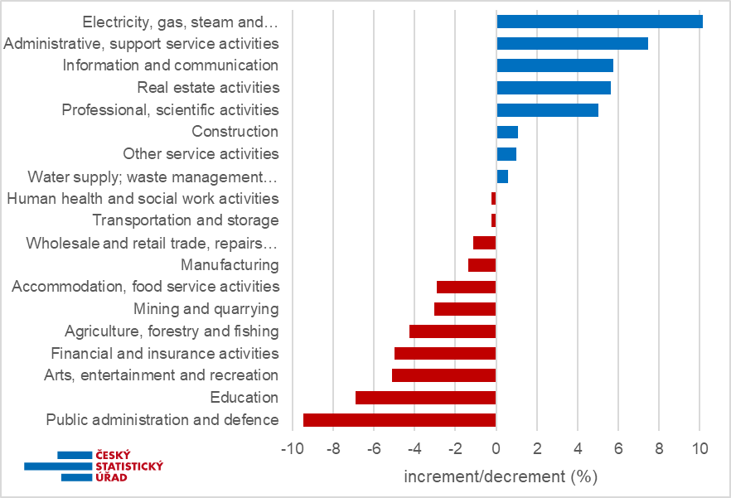Sources: price statistics of the CZSO, wage statistics of the CZSO

Eight economic activities (CZ-NACE sections) already report a higher level of real wages than they had in the first half-year of 2019; on the other hand, the remaining eleven ones still have not reached it. Five CZ-NACE sections even have real wage level by 5 or more percent higher. First of all, it is the energy sector (‘electricity, gas, steam and air conditioning supply’), in which the real wage increased during the surveyed period by 9.5%. ‘Administrative and support service activities’ ranked second with an increase by 7.5%, ‘information and communication’ ranked third with 5.8%, ‘real estate activities’ ranked fourth with 5.6%, and ‘professional, scientific and technical activities’ ranked fifth with 5.0%.

On the other hand, those working in four economic activities where wages slumped in real terms by 5 or more percent have much worse wage level. It is in ‘public administration and defence; compulsory social security’ (-9.5%), ‘education’ (-6.9%), ‘arts, entertainment and recreation’ (-5.1%), and ‘financial and insurance activities’ (-5.0%).

While in some economic activities trends were smooth, in other ones there were step changes in wage levels, which was mainly related to the tumultuous development on the labour market in connection with measures against the COVID-19 infection. That’s why the year 2019 has been chosed as a comparison basis, because it had preceded that.

It is mainly typical for ‘human health and social work activities’, where in the Q1 2021 high extraordinary bonuses were paid and the average wage increased in nominal terms by 27%, whereas the following year it slumped by 12%. In the energy sector, the jump occurred in the Q1 2023, when wages nominally increased by 18% and the following year only by 4%. The development was also considerably fluctuating in ‘real estate activities’, in which there was a slump by 6% (Q1 2020) and two years later there was an increase by 19%. What is also interesting is a change on the top: whereas in 2019 and 2020 the highest average wage was in ‘financial and insurance activities’ (rank first), since 2021, ‘information and communication’ is already leading, namely with an increasing gap.

Development in Regions
In terms of the number of employees, the development in various Regions in the Q2 2025 differed again. In nine Regions, there was a decrease, year-on-year. The most considerable ones were by 1.1% in the Moravskoslezský Region followed by a 1.0% decrease in the Karlovarský Region, the same 0.8% decrease in both the Liberecký Region and the Královéhradecký Region, and in the Ústecký Region they decreased by 0.6%. In the remaining Regions, the numbers decreased by up to 0.5%. In total, there were by 12 thousand jobs less in those Regions. The overall balance was positive again primarily thanks to a massive increase in the Capital City of Prague (the Hl. m. Praha Region) by 23.4 thousand, which was a relative increase by 2.9%. Smaller increases in four other Regions also added to that besides the growth in the Capital City; however, those only added 2.7 thousand in number: the Jihomoravský Region with an increment of 0.4%, the Středočeský Region, the Plzeňský Region, and the Pardubický Region (the same 0.1%).

As for the development of average wages, the dispersion in the Q2 2025 is much smaller among Regions than in the breakdown by economic activity (industry). Wages were increasing nominally in the range from 5.6% to 8.2%. This highest wage growth was this time in two Regions: the Capital City of Prague (the Hl. m. Praha Region) and the Moravskoslezský Region. With a small gap, the Jihomoravský Region and the Pardubický Region followed them with 8.1%. In the Středočeský Region, wages increased by 7.8%, year-on-year; in other Regions, the increase was already below the average. Currently, the Ústecký Region was the worst off (5.6%); in the Liberecký Region, wages only increased by 6.4%, in the Vysočina Region by 6.7%, and in the Karlovarský Region by 6.8%.

According to the absolute level of earnings, the Capital City of Prague (the Hl. m. Praha Region) remained to be the richest as for the earnings among the Regions of the Czech Republic. The average wage there was CZK 62 307. The Středočeský Region was the second with CZK 52 381. The Jihomoravský Region was the third with CZK 48 049. The 45-thousand threshold was also overcome by the Královéhradecký Region with CZK 46 807, the Plzeňský Region with CZK 45 708, and the Ústecký Region with CZK 45 024, the other remained below it. On the other hand, the Karlovarský Region remained to be the Region with the lowest wage level (CZK 41 944) and, currently, the only Region below the 43-thousand threshold. In the Moravskoslezský Region, which is following the Capital City of Prague (the Hl. m. Praha Region), the Jihomoravský Region, and the Středočeský Region a Region with the highest number of employees (413.1 thousand), the average wage reached the value of CZK 44 370.

* * *

Median wages and decile intervals of wages by sex
The news release of the CZSO for the Q2 2025 also contains a piece of data on the median wage, which is calculated from a mathematical model of the distribution. It shows the wage of a middle employee, i.e. a common wage level. Extreme deciles were also calculated; data for the previous period have been revised. In the Q2 2025, the median wage got to CZK 41 115, which is by 7.2% (CZK 2 778) more than in the corresponding period of the previous year.

One tenth of employees with the lowest wages were receiving a gross wage below CZK 22 283 (the bottom decile increased by 8.3%, y-o-y), whereas the tenth with the highest wages had wages over CZK 80 856 (the top decile increased by 8.0%). The decile ratio as one of the indicators of the distribution range stagnated, year-on-year, at 3.6; the area of median wages increased the least.

Male median wages were higher than female ones; in the Q2 2025, the female median wage was CZK 37 935 (it increased by 7.3%, year-on-year), whereas the male median wage was CZK 44 465 (it increased by 7.5%). The gap between median earnings by sex insignificantly increased, year-on-year, by 0.2 p. p. to 14.7%.

At the same time, wages of males were distributed over a substantially wider interval, especially the area of high earnings was significantly higher for males than for females: the top decile for females was CZK 69 143 and for males it was CZK 92 847, by which there was a gap of 25.5% in high earnings. On the other hand, as for low earnings, the difference was smaller and it was weaker, y-o-y: the bottom decile for females was CZK 21 598 and for males it was CZK 22 961, which is a gap of 5.9%.

* * *

Preliminary results from the Information System on Average Earnings (ISAE) for the first half-year of 2025 bring a more detailed view of wage structures, distributions, and socio-economic breakdowns. However, the ISAE applies a different methodology for the calculation of personal earnings of an employee (first of all, it excludes all absences at work) and therefore these data are not comparable either to the aforementioned amounts of wages or to figures given in tables annexed to the news release of the CZSO.

Half-year results of the ISAE show the median wage of CZK 42 926; by 6.6% higher, year-on-year. Female median wage was CZK 39 675 and the male one was CZK 46 206. The number of records on males decreased by 0.3%, y-o-y, whereas the female one increased by 1.4%.

In the breakdown according to the valid Classification of Occupations (CZ-ISCO), managers were the group with highest earnings having the median wage of CZK 85 422; it increased by 8.2%, year-on-year, i.e. above standard. Wages of managers were the most differentiated ones; the decile ratio was 4.8, because a tenth of the best-paid earned over CZK 212 348, while the opposite tenth received less than CZK 43 985. The second major group of professionals had the second highest median wage of CZK 58 544; the richest tenth earned over CZK 125 219, the decile ratio was 3.2. Their median wage at the same time increased less (by 6.9%), year-on-year. The third major group of CZ-ISCO includes technicians and associate professionals; they had the median wage of CZK 49 389. The fourth major group of clerical support workers had the median wage of CZK 38 151. Median wages in those major groups increased, y-o-y, rather more (by 7.7% and 7.4%, respectively). In the fifth major group of service and sales workers, about one of three belonged to low-income employees (in general, such an employee is considered to be a low-income (low-wage) employee who earns less than 2/3 of the total median wage; according to the ISAE for the first half-year of 2025, the threshold was CZK 28 617); they had the decile ranging from CZK 22 846 to CZK 50 752 and their median wage was CZK 32 459. At the same time, their wages increased, year-on-year, only slowly (by 5.6%). Qualified workers in ‘agriculture, forestry and fishing’ are permanently the least numerous major group; their median wage was CZK 34 638, which increased by 5.8%, year-on-year. Craft and related trades workers had the median wage of CZK 40 394 and plant and machine operators and assemblers CZK 38 871; there were weaker increases by 5.9% and 6.5%, respectively. At elementary occupations, there is constantly the lowest wage level; currently, the median increased the most by 8.6% to CZK 27 145; despite that, they had over a half share of low-income employees, their decile range was from CZK 21 105 to CZK 42 255 and the lowest decile ratio can be found there (2.0), i.e. weak differentiation.

For median wages broken down by age group it holds true that, year-on-year, the fastest increase (by 6.9%) was in the age groups of a higher middle age (40–49 years and 50–59 years), which are the most numerous, whereas as for the youngest category of employees up to 20 years of age it was only by 2.0%. In this category, which is not numerous, there is, moreover, usually the lowest medium wage; currently it was only CZK 29 137. At the same time, their number in the survey sample significantly increased (by 5.1%). In the age group of 20–29 years, the median wage was already much higher (CZK 39 351) and in the age group of 30–39 years, the median was the highest of all (CZK 45 118). In the other two ten-year age categories, wages are gradually decreasing, to CZK 44 451 for the category of those aged 40–49 years, and to CZK 42 298 for the aged 50–59 years. Finally, for those aged 60+ years, the median wage was CZK 41 956, i.e. only a bit lower than for the preceding category; however, in this category, there are only 41% of employees compared to the previous one and it is usual that those who are more qualified and paid better remain to work longer. Nevertheless, the number of records there increased by 7.1%, because the population is ageing on average and working career extends into older age.

Wages are also highly structured by the level of educational attainment of an employee. Employees with higher education had the highest earnings again, their median wage was CZK 59 155. Moreover, it increased the fastest, year-on-year (by 7.5%). Conversely, wages of employees with primary education or with incomplete primary education increased the least (by 5.2%) and remained the lowest (CZK 33 768). Graduates of secondary schools with an A-level examination earned much more (CZK 43 504) than those without the A-level examination (CZK 36 475), but less than employees with short-cycle tertiary education or graduates from bachelor study programmes (CZK 50 061).

Earnings of employees by state citizenship are also measured, because about a tenth of ISAE records belong to employees with other than Czech citizenship. From large groups of foreigners in the CR, the highest representation now belongs to Ukrainians, for whom the number of records further increased, y-o-y, currently by 4.8%, whereas numbers of Poles and Bulgarians decreased by about a tenth. However, the undifferentiated group of other citizenships increased even more (by 11%). The highest median wage of large groups of foreigners in Czechia belonged to Slovaks (CZK 50 316); it was even by 16% higher than for employees with Czech citizenship (CZK 43 283). On the other hand, by 22% lower than the Czech one was the median wage of Ukrainians (CZK 33 828); however, it increased by almost 9%, y-o-y. Lower than Czech ones were also wage levels of other three smaller groups, i.e. of Bulgarians (lower by 7%), Romanians (by 4%), and Poles (by 2%). In the expanding group of other foreigners, the median wage (CZK 41 889) only increased by 2.9%.

Elaborated by: Dalibor Holý
Labour Market and Equal Opportunities Statistics Department of the CZSO
Phone number: (+420) 274 052 694
E-mail: dalibor.holy@csu.gov.cz

