9 January 2012

CONSUMER PRICE INDICES iN Q4 2011
AND IN the year 2011

Consumer prices increased by 0.5% in Q4 2011 compared with Q3 2011; market prices were up by 0.4% and regulated prices*) by 1.3%. The quarter-on-quarter (q-o-q) price level increase was affected especially by a price rise in 'food and non-alcoholic beverages' and in 'clothing and footwear'. Prices in 'recreation and culture' caused primarily a contrary effect on the price level.

In Q4 2011, the rise in prices of the majority of kinds of food accelerated, of which the fastest speed-up was in some kinds of fruit and vegetables. The increase in prices of ‘clothing and footwear’ was caused higher prices of new seasonal models, which were offered on the market namely in October. In 'housing, water, electricity, gas and other fuels', prices of natural gas rose by 5.4%. The price level in 'health' was affected by an increase in the regulatory fee per stay in health establishments. In 'recreation and culture' prices of package holidays dropped due to the end of the main season.

The average month-on-month (m-o-m) growth rate in Q4 2011 was 0.4%, in Q4 2010 it was only 0.2%. This was demonstrated in an acceleration of the year-on-year (y-o-y) price increase in Q4 2011.

Consumer price indices
the previous quarter = 100

 | 2010 | 2011
DIVISION | Q4 | Q1 | Q2 | Q3 | Q4
TOTAL | 99.8 | 101.2 | 100.6 | 100.1 | 100.5
Food and non-alcoholic beverages | 101.0 | 102.9 | 101.6 | 98.5 | 102.3
Alcoholic beverages and tobacco | 99.9 | 101.5 | 100.4 | 101.1 | 99.8
Clothing and footwear | 102.7 | 96.3 | 102.7 | 96.8 | 103.0
Housing, water, electricity, gas and other fuels | 100.0 | 101.7 | 100.3 | 100.8 | 100.6
Furnishings, household equipment and routine maintenance of the house | 99.5 | 99.6 | 99.7 | 99.5 | 99.7
Health | 99.6 | 100.3 | 101.1 | 100.9 | 101.4
Transport | 99.6 | 102.2 | 101.1 | 100.0 | 100.5
Communications | 99.9 | 100.0 | 99.9 | 99.7 | 99.6
Recreation and culture | 96.1 | 100.1 | 99.5 | 102.0 | 97.0
Education | 101.3 | 100.2 | 100.1 | 100.6 | 101.2
Restaurants and hotels | 100.1 | 100.4 | 100.4 | 100.6 | 100.5
Miscellaneous goods and services | 100.3 | 100.6 | 99.7 | 100.1 | 100.2

Consumer prices rose by 2.4% y-o-y in Q4 2011 compared with Q4 2010, i.e. by 0.6 percentage points (p.p.) more than in Q3 2011 and the most of all quarters of 2011. The majority of the consumer basket divisions showed acceleration in the y-o-y increase or a slowdown in the decline.

The growth in market prices accelerated to 1.7% (from 1.2% in Q3 2011) and that of regulated prices speeded up to 6.0% (from 4.5% in Q3 2011).

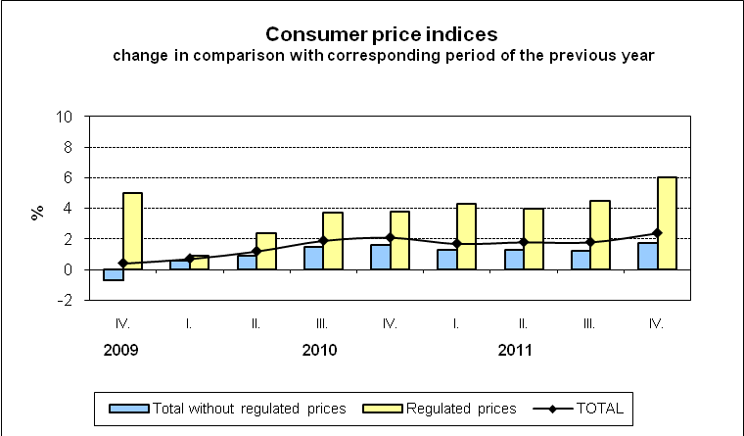

The trend in regulated prices was affected by prices in 'housing, water, electricity, gas and other fuels' where natural gas prices increased by 17.7% (by 11.5% in Q3 2011). Electricity prices rose by 4.7%. The net actual rentals went up by 4.0% (from 3.2% in Q3 2011), of which that for dwellings with regulated rentals rose by 10.4% and that for dwellings with market rentals were up by 1.2%.

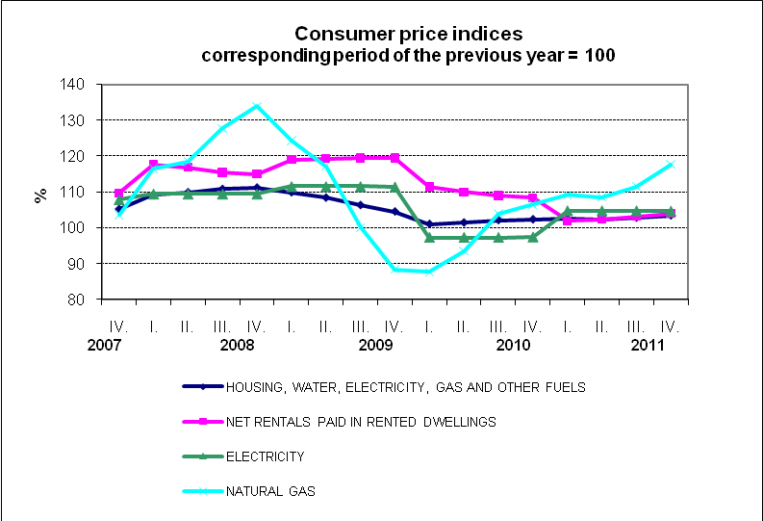

The rise in prices in 'health' was caused, first of all, by an increase in the regulatory fee per stay in health establishments from 60 CZK/day to 100 CZK/day.

A marked acceleration in the price growth was shown in 'food and non-alcoholic beverages' as a result of a speed-up in the price rise of almost the entire range of foods. Prices of bread and cereals, which (due to their strong growth at the end of 2010) demonstrated a slowdown in the year-on-year growth in Q4 2011, made an exception. Prices of bread were higher by 19.2% (by 24.7% in Q3 2011) and prices of rolls and baguettes by 26.8% (by 35.5% in Q3 2011). Prices of sugar and coffee increased by 33.4% and 29.2%, respectively. Prices that went up by 10% to 20% were, in particular, those of flour, eggs, edible oils, vegetable fats, cocoa, and some non-alcoholic beverages. A steep fall in annual indices of seasonal goods in 2011 was stopped in Q4 2011 and, on the contrary, their decline got mitigated, as is evident from the graph below.

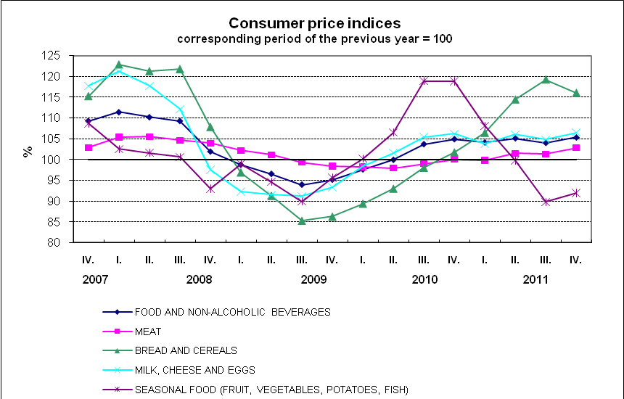

An acceleration of the price growth was demonstrated also in 'transport' due to both higher fuel prices and by a slowdown in the decrease in car prices. Prices of transport services went up by 2.5% (from 1.7% in Q3 2011). Fuel prices climbed by 10.2%, y-o-y in Q4 2011 (by 9.4% in Q3 2011). The trend in consumer fuel prices in relation to the industrial producer prices and import prices of petroleum products is plotted in the following graph.

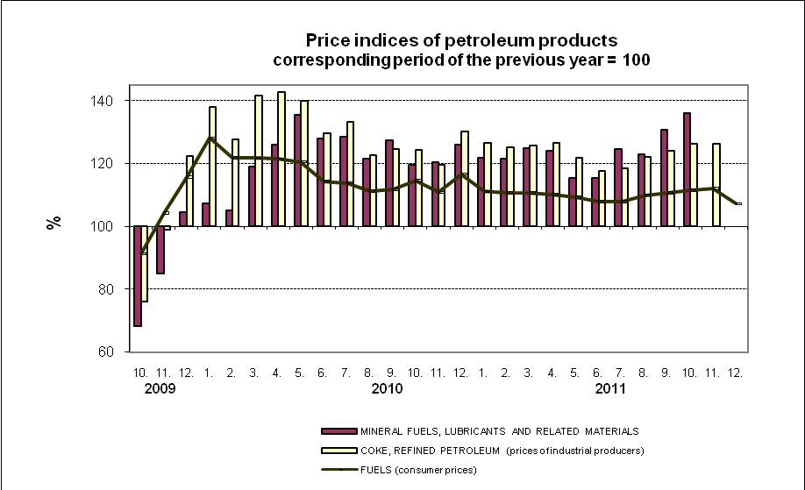

The y-o-y drop in prices, which, however, slowed down in Q4 2011, continued in clothing, household appliances, mobile phones, audio-visual, photographic and information processing equipment.

Prices of goods in total rose by 3.1% (by 2.2% in Q3 2011) and prices of services by 1.3% (by 1.0% in Q3 2011). It can be seen in the graph that in 2011 prices of services grew slower than prices of goods after a four-year period.

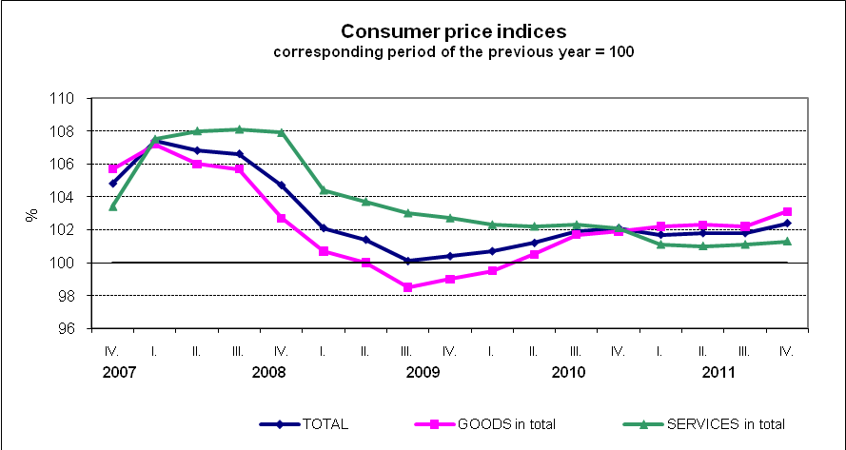

Harmonized index of consumer prices in the EU27

According to Eurostat preliminary data the y-o-y increase in the average harmonized index of consumer prices (HICP) in the EU27 in 2011 was 3.3% in October and 3.4% in November. In the Czech Republic (CR) the y-o-y change of the HICP was 2.6% and 2.9% in the same months. According to preliminary data the HICP growth in the CR amounted to 2.8% in December 2011. It can be seen in the chart below that the y-o-y HICP in the CR was lower than the average HICP in the EU27member states over a long term and their difference was reduced at the end of 2011.

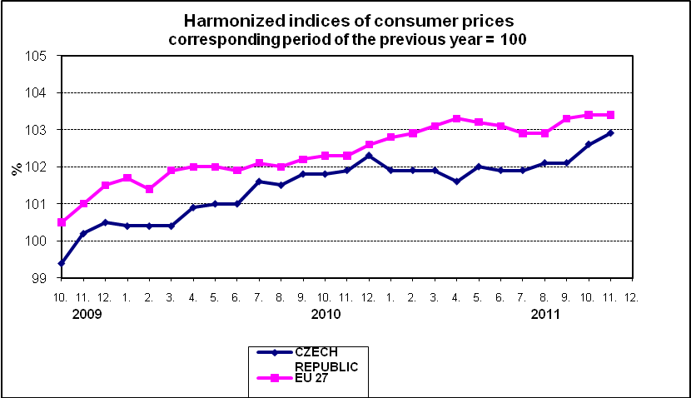

The average inflation rate in 2011 reached 1.9%, which was a value higher by 0.4 percentage points than in 2010. Especially prices in 'food and non-alcoholic beverages' and 'housing, water, electricity, gas and other fuels' increased markedly in 2011 compared with 2010. Concerning the inflation trend since 2000, the inflation was below average in 2011.

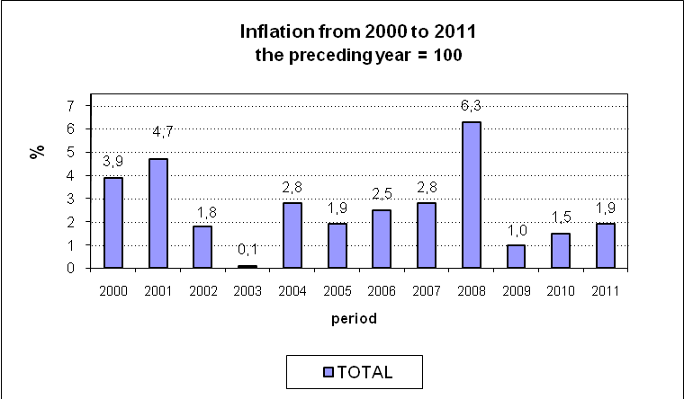

The influence of respective divisions of the consumer basket on the price level increase by 1.9% in 2011 is illustrated in the breakdown of the total increase of the consumer price index.

Breakdown of the y-o-y change of the consumer price index in 2011
in percentage points

DIVISION
TOTAL | 1.9
Food and non-alcoholic beverages | 0.8
Alcoholic beverages and tobacco | 0.3
Clothing and footwear | -0.1
Housing, water, electricity, gas and other fuels | 0.7
Furnishings, household equipment, and routine maintenance of the house | -0.1
Health | 0.1
Transport | 0.3
Communications | 0.0
Recreation and culture | -0.2
Education | 0.0
Restaurants and hotels | 0.1
Miscellaneous goods and services | 0.1

It is clear from the table that prices in 'food and non-alcoholic beverages' had the highest effect on the price level growth and their y-o-y growth appeared at the end of 2010 and then fluctuated in the range of 3.7% and 6.7% for the whole year 2011. Prices in 'food and non-alcoholic beverages' increased by 4.6% on average (by 1.5% only in 2010), of which prices of bread rose by 15.6%, rolls and baguettes by 25.6%, flour by 29.9%, milk by 11.9%, butter by 12.6%, cooking oils by 21.0%, sugar by 21.4%, cocoa by 16.7%, coffee by 18.1%. Prices of vegetables, including potatoes, were lower by 7.1% compared with 2010.

Prices in 'housing, water, electricity, gas and other fuels' had the second highest effect on the growth in the total level of the consumer prices, which was a result of especially the gradual rise in natural gas prices, which on average amounted to 11.8% y-o-y in 2011. Prices of electricity, after their increase by 4.8% in January 2011, kept at this level for the whole year. Prices of the net actual rentals gradually increased in particular due to prices, which were regulated in 2011 as well. The net actual rentals rose by 2.9%, of which for dwellings with regulated rentals by 7.6%.

The development in 'transport' was influenced mainly by prices of automotive fuel, in which the y-o-y growth in 2011 fluctuated in the range of 7.2% and 12.0% following the monthly prices in 2011 and 2010. Prices of automotive fuel increased by 9.9% on average in 2011 compared with 2010, of which prices of diesel oil rose by 12.2%. Prices of diesel oil reached their maximum in history at the end of the year.

The price development in 'clothing and footwear', 'furnishings, household equipment and routine maintenance of the house', 'communications', and 'recreation and culture' affected the reduction of the price level in a similar way as in the recent years due to a permanent moderate decrease in prices of clothing, footwear, household equipment, mobile phones, equipment for the reception, recording and reproduction of sound and pictures.

Consumer price indices Q4 2011

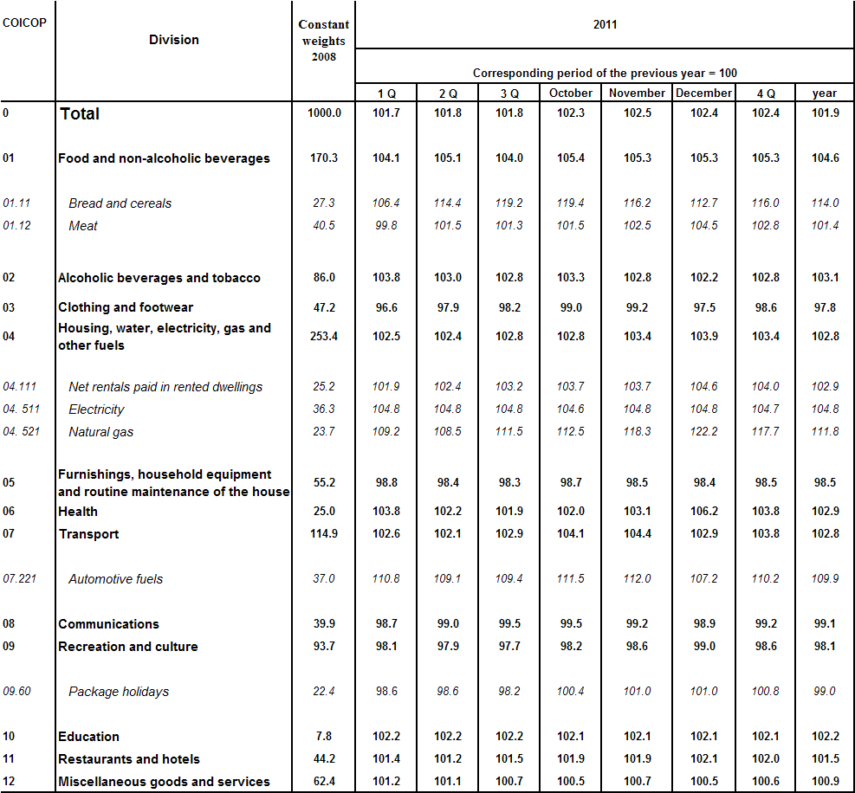

*) Goods and services prices of which are partly or entirely regulated.

