Overall Economic Performance

Gross domestic product shrunk by 0.9 % in 2013, it thus contracted for second year in a row. All significant items of demand apart from the final consumption expenditures of government institutions contributed to the fall |  | Year 2013 was a second recession year in a row. Gross domestic product (GDP) contracted in total by 0.9 %, which was a comparable decrease as in the preceding year. The lowering of performance was similarly to year 2012 a result of the strong pressure of weak demand after gross fixed capital formation, i.e. investment – it contributed to the lower GDP by -0.8 p.p. If in 2012 a slower increase of the stock of inventories occurred in comparison to 2011 in the economy, for the whole year 2013 the inventories in the aggregate fell (due to the slump in Q2) and contributed thus to the contraction of GDP -0.2 p.p. – increase of inventories in the economy renewed again only in the second half of the year. In 2013 the result of foreign trade also contributed to the decrease of GDP (-0.3 p.p.), which occurred last in year 2007 – i.e. on the top of boom resulting from strong domestic demand causing high imports. Opposed to this, in 2013 a negative contribution on the part foreign trade was realised due to the notable fall of exports in Q1 in the year-on-year comparison combined with a relatively strong increase of imports in Q3, most likely allocated into the strengthening of inventories. If also the household consumption negatively contributed to the development of GDP (-0.1 p.p.), the only demand item, which prevented a deeper contraction of GDP in 2013, were the final consumption expenditures of the government institutions (+0.4 p.p.) – in aggregate two years lasting fiscal restriction limiting the consumption of government institutions did not continue in 2013 anymore.
Growth of GDP by 1.9 % in the last quarter of 2013 in the q-on-q comparison was affected mostly by considerable increase of the balance of taxes on products and product subsidies, only then it was caused by real increase of the Czech economy performance |  | Gross domestic product expanded by 1.9 % in the last quarter of 2013 compared to the previous quarter. Such high rate of growth has not been observed since Q1 2007 (2.3 %). However, if we compare the quarter-on-quarter dynamics of GDP with the increase of gross value added (+0.6 %), it is obvious, that the main share on the significant rate of growth belonged to the notable increase of the balance of taxes on products and product subsidies, only then the growth of actual performance of the domestic economy. Reason behind the increase of the balance can be seen in the announced raising of the consumption tax on tobacco starting at the beginning of year 2014 – the traders with this good thus pre-stocked in the last quarter of 2013 and paid its consumption tax, which consequently led to a significant growth of collected taxes on products.
Contraction of performance of domestic economy halted according to the quarter-on-quarter data in the half of 2013 |  | The effect of uneven collection of taxes on products however had an impact throughout the whole year 2013. If it was possible to attribute the marked contraction of GDP in the quarter-on-quarter comparison by 1.2 % at the beginning of year 2013 in part to the weaker collection of taxes on products (again due to the pre-stocking of tobacco products in the last quarter of year 2012 and thus a higher collection of taxes in this period), the quarter-on-quarter rate of growth in Q2 (+0.3 %) was partially affected by a low comparative basis. Only the following increase in Q3 2013 (similarly by 0.3 %) showed, that the contraction of the Czech economy performance ceased – the gross value added increased for the first time in seven quarters, specifically by 0.2 %. Quarter-on-quarter rate of growth of gross value added from the last quarter of 2013 in the amount of 0.6 % confirmed this turn.
Quarter-on-quarter growth of GDP in the CR in the last quarter of 2013 was based on accessible data the highest among the EU28 countries |  | Expansion of GDP in the CR in the last quarter of 2013 – in the quarter-on-quarter comparison – was definitely the highest among the EU28 countries in the view of accessible data. The second place belonged to Sweden (+1.7 %) followed by Lithuania and Slovenia (similarly by +1.2 %). In the whole European Union the GDP expanded by 0.4 %. If at the beginning of year 2013 the GDP in the CR was declining faster compared to the EU28 (by 1.2 %, in the EU28 only by 0.1 %), in Q2 the expansion in the CR was slightly lower (by 0.3 % compared to 0.4 %) and in Q3 the rate of growth already attained similar values. In the year-on-year comparison the GDP in the CR expanded by 1.3 % in the last quarter, i.e. by 0.2 p.p. more than in the EU28. The highest year-on-year rate of growth was recorded in Lithuania (+3.3 %), the deepest contraction occurred in Italy (-0.8 %).
Final consumption expenditures of households did increase already a second quarter in a row in the last quarter of 2013 (in the year-on-year comparison), these numbers were however influenced by very low comparative basis from the second half of the previous year |  | Final consumption expenditures of households increased by 0.7 % in the year-on-year comparison in the last quarter of 2013. The increase of consumption thus occurred already a second quarter in a row (following a mild increase by 0.3 % from Q3), however this development was to a high extent influenced by a very low comparative basis from the second half of the year 2012. So we cannot most likely talk about the recovery of the household consumption yet and it can be assumed, that it will not happen until the time, when the income situation of households improves. This for now do not confirm neither the latest data regarding the development of real wages (in Q4 2013 the wages in the year-on-year comparison fell by 2.9 % - despite this number being strongly affected by marked bonuses paid out in the last quarter of 2012, in the last eight quarters the real wages were reduced already for the sixth time), nor the data related to the unemployment rate of persons aged 15-64 years, which in Q4 2013 reached still high 6.8 % (which is compared to a two-year average only by 0.2 p.p. less). Only the Business Cycle Surveys thus still speak about the optimism of households-consumers, pointing to the gradual mitigation of no-confidence of consumers in the economy already since the half of 2012.
Final consumption expenditures of government institutions has not dropped any more in 2013 – the volume of government institutions consumption was higher in all individual quarters of year 2013 year-on-year |  | Throughout the whole year 2013 the final consumption expenditures of government institutions were year-on-year increasing. If in Q1 and Q2 of 2013 these were higher year-on-year by 1.3 % respectively by 1.5 %, in Q3 and Q4 by 2.6 % and 2.1 %. The growth occurred in 2013 after nine quarters lasting fall. The fiscal restrictions on the expenditure side thus stopped, nevertheless from the increase of the year-on-year rate of growth in the second half of the year 2013 for the time being cannot be deducted further easing of consumption – its growth above the 2 % level in both quarters had roots in very low comparative basis in the second half of year 2012.
In the last quarter of 2013 investment expanded by notable 5.1 % in the quarter-on-quarter comparison and their level was comparable with the Q3 of the previous year |  | In the last quarter of 2013 the volume of new investment in the economy very significantly expanded. If in Q2 2013 the investment fell in the quarter-on-quarter comparison already sixth quarter in a row, only in Q3 it went up by moderate 0.4 %. In Q4 2013 however it increased by high 5.1 %, which was the rate of growth not observed since the beginning of year 2008 (+13 %). The volume of created investment in the last quarter of 2013 was thus higher even in the year-on-year comparison (by 2.7 %) and comparable to the level of investment realised in Q3 2012.
Increase of investment in the year-on-year comparison in the last quarter of 2013 was apparent mostly for machinery and equipment; investment into buildings, constructions and dwelling however still missing in the domestic economy |  | Increase of investment in the last quarter of 2013 directed especially into machinery and equipment – these investment increased by 6 % year-on-year (the structure of investment in non-adjusted data), when their volume had been falling the whole six preceding quarters. Investment into the transport equipment increased too (by 1.9 %, already third quarter in a row), which benefited also the domestic automobile industry, but also into intangible fixed assets, which is a type of investment, whose accumulated balance is compared to other investment relatively low. On the contrary in the Czech economy there is still missing the investment into buildings and constructions (year-on-year decreasing already eleven quarters in a row) and investment into dwellings, which had not grown already twelve quarters in a row. This consequently lowers the performance of the domestic construction in the long term. From the development of the structure of investment in the last quarter of 2013 it can be assumed, that mostly businesses shared on this growth, most likely expecting the improvement of demand for its production. The increase of investment of businesses is thus consistent with the development of confidence of entrepreneurs in the economy.
The optimism of domestic businesses can be also discern from the gradual increasing of the value of inventories in the economy in the second half of year 2013 |  | The development of inventories in the Czech economy also confirmed the positive expectations of businesses in relation to the future economic development. If in Q1 and Q2 of 2013 a gradual reduction of inventories still eventuated by 1.8 and 10.6 bn crowns in current prices, in Q3 the value of inventories already increased by 4.7 bn crowns and in the last even by 6.6 bn crowns (quarter-on-quarter). Even though the already mentioned pre-stocking of tobacco products also probably contributed to this development, its roots most likely lie in the positive anticipations of the future demand development.
Foreign demand for Czech products revived step by step during year 2013. The result of foreign trade however contributed favourably to the performance of the domestic economy in the quarter-on-quarter comparison only in Q2 and Q4 |  | The result of the foreign trade contributed to the development of GDP favourably in Q4 2013 – the exports expanded compared to the preceding quarter by 1.1 %, imports only by 0.3 %. This development was thus the parallel of the Q2 2013, when the exports rose by 2.6 % and imports by 0.6 %, but it was the opposite of Q3, when the exports increased by 1 % and imports by 3.2 %. From the development of exports, which in quarter-on-quarter comparison enlarged apart from Q1 2013 throughout the whole year, a very gradual recovery of the foreign demand was visible. The growth of demand abroad most likely led to the increase of optimism on the side of businesses, which started to increase their inventories. These were most likely partially satisfied from abroad, which proves the already mentioned notable quarter-on-quarter rate of imports in Q3 (+3.2 %).
All main components of demand with the exception of inventories, which grew in the year-on-year comparison slower, worked in the last quarter of 2013 in the direction of year-on-year growth of GDP |  | The increase of investment (+0.6 p.p) the most strongly participated on the growth of GDP in the year-on-year comparison by 1.3 % in the last quarter of 2013, contributing negatively for the whole nine preceding quarters. The final consumption expenditures of households, final consumption expenditures of government institutions, but also the result of foreign trade contributed as well to the growth of GDP similarly 0.4 p.p. The change of inventories (-0.5 p.p.) was thus the only component of demand, which worked in the direction of GDP fall. The inventories in the economy did increase in the last quarter of 2013, however their growth was weaker compared to the same period of the previous year.
The industry strongly contributed to the growth of the aggregate gross value added in the economy in the year-on-year comparison by 0.6 % in Q4 2013, increasing its performance by 2.9 %, in that the manufacturing industry itself by 3 %, ... |  | As already mentioned, the gross value added increased by 0.6 % in Q4 2013 compared to the preceding period and grew already second quarter in a row. It also increased by the same portion in the year-on-year comparison, the growth eventuated for the first time since Q1 2012. Mostly the industry (CZ NACE B-E) contributed to the growth of gross value added in the year-on-year comparison, increasing its performance by 2.9 %, in that the manufacturing industry itself by precise 3 %. It can be assumed, that the growth of the performance of the manufacturing industry was the result of the gradually improving foreign demand during the year in connection with the marked investment activity in Q4 at home.
…on the contrary the gross value added in services as a whole was going down compared to the same period of the previous year already seventh quarter in a row in the last quarter of 2013 |  | The drop of gross value added continued in the year-on-year comparison on the contrary in the group of economic activities trade, transportation, accommodation, restaurants and in information, communication activities (in the last quarter of 2013 similarly by 0.9 %), but also in activities in the real estate area (-2.4 %) or in professional activities (-3.5 %). The gross value added in services as a whole (CZ NACE G-U) fell in the year-on-year comparison for already seventh quarter in a row in Q4 2013 and thus reflected both the weak domestic demand and the saving measures in the public sector. The activities including agriculture, forestry and fishing (-5.7 %) also returned to fall following the year-on-year growth of gross value added in the amount of 1.4 % in Q3 2013.

Chart 1 | GDP (constant prices, adjusted for seasonal and calendar effects, in %) | Chart 2 | GDP (constant prices, adjusted for seasonal and calendar effects, y/y in %, r.a.) and confidence indicators (2005=100, l. a.)
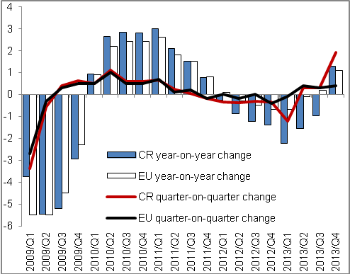 |  | 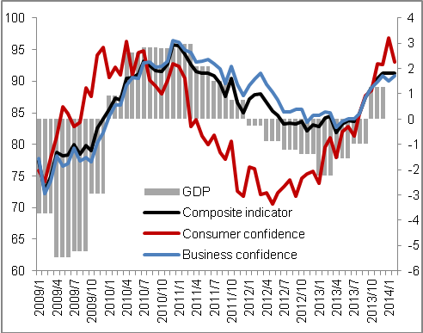
Source: CZSO, Eurostat

Chart 3 | Contributions of expenditure items to GDP change (constant prices, y/y in p.p.) | Chart 4 | Contributions of branches to change in gross value added (constant prices, y/y in p.p.)
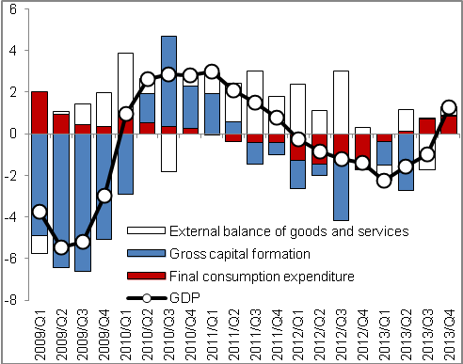 |  | 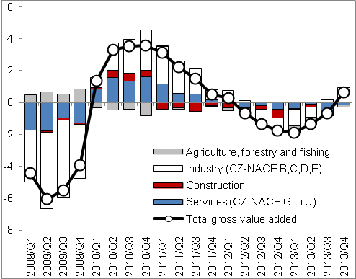
Source: CZSO

In real terms, adjusted for seasonal and calendar effects – unless stated otherwise. Contraction of GDP in 2013 according to non-adjusted data also corresponded to 0.9 %, which was compared to year 2012 by 0.1 p.p. a better result.

