Monetary Conditions

 | Monetary intervention of the CNB from November 2013… |  |  |  | The most significant change in the monetary conditions in Q4 as well as throughout the whole year 2013 was the monetary intervention of the Czech National Bank, which to a considerable extent artificially weakened the exchange rate of the Czech crown. This action from the beginning of November had as its primary goal to prevent deflation with all the consequences, which arise from the fall of prices in the economy. Further construction in the form “Strengthening of competitiveness of exporters due to the weak crown - their higher incomes - creation of bigger number of jobs - improvement of growth of wages - increased household consumption (including the awareness of its initial weakening by the inflation impulse flowing from the higher import prices) - possibility of improved investment - long-term income effect in the form of higher growth of GDP” can be given the actual absence of the economic policy understood as an attempt to resolve the two-year recession of the Czech economy.
 | … - for assessment of wider impacts on the real economy still a very short time elapsed |  |  |  | Risks flowing from the fact, that some of the expectations linked to the mentioned construction are not going to be fulfilled, do not show according to the first „post intervention“ data from the real economy for the time being to be fatal. Faster growth of export prices compared to import prices strengthened given the import-export nature of the Czech economy the profits to the export companies. To explain the proven higher investment in the last quarter of 2013 by this fact is however still premature. Within the range of consumer prices, the inflation rate is low, production prices in the industry are following the first impact connected to the weaker crown affected as a whole by the slump of the energy prices. Household consumption stagnated quarter-on-quarter in Q4, wages were affected by extraordinary influences (more in the Chapter on Labour Market).
 | Expansion of bank loans to non-financial businesses provided in foreign currencies… |  |  |  | Significant turn arrived according to the banking statistics data in the loan dynamics provided to non-financial businesses (rezidents). Massive lending to businesses, especially in foreign currencies is apparent approximately from August 2013 and both the rate and absolute additions to the balances of these loans further sharply increased towards the end of the year.  This commencement of the loan expansion targets mostly loans to businesses in foreign currencies and is dominated by long-term loans. While from August till December 2013 the aggregate balances of loans to businesses expanded on average year-on-year by 2.1 % every month - while in November and December by 4 %, resp. 3.8 % -, increments of business loans in foreign currencies were several times higher: they enlarged during that time monthly on average by 15.5 %, while in November by 22.5 % and in December even by 28.5 %. The month-on-month boosts in balances of these loans were especially sharp – in November they rose by 27.9 bn crowns compared to October, in that loans in foreign currencies by full 21.1 bn crowns. At the same time, such jump cannot be of course attributed to pure conversion of these foreign-currency loans into crowns due to the depreciation of the currency.  Simultaneously, the bank loans to non-financial businesses in foreign currencies are not with respect to volume in the Czech economy negligible (towards the end of 2013 they amounted to 22.2 % of total loans to non-financial businesses, for medium term loans even 31.6 %), even though the interest differential promotes in theory rather the loans in Czech crowns.
 | … occurs mostly for long-terms loans and there is hope for the expansion of investment activity |  |  |  | The long-term loans play the largest part in the sharp rise of loans to businesses – they shared 21.3 bn crowns out of total addition to bank loans to non-financial businesses from August till December in the amount of 31.2 bn. . Analogous to this, out of the additions to the loans in foreign currencies themselves the businesses borrowed from banks for a period longer than five years 15.5 bn crowns.  Since the long-term loans have an investment nature, their high proportion can be considered the start of the Czech economy to the revival of investment activity assuming these massive growths are not caused mostly by the financial investments. With respect to economic activity, majority of these additions to long-term loans belongs mainly to non-financial businesses specialised on the real estate area.
 | Deposits of households and businesses in total falling for the second year in a row |  |  |  | Deposits in the banking sector on accounts with maturity and accounts with a notice period were in the aggregate number for both households and firms by 2 % lower by the end of year 2013 in comparison to the same period of 2012, when however their year-on-year slump was even deeper (-3.8 %). In years 2011 and 2010 these deposits were still year-on-year increasing. The recession weakened the dynamics of disposable incomes of households, which had the decisive effect on the fall of total deposits – their regular deposits on accounts with maturity fell nearly by one tenth (-9.5 %) by the end of 2013 and thus also weakened the households deposits with a notice period (-1.3 %). People thus partially utilise the previously saved funds for consumption.
 | The rate of growth of loans to population on housing strengthened, consumption loans after the previous falls of balances went slightly up |  |  |  | In spite of less favourable situation with respect to the household incomes the loans to population were boosted in 2013 more than in 2012 – the balances of mortgages were year-on-year higher by 5.2 % in December 2013 and amounted to 852.1 bn crowns, in that mortgages 746.4 bn crowns (+6.6 %). The long-time falling balances of consumption loans also slightly revived (+0.4 % year-on-year compared to -0.7 % from the end of 2012) and reached 195.2 bn crowns. It is however obvious, that the segment of loan clients is for both types of loans rather different.
 | Growing volume of both currency in circulation and property in mutual funds |  |  |  | The volume of currency enlarged year-on-year by 4.3 %, i.e. more than presented addition by the end of year 2012. It suggests, that a significant part of the household purchasing power can lie as ready cash in homes (hoarded money). Regarding the alternatives of household savings to bank deposits and their eventual strengthening to the detriment of these regular deposits, data known at the time of this analysis preparation were limited only to the volume of property in mutual funds. These data show, that households and institutions saved in domestic and foreign mutual funds operating in the CR in total 269.8 bn crowns by the end of year 2013, which was year-on-year by 14.7 % more. This very favourable expansion however does not mean, that people and institutions purchased by 34.6 bn crowns more mutual fund shares. It is given mainly by the favourable development on the financial markets, especially the share markets (property in these markets enlarged year-on-year by 27.4 %), which above all enabled such strong increase of property.
Chart 19 |  |  | Bank loans to non-financial businesses in foreign currency (y/y, in %) |  |  | Chart 20 | Household deposits (y/y, in %)
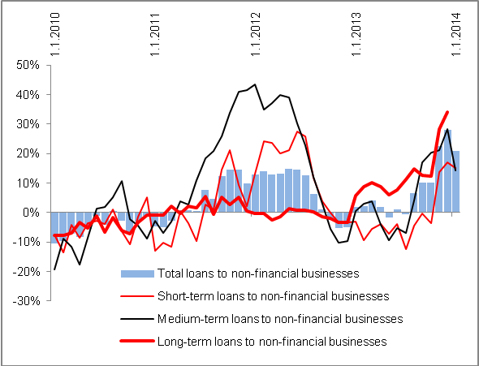 |  |  |  |  |  | 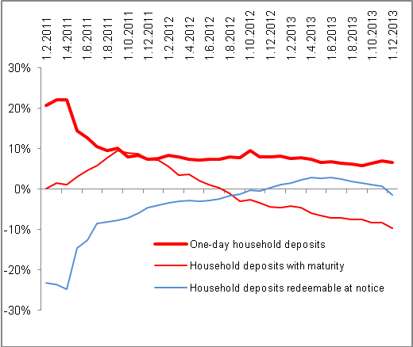
 |  | Source: CNB, own calculations

