The Czech Economy Development in 2012 March 2013

Labour Market
 | - “Paradoxes” of Czech labour market in 2012 |  |  | Situation on the Czech labour market was characterised in the year 2012 by several on the first sight opposing phenomena. In spite of the economy finding itself according the development of GDP in recession, the rate of employment has been continuously growing for already several quarters in a row. Simultaneously, the number of registered persons without a job strongly grows and the rate of unemployment is increasing. These phenomena can be explained at the micro level of the labour market and are connected to the usage of alternative types of work opportunities compared to those, which are given by an employment relationship or entrepreneurship. Apart from the employment, the atypical development also occurred in Q4 in the sphere of wages.
 | - Total employment in 2012 increased and its additions during the year accelerated |  |  | In 2012 there were – according to the data from the national accounts conception – total of 5 091.5 thousand of persons working in the CR, i.e. by 0.39 % more than in 2011, when the employment also rose (+0.26 %) following two years of year-on-year decreases (-1.78 % in 2009 and -1.02 % in 2010). In addition, the growth of total employment accelerated during the year, lead by its improvement in industry (still the numbers of employed were for the whole year 2012 lower). Dynamics of the strongest grouping given the employment, i.e. trade, transportation, accommodation and hospitality was on the contrary throughout the year 2012 weakening.  .
 | - Decreases of employed in industry, agriculture, construction and public services, additions mostly in trade and transportation |  |  | Apart from industries where the number of employed persons in 2012 decreased, i.e. in agriculture (-1 %), industry (-0.3 %), construction (-1.1 %) and public services (governance, defence, education and health and social care) by 0.4 %, in other industries the employment grew. In that the most in activities in the real estate area (+5.8 %), in financial services and insurance services (+4 %) and in total for professional, scientific, technical and administrative activities (+2.1 %).  The most new workers were absorbed by trade (12 thousand), which gives work to more than one quarter of employed in the Czech economy, as well as the industry – here however the job places were disappearing in 2012 (-4.2 thousand of persons). Decreases of job positions in some fields were not as deep as in 2011. E.g. public services, which cut over 31 thousand of job positions in the last four years (in that 16.8 thousand in 2011) recorded in 2012 a loss of 3.6 thousand of employed persons. In construction the number of employed has been falling already for three years in a row (in total -26.9 persons), in that in 2011 over 14.3 thousand of persons and in 2012 further 5.2 thousand of persons.  The working as an employment relationship however as opposed to the total employment has been decreasing for four years in a row. In 2012 however only one thousand of employees left (compared to 17 thousand in 2011 and 89 thousand in 2010), the most in public services (-6.2 thousand), in construction (-6.2 thousand) and manufacturing industry (-5.9 thousand).
 | - The number of employees falling year-on-year |  |  | A group of persons without the employee status thus participated on the growth of aggregate employment in the CR economy, composed not only by entrepreneurs (physical persons with Identification Number), but also helping family members, people working on work contracts and working activity contracts and owners of business companies (whose main activity is the work in this company). It can be assumed, that it is this group strengthening the total employment in the CR even in times of economic recession.  In 2012 there were 955.8 thousand of persons working, which was by 21 thousand more than in 2011. In percentage terms, the highest increase was in financial services (+8.3 %), public services (+7.1 %), activities in the real estate area (+6.5 %) and also in so called other activities (+5.9 %), i.e. in total +15.2 thousand of persons.
 | - General rate of unemployment increased, it stayed lower compared to the EU and the euro area |  |  | General rate of unemployment according the methodology of the International labour organisation increased during the year 2012 to 7 % of population aged above 15 years, following 6.7 % in 2011 and 7.3 % in 2010. During the year 2012 it grew gradually seasonally adjusted from 6.8 % in Q1 to 7.2 % in Q4. In the EU 27, there were by the end of 2012 10.7 % of people without a job, in the euro area 11.8 %. One digit rate of general unemployment recorded in the EU apart form the CR also 11 another countries (the lowest was in Austria 4.7 %, Luxembourg 5.2 % and Germany 5.3 %). In Greece and Spain, more than one quarter of people were without a job (26.4 % resp. 26.1 %).
 | - Historically the highest number of registered persons without a job |  |  | The number of registered persons without a job increased in December 2012 to 545.3 thousand of persons (by the end of February of 2013 then to 593.7 thousand of persons). The rate of registered unemployment at the year’s conclusion arrived at 9.4 %. The growth started only in September (8.3 %), till the half of the year the rate of registered unemployment was falling. The number of job vacancies in reality for the whole year stagnated, which indicates that the growing employment can be ascribed in most part to the works done on contracts, helping of family members etc.
 | - Reserves in the flexibility of the CR labour market |  |  | The labour market in the CR still displays large reserves, with respect to its flexibility. According to the Eurostat data for year 2011, e.g. the part-time jobs were used by 32 % of employed women in the age of 25-54 caring for one child, in the CR only 11 % women (for females with no children this ratio was 22 % to 4 %).
 | - The growth of average nominal wage in Q4 result of tactics of firms in connection to the legislative change… |  |  | The average monthly nominal wage in 2012 increased compared to 2011 by 665 crowns to 25 101 crowns, i.e. by 2.7 %. It grew faster in the business (+2.8 %) than in the non-business sector (+2.2 %). Despite the year-on-year increments of wages decreasing during the first three quarters, in Q4 a significant rise occurred especially in the non-business sector (e.g. in financial services and insurance industry nearly by one quarter). It can be assumed, that this largely atypical development had a connection with the tactics of employers to use the so far favourable legislation for the provision of extraordinary benefits. Similar effect, however, with „the opposite sign“ occurred in year 2008, when in its Q1 the average wage in the business sector grew year-on-year by 11.4 % due to the transfer of benefits, which were paid out standardly in Q4 of the previous year („ceiling“ of paid social insurance for high income employees).
 | - …was not expressed in the non-business sector and lead here to the drop of real wage for already ten consecutive quarters |  |  | In the non-business sector this effect did not occur. The drop in the rate of growth of the average nominal wage continued also in Q4 2012.  As a result the decrease of the real wage for year 2012 (-1.1 %) was maintained for the second consecutive year – following the real stagnation in 2010 and continuous declining lasting already ten quarters – and it was deeper than for the real wage in the business sector (-0.5 %). Average wage in the economy thus fell in real terms by 0.6 %, even though in Q4 the above mentioned reasons caused its temporary addition (+0.9 %).
Chart 15 |  |  | Aggregate employment and number of employees (y/y in %, seasonally adjusted) |  |  | Chart 16 | Nominal and real wage (y/y in %, to recalculated numbers, monthly average)
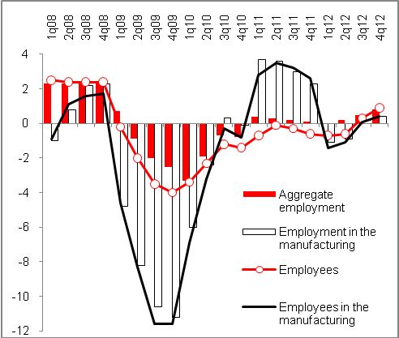 |  |  |  |  |  | 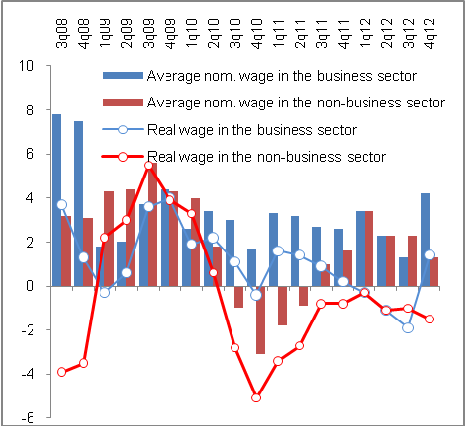
Chart 17 |  | Number of persons without a job (in thousand) and registered rate of unemployment (in %) |  |  | Chart 18 |  |  | Development of the number of job vacancies (selected regions)
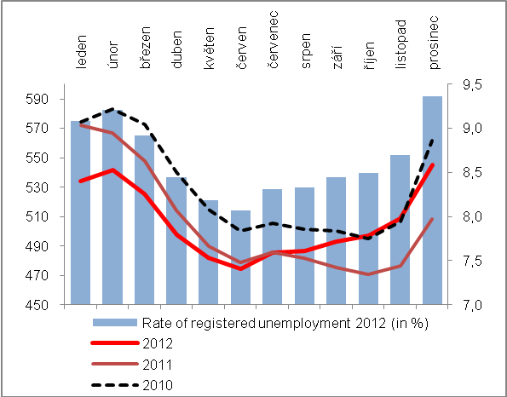 |  |  |  |  | 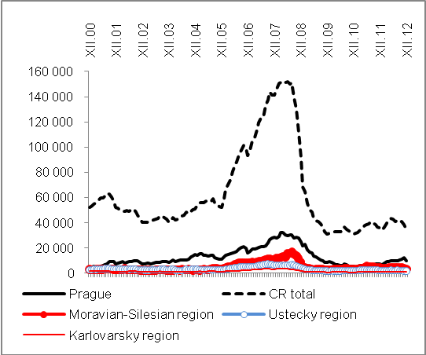

Source: CZSO, MLSA

