4 December 2012

COMMENTary: development of average wages of employees in Q3 2012

The growth in average nominal wages has been decelerating and has been accompanied with a decrease in the number of employees as well as in the number of hours worked, especially overtime hours; the number of days of absence has been increasing. Prices have been rising substantially faster than wages.

Up-to-date data on employees and wages in the Czech Republic economy have brought an image of gradual deepening of the negative trend. The average nominal wages increased by mere 1.4% in Q3 2012, compared to the same period of the previous year. This is the lowest but one increase since the beginning of the comparable time series in 2000 (following 0.7% in Q4 2010).

In Q3 2012 the registered number of FTE employees decreased by 1.1% compared to the same period of the previous year and this means it dropped by almost 41 thousand persons.
The increase in the average nominal wages did not compensate the growth of consumer prices - inflation, which was 3.3% in the period measured. Therefore, in Q3 2012 the real purchasing power of the employees declined by 1.8%.

The main reason is in a significant slowdown of dynamics of the business sector in which the wage growth, nominally by 1.3%, was by one percent point lower than that in the previous quarter, while in the non-business sphere the growth in salaries was the same as that in Q2 2012 (2.3%).

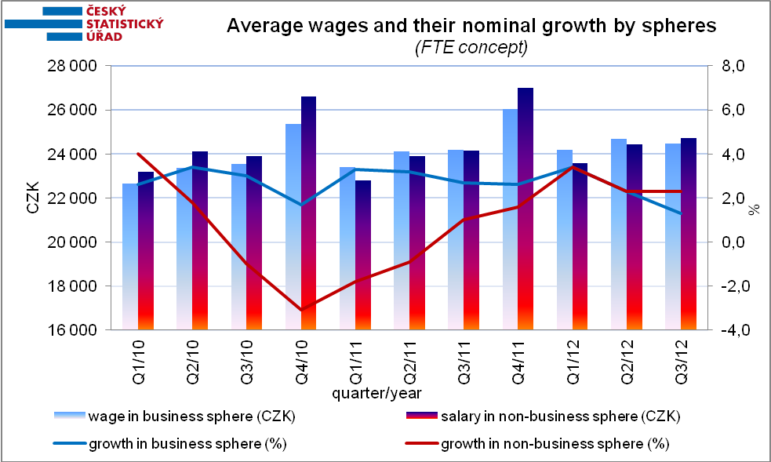

As a result of an implemented change to the methodology the wage levels of the business sphere and the non-business one have got closer to each other since Q1 2012 and in Q3 2012 the average wage in the non-business sphere was higher by CZK 232. However, the average wages in both the spheres were decreasing in real terms. While the business sphere experiences a decline in the average real wage this year for the first time, in the non-business sphere there has been a negative trend continuously since Q3 2010. The number of employees has also decreased in both the sphere recently compared to the same period of the previous year, in the business sphere by 1.2% and in the non-business one by 0.5%.

From points of view of institutional sectors and size groups of companies, as well as of respective economic activities, the development was differentiated. In three sections of the CZ-NACE real wages increased and other sections experienced drops of various sizes, in five of them even a nominal decrease occurred. In section of ‘accommodation and food service activities’ there was a decline in the number of employees by 5.6% while the average wages in the activities decreased nominally by 1.7%. Conditions in ‘construction’ were also not at ease because the number of employees dropped by 4.3% (i.e. by 10.4 thous. persons) year-on-year while the average nominal wage increased by 0.4%.

‘Manufacturing’, which is the largest economic activity of the national economy, recorded a positive trend in employment in Q1 2012 but in the current period there has been a decrement by 0.8%, i.e. by 9.0 thous. persons compared to the same period of the previous year. The recession continued in ‘public administration and defence’ where both real earnings and numbers of employees (currently by –2.5%) have been decreasing over a long term. The numbers of employees in ‘human health and social work activities’ decreased again (-1.4%) and the number of employees in ‘education’ stagnated. The development in ‘transportation and storage’ has brought also adverse message with a fall in the number of employees by 2.2%, i.e. by 5.4 thous. persons and the average nominal wage decreased by 0.8%.

On the other hand, ‘financial and insurance activities’ recorded a significant growth in wages and in the number of employees when the number of employees grew by 0.2% and the average wage increased by 2.8%. The economic activities of ‘information and communication’ were also doing good, the average wage in these activities rose even by 4.1% and the number of employees increased by 0.9%.

* * *
The cumulative data for the Q1 to Q3 2012 demonstrate a nominal growth in the average wage by 2.4%, however, once an increase in inflation by 3.4% has been taken into account the average wage falls by 1.0% in real terms. The adverse development for the entire period is even further depicted by a decrease in the number of employees by 0.9%, i.e. by 32.6 thous. persons. There was a rather substantial increase in the number of employees solely in ‘real estate activities’ (by 7.6%), yet it was accompanied by a decrease in their average nominal wage by 4.9%. From points of view of the respective spheres the average wages increased in similar manner: nominally by 2.3% in the business sphere and by 2.6% in the non-business one. The numbers of employees slightly decreased in both the spheres: in the business sphere by 0.9% and in the non-business one by 0.5%.

* * *

The minimum wage has showed no change since January 2007 and accounts for CZK 8 000.

Dalibor Holý
Labour Market and Equal Opportunities Statistics Department of the CZSO

