16 February 2026

Sector of services was strengthening its position on the labour market for a long period of time

Employment and unemployment in the Czech Republic as measured by the Labour Force Sample Survey – 4th quarter of 2025
The number of the employed persons was by 68.2 thousand higher, year-on-year (y-o-y); the total employment thus moderately increased. The number of the unemployed, according to the methodology of the International Labour Organization (ILO), increased by 24.7 thousand persons. The number of the economically inactive aged 15+ years decreased by 18.7 thousand, during the same period.

Employment

In the Q4 2025, the seasonally adjusted average number of employed persons increased by 6.5 thousand persons, compared to the Q3 2025.

The number of working persons aged 15+ years slightly increased, y-o-y. In the Q4 2025, an increase by 68.2 thousand persons (i.e. by 1.3%) to the total of 5 272.2 thousand employed persons was recorded. The increase was mainly thanks to an increase in the number of working females. Their number was by 78.3 thousand higher, y-o-y, whereas the number of working males decreased by 10.1 thousand persons. The most marked increment was recorded in working persons aged 60+years; their number increased by 79.5 thousand (i.e. by 14.2%). An increase was also recorded in the youngest age category of 15–24 years, in which there were by 26.4 thousand persons more (i.e. by 10.0%). The number of working persons also moderately increased in the age group of 45–59 years, namely by 38.5 thousand persons (i.e. by 1.8%). On the other hand, there was a year-on-year decrease in the age group of 30–44 years, where the number of working persons dropped by 65.3 thousand persons (i.e. by 3.5%) and in the age group of 25–29 years by 10.8 thousand persons (i.e. by 2.6%). Year-on-year changes in the number of working persons in individual age groups are to a considerable extent influenced by the demographic structure of the population and by shifts of persons to higher age groups.

Chart 1: The number of working persons in the national economy and their structure by age group (thousand)

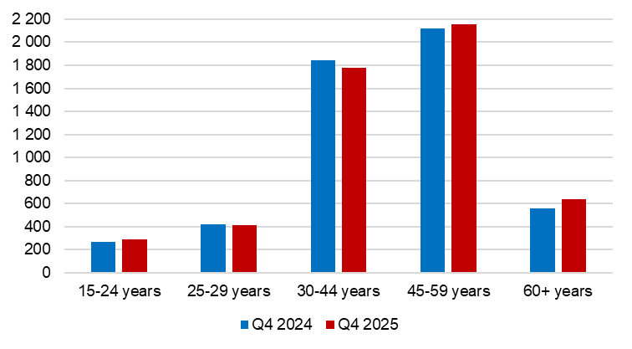
Source: CZSO, LFSS

In terms of sex, the most marked relative decrease in the number of working persons was recorded in females in the age group of 25–29 years, among whom the number decreased by 13.5 thousand persons (i.e. by 7.5%). Conversely, the biggest relative increase was among males aged 60+ years, the number of whom increased by 44.7 thousand persons (i.e. by 14.6%).
The number of employees increased by 33.2 thousand, i.e. by 0.8% to 4 425.0 thousand persons. The number of the self-employed (without unpaid contributing family workers) increased by 36.3 thousand persons. The number of the self-employed without employees (own-account workers) increased by 34.0 thousand (i.e. 5.0%), the number of the self-employed with employees (employers) increased by 2.3 thousand, y-o-y (i.e. by 2.0%). To put it concretely, the number of the self-employed (entrepreneurs) without employees was 719.8 thousand and that of entrepreneurs with employees 116.1 thousand. In the Q4 2025, the share of the self-employed in the total employment was 15.9%.
According to data for the Q4 2025, the development of employment in individual economic activities (CZ-NACE sections) in the Czech Republic was different⁾. In the primary sector of agriculture, forestry and fishing, the number of working persons decreased, year-on-year, by 10.1 thousand to 135.6 thousand. In the secondary sector of industry and construction, employment also slightly decreased; a decrease in the number of working persons by 37.6 thousand to 1 802.7 thousand persons was recorded. In the tertiary sector of services, the total employment increased, y-o-y, by 115.8 thousand to 3 333.9 thousand persons. In this sector, the highest relative increase in the number of working persons was in the section of ‘administrative and support service activities’, namely by 17,3 thousand persons, i.e. by 15.0%, the section of ‘arts, entertainment and recreation’ was also considerably increasing (by 9.8 thousand persons, i.e. by 10.5%). A decrease in employment was recorded, for example, in the section of ‘real estate activities’, in which by 2.2 thousand less persons worked (i.e. by 5.3%) and in the section of ‘wholesale and retail trade, repair of motor vehicles and motorcycles’, in which there was a decrease by 17.6 thousand persons (i.e. by 3.1%).

63.2% in total worked in the tertiary sector of services out of all working persons in the Q4 2025. In terms of sex, females were markedly prevailing in services. 77.7% of working females were working in this sector, whereas 20.7% of females worked in the secondary sector and 1.7% in the primary sector. Males had much smaller representation in services. 50.8% of working males worked in the tertiary sector, 45.9% in the secondary sector, and 3.4% in the primary sector. The biggest share of males employed in services worked in the section of ‘wholesale and retail trade, repair of motor vehicles and motorcycles’ (17.7%), ‘transportation and storage’ (16.6%), and ‘administrative and support service activities’ (12.0%). Females in services worked most often in the section of ‘education’ (19.4%), ‘public administration and defence; compulsory social security’ (18.1%), and ‘wholesale and retail trade, repair of motor vehicles and motorcycles’ (16.0%).
The share of employment in the sector of services has been increasing over a long period of time. 10 years ago, in the Q4 2015, 58.8% of all working persons worked there; 74.3% of the total number of working females and 46.9% of working males. 30 years ago, in 1995, 51.9% of all working persons worked in the sector of services, while 64.2% of females and 42.2% of males worked there. In the years 2015 and 1995, both sexes worked the most often in the section of ‘wholesale and retail trade, repair of motor vehicles and motorcycles’.
Chart 2: The number of working persons in the national economy by economic activity (thousand)
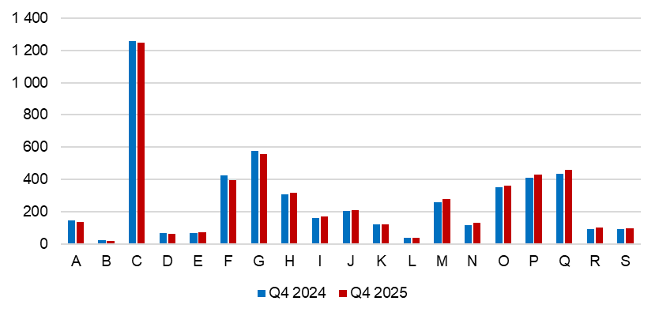
A – Agriculture, forestry and fishing; B – Mining and quarrying; C – Manufacturing; D – Electricity, gas, steam and air conditioning supply; E – Water supply; sewerage, waste management and remediation activities; F – Construction; G – Wholesale and retail trade; repair of motor vehicles and motorcycles; H –Transportation and storage; I – Accommodation and food service activities; J – Information and communication; K – Financial and insurance activities; L – Real estate activities; M – Professional, scientific and technical activities; N – Administrative and support service activities; O – Public administration and defence; compulsory social security; P – Education; Q – Human health and social work activities; R – Arts, entertainment and recreation; S – Other service activities.
Source: CZSO, LFSS

Along with changes in the structure by economic activity (CZ-NACE section), changes in the structure of working persons by occupation occurred, too. According to the Classification of Occupations (CZ-ISCO), the number of working persons increased relatively the most in the major group of elementary occupations (by 21.0 thousand persons, which is an increase by 8.0%) and the group of technicians and associate professionals (by 47.0 thousand persons, i.e. by 5.5%). The biggest decrease occurred in the major group of skilled agricultural, forestry and fishery workers (by 7.8 thousand persons, i.e. by 11.2%).

Chart 3: The number of working persons in the national economy by Classification of Occupations (thousand)

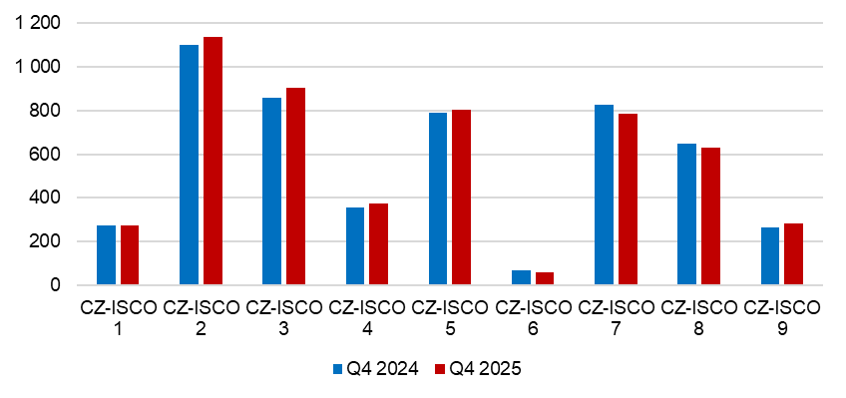
CZ-ISCO 1 – Managers; CZ-ISCO 2 – Professionals; CZ-ISCO 3 – Technicians and associate professionals; CZ-ISCO 4 – Clerical support workers; CZ-ISCO 5 – Service and sales workers; CZ-ISCO 6 – Skilled agricultural, forestry and fishery workers; CZ-ISCO 7 – Craft and related trades workers; CZ-ISCO 8 – Plant and machine operators, and assemblers; CZ-ISCO 9 – Elementary occupations.
Source: CZSO, LFSS

The number of working persons by level of education attained (educational attainment) is also developing along with the mentioned changes in the employment structure. The number of working persons with primary education remained almost unchanged; there was an increase by 2.9 thousand to 233.5 thousand persons. The number of working persons with secondary education without A-level examination decreased by 10.8 thousand to 1 563.0 thousand persons. On the other hand, the number of working persons with secondary education with A-level examination increased by 19.9 thousand, y-o-y. The biggest increase was in employed persons with tertiary education by 55.3 thousand to 1 540.8 thousand working persons. That increase was mainly in working females with higher education the number of whom increased by 34.2 thousand, year-on-year.

The employment rate (the percentage of working persons in the age group of 15–64 years old) stagnated in the Q4 2025 compared to the corresponding period of the previous year; it decreased by 0.1 p. p. to 75.7%. The development among males and females was opposing. A year-on-year change was also minimum in both sexes. The male employment rate decreased by 1 p. p. to 80.2%, whereas in female one there was a moderate increase by 0.9 p. p. to 71.1%.
The increase in the total employment was also influenced by the development of part-time jobs in main employment the number of which has been increasing during recent years.
In the Q4 2025, 514.2 thousand persons worked part-time, which is by 30.9 thousand persons more, y-o-y (an increase by 6.4%). In 2018, 387.9 thousand persons worked part-time, which means that during the last seven years their number increased by 126.3 thousand (i.e. an increase by 32.6%).
The year-on-year increase in the number of part-time jobs in the Q4 2025 was mainly related to their increase in females, in whom the increment reached 25.6 thousand persons (an increase by 7.5%). In males, the number of part-time jobs increased by 5.3 thousand persons (an increase by 3.7%).
In the reference period, 365.6 thousand females worked part-time. It was 71.1% of all persons working part-time in their main employment. Reduced working hours allowed them for greater flexibility, especially when carrying out care duties. Females worked the most often in the economic activity of ‘education’, ‘human health and social work activities’, and ‘wholesale and retail trade, repair of motor vehicles and motorcycles’. Of the total number of all working females, 15.0% of them had a part-time job.
Females most often stated that they had part-time jobs due to other personal reasons (72.3 thousand), because they cared for a child or an adult needing care (65.7 thousand) or they stated that only a part-time job was available (58.4 thousand). The highest number of females working part-time was in the age of 30–44 years (128.1 thousand, i.e. 35.0% of all females working part-time).
Considerably fewer males used reduced working hours. 148.6 thousand males had a part-time job, which is only 5.3% of all working males. They worked mainly in ‘wholesale and retail trade, repair of motor vehicles and motorcycles’, ‘public administration and defence; compulsory social security’, but also in ‘manufacturing’. As for males, they worked for reduced working hours especially due to other personal reasons (45.0 thousand). The highest number of males working part-time was in the age of 60+ years (65.1 thousand, i.e. 43.8%). Females thus mainly use part-time jobs while taking care of small children; males work part-time in their higher age.
Chart 4: The number of part-time workers and their age structure (thousand)

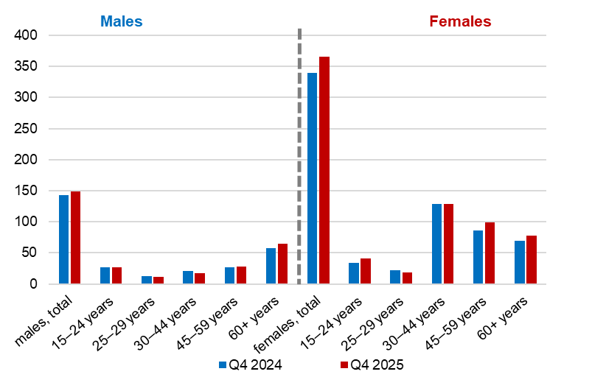
Source: CZSO, LFSS

Unemployment

The seasonally adjusted average number of unemployed persons according to the ILO methodology⁾ increased in the Q4 2025 by 7.2 thousand, compared to that in the Q3 2025.
Chart 5: The number of the unemployed in Regions of the Czech Republic (thousand)
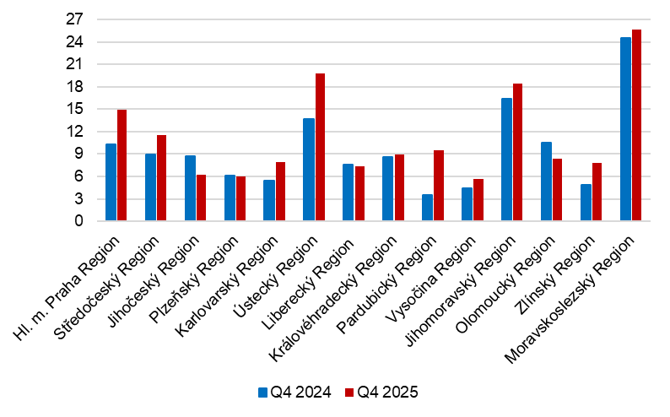
Source: CZSO, LFSS

The total number of the unemployed aged 15+ years increased by 24.7 thousand to 158.2 thousand persons, year-on-year. The number of unemployed females increased by 9.1 thousand to 82.1 thousand. The number of unemployed males by 15.6 thousand to 76.1 thousand. The unemployment often affects persons in lower middle age; the highest number of the unemployed was in the age category of 30–44 years; the number of unemployed males in that age was 22.7 thousand and of females 31.5 thousand.
The number of persons unemployed for one year and longer (the long-term unemployed) also increased, by 12.9 thousand, y-o-y, to 52.2 thousand persons. In the Q4 2025, 33.0% of the unemployed were thus unemployed for a long period of time.
A higher increase in the number of the unemployed for one year and longer was in males; it increased by 9.0 thousand; the number of the long-term unemployed females increased by 3.9 thousand.
The number of the long-term unemployed males was 26.8 thousand in total; most of them were in the age of 30–44 years (8.5 thousand). In females, the number was 25.5 thousand, while the most of them were also in the age group of 30–44 years (8.9 thousand). A higher number of the long-term unemployed was also in the age group of 45–59 years; there were 8.2 thousand of the long-term unemployed males and 7.9 thousand females.
Chart 6: The number of the long-term unemployed (for 1 year and longer) and their age structure (thousand)
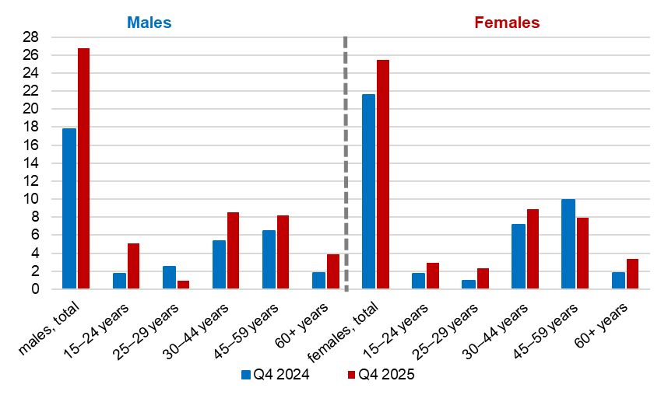
Source: CZSO, LFSS

The general unemployment rate according to the ILO definition in the age group of
15–64 years old (the percentage of the unemployed in the labour force, i.e. in the sum of the employed and the unemployed) increased by 0.4 p. p., year-on-year, and in the Q4 2025 it was 3.0%.

Chart 7: Unemployment rate of the 15–64 years old in Regions of the Czech Republic (%)
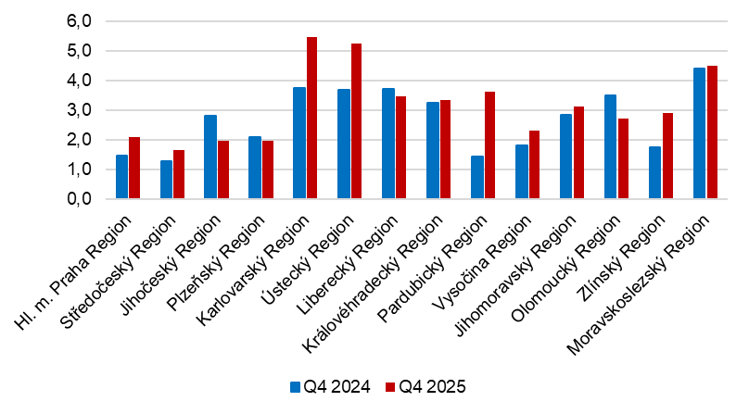
Source: CZSO, LFSS
In terms of a regional comparison, the general unemployment rate of the 15–64 years old was the highest in the Karlovarský Region (5.5%), in the Ústecký Region (5.2%), and in the Moravskoslezský Region (4.5%). The lowest values were reported by the Středočeský Region (1.6%), by the Jihočeský Region and the Plzeňský Region (both the same 2.0%), and by the Hl. m. Praha Region (the Capital City of Prague; 2.1%). The most marked year-on-year decrease in the unemployment rate was in the Jihočeský Region (by 0.8 p. p. to 2.0%) and in the Olomoucký Region (by 0.8 p. p. to 2.7%). On the other hand, the biggest y-o-y increase was in the Pardubický Region (by 2.2 p. p. to 3.6%), and in the Karlovarský Region (by 1.7 p. p. to 5.5%).

Economic inactivity

The number of economically inactive persons aged 15+ years was by 18.7 thousand lower, year-on-year, and amounted to 3 445.5 thousand. The number of economically inactive males increased by 14.9 thousand to the amount of 1 388.3 thousand, whereas the number of economically inactive females was by 33.6 thousand lower than a year ago and their number thus was 2 057.2 thousand.

In the sample survey, data are also collected on persons who do not work and do not seek a job in an active manner and therefore do not comply with the ILO conditions for the unemployed, yet they state that they would like to work. In the Q4 2025, the number of such persons was 75.1 thousand persons, i.e. by 1.9 thousand persons less than in the corresponding period of 2024. The number of persons who are willing to work, however, they are not able to start in a potential job immediately, is relatively high. Only 15.8 thousand of the persons are able to start in a job within a fortnight, at the latest.

Note:
Data in the analysis are not seasonally adjusted, unless otherwise stated.
Recalculation to the same population structure
The Labour Force Sample Survey (LFSS) is carried out in selected dwelling households. Collective accommodation establishments are not included in the survey. The data found were weighted to the population of the Czech Republic based on the results of the population statistics as at the beginning of the reference quarter; estimates of the number of persons living outside private households were subtracted from the population totals of the demographic statistics.
Starting with the Q1 2026, results in the quarterly analysis will be published in the territorial breakdown on the NUTS 2 level (cohesion regions) instead of the existing NUTS 3 (Regions).
Authors:
Marta Petráňová, phone number: (+420) 274 054 357, e-mail: marta.petranova@csu.gov.cz
Gabriela Strašilová, phone number: (+420) 567 109 071, e-mail: gabriela.strasilova@csu.gov.cz
Labour Force Statistics Unit

⁾ Data for economic activities (CZ-NACE sections) may be influenced by the employed methodology of the Labour Force Sample Survey (LFSS). The survey only covers persons living in dwellings (flats), i.e. private households. Data on persons living in collective accommodation establishments are not measured; these establishments often give accommodation to foreign nationals.
⁾ The ILO methodology defines the unemployed as persons who during the reference period were without a job, did not work an hour for pay or remuneration, and were in an active manner seeking a job they would be able to join within fortnight at the latest. This methodology is uniform for all EU Member States and provides internationally comparable data. It has to be taken into consideration that the definition of “the unemployed” by the ILO differs from the definition of “job applicants kept in the register of the labour offices” of the Ministry of Labour and Social Affairs.

