The Czech economy development in 2011 May 2012

Overall Economic Performance
- Rate of growth of Czech economy was year-on-year decreasing in every quarter of 2011 | Dynamics of GDP of the CR was characterised in 2011 by a downward tendency. Even though this development optically corresponded to the development in Europe, the structure of growth based on GDP components revealed, that the plunge of the Czech economy was notably affected by local conditions.  GDP in real terms, adjusted for seasonal effects and various number of working days grew in 2011 year-on-year by 1.7 %. Further, the rate of growth was decreasing in every quarter. While in the 1st and 2nd quarter (+2.7 %, resp. +2 %) grew the Czech economy faster than the economy of EU (+2.4 %, resp. 1.6 %), second half of the year featured a slow down of both Czech and European economies. In 3rd quarter, the Czech GDP grew year-on-year by 1.2 %, in 4th quarter slowed down to 0.6 %. The European economy grew in 3rd as well as 4th quarter faster (+1.4 % and 0.9 %).  GDP of Germany, significantly determining by its weight the direction of growth in Europe, grew compared to CR as well as EU 27 more energetically, even though it still experienced a slow down by more than one half (from strong +4.6 % and +2.9 % in the first half of the year to +2.7 % and 2 % in the remaining two quarters).
- CR GDP quarter-on-quarter decreased mildly in both 3rd and 4th quarter | Quarter-on-quarter the leaving of growth positions of the Czech economy in the first half of the year was more continual compared to the development in EU. GDP of the CR fell in the 3rd as well as 4th quarters compared to the previous period by 0.1 %. Despite such development suggesting, that the economy finds itself technically in recession, it is only a mild decline to be interpreted with caution. On the contrary, the GDP of the European union in the 3rd quarter still grew quarter-on-quarter by 0.3 %, in the 4th quarter it then more significantly decreased (-0.3 %), pulled down by the fall in the large economies (Italy -0.7 %, Great Britain -0.2 %, Germany -0.2 %). Especially in Germany, the GDP fell notably compared to its growth in the 3rd quarter by 0.6 %.
- „Domestic“ components of GDP slowed down its year-on-year growth, it stayed in positive numbers only due to the foreign trade | Only foreign trade contributed exclusively to the growth of GDP of the Czech Republic in 2011. Surplus in the trade with goods and services contributed to the year-on-year growth of GDP 2.6 p.p., other components slowed down the growth of the economy – household final consumption expenditure by 0.2 p.p., government sector expenditure by 0.3 p.p. Rate of growth of GDP also lost from the gross capital formation - investment -0.3 p.p., change in inventories -0.1 p.p.  Negative contribution of household consumption was rather increasing quarter by quarter (to -0.3 p.p. in 4th quarter), it fluctuated for both components of gross capital formation (in 4th quarter investment -0.4 p.p., change in inventories -0.5 p.p.). Net export increased the growth of GDP in 4th quarter by 2.3 p.p., which was however significantly less than in the 3rd quarter (+3.5 p.p.).
- Further decline in final consumption expenditure of households as well as government sector | The loss of year-on-year rate of growth of GDP and its decline in quarter-on-quarter view was affected by internal causes – final consumption expenditure as well as the gross capital formation weakened in real terms year-on-year, while they still grew in 2010 (+0.5 %, resp. +5.6 %). Final consumption was in 2011 lower compared to 2010 by 0.7 %. Households limited their expenditure by 0.5 %, governmental sector even more significantly (-1.4 %).  In the 4th quarter the systematic and continuing year-on-year decline in aggregate final consumption expenditure noticeable during the year stopped, since the government consumption slowed down its fall (to -1.7 % from -3 % in 3rd quarter). Nevertheless, fall of the household consumption continued (-0.7 % compared to -0.4 % in third quarter).  Quarter-on-quarter the household final consumption expenditure remained the same compared to the 3rd quarter, decline in the government consumption further deepened (to -1.1 % from -0.4 %). It has been lasting for already five quarters in a row.
- Lower investment, slower growth of import and export | Gross capital formation was in comparison to 2010 lower by 1.6 %, investment alone by 1.2 %. Year-on-year fall of investment occurred only in the second half of the year as a reaction to weaker economic activity given by the lowered demand. However, in 4th quarter it was less deep compared to previous quarter both in year-on-year (-1.2 % as opposed to -1.9 % in 3rd quarter) and quarter-on-quarter comparisons (-0.2 % compared to -0.5 % in 3rd quarter).  Even though the foreign trade was the only factor standing behind the year-on-year growth of GDP in 2011, in comparison to 2010 its rate of growth slowed down. Especially in case of import, whose significant slowdown confirmed the dive of the Czech economy (in 2010 the dynamics of both imports and exports was really the same). Export grew in 2001 year-on-year by 11 % in real terms, import by 7.5 % (in 2010 +16 %, resp. +15.7 %).  The development of rates of growth of export and GDP in individual quarters correlated, thus confirming the key meaning of export for the development of GDP. In numbers, export still increased year-on-year in 1st quarter by 18.5 % in real terms, in 4th quarter already only by 5 %. Quarter-on-quarter in the last quarter import as well as export fell (-6 %, resp. -2.6 %).
- Gross value added compared to 2010 increased, in 4th quarter year-on-year stagnated and it fell quarter-on-quarter | Sources of GDP in the form of gross value added created in industry increased in 2011 by 1.5 %, i.e. less than the expenditure side of GDP. Contribution did not reach even half of the rate of growth of gross value added in 2010 (+3.2 %). Throughout the first three quarters, its year-on-year rate of growth was falling, in 4th quarter it started stagnating, while quarter-on-quarter the gross value added in the Czech economy decreased. The difference between its addition and higher growth of GDP formed the favourable development of balance of taxes on products, which grew notably especially in 4th quarter. The reason was the coming changes in the tax rates followed by the strategy of creating inventories ahead.

- Decrease of government consumption in 4th quarter the same as in Greece; indebtedness one of the lowest in Europe | Restrictive features of development of most expenditure components of GDP are significant especially in comparison to EU 27. While their government sector consumption in 2010 till the half of 2011 year-on-year grew and stagnated only in the last two quarters, in the CR the drop started already in the 4th quarter of 2010. In 3rd quarter of 2011 (-3 %) it was the deepest in Europe following Ireland and Spain. Based on data for 4th quarter – complete data for all countries are not yet available - falls the decrease of government consumption in the CR despite partial moderation (-1.4 %) among three most significant after Spain and Slovenia.  Sharp quarter-on-quarter reduction in 4th quarter shows deep fall of the government consumption in the CR. At the same time the indebtedness belongs to one of the lowest in Europe. In 2010, the gross consolidated debt of the government sector in the CR came to 37.6 % of nominal GDP, which was after Estonia, Luxembourg, Bulgaria and Romania the least in EU 27.
- Households in the CR limit consumption as in countries with debt crisis; investment as opposed to Europe did not grow | The intensity of reduction of final consumption expenditure of households also markedly differs in the CR. Their decrease was reported in every quarter of 2011 year-on-year apart from the CR only households in Ireland, Netherlands, Portugal and also Slovakia. Simultaneous drop of consumption of households as well as general government was observed for the most part of 2011 in addition to CR only in countries with notable budget problems (Ireland, Spain, Hungary, Portugal), in Netherlands and currently also in Slovenia.  The development of investment in CR also differs from Europe (gross fixed capital formation). In EU 27 they grew for the whole year 2011 year-on-year – even though with decreasing dynamics -, but they were decreasing in the CR except for 2nd quarter. It is a reflection of weaker construction investment, but also certain cautiousness of firms in the long-term allocation of funds.
- Real gross domestic income lower than GDP due to the adverse development of prices in the foreign trade | Adverse development of terms of trade caused a loss for the CR in 2011 from the operations of foreign trade in the amount of 62.3 bn crowns. By this amount affected by the development of prices was the real gross domestic income of the CR lower than GDP (in average prices of the previous year). In 2010 was this loss of national work on foreign markets practically the same (63.9 bn crowns). However, at that time the real gross domestic income grew year-on-year by 1 %, while in 2011 it remained the same. Business losses were occurring in the last two years in every quarter; in 2011 they were gradually decreasing. However, it did not need to be caused exclusively by the price impact, but also the fact, that the flow of goods gradually weakened.

Graf 1 |  | Gross Domestic Product (constant prices, seasonally adjusted) (y-o-y in %) | Graf 2 | GDP (in c.p. y-o-y in %) and Confidence Indicators from Business Cycle Survey CZSO
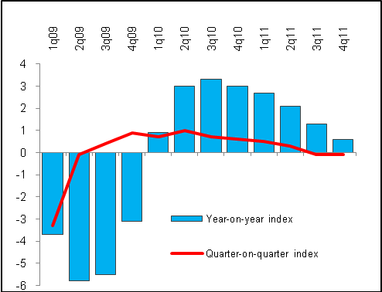 |  |  | 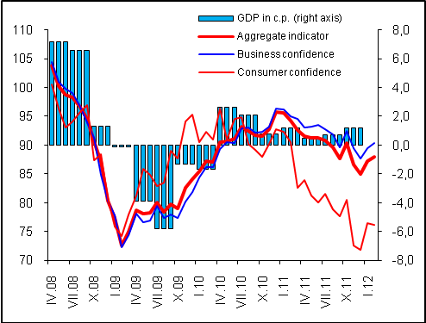
Graf 3 | Contributions of Expenditure Components to Growth of GDP (in p.p) |  | Graf 4 |  | Contributions of Industries to Growth of Gross Value Added (in p.p.)
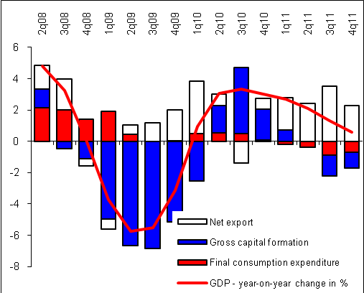 |  |  | 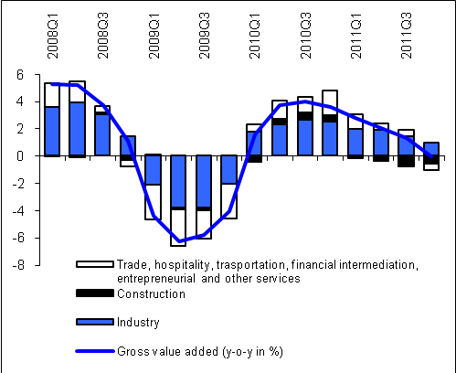
Source: CZSO

Wider definition of a country falling to recession assumes that quarter-on-quarter decline lasting two following quarters relates not only to GDP, but to employment as well.
More on the structure of growth of the gross value added in chapter Industry Performance.
Data for Greek economy are stated by Eurostat only till 2nd quarter of 2011.

