4 June 2025

Development of the Czech labour market in the Q1 2025
The development on the labour market was affected by employees moving from the primary and the secondary sector to the sector of services and care. The employment was insignificantly growing, the unemployment stagnated. The economic activity kept on a very high level. Females still helped the labour market more, participation of males was decreasing. The average wage increased in nominal terms by 6.7%, year-on-year (y-o-y), and in real terms by 3.9%.

Employment, unemployment, and economic inactivity
Results of the Labour Force Sample Survey (LFSS) do not show for the Q1 2025 a marked tendency in the total numbers of the employed and the unemployed. However, it does not mean that internal structures on the labour market have not been changing in relation to long-term trends. The employment increased by insignificant 0.5%, i.e. by 24.3 thousand, to the total of 5 225.3 thousand employed persons. While in the primary and the secondary sector the number of working persons was slightly decreasing (by 8.6 thousand in total), in the tertiary sector it further increased by 33 thousand. In the sector of services and care, already 62.3% of working persons were thus currently working.

Also composition by sex was corresponding to that development: among females, who mostly work in the growing tertiary sector, the employment increased by 87.1 thousand, year-on-year. Conversely, the number of working males decreased by 62.7 thousand. Males are strongly dominating in the heavy industry, which is in the doldrums. Similarly as their employment decreased, the number of the economically inactive males out of the labour market increased (by 60.8 thousand). What is also corresponding to that is that the numbers of unemployed males according to the results of the LFSS did not increase, year-on-year.

The economic activity rate (calculated according to the new methodology, for the group of the aged 15–64 years) went up to 77.6%, which is a record value for the first quarter; in the year-on-year comparison, it increased by 0.5 percentage point (p. p.). It was purely thanks to the female part of the population; as it was already mentioned, participation of males in the labour market is decreasing. The same effect was reflected in the employment rate (the share of the number of working persons in the group of the 15–64 years old) that increased by 0.6 p. p. to 75.5%. The male employment rate (80.1%) was by 0.8 p. p. lower, y-o-y, the female one increased by 2.1 p. p. to 70.9%.

What is also remarkable from the results of the LFSS is a spill-over from the group of entrepreneurs to employees the number of whom increased by 69.5 thousand (by 1.6%), year-on-year, whereas the number of the self-employed (own-account workers) decreased on the other hand by 44.4 thousand (by 5.3%). This overall decrease is owing to both the decrease in the number of entrepreneurs without employees (own-account workers) by 43.4 thousand as well as of the employers whose number decreased by 1 thousand, year-on-year. The share of entrepreneurs in the total employment thus decreased, year-on-year, from 16.2% to 15.3%.

A trend of development of part-time jobs further continued. Currenthly there are 499.8 thousand of them; their number increased by 27.3 thousand, y-o-y, i.e. by 5.8%. Already 14.6% of working females had a part-time job; as the most frequent reason for that they stated childcare. As for males, only 5.2% of them worked part-time, most often the elderly.

The unemployment has not changed much, year-on-year. The number of persons who seek a job decreased by 9.7 thousand to 139.4 thousand. The unemployment rate decreased by 0.2 p. p. to 2.7%. When looking at the unemployment in terms of Regions, the situation was the worst in the Karlovarský Region (4.9%), in the Ústecký Region (4.5%), and in the Moravskoslezský Region (4.0%). On the other hand, the lowest unemployment rate remained in the Středočeský Region (1.1%). The number of the unemployed who were jobless for over one year was 35.2 thousand, i.e. a quarter (25.2%) of all the unemployed. The number of the long-term unemployed decreased by 12 thousand, y-o-y.

The surplus labour (persons who do not work, are not actively seeking a job and therefore they do not comply with the ILO requirements for the unemployed, yet they state that they would like to work) decreased by 1 thousand to 79.4 thousand.

Note: The LFSS only covers persons living in dwellings (flats), not those living in hostels and similar collective households. It has a negative influence on the capture of some groups of foreigners who often use such ways of housing. As of 2023, the methodology of weighting and grossing up in the LFSS was adapted to this type of survey, which had an impact on the time series of absolute data on employment, especially in the breakdown by age group. The LFSS weights are modified every year according to the results of demographic statistics.

Registered number of employees converted to full-time equivalent employees
Preliminary data of the CZSO’s business statistics confirm a trend of an insignificant growth. The registered number of employees converted to full-time equivalent (FTE) increased, y-o-y, in the Q1 2025, by 15.7 thousand, in relative terms by 0.4%. (The registered number of employees (headcount) increased by 24.7 thousand or by 0.6%).

While the overall figures for the last two years represent rather stagnation in the number of employees, in the breakdown by CZ-NACE section we can even now find some significant increases and decreases, which indicates that the labour market is changing internally and that employees are fluctuating.

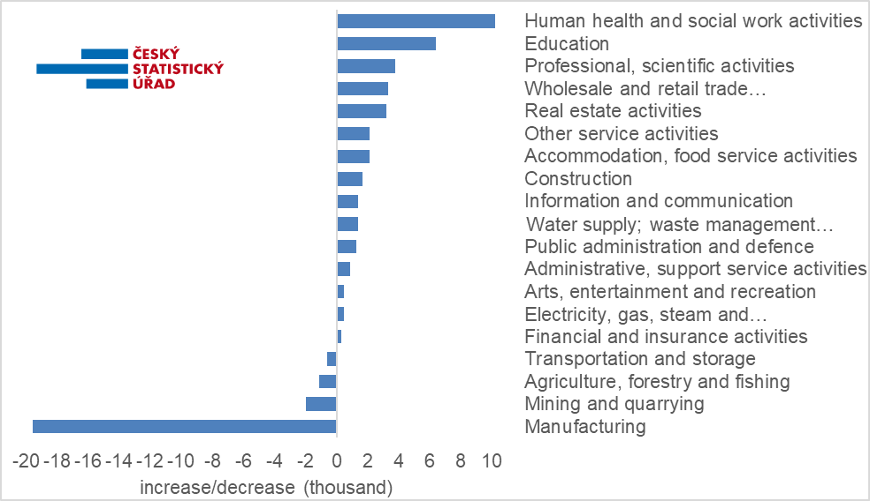Chart: Year-on-year increases/decreases in the FTE numbers of employees by CZ-NACE section
Source: wage statistics of the CZSO

In the Q1 2025, the increase in the number of employees again concentrated in the area of services and care, whereas decreases can be found in the primary sector and in ‘manufacturing’, and in ‘transportation and storage’ that are strongly connected to it. In four CZ-NACE sections, the number of employees decreased, year-on-year, by 23.3 thousand in total. In the remaining fifteen sections it increased by 39.1 thousand. As for individual sections, relative increments or decrements were ranging in a wide scope from -11.0% to 7.7%. However, those extremes were in economic activities that were numerically insignificant.

The absolute majority of the decrease is due to ‘manufacturing’, in which there were by 19.6 thousand less employees. In relative terms, the decrease was not very dramatic, by 1.8%; however, the decrements have been accummulating for many successive years already. In the Q1 2018, it still had 1 152.2 thousand employees, now it is 1 043.9 thousand, i.e. it decreased by 108.3 thousand (or by 9.4%). Anyway, ‘manufacturing’ is still the biggest economic activity in Czechia and also in the Q1 2025 it employed, as the only CZ-NACE section, over one million employees. Table 1 in the news release on average wages therefore provides CZ-NACE divisions of this section, which were the biggest as for the number of employees. In six of those divisions, we can find decreases in the number of employees. The deepest one in relative terms was in ‘manufacture of electrical equipment’ (by 3.7% or by 3.4 thousand). It was the highest as for the number in ‘manufacture of motor vehicles, trailers and semi-trailers’ (by 2.9%; 4.8 thousand). The only selected division with an increase in the number of employees was ‘manufacture of food products’ (by 3.0%; 2.5 thousand).

The biggest relative decrease in the number of employees was in ‘mining and quarrying’, an utterly marginal industry already, in which the number currently decreased by 11.0%. It was a decrease by 2.0 thousand to 16.0 thousand. Also in ‘agriculture, forestry and fishing’ where 88.1 thousand employees were currently employed, there was a slight decrease (by 1.3%; 1.1 thousand). The last section with a negative value was ‘transportation and storage’ (by 0.2%; 0.6 thousand).

The number of employees increased mainly thanks to two economic activities in which the state is dominating: in ‘human health and social work activities’ there was a year-on-year growth by 10.2 thousand (or by 2.9%) and in ‘education’ by 6.4 thousand (or by 1.9%). A more moderate increase was this time (after a decrease last year) also in ‘public administration and defence; compulsory social security’ (by 1.3 thousand; 0.4%). Therefore, in those three economic activities, roughly a million employees in total are currently working.

‘Construction’ was more successful again; the number of employees increased there by 1.7 thousand or by 0.8%, year-on-year. The recovery sustained in ‘accommodation and food service activities’, in which the number of employees increased by 2.1 thousand, year-on-year, i.e. there was an increase by 1.8%.

In ‘real estate activities’, there was the highest relative increase by 7.7%, which in this smaller economic activity was an absolute increase by 3.2 thousand. A more significant thus was an increase in ‘professional, scientific and technical activities’, in which there were by 3.8 thousand more employees (by 2.2%). ‘Financial and insurance activities’ had an increment by 0.3 thousand only, which is an increase by 0.5%. It was higher in ‘information and communication,’ by 1.4 thousand (by 1.0%) and also in ‘other service activities’ (2.1 thousand; 5.7%).

‘Wholesale and retail trade; repair of motor vehicles and motorcycles’ saw an increase by another 3.3 thousand jobs (an increase by 0.7%), by which it balanced on the half a million threshold (500.1 thousand) and was still the second most numerous in Czechia. Two smaller industrial economic activities were growing: in the power industry (‘electricity, gas, steam and air conditioning supply’), the number of employees increased by 0.5 thousand (by 1.4%) and in ‘water supply; sewerage, waste management and remediation activities’ even by 1.4 thousand (by 2.6%).

Quarterly average gross monthly wages
According to preliminary data, the average wage (CZK 46 924) increased nominally, compared to the corresponding period of the previous year, by CZK 2 943 in the Q1 2025, i.e. by 6.7%. It is an average of a very diverse development on the level of individual branches (fields of activity), enterprises, or organisations.

In the beginning of 2025, the wage growth did not deviate from the context of the preceding years; for the whole year 2024, the wage growth was 7.2%. During individual quarters, the growth was gradually decreasing from 7.8% to 6.9%. Revised (final) data for the year 2023 also show the nominal growth by 7.2%.

What was more important from the point of view of employees, however, was the real development that compares the increase of earnings with the consumer price increase (inflation) and thus it shows how many goods and services an employee could purchase for the wage. The consumer price index reached the value of 2.7% in the Q1 2025; the average wage thus increased in real terms by 3.9%, year-on-year. It is somewhat worse result than for the whole year 2024, when the real wage increased by 4.7%. However, it is much better than in the previous two years when the purchase power of earnings of employees was slumping in real terms.

Although average wages increased in real terms in all economic activities, their dynamics varied widely again. The highest nominal year-on-year increase (12.4%) can be currently found in the ‘real estate activities’ section. With a gap, it is followed by ‘professional, scientific and technical activities’ with 10.9%, ‘construction’ with 10.3%, and ‘arts, entertainment and recreation’ with 10.0%. Other sections remained below the ten percent level. ‘Accommodation and food service activities’ with 9.2% and ‘information and communication’ with 8.8% got the closest to that level. An above-average wage increase was futher in ‘transportation and storage’ (7.7%) and in ‘administrative and support service activities’ (7.6%).

On the other hand, in another two economic activities only a three-percent year-on-year increase can be found. In ‘mining and quarrying,’ wages increased by 3.1% and in ‘electricity, gas, steam and air conditioning supply’, in which there was a high comparison basis from the previous year, by 3.3%.

Weak values were also in ‘other service activities’ (4.3%), in ‘water supply; sewerage, waste management and remediation activities’ (4.4%), in ‘human health and social work activities’ (4.8%), in ‘public administration and defence; compulsory social security’ (5.1%), in ‘wholesale and retail trade; repair of motor vehicles and motorcycles’ (5.8%), and in ‘financial and insurance activities’ (6.0%).

To employees in ‘education’, the salary level increased by 6.7%, y-o-y, which was significantly more than in the previous three years, although it is only a value on the level of an increase of the total average wage.

The highest wage level in the Q1 2025 can be found, as usually, in ‘information and communication’, in which the average wage reached CZK 92 288. With a gap, ‘financial and insurance activities’ ranked second with the level of CZK 84 069 and the third one was ‘electricity, gas, steam and air conditioning supply’ with CZK 83 725. Those three are on the top, for a long time.

From the opposite side, the ranking was slightly innovated. In ‘accommodation and food service activities’, the average wage despite a rather marked relative increase (by 9.2%) was still the lowest (CZK 27 953). The second lowest average wage was in ‘agriculture, forestry and fishing’ where it increased by 6.3% to CZK 33 945. The third were ‘other service activities’ with CZK 34 731 closely followed by the fourth ‘administrative and support service activities’ with the average wage of CZK 34 803.

Development in Regions
In terms of the number of employees, there was again a year-on-year decrease in most of the Regions of Czechia in the Q1 2025. The most noticeable one, by 0.9%, was in the Moravskoslezský Region followed by the Královéhradecký Region (by 0.8%) and by the Vysočina Region (0.6%). In the Liberecký Region and in the Ústecký Region there was the same decrease by 0.5%, in the Jihočeský Region and in the Karlovarský Region by 0.4%, in the Olomoucký Region by 0.3%, and in the Zlínský Region by 0.2%. In total, the number of jobs decreased by 10.5 thousand in those Regions. The total balance was again equalised largely thanks to a massive increase in Prague by 21.3 thousand, which was a relative increase by 2.7%. Smaller increases were also recorded by another four Regions, which, however, added only 4.9 thousand jobs, as follows: the Plzeňský Region with an increment by 0.9% followed by the Jihomoravský Region (0.3%), the Středočeský Region (0.2%), and the Pardubický Region (0.2%).

As for the development of average wages, the dispersion was substantially smaller among Regions than in the breakdown by economic activity (industry) in the Q1 2025. Wages were increasing nominally in the range from 5.0% to 7.6%. The highest wage growth was this time in the Capital City of Prague (7.6%), followed with a small gap by the Jihomoravský Region with 7.2%. In other Regions, the increase was below-average. The Pardubický Region ranked the third best with 6.4%. On the other hand, currently, the Liberecký Region came off worst; the average wage only increased with a five-percent growth rate there. In the Královéhradecký Region and in the Zlínský Region, it increased by 5.2%, in the Karlovarský Region and in the Ústecký Region, it increased by 5.7%.

According to the absolute level of earnings, Prague still remained to be the richest among the Regions of Czechia. The average wage there was CZK 62 472. The Jihomoravský Region reached the second place with the value of CZK 46 066 and the Středočeský Region with CZK 45 952 ranked third. The threshold of 43 thousand was overcome by the Plzeňský Region, too (CZK 43 498). Other Regions remained below that threshold, although for the Ústecký Region it was close: CZK 42 944. On the other hand, the Karlovarský Region remained to be the Region with the lowest wage level (CZK 39 642) and, currently, the only Region below the CZK 40 thousand threshold. In the Moravskoslezský Region, which is following Prague, the Jihomoravský Region, and the Středočeský Region a Region with the highest number of employees (412.8 thousand), the average wage reached the value of CZK 41 653.

* * *

Median wages and decile intervals of wages, broken down by sex
The news release of the CZSO for the Q1 2025 also contains a piece of data on the median wage, which is calculated from a mathematical model of the distribution. It shows the wage of a middle employee, i.e. a common wage level. Extreme deciles have been calculated concurrently, too; data from the previous period have been revised. In the Q1 2025, the median wage got to CZK 38 385, i.e. by 5.3% (CZK 1 931) more than in the corresponding period of the previous year.

One tenth of employees with the lowest wages were receiving a gross wage below CZK 21 136 (the bottom decile increased by 6.3%, y-o-y), whereas the tenth with the highest wages had wages over CZK 73 611 (the top decile increased by 6.1%). The decile ratio reached the value of 3.48.

Male median wages were higher than those of females; in the Q1 2025, the female median wage was CZK 35 226 (it increased by 5.1%, year-on-year), whereas the male median wage was CZK 41 677 (it increased by 5.3%). The gap between median earnings by sex thus increased by 0.2 p. p., year-on-year, to 15.5%.

At the same time, wages of males were distributed over a substantially wider interval, especially the area of high earnings is significantly higher for males than for females: the top decile for females was CZK 63 337 and for males it was CZK 83 174, by which there was a gap of 23.8% in high earnings. On the other hand, as for low earnings, the difference was weaker: the bottom decile for females was CZK 20 293 and for males CZK 22 028, which is a gap of 7.9%.

Elaborated by: Dalibor Holý
Labour Market and Equal Opportunities Statistics Department of the CZSO
Phone number: (+420) 274 052 694
E-mail: dalibor.holy@csu.gov.cz

