18 May 2026

Number of inactive persons willing to work is decreasing

Employment and unemployment in the Czech Republic as measured by the Labour Force Sample Survey – 1st quarter of 2026
Year-on-year (y-o-y), the number of the employed persons was by 58.6 thousand higher; the total employment thus moderately increased. According to the methodology of the International Labour Organization (ILO), the number of the unemployed was by 31.4 thousand persons higher. The number of the economically inactive aged 15+ years decreased by 39.8 thousand during the same period.

Employment
In the Q1 2026, the seasonally adjusted average number of employed persons increased by 24.9 thousand persons, compared to the Q4 2025.
The number of working persons aged 15+ years moderately increased, year-on-year. In the Q1 2026, an increase by 58.6 thousand persons (i.e. by 1.1%) to the total of 5 283.9 thousand employed persons was recorded. This increase was owing to an increase in the number of working persons of both sexes; the number of working males increased by 30.7 thousand, y-o-y, and the number of working females increased by 27.9 thousand, y-o-y. The most marked increment was recorded as for working persons aged 60+ years; the number of them increased by 58.9 thousand (i.e. by 10.1%). An increase was also recorded in the youngest age category of 15–24 years, in which there were by 17.2 thousand persons more (i.e. by 6.2%). The number of working persons aged 45–59 years also moderately increased, namely by 12.7 thousand persons (i.e. by 0.6%). Conversely, there was a year-on-year decrease in the age category of 30–44 years, where the number of working persons decreased by 19.8 thousand persons (i.e. by 1.1%) and in the age group of 25–29 years there were by 10.5 thousand persons less (i.e. by 2.5%). Year-on-year changes in the number of working persons in individual age groups are influenced, to a large extent, by the demographic structure of population and by shifts of persons to higher age groups.
Chart 1: The number of working persons in the national economy and their structure by age group (thousand)
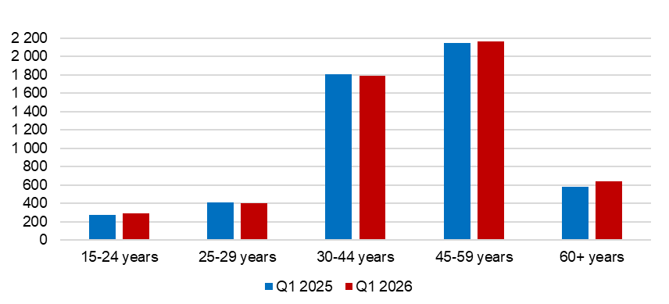
Source: CZSO, LFSS

In terms of sex, the most marked relative decrease in the number of working persons was recorded among females aged 25–29 years; their number decreased by 9.0 thousand persons (i.e. by 5.3%). The biggest relative increase was also among females; it was in the age group of 60+ years, the number of whom increased by 36.0 thousand persons, year-on-year (i.e. by 14.1%).
The number of employees increased by 29.9 thousand persons (i.e. by 0.7% to 4 445.1 thousand persons). The number of the self-employed (without unpaid contributing family workers) increased by 27.9 thousand persons. The number of the self-employed without employees (own-account workers) increased by 35.9 thousand (i.e. by 5.3%); however, the number of the self-employed with employees (employers) was by 8.1 thousand lower, year-on-year (i.e. a decrease by 7.0%). In concrete numbers, there were 718.7 thousand entrepreneurs without employees and 107.4 thousand entrepreneurs with employees. In the Q1 2026, the proportion of entrepreneurs (the self-employed) in the total employment was 15.8%, which is only by 0.5 p. p. more than in the corresponding period of 2025.
According to data for the Q1 2026, the development of employment in individual economic activities (CZ-NACE sections) in the Czech Republic was different⁾. In the primary sector of agriculture, forestry and fishing, the number of working persons decreased, year-on-year, by 8.2 thousand to 132.9 thousand. Employment in the secondary sector of industry and construction also slightly dropped; a decrease in the number of working persons by 22.5 thousand to 1 808.3 thousand was recorded. In the tertiary sector of services, the total employment increased, y-o-y, by 89.3 thousand to 3 342.7 thousand persons. In this sector, the biggest relative increment in the number of working persons was in the section of ‘professional, scientific and technical activities’, namely by 37.4 thousand persons (i.e. by 14.5%). The section of ‘administrative and support service activities’ also considerably increased (by 14.2 thousand persons, i.e. by 12.0%). A decrease in employment was recorded, for example, in the section of ‘wholesale and retail trade; repair of motor vehicles and motorcycles’; there were by 34.4 thousand persons less (i.e. by 5.8%) and in the section of ‘financial and insurance activities’, where there was a decrease by 4.9 thousand persons (i.e. by 3.9%).
In the primary sector of agriculture, forestry and fishing, 2.5% of all working persons in total worked in the Q1 2026. Males outnumbered females (90.8 thousand and 42.1 thousand, respectively). Males also dominated in the secondary sector of industry and construction (1 304.3 thousand); the number of females working there was considerably lower (504.0 thousand). On the other hand, in the tertiary sector, females were more numerous than males (1 909.9 thousand and 1 432.8 thousand, respectively).
The share of employment in the primary and in the secondary sector has been decreasing for a long time and the tertiary sector is increasing. Ten years ago, i.e. in the Q1 2016, 2.8% of all working persons were working in the primary sector, in the secondary sector it was 38.2%, and in the tertiary sector it was 59.0%. In the Q1 2026, the shares were as follows: 2.5% in the primary sector, 34.2% in the secondary sector, and 63.3% in the tertiary sector.
Chart 2: The number of working persons in the national economy by economic activity (thousand)
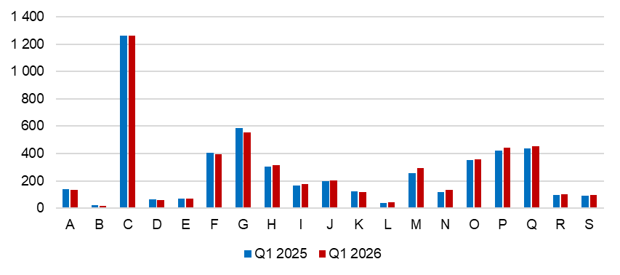
A – Agriculture, forestry and fishing; B – Mining and quarrying; C – Manufacturing; D – Electricity, gas, steam and air conditioning supply; E – Water supply; sewerage, waste management and remediation activities; F – Construction; G – Wholesale and retail trade; repair of motor vehicles and motorcycles; H –Transportation and storage; I – Accommodation and food service activities; J – Information and communication; K – Financial and insurance activities; L – Real estate activities; M – Professional, scientific and technical activities; N – Administrative and support service activities; O – Public administration and defence; compulsory social security; P – Education; Q – Human health and social work activities; R – Arts, entertainment and recreation; S – Other service activities.
Source: CZSO, LFSS
Along with changes in the structure by economic activity (CZ-NACE section), changes in the structure of working persons by occupation also occurred. According to the Classification of Occupations (CZ-ISCO), the number of working persons increased relatively the most in the major group of technicians and associate professionals (by 46.2 thousand persons, which is an increase by 5.4%) and in the major group of clerical support workers (by 18.1 thousand persons, i.e. by 4.9%). The biggest relative decrease occurred in the major group of skilled agricultural, forestry and fishery workers (by 6.0 thousand persons, i.e. by 8.7%) and in the major group of plant and machine operators, and assemblers (by 43.9 thousand persons, i.e. by 5.4%).
Chart 3: The number of working persons in the national economy by Classification of Occupations (thousand)
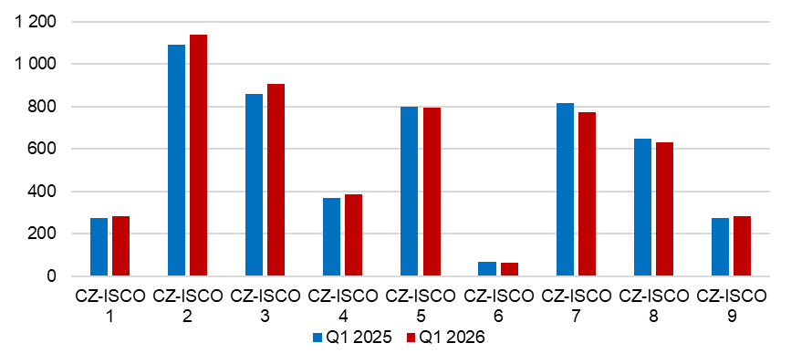
CZ-ISCO 1 – Managers; CZ-ISCO 2 – Professionals; CZ-ISCO 3 – Technicians and associate professionals; CZ-ISCO 4 – Clerical support workers; CZ-ISCO 5 – Service and sales workers; CZ-ISCO 6 – Skilled agricultural, forestry and fishery workers; CZ-ISCO 7 – Craft and related trades workers; CZ-ISCO 8 – Plant and machine operators, and assemblers; CZ-ISCO 9 – Elementary occupations.
Source: CZSO, LFSS
The number of working persons according to the educational attainment also develops along with the mentioned changes in the employment structure. The number of working persons with primary education decreased by 11.2 thousand to 226.3 thousand. The number of working persons with secondary education without A-level examination remained almost unchanged (a decrease by 3.5 thousand to 1 564.9 thousand persons). On the other hand, the number of working persons with secondary education with A-level examination was 1 946.1 thousand persons, i.e. by 17.5 thousand more, year-on-year. The biggest increase occurred in employed persons with tertiary education the number of whom increased by 53.9 thousand to 1 544.4 thousand working persons. This increase mainly applied to working males with tertiary education the number of whom increased by 32.6 thousand, year-on-year; the number of working females with tertiary education increased by 21.4 thousand, y-o-y.

The employment rate (the percentage of working persons in the age group of 15–64 years old) reached the same value in the Q1 2026 compared to the corresponding period of the previous year, i.e. 75.5%. In terms of sex, there wasn’t any year-on-year change, either. The male employment rate reached 80.1%, the female one 70.9%; the figures were the same as in the Q1 2025.
Continuing development of part-time jobs in the main job also had an influence on the growth of the total employment. Their number in individual quarters has been constantly increasing in recent years.
In the first quarter of 2026, 524.4 thousand persons worked part-time, which was a year-on-year increase by 24.6 thousand persons (an increase by 4.9%). In the Q1 2018, there were 394.7 thousand persons who worked part-time; thus, during the last eight years, their number increased by 129.7 thousand (i.e. an increase by 32.9%).
In the Q1 2026, the number of part-time jobs was mainly increasing among females; it increased there by 24.1 thousand persons (by 6.8%). As for males, the number of part-time jobs was virtually stagnating when it only increased by 0.5 thousand persons (i.e. by 0.3%).
During the reference period, there were 378.2 thousand females working part-time. It was 72.1% of all persons using part-time jobs in the main job. Reduced working hours gave them more flexibility, mainly when performing their caring responsibilities. Females were working part-time most often in the following economic activities of the CZ-NACE classification: ‘education’, ‘human health and social work activities’, and ‘wholesale and retail trade; repair of motor vehicles and motorcycles’. Of the total number of all employed females, 15.4% worked part-time. Females gave most often the following reasons for working part-time: other personal reasons (80.3 thousand), childcare or care for an adult person in need of care (74.7 thousand), or that only a part-time job was available (56.8 thousand). The highest number of females working part-time was in the age of 30–44 years (125.9 thousand, i.e. 33.3% of all females working part-time).
Males used reduced working hours significantly less. 146.2 thousand males worked part-time, which is only 5.2% of all working males. They were employed most often in ‘manufacturing’, ‘education’, and also in the section of ‘wholesale and retail trade; repair of motor vehicles and motorcycles’. Males worked part-time mainly due to “other personal reasons” (45.4 thousand). Most of males working part-time were in the age of 60+ years (65.4 thousand, i.e. 44.8%). Thus, females use part-time jobs mainly while taking care of small children, males work part-time in higher age.
Chart 4: The number of part-time workers and their age structure (thousand)
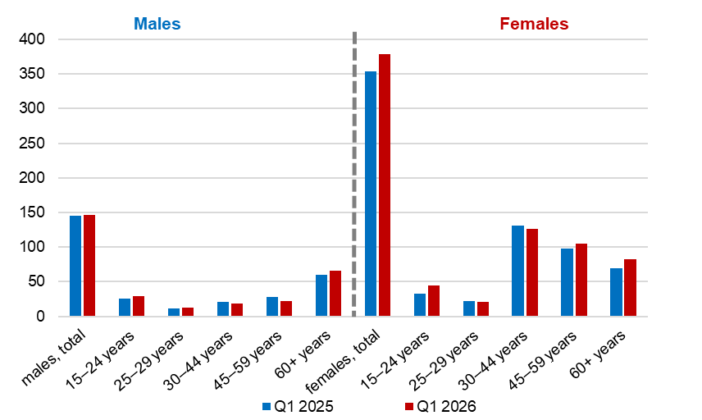

Source: CZSO, LFSS

Unemployment
The seasonally adjusted average number of unemployed persons according to the ILO methodology⁾ increased in the Q1 2026 by 3.2 thousand persons, compared to that in the Q4 2025.
Chart 5: The number of the unemployed in cohesion regions of the Czech Republic (thousand)
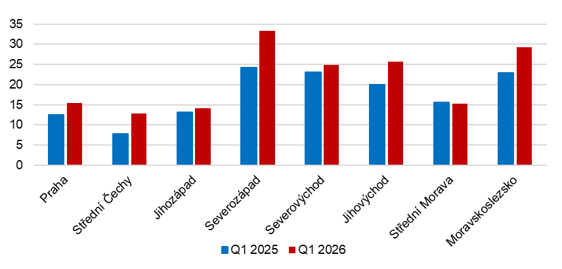
Source: CZSO, LFSS
The total number of the unemployed aged 15+ years increased, year-on-year, by 31.4 thousand to 170.8 thousand persons. The number of the unemployed females increased by 17.2 thousand to 91.3 thousand, the number of the unemployed males by 14.2 thousand to 79.4 thousand. Unemployment often affects persons in lower middle age; the highest number of the unemployed were in the age category of 30–44 years; there were 25.3 thousand of unemployed males of that age and 33.2 thousand females of that age.
The number of persons unemployed for one year and longer, i.e. the long-term unemployed, also increased. Their number increased by 19.6 thousand, y-o-y, to 54.7 thousand. In the Q1 2026, the long-term unemployed thus made 32.1% of all the unemployed. A more marked increase in the number of persons unemployed for one year and longer was recorded in males, the number of whom increased by 11.0 thousand, y-o-y. In females, there were by 8.6 thousand of the long-term unemployed more.
The number of the long-term unemployed males was 27.3 thousand in total, while most of them were in the age of 30–44 years (10.3 thousand). In females, the number was 27.5 thousand and the most numerous was the age group of 45–59 years (10.7 thousand).
Chart 6: The number of persons unemployed for one year and longer and their age structure (thousand)

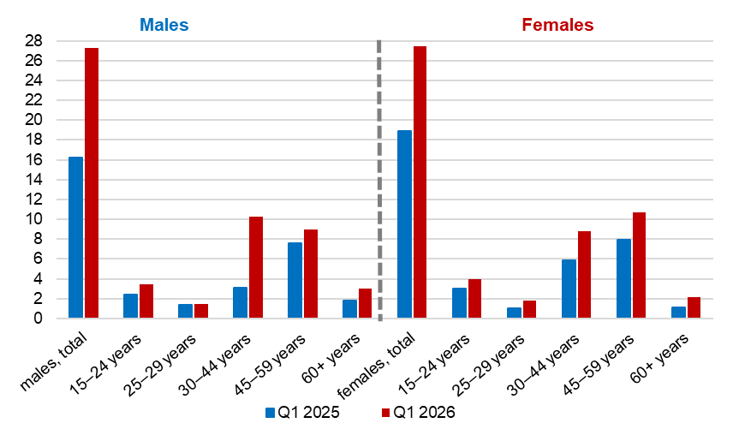
Source: CZSO, LFSS
The general unemployment rate according to the ILO definition in the age group of
15–64 years old (the percentage of the unemployed in the labour force, i.e. in the sum of the employed and the unemployed) increased by 0.6 p. p., year-on-year, and in the Q1 2026 it was 3.2%.
Chart 7: Unemployment rate of the 15–64 years old in cohesion regions of the Czech Republic (%)
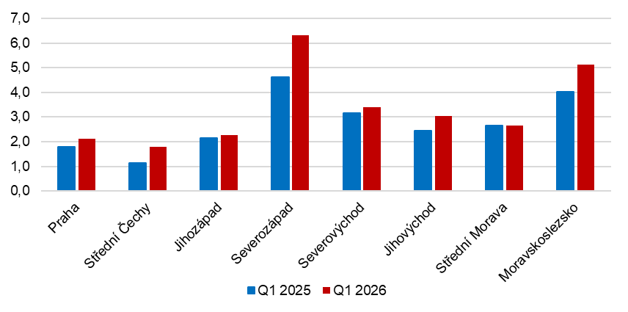
Source: CZSO, LFSS
In terms of comparison of cohesion regions, the general unemployment rate of the 15–64 years old was the highest in the Severozápad cohesion region (6.3%) and in the Moravskoslezsko cohesion region (5.1%). The lowest figures were reported by the Střední Čechy cohesion region (1.8%), the Praha cohesion region (2.1%), and the Jihozápad cohesion region (2.3%). The unemployment rate increased, year-on-year, in almost all cohesion regions; only in the Střední Morava cohesion region it stagnated. The unemployment rate increased the most markedly in the Severozápad cohesion region (by 1.7 p. p. to 6.3%) and in the Moravskoslezsko cohesion region (by 1.1 p. p. to 5.1%).

Economic inactivity
The number of economically inactive persons aged 15+ years was by 39.8 thousand lower, year-on-year, and amounted to 3 441.1 thousand. The number of economically inactive males decreased by 21.0 thousand to the value of 1 374.2 thousand. The number of economically inactive females was by 18.8 thousand lower than a year ago, therefore it was 2 066.9 thousand.
In the sample survey, data are also collected on persons who do not work and do not seek a job in an active manner and therefore do not comply with the ILO conditions for the unemployed, however, they state that they would like to work. In the Q1 2026, the number of economically inactive persons willing to work was 73.3 thousand, i.e. by 6.1 thousand persons less than in the corresponding period of 2025. Recently, their number has been decreasing. In the Q1 2018, it was 108.4 thousand persons, while females (65.7 thousand) outnumbered males (42.7 thousand). In the Q1 2021, their number decreased to 102.1 thousand persons (60.7 thousand females and 41.5 thousand males).
The number of persons who would like to work, yet they are not able to start in a potential job immediately, remains relatively high. Only 14.1 thousand of them are able to start in a job within a fortnight, at the latest. It is 19.3% of those stating their willingness to work. Compared to the previous years, the proportion is decreasing; in the Q1 2021, 39.0 thousand persons were prepared to start in a job (38.2%). These data show that available labour force in the labour market is used to a high extent.

Note:
Data in the analysis have not been seasonally adjusted unless otherwise stated.
Recalculation to the same population structure
The Labour Force Sample Survey (LFSS) is carried out in selected dwelling households. Collective accommodation establishments are not included in the survey. The data found were weighted to the population of the Czech Republic based on the results of the demographic statistics as at the beginning of the reference quarter; estimates of the number of persons living outside private households were subtracted from the population totals of the demographic statistics.
Starting with the first quarter of 2026, results in the quarterly analysis are published in the territorial breakdown at the NUTS 2 level (cohesion regions) instead of the previous NUTS 3 level (Regions).
Authors:
Marta Petráňová, phone number: (+420) 274 054 357, e-mail: marta.petranova@csu.gov.cz
Gabriela Strašilová, phone number: (+420) 567 109 071, e-mail: gabriela.strasilova@csu.gov.cz
Labour Force Statistics Unit

⁾ Data for economic activities (CZ-NACE sections) may be influenced by the employed methodology of the Labour Force Sample Survey (LFSS). The survey only covers persons living in dwellings (flats), i.e. private households. Data on persons living in collective accommodation establishments are not measured; these establishments often give accommodation to foreign nationals.
⁾ The ILO methodology defines the unemployed as persons who during the reference period were without a job, did not work an hour for pay or remuneration, and were in an active manner seeking a job they would be able to join within fortnight at the latest. This methodology is uniform for all EU Member States and provides internationally comparable data. It has to be taken into consideration that the definition of “the unemployed” by the ILO differs from the definition of “job applicants kept in the register of the labour offices” of the Ministry of Labour and Social Affairs.

