External Economic Relations

 | External balance did not worsen and remains relatively favourable… |  |  | External economic relations based on the deficit of the current account of balance of payments did not virtually change in 2013 – its deficit in the amount of 56 bn crowns was only by 4.7 bn crowns deeper compared to the preceding year. In relation to the nominal GDP, the current account deficit of 1.4 % reached the third lowest in the last nine years and compared to year 2012 (1.3 %) increased only negligibly. It means, that in years of recession and with relatively weak dynamics of prices the CR maintains a favourable level of external balance.
 | … with comfortable coverage of the current account deficit by marked surpluses of other items of the balance of payments |  |  | Current account deficit is comfortably covered by the surpluses of other items of the balance of payments – only the capital account balance itself would suffice to its elimination (+74.6 bn crowns) without the need to consider the high surplus on the financial account (+187.9 bn crowns). Also from this view the external imbalance in the Czech Republic does not present a problem for the economy.
 | Record trade balance as well as notable improvement of current transfers result improved the current account imbalance… |  |  | Current account maintained in practice the same level due to the improved trade balance for the whole year 2013, its surplus rose by 39.4 bn crowns and was (according to imports and exports data in the national conception in FOB prices) in fact the best result for the time of the CR existence. The result of current transfers was the second factor working towards reduction of the current account deficit, improving by 17.8 bn crowns (to 15.4 bn crowns) due to the effect of payments from the EU funds, which had an atypical progress in both 2012 and 2013. Also in case of current transfers, the result is the best for the last nine years.
 | … on the contrary the income balance and reduced surplus of the trade in services made it worse |  |  | Outflow of dividends of companies under foreign control had the highest effect on further deepening of the income balance deficit, which worsened by 52.7 bn (to 312.5 bn crowns). Data for the whole year are not yet available, however the outflow of dividends was year-on-year lower in 2012 (204.1 bn crowns, i.e. by 14.4 bn) despite the profits from the preceding year 2011, where the dividends originated, not yet being hit by the recession.  Except for the worsened income balance, the CR earned less also in the trade in services. Here the balance was worse by 9.3 bn crowns compared to 2012. Lower revenues from transportation and markedly weaker than from exports of other services (revenues from tourism remained approximately the same) participated in the surplus of 53 bn crowns.
 | Year-on-year lower inflow of foreign direct investment due to the repayments of loans to parent companies |  |  | The CR gained foreign direct investment in the amount of 97.7 bn crowns. It was less than in 2012 (156.3 bn), but still the investors here together with the reinvested profits and new capital entrances spent 155.6 bn crowns, the most since year 2007. At the same time however the loans of subsidiaries to parent companies abroad were being repaid, in the highest volume so far annually recorded (57.9 bn crowns). It was just this transfer, which lowered year-on-year inflow of foreign direct investment into the CR in 2013.
 | Return of funds into the country in the form of portfolio investment |  |  | Inflow of funds into the CR in the form of portfolio investment intensified (net balance 94.9 bn against 54.8 bn crowns in 2012). While the interest of foreign investors in Czech bonds increased – in contrast to their purchases in 2012 – only mildly (+8.3 bn to 92.4 bn crowns) and revived also their interest regarding the Czech shares, domestic entities on the contrary realised profits from sales of their purchased foreign bonds. If they spent net for these bonds in 2012 22.1 bn crowns, in 2013 the funds in this form on the contrary returned back into the CR in the amount of 7.6 bn crowns. Also the appetite of Czech portfolio investors to purchase foreign shares – also with respect to their high prices on capital markets – markedly weakened.
 |  |  |  | Neither direct nor portfolio investment would in spite of their flows manage such a high level of the financial account surplus, i.e. its jump year-on-year by 113.6 bn crowns in 2013. The item of so called other investment stood behind this development with its balance year-on-year swinging from the deficit of 110.4 bn into the surplus of 58 bn crowns. It occurred due to massive transfers of funds in the sphere of commercial banks.
 | Strengthening imports from half of 2013 proves the improving demand in the Czech republic economy |  |  | With respect to the very favourable result of the CR trade balance, the development of imports – according to the CZSO data in the national conception in the current prices, CIF - showed also together with other characteristics of the production nature during 2013, that the Czech economy started to recover from the second half of the year. The positive year-on-year increases of total imports can be attributed to improved domestic demand also for foreign goods – in July these grew as a whole year-on-year for the first time in seventeen months (+3.7 %) and in December the value of imports was even already higher by 17 %.
 | Exports of the most significant items gained above average pace in the long term, with the highest year-on-year dynamics then the exports of wood, furniture, medicines and beverages –double-digit December rates of growth influenced similarly to imports by weakened exchange rate of crown |  |  | Exports of goods from the CR following the increasing year-on-year falls in the first three months of 2013 (in March by -5.2 %) started to gain pace and its dynamics significantly accelerated (+16.4 % in December 2013). Regarding the individual products, the exports of „non-machinery“ commodities such as wood (+28 %), furniture (+17 %), hides (+14 %), further then medicines (+13 %) and beverages (12 %) experienced the highest growth. If we consider the exported value, the increments were rather smaller, which follows from the nature of this goods. Among significant export items the CR earned for exports of motor vehicles and their parts according to the data of foreign trade statistics in the national conception by 32 bn crowns more (+5.8 %), for exports of electrical appliances by 15 bn more (+6.8 %) and for exports of other machinery by 20 bn crowns more (+6 %) in 2013 compared to 2012. Only the exports of energy commodities (black coal -26 %, electricity -22 %, crude petroleum and natural gas (-14 %)) were notably weaker year-on-year, with the falling prices on world markets playing a role. It was also less exported of clothing (-0.4 %), recording media (-11 %), coke and refined petroleum products (-5 %). The third largest by volume item of exports from the CR, concretely computers and electronic appliances (-4 %) was also in negative numbers.  Enlarged dynamics of exports corresponded to the improving demand in the European Union countries, the double-digit growth in December was also affected by the weaker crown (similarly as in case of imports).
Chart 9 |  | Imports and exports of goods (y/y in %) |  |  | Chart 10 | Imports of selected types of goods into the CR during 2013 (y/y in %)
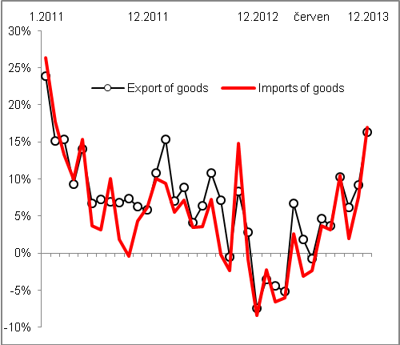 |  |  |  |  | 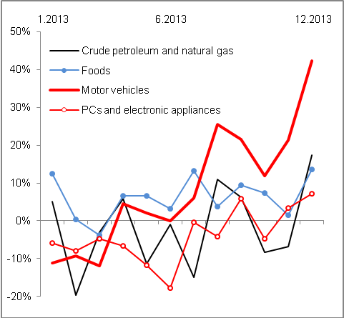  Source: CZSO

Based on data in the national conception in the current prices, FOB.
Item of the classification of products (CZ-CPA) „Machinery and equipment n.e.c.“.

