10 February 2026

Development of international trade in goods price indices in the Q4 2025 and in the year 2025
In the Q4 2025, compared to the Q3 2025, export prices decreased by 0.7%. In the year-on-year (y-o-y) comparison, they decreased by 4.2% in the Q4 2025. Import prices decreased by 1.1% in the Q4 2025 compared to the Q3 2025. In the y-o-y comparison, they decreased by 5.1% in the Q4 2025. The terms of trade reached the value of 100.4% in the Q4 2025 compared to the Q3 2025. In the y-o-y comparison, they reached the value of 100.9% in the Q4 2025. On the average for the whole year 2025, compared to the year 2024, export prices decreased by 1.2%, import prices by 1.6%, and the terms of trade reached the value of 100.5%.

Export prices
Quarter-on-quarter (q-o-q; in the Q4 2025 compared to the Q3 2025), export prices decreased by 0.7%. Mainly prices of the following decreased: food products and chemicals and chemical products – both the same, by 3.3%. Prices of the following increased the most: products of forestry, logging and related services by 10.6% and prices of electricity by 7.9%.
Year-on-year, in the Q4 2025, export prices decreased by 4.2% (in the Q3 2025 by 2.7%). Prices of the following decreased the most considerably: electricity by 16.4% and prices of coke and refined petroleum products by 13.5%. Mainly prices of the following increased: products of forestry, logging and related services by 13.2% and prices of wood and products of wood and cork, except furniture by 5.8%.
On the average for the whole year 2025, compared to the year 2024, export prices decreased by 1.2% (for the year 2024 they increased by 3.1%). Prices of the following significantly decreased: prices of coke and refined petroleum products by 15.0% and prices of waste collection, treatment and disposal services by 9.5%. Prices of the following increased the most: products of forestry, logging and related services by 7.5% and prices of wood and products of wood and cork, except furniture by 6.5%.

Import prices
Quarter-on-quarter (in the Q4 2025 compared to the Q3 2025), import prices decreased by 1.1%. Prices of the following significantly decreased: crude petroleum and natural gas by 7.5%, coke and refined petroleum products by 3.3%, and food products by 3.2%. Especially prices of the following were increasing: electricity by 11.0%, leather and related products by 3.1%, and textiles by 1.2%.
Year-on-year, in the Q4 2025, import prices decreased by 5.1% (in the Q3 2025 by 3.2%). The most significant price decreases were in crude petroleum and natural gas by 25.9%, coke and refined petroleum products by 10.9%, and prices of electricity by 8.6%. Considerable price increases were especially in prices of beverages by 7.8% and prices of furniture by 3.0%.
On the average for the whole year 2025, compared to the year 2024, import prices decreased by 1.6% (for the year 2024 they increased by 1.5%). The following considerably decreased: prices of coke and refined petroleum products by 13.2% and prices of crude petroleum and natural gas by 11.1%. Prices of food products markedly increased by 5.1% and prices of furniture by 5.0%.

The terms of trade
Quarter-on-quarter (in the Q4 2025 compared to the Q3 2025), the terms of trade reached the value of 100.4%. The same significant positive value (101.0%) was reached by three divisions of the CPA classification – machinery and equipment n.e.c., the division of computer, electronic and optical products, and the division of wood and products of wood and cork, except furniture. A marked negative value was recorded by textiles (96.8%).
Year-on-year, in the Q4 2025, the terms of trade reached the value of 100.9% (in the Q3 2025 the value was 100.5%) and for the twelfth successive quarter they remained in positive values – see the Chart No 2. A significant positive value was recorded by wood and products of wood and cork, except furniture (108.9%) and a negative value mainly by furniture (90.9%).
On the average for the whole year 2025, compared to the year 2024, the terms of trade reached the value of 100.5% (in 2024, they amounted to 101.5%). A significant positive value was recorded by wood and products of wood and cork, except furniture (107.8%), a negative value by furniture (91.0%).

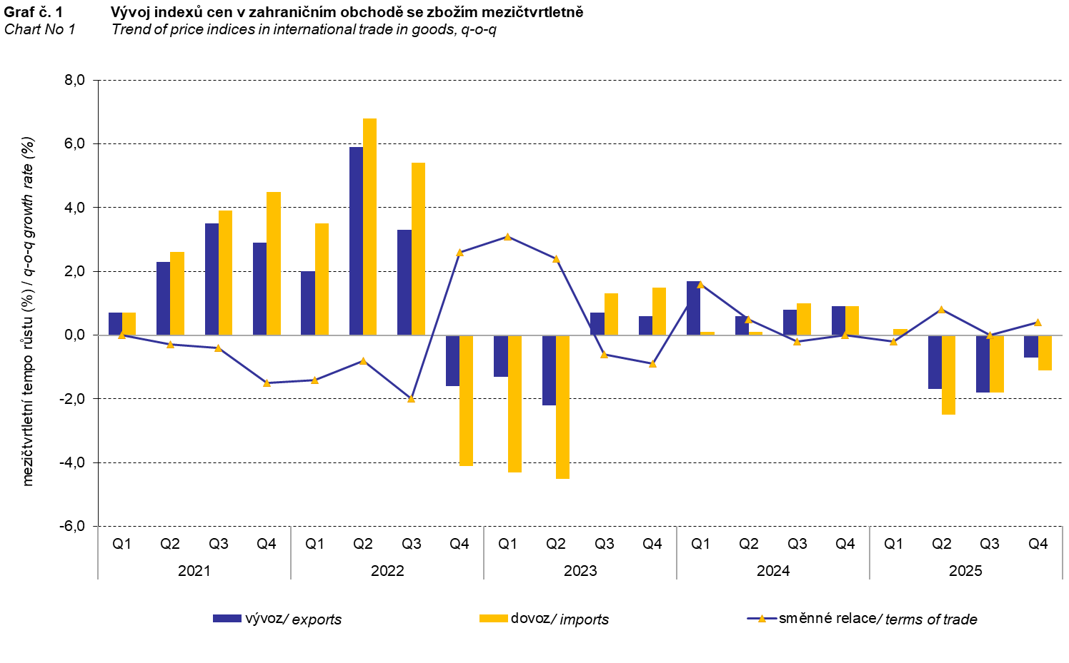

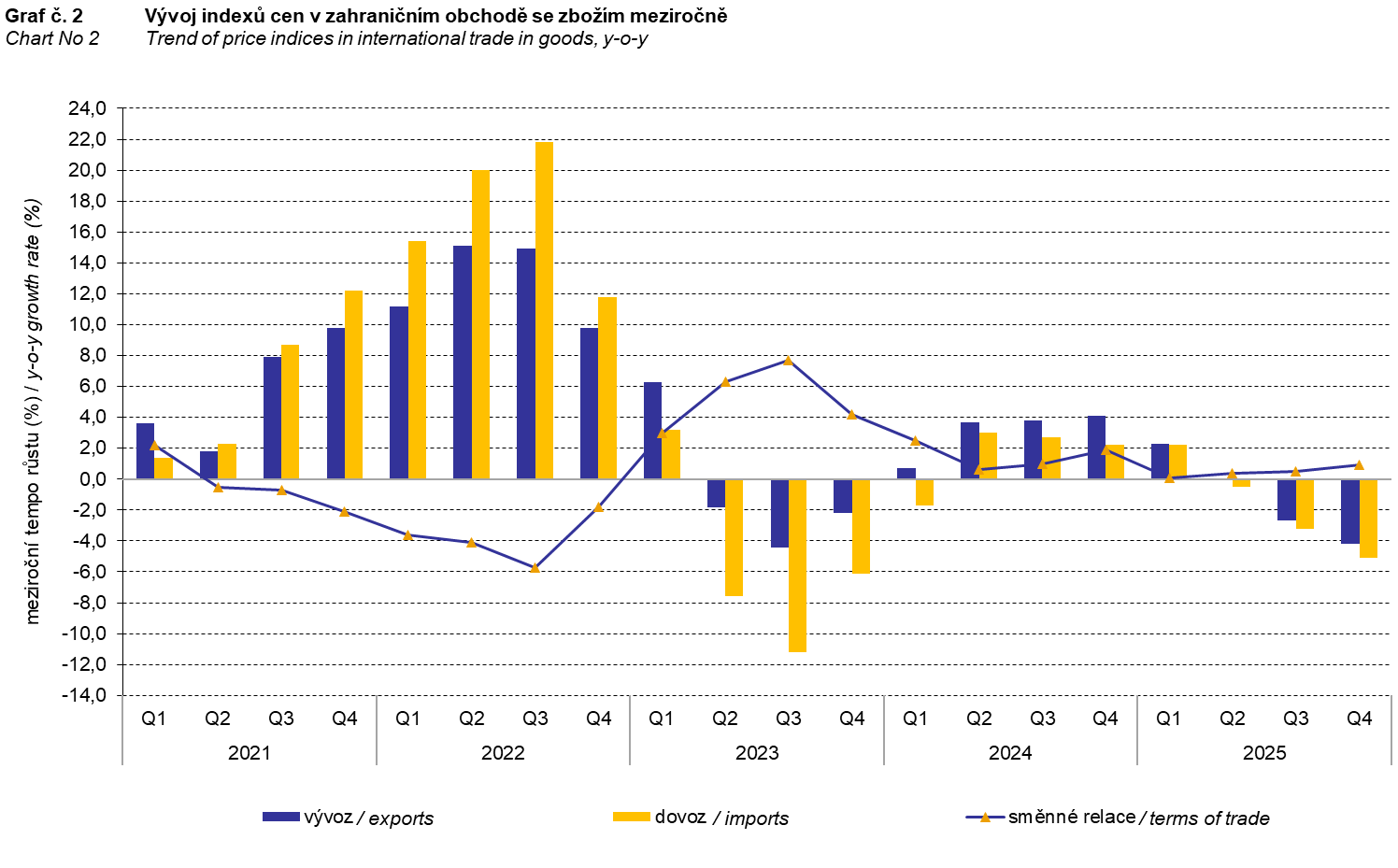

The international trade in goods (change of ownership) price development was also significantly influenced by the CZK exchange rate to the major foreign currencies. All monitored foreign currencies have been included in the quarter-on-quarter exchange rate index. Q-o-q indices of the CZK exchange rate to these currencies were weighted by the respective weight, which pertains to those foreign currencies in the export price index and in the import price index (before the Q3 2023, only two most important currencies, i.e. EUR and USD, have been included; as of the Q3 2023, the calculation was refined by the inclusion of all currencies and it was calculated backwards to the year 2021).

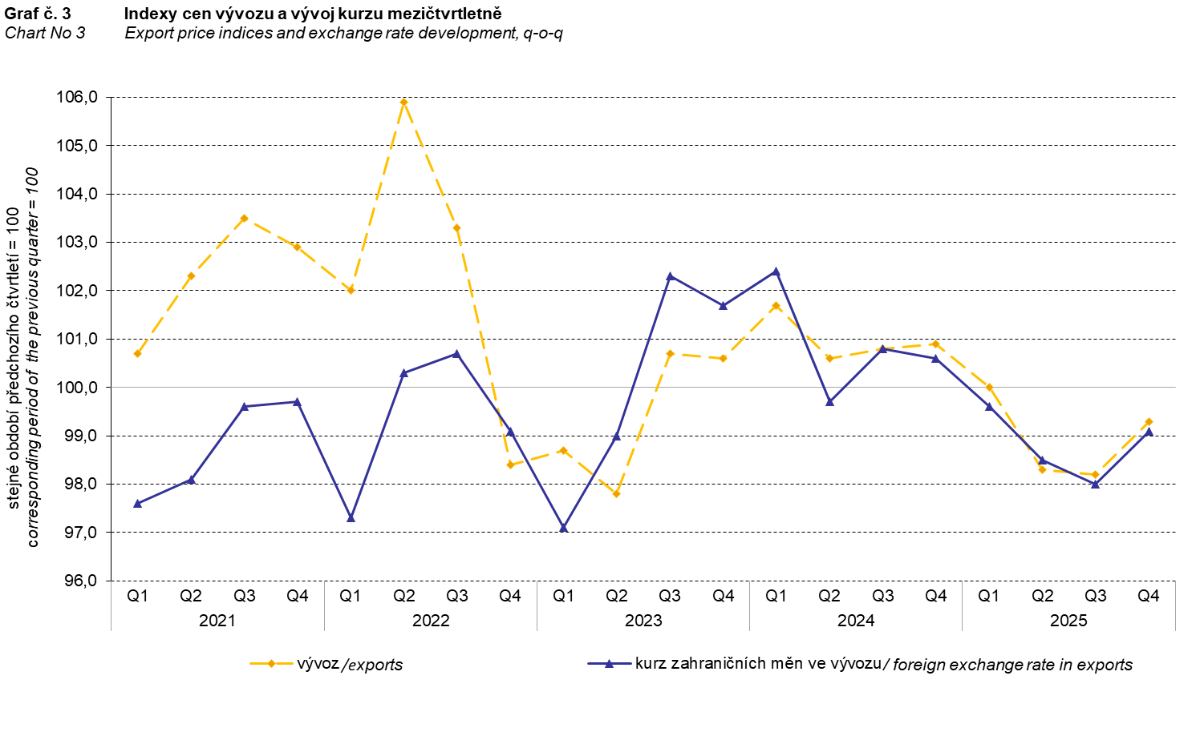
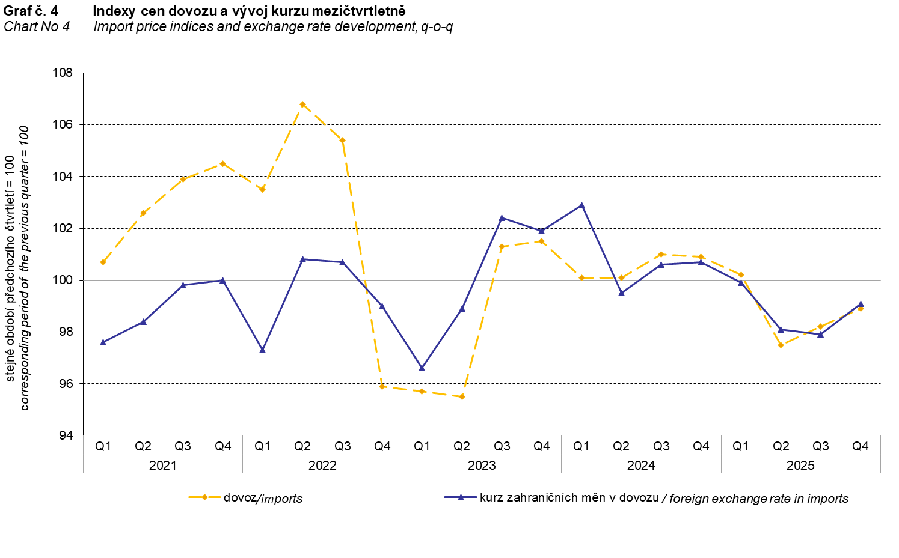
From the Charts Nos 3 and 4 above, it is apparent that in both exports and imports, international trade in goods prices have a relation to exchange rate effects. Contracts with foreign entities are usually concluded for longer periods of time and the longer the contract period is, the stronger the relation to exchange rates is.

International trade in goods price indices, year-on-year, adjusted for exchange rate influence
The Czech Statistical Office (CZSO) also calculates year-on-year international trade in goods price indices adjusted for exchange rate effects. The calculation is carried out as follows: prices in foreign currencies reported in the current month are converted to Czech crowns by the exchange rate of the same month of the previous year. Afterwards, together with prices reported in CZK, they are used for the weighted mean calculation. This exchange rate adjusted base price index of a month is related to the non-adjusted base price index of the corresponding month of the previous year and thus the year-on-year adjusted price index for the month is calculated. Year-on-year adjusted price indices for a quarter are calculated similarly, too.

Differences between the adjusted and non-adjusted price indices may be considerable. They are obvious in the Charts Nos 6 and 7, for example, in the third and fourth quarter of 2025.

The employed method does not enable to make a 100% exchange rate adjustment because not all trade transactions made in foreign currencies are also reported in foreign currencies. The proportion does not exceed 30%. It follows from the aforementioned that at the full exchange rate adjustment, differences between the published price indices and the exchange rate adjusted ones would probably be further increasing.

The exchange rate adjusted indices described above can also be used to make the exchange rate adjusted breakdown of increments of price indices. The Tab. 1 gives the published and exchange rate adjusted breakdown of increments of export and import price indices. The breakdown illustrates well how many percentage points each of the groups “exchange rate contributed” to the index.

It holds generally true that the exchange rate effect decreases the value of price indices in international trade in goods if CZK is strengthening to foreign currencies in total. Conversely, the exchange rate effect pushes the price indices up if CZK is weakening to foreign currencies in total.

The Chart No 5 below illustrates the CZK exchange rate to the two most important foreign currencies, i.e. to EUR and to USD.

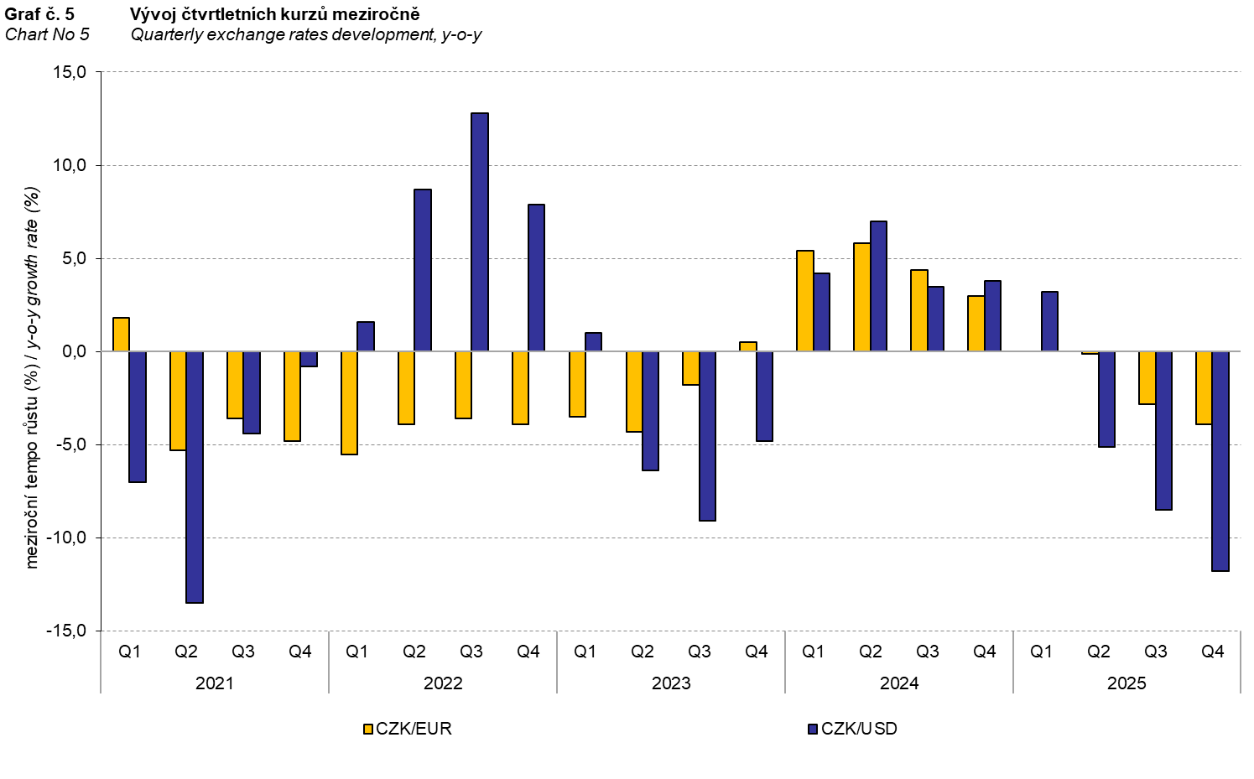

From the Charts Nos 6 and 7 below, it is apparent how significant the exchange rate influence of all monitored foreign currencies on the value of the export and import price indices was.

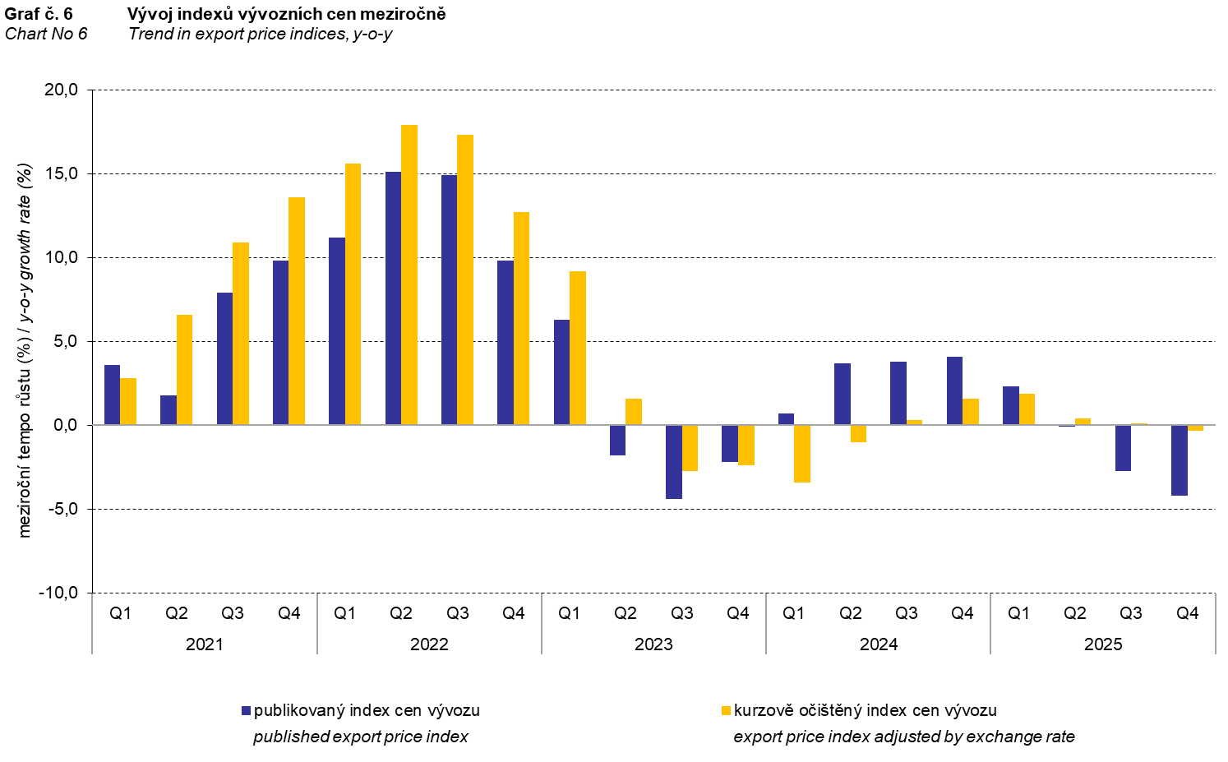

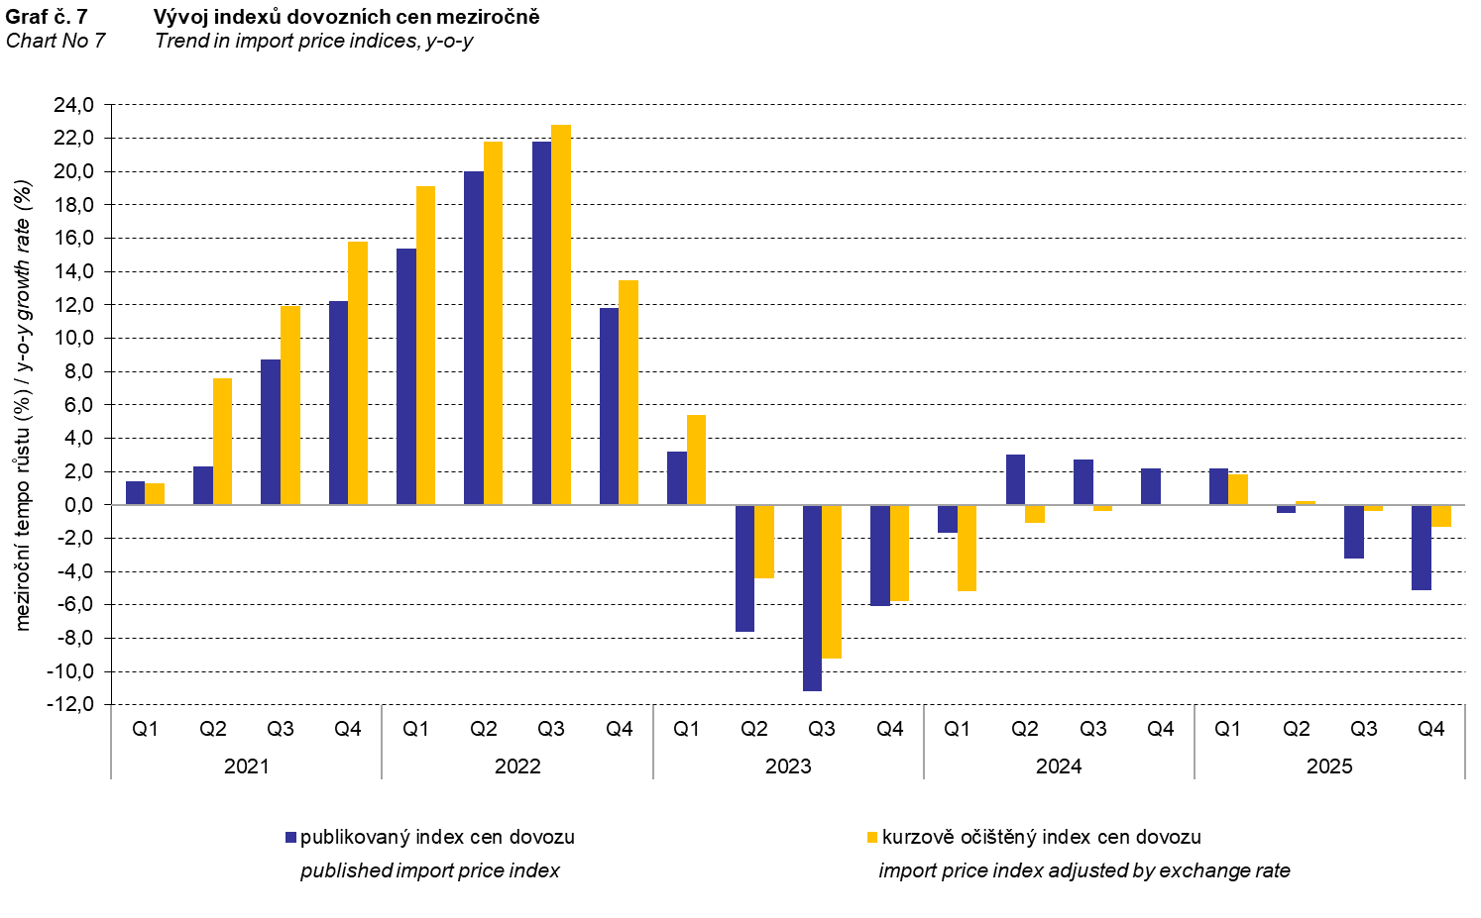

The Chart No 8 shows the exchange rate influence on the value of the year-on-year terms of trade.

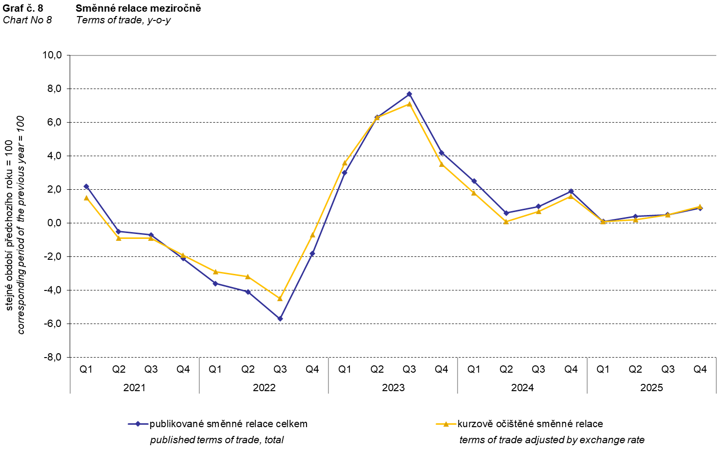

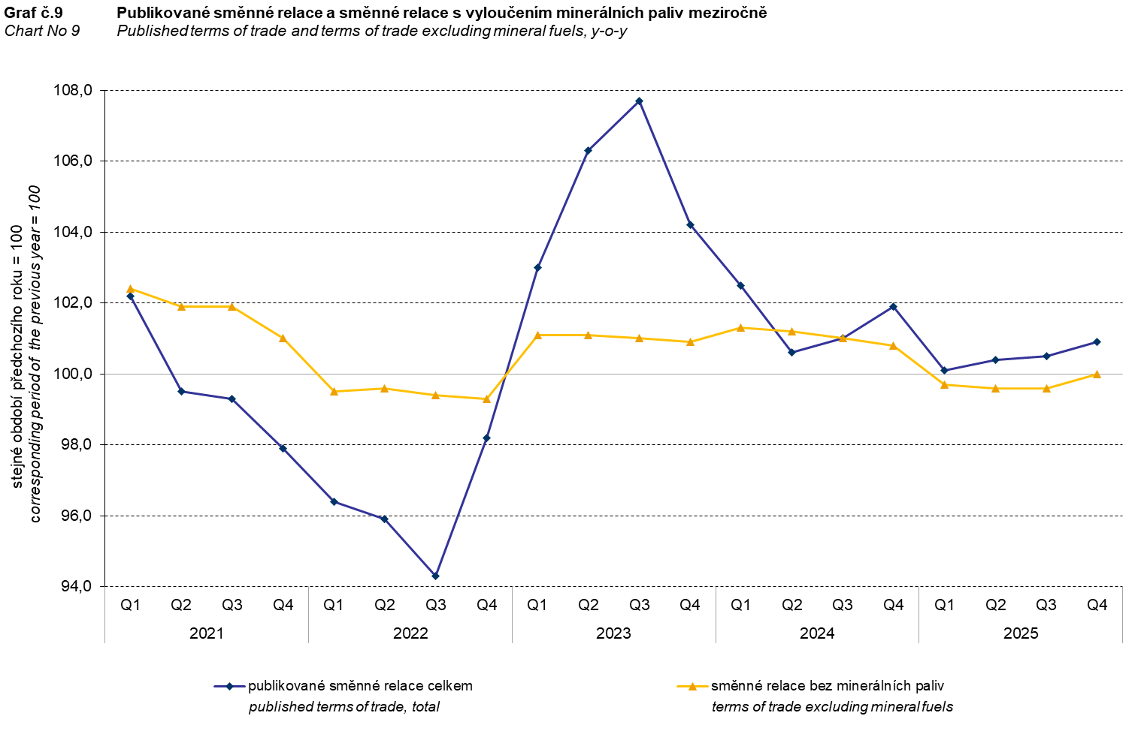

The Chart No 9 shows the development of the value of the terms of trade when mineral fuels are excluded, i.e. two-digit divisions 05, 06, 19, and 35 of the CPA classification (which correspond to the SITC 3 section called ‘mineral fuels, lubricants and related materials’). In this chart, the effect of mineral fuels can be observed that has an influence on the total value of the y-o-y terms of trade. Since the Q1 2023, mineral fuels were increasing the value of the terms of trade. However, in the Q2 2024, there was a turnabout and mineral fuels decreased the value of the terms of trade. In the Q3 2024, the terms of trade with the mineral fuels excluded and the total year-on-year terms of trade reached the same value. Since the Q4 2024, mineral fuels have been increasing again the value of the terms of trade. This development is related to price fluctuations on world markets, mainly of crude petroleum prices. Import prices, which have a higher proportion of crude materials (compared to export prices), respond in a more sensitive way to price turbulences. Therefore, the terms of trade are usually increasing when prices of crude materials are decreasing, and, vice versa, when prices of crude materials are increasing, the terms of trade are decreasing.

Final summary
In the Q4 2025, the exchange rate effect decreased, year-on-year, both the export price index and the import price index. Export prices decreased less than the import ones; therefore the terms of trade reached a positive value, year-on-year. After elimination of the exchange rate effect, the terms of trade reached by 0.1 percentage point higher value than the published terms of trade. Values free of the exchange rate effect correspond to the exchange rate adjusted indices – see the Charts Nos. 6, 7, and 8.

The closing table gives published non-adjusted international trade in goods price indices.

Note: For internal reasons, the Czech decimal comma is used instead of the English decimal point as a decimal separator in tables and charts of this analysis.

Elaborated by: Hana Lapáčková, Prices Statistics Department
phone number: (+420) 274 052 709, e-mail: hana.lapackova@csu.gov.cz

