19 May 2025

Number of young working persons was increasing

Employment and unemployment in the Czech Republic as measured by the Labour Force Sample Survey – 1st quarter of 2025
Year-on-year (y-o-y), the number of the employed persons increased by 24.3 thousand and the development of the total employment thus can be labelled as stagnating. According to the methodology of the International Labour Organization (ILO), the number of the unemployed decreased by 9.7 thousand persons. The number of the economically inactive aged 15+ years increased by 51.8 thousand during the same period.

Employment

In the Q1 2025, the seasonally adjusted average number of employed persons increased by 69.8 thousand persons, compared to the Q4 2024.
The number of working persons aged 15+ years stagnated, year-on-year. An increase by 0.5%, i.e. by 24.3 thousand persons to the total of 5 225.3 thousand employed persons was recorded in the Q1 2025. The number of working females increased; it was by 87.1 thousand higher, y-o-y, whereas the number of working males dropped by 62.7 thousand persons. The most marked increment was recorded as for working persons aged 60+ years, whose number grew by 27.8 thousand (i.e. by 5.0%). An increase was also recorded in the youngest age category of 15–24 years, in which there were by 10.6 thousand persons more (i.e. by 4.0%). The number of working persons aged 45–59 years also increased, namely by 16.1 thousand persons; however, in relative terms, it is rather a stagnation (an increase by 0.8%). Conversely, there was a year-on-year decrease in the age group of 25–29 years; it was a decrease by 12.4 thousand working persons (i.e. by 2.9%), and in the age group of 30–44 years, where the number of working persons dropped by 17.8 thousand persons (i.e. by 1.0%).
Chart 1: The number of working persons in the national economy and their structure by age group (thousand)
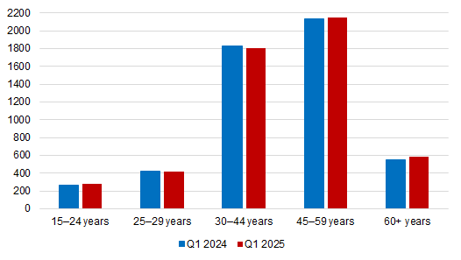
Source: CZSO, LFSS

In terms of sex, the most marked decrease in the number of working persons was recorded among males aged 30–44 years, among whom the number decreased by 60.4 thousand persons (i.e. by 5.7%). Conversely, the biggest increase was among females aged 45–59 years, the number of whom increased by 52.2 thousand persons (i.e. by 5.1%).

The number of employees increased by 69.5 thousand persons, i.e. by 1.6%. The number of the self-employed (without unpaid contributing family workers) decreased, on the other hand, by 44.4 thousand persons (i.e. by 5.3%). This overall decrease is mainly owing to a decrease in the number of the self-employed without employees (own-account workers) by 43.4 thousand. The number of the self-employed with employees (employers) was by 1.0 thousand lower, year-on-year. The share of the self-employed in the total employment thus decreased from 16.2% to 15.3%, year-on-year.

According to data for the Q1 2025, the development of employment in individual economic activities (CZ-NACE sections) in the Czech Republic was different⁾. In the primary sector of agriculture, forestry and fishing, the number of working persons decreased, year-on-year, by 6.8 thousand to 141.2 thousand. The secondary sector of industry and construction was virtually stagnating; a decrease in the number of working persons by 1.8 thousand to 1 830.7 thousand was recorded. In the tertiary sector of services, the total employment increased, y-o-y, by 33.0 thousand to 3 253.4 thousand persons. In this sector, the number of working persons especially increased in the section of ‘public administration and defence; compulsory social security,’ namely by 20.1 thousand persons. An increase was also recorded in the section of ‘wholesale and retail trade; repair of motor vehicles and motorcycles’; there were by 18.9 thousand employed persons more. A decrease in employment was recorded, for example, in the section of ‘professional, scientific and technical activities’, in which the decrease was by 23.7 thousand persons and in the section of ‘transportation and storage’, in which there was a decrease by 7.9 thousand persons.
Chart 2: The number of working persons in the national economy by economic activity (thousand)

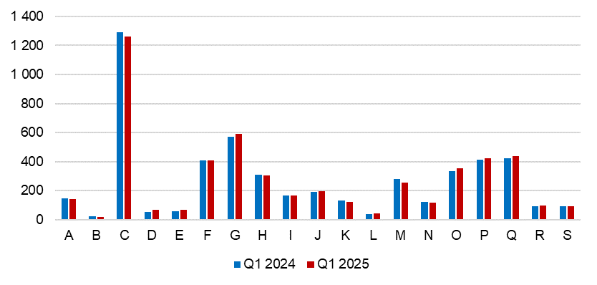
A – Agriculture, forestry and fishing; B – Mining and quarrying; C – Manufacturing; D – Electricity, gas, steam and air conditioning supply; E – Water supply; sewerage, waste management and remediation activities; F – Construction; G – Wholesale and retail trade; repair of motor vehicles and motorcycles; H –Transportation and storage; I – Accommodation and food service activities; J – Information and communication; K – Financial and insurance activities; L – Real estate activities; M – Professional, scientific and technical activities; N – Administrative and support service activities; O – Public administration and defence; compulsory social security; P – Education; Q – Human health and social work activities; R – Arts, entertainment and recreation; S – Other service activities.
Source: CZSO, LFSS

Along with changes in the structure by economic activity (CZ-NACE section), changes in the structure of working persons by occupation also occurred. According to the Classification of Occupations (CZ-ISCO), the number of working persons increased the most in the major group of professionals (by 27.8 thousand persons) and in the group of managers (by 14.0 thousand persons). On the other hand, the biggest decrease occurred in the major group of plant and machine operators, and assemblers (by 12.8 thousand).

The aforementioned increment among young workers was mainly obvious in the age category of 20–24 years, in which 250.9 thousand persons were working. This increase was especially in males; their number increased by 13.2 thousand, y-o-y, whereas as for the number of working females, it was by 0.3 thousand lower, year-on-year, in this category. It is because females of that age more often continue in their studies. Almost a third of males aged 20–24 years was working in manufacturing (47.5 thousand), a lower number in the section of ‘wholesale and retail trade; repair of motor vehicles and motorcycles’ (20.8 thousand) and in ‘construction’ (16.5 thousand). Females of that age category were working the most in the sections of ‘wholesale and retail trade; repair of motor vehicles and motorcycles’ (21.0 thousand), ‘human health and social work activities’ (16.7 thousand), and in ‘accommodation and food service activities’ (15.7 thousand). According to the Classification of Occupations (CZ-ISCO), young males were most often employed in the category of craft and related trades workers (45.2 thousand), whereas young females were predominantly working as service and sales workers (36.0 thousand).

Chart 3: The number of working persons in the national economy by Classification of Occupations (thousand)
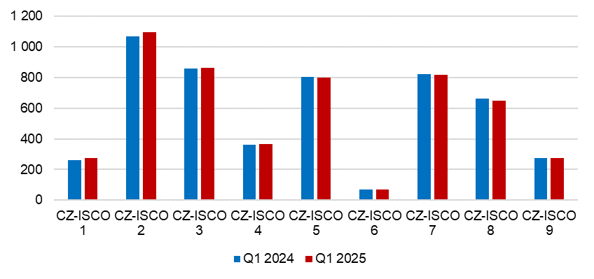
CZ-ISCO 1 – Managers; CZ-ISCO 2 – Professionals; CZ-ISCO 3 – Technicians and associate professionals; CZ-ISCO 4 – Clerical support workers; CZ-ISCO 5 – Service and sales workers; CZ-ISCO 6 – Skilled agricultural, forestry and fishery workers; CZ-ISCO 7 – Craft and related trades workers; CZ-ISCO 8 – Plant and machine operators, and assemblers; CZ-ISCO 9 – Elementary occupations.
Source: CZSO, LFSS

The development trend in the number of working persons according to the educational attainment is also related to the mentioned changes in the employment structure. The number of working persons with primary education decreased by 0.3 thousand to 237.5 thousand. The number of working persons with secondary education without A-level examination decreased by 76.0 thousand to 1 568.5 thousand persons. On the other hand, the number of working persons with secondary education with A-level examination was higher, year-on-year, by 35.9 thousand. The biggest increase occurred in employed persons with tertiary education the number of whom increased by 65.7 thousand to 1 490.5 thousand. This increase mainly applied to females the number of whom increased by 62.8 thousand, year-on-year.

The employment rate (the percentage of working persons in the age group of 15–64 years old) increased in the Q1 2025 compared to the corresponding period of the previous year by 0.6 percentage point (p. p.) to 75.5%. The development among males and females was opposing. The male employment rate decreased by 0.8 p. p., y-o-y, to 80.1% and the female one increased by 2.1 p. p. to 70.9%.

Development of part-time jobs also had an influence on the growth of the total employment. In the first quarter of 2025, 499.8 thousand persons were working part-time, which is a year-on-year increase by 27.3 thousand persons (i.e. by 5.8%). Numbers of part-time workers have been increasing during recent years. In the Q1 2018, there were 383.3 thousand of them, which means that during the last 7 years their number increased by 116.5 thousand persons, which is an increase by 30.4%. Part-time jobs were mainly used by females. During the last reference period, there were 354.2 thousand of them, i.e. 70.9% of all part-time jobs in main job. A part-time job enables them to be more flexible, mainly when carrying their caring responsibilities. Females were working part-time most often in ‘human health and social work activities’, ‘education’, and ‘wholesale and retail trade; repair of motor vehicles and motorcycles’. In total, 14.6% of working females worked part-time. Females gave most often the following reasons for working part-time: childcare or care for an adult person in need of care (71.9 thousand), other personal reasons (68.1 thousand), or that the job is only available as part-time (56.9 thousand). The highest number of females working part-time was in the age of 30–44 years (131.5 thousand, i.e. 37.1%).
Males used part-time work significantly less. 145.7 thousand males worked part-time, which is only 5.2% of all working males. It was mainly work in ‘wholesale and retail trade; repair of motor vehicles and motorcycles’ or in ‘manufacturing’. Males worked part-time mainly due to “other personal reasons” (38.7 thousand). Most of males working part-time were in the age of 60+ years (60.4 thousand, i.e. 41.5%).
Chart 4: The number of part-time workers and their age structure (thousand)
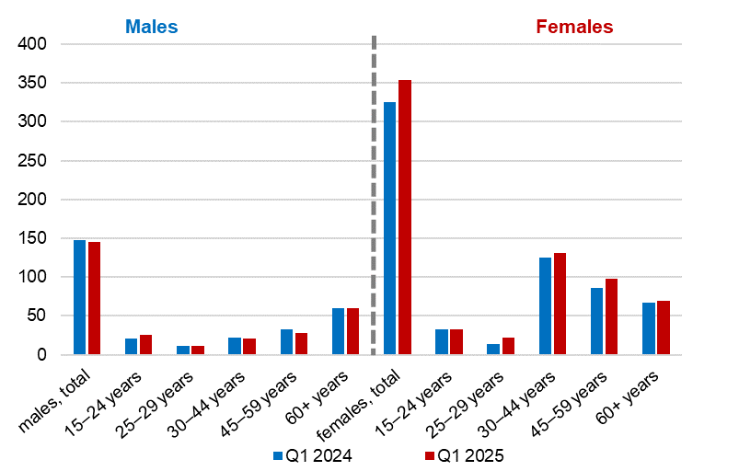

Source: CZSO, LFSS

Unemployment

The seasonally adjusted average number of unemployed persons according to the ILO methodology⁾ decreased in the Q1 2025 by 4.0 thousand persons, compared to that in the Q4 2024.

Chart 5: The number of the unemployed in Regions of the Czech Republic (thousand)
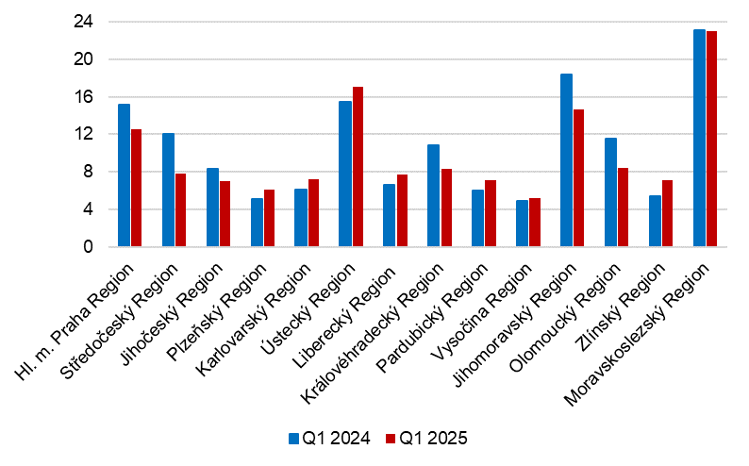
Source: CZSO, LFSS

The total number of the unemployed aged 15+ years decreased, year-on-year, by 9.7 thousand to 139.4 thousand persons. It was a decrease in the number of the unemployed females by 6.4 thousand to 74.1 thousand and in the number of the unemployed males by 3.3 thousand to 65.3 thousand.

The most marked decrease of the unemployment was recorded in the Středočeský Region (by 4.2 thousand), in the Jihomoravský Region (by 3.6 thousand), and in the Olomoucký Region (by 3.1 thousand).
The number of persons unemployed for one year and longer (the long-term unemployed) has also decreased; it was by 12.0 thousand, y-o-y, to 35.2 thousand. The number of the long-term unemployed males decreased by 9.4 thousand, y-o-y, the number of the long-term unemployed females in the Q1 2025 decreased by 2.6 thousand compared to the corresponding period of 2024.

Chart 6: The number of persons unemployed for one year and longer and their age structure (thousand)

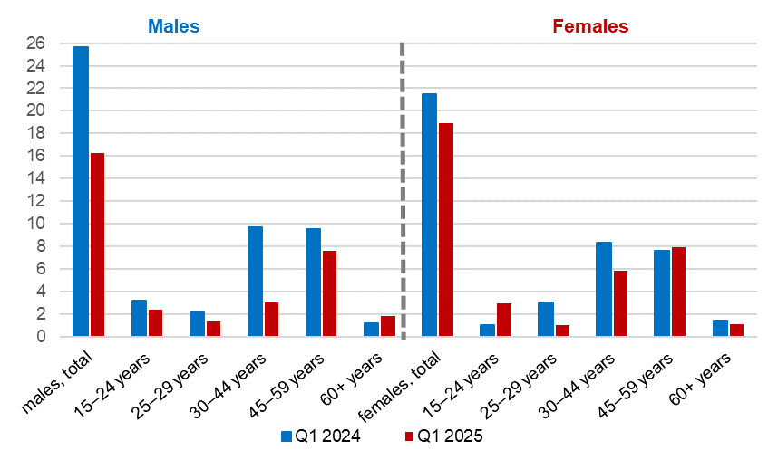
Source: CZSO, LFSS

The general unemployment rate according to the ILO definition in the age group of
15–64 years old (the percentage of the unemployed in the labour force, i.e. in the sum of the employed and the unemployed) decreased by 0.2 p. p., year-on-year, and in the Q1 2025 it was 2.7%.

Chart 7: Unemployment rate of the 15–64 years old in Regions of the Czech Republic (%)
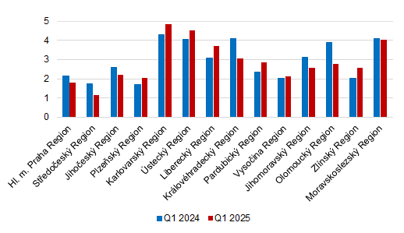
Source: CZSO, LFSS

In terms of a regional comparison, the general unemployment rate of the 15–64 years old was the highest in the Karlovarský Region (4.9%), in the Ústecký Region (4.5%), and in the Moravskoslezský Region (4.0%). The lowest unemployment rate was in the Středočeský Region (1.1%), followed by the Hl. m. Praha Region (1.8%), the Plzeňský Region, and the Vysočina Region (both 2.1%). The biggest y-o-y decreases in the unemployment rate were in the Královéhradecký Region (by 1.1 p. p. to 3.0%) and in the Olomoucký Region (by 1.1 p. p. to 2.8%). The biggest year-on-year increases were, on the other hand, in the Karlovarský Region (by 0.6 p. p. to 4.9%) and in the Liberecký Region (by 0.6 p. p. to 3.7%).

Economic inactivity
The number of economically inactive persons aged 15+ years was by 51.8 thousand higher, year-on-year, and amounted to 3 480.9 thousand. The number of economically inactive males increased by 60.8 thousand, whereas the number of economically inactive females was by 9.0 thousand lower than a year ago.
In the sample survey, data are also collected on persons who do not work and do not seek a job in an active manner and therefore do not comply with the ILO conditions for the unemployed, however, they state that they would like to work. In the Q1 2025, the number of such persons was 79.4 thousand, i.e. by 1.0 thousand persons less than in the corresponding period of 2024. The number of persons who are willing to work, yet they are not able to start in a potential job immediately, is relatively high. Only 10.9 thousand of the persons are able to start in a job within a fortnight, at the latest.

Note:
Data in the analysis have not been seasonally adjusted unless otherwise stated.
Recalculation to the same population structure
The Labour Force Sample Survey (LFSS) is carried out in selected dwelling households. Collective accommodation establishments are not included in the survey. The data found were weighted to the population of the Czech Republic based on the results of the demographic statistics as at the end of the given year; estimates of the number of persons living outside private households were subtracted from the population totals of the demographic statistics.

Authors:
Marta Petráňová, phone number: (+420) 274 054 357, e-mail: marta.petranova@csu.gov.cz
Gabriela Strašilová, phone number: (+420) 567 109 071, e-mail: gabriela.strasilova@csu.gov.cz
Labour Force Statistics Unit

⁾ Data for economic activities (CZ-NACE sections) may be influenced by the employed methodology of the Labour Force Sample Survey (LFSS). The survey only covers persons living in dwellings (flats), i.e. private households. Data on persons living in collective accommodation establishments are not measured; these establishments often give accommodation to foreign nationals.
⁾ The ILO methodology defines the unemployed as persons who during the reference period were without a job, did not work an hour for pay or remuneration, and were in an active manner seeking a job they would be able to join within fortnight at the latest. This methodology is uniform for all EU Member States and provides internationally comparable data. It has to be taken into consideration that the definition of “the unemployed” by the ILO differs from the definition of “job applicants kept in the register of the labour offices” of the Ministry of Labour and Social Affairs.

