Overall Economic Performance

GDP in the CR fell already for the sixth quarter in a row in Q2 2013 year-on-year, the depth of fall was however in comparison to previous three quarters lower… |  | GDP fell in Q1 and Q2 2013 in comparison to the same period of the previous year by 2.4 % and 1.3 %, in total for H1 by 1.9 %. Viewed from the point of year-on-year development, the economic performance was falling already six quarters in a row. If the year-on-year falls of GDP gradually deepened quarter by quarter from -0.4 % in Q1 2012 down to -2.4 % in Q1 2013, in Q2 2013 the GDP fell „only“by mentioned 1.3 %. This corresponded to a milder year-on-year decrease compared to preceding three quarters.
...the GDP thus after six quarters increased for the first time in quarter-on-quarter terms by 0.6 % |  | Milder year-on-year drop of GDP in Q2 2013 was caused by quarter-on-quarter increase of GDP by 0.6 %. If the GDP still decreased in Q1 2013 over the previous quarter by 1.3 %, in Q2 2013 the domestic economy already displayed a growth after a quarter-on-quarter fall lasting six quarters. In total the GDP fell in the period of contraction by 3.1 %, which corresponded approximately to half of the fall occurring in the period of 2008/2009.
Quarter-on-quarter decrease of GDP in the CR in Q1 2013 one of the largest in the EU, while the growth of GDP in Q2 on the contrary one of the highest |  | Position of the CR in the EU based on the quarter-on-quarter rate of growth of GDP markedly improved. Given the quarter-on-quarter decrease of GDP in the CR in Q1 2013 being one of the deepest in the whole EU (GDP in the EU lowered in the same period only by 0.1 %), quarter-on-quarter addition in Q2 2013 in the CR reached an above average rate of growth (GDP in the EU in Q2 2013 rose by 0.4 %). Higher rate of growth compared to the domestic economy occurred in Q2 2013 only in Portugal (+1.1 %) and further in Germany, Great Britain, Latvia, Lithuania, Malta (similarly +0.7 %). Also the last country out of the three largest economies according to GDP (France) reached an above average quarter-on-quarter growth (nevertheless lower compared to the CR) in the amount of 0.5 %.
Behind the quarter-on-quarter recovery stood especially the foreign trade… |  | Quarter-on-quarter increase of GDP in the CR in Q2 2013 was under the direction of foreign trade. In the last quarter of 2012 the exports still fell compared to the previous quarter by 1.9 %, imports did not change and the balance of foreign trade thus contributed to the quarter-on-quarter decrease of GDP. In Q1 2013, the exports fell by further 0.6 %, imports however already by 1.1 % and the positive result of the foreign trade started to soften the fall of GDP. In Q2 2013 the exports quarter-on-quarter even improved (by 3.6 %) and the same was valid for imports (by 2.5 %). Higher growth of imports compared to exports (by 1.1 p.p.) in Q2 2013 led to a more notable increase of the foreign trade surplus than the 0.5 p.p. milder drop of exports in comparison to exports in Q1 2013.
…which recorded a better result in Q2 2013 mainly thanks to the demand from Germany |  | In the growth of domestic exports in Q2 2013 significantly assisted the improved performance of the German economy. GDP in Germany in the last quarter of 2012 fell year-on-year by 0.5 % and in Q1 2013 stagnated, to which corresponded also the changes in the aggregate volume of imports into this country – in the last quarter of 2012 the imports decreased by 0.9 %, in Q1 2013 by further 0.4 %. Quarter-on-quarter expansion of the German GDP in Q2 2013 however again increased the imports by exactly two percent, which benefited also the CR.
The most significant expenditure component of GDP by volume - the final consumption expenditure – in 2Q 2013 in year-on-year terms grew, however they were by half a percentage lower compared to Q1 2013… |  | The most significant expenditure component of GDP by volume, the final consumption expenditure, again grew in Q2 2013 year-on-year (by 0.8 %). This turn occurred after a two-year fall. Positive rate of growth of consumption was however given only by a low comparative basis in Q2 2012, when the consumption year-on-year decreased by 2.4 %, the most across the whole recession. Quarter-on-quarter the consumption grew already in the last quarter of 2012 (by 0.5 %) and in Q1 2013 (by 1.3 %). On the contrary, the final consumption expenditure again decreased in Q2 2013, specifically by 0.5 %.
…which was again the effect of both the weaker consumption of the household sector… |  | Repeated reduction of the consumption of the domestic economy in Q2 2013 was caused by the lowered consumption of households, which was reduced quarter-on-quarter by 0.4 %. Given the fact that the household consumption was already rising in the last quarter of 2012 and Q1 2013 by 0.3 % and 1.5 %, returned slump put further increase to a halt. Despite Business Cycle Surveys signalling relatively long-term improving of the consumer confidence in the future economic development (consumer confidence indicator grew already roughly from the half of year 2012), real data related to consumption did not confirm these findings.
…and the final consumption expenditure of the government institutions |  | To the lowering of the overall consumption in the economy in Q2 2013 in comparison the previous quarter contributed also the repeated drop in the final consumption expenditure of the government institutions. Consolidation of public finances gradually limited the volume of funds provided to public services starting the last quarter of 2010 until Q2 2012 (with the exception of quarter-on-quarter growth by half a percentage in Q1 2012). Beginning the second half of 2012 a gradual ceasing of expenditure restrictions eventuated – consumption of government institutions increased quarter-on-quarter by 0.2 % in Q3 2012 and 1 % in the last quarter. Growth of final consumption expenditure of government institutions continued also in Q1 2013 (by 0.9 %). In Q2 2013 however again the government institutions consumption was restricted by 0.7 % – the consolidation of public finances from the point of view of restrictions on the expenditure side thus was not yet fully completed.
The last main expenditure item, gross capital formation, did not contribute to the quarter-on-quarter growth of GDP either |  | The last main expenditure item, the gross capital formation, did not contribute to the quarter-on-quarter growth of GDP either. If in Q1 2013 the gross capital formation downswinged by 10.7 % in comparison to the last quarter of 2012, in Q2 2013 its volume rather stagnated (-0.1 %).
If the gross capital formation sank in Q1 2013 by more than one tenth as a result of lowering of the volume of inventories in the economy, in Q2 the lowering of stock of inventories slowed down and consequently limited the negative impact of the lower investment on the gross capital formation |  | Causes of the specific quarter-on-quarter shifts in the volume of gross capital formation in H1 is necessary to search for already in the last quarter of 2012, when the gross capital formation increased by 3.2 %, investment (gross fixed capital formation) however decreased by 2.2 %. The source of growth of the gross capital formation was thus in Q4 2012 the increase of inventories in the domestic economy, which was most likely supported by the pre-stocking of tobacco products for the reason of expected increase in the consumption tax at the beginning of year 2013. In Q1 2013 the gross capital formation sank by the above mentioned 10.7 %, investment however increased by modest 0.2 % – what occurred most likely was a significant sell out of inventories prestocked in the preceding quarter. In Q2 2013 the gross capital formation stagnated, but investment again decreased – by 1.5 %. The stock of inventories in the economy continued to fall, however, it can be assumed that by a lower pace compared to Q1 2013.
The long-term low tendency of firms to acquire new investment led to a fact, that the volume of new investment in Q2 2013 reached only 92.8 % of the volume of investment from the end of 2011 |  | Relatively adverse development of the gross capital formation was strongly impacted also by the weak investment activity in the long-term in the CR. Beginning year 2012 the quarter-on-quarter increase in investment eventuated only twice – in Q2 2012 by 0.6 %, in Q1 2013 by mentioned 0.2 %. The volume of the gross fixed capital formation was thus in Q2 2013 by 7.2 % lower compared to the end of 2011. This fact has its root probably in the low investment activity of firms, which can be observed from the long-term weak business confidence in the economic development – the indicator of business confidence has been decreasing already from the start of 2011.
Weakened domestic demand led to only a minimal quarter-on-quarter growth of gross value added in the economy (by 0.2 %) |  | Domestic demand in Q2 2013 fell down, with a contribution apart from a milder reduction of the stock of inventories of all its major components. The source of quarter-on-quarter growth of GDP thus remained in the positive result of the foreign trade. Adverse development in the economy – notable from the expenditure structure of GDP – negatively affected also the supply side (total gross value added increased compared to the previous quarter only by 0.2 %).
Slump of the aggregate gross value added was averted by high performance of the financial and insurance activities together with growth of GVA in industry |  | More signification source of the growth of gross value added in Q2 2013 thus remained financial and insurance activities, which increased its quarter-on-quarter rate of growth of gross value added from 1.2 % in Q1 to 6.2 % in Q2. Also industry (CZ NACE B to E) increased gross value added by 1.7 %, when it was still decreasing in Q1 by 0.8 % – with respect to the reduction in the gross value added formation of the manufacturers in Q1 by 0.2 % and its growth by 0.2 % in the second it can be assumed, that the main role in the dynamics of gross value added as a whole played the energy industry.
… quarter -on-quarter lowering was on the contrary observed for groups of branches significant by volume - trade, transportation, food service activities and accommodation but also for real estate activities |  | The drop of gross value added in Q2 2013 was deepened for groups of branches of trade, transportation, food service activities and accommodation (from quarter-on-quarter -0.1 % to -0.9 %). A slump in Q2 recorded also a branch significant by volume in the area of real estate (-1.5 %) or the group of public governance and defence, education, health and social care (-0.2 %) – all these branches are sensitive to shifts in the domestic demand.

Chart 1 | GDP (constant prices, adjusted for seasonal and calendar effects, in %) | Chart 2 | GDP (constant prices, adjusted for seasonal and calendar effects, y/y in %, r.axis) and confidence indicators (2005=100, l. axis)
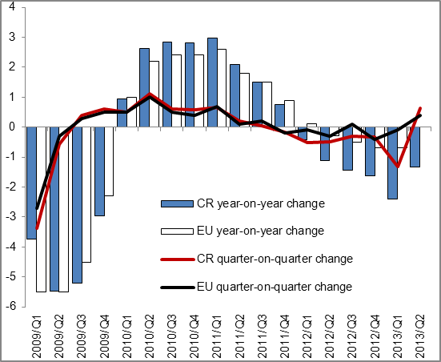 |  | 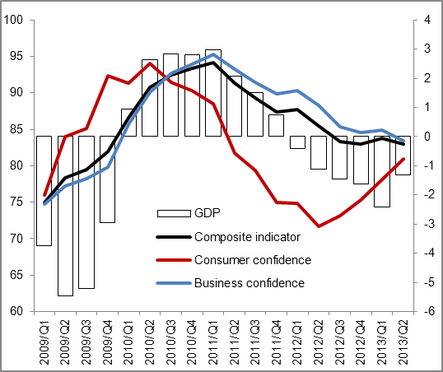
Source: Eurostat, CZSO

Chart 3 | Contributions of expenditure components to variation in GDP (constant prices, y/y in p.p.) | Chart 4 | Contributions of branches to variation in gross value added  (constant prices, y/y in p.p.)
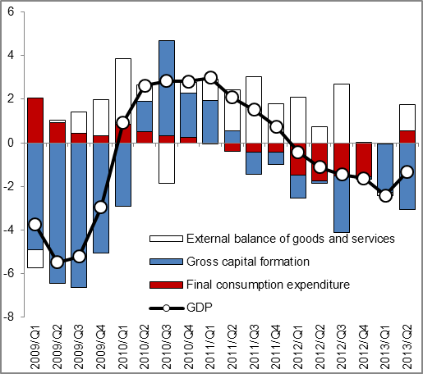 |  | 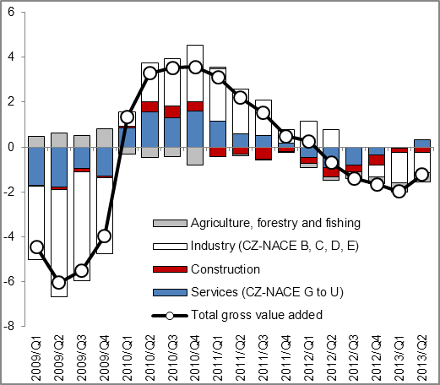
Source: CZSO

In real terms, adjusted for seasonal effects and effects of variable number of working days – unless stated otherwise.
EU27

