The Czech economy development in 2011 May 2012

Prices
Aggregate price level decreased given varied development of producer prices, consumer prices and opposing effect of terms of trade | Movement of prices was characterised by the decrease in the aggregate price level in 2011. Adverse development of prices in foreign trade had such an impact that even though producer prices in industry and agriculture grew markedly and consumer prices increased, implicit deflator gauging the aggregate price level in the Czech economy dropped year-on-year by 0.7 %.  Prices in agriculture were determined by the effect of closing scissors of prices of vegetable and animal production, rate of growth of prices in industry then strong additions in the first half of the year. Price deflation of construction works deepened, prices of market services renewed their growth. Terms of trade were negative and only slightly better compared to 2010. Overall the price development was affected by stronger supply impulses in the first half of the year and the drop in demand in the rest of the year.
- Agricultural prices grew in 2011 by one fifth, prices of grain by 47 %; compared to prices of 2005 the prices of vegetable production were raised by one half, animal production was cheaper | Rate of growth of agricultural prices were from the second half of the year diminishing based on the dynamics of prices of vegetable production, which on the contrary for the prices of animal products practically stagnated in each quarter. Thus it created a phenomenon, last occurring by the end of 2008 – that the animal production was regarding the prices below the dynamics of the prices of vegetable production, however at that time in the deflation zone. In the 4th quarter, the prices of vegetable products grew year-on-year only mildly (+3.1 %) after notable drop in prices of vegetables (-37 %) and potatoes (-46 %). Prices of animal products were up by 8.3 % (prices of eggs and pigs were raised by one tenth).  Lowering of the rate of growth of prices of the agricultural producers was enabled in 2011 by a good harvest. Development of prices also allowed the growth of profits in agriculture – operating economic result for 2011 was remarkably higher compared to 2010. For the whole year the prices grew by 19.1 % (for vegetable production by 29.9 %, for animal production by 7.6 %). Prices of grain raised nearly by one half (+46.9 %) had in the price chain via manufacturers and traders a sharp impact on the prices of bread.  In comparison to 2005 the agricultural prices were higher by 21.2 %, in that the prices of vegetable production by 48.7 %. Prices of animal products on the contrary for the last six years went down by 2.2 %.
- Second largest growth of prices in industry since 1995 | Industrial prices moved up in 2011 by 5.6 %, which was second largest year-on-year growth for the last sixteen years (in 1995 +7.4 %). It was the consequence of the growth in the preceding grades of the price chain, which were influenced by one fifth’ increases of prices in manufacture of coke and refined petroleum products. Above average lay also manufacture of food products (+7.7 %), mining (+6.9 %), chemical products (+8.6 %) and metallurgy (+8.5 %). The last two named however experienced in the last quarter a slower rate of growth due to the reaction on changes in demand. Continuous fall of prices occurred in manufacture of computer, electronic and optical products, prices of transport vehicles were in 2011 year-on-year lower by 1.9 %.
- Quarter-on-quarter revival of prices in 4th quarter favourable | Strong quarter-on-quarter growth of prices in the first half of the year slowed down to stagnation in the 3rd quarter, in the 4th quarter then prices quarter-on-quarter revived somewhat (+0.4 %), which is positive when evaluating the demand for industrial goods. Quarter-on-quarter growth in the 4th quarter was affected mostly by the revival of the prices of transport vehicles (+2 %) after previous relatively long deflation, which increased also the quarter-on-quarter growth of prices in manufacturing, which then determined the overall dynamics of industrial producer prices. The revival of industrial prices in 4th quarter is important, since it can signal more favourable turn of the demand, which is noticeable also from the cessation of falling tendency of orders in industry.
- Prices of construction works further fell, prices of market services revived | Drop of prices of construction works from 2010 (-0.2 %) deepened to -0.5 % as a reflection of adverse situation in industry (reduction of prices was continuous in every quarter). On the contrary the prices of construction materials and products used in construction grew more notably (+2.8 %) than in 2010 (0.6 %). Prices of market services grew for the whole year by 0.9 %, again following a continuous growth in individual quarters: in 1st quarter only by 0.3 % - which was first addition after deflation in 2010 -, in the last quarter then by 1.3 %. Prices surprisingly revive even though the sales for these services were falling nearly the whole year.
- Inflation relatively low given marked raising of prices of food products, housing and supportive services and also the transportation | Prices were for consumers in 2011 by 1.9 % higher than in 2010. This relatively low increase however covers the fact, that considerably faster grew prices of goods and services which are necessities for consumers, which was in part compensated by the drop in prices of items, whose consumption is not regular. Overall growth of prices started at +1.7 % in the 1st quarter and ended at +2.4 % in the last quarter. Raised prices of necessities, which were faster than the aggregate inflation, were the most notable for food products (+4.6 %, in the 4th quarter by +5.3 %). These increased in the sharp rise of the prices of bread – from +6.4 % in 1st quarter to +16 % in 4th quarter – to year-on-year growth of +14 %, but the raising of prices occurred through the whole range of food products. Prices of housing and energies were higher by 2.8 % given the growth of prices of natural gas by 11.8 %. Prices in transportation (+2.8) were affected by the growth of prices of fuels (+9.9 %), where the increments stayed around 10 % for the whole year. Prices of holiday, household equipment fell down and lower were for the whole year as usual also the prices of clothing and footwear.
- Unfavourable terms of trade with growing import prices and stagnation of export prices | Unfavourable terms of trade (negative since April 2010) worsened the nominal result of the foreign trade – less intensively since the 2nd quarter. Quarter-on-quarter view improved the 2nd quarter (in June the import prices dropped and the terms of trade jumped to positive values). In 4th quarter the prices of import grew faster (+6-5 %, whole year +4-3 %) than export prices (+4.6 %, whole year +1.7 %). Exporters of motor vehicles exported in 2011 cheaper than in the previous year (-2.5 %), import prices were pushed up by the imported mineral oils, whose prices were raised by one quarter. Machinery and transport vehicles were imported cheaper. Exchange rate effect in the 4th quarter due to the depreciation of crown prices in the foreign trade pushed up.

Graf 11 | Prices of producers (y-o-y in %) | Graf 12 | Consumer price inflation by social groups (CPI, y-o-y in %)
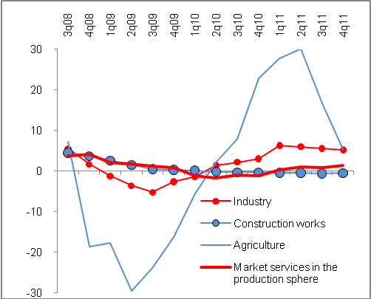 |  | 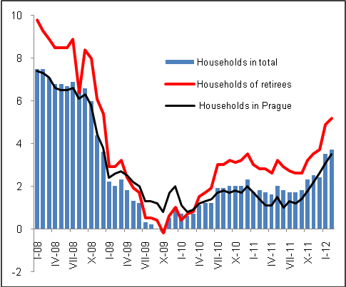
Source: CZSO

