Internal and External Imbalance
Departion of the Czech economy from balance was not apparent in 2012 despite the country being in recession. Internal imbalance according to the size of relative deficit of the public finances improved as well as the external imbalance according to the deficit of current account of balance of payments. Among other significant imbalances on the macroeconomic level further deepened the disproportion between supply and demand on the labour market, relation between development of real wage and labour productivities also transformed.

Deficit and debt of the government sector
Debt crisis, which Greece entered already during 2010 and which also subsequently hit some other countries of the South Europe, impacted also on the other countries of the euro area due to the need to share the „rehabilitation of losses“. The CR according to the Eurostat data fared in this period very well and its government institutions deficits as well as their projections into the development of gross consolidated debt of the government sector did not presented any marked worsening of the relative position in the European context. Also the private debt in the CR in relation to GDP belongs to the lowest in the EU.

Deficit of government institutions
Extraordinary influences significantly affected the year-on-year worsening of the government sector deficit in the CR to 169 bn in 2012 from 124.9 bn in 2011… |  |  | Government sector in the CR ended in 2012 in deficit, which amounted to 169.003 bn crowns against 124.943 bn crowns in 2011. The worsening was caused based on the notification submitted by CZSO to the European Commission „inclusion of financial compensations linked to the restitution of church property in the amount of 59 bn crowns and the correction of EU subsidies pre-financed from the state budget (returned funds in the amount of 12 bn crowns). With both influences the government sector deficit would reach the size of 2.5% of GDP.
… i.e. 4.4 % of nominal GDP from 3.3 % in 2011 |  |  | Following the year-on-year improvement of the government sector deficit in the CR in years 2010 (by 35.6 bn crowns) and 2011 (by 57.8 bn crowns) thus the shown deficit in 2012 worsened year-on-year by 44.1 bn crowns, which represented 4.4 % of nominal GDP (4.8 % in 2010 and 3.3 % in 2011).
Chart 38 | Government sector deficit  (in % of nominal GDP) |  |  | Chart 39 | Gross consolidated government sector debt (in % of nominal GDP)
 |  |  |  | 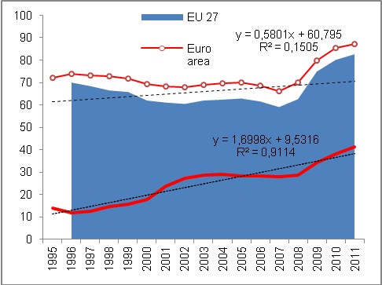
Source: Eurostat, own calculations

Worse deficit of central government institutions, better of local government institutions and effectively the same of social security funds  The only EU country with a government sector surplus in 2012 was Germany |  | On the size of government sector deficit in the CR in the amount of 169 bn in 2012 shared the government institutions by their deficit in the amount of 160 bn crowns expanded against year 2011 by 56.8 bn crowns. On the contrary, improved budget presented the local government institutions, which reduced the 2011 deficit (14.7 bn) to 2.2 bn crowns. They restricted their deficits also in years 2010 (by 1.7 bn) and 2011 (5.6 bn crowns). On the contrary, the deficit of social security funds remained nearly the same (6.8 bn crowns against 6.9 bn in 2011).  Practically whole government sector deficit in the CR in 2012 represented the deficit of state finances (central government), i.e. 95 % of government deficit (in 2011 it was 83 % and in 2010 84 % of total deficit).  In the view of international comparison the only country of the EU, whose government sector budget ended in 2012 with an excess of revenues over outlays was Germany (chart 40). Even here however the surplus was only small, arriving at 0.2 % of German GDP. All other countries of the Union were with their government sectors in deficits.
Chart 40 Government sector deficit (in % of nominal GDP, EU countries, EU 27 average)
Source: Eurostat
Chart 41 Government sector deficit of South Europe countries (in% of nominal GDP, EU countries,
EU 27 average)
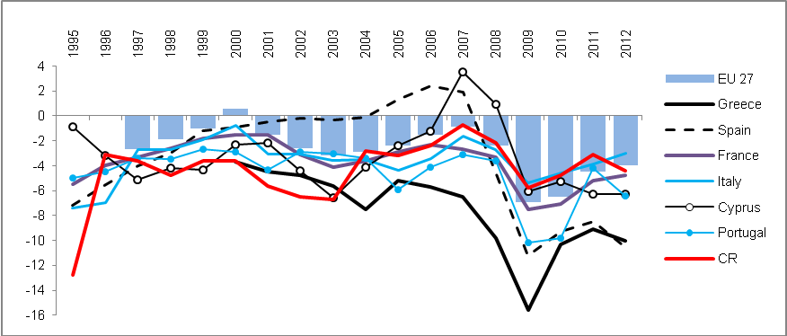
Source: Eurostat
In 2012 in deficits even the traditionally the „budget successful“ countries of North Europe |  | Year 2012 was not successful for government sectors practically of all European countries. Even states showing surpluses in past occurred in 2012 in deficits – e.g. the long-time in surplus North of Europe – in Sweden (-0.5 % of GDP) the deficit showed similarly to crisis year 2009, it strongly deepened in Denmark (from -1.8 % to -4 % of GDP, i.e. to European average), slightly less then in Finland (from -0.8 % to -1.9 %). Improvement of a not very good situation of the government sector budget recorded Netherlands (from -4.5 % to -4.1 % of GDP).  Excellent result on the contrary most likely sustained Norway, standing outside the European Union. According to the latest available data for year 2011 amounted their surplus of the government sector to 13.6 % of GDP, year earlier then to 11.2 %.
Mild improvement of deficits in Poland and Slovakia, out of troubled countries also Italy and France |  | To improve the results of government sector budgets managed out of the „economically related countries“ to the Czech Republic in Poland (-3.9 % of GDP), Slovakia -4.3 %) %), Slovenia (-4 %), distinctive development occurred also in Ireland (from -13.4 % in 2011 to -7.6 % in 2012), which in the previous period provided guarantees to its collapsing bank sector. In troubled countries of South Europe (chart 41) further increased the year-on-year mildly deep deficits of Greece (-10 %) and Spain (-10.6 %), faster the in comparison so far smaller deficit of Portugal (-6.4 %). On the contrary the deficit of France (-4.8 % of GDP) and Italy (-3 %) improved.

Gross consolidated debt of the government institutions
Gross consolidated debt of the government institutions in the CR increased in 2012 to 1758.8 bn crowns, i.e. year-on-year growth of  12.1 % |  | Government sector in the CR was by the end of 2012 indebted in the amount of  1 758.872 bn crowns. Nominal value of this gross consolidated debt of government institutions was compared to 2011 higher by 189.9 bn crowns, i.e. by 12.1 %. It represented a faster year-on-year growth compared to years 2010 (+11.7 %) and 2011 (+9.2 %). In the European context was then the relative size of this debt to GDP in 2012 despite the significant increase still only the roughly a half level in comparison to the relative debt of the government sector for the EU 27 %.  In the view of financial instruments this debt was focused mostly into long-term bonds (1390.8 bn crowns the balance as of the end of 2012), which also dominated its yearly addition (147 bn crowns).
Interest cost on gross consolidated debt of the government sector increased in 2012 to 57 bn crowns |  | Servicing the gross consolidated debt in 2012 required to pay out on interest 57 bn crowns (interests based on ESA 95, consolidated). These interest costs grow in time (from 52.5 bn in 2011 and 51.1 bn crowns in 2010, when they for the first time exceeded the fifty billion boundary).
Debt of local government institutions only 6.2 % of total gross debt of government institutions in the CR in 2012 |  | Similarly to deficit, on the government sector debt also participates the indebtedness of central government institutions from 1652.9 bn crowns based on the balance as of the end of 2012 with the growth against the year 2011 by 12.4 %. The debt of local government institutions represented 109.4 bn crowns (year-on-year growth by 9.6 %) and the debt of social security funds  172 mil crowns with a year-on-year change of -9.5 %).

Chart 42 | Gross consolidated debt of the government sector for year 2012 (in % nom. GDP) | Chart 43 | CR ranking among EU 27 according to the government sector debt (debt/nom. GDP, in %)
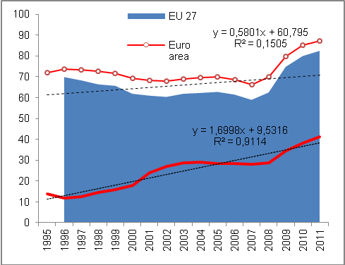
Source: Eurostat, own calculations

Debt/GDP in the CR in 2012 45.8 %, in the EU 27 on average 85.3 % |  | Czech Republic from the position of the seventh least indebted country of the EU 27 in 2011 with 40.8 % of gross consolidated debt of the government sector in relation to the nominal GDP shifted in 2012 to the eight position with the relation of debt to GDP in the size of 45.8 %.
The speed of indebtedness in 2012 the highest in Portugal, Cyprus and Ireland, in the CR in the view of the EU rather medium |  | Even though the speed of the relative indebtedness of the government sector in the CR is often highlighted as the highest risk for its public finances, development in 2012 shows, that year-on-year increase by 5 percentage points was in the context of the EU 27 countries rather lower.  The government sector debt grew in 2012 the most in Portugal, by 15.3 p.p. to 123.6 % of GDP, in Spain by 14.9 p.p. to 84.2 %, in Cyprus by 14.7 p.p. to 85.8 % and in Ireland by 11.2 p.p. to 117.6 % of GDP of these countries. These are mostly the countries having faced the debt crisis already before the year 2012 and its solving is as can be seen from the speed of debt growth still an issue.
Year-on-year growth of relative indebtedness in the CR in 2012 in percentage points roughly the same as in Netherlands or United Kingdom |  | In the CR, as noted before, the relative debt of the government sector increased in 2012 by 5 p.p., which was approximately the same as in the Netherlands (+5.7 p.p.) or in the United Kingdom (+4.5 p.p.). Both countries were however in 2012 in relation to GDP considerably more indebted (71.2 % and 90 % of GDP resp.) compared to the CR (45.8 % of GDP). In this sense roughly comparable countries, i.e. by the relative debt of the government sectors, as Denmark, Latvia and Lithuania (45.8 %, 40,7 % and 40,7 % of GDP) nevertheless managed in 2012 to guard its growth better, since the year-on-year additions of this indebtedness were compared to the CR lower or the relative debt even decreased (Denmark -0.6 p.p., Latvia -1.2 p.p. and Lithuania +2.2 p.p.).
Countries with favourable relations of government debt to GDP – Estonia, Bulgaria, Luxembourg |  | The least indebted country of EU 27, with regards to the government sector debt to GDP was in 2012 Estonia, whose debt represented a mere one tenth of the nominal GDP (10.1 %). However, even in this case the year-on-year increase amounted to 3.9 p.p., which is with respect to the size of the debt in 2011 (6.2 % HDP) a rather high increase.  Among other countries with favourable relation of gross consolidated debt of the government sector to GDP were in 2012 in the EU 27 apart from Estonia also Bulgaria, Luxembourg, Romania and Sweden except for already mentioned Latvia and Lithuania (chart 44). In these countries the relative indebtedness was in comparison to the CR in 2012 lower. Its year-on-year worsening occurred only in case of Bulgaria, Romania, Luxembourg and Lithuania, mostly no more than only by 2.5 p.p. In the remaining part of this group of lowly indebted countries of the Union, the government sector debt compared to 2011 decreased.
Chart 44 Gross consolidated debt of the government sector in 2012 (in % of nominal GDP)
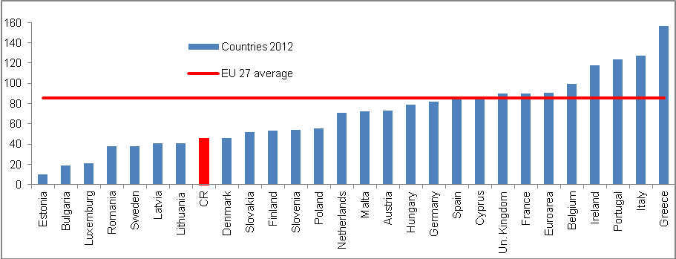
Source: Eurostat 2012

Private debt
Apart from the government sector, other institutional sectors of countries have also other liabilities. If we sum up the indebtedness of companies (non-financial businesses), households and non-profit institutions serving households, we acquire a so called private debt of a given country. The balance of this debt in relation to GDP can supplement the view on the liabilities of the government sector and formulate the indebtedness in the given country more completely.

Private debt in the CR gauged at 78.6 % of GDP in 2011 was in the EU 27 benchmark the fourth lowest |  | Private debt involving the debt balances of non-financial businesses, households and institutions serving households in the Czech Republic amounted according to the latest Eurostat data in 2011 in total to 78.6 % of nominal GDP. It was the fourth lowest private debt in this relative expression out of all countries of the union (chart 45). Lower debt reported in this year only Lithuania (70.1 %), Rumunsko (71.8 %) and Slovakia (76.3 % of nominal GDP). Against 2010 the CR kept this position (then the better relative result reached apart from Romania and Slovakia also Poland).
Long-term accrual of this relative private debt for years 2003-2011 by 22.8 percentage points was after Netherlands (+22 p.p.) and fall of private debt in Germany (-19.6 p.p.) the lowest in the EU 27 despite a sharp increase of household debt in this period |  | In light of years 2003-2011 the accruals of private debt increased the most in countries now facing also immense complications with the debts of their government sectors – in Ireland the private debt increased for the given period by 153 p.p. to 309.5 % of GDP, in Cyprus by 124 p.p. to 289.4 % of GDP. Somewhat lower accruals for years 2003-2011 are obvious for the private debt of Italy and Greece (+35.2 p.p. and +58 p.p. resp.), but still considering a hypothetical comparison, these countries would need more than whole annual GDP of year 2011 to amortize the balance of their debt (128.6 % of GDP and 130 % of GDP resp.).  On the contrary, the Czech Republic recorded a very low accrual of private debt for the period 2003-2011, which is surprising, since the major growth of household debt falls just into this time period, mainly in years 2004-2008. People borrowed especially to acquire their own housing – more than three quarters of household debts consisted of and consist also in 2013 – just the mortgages and loans from building societies. Year-on-year rates of growth of mortgages exceeded in this period of ongoing boom 30 %. Also in 2012, when the significant slump of the household loans from commercial banks continued, the year-on-year addition remained positive.  Role when assessing the low growth of private debt in the Czech Republic however most likely plays the fact, that the crisis of year 2009 markedly lowered the rate of lending to firms and after a relatively long time period, the loans to firms year-on-year declined.

Chart 45 | Private debt* - CR ranking in EU 27  (in % of nom. GDP) | Chart 46 | Development of relation private debt/nom. GDP in the CR and selected countries (in %)
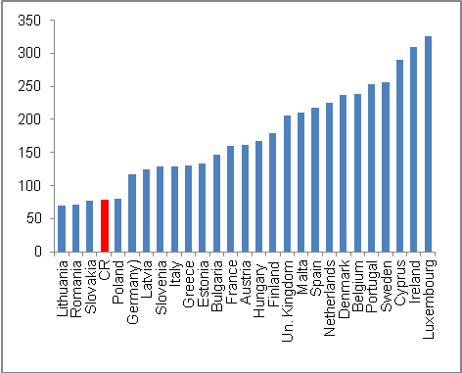

*Debt of non-financial businesses and households inc. non-profit institutions serving households
Source: Eurostat

Relative private debt fell for years 2003-2011 out of EU 27 countries only in Germany |  | For years 2003-2011 increased in the EU 27 relative private debt less than in case of the Czech Republic (+22.8 p.p..) only in Netherlands (+22 p.p.), its decline recorded as the only one EU 27 country only Germany (-19.6 p.p.).

Indebtedness of the CR – private debt and debt of government institutions
Indebtedness of the Czech Republic according to private debt and government sector debt together amounted to 119.4 % of nominal GDP in 2011, which was the third best result among the EU 27 countries following Romania and Lithuania |  | If we aggregate the debt of the government sector and the private debt – both in the relative expression to nominal GDP – the position of the Czech Republic is on the EU 27 countries ranks even better compared to individual rankings (chart 47).  As stated, according to the relative size of the gross consolidated debt of the government sector was the CR in eight and in 2011 it was placed seventh among the EU 27 countries. In case of private debt again relative to GDP, it ranked then in both years the fourth. Thus if we calculate the relative position of the CR in the indebtedness according to the government as well as private debt, we arrive at the conclusion, that in the EU 27 there are only two countries indebted less than the Czech Republic (Romania with 106.5 % of these debts in relation to GDP and Lithuania with 108.6 %).  Debt in the CR in 2011 according to the private debt together with the debt of the government sector represented 119.4 % of nominal GDP, which was only negligibly more compared to this way defined debt of Slovakia (119.6 % of GDP).
The most indebted was in 2011 Ireland with 416 % of GDP of private and government debt together |  | The highest debt recorded in year 2011 Ireland (chart 47), where the private debt and the debt of government sector represented together 415.9 % of GDP. On this participated from three quarters the relative private debt (309.5 % of GDP), and from the remaining part also in the European context very high debt of the government sector (109.5 % of GDP).
Chart 47 Gross consolidated debt of the government sector incl. private debt (in % of nominal GDP)
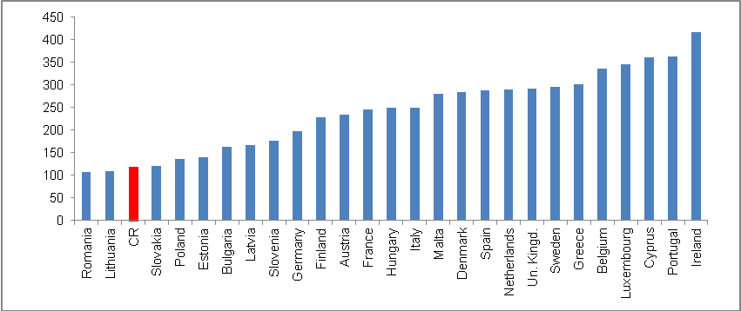
Source: Eurostat, own calculations

External imbalance
The extent of external imbalance of the Czech economy given by the balance of the current account of the balance of payments determines the ability of the performance balance to create surpluses and on the contrary, the intensity of the income balance deficits increases.

For the whole decade 2003-2012 the relatively favourable external imbalance at the size of average deficit of current account of 3.2 % of nominal GDP |  |  | For the decade of 2003-2012 the deficit of the current account of the balance of payments as one the basic measures of the external imbalance moved in the CR on average around an annual 3.2 % of the nominal GDP. Before the accession to the EU, when the Czech economy regularly recorded the deficits in the foreign trade with goods, the current account deficit occurred in 2003 on 6 % of GDP. However, after that already in 2005 due to the marked dynamism of exports following the elimination of administrative barriers for the penetration on the European markets, it fell thanks to the trade balance surplus to mere one percentage of the nominal GDP (chart 48). However, it was also the best result of the monitored period 2003-2012.
Fluctuation of the imbalance towards its lowering |  |  | Certain instability of the external imbalance according to the current account deficit was characteristic for the observed period. Still the trend of its gradual improvement roughly since 2006 can be observed. In years 2011 and 2012, the deficit of the current account moved to an improved level (-2.7 % and -2.5 % of nominal GDP resp.) compared to the long-time average (-3.2 % in years 2003-2012).
In the CR, the imbalance in the economic relations „paradoxically“ reduced in times of crises and recessions – due to the higher surpluses of the trade balance; this was confirmed also in 2012  In 2012 came to the CR direct investment from abroad in the amount of 207.4 bn crowns, in that 57 % constituted the reinvested profits … |  |  | It is typical for the Czech economy that in times of economic slowdown, respectively recessions or crises, the result of the foreign trade with goods improves even given the notable loss of the rate of growth of the goods flows. In the 2009 crisis, when the exports from the CR were falling for several months year-on-year roughly by one quarter, the trade balance reached high positive values. Similarly, although to a lesser extent, worked the situation in 2012. It can be most likely explained by high export-import interconnectedness of the Czech economy, the structure of exports, changed foreign demand and also the fact, that the trade balance is improved by weak imports into the CR. In addition, in recession in case it has a more global character, the prices of crude petroleum fall and thus so does imports. It was typically for year 2012 mostly for the reason, that domestic demand was very weak and the drop on foreign markets arrived only approximately in the last quarter.  Balance of the financial account of the balance of payments, whose positive result can compensate a deficit current account is in case of the Czech Republic in the long-time view markedly influenced by the intensity of the foreign direct investment inflow.  In 2012, the CR recorded the third highest inflow of foreign direct investment for the whole period 2002-2012 (chart 49) in the amount of 207.4 bn crowns (compared to 277.7 bn crowns in 2002 and 279.2 bn crowns in 2005). In that 118.3 bn crowns constituted the profits reinvested back into the Czech economy. Capital inputs as such represented 63.5 bn crowns and the rest, i.e. 25.6 bn crowns presented the other capital.
Chart 48 | Current account of balance of payments deficit (in % nominal GDP) |  |  | Chart 49 | Inflow of foreign direct investment into CR and sale of state shares (in bn crowns)
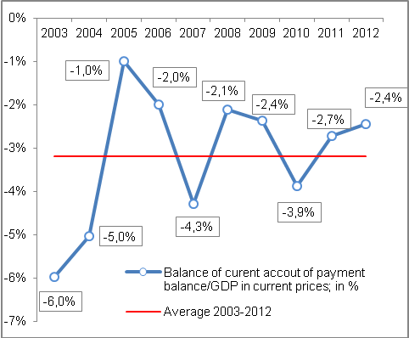 |  |  |  | 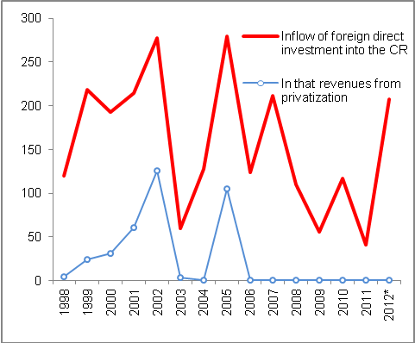
*Preliminary data Source: CNB, own calculations

… and 31 % of direct investment constituted the direct inputs into the equity of companies – privatizations do not play any role already since 2006 |  | While in the first half of the past decade had a role in the inflow of direct investment the sales of state shares in companies to the hands of foreign investors, starting 2008 the factor of privatization practically disappeared (chart 49). Last sale of state property to foreign hands eventuated in 2005.
Investment of Czech entities abroad amount annually on average for years 2002-2012 just under mere one eighth of foreign direct investment |  | With respect to the investment of domestic entities abroad, there is for the whole period obvious – in fact since the beginning of independent Czech Republic – a marked disproportion compared to the flows of foreign investment into the CR. For the period 2002-2012 were arriving into the CR annually on average directed investment in the value of 146.5 bn crowns, but investment of domestic entities abroad amounted only to 21.7 bn crowns annually on average, i.e. something below 15 %. In 2012 the direct investors from the CR invested abroad 26.2 bn crowns, in years 2005 and 2011 they reduced their investments (returned flow of funds into the CR).

Labour market imbalance
Very favourable imbalance of the supply and demand on the labour market in the CR in the finishing boom of 2008… |  | High imbalance on the Czech Republic labour marked has been already lasting longer than three years. At the end of boom of the Czech economy, i.e. approximately in the half of 2008, there was a relatively favourable imbalance on the labour market. Numbers of vacancies in some months of the first half year of 2008 exceeded 150 thousand of offers and the number of job applicants progressed below the boundary of 300 thousand persons.
…replaced by a sharp fall of vacancies, when the numbers of job applicants were rising since 2009 |  | In 2010 the numbers of job applicants registered by the employment offices overtook the boundary of half a million persons (in chart 50 the seasonal fluctuations of this indicator in individual years is shown, their numbers were falling in the summer months, when the opportunities of seasonal employment are growing).
Stagnation of the number of job vacancies from September 2009 till March 2012 between 30-40 thousand |  | On the contrary, the business sector did not create job vacancies, pressure on the labour market presented also the laying off the persons employed in the public sector resulting from the government saving measures. Practically since the second half of 2009 the number of offered vacant positions stagnates between 30-40 thousand.
Very mild recovery of supply of vacancies from April to October 2012, afterwards the number of job applicants again higher than half a million persons |  | Very mild recovery was in this direction apparent in 2012 from April till October, when the numbers of supply of vacant positions exceeded 40 thousand, however in the last two months of the year, the supply again decreased. There were again more than half a million job applicants (509 thousand persons in November and 545 thousand persons in December 2012).

Chart 50 | Supply of vacant positions and numbers of job applicants (in thous. of persons) | Chart 51 | Unemployment rate* (according to ILO, in %) and changes of economic activity  (in percentage points)

*Since 2009 the average rate of unemployment not seasonally adjusted; additions/reductions in the rate of economic activity year-on-year for Q4
Source: CNB, own calculations

Labour productivity and real wage development
During years 2004-2007 faster growth of labour productivity over real wage... |  |  | Following the strong growths of the labour productivity in the Czech economy in years 2004-2007, when its rate of growth markedly overtook the growth of the real wage and the character of the Czech economy thus could have been titled as intensive, the subsequent period proved to be considerably less favourable.
…and different development in the subsequent years |  |  | Year-on-year fall of the labour productivity in 2009 was linked to the slump of the economic performance – the gross value added declined year-on-year more (-2.4 %) than the employment (-1.8 %). Returned growth of the labour productivity in years 2010 and 2010 was caused by the fact, that the labour market reacted with a lag and the number of employed persons was decreasing in both years (-1.2 % and -0.03 % resp.). The created gross value added however already mildly grew (by the same number of 0.7 % in both years 2010 and 2011).  In 2010 an atypical phenomenon occurred, when the growth of employed persons (year-on-year by +0.4 %) was accompanied by a decrease of the economy (-0.2 % according to the gross value added). The cause lied in the specific changes on the Czech labour market with the growth of till that time limitedly used part-time employment.
Chart 52 | Relation of labour productivity and real wage dynamics (y/y in %) |  |  | Chart 53 | Labour productivity and average wage (increases against 2002)

Source: CZSO, own calculations

Lead of the year-on-year rates of growth of real wage before the rates of growth of the labour productivity only in 2003 and 2009; in 2012 decrease in both cases |  | Faster growth of the real wage compared to the labour productivity in the decade of 2003-2012 occurred only in 2003 (+5.7 % year-on-year against +5.6 % year-on-year for the labour productivity) and in 2009 (+2.3 % against -0.6 %). In 2012 fell both the real wage and the labour productivity (similarly by -0.6 %). The fall of real wage eventuated in 2012 in the CR for the first time and was to a considerable extent influenced by a high rate of inflation (+3.3 %), as the average nominal monthly wage increased in comparison to year 2011 by 2.7 %.  Roughly from year 2008 the economy already lost the intensive growth character. As can bee seen in chart 53, „the opening scissors“between the rate of growth of labour productivity and the growth of real wage ceased to be visible since year 2009.

Government sector of the CR, i.e. sector of government institutions constitutes organizational state bodies, municipalities, selected state-funded institutions, state and other extra-budgetary funds (Estate fund, Support and warranting forest and agrarian fund, Wine fund and others), Railway infrastructure administration, transformation institution Prisko, PPP Centrum, public universities, public research institutions, health insurance companies, associations and unions of health insurers and Centrum of interstate payments. From year 2010 was based on the repeated test transferred several public non-financial businesses into the sector of government institutions, transferred were also selected state-funded institutions between sectors of non-financial businesses and government institutions.
Notification of the deficit and government debt from April http://www.czso.cz/csu/redakce.nsf/i/notifikace_vladniho_deficitu_a_dluhu_20130422.

