Overall Economic Performance
Economy of the Czech Republic returned in 2012 back into recession. Gross domestic product fell in real terms by 1.2 %, which presented one of the largest decreases of performance in the whole European Union. On this participated weak investment activity in the long-term, but also already for a third year the ongoing fiscal restriction limiting both the investment expenditure and the provision of public services. Consolidation of public budgets adversely affected both expenditures and incomes of the household sector – which together with deepening anxiety regarding the future economic development limited their consumption in year 2012. Deeper fall of GDP, than the observed result, was prevented only by the foreign trade, which managed even in this year - strongly affected by the consequences of debt crisis - to show surplus.

Gross domestic product
Czech Republic given the growth of GDP in years 2003-2012 took the eighth place in the current EU… |  | For years 2003-2012 the GDP of the Czech Republic grew by one third, which placed it in the EU (growth by 12.4 %) on solid eighth position. First three places were taken by the countries of former Eastern Bloc (Slovakia with the growth of 55.5 %, Poland 51.9 % and Lithuania 47.7 %). The reason was obvious – these economies disposed of low volumes of GDP, presenting a high growth potential. Developed economies such as Sweden (24.6 %), Austria (17.5 %) or Germany (12.7 %) stood in the context of long-term growth during years 2003-2012 behind the CR. There were also however countries in the European Union, which in the given period did not grow, but even worse – fell. Among these economies were Portugal (-0.7 %), Italy (-0.8 %) or Greece (-1.2 %).
…and increase of the performance in years 2008-2012 was in the CR the tenth highest |  | In the medium-term view (2008-2012) the CR slightly worsened, with the growth of +1.5 % compared to year 2007 it took the overall tenth place among the countries of the European Union. Still, it represented an above-average growth, since totally the European Union for the period 2008-2012 fell by 0.7 %, Euro Area also  (-1.2 %). This significantly worsened economic development of the EU was caused by the economic difficulties during 2008-2009 flowing from the consequences of mortgage crisis in the USA – adversely affecting the foreign trade followed by the decrease of the investment activity -, but also a later government cost-cutting measures introduced as a reaction to the consequences of the debt crisis.
However, the slump in the CR in 2012 was the eighth deepest |  | In 2012 the GDP of the Czech Republic fell by 1.2 %, which placed the domestic economy on the overall eighth worst position in the European Union (decrease of 0.3 %). Behind the CR ended the countries of the south wing such as Greece  (-6.4 %), Portugal (-3.2 %), Italy (-2.4 %), Cyprus (-2.4 %) and Spain (-1.4 %), which were heavily hit by the consequences of the debt crisis. Among remaining economies showed higher fall than the CR only Slovenia (-2.3 %) facing considerable growth of government indebtedness after 2008 as a result of a markedly worsened state of the domestic economy and troubles in the banking sector, but also Hungary (-1.7 %).
Among countries from the 2004 wave, apart from the CR was in 2012 decreasing only Cyprus, Slovenia and Hungary… |  | Among countries accessing the European Union in year 2004, the GDP fell in 2012 apart from Czech Republic in the mentioned Cyprus (by 2.4 %), in Slovenia (-2.3 %) and Hungary (by 1.7 %). Other countries from the 2004 wave despite the adverse situation in Europe as well as not very positive anticipations regarding the future development their economic level not only increased, but also reached in 2012 the highest growths in the whole EU 27.
…and Baltic states accrued the highest growths in the whole European Union |  | In Malta, the GDP increased by one percentage point. Poland gained a year-on-year growth of GDP in the amount of 1.9 %, Slovakia even a growth higher by one tenth of p.p.. First three positions were then seized by the Baltic states, which unequivocally stood out by the reached values in the context of the whole EU (Estonia 3.2 %, Lithuania 3.7 % and Latvia 5.6 %). Reasons behind the very high growths of these three countries were twofold – they were growing out of low basis, since all in 2009 faced double-digit slumps of GDP (largest slumps in the whole EU), nevertheless the growth was also caused by the executed reforms of public finances. It is also certainly worth mentioning the countries accessing the EU in 2007, i.e. Romania (+0.7 %) and Bulgaria (+0.8 %) - also these countries thus exceeded the development of the CR economy in 2012.
The largest economies in the EU softened the fall of GDP in the European Union in 2012 |  | Out of three largest economies of the European Union (based on GDP) slightly grew the GDP in 2012 in the United Kingdom (by 0.2 %) and Germany (by 0.7 %). France kept the original value of GDP from year 2011. Thus these economies at least partially compensated the lowering of performance, facing in 2012 several other European economies, in the forefront with the countries of the South wing. These rather positive results were helped by the opposite strategy to that employed by a number of other EU countries including the Czech Republic – governments of the United Kingdom, Germany and France in the unfavourable period increased their final consumption expenditure compared to year 2011 and thus fought against the adverse development in the remaining part of the economy.

Chart 1 | GDP in the CR, European Union and the euro area (constant prices, y/y in %)
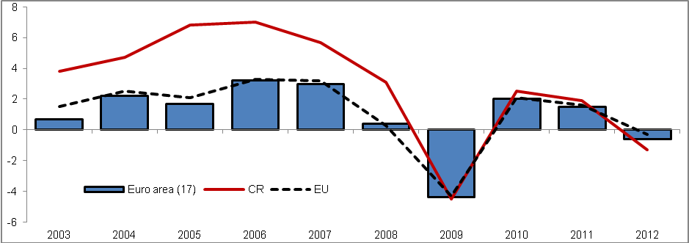
Source: Eurostat

Chart 2 | GDP in the CR and selected countries (constant prices, y/y in %)
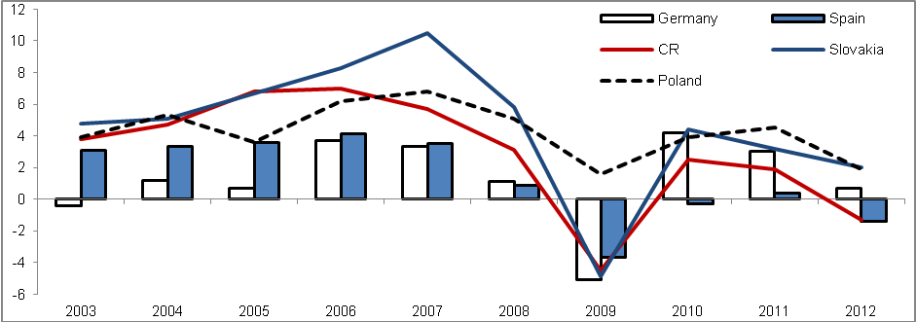
Source: Eurostat

Expenditure side of GDP
The long-term growth of GDP of the CR was caused mostly by the net exports… |  | The moving force of the development of GDP in real terms was in the CR in the long-term especially the net exports, which participated on its growth in years 2003-2012 from 47.3 %. It acquired a significance already in 2004, when thanks to the increase of the exports volume resulting from the accession of the CR to the EU, the foreign trade balance gained a surplus in current prices – in constant prices the foreign trade still remained in deficit (constant prices did not consider the positive aspect of the terms of trade). Since that year, the foreign trade balance has never decreased into deficit anymore (neither in current prices nor in real terms).
…compared to the European Union was its impact on the GDP growth more than twice as high... |  | The comparison with the whole EU (21.3 %) confirms the above average effect of the foreign trade on the growth of GDP in this time period – it was more than twice as high. To the significant share of the foreign trade on the GDP growth surely contributed also a continuing inflow of foreign direct investment into the Czech Republic, which positively contributed to the increase in the competitiveness of the domestic producers on the foreign market.
…still it faced fluctuations similarly to the other GDP components – year-on-year decrease of the net exports lowered the performance of the domestic economy in the form of GDP in 2007 |  | Still the component of net exports since 2005 (in constant prices) did not contribute to the growth of GDP absolutely – in 2007 a situation occurred, when the increase of imports (12.8 %) exceeded the growth of exports of goods and services from the Czech Republic (11.2 %). The unusually high growth of imports (it reached higher rate of growth only in 2010 – mainly due to the low comparative basis of the preceding year) was the result of a strong domestic demand affected by a notable performance of the domestic economy – the interest in foreign products for consumption as well as further production grew. Lower rate of growth of exports against imports then led to the drop of net exports by 10.9 %.
In 2012 the net exports as the only expenditure component halted a larger fall of GDP – still its increase was below the average compared to year 2011… |  | Increase in the net exports in 2012 by 19.7 % averted a more marked fall of GDP. This increase resulted from the higher growth of exports (4.0 %) compared to imports (2.3 %) - foreign demand thus year-on-year grew more strongly than the foreign supply. Still it represented a significant slowdown in comparison to 2011, when the net exports climbed up by 39.3 % – the rate of growth of foreign exchange of goods and services decreased as a consequence of weakened performance of nearly the whole EU facing the impact of the debt crisis.
…the growth of net exports in the CR in 2012 was below average also compared to the EU |  | Rate of growth of net exports of the Czech Republic was in 2012 below average even in comparison with the EU (increase by 47.9 %) - exports from the CR in 2012 increased compared to EU by 1.7 percentage point more notably, imports even by 2.5 percentage point – as a result of a higher rate of growth of imports in the CR against the EU compared to the exports then the CR recorded also a lower increase of the net exports. However even in the European Union compared to 2011  (+74.9 %) eventuated a significant lowering of the foreign trade balance dynamics.
Still the growth of foreign trade balance ended more notable compared to years 2009 or 2010 |  | The increase in the net exports of the domestic economy in 2012 was however higher compared to 2010 (15.9 %) and notably higher compared to 2009 (5.5 %). If in 2009 the economic troubles of Czech foreign partners pushed down the domestic exports by 10.9 %, a notable interconnection of exports and imports (Czech producers-exporters to a large extent use also the imported products as an input for their production) pressed also the imports down (-12.1 %). On the contrary in 2010 occurred a high growth of exports by 15.4 %, the same rate of growth however showed also the imports – large growths were given mostly by the low comparative bases of 2009.
The second most significant source of GDP growth was the final consumption expenditure of households – compared to the EU however, its share on the growth was below-average |  | The second most significant expenditure item from the view of long-term growth of GDP in the CR was the final consumption expenditure of households, which contributed to the increase of GDP in years 2003-2012 by 36.0 %. Even despite a notable share on the growth of performance, this component ended below average, when we compare the development with the EU (47.2 %) – domestic household consumption was in comparison to the European Union still relatively low – in 2012 the share of household consumption accounted in the EU for 55.7 % GDP, in the CR only for 46.9 %. No matter how the household consumption following the transition to the market economy after year 1989 expanded by high rates of growth – especially due to the not-saturated consumption – it still has not managed to reach the comparable level to the EU.
In 2012 the household sector decreased its expenditure aimed for consumption – it occurred for the fist time in years 2003-2012 |  | Adverse development of the household sector consumption dynamics in years 2009-2011 resulted in 2012 even in the decline – by 2.7 %. Lowering of this component was extraordinary, in years 2003-2012 it did not happen even once. Its share on this slump had most probably a marked deepening of the anxiety of households regarding the coming economic development in connection to the real fall of the disposable income.
Anxiety of domestic households regarding the future was in 2012 most likely higher than in the EU... |  | It seems that the anxiety of Czech households was in 2012 much higher to the corresponding average of the EU, where the final consumption expenditure of households fell only by 0.7 %. The rising worries of the Czech households related to the future development were also confirmed by the consumer confidence indicator, which was in 2012 the lowest since 1999.
... which was also reflected in the sharp growth of savings in the nominal terms... |  | Lowering of the household consumption was also partially reflected in the growth of their net savings (in current prices). If in years 2010 and 2011 the net savings decreased – by 8.3 % and 17.3 % - in 2012 the willingness of households to save again enlarged markedly – net savings expanded by 23.3 %. The impact had also a development of household net disposable income (including the adjustments for the change in net equity of households in pension funds reserves) in 2012, which increased year-on-year in nominal terms by 0.8 %. In the period 2003-2012 it grew on average by +4 % annually, in the second half of this time period however the rate of growth notably fell to year-on-year +2.2 %.
... while the households net disposable income again fell in real terms |  | Net disposable income of households in real terms was falling already for a third year with an increasing rate of fall – from -1.3 % in 2010 via -2.1 % in 2011 down to – 2.4 % in 2012 (the rate of growth of consumer prices was increasing).
Slump in the rates of growth of household consumption was however observed in the Czech Republic already since 2009 |  | Issues with the household consumption dynamics were however observed already since 2009, when its rate of growth declined to 0.2 %. In years 2010-2011 the growth of consumption was still negligible (1 % in 2010 and 0.5 % in 2011).
In 2003-2012 the household consumption grew on average by 2.1 % per year, in the second half of this period already only by 0.4 % |  | If we compare the average rate of growth of final consumption expenditure of households during the period 2003-2012 (+2.1 %) with years 2008-2012 (+0.4 %), there is obvious a large change. Apart from the reduction following 2008 the reversal was affected also by high growths of consumption in years 2003-2008, which except for year 2005 (2.9 %) did not fall below three percent. The household sector profited from the mentioned accession to the EU in 2004 – it launched a growth of significance of the foreign trade for the CR, which benefited in the form of increase of the disposable income just also the households.

Chart 3 | Exports, imports and GDP (constant prices, y/y in %) | Chart 4 | Final consumption expenditure, gross capital formation and GDP (const. prices, y/y in %)
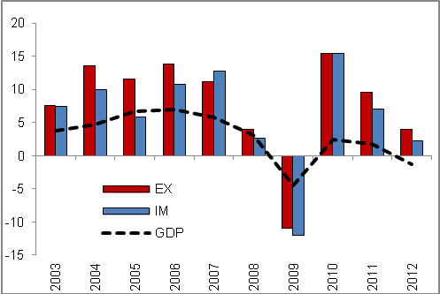 |  | 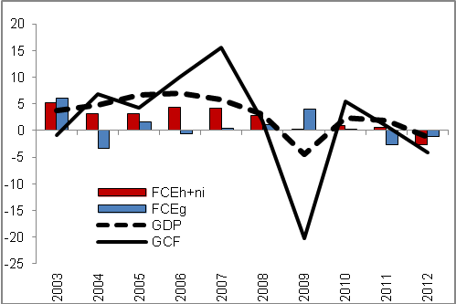
Source: Eurostat

Growth aspect of final consumption expenditure of government was in the CR below the EU average in the long-term |  | Minor effect on the long-term growth of the economic performance of the domestic economy in years 2003-2012 in the form of GDP had the final consumption expenditure of government (4.0 %) - in comparison to the European Union (26 %) nearly one seventh. So it was valid, that mostly the public services were in the CR provided to a lower extent to the rate corresponding to the EU average.
2010, 2011, 2012 – gradual cuts of the government consumption resulting from the saving measures… |  | From the strong growth of the government consumption in 2009, when its consumption increased as a result of the effort to limit the adverse economic development in the CR by unusual 4 %, a notable restrictions occurred. Already in 2010 the rate of growth of government consumption fell to mere two tenth of percentage. In the following year, the consumption was even decreased (-2.7 %) and the unfavourable development continued also in 2012 (-1.2 %). These three years of limited consumption of government institutions corresponded to the government cuts, which took place in a large extent both on the expenditure side and the revenue side. Reasons can be found in the effort to halt the increase of the government debt, which would thwart its financing with low interest rates (resulting from the loss of credibility on the part of the financial market) – in a way gradually observed mostly in countries of so called South wing in years 2010-2012.
…which were markedly higher compared to the European Union |  | Consequences of the fiscal consolidation in the CR – which in terms of the rate of growth of government consumption lasted in 2012 already for a third year – were more notable to those in the EU. In 2010 the government sector consumption in the EU still grew by 0.7 %, in 2011 it declined by 0.2 %, in 2012 already the level of its consumption stagnated. Thus it held true, that in all three years, the government consumption cuts in the CR were larger. It lowered the performance in the form of GDP in the given year, however the reforms should bring positive effects in the future both in the form of preserving the low rates of state debt financing and maintaining or even increasing the attractiveness of the CR as a promising investment locality for foreign investors.

Chart 5 | Consumer confidence indicator (2005=100, left axis) and final consumption expenditure of households (constant prices, y/y in %, right axis) | Chart 6 | Gross fixed capital formation of individual institutional sectors (current prices, in mil. crowns)
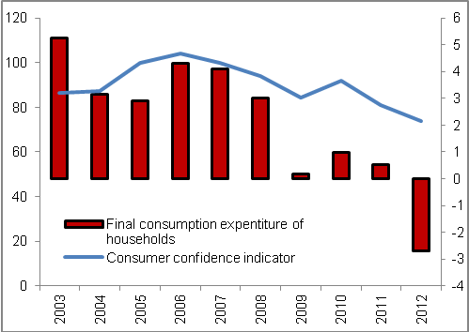 |  | 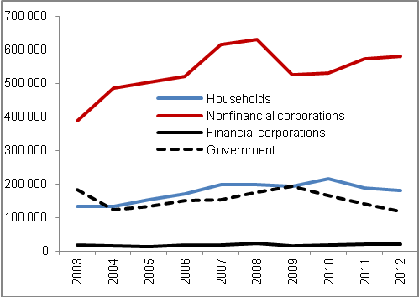
Source: CZSO, Eurostat

In 2012 the volume of gross capital formation also fell – both as a result of the limitation of investment and lowering of the stock of inventories |  |  | In 2012 the gross capital formation in the CR experienced also a negative development – the volume of this component fell by 4.1 %. If the gross fixed capital formation (investment) lowered by 2.7 %, the inventories must have also shared in its fall. The development from 2009 was thus repeated, when the investment fell by 11 %, gross capital formation however by larger 20.2 %. Higher fall of the gross capital formation compared to investment was in 2012 recorded also in the European Union. The decline in the stock of inventories could have been interpreted in a way, that on the part of producers a marked change in the demand was not expected – they believed that they can cover its potential increase from the regular production.
Gross fixed capital formation decreased in years 2009-2012 already twice |  |  | Lowering of the gross capital formation in 2012 reached one fifth of the fall in 2009, of the gross fixed capital formation one quarter. The volume of investment thus in years 2009-2012 decreased already twice – gross fixed capital formation in years 2010 and 2011 grew by 1 % and 0.4 %. Gross capital formation decreased in years 2009-2012 also for the second time.
Strong years of 2005-2007 increased the average rate of growth for the whole decade 2003-2012 to 1.9 % - however in years 2008-2012 the investment fell on average by 1.8 % per year |  |  | For the whole decade 2003-2012 the volume of gross fixed capital grew on average by 1.9 %. In years 2008-2012 however the rate of growth decreased significantly and achieved negative 1.8 %. Apart from the fall of investment in years 2009 and 2012 the notable development change affected the strong years 2005-2007, when a marked investment into own housing by households and increase in capital stock by firms occurred. Gross fixed capital formation grew by 6 % in 2005, in 2006 by 5.8 %. The largest increase of investment was then recorded in 2007 – it increased by a notable 13.2 %. Out of investment significant by volume in this year increased the investment into buildings by 6.4 %, into civil engineering buildings by 15.7 %, into machinery and equipment even by one third.
Limitation of investment in 2012 on the part of individual institutional sectors differed from 2009… |  |  | In 2009 the fall of gross fixed capital formation was observed mostly for companies (nonfinancial corporations by 16.6 %, financial corporations less significant by volume even by 34.4 %), which as a result of downswing of the foreign trade limited spending of the resources on further investment. The households also contributed to the fall of investment in 2009 (-3.5 %), which was the effect of the high demand for own housing before year 2008, which led even towards the overheating of the real estate market. On the contrary in 2012 the investment fell mostly on the side of government institutions.
…in 2012 the most markedly fell the gross fixed capital formation of the government institutions… |  |  | While in 2009 the government sector moderated the slump of the economy by an increase of new investment by 8.9 % (for instance total investment into the civil engineering buildings in the CR grew by 4.8 %), in 2010 it decreased it by 14.5 %, in the following year by 14.6 %. The slump of investment in 2012 was however the deepest – by 15.2 %. The consolidation of public finances taking place from 2010 inhibited the value of new investment in the economy still to a larger and larger extent.
…but even the household sector did not increase the volume of new investment |  |  | In 2012 the volume of gross fixed capital formation of households kept falling  (-4.1 %). Still compared to the previous year (-12.8 %) there was an improvement. On the contrary as a continuation of the adverse development can be year 2012 seen with respect to years 2008-2012, when the growth of investment in the household sector eventuated only in year 2010 (by 12.5 %), year 2008 can be considered rather as a year of stagnation (+0.2 %).
The lowering of the gross fixed capital formation in the CR in 2012 was also caused by the drop of investment into the solar panels… |  |  | On the drop of the gross fixed capital formation in 2012 had also an effect the subsiding positive influence of investment into the solar panels, which had been affecting the total investment in the economy already since year 2009 – then they only prevented the gross fixed capital formation from deeper decrease, they gained significance especially in 2010 and 2011, when it contributed to the growth of total investment in the economy by 1 % and 0.4 %.
…nonfinancial corporations thus increased the gross fixed capital formation in 2012 only by 1.6 % - compared to the previous year by mere one fifth of the percentage addition |  |  | It can be assumed, that the investment into solar panels was executed mostly by the sector of nonfinancial corporations. Subsiding of these investments in 2012 then caused the drop of the rate of growth of gross fixed capital formation in this sector from 8% in 2011 to mere 1.6 %. However, it is necessary to add, that the limitation of nonfinancial corporation investment was also caused by a lower rate of growth of goods and services exchange with abroad, as well as the weak household consumption – businesses thus changed the expectations regarding the future economic development and moderated their investment formation.
Still the gross capital formation participated on the long-term growth of GDP in the CR more than in the EU |  |  | Despite the adverse development of gross capital formation in 2012, it can still be considered as a more significant source of long-term GDP growth compared to the case of the EU. This component participated on the growth of GDP in years 2003-2012 from 13.7 %, which was roughly three times more compared to the EU as a whole (growth of GDP was affected only from 4.6 %). Main reasons of this growth can be seen in a gradual increase of the capital stock – the domestic economy was in comparison to the EU underinvested for a long-term – to the increase of the capital stock also contributed to a great extent the visions of profit opportunities on the part of foreign direct investors, who invested significantly in the CR.
Table 1 | Gross capital formation (GCF) and gross fixed capital formation (GFCF) in the CR and in the EU (constant prices, y/y in %)
GCF | 2003 | 2004 | 2005 | 2006 | 2007 | 2008 | 2009 | 2010 | 2011 | 2012
EU | 1,9 | 4,1 | 2,4 | 7,2 | 7,9 | -2,1 | -17,6 | 4,3 | 3,0 | -5,5
CR | -0,9 | 6,8 | 4,3 | 10,2 | 15,5 | 1,9 | -20,2 | 5,4 | 0,8 | -4,1
GFCF | 2003 | 2004 | 2005 | 2006 | 2007 | 2008 | 2009 | 2010 | 2011 | 2012
EU | 1,1 | 3,0 | 3,5 | 6,3 | 6,3 | -1,1 | -13,0 | 0,0 | 1,4 | -3,0
CR | 0,6 | 3,0 | 6,0 | 5,8 | 13,2 | 4,1 | -11,0 | 1,0 | 0,4 | -2,7

Source: Eurostat

The fall of GDP in 2012 was to the highest extent affected by the household and non-profit institutions consumption expenditure  (-1.3 p.p.)… |  | In the view of contributions of individual expenditure components on the fall of GDP in 2012 in the Czech Republic participated to the highest rate the final consumption expenditure of households and non-profit institutions (-1.3 p.p.). Despite the gross capital formation was falling faster compared to the households and non-profit institutions consumption, it contributed to the fall by less notable -1 p.p. – this is given by its lower share on the GDP (24.3 % in 2012) than in case of final consumption expenditure of households and non-profit institutions (in 2012 47.6%). Similarly, final consumption expenditure of government also contributed to the fall of GDP (-0.2 p.p.). The impact of unexplained discrepancy resulting from using the data in constant prices was in the amount of -0.3 p.p.
…net exports softened the drop of performance with its contribution in the amount of +1.6 p.p. |  | The growth of net exports then softened the adverse development in 2012 only to a limited extent, specifically by +1.6 p.p. It is evident, that despite the CR is a very open economy exposed to notable fluctuations on the part of the foreign trade, in 2012 the slump of GDP was caused by a lowered household and government consumption as well as dampened investment activity – all components of the domestic demand played a part in the decrease.

Chart 7 | Contributions to GDP growth in the CR  (constant prices, in p.p.) |  |  | Chart 8 | Contributions to GDP growth in the EU  (constant prices, in p.p.)
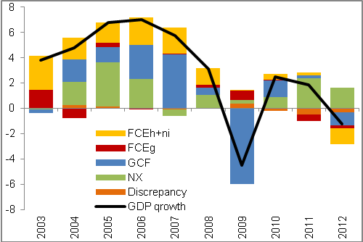 |  |  |  | 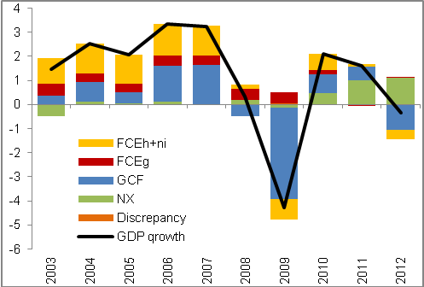
Source: Eurostat, own calculations

Supply side of GDP
Gross value added decreased in 2012 for four fifths of all industries |  |  | In 2012 the gross value added decreased by one percentage – thus after a two years' growth of 3.1 % in 2010 and 1.8 % in 2011 the gross value added of the economy again decreased. In comparison to the slump in 2009 (-5.2 %) it represented a roughly one fifth fall. The magnitude of the 2012 decrease can be however seen in a different aspect to the depth of its decrease. If in 2009 decreased the gross value added in 14 out of 20 industries, in 2012 it was already 16 of these. The main reason can be assigned to the fact, that the economic troubles in 2012 were caused both by the lowering of the rate of growth of the foreign demand (from 9.5 % to 4 %) and especially by a lower domestic demand – opposed to this in 2009 the foreign demand and the domestic investment activity decreased – final consumption expenditure softened the fall. Thus in 2012 the economic complications were related to a wider spectrum of expenditure activities compared to 2009.
The manufacturing industry, most significant by volume, faced a decrease, in comparison to slump of 2009 however it was a decrease rather negligible |  |  | Manufacturing industry most significant by volume (in 2012 it represented already 31.6 % of total gross value added in the economy) recorded in 2012 a reduction of value added by 0.4 %. Although it seems as a negligible decrease, it presented a lowering of value added by 4.4 bn crowns. Still compared to the drop by 15.4 % in 2009 (for the reason of weakened foreign demand as well as lower domestic investment activity) it was a decrease rather negligible – comparable values of year 2008 achieved the manufactory industry only in 2011.
…especially due to a continuing increase of the foreign exchange |  |  | Opposed to this in 2012 the lowering of gross value added in the manufacturing industry could be seen mostly in the lower domestic consumption, the investment activity was restricted to a much lesser extent. However more importantly – the fall in the foreign demand did not eventuate, only a lowering of the rate of growth – manufacturing industry is sensitive to the changes in the foreign trade dynamics.
Weak household consumption and a lower rate of growth of exports in 2012 adversely affected also the wholesale and retail trade |  |  | Second most significant industry in the Czech Republic economy by volume is the wholesale and retail trade. Its gross value added decreased in 2009 as well, however by much lower 3.7 % - this industry is usually less sensible to changes in foreign demand compared to the manufacturing industry. In years 2010 and 2011 the gross value added increased as a result of the exchange recovery of production with abroad but also a weak improvement of the household consumption – by 5.5 % and 8.1 %. Considerable fall in the household consumption in connection to the weaker rate of growth of foreign exchange however the increase of value added in 2012 halted – gross value added of wholesale and retail trade fell by 1.7 %.
Gross value added of construction was in 2012 lowered already for the second year in a row – it fell to the level of 2005 |  |  | Construction faced prolonged troubles. Restricted demand for housing on the part of households, lower investment activity of companies and also a considerable limitation of gross fixed capital formation of the government institutions (already since 2010) resulting from a notable reduction of the number of public procurements (their number fell in 2012 by 11.3 %, however they had already been cut for a fourth year in a row) decreased the gross value added in construction already for a second year. If in 2011 the gross value added in construction fell by 5.2 %, in 2012 then already by 5.4 %. The value of gross value added in 2012 thus reached the level of 2005. Still it is necessary to note, that construction has been facing troubles for a much longer time period – out of years 2008-2012 the gross value added fell already in four of them.
Saving measures of the government sector restricted the gross value added of public administration and defence, education as well as health and social work activities |  |  | For a second year the gross value added of the public administration and defence fell by a fast rate of growths as well. If still in 2010 the value added of this industry rose by 0.9 %, in 2011 it decreased by 2.4 %, in 2012 even by one tenth of percentage point more. With the fall of half a percentage in 2010 fought also the education. Long-term drop of performance (already since 2006) continued in the health and social work activities. Because these are the sectors with a considerable weight of the public sector, it is possible to assume, that the lowering of their gross value added was a consequence of the several times mentioned government saving measures.
Industry of arts, entertainment and recreation less significant by volume faced a decrease of gross value added by 5.8 bn crowns, that is more than the manufacturing industry… |  |  | Even if the industry of arts, entertainment and recreation forms only approximately one percentage of total value added in the economy, in 2012 as a result of notable weakening of demand after services of this industry the gross value added fell by high 17.8 %, which represented 5.8 bn crowns. Main role in this fall played the lowered household consumption – they in the complicated economic situation preferred to consume only essential products and services, which does not include the production of this industry.
…still the highest decrease in monetary terms was observed in financial and insurance activities |  |  | The highest decrease of gross value added in 2012 in monetary terms occurred in financial and insurance activities – by 10.9 bn crowns (-7.8 %). In years 2003 to 2012 the drop in this industry occurred only for the third time (in 2005 by 8.9 %, in 2010 by 3 %). Slump in 2012 can be ascribed to the lower interest in financial services on the part of business clients as well as physical persons, which in hard times searched for savings also in used services of this industry. The decrease was also caused by the already relatively high competition between individual institutions, which were forced to limit or completely eliminate payments for certain services – for instance in the form of fees.
The growth of proportion of alternative employment types had a positive effect on the gross value added creation in real estate activities… |  |  | Growth of gross value added in 2012 was on the contrary observed for real estate activities (by 3.3 %). Considerable share on this growth had the increase in employment in number of persons by 6.1 %. Less notable was however the increase in employment in number of hours worked (by 5.8 %) - thus it can be assumed, that in this industry there was an increase in the alternative employment types and trade license work. Total increase of gross value added in this industry created further 7.5 bn crowns against year 2011, which is nearly the double compared to the loss of manufacturing industry most significant by volume.
…and record net exports of electricity in connection to the marked share of electricity production from solar panels increased the gross value added in the energy industry by 14 % |  |  | Notable increase of the gross value added was recorded also in the energy industry (by 14 %) - the highest growth since 2008 (16.6 %). It is necessary to note that due to this increase in the value added the energy industry returned to the level comparable to 2009, because following the stated growth in 2008 the gross value added kept falling. The considerable rate of growth of value added of this industry was in 2012 most likely also influenced by the record net exports of electricity from the CR, as well as the high share of electricity production out of solar panels, which create energy out of de facto „nothing“.
Growth of share of alternative employment types probably increased the gross value added also in administrative and support service activities and professional, scientific and technical activities |  |  | Third industry, which managed in 2012 to increase the gross value added produced were the administrative and support service activities – by 6.2 %, which amounted to 3.5 bn crowns, the last one was then the professional, scientific and technical activities – by 5.8 % and 8.2 bn crowns. Similarly to the case of real estate activities had on the growth of gross value added of this two industries a marked share the growth of employment in number of persons by 2.3 %, in number of hours worked only by 1.2 %. Thus it can be again assumed, that in these industries the share of alternative employment types increased.

Chart 9 | Gross value added of sectors in the CR (constant prices, in bn crowns, pr. sector on the right axis) |  |  | Chart 10 | Contributions to gross value added change (constant prices, in p.p.)
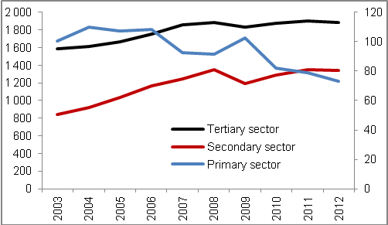 |  |  |  | 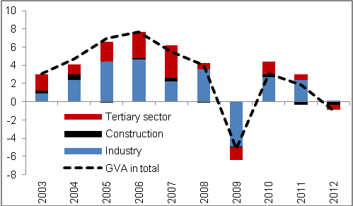
Source: CZSO, own calculations

Sources of long-term growth of GDP
Capital stock in the Czech Republic in years 2013-2012 was continually increasing and thus supported the growth of GDP in a stable way |  |  | Capital stock (gross stocks of fixed assets) was in the Czech Republic for a long-term a stable source of GDP growth, in the period of 2003 to 2012 showed constant growth on average of 2.4 % and shared in the growth of GDP with an average contribution in the amount of +1.0 p.p. Even in times of GDP decrease in 2009 was the fall softened by the growth of this quantity (+1.0 p.p.). We attribute the causes of this constant increase of capital stock to the underinvestment of the domestic economy – even despite the fact, that in two out of last four years (2009 and 2012) the gross fixed capital formation year-on-year decreased.
On the other hand the labour stock in the number of hours worked fluctuated and reacted to the given development of GDP – it was decreasing both in years 2009 and 2012 |  |  | The labour stock, on the other hand, could not be considered as stable (employment- in number of hours worked), since its value quite fluctuated through time – this development flows from the nature of this quantity itself, as the amount of labour stock is possible to relatively easily adjust to the actual economic situation, which was noticeable both in years 2009 (-3.0 %) and 2012 (-1.1 %), when the stock of labour fell considerably. Contribution of the stock of labour to GDP growth between years 2003 and 2012 reached an average of +0.1p.p. The contribution gained the highest value in year 2008 (+1.6 p.p.), i.e. in the period, when the growth of GDP already slowed down, the lowest value then in the mentioned year 2009 (contribution gained -1.8 percentage point) – stock of labour deepened the slump of GDP.
In years 2003 to 2012 the main sources of long-term GDP growth were the intensive factors… |  |  | In total these extensive sources from year 2003 to 2012 contributed by an average amount +1.1 p.p. and affected the growth of GDP by 39 %. Still the main factors in the GDP growth were in the monitored period the intensive sources, that is the labour productivity (based on the number of hours worked) and capital productivity. Together they shared on the growth of GDP between year 2003 and 2012 on average +1.8 p.p. (in the form of total factor productivity contribution). Intensive sources thus affected the GDP out of 62 %.
…while the labour productivity played the main role |  |  | Contribution of the labour productivity was acquiring positive values in the long-term – the exception was year 2009, when it reached -0.9 p.p. In the whole decade, the contributions amounted to on average +1.6 p.p. This development was given by the higher growth of GDP to employment, which subsequently implied a higher labour productivity. Contribution of the capital productivity achieved in the last ten years an average of +0.2 p.p. As a consequence of constant growth of capital stock and GDP decrease in years 2009 and 2012 the capital productivity was in these years decreasing and the contributions to the growth of GDP were negative. Due to the higher rate of growth of capital stock in 2011 over GDP, there was a negative contribution on the side of capital productivity also in this year. Out of last four years (2009-2012) was thus the contribution of the capital productivity negative in three of them.
Fall of GDP in 2012 was caused especially by the lowering of capital productivity… |  |  | The fall of GDP in 2012 was the effect especially of the intensive sources, concretely with the contribution of -1.5 p.p. GDP fell in nearly the same size as the number of hours worked, and the contribution on the side of labour productivity was nearly zero. On the other hand following the decrease of GDP and further growth of capital stock, there arose a fall of the capital productivity, which subsequently contributed to the fall of GDP -1.5 p.p.
…the fall was however also influenced by the decline of the stock of labour, growth of capital stock on the contrary the fall of GDP slowed down |  |  | Extensive sources as a whole softened the fall of GDP, by positive 0.3 percentage points. With respect to the decline of stock of labour, this source contributed to development of GDP -0.7 percentage points and thus deepened the fall of GDP. On the other hand the capital stock thus had to work against the lowering of GDP – it contributed to the development +1.0 p.p.

Chart 11 | Sources of long-term growth of GDP in the CR (constant prices, 2003=100)
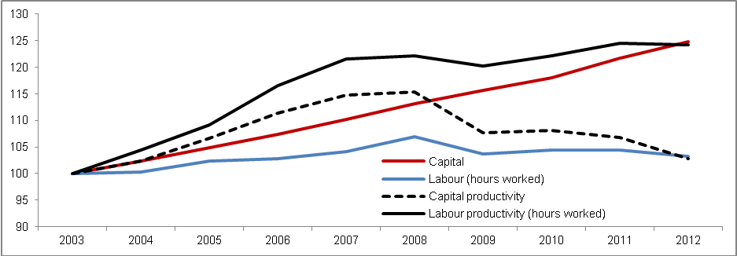
Source: CZSO, own calculations

Chart 12 | Contributions of sources of long-term growth of GDP in the CR (constant prices, in p.p.)
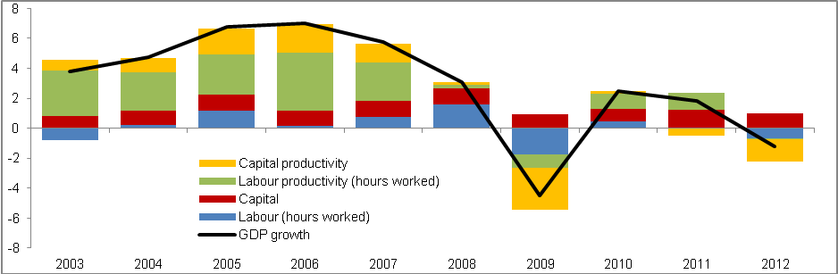
Source: CZSO, own calculations

Eurostat data, constant prices (unless stated otherwise).
European Union with 27 member countries (unless stated otherwise).
Euro area with 17 member countries (unless stated otherwise).
Eurostat data, in constant prices – unless stated otherwise. For the reason of using data in constant prices arises the discrepancy (unexplained diference between GDP and expenditure components caused by chaining of the values from current prices to constant prices).
EX – exports, IM - imports
FCEh+ni – final consumption expenditure of households and non-profit institutions, FCEg – final consumption expenditure of government institutions, GCF – gross capital formation
Commodity structure of the gross fixed capital formation – in current prices, data of the CZSO national accounts.
Gross fixed capital formation of invididual institucional sectors – in current prices, data of the CZSO national accounts.
In constant prices. Data of CZSO annual national accounts.
Unavailable information about the 21st branch „Activities of extraterritorial organisations and bodies“.
Primary sector = agriculture, forestry and fishing + mining and quarrying. Secondary sector = manufacturing industry + energy + water supplies and activities connected to the waste waters + construction. Terciary sector = other branches (services).
This chapter is based on the CZSO national accounts. Value of the capital stock (gross stocks of fixed assets) for year 2012 was due to the absence of data in the national accounts estimated. For the reason of comparability of data are based on national accounts also the values for labour stock (employment). GDP and capital stock in constant prices.
The sum does not have to correspond for the reason of operations with average values and rounding.

