6 March 2025

Development of the Czech labour market in the Q4 2024
Females helped the employment again. The economic activity of the population attained record high values, while the unemployment stagnated. The average wage increased in nominal terms by 7.2%, year-on-year (y-o-y), an in real terms by 4.2%. The wage growth was still hobbled by the economic activities of education and public administration and defence, in which salaries decreased in real terms, year-on-year.

Employment, unemployment, and economic inactivity
Results of the Labour Force Sample Survey (LFSS) brought predominantly positive figures for the Q4 2024. The economic activity rate (calculated according to the new methodology, for the group of the aged 15–64 years) reached a record high value of 77.8%; in the y-o-y comparison, it increased by 0.4 percentage point (p. p.).

The number of working persons (aged 15+ years) increased by 116.6 thousand, year-on-year, i. e. by 2.3% to 5 204.0 thousand. It is solely thanks to females again, because among them the number was by 118.2 thousand higher.

The number of employees increased by 151.1 thousand persons, i.e. by 3.6%. On the other hand, the number of entrepreneurs decreased; it applied to both the self-employed (own-account workers) and employers. The employment was considerably increasing especially in the sector of services (+75.6 thousand); however, the primary sector and the secondary sector increased, too (+5.1 thousand and +35.9 thousand, respectively). The employment rate increased by 0.4 p. p., y-o-y, to 75.8%. The male employment rate dropped by 0.3 p. p. to 81.3% and the female one increased by 1.4 p. p. to 70.2%. The trend was contributed to by the development of part-time jobs the number of which was 483.3 thousand; in the y-o-y comparison, it increased by 40.0 thousand, i.e. by 9.0%. 14.4% of working females had reduced working hours; they stated most frequently that it is because they cared for a child.

The unemployment remained almost unchanged, year-on-year. The number of persons who seek a job only increased by 0.3 thousand to 133.5 thousand. The unemployment rate remained unchanged at 2.6%. When looking at the unemployment in terms of Regions, the situation has only slightly changed; it was the worst in the Moravskoslezský Region (4.4%), followed by the Karlovarský Region, the Liberecký Region, and the Ústecký Region (the rates were the same, 3.7%), whereas the lowest unemployment rate remained in the Středočeský Region (1.3%). The number of the unemployed who were jobless for over one year was 39.4 thousand, i.e. 29.5% of all the unemployed. The number of the long-term unemployed thus slightly decreased, y-o-y, by 2.6 thousand.

Surplus labour (persons who do not work, are not actively seeking a job and therefore they do not comply with the ILO requirements for the unemployed, yet they state that they would like to work) decreased by 4.2 thousand to 77 thousand.

Note: The LFSS only covers persons living in dwellings (flats), not those living in hostels and similar collective households. It has a negative influence on the capture of some groups of foreigners who often use such ways of housing. In 2023, the methodology of weighting and grossing up in the LFSS was adapted to this type of survey, which had an impact on the time series of absolute data on employment, especially in the breakdown by age group.

Registered number of employees converted to full-time equivalent employees
Preliminary data of the CZSO’s business statistics do not show the same trend in the increase in the number of employees as it is observed in the LFSS. It can be caused by changes in forms of employment and inclusion of groups of foreigners as well as in the aforementioned growth of share of part-time jobs. The registered number of employees in full-time equivalent (FTE) only increased, y-o-y, in the Q4 2024, by 5.3 thousand, which was a relative increase by 0.1%. (The registered number of employees (headcount) increased by 0.6%.)

While the overall figures for the last two years represent rather stagnation in the number of employees, in the breakdown by CZ-NACE section we can even now find some significant increases and decreases, which indicates that the labour market is changing internally and that employees are fluctuating.

In the Q4 2024, the increase in the number of employees again concentrated in the area of market services, whereas decreases can be found in the primary sector, in ‘manufacturing’ and in ‘transportation and storage’, which are strongly connected to it. In five CZ-NACE sections, the number of employees decreased by 26.4 thousand, year-on-year. In eleven sections it increased by 31.5 thousand, and in the remaining two it stagnated. As for individual sections, relative increments or decrements were ranging in a wide scope from -7.8% to 17.2%. However, those extremes were in economic activities that were numerically insignificant.

The biggest absolute decrease (by 20.5 thousand, by 1.9% in relative terms) can be found in ‘manufacturing’. It still employs over one million employees (1 050.3 thousand) in Czechia, which is far the most numerous CZ-NACE section. Table 1 in the news release on average wages therefore provides CZ-NACE divisions of this section, which were the biggest as for the number of employees. In six of those divisions, we can find decreases in the number of employees. The deepest one was in ‘manufacture of electrical equipment’ (by 4.4% or by 4.2 thousand). It was also high in ‘manufacture of machinery and equipment n.e.c.’ (by 3.7% or by 4.1 thousand). The only selected division with an increase was ‘manufacture of food products’ (by 2.7% or by 2.3 thousand). ‘Manufacture of motor vehicles, trailers and semi-trailers’ remains to be the most numerous division; the number of employees decreased there by 2.4% or by 4.1 thousand to 163.5 thousand.

A relatively largest decrease in the number of employees was in ‘mining and quarrying’, an utterly marginal industry already, in which the number currently decreased by 7.8%. It was a decrease by 1.4 thousand to 16.8 thousand. Also in ‘agriculture, forestry and fishing’ where 89.4 thousand employees are employed now, there was a decrease (by 2.0% or 1.9 thousand). A more important decrease as for the number was in ‘transportation and storage’ by 2.1 thousand (in relative expression by 0.8%). The last CZ-NACE section, in which the number of employees decreased, currently by 0.5 thousand or by 0.2%, was ‘public administration and defence; compulsory social security’.

‘Construction’ was more successful and the number of employees increased there by 0.5 thousand or by 0.3%, year-on-year. The recovery was even more visible in ‘accommodation and food service activities’, in which the number of jobs increased by 4.1 thousand, i.e. an increase by 3.6%.

However, other three economic activities saw the biggest increases in the number of employees. In ‘real estate activities’, the increase was by 7.4 thousand, which in this smaller economic activity meant a relative increase by 17.2%. Further, it was ‘human health and social work activities’ with an increment by 6.9 thousand jobs (2.0% in relative terms) followed by ‘education’ with an increment by 5.3 thousand, i.e. by 1.6%. Finally, it is worth noticing ‘professional, scientific and technical activities’, in which there were by 3.8 thousand employees more, which is an increase by 2.2%, and ‘financial and insurance activities’ with an increment by 1.1 thousand, which is an increase by 1.6%.

Quarterly average gross monthly wages
The average wage (CZK 49 229) increased nominally, compared to the corresponding period of the previous year, by CZK 3 322 in the Q4 2024, i.e. by 7.2%. It is an average of a very diverse development on the level of individual branches (fields of activity), enterprises, or organisations.
In the end of 2024, the wage growth did not deviate from the context of the preceding quarters of the previous year; for the whole year 2024, the wage growth was 7.1%. For the year 2023, the nominal growth was extraordinarily high (8.0%); it was only comparable to the boom year of 2018, when it even reached 8.1%. Before, Czechia only reached such high values in the beginning of the century.

Chart 1: Consumer price index and average wage index (seasonally adjusted), 2019 = 100%
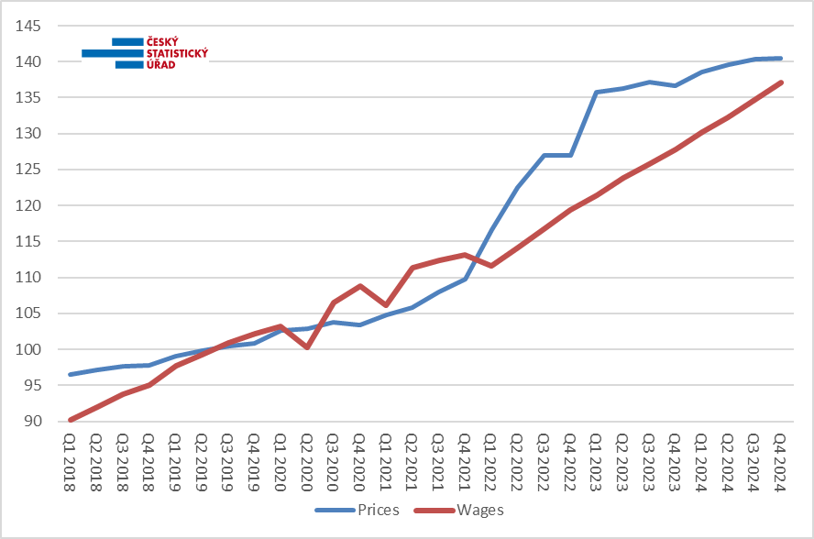Sources: wage statistics of the CZSO; price statistics of the CZSO

What was more important from the point of view of employees, however, was the real development that compares the increase of earnings with the price increase and thus it shows how many goods and services an employee could purchase for the wage. The consumer price index reached the value of 2.9% in the Q4 2024; the average wage thus increased in real terms by 4.2%, year-on-year. For the whole year 2024, it is an increase by 4.6%. This higher increase means catching up on the increased price level, see Chart No 1. It is coming after two years of considerable year-on-year decreases of real wage, when in 2022 there was a decrease by 9.4% and in 2023 by 2.4%.

Wage dynamics, however, varied widely by economic activity. The highest nominal year-on-year increase (16.0%) can be currently found in the ‘real estate activities’ section. With a gap, it is followed by ‘professional, scientific and technical activities’ with 12.2% and by ‘accommodation and food service activities’ with 10.3%. Other sections remained below the ten percent level. ‘Construction’ with 9.9% followed by ‘human health and social work activities’ with 9.2% got the closest to that level. Real purchase power of wages significantly increased, year-on-year, to employees in those economic activities.

Right the opposite situation was in two other economic activities, in which 644.5 thousand employees are working in total. In ‘education’ and in ‘public administration and defence; compulsory social security’ the salary level only increased by 2.3%, y-o-y, which was under the inflation rate level (2.9%). It means that for employees of those two economic activities (in which the state is dominating) real wages slumped again in the Q4 2024, namely after previous three years of decreasing of their purchase power.

Another extraordinary situation occurred in ‘mining and quarrying’ where the number of employees dramatically decreased (by 7.8%) while the average wage negligibly increased by CZK 663, by 1.2%, which was the least of all the sections.

Except for those three economic activities, real wages of employees currently increased, year-on-year.

The highest wage level in the Q4 2024 can be found in ‘information and communication’, in which the average wage reached CZK 85 270. In the year-on-year comparison, it increased by 7.3%, which in this case was an increment by CZK 5 782. With a gap, ‘financial and insurance activities’ ranked second with the level of CZK 74 615 (an increase by 6.8%) and the third one was ‘electricity, gas, steam and air conditioning supply’ with CZK 72 424 (an increase by 4.7%). Those three are on the top, for a long time.

From the opposite side, the ranking was as usual, too. In ‘accommodation and food service activities’, the average wage despite a rather marked relative increase (by 10.3%) was still the lowest (CZK 29 126). The second lowest average wage remained in ‘administrative and support service activities’, where it increased by 8.6% to CZK 33 763. The third lowest were ‘other service activities’ with the average wage of CZK 38 372 (an increase by 8.7%) closely followed by the fourth ‘agriculture, forestry and fishing’ with the average wage of CZK 39 473 (an increase by 6.4%).

Long-term development in economic activities (CZ-NACE sections) – comparison with the year 2019
It must be noted that the cumulative figures for the Q1 through Q4 2024 are preliminary, they come from the task with a smaller sample of enterprises or oganisations (“Práce 2-04” questionnaire/report). Only after including results of annual tasks (“ÚNP 4-01” and “P 5-01” questionnaires/reports) and after connecting it with administrative data sources (especially from the Czech Social Security Administration) they will be refined in the periods to come. The year 2019 is closed with final results.

In total, the wage level increased for the surveyed five-year period in nominal terms by a third (33.5%). In real terms, however, it decreased by 4.5%, because consumer prices increased in that period almost by 40% (39.8%). However, situation in individual economic activities could considerably differ, see the Chart 2.

Chart 2: Increment of real average wage by CZ-NACE section, years 2024 and 2019 compared (%)

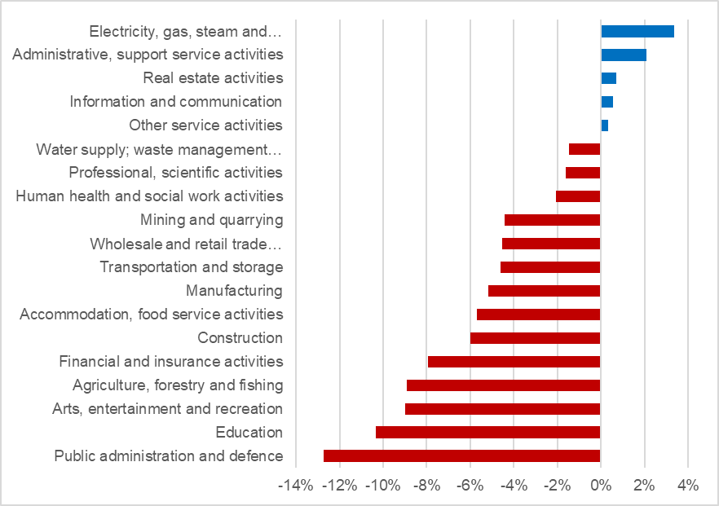Sources: wage statistics of the CZSO; price statistics of the CZSO

In the past years, all economic activities (industries) underwent a period of a real wage decrease, which differed in its length and depth and was followed by periods of growth that were of different durations. In five CZ-NACE sections, the last year’s level already overcame the forty-percent threshold of the inflation increase, whereas in the remaining fourteen sections wages still remained under the real level from the year 2019.

Employees in the energy sector (‘electricity, gas, steam and air conditioning supply’) were well off the most of all. For the five-year period measured, the real wage increased there by 3.4%. ‘Administrative and support service activities’ ranked second with an increase by 2.1%. ‘Real estate activities’ ranked third with an increase by 0.7% and ‘information and communication’ ranked fourth with 0.5%. The last section with a positive increment was ‘other service activities’ with 0.3%.

In ‘information and communication’, in the surveyed period, the number of employees concurrently significantly increased by 9.4%. Conversely, in ‘administrative and support service activities’, the number decreased by 9%.

On the other hand, wages of employees of three economic activities in which the state is dominating were the worst off. They slumped in real terms by at least nine percent. They are as follows: ‘public administration and defence; compulsory social security’ (12.7%), ‘education’ (10.3%), and ‘arts, entertainment and recreation’ (9.0%). A considerable decrease in real wage also occurred in ‘agriculture, forestry and fishing’ (8.9%). What was different in those economic activities was the development of the number of employees: whereas in ‘education’ it considerably increased (by 13.8%), in ‘arts, entertainment and recreation’ it decreased by 2.3%, in ‘agriculture, forestry and fishing’ it dropped by 3.8%, and in ‘public administration and defence; compulsory social security’ the number of employees in 2024 was by 0.6% lower. Far the biggest reduction in the number of employees occurred during the five-year period in ‘mining and quarrying’, by 26.9%, whereas the highest increase was in ‘human health and social work activities’ by 15.5%.

Development in Regions
In terms of the number of employees, there was again a year-on-year decrease in most of the Regions of Czechia in the Q4 2024. The most noticeable one, by 1.3%, was in the Moravskoslezský Region followed by the Královéhradecký Region (by 1.1%) and by the Karlovarský Region (by 0.9%). In the Liberecký Region and in the Jihočeský Region, there was the same decrease by 0.8% and in the Ústecký Region by 0.7%. The total balance was again equalised largely thanks to a massive increase in Prague by 2.2%. Smaller increases were also recorded by the two following Regions: the Středočeský Region with an increment by 0.2% and the Plzeňský Region with 0.1%. The Jihomoravský Region was stagnating.

As for the development of average wages, the dispersion was substantially smaller among Regions than in the breakdown by economic activity (industry) in the Q4 2024. Wages were increasing nominally in the range from 5.0% to 9.0%. The highest wage growth was in the Pardubický Region (9.0%), followed with a gap by the Capital City of Prague (7.9%), the Olomoucký Region (7.5%), and the Zlínský Region (7.4%). In other Regions, the increase was below-average. Currently, the Karlovarský Region came off worst; the average wage only increased there with a five-percent growth rate. In the Ústecký Region, it increased just by 5.4% and in the Vysočina Region by 6.0%.

According to the absolute level of earnings, Prague still remained to be the richest among the Regions of Czechia. The average wage there was CZK 59 870. The Středočeský Region kept the second position with CZK 49 442 and the third one was, as usual, the Jihomoravský Region (CZK 48 807). The threshold of 46 thousand was overcome by the Plzeňský Region, too (CZK 46 767), other Regions remained below that threshold. On the other hand, the Karlovarský Region remained to be the Region with the lowest wage level (CZK 42 284) and, currently, the only Region below the CZK 44 thousand threshold. In the Moravskoslezský Region, which is following Prague, the Jihomoravský Region, and the Středočeský Region a Region with the fourth highest number of employees (409.2 thousand), the average wage reached the value of CZK 44 660.

* * *

Median wages and decile intervals of wages, broken down by sex
The news release of the CZSO for the Q4 2024 also contains a piece of data on the median wage, which is calculated from a mathematical model of the distribution. It shows the wage of a middle employee, i.e. a common wage level. Extreme deciles have been calculated concurrently, too; data from the previous period have been revised. In the Q4 2024, the median wage got to CZK 41 739, which is by 4.2% (CZK 1 682) more than in the corresponding period of the previous year.

One tenth of employees with the lowest wages were receiving a gross wage below CZK 21 577 (the bottom decile increased by 6.6%, y-o-y), whereas the tenth with the highest wages had wages over CZK 80 431 (the top decile increased by 2.4%). The decile ratio thus reached the value of 3.73.

Male median wages were higher than female ones; in the Q4 2024, the female median wage was CZK 38 643 (it only increased by 2.9%, year-on-year), whereas the male median wage was CZK 45 004 (it increased by 6.3%). The gap between median earnings by sex thus increased by 2.8 p. p., year-on-year, to 14.1%.

At the same time, wages of males were distributed over a substantially wider interval, especially the area of high earnings is significantly higher for males than for females: the top decile for females was CZK 71 279 and for males it was CZK 89 366, by which there was a gap of 20.2% in high earnings. On the other hand, as for low earnings, the difference was smaller: the bottom decile for females was CZK 20 982 and for males CZK 22 239, which is a gap of 5.7%.

* * *

Preliminary results from the Information System on Average Earnings (ISAE) for the year 2024 bring a more detailed view of wage structures, distributions, and socio-economic breakdowns. However, the ISAE applies a different methodology for the calculation of personal earnings of an employee (first of all, it excludes all absences at work and and it does not take into account part-time jobs) and therefore these data are not comparable either to the aforementioned amounts of wages or to figures given in tables annexed to the news release of the CZSO.

According to preliminary results, the total median wage in 2024 was CZK 41 740. It was by 6.3% more compared to the previous year. When compared to the average wage growth (7.1%), the median thus grew slower, which held true for the whole median zone. The following were increasing faster than the median: high earnings in the 9th decile (by 7.7%), which increased to CZK 77 120, and low wages in the 1st decile (by 7.5%), which increased to CZK 23 745.

Wages of males were increasing faster, year-on-year, than wages of females, namely in the whole zone. The male median wage reached CZK 44 749; in the y-o-y comparison, it increased by 6.7%; the median wage of females increased by 6.1% to CZK 38 672.

According to the valid Classification of Occupations (CZ-ISCO), managers having the median wage of CZK 82 609 were the group with the highest earnings. Wages of managers are the most differentiated ones; a tenth of the best-paid earned over CZK 195 320, while the opposite tenth received less than CZK 42 246. The second major group of professionals has the second highest wage level with the median wage of CZK 57 946, while a tenth earned over CZK 118 015. Namely wages of the best paid professionals increased far the most, year-on-year (by 10.5%), otherwise the increases were not much differentiated in terms of big professional groups.

The third major group includes technicians and associate professionals; they had the median wage of CZK 47 639. The fourth major group of clerical support workers had the median wage of CZK 36 291. In the fifth major group of service and sales workers, approximately one of three belonged to low-income employees (in general, such an employee is considered to be a low-income (low-wage) employee who earns less than 2/3 of the total median wage; according to the ISAE for the year 2024, the threshold was CZK 27 829); they had the decile ranging from CZK 21 597 to CZK 49 370 and their median wage was CZK 31 585. Qualified workers in ‘agriculture, forestry and fishing’ are permanently the least numerous major group; their median wage was CZK 34 944. Craft and related trades workers had the median wage of CZK 39 617 and plant and machine operators and assemblers had CZK 37 762. At elementary occupations, there is constantly the lowest wage level; currently, the median got to CZK 25 620; therefore, they have over a half share of low-income employees, their decile range was from CZK 19 453 to CZK 40 543.

Wages are also highly structured by age group. As for year-on-year increases, a slightly more better off were groups of those in their forties and fifties, whereas median wages increased less in younger categories of employees up to 29 years. Namely at the youngest employees up to 20 years, the median wage remained by far the lowest, only CZK 29 502. At the same time, their number increased in the survey sample by 6.5%, whereas in the age categories from 20 to 49 years we can find decreases in numbers. The median wage of those in their twenties (20–29 years) was already on a substantially higher level (CZK 38 385) than that of the youngest. It was the highest as for those in their thirties (CZK 43 922). In the other two ten-year age categories, wages are gradually decreasing, to CZK 42 877 for the most numerous category of those aged 40–49 years, and to CZK 41 252 for the aged 50–59 years. Finally, for those aged 60+ years, the median wage was CZK 41 187, i.e. just a bit lower than for the preceding category. However, in this category, there are only 38% of the number of employees and it is usual that those who are more qualified a paid better remain to work longer. Nevertheless, the number of records increased there by 6.4%, because the population is ageing on average, and professional career extends to a higher age.

For wages that are broken down by the level of educational attainment of an employee it holds true that median wages for low levels of educational attainment increased more, y-o-y, whereas median wages of employees with higher education were increasing the least. However, they still earned the most on the absolute level; their median wage was CZK 57 991. On the other hand, median wages of employees with primary education or with incomplete primary education remained the lowest (CZK 33 242). Graduates of secondary schools with an A-level examination earned much more (CZK 42 338) than those without the A-level examination (CZK 35 247), but less than employees with short-cycle tertiary education or graduates from bachelor study programmes (CZK 48 688).

The ISAE also monitores earnings of employees by state citizenship. From large groups of foreigners, the highest representation now belongs to Ukrainians, for whom the number of records further increased by a tenth, y-o-y, whereas numbers of Bulgarians and Poles have considerably decreased. The highest median wage of those groups in Czechia belonged to Slovaks (CZK 48 092); it was even by 14% higher than for employees with Czech citizenship (CZK 42 069). On the other hand, by 23% lower than the Czech one was the median wage of Ukrainians (CZK 32 560); however, it increased by 7.5%, y-o-y. Lower than Czech ones were also wage levels of other three smaller groups, i.e. of Bulgarians (by 12% lower), Romanians (by 8% lower), and of Poles (by 5% lower). However, they were increasing faster, y-o-y, than wages of Czechs; the fastest it was among Romanians by 11.6%.

Elaborated by: Dalibor Holý
Labour Market and Equal Opportunities Statistics Department of the CZSO
Phone number: (+420) 274 052 694
E-mail: dalibor.holy@csu.gov.cz

