The Czech Economy Development in 2012 March 2013

Overall Economic Performance
- Recession of the Czech economy deepened during the 2012 in year-on-year comparison… | Economic development in the Czech Republic was in 2012 characterised by the fall of GDP. Starting with the mild year-on-year decrease in the first three months by 0.4 %, it gradually deepened in the subsequent quarters (through -1.1 % and -1.5 % in Q2 and Q3) to -1.7 % in the last quarter of 2012. Prevailing causes of the economic slump can be found mostly in the first three quarters in the weak domestic demand with limited final consumption expenditure, in the last quarter then mostly in the weakened foreign demand.  For the whole year of 2012, the economic performance fell by 1.2 % against the year 2011 (+1.9 %). Fall was mitigated by +1.5 percentage points by the foreign trade, final consumption expenditure and capital formation were on the contrary the rate of growth of GDP decreasing (-2 p.p. and -0.8 p.p. respectively). Most adverse effects came from the limited household consumption expenditure (- 1.8 p.p.).
- …but quarter-on-quarter, the fall slowed down beginning Q3 | In the last three months of 2012, the drop of Czech economy was compared to the preceding quarter milder (-0.2 %) in comparison to the quarter-on-quarter decreases during the year (in first three quarters by -0.5 %, -0.6 % and -0.4 %). This slowing down of fall was impacted by the quarter-on-quarter growth of total final consumption expenditure (+0.9 %), both by household (+0.9 %) and government sector (+1 %). Gross capital formation also rose (+4.8 %), but was not driven by the favourable development of investment, which quarter-on-quarter fell by 3.8 % (in Q3 of 2012 only by 1.9 %).
- Quarter-on-quarter fall of the CR economy in Q4 milder than in the EU and the euro area | Also in the European context, the lowered economic performance of the Czech economy, quarter-on-quarter by 0.2 % in the last quarter, was better compared to the EU 27 average (-0.5 %) and euro area (-0.6 %). In spite of this fact, the recession lasting in the CR the whole past year was in the European comparison longer only in Slovenia, Italy and Cyprus, whose economies experienced recession for six quarters. One quarter longer than in the CR the recession lasts also in Spain and the economy of United Kingdom. The longest recession troubles Portugal with nine consecutive quarters of economic fall in a row.  Regarding the comparison of the structure of the growth, markedly worse compared to the EU average were in the CR in the first three quarters quarter-on-quarter falls of the household consumption – e.g. in Q1 by 3.1 %, against the real stagnation in EU (-0.1 %), in Q3 by -1.4 % compared to -0.1 % in the EU. However, in the last three months a turning point occurred in the CR. Households spent on consumption more compared to the preceding quarter by 0.9 %, while in the EU the household consumption decreased (-0.3 %). Notably deeper were in the CR nevertheless against the EU the quarter-on-quarter fall in investment in the last two quarters, the export dynamics fluctuated more and also the quarter-on-quarter decreases of imports were more noticeable given the deeper recession of the Czech economy.
- Year-on-year decrease of the Czech economy three to four times deeper in individual quarters of 2012 compared to the fall in the EU | While in the EU economy fell to red numbers from Q2 2012 (-0.3 %) and in the last three months showed year-on-year decrease of the performance by 0.6 %, drops of the Czech economy were in each quarter several times deeper. The main cause was the drop in the Czech household consumption in the first three quarters and also the consumption of the government sector. EU as a whole then recorded in each quarter of 2012 mild additions to the government consumption. It suggests, that countries (especially Germany) tried even in the times of economic downturn not to hurt the economy by weakening the government expenditure.  Germany sustained growth in the last quarter of 2012 (+0.4 %) despite gradual decline of the rate of growth of GDP from Q2 2011, as well as Austria (+0.4 %). Apart from the strongest European economy thus in the sample of accessible countries recorded growth also Lithuania (+3 %), Norway (+1.9 %), Sweden (+1.5 %), Switzerland (+1.2 %) and Poland (+1.1 %).  Year-on-year falls for three quarters were recorded in Finland due to the troubles of the biggest business in the country, marked fall then in Slovenia (-2.8 % in the last two quarters) and Italy with more then two percentage falls (-2.7 % in Q4). Further loss of economic performance experienced Spain (-1.9 %). Mild containment of the debt crisis in the euro area thus was not reflected in the mitigation of the European recession.
- Decline of household final consumption expenditure deepened throughout the year and in 2012 was one of the deepest in Europe | Despite the consumer confidence in the Czech economy starting to show a rise from its bottom from the half of the year and given its trend values, the decreases were milder and milder, this fact was not reflected in the development of the household expenditure. On the contrary: every quarter their consumption expenditure year-on-year significantly worsened (-1.7 %, -3.4 %, -3.9 %, to .4.1 % in Q4), in declines, which are unique in the history of the Czech economy.  More intensely lowered their consumption only households in Portugal (year-on-year by more than 5 %) and Italy (by more than 4 %). In the context of the last 15 years, these are in case of the CR, as well as these countries, the deepest declines of the household expenditure across the whole Europe. They are exceeded only by double-digit drops of the household expenditure in the Baltic countries and tenth drops in Romania in crisis year 2009.
- More favourable development of the government consumption, weakening of the investment expenditure and the rate of growth of both imports and exports in positive values | Year-on-year fall of the CR government sector consumption was becoming milder during individual quarters of 2012 (-3.3 %, -1.9 %, -0.4 %). In the last three months was the government consumption against the same period of 2011 by 0.8 % higher. This development is the evidence of loosening of the expenditure restrictions.  The gross capital formation fell notably in Q3 (-9.2 %), in Q4 it stagnated year-on-year (-0.2 %). Investment alone was following mild increases in first two quarters again falling in the second half of the year (-3 % and -5 % year-on-year in Q3 and Q4 2012).  Foreign trade managed to sustain mild year-on-year increases in each quarter (with the exception of the decline of imports of goods in Q3 and decline of exports of services in Q2). However, in total exports of goods and services during the year grew given a mild weakening of its rate of growth (+6.4 %, +4.1 %, +4.3 % to +1.4 % in the last quarter). Surprisingly also the imports dynamics did not weakened into a year-on-year decrease (+3.7 %, +3.1 %, +0.3 % to +1.2 %) in a situation, when the domestic demand weakened. It can be most likely explained by the still good results achieved by exporters from the CR on the foreign markets with a strong interconnection of exports and imports characterizing the Czech economy. On the contrary, in the euro area for the whole 2012 and in the EU except for a stagnation in Q2, the imports were year-on-year lower.
- In Q4 net exports, government consumption and inventory increases contributed to the growth of GDP, for the whole 2012 nevertheless only net exports | From the dynamics of individual GDP components arises also their contribution to the development of economic performance. In Q4 2012 had a favourable effect, the same as in preceding eight quarters, the foreign trade. Net exports added to the GDP rate of growth negligible 0.2 p.p. (such modest contribution was last recorded in Q2 2009). For the first time in eight quarters of a negative influence, the government sector consumption contributed favourably as well (+ 0.2 p.p.). On the contrary, the household consumption lowered the GDP growth rate by 2.1 p.p. and investment also negatively contributed (-1.2 p.p.). In the opposite direction, the increase in inventory in Q4 added to the rate of growth of GDP 1.1 p.p., when in the preceding quarters of 2012 the effect of its change was negative.  For the year 2012, only net exports contributed positively to the rate of growth of GDP (+1.5 p.p.).

Chart 1 |  | Gross domestic product (constant prices, seasonally adjusted, y/y in %) | Chart 2 | GDP (in current prices, y/y in %) and confidence indicators according to the CZSO Business Cycle Surveys
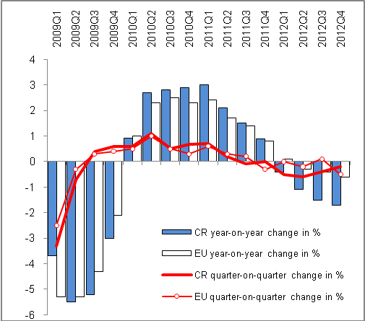 |  |  | 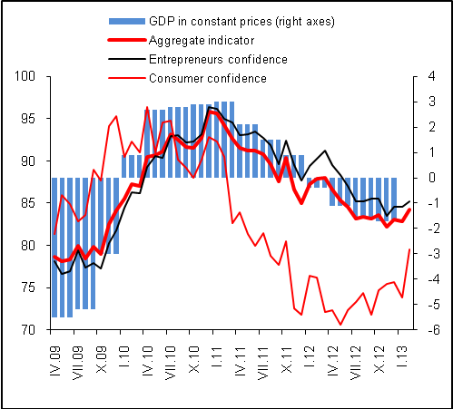
Chart 3 | Contributions of expenditure components to the growth of GDP (in p.p.) |  | Chart 4 | Contributions of industries in relation to growth of gross value added (in p.p.)
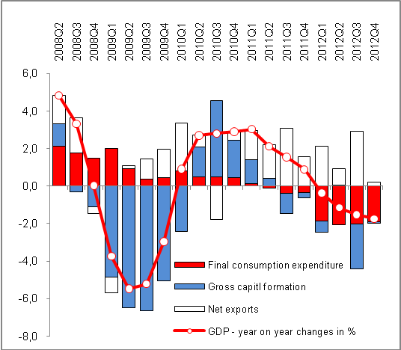 |  |  | 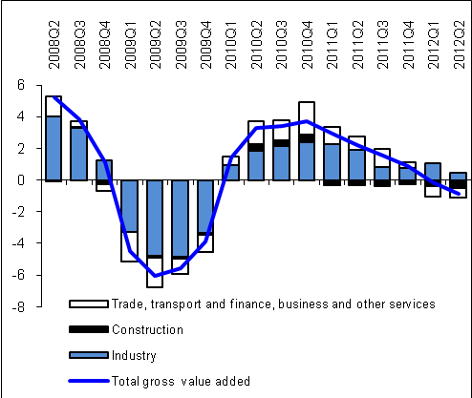  Source: CZSO

