3 September 2012

COMMENTary: development of average wages of employees in Q2 2012

Moderate growth in average nominal wages was accompanied with a decrease in the number of employees as well as in the number of hours worked, especially overtime hours.

The average wage in the Czech Republic increased nominally by 2.3% in Q2 2012 compared to the same period of the previous year. This growth was contributed by an increased share of extraordinary (irregular) bonuses and reimbursements in certain economic activities. The year-on-year comparison was also affected by the fact that after two years there were the two bank holidays in May held on working days (Tuesdays). Thus vacations taken in this period (for a so-called prolonged weekend) led to an increased number of paid but not worked days, which could affect wages as well, because the reimbursement for holidays and vacations is paid as an average pay in the previous period.
In Q2 2012 the registered number of FTE employees decreased by 1.0% compared to the same period of the previous year and it means it dropped by 38 thousand persons.
The increase in the average nominal wages did not compensate the growth of consumer prices - inflation, which was 3.4% in the period measured. Therefore, the real purchasing power of the employees declined by 1.1% in Q2 2012.
From points of view of the institution and size groups of companies, as well as of respective economic activities, the development was differentiated. In five sections of the CZ-NACE real wages increased and in thirteen sections average wages decreased in real terms; in three sections there were even nominal decreases recorded.
The most critical development was in ‘construction’, in which the number of employees dropped by 3.5% (i.e. by 8.4 thous. persons), while the average nominal wages were simultaneously reduced by 2.8%. Conditions were not easy also in ‘accommodation and food service activities’, in which the number of employees went down by 3.1% and there was a nominal decrease in the average wage by 1.0%.
‘Manufacturing‘, which is the largest economic activity of the national economy, recorded a positive trend in employment in Q1 2012 but in the current period there has been a decrement by 0.5%, i.e. by 4.9 thous. persons compared to the same period of the previous year.
The recession continued in ‘public administration and defence’ where both real earnings and numbers of employees have been decreasing over a long term. In Q1 and Q2 2012 the numbers of employees in economic activities dominated by state as ‘education’ and ‘human health and social work activities’ were also reduced.
The development in ‘transport and warehousing’, in which there was a decrease of the employees by 2.6%, i.e. by 6.4 thous. persons, was a negative message as well. Their average wages increased nominally by mere 0.5%.
On the other hand, ‘financial and insurance activities’ recorded a significant growth in wages and in the number of employees when the number of employees grew by 1.0% and the average wage increased by 4.9%. The second richest economic activities of ‘information and communication’ were doing relatively good, the average wage in these activities rose by 2.9% and the number of employees increased by 0.3%.

The comparison of the business sphere and the non-business one differs from that in previous years due to the change to methodology that was carried out in Q1 2012 and described in detail already in the last commentary to the appropriate News Release. Classification of certain organisations was made more precise according to so-called 50% criterion based on the share of resources in the reimbursement of operating costs, which caused a one-time massive movement of hundreds of units in between the spheres. In time series this change affects the comparisons of all quarters of 2010 to those of 2009 by distorting the comparison basis. Indices are consistent starting from Q1 2011, because the time series of values of the average wage is comparable in terms of methodology since the beginning of 2010.
As a result of this change the wage levels of the business sphere and the non-business one got closer to each other. In Q2 2012 the average wage in the non-business sphere was by CZK 237 lower than that in the business one. Then, the current development shows identical growth of earnings in both the spheres nominally by 2.3%, yet a decrease by 1.1% in real terms. While the business sphere experiences a decline in the average real wage this year for the first time, in the non-business sphere there has been a negative trend continuously since Q3 2010.
The number of employees fell in both the spheres compared to the same period of the previous year, in the business sphere by 1.1%, and in the non-business one by 0.5%.

* * *

The cumulative data for the first half of 2012 demonstrate a nominal growth in the average wage by 2.8%, however, once an increase in inflation by 3.5% has been taken into account the average wage falls by 0.7% in real terms. The adverse development for the entire half year is even further depicted by a decrease in the number of employees by 0.7%, i.e. by 26.4 thous. persons. There was a rather substantial increase in the number of employees solely in ‘real estate activities’ (by 7.8%), yet it was accompanied by a decrease in the nominal wage by 3.6%. From the business and non-business spheres points of view the average wages grew identically, nominally by 2.8%, and the numbers of employees slightly decreased, in the business sphere by 0.7% and in the non-business one by 0.5%.

* * *

The minimum wage has showed no change since January 2007 and accounts for CZK 8 000.

Dalibor Holý
Labour Market and Equal Opportunities Statistics Department of the CZSO
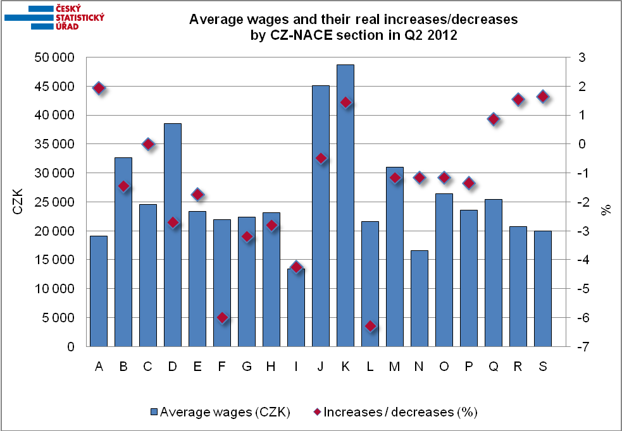

ECONOMIC ACTIVITIES according to CZ-NACE
A | Agriculture, forestry and fishing
B | Mining and quarrying
C | Manufacturing
D | Electricity, gas, steam and air conditioning supply
E | Water supply; sewerage, waste management and remediation activities
F | Construction
G | Wholesale and retail trade; repair of motor vehicles and motorcycles
H | Transportation and storage
I | Accommodation and food service activities
J | Information and communication
K | Financial and insurance activities
L | Real estate activities
M | Professional, scientific and technical activities
N | Administrative and support service activities
O | Public administration and defence; compulsory social security
P | Education
Q | Human health and social work activities
R | Arts, entertainment and recreation
S | Other services activities

