1. Comparison of results of IFS 2023 and Agrocensus 2000

Agricultural holdings and their legal forms
The Integrated Farm Survey 2023 provided updated data on the agricultural sector in the Czech Republic. In total 33 166 agricultural holdings met the thresholds for inclusion in the survey; out of them, there were 28 037 (84.5%) natural persons and 5 129 (15.5%) legal persons. Agricultural entrepreneurs prevailed among natural persons (23 008 holdings; 82.1% of natural persons). The greatest share of legal persons was represented by limited liability companies (3 643 holdings; 71.0% of legal persons) followed by joint stock companies (680 holdings; 13.3%) and cooperatives (515 holdings; 10.0%).
The total number of agricultural holdings declined by 15.1% since the year 2000. The number of natural persons decreased almost by a quarter (−22.5%) while the number of legal persons went up by three quarters (+77.8%). A significant growth was recorded in the number of limited liability companies (+169.7%) while the number of cooperatives went down (−30.6%).

Table 1: Agricultural holdings and their utilised agricultural area
 |  | AGC 2000 |  | IFS 2023 |  | Index 2023/2000  (%)
 |  | abs. | share (%) | abs. | share (%) | Index 2023/2000  (%)
Agricultural holdings, total | Agricultural holdings | 39 082 | 100.0 | 33 166 | 100.0 | 84.9
Agricultural holdings, total | Utilised agricultural area (ha) | 3 623 929 | 100.0 | 3 521 180 | 100.0 | 97.2
Agricultural holdings, total | Average area (ha) | 93 | x | 106 | x | 114.5
Holdings of natural persons | Agricultural holdings | 36 198 | 92.6 | 28 037 | 84.5 | 77.5
Holdings of natural persons | Utilised agricultural area (ha) | 943 182 | 26.0 | 1 080 368 | 30.7 | 114.5
Holdings of natural persons | Average area (ha) | 26 | x | 39 | x | 147.9
Holdings of legal persons | Agricultural holdings | 2 884 | 7.4 | 5 129 | 15.5 | 177.8
Holdings of legal persons | Utilised agricultural area (ha) | 2 680 746 | 74.0 | 2 440 813 | 69.3 | 91.0
Holdings of legal persons | Average area (ha) | 930 | x | 476 | x | 51.2
Business companies & partnerships | Agricultural holdings | 1 998 | 5.1 | 4 364 | 13.2 | 218.4
Business companies & partnerships | Utilised agricultural area (ha) | 1 578 943 | 43.6 | 1 785 004 | 50.7 | 113.1
Business companies & partnerships | Average area (ha) | 790 | x | 409 | x | 51.8
Limited liability companies | Agricultural holdings | 1 351 | 3.5 | 3 643 | 11.0 | 269.7
Limited liability companies | Utilised agricultural area (ha) | 783 769 | 21.6 | 961 151 | 27.3 | 122.6
Limited liability companies | Average area (ha) | 580 | x | 264 | x | 45.5
Joint stock companies | Agricultural holdings | 608 | 1.6 | 680 | 2.1 | 111.8
Joint stock companies | Utilised agricultural area (ha) | 779 710 | 21.5 | 809 184 | 23.0 | 103.8
Joint stock companies | Average area (ha) | 1 282 | x | 1190 | x | 92.8
Cooperatives | Agricultural holdings | 742 | 1.9 | 515 | 1.6 | 69.4
Cooperatives | Utilised agricultural area (ha) | 1 059 451 | 29.2 | 624 349 | 17.7 | 58.9
Cooperatives | Average area (ha) | 1 428 | x | 1 212 | x | 84.9

Size structure of agricultural holdings
The utilised agricultural area was concentrated mainly in holdings of legal persons (69.3%); this share decreased since 2000 to the benefit of holdings of natural persons by 4.7 percentage points.
Holdings with 10 to 50 ha of utilised agricultural area prevailed (30.0% of the total number of holdings), while the smallest share belonged to holdings with more than 2 000 ha of UAA (0.8%) and, on the other side, to holdings without UAA (1.3%). Holdings with more than 500 ha comprised only 4.9%; however, they shared 61.6% of the total agricultural area. On the contrary, holdings with less than 50 ha (72.7%) utilised only 8.3% of the UAA.
Holdings of natural persons utilised usually smaller areas than holdings of legal persons. For example, among holdings with less than 50 ha of UAA, natural persons shared 92.0% of the total number of holdings, whereas legal persons only 8.0% in 2023. On the contrary, the category above 500 ha of UAA was dominated by holdings of legal persons (90.5%). Since 2000, the number of holdings decreased in the category with less than 50 ha of UAA (−12.5 p. p.) while the number of holdings above 500 ha did not change (+0.1 p. p.).

Graph 1: Structure of agricultural holdings
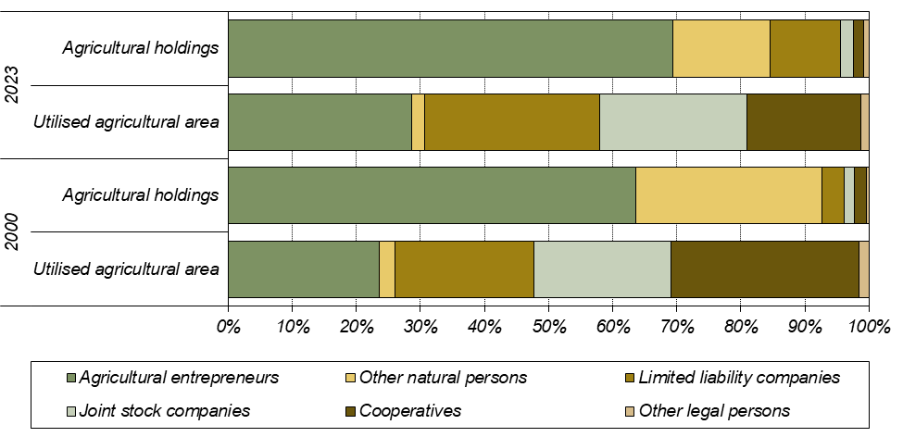

Average agricultural area per holding
The average utilised agricultural area per holding in the period 2000–2023 increased from 93 ha to 106 ha. It grew by 50.0% (from 26 ha to 39 ha) in holdings of natural persons and decreased by 48.8% (from 930 ha to 476 ha) in holdings of legal persons. The most distinct decrease occurred in limited liability companies (−54.5%).

Organic farming
In total 4 798 agricultural holdings dealt with organic farming in 2023. Organic production methods were applied on 537 232 ha of the utilised agricultural area (15.3% of the total UAA). In 2000, there were only 418 holdings involved in organic production and 132 254 ha of the UAA under organic farming. Therefore, the number of holdings dealing with organic farming grew more than eleven times and the utilised agricultural area under organic farming quadrupled.

Table 2: Agricultural holdings involved in organic farming and their utilised agricultural area
 | AGC 2000 |  | IFS 2023 |  | Index  2023/2000  (%)
 | abs. | share (%) | abs. | share (%) | Index  2023/2000  (%)
Agricultural holdings, total | 39 082 | 100.0 | 33 166 | 100.0 | 84.9
of which holdings applying organic methods (certified  or in conversion period) | 418 | 1.1 | 4 798 | 14.5 | 1 147.8
Utilised agricultural area, total (ha) | 3 623 929 | 100.0 | 3 521 180 | 100.0 | 97.2
of which organically utilised area (certified  or in conversion period) (ha) | 132 254 | 3.6 | 537 232 | 15.3 | 406.2

Agricultural land hired and owned
In total 445 agricultural holdings (1.3%) did not possess any agricultural land in 2023. Most holdings with agricultural land farmed on hired land (71.8%), only 28.2% of the utilised agricultural area was owned by holdings. The share of own land decreased with the increasing total UAA: holdings with less than three ha of the UAA kept 78.7% of own land whereas holdings with more than 500–2 000 ha owned only 22.1% of their UAA.
Since 2000, the share of own land in holdings rose; at that time it only achieved 8.0% of the total UAA. The most distinct growth – by 23.1 percentage points – was recorded in the size group 2 000 ha and more.
Own land in holdings of natural persons represented two fifths of their total UAA (42.4%). The smallest share was 37.9% for the size group 50 to 100 ha, holdings above 2 000 ha farmed on own land in 57.4% and the smallest holdings up to 10 ha even in 67.8% of their UAA. On the contrary, holdings of legal persons preferred hiring the agricultural land: their own land represented only 21.9%. Holdings up to 10 ha owned 37.1% of the UAA while holdings with more than 500 ha only 21.6% of the UAA.

Graph 2: Hired and owned land, by legal form
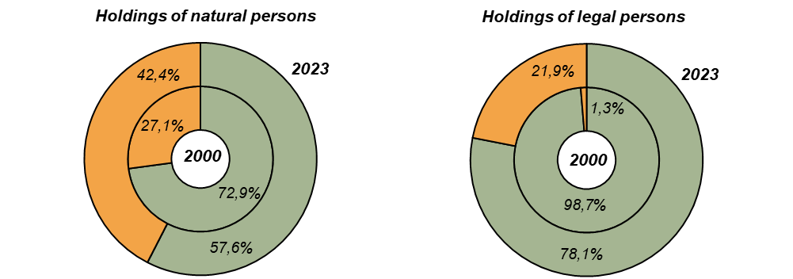

The percentage of hired land distinctly decreased in holdings of both natural and legal persons during the period 2000–2023. This decrease accounted for 15.3 p. p. in natural persons and for 20.6 p. p. for legal persons. The greatest increments of owned land were recorded in holdings of both natural persons and legal persons with 2 000 ha of UAA and more (+56.2% and +22.8 p. p., respectively).

Graph 3: Hired and owned land, by size of holding
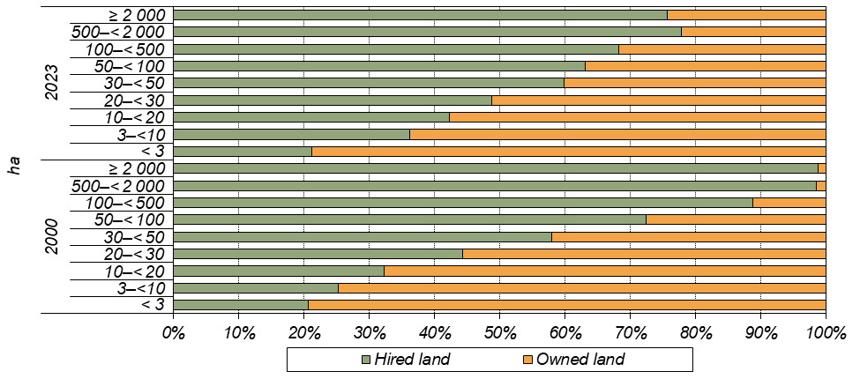
Agricultural land use
In 2023, the utilised agricultural land covered 3 521 180 ha, i.e. 44.6% of the area of the Czech Republic. A loss of 1.3 percentage point occurred since 2000 to the benefit of artificial area or wooded land. Utilised agricultural area went down by 2.8% (i.e. by 102 749 ha) and arable land even by 8.6% (i.e. by 237 425 ha). The share of arable land decreased during the period 2000–2023 by 4.5 p. p. A certain part of arable land was grassed as a result of subsidies provided by the European Union and for this reason the area of permanent grasslands rose since 2000 by 16.8%, i.e. by 138 867 ha. Vineyard area increased by 49.1% while area of orchards decreased by 40.5%.
Arable land covered 71.4% of the total utilised agricultural area and permanent grasslands further 27.4%. Other permanent crops (hop-gardens, vineyards, orchards, nurseries, other permanent crops as e.g. short rotation coppices on UAA) represented only 1.2% share in the UAA. In holdings of natural persons, the share of arable land (59.9%) was distinctly lower than in holdings of legal persons (76.5%), especially in cooperatives (83.2%) and joint stock companies (82.7%). Holdings of natural persons utilised one quarter (25.7%) of arable land in Czechia in 2023; in 2000, it was by 2.3 p. p. less.

Graph 4: Share of arable land, permanent grasslands and permanent crops, by size of holding
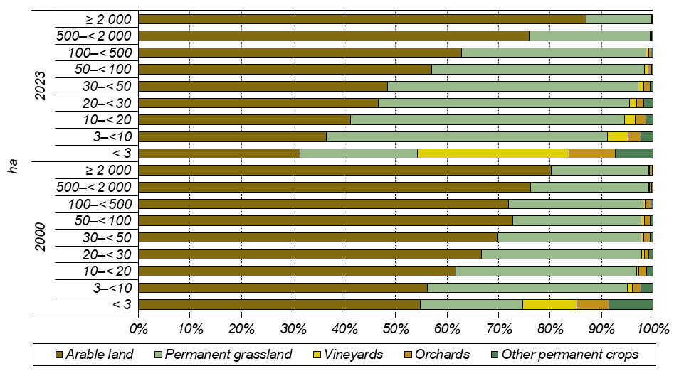

Although permanent crops cover only small portion of arable land, they form a considerable part of the crop production in small-size holdings. In agricultural holdings with less than three ha of the UAA, vineyards comprised 29.5% and orchards 9.1% of their area. The share of vineyards increased significantly by 19.0 p. p. compared to 2000.
On the contrary, large agricultural holdings focused mainly on arable land crops: in the size group of 500 ha of the UAA and more, their arable land covered 79.9% of the UAA in this category in 2023. There has been no significant change here since 2000, when the share was 77.9%. The share of arable land decreased mainly in holdings with their area of up to 50 ha from 63.5% to 44.1%.
The share of permanent grassland increased the most in the size category of 30 to 50 ha during the past 23 years, from 28.0% to 48.7%. The size category of holdings with 2 000 ha and more, which recorded a decrease by 6.2 p. p., was out of the general trend.

Table 3: Agricultural land use, by legal form
 | Year | Agricultural holdings,  total | by legal form
 | Year | Agricultural holdings,  total | Natural  persons,  total | of which agricultural entrepre-neur  – natural person | Legal  persons,  total | of which
 |  |  |  |  |  | Business companies & partner- ships | of which |  | Coopera- tive
 |  |  |  |  |  |  | Limited  liability company | Joint stock company | Coopera- tive
Agricultural holdings | 2023 | 33 166 | 28 037 | 23 008 | 5 129 | 4 364 | 3 643 | 680 | 515
Agricultural holdings | 2000 | 39 082 | 36 198 | 24 880 | 2 884 | 1 998 | 1 351 | 608 | 742
Utilised agricultural  area (ha) | 2023 | 3 521 180 | 1 080 368 | 1 011 342 | 2 440 813 | 1 785 004 | 961 151 | 809 184 | 624 349
Utilised agricultural  area (ha) | 2000 | 3 623 929 | 943 182 | 853 440 | 2 680 746 | 1 578 943 | 783 769 | 779 710 | 1 059 451
Arable land (ha) | 2023 | 2 513 702 | 646 928 | 602 973 | 1 866 774 | 1 329 707 | 649 748 | 669 021 | 519 218
Arable land (ha) | 2000 | 2 751 127 | 646 084 | 589 635 | 2 105 044 | 1 211 140 | 560 624 | 639 891 | 863 287
Hop-gardens (ha) | 2023 | 5 176 | 517 | 488 | 4 659 | 3 636 | 3 049 | 587 | 1 023
Hop-gardens (ha) | 2000 | 6 966 | 1 246 | 1 048 | 5 721 | 3 853 | 2 717 | 977 | 1 788
Vineyards, total (ha) | 2023 | 16 756 | 5 997 | 5 005 | 10 760 | 9 687 | 6 236 | 3 391 | 864
Vineyards, total (ha) | 2000 | 11 240 | 3 510 | 2 234 | 7 729 | 6 031 | 2 518 | 3 267 | 1 349
Orchards (ha) | 2023 | 13 375 | 5 980 | 5 500 | 7 396 | 6 376 | 5 282 | 1 034 | 951
Orchards (ha) | 2000 | 22 489 | 6 419 | 5 479 | 16 070 | 11 156 | 5 317 | 5 707 | 4 581
Permanent grassland, total (ha) | 2023 | 965 143 | 417 365 | 394 250 | 547 778 | 432 626 | 294 475 | 134 555 | 102 006
Permanent grassland, total (ha) | 2000 | 826 276 | 281 726 | 252 141 | 544 550 | 346 019 | 212 192 | 129 535 | 187 930

Organic production methods were applied predominantly on permanent grasslands, which formed 79.2% of the total acreage of organically utilised agricultural area. Out of the total permanent grasslands area, 44.1% were utilised organically. Organic production methods were practised also in fruit orchards (16.9% of their area) while for vineyards it represented 8.7% of their total area and for arable land even only 4.3% of the total area.

Graph 5: Share of land use types in organically utilised agricultural area
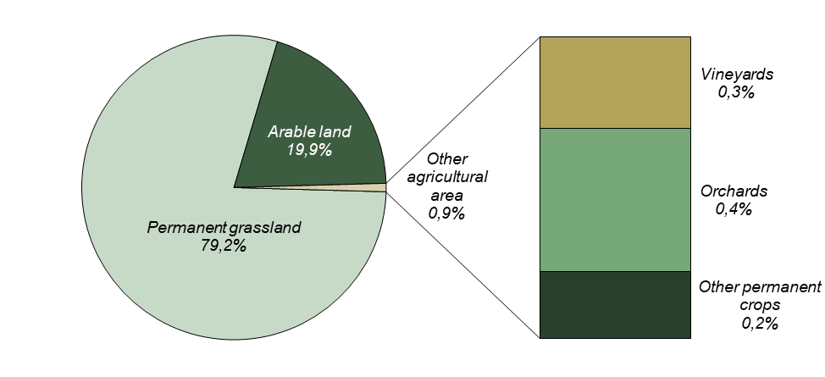

Sown areas
In 2023, agricultural holdings utilised 2 513 702 ha of arable land. Cereals comprised the largest share (52.8%), especially wheat with three fifths (61.7%) of cereals’ area. Another one quarter (24.2%) of cereals’ area was sown with barley. In comparison with 2000, the most remarkable finding is that areas of maize for grain distinctly grew (+64.8%) while rye and barley areas declined by 36.2% and 28.4%, respectively.
Compared to 2000, areas of industrial crops grew by 46.7 thous. ha (+11.0%). Planting of rape contributed the most to this increase as its areas grew by 48.2 thous. ha (+14.7%); in 2000 the rape shared 11.9% of arable land and its share grew by 2023 by 3.1 percentage points. This situation was influenced by a growing demand for rape seed for the production of fatty acid methyl ester – a basic compound of biofuels. Areas of soya grew more than eleven times (+1 246.7%) since 2000 to 26 thous. ha.
On the contrary, potatoes are an example of a crop whose areas declined almost by a half (−46.9%) due to combination of lower consumption and increased import. Distinct declines were recorded also for green fodder on arable land (−21.3%) affected by a decline in cattle numbers.
Shares of arable land crops in particular legal forms were similar with rare exceptions. On the other hand, there are distinct dissimilarities among size groups of holdings. In all types of holdings, growing of cereals is the most frequent production type. However, in holdings of natural persons utilising less than 3 ha of the UAA there was only 47.2% of arable land used for cereals. In size group 3 to 10 ha, it was 59.6% and for larger holdings, it continually slightly decreased from 61.5% for holdings in size group 10 to 20 ha to 51.5% for holdings with more than 2000 ha. Holdings of legal persons up to three ha planted cereals even on only 4.3% of arable land and in higher categories the share rose to more than one half (the largest proportion was 52.6% for the group with 100–500 ha). Growing of root crops and other crops such as pulses, vegetables and strawberries was the domain of small farmers, regardless of their legal form, while industrial crops tended to be the focus of large holdings.

Graph 6: Shares of groups of crops in arable land, by size of holding
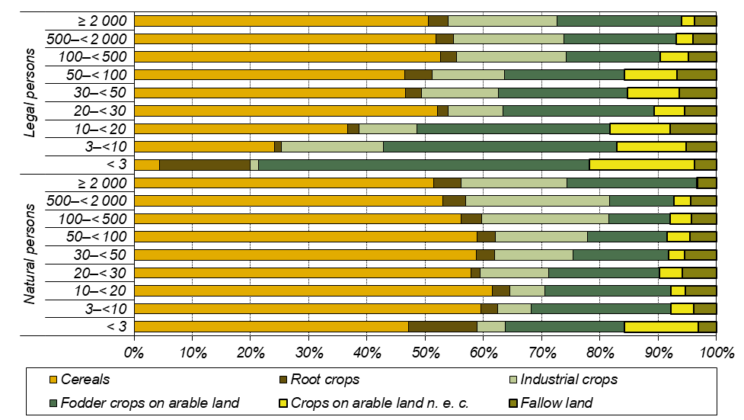

Agricultural holdings without agricultural land
A little group of agricultural holdings (346 holdings of natural persons, i.e. 1.2%; and 99 holdings of legal persons, i.e. 1.9%) did not utilise any agricultural land and specialised in animal production. Compared to 2000, the number of such holdings decreased by a half (−53.5%); the number of holdings of natural persons went down by 52.7% and the number of legal persons by 56.3%.

Table 4: Agricultural holdings without agricultural land
 | Agricultural holdings,  total | by legal form
 | Agricultural holdings,  total | Natural  persons,  total | of which  agricultural entrepre-neur  – natural person | Legal  persons,  total | of which
 |  |  |  |  | Business companies & partner- ships | of which
 |  |  |  |  |  | Limited  liability  company | Joint stock company
Agricultural holdings | 445 | 346 | 172 | 99 | 90 | 73 | 16
Cattle (head) | 8 801 | 2 635 | 1 352 | 6 166 | 6 142 | 4 210 | 1 932
Pigs (head) | 161 316 | 8 785 | 7 562 | 152 531 | 152 114 | 33 806 | 103 712
Poultry (head) | 9 453 624 | 746 443 | 707 586 | 8 707 181 | 8 645 874 | 6 007 914 | 2 637 960
Average number of head per holding without agricultural land
Cattle (head) | 20 | 8 | 8 | 62 | 68 | 58 | 119
Pigs (head) | 363 | 25 | 44 | 1 545 | 1 682 | 462 | 6 374
Poultry (head) | 21 253 | 2 157 | 4 113 | 88 168 | 95 620 | 82 134 | 162 121
Share of legal forms on agricultural holdings without agricultural land (%)
Agricultural holdings | 100.0. | 77.8. | 38.7. | 22.2. | 20.3. | 16.4. | 3.7.
Cattle (head) | 100.0 | 29.9 | 15.4 | 70.1 | 69.8 | 47.8 | 22.0
Pigs (head) | 100.0 | 5.4 | 4.7 | 94.6 | 94.3 | 21.0 | 64.3
Poultry (head) | 100.0 | 7.9 | 7.5 | 92.1 | 91.5 | 63.6 | 27.9
Share on total number of agricultural holdings (%)
Agricultural holdings | 1.3 | 1.2 | 0.7 | 1.9 | 2.1 | 2.0 | 2.4
Cattle (head) | 0.6 | 0.7 | 0.4 | 0.6 | 0.9 | 1.4 | 0.5
Pigs (head) | 11.7 | 12.2 | 14.5 | 11.7 | 12.9 | 17.2 | 10.7
Poultry (head) | 39.5 | 62.5 | 62.3 | 38.3 | 40.4 | 47.4 | 30.2

Although agricultural holdings without agricultural land represent only a negligible group of holdings. they share an important part of animal production. In 2023, these holdings raised two fifths (39.5%) of all poultry and more than a tenth (11.7%) of all pigs.
The largest proportion of livestock in holdings without UAA belonged to holdings of legal persons that kept 94.6% of pigs, 92.1% of poultry, and 70.1% of cattle. In total 64.3% of pigs were raised in joint stock companies without agricultural land. Limited liability companies shared 47.8% of cattle and 63.6% of poultry. Agricultural entrepreneurs without agricultural land kept 15.4% of cattle, 7.5% of poultry, and 4.7% of pigs.

Graph 7: Share of legal forms in agricultural holdings without agricultural land
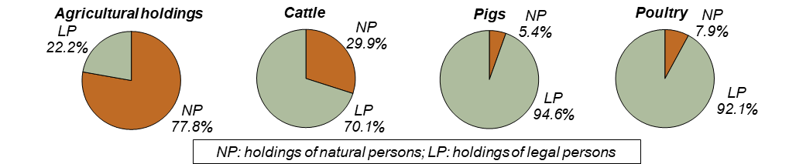

In comparison with 2000, the concentration of poultry in holdings without UAA rose from 13 197 head per holding to 21 253 head per holding while the concentration of pigs plummeted from 758 head per holding to 363 head per holding. The concentration of cattle did not change (20 head per holding).

Livestock numbers
During the period 2000–2023. the number of livestock declined in all principal categories except sheep and goats. The sharpest plummet was recorded for pigs (−60.0%) and less distinct ones for poultry (−20.2%) and cattle (−9.1%). Raising of pigs ceased in 84.3% of holdings, poultry raising in 77.3% of holdings, and cattle raising in 36.2% of holdings. This fact led to increased concentrations of livestock in particular agricultural holdings. On the contrary, increments were recorded during the abovementioned period for sheep by 155.3% and for goats by 122.3%.
However, there were exceptions from abovementioned trends for each livestock category in particular legal forms: they were recorded, for example, for cattle in holdings of natural persons (+21.2%), for poultry in limited liability companies (+62.2%), or for sheep and goats in cooperatives (−48.0% and −56.7%, respectively).

Table 5: Basic characteristics of animal production, by legal form
 | Year | Agricultural holdings.  total | by legal form
 | Year | Agricultural holdings.  total | Natural  persons,  total | of which  agricultural entrepre-neur  – natural person | Legal  persons,  total | of which
 |  |  |  |  |  | Business companies & partner- ships | of which |  | Coopera- tive
 |  |  |  |  |  |  | Limited  liability  company | Joint stock company | Coopera- tive
Agricultural holdings | 2023 | 33 166 | 28 037 | 23 008 | 5 129 | 4 364 | 3 643 | 680 | 515
Agricultural holdings | 2000 | 39 082 | 36 198 | 24 880 | 2 884 | 1 998 | 1 351 | 608 | 742
Cattle (head) | 2023 | 1 415 300 | 370 441 | 346 764 | 1 044 859 | 691 629 | 298 630 | 390 618 | 340 752
Cattle (head) | 2000 | 1 557 408 | 305 619 | 276 333 | 1 251 789 | 658 773 | 263 431 | 389 710 | 574 480
Pigs (head) | 2023 | 1 377 841 | 71 830 | 52 134 | 1 306 011 | 1 178 845 | 196 095 | 968 152 | 120 463
Pigs (head) | 2000 | 3 445 908 | 368 908 | 336 644 | 3 077 000 | 2 116 385 | 611 518 | 1 498 837 | 931 276
Poultry (head) | 2023 | 23 924 229 | 1 194 872 | 1 135 019 | 22 729 357 | 21 407 824 | 12 681 732 | 8 726 049 | 1 278 936
Poultry (head) | 2000 | 29 988 411 | 4 852 839 | 4 170 330 | 25 135 572 | 21 392 765 | 7 817 851 | 13 574 914 | 3 609 453
Sheep (head) | 2023 | 166 888 | 137 614 | 125 961 | 29 275 | 25 110 | 23 081 | 1 653 | 1 608
Sheep (head) | 2000 | 65 365 | 50 274 | 41 959 | 15 091 | 11 851 | 9 587 | 2 046 | 3 094
Goats (head) | 2023 | 22 389 | 16 271 | 13 757 | 6 118 | 5 486 | 5 275 | 209 | 159
Goats (head) | 2000 | 10 073 | 9 293 | 6 875 | 780 | 313 | 302 | 5 | 367

Graph 8: Share of holdings in livestock totals, by legal form
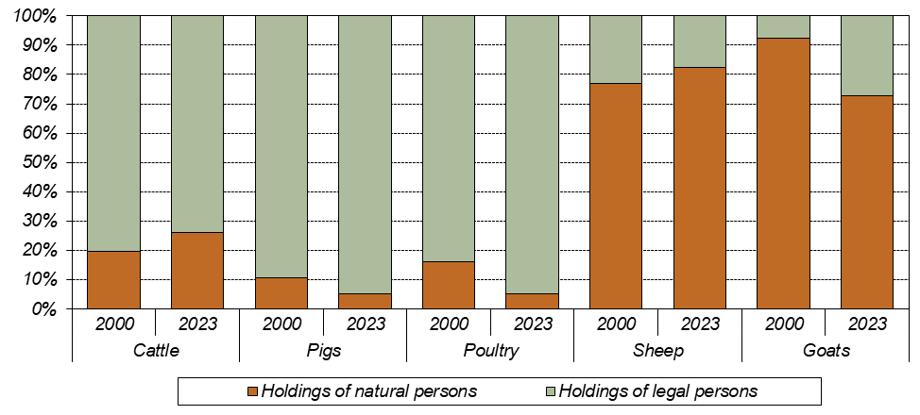

Organic production methods were applied mainly in raising of sheep (29.8% of their total number), and goats (20.8%). In total 14.1% of cattle were ecologically reared; however, it is 40.2% of cows other than dairy ones. Raising of poultry and pigs using organic production methods is negligible (0.3% for poultry and 0.2% for pigs).

Raising of cattle
In 2023, there were 1 415 300 head of cattle reared in 12 902 agricultural holdings. Compared to 2000, the cattle number went down by 9.1% and the number of their breeders by 34.2%. This resulted in increased average number of cattle per holding from 77 head to 110 head. Cattle density declined from 43 head per 100 ha of the UAA to 40 head per 100 ha of the UAA.
Three quarters (73.8%) of cattle were kept in holdings of legal persons; this share was 80.4% in 2000. In holdings of natural persons the number of cattle increased by 21.2% and the average number per holding went up from 17 head to 35 head, while in holdings of legal persons the number of cattle declined by 16.5% and the average number per holding went down from 702 head to 463 head.
The largest share in the number of cattle in holdings of legal persons was represented by joint stock companies (27.6%); cattle numbers in limited liability companies increased by 13.4% since 2000. The overall decline in cattle breeding was caused mainly by the plummet of cattle numbers in cooperatives (−40.7%); as the share of cooperatives in all cattle breeders was 24.1%, this represents a decline by 234 thousand head.
Three fifths (58.4%) of cattle were concentrated in large holdings with more than 500 head. However, there were distinct differences between particular legal forms. Holdings of natural persons reared typically small herds; only 19.2% of them reared more than 50 head. Nevertheless, this share was only 6.0% in 2000. On the contrary, in holdings of legal persons the most typical size category was 101–500 head, present in 35.5% of cattle farms. Compared to 2000, the share of holdings of legal persons having herds up to 100 heads distinctly rose from 10.1% to 32.7%.
In comparison with 2000, the number of cows decreased by 15 441 head to 581 638 head; their share in the total number of cattle rose from 38.3% in 2000 to 41.1% in 2023. Three fifths (59.0%) of cows kept in agricultural holdings in 2023 were dairy cows. In comparison with 2000, the share of dairy cows went down by 24.7 p. p. Raising of dairy cows is influenced by long-term trends in farmers’ milk prices which were not favourable during the period 2000–2023. On the contrary, raising of beef cows was supported by subsidies from both national and European Union sources.

Graph 9: Shares of holdings by legal form in categories by cattle number per holding
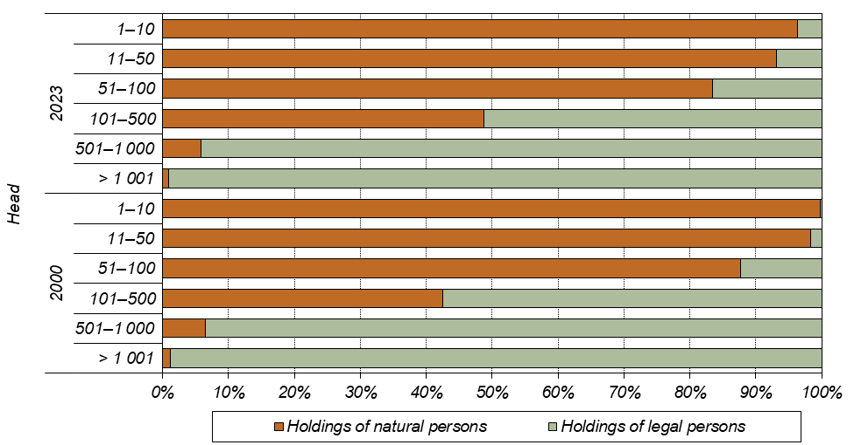

Raising of pigs
In total 1 377 841 pigs were kept in agricultural holdings in 2023; compared with 2000, their number dropped to two fifths (−60.0%). The number of pig farms declined even by 84.3% to 2 696 holdings. The number of head per one holding increased (from 201 head to 511 head) while their livestock density went down since 2000 to less than one half: from 125 head per 100 ha of arable land to only 55 head per 100 ha of arable land.
There were 377 holdings of legal persons raising pigs; since 2000, their number decreased to one quarter (25.6%). They reared 94.8% of all pigs. One holding of legal person reared on average 3 464 head, i.e. by 1 374 head more than in 2000.
Out of 15 681 holdings of natural persons in 2000, only 2 319 did not ceased their activity until 2023. Number of their pigs declined by four fifths (−80.5%) to 71.8 thous. head. Due to a huge plummet in the number of pig farmers, the average number of pigs per one holding rose as well from 24 head to 31 head.
The prevailing way of pig rearing were large piggeries with more than 1 000 head (97.5% of the total number); only 2.0% of pigs were kept in groups of less than 100 head. Groups up to 10 head prevailed (64.9% of farms) among holdings of natural persons while the most frequent size category of holdings of legal persons was that with more than 1 000 head (38.2%). Since 2000, the number of small farms up to 10 pigs declined by 13.2 p. p., but the share of the category with 11 to 50 head rose by 12.5 p. p.

Graph 10: Shares of holdings by legal form in categories by number of pigs per holding
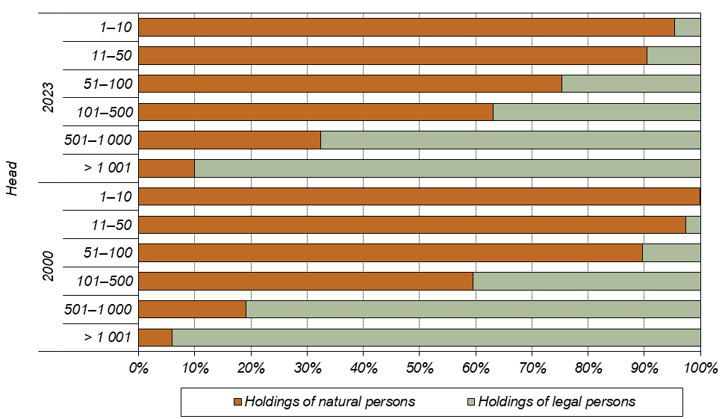

Raising of poultry
In total 4 049 holdings raised almost 24 million head of poultry in the Czech Republic in 2023. Two fifths (39.5%) of poultry were kept in agricultural holdings without utilised agricultural land. Holdings of natural persons prevailed (4 783 farms; i.e. 93.4%), but their share on poultry numbers was only 5.0% of the total number of poultry. The remaining 95.0% of poultry were concentrated in 266 holdings of legal persons.
During the period 2000–2023, the number of poultry decreased by 20.2% and the number of their breeders dropped by 77.3%. The average number per holding rose three and a half times from 1 683 head to 5 909 head per holding. Poultry density went down from 1 090 head per 100 ha of arable land to 952 head per 100 ha of arable land. This decline was caused mainly by reduced number of broilers (−28.7%), while the number of hens increased (+19.6%).
In holdings of natural persons, the decline amounted to 75.4% for poultry totals; it was by 71.5% for hens and by 77.1% for broilers. In holdings of legal persons, the total poultry numbers went down by 9.6% but the number of hens rose by 31.7%. The number of poultry kept in cooperatives plummeted by two thirds (−64.6%) and a decrement by 35.7% was noted in joint stock companies. Limited liability companies, on the contrary, recorded an increase by 62.2% to 12.7 million head.

Graph 11: Raising of poultry, by legal form
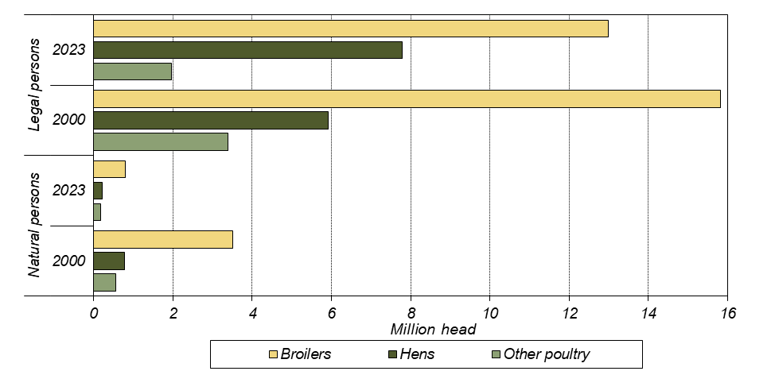

Out of holdings of natural persons, 95.3% raised less than 100 head of poultry while a half (47.7%) of holdings of legal persons had large farms with more than 10 thous. head. The reduction of poultry farming since 2000 influenced all size categories of holdings of natural persons, mainly those with up to 100 head (−78.8% of holdings) and the category with 5–10 thous. head (−75.8% of poultry numbers). As for holdings of legal persons, the largest reduction occurred also in size group of 10–50 thous. head (by 68.8% of holdings and by 61.8% of poultry numbers). On the contrary, the number of small farms up to 100 head rose more than two times (+128.6% of holdings) and their poultry numbers to more than two and a half times (+155.3% of poultry). Although only several tens of holdings are involved, it can be interpreted as a sign of growing interest in poultry raising with respect to animal welfare standards.
The shares of particular poultry categories in the total poultry number did not change much during the period 2000–2023; the share of hens rose to the detriment of broilers. Raising of chickens predominated (91.1%). As for poultry species other than chickens, ducks reached 6.3%, and turkeys 2.1% of total poultry. In 2000, raising of chicken prevailed as well (86.8%); out of other species, turkeys shared 2.9%, and ducks 1.7% of the total poultry numbers.

Raising of sheep and goats
Sheep and goats numbers, in opposite to other livestock categories, recorded an increment since 2000. The number of sheep rose by 155.3% to 166 888 head and the number of goats by 122.3% to 22 389 head. In 2023, there were 4 043 sheep farmers and 1 531 holdings raising goats. While the number of holdings raising sheep went up by 24.9%, the number of goat breeders dropped by 52.1% compared to 2000.
Raising of both sheep and goats was concentrated in holdings of natural persons; they involved 88.0% of sheep farmers and 86.0% of goat farmers and they kept 82.5% of sheep and 72.7% of goats. In comparison with 2000, there is a positive trend in number of these species among holdings of legal persons: their sheep numbers rose almost twofold (from 15 091 to 29 275 head) and goat numbers almost eight times (from 780 to 6 118 head).
Sheep are kept mostly in flocks of 11–50 head. This size category involves a half of farmers (48.4%) and 29.2% of sheep; this concerns especially holdings of natural persons. Among holdings of legal persons, this size group represented the largest share of the holdings as well (42.8%) but more than a quarter (28.0%) of sheep was concentrated in flocks of more than 500 head belonging to only ten holdings (2.1%).

Graph 12: Raising of sheep, by legal form
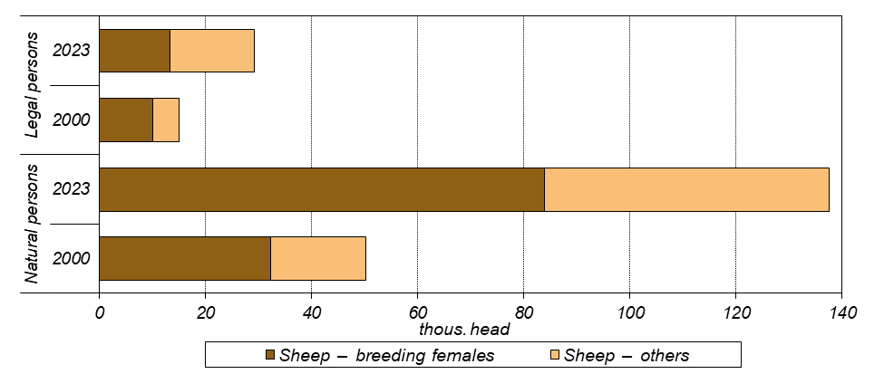
As for raising of goats, size group up to 10 head per holding prevailed in both holdings of natural persons (71.9% of holdings) and legal persons (59.5%). Flocks larger than 50 head belonged to 47 holdings of natural persons (3.6%) and to 28 holdings of legal persons (13.0%).

Graph 13: Raising of goats, by legal form
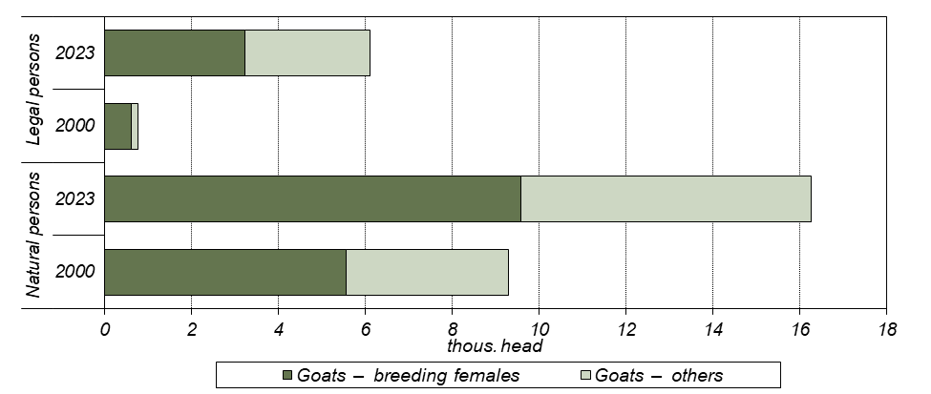

Labour force in agriculture
In 2023, in total 173 306 persons were involved in agricultural work; out of them. 128 045 persons were regularly employed and 41 986 persons irregularly employed (i.e. working on the basis of contract for work or for services). Other 3 276 persons were employed not directly by agricultural holdings; they were either self-employed persons or workers employed by job agencies. Because of high seasonality of some agricultural work. this type of employment is widely utilised by agricultural holdings during work peaks.
Labour force regularly employed in agriculture consisted mainly of employees (including family members of the holder with employment contract), whose share was 54.2%; however, it was 70.9% in 2000. In holdings of natural persons, holders represented 47.7% and members of their families 44.0% of persons regularly employed; in holdings of legal persons. 6.8% of workers were working owners.
During the period 2000–2023, the labour force totals decreased by 68 437 persons, i.e. by 28.3%. This decline was observed mainly in holdings dealing with animal production as the consequence of lowered interest in raising of main livestock species.
In holdings of natural persons, in total 65 258 persons were working in 2023, i.e. by 19.8% less than in 2000. Compared to 2000, there were more family members involved in the farm work instead of employees and persons working on the basis of contracts. While there were 13.2% of employees and 34.6% of holders’ family members in 2000, in 2023 these shares were 7.5% for employees and 43.0% for family members.
Even more distinct decline of labour force occurred in holdings of legal persons during the period 2000–2023. The number of workers decreased almost by a third (−32.6%) to 108 048 persons and the number of workers regularly employed even by 46.6% to 69 256 persons. Agricultural holdings frequently engaged persons working on the basis of contracts or employed by job agencies for short-term activities with high share of manual work (harvest of vegetables. fruits. or potatoes). In 2023, holdings of legal persons engaged 36 541 persons working on the basis of contracts and 2 251 self-employed persons and persons employed by job agencies.

Graph 14: Labour force structure in holdings of natural and legal persons
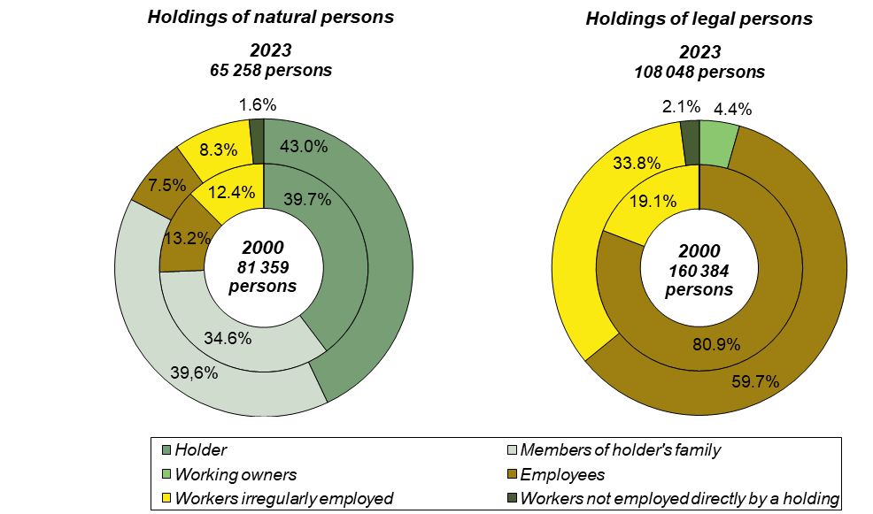

According to standard EU methodology, data on labour force in agricultural sector is expressed in Annual Work Units (AWU). One AWU is the full-time equivalent employment, i.e. the total number of hours worked divided by the average annual number of hours worked in full-time jobs in the country. The annual fund of working hours is set at 1 800 hours in the Czech Republic and is based on the number of working days with 8 working hours a day minus minimum statutory claim for holiday and minus the average number of hours not worked for incapacity for work.
Expressed in Annual Work Units, the labour force number in 2023 was 95 174 AWU, i.e. 54.9% share in the total number of working persons. In 2000, this value accounted for 174 262 AWU (i.e. there was a decline by 45.4% by 2023) and 72.1% share in the working persons total. The decrease of the ratio between the number of persons and AWU shows increasing share of utilisation of part-time and temporary jobs in agricultural holdings. It was more frequent in holdings of natural persons, where the share after recalculation was 48.3% (31 550 AWU) while in holdings of legal persons the share was 58.9% (63 624 AWU).
The share of women in the total number of labour force regularly employed increased from 27.3% to 32.9%. In 2023, the share of women in holdings of natural persons was slightly lower (30.8%) than in holdings of legal persons (34.7%).

Workers per 100 hectares of UAA
From 2000 to 2023, the average number of workers per 100 ha of utilised agricultural area (computed only for holdings with UAA) has decreased by almost a quarter (-24.5%) from 6.4 to 4.8 persons per 100 ha. In holdings of natural persons, there was a decrease from 8.5 to 6.0 persons per 100 ha; in holdings of legal persons, it fell from 5.7 to 4.3 persons per 100 ha.
The recalculated number of workers per 100 ha of UAA is approximately inversely proportional to the size of the agricultural holding. In holdings with up to 5 ha of UAA, the average number of workers per 100 ha in 2023 was 154.0 persons, which is by 48.0 persons more than in 2000; this category involves mainly holdings dealing with production of highly labour-intensive commodities as vegetables, fruit, or grapes. In holdings with 5 to 10 ha, the numbers were only 36.1 and 32.0 in 2023 and 2000, respectively. For holdings larger than 2 000 ha, 3.4 workers per 100 ha of agricultural land were sufficient, by 1.8 less than in 2000. In 2023. 2.7% of persons worked in entities without agricultural land, compared with 3.6% in 2000. From 2000 to 2023, the share of workers in holdings by size group decreased the most in the largest holdings over 2 000 ha, by 9.9 p. p to 15.3%, followed by holdings with 1 000 to 2 000 ha having a decrease of 3.9 p. p. to 16.4%. The largest increase of this share occurred in holdings with 100-500 ha, by 5.5 p. p. to 14.0%.
A similar trend as for absolute numbers of workers can be observed after converting the workforce into Annual Work Units (AWU). A comparison of the ratios between the number of persons and the number of AWU in each size group shows that part-time and occasional employment is more common in smaller holdings. However, in all size categories, there has been a decrease in this ratio, i.e. an increase in the proportion of part-time jobs from 2000 to 2023, with the smallest decrease in the size group of 5 to 10 ha (-8.0 p. p.) and the largest decrease in the size group of 500 to 1 000 ha (-20.1 p. p.).

Table 6: Workers per 100 ha of the utilised agricultural area in agricultural holdings by size group
 | Total  in holdings with UAA | size group of the utilised agricultural area (ha)
 | Total  in holdings with UAA | >0 –  < 5 | 5–  <10 | 10–  < 50 | 50–  < 100 | 100–  < 500 | 500–  < 1 000 | 1 000–  < 2 000 | ≥ 2 000
persons
2023 | 4.8 | 154.0 | 36.1 | 10.7 | 4.3 | 3.0 | 3.1 | 3.5 | 3.4
2000 | 6.4 | 106.0 | 32.0 | 13.0 | 6.6 | 4.6 | 4.2 | 4.7 | 5.2
Index 2023/2000 (%) | 74.5 | 145.3 | 112.6 | 82.8 | 65.2 | 64.2 | 72.9 | 74.8 | 65.5
AWU
2023 | 2.6 | 58.8 | 16.2 | 5.3 | 2.6 | 1.7 | 1.8 | 2.2 | 2.2
2000 | 4.6 | 49.7 | 16.9 | 8.0 | 4.6 | 3.2 | 3.3 | 3.8 | 4.3
Index 2023/2000 (%) | 57.1 | 118.3 | 95.6 | 66.5 | 55.6 | 53.0 | 54.3 | 57.3 | 51.3
AWU/person (%)
2023 | 55.1 | 38.2 | 44.9 | 49.6 | 59.2 | 56.9 | 58.9 | 62.7 | 65.2
2000 | 71.9 | 46.9 | 52.8 | 61.8 | 69.4 | 68.8 | 79.0 | 81.7 | 83.3
Difference (p. p.) | -16.8 | -8.7 | -8.0 | -12.2 | -10.2 | -12.,0 | -20.1 | -19.1 | -18.1

Managers of agricultural holdings
Four fifths (81.8%) of the managers of Czech agricultural holdings are males. There is little difference between legal forms in this respect: females manage 18.6% of holdings of natural persons and 15.5% of holdings of legal persons. In 98.4% of holdings of natural persons, the manager is the owner of the holding.
Holdings of natural and legal persons differ significantly in the educational background of their agricultural managers. While 51.3% of holdings of natural persons are headed by persons with only practical experience (49.5% of males and 59.0% of females), holdings of legal persons are mainly headed by persons with secondary and higher education in agriculture (63.9%; 65.3% of males and 56.0% of females). Nearly two fifths (38.6%) of the managers of natural persons and almost three fifths (57.9%) of the managers of legal persons had received further training in the 12 months prior to the survey date.
The age structure of agricultural managers is not very favourable. Only 11.6 % of the heads of natural persons and 8.4 % of the heads of legal persons are under 34 years of age. By contrast, 42.8% of natural persons and 38.5% of legal persons are headed by a person aged 55 or over. The age structure of females is slightly more favourable than that of males: 13.3% of natural persons and 11.9% of legal persons are headed by females aged under 34, while females aged over 55 are in charge of 39.8% of natural persons and 28.6% of legal persons. Males aged under 34 years manage 11.1% and these aged 55 and over 42.2% of natural persons, while in legal persons, the ratio is 8.4% for males aged 34 and under and 42.8% for males aged 55 and over.

Graph 15: Age structure of managers
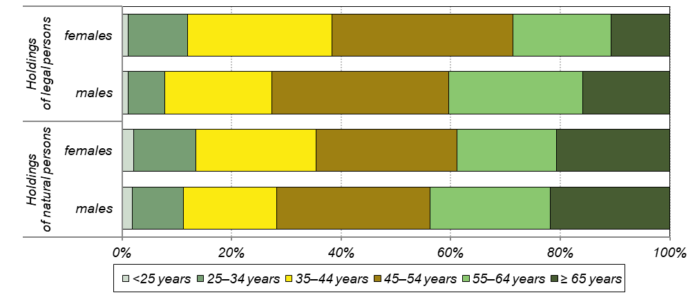

In holdings of natural person, male managers are most often represented by those who have held their managerial position for 26 years or more (33.1%). while the largest proportion of female managers have held their position for less than 5 years (23.0%). In case of legal persons, managers who have held their position for less than 5 years dominated both for males (32.0%) and females (37.0%).

Machinery and equipment in agriculture
The Integrated Farm Survey 2023 included also questions on farm machinery and equipment, both owned and rented. The survey showed that a total of 24 845 farms (74.9% of all farms) owned 77 650 tractors. Of these, 9 246 tractors with a power of up 40 kW inclusive were owned by 6 889 holdings (20.8% of all holdings), 11 260 agricultural holdings (34.0% of all holdings) owned 21 095 tractors with a power over 40 kW to 60 kW inclusive, and 13 231 holdings (39.9% of all holdings) owned 24 445 tractors with their power over 60 kW to 100 kW inclusive. There were 22 863 tractors over 100 kW, owned by 8 830 farms (26.6% of all holdings). Ownership of soil tillage machinery was also surveyed, with a total of 16 179 farms owning (48.8% of all holdings) a total of 50 020 pieces of machinery. A total of 11 928 agricultural holdings (36.0% of all holdings) owned 18 078 seeders and planters. Spreaders, pulverisators or sprayers for fertilisers were owned by 12 272 holdings (37.0 % of all holdings), representing 23 534 units. The number of combine harvesters accounted for 8 742 pieces owned by 6 961 farms (21.0% of all holdings). The last item surveyed were other fully mechanised harvesters, of which there were a total of 12 238 pieces, owned by 6 372 farms (19.2% of all holdings).
A certain part of agricultural holdings use hired machinery. 7 517 farms (22.7% of all holdings) hired tractors. In total 8 626 holdings hired cultivators, ploughs, seeders, pulverisators, sprayers or equipment for application of plant protection products or fertilisers (26.0% of all holdings). A total of 8 617 farms (26.0% of all holdings) hired combine harvesters. Other fully mechanised harvesters were hired by a total of 7 014 holdings (21.1% of all holdings).
A total of 25 999 agricultural holdings owned one or more type of mechanisation (78.4% of the total number of holdings surveyed), of which 22 054 were natural persons (78.7% of all natural persons) and 3 945 were legal persons (76.9% of all legal persons). A total of 16 968 agricultural holdings (51.2% of all surveyed holdings) rented some type of machinery. Of these, 13 832 were natural persons (49.3% of all natural persons) and 3 135 were legal persons (61.1% of all legal persons).
A total of 7 919 farms (23.9% of all holdings) used equipment for the application of plant protection products. 6 137 holdings (18.5% of all holdings) used equipment fully equipped with low-risk nozzles, 627 holdings (1.9% of all holdings) used equipment partially equipped with low-risk nozzles and 1 154 holdings (3.5% of all holdings) used equipment not equipped with low-risk nozzles.

Smart technologies in agriculture
Another new set of questions focused on precise farming machinery and equipment and smart technologies in livestock farming. One or more type of such technology was used by 3 879 holdings, i.e. 11.7% of all surveyed holdings. Smart technologies were used by 2 175 natural persons (7.8% of all natural persons) and 1 704 legal persons (33.2% of all legal persons).
Of the machinery and equipment for precise farming, robotics was the most used one, with a total of 1 126 holdings (3.4% of all holdings), of which 280 holdings (0.8% of all holdings) used robotics for plant protection products. A total of 252 subjects (0.8% of all subjects) used equipment for band spraying of plant protection products. Variable rate techniques was used by 1 096 holdings (3.3% of all holdings). 580 holdings (1.7% of all holdings) used precision equipment for monitoring of crop. 443 holdings (1.3% of all holdings) used equipment for soil analysis. A total of 911 holdings (2.7% of all holdings) used equipment for welfare and health monitoring of animals. Using grinder mixers for animal feeding was the most frequent technology in livestock farming, used by 2 310 holdings (7.0% of all holdings). Automatic feeding systems were used by 592 holdings (1.8% of all holdings). In total 725 holdings (2.2% of all holdings) used equipment for automatic regulation of barn climate. A total of 257 holdings (0.8% of all holdings) use milking robots.

Graph 16: Using of smart technologies in agriculture
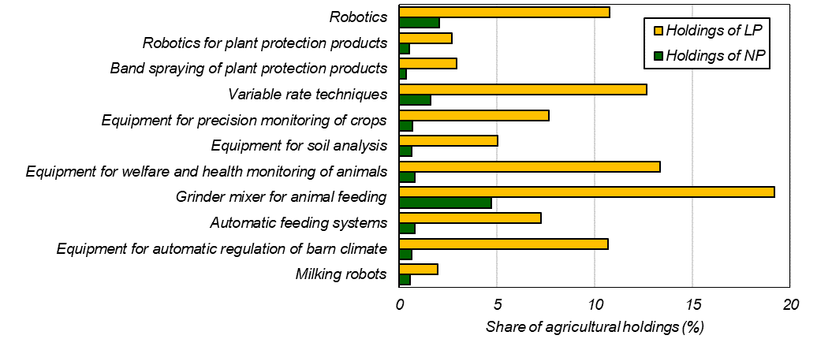

Robotics was the precision farming equipment used by natural persons the most, with a total of 573 agricultural holdings (2.0% of all individuals) using it. Legal holdings used variable rate techniques the most, with a total of 650 agricultural holdings (12.7% of all legal holdings) possessing this technology.
The most widespread advanced technology in livestock farming in holdings of natural persons were grinder mixers for animal feeding, used by a total of 1 325 farms (4.7% of all individuals). For legal holdings, grinder mixer for animal feeding were also used the most, with 985 agricultural holdings (19.2% of all legal holdings).
A total of 31 028 farms (93.6% of all holdings) had access to the internet. In addition, 4 232 holdings (12.8% of all holdings) used management information systems. An Access to the internet was available for 26 029 natural persons (92.8% of all natural persons) and 4 999 legal persons (97.5 % of all legal persons)

Equipment for the production of energy from renewable sources
Another topic addressed by the Integrated Farm Survey 2023 was the operation of renewable energy production facilities. A total of 31 884 farms (96.1% of all holdings) reported that they did not use any equipment for renewable energy production. 1 282 holdings (3.9% of all holdings), on the other hand, reported that they used one or more facilities. Wind power was a source used the least, with only 9 holdings using it (0.03% of all holdings). A total of 316 holdings (1.0% of all holdings) used biomass for energy production and 221 holdings (0.7% of all holdings) used biogas from biomass. Solar radiation was used for thermal energy production by 146 holdings (0.4% of all holdings). Solar radiation for electricity generation is the most used renewable energy source, with 820 agricultural holdings using these facilities (2.5% of all holdings). Hydroelectric power generation was used by 35 holdings (0.1% of all holdings). The remaining 57 holdings (0.2% of all holdings) used other types of renewable energy sources.
Renewable energy production facilities were used by 651 natural persons (2.3% of all natural persons) and 631 legal persons (12.3% of all legal persons). The most represented way of renewable energy production was production of electricity from solar radiation. Such equipment was operated by 472 natural persons (1.7% of all natural persons) and by 348 legal persons (6.8% of all legal persons).

Graph 17: Equipment for the production of energy from renewable sources
