The Czech Economy Development in the First Half of 2012 September 2012

External economic relations
- Half year surplus on the current account for the first time since 2006 |  | In 2011, the half year results of the balance of payments current account recorded for the first time since 2006 a surplus for this period – the balance as a result of a low deficit in Q2 (-6.6 billion CZK) remained positive in the amount of CZK 16.3 billion. Also the financial account recorded a surplus, and therefore the external economic relationships of the Czech Republic in aggregate have seen a positive development in this period. The surplus of the current account represented 0.9% of nominal GDP (in the first half of 2011 the deficit stood at 1.8% GDP).
- Strong trade balance and more positive income balance … |  | Despite the worsening of the balance of services and current transfers balance, it has not influenced the very positive result of the current account of the balance of payments. The output related balance – as a result of a strong trade balance – was CZK 30billion better than in the same period in 2010 and 2011. However, this time, the balance of income have shaped less negatively with a deficit of CZK 32 billion less than in the first half of 2011. The outflow of income from the Czech Republic in Q2 was the lowest since 2006, also in net terms (as a result of the paid dividend Q2 is usually the strongest with regard to repatriated profits and in the last eight years, only 2010 was an exception). Q2 2012 thus influenced even the half year result with the outflow of yields in the amount of CZK 164 billion, representing in net terms CZK 108 billion (in the first half of 2011 it represented the outflow of CZK 188 billion and 140 billion respectively).
- … and easily eliminated the worsening of balance of services and current transfers |  | The result of current transfers was worse by almost CZK 12 billion than in the half year of 2011 due to lower payments from European funds. The surplus of the balance of services declined year on year by CZK 8.5 billion to 26 billion. Despite the fact that the income from transport services and tourism rose year on year more significantly than in the same period in 2011, they were not sufficient to cover the slump regarding other services. These grew year on year only by CZK 0.4 billion, while this figure stood at the half year mark of 2011 at 8.5 billion.  The growth of transport expenditure was year on year significantly lower, as well as in active tourism, for which economic recession may be responsible. The half year worsening of the balance of services was caused, however, by a sharp surge in expenses for all other services by CZK 17.1 billion against a mere +2.8 billion in the same period of 2011. According to the available data for Q1, significant growths were recorded by costs for hedging and particularly the component “Profitable operations and other services” connected with goods. Advertising expenditure declined.
- Another slowdown in import and export of goods |  | The weakening pace of imports given by lower domestic demand for imported goods was responsible for an increased surplus of the trade balance – against the first half of 2011 by CZK 38 billion. The value of exports of goods exceeded the value of imports by CZK 101.4 billion, with a single digit growth rate which was last notable in Q1 2010. The slowdown of foreign trade has deepened in Q2 (with exports at +6.8%, and imports at +4%) when their dynamics worsened already in Q1 (exports +11.1%, imports +8.2%).
- In Q2, particularly exports of cyclical industries weakened significantly |  | Exports of machinery and transport vehicles contributed to total exports in the first half by 49.3% (against the same period of 2011 the share increased by 0.4 p.p.). In Q2, this share slightly decreased as opposed to imports, where the share of machinery and transport vehicles in total imports rose in Q2 and at the half year mark represented 35.6% of total imports in the Czech Republic. The half year balance has worsened year on year only with regard to trading with mineral fuels, chemical products and commodities of the SITC classification group 9 (not classified).  Exports of foodstuffs (+19% against the half year of 2011), mineral fuels (+16%) and beverages and tobacco (+13%) recorded the fastest growth, in all cases much more significantly than their imports. However, a full four fifths of exports from the Czech Republic are permanently reserved for exports of machinery and transport vehicles, industrial consumer goods and the component “Marketable goods classified according to material”.  The export of production of cyclical character recorded a significant drop, particularly in Q2 when exports of cars posted a year on year increase by 9.2%, but in Q1 by 17.3%. An even more significant drop in the pace, by approximately two thirds, was recorded by metallurgy – exports of metals grew in Q1 2012 in a year on year comparison by 12.2%, but in Q2 only by 4.3% (similar to exports of metal-working products from +12.8% to 4.6%). Apart from weak domestic demand influencing the dynamics of imports, the worsened foreign demand was reflected into the slowdown of the pace of exports.
- Reduction of financial account surplus caused by transactions of commercial banks under “Other investment” |  | The surplus on the financial account of the balance of payments in the amount of CZK 14.2 billion achieved in comparison with the same period in 2011 (CZK 58.5 billion) only 25% of last year’s figure. At the same time, the inflow of direct foreign investment in the Czech Republic did not record any significant drop (CZK 59.8 billion against 64.4 billion in the half year of 2011). Net portfolio investment have even shown significant progress when foreign financial investors purchased four times more bonds than a year ago and cash outflow from the country in investment of domestic portfolio investors was lower. However, as opposed to bonds, there was mutually less activity with regard to stock transactions. On the whole, portfolio investment reported an inflow of cash into the country in the amount of CZK 40.3 billion, while at the half year mark of 2011, the aggregate result posted an outflow of portfolio investment from the Czech Republic (CZK -10.5 billion).  The year on year decrease in the surplus on financial account was therefore caused by the “Other investment” item, particularly by commercial banks. In particular, their short term active transactions under this item ensured the inflow of cash into the country at the half year mark of 2011 (CZK 70 billion), but at the half year mark of 2012 they resulted in their outflow in the amount of CZK 50 billion. This outflow occurred mostly in Q1 (CZK -44 billion).
- According to half-year averages the Czech koruna weakened |  | On average, the exchange rate of CZK towards major currencies weakened in the first half of the year by 3.25% to an average CZK/EUR 25.20 and by 8.12% to an average CZK/USD 19.34. At the same time, a steady strengthening of the Czech currency was apparent from January to April, then the currency weakened, and more significantly in case of CZK/USD. The Czech koruna may have possibly responded to worsening fundamentals in the Czech economy.
Chart No. 9 | Change in the balance of current account components (in million CZK, the first half of 2011 and 2012) |  | Chart No. 10 | Financial Account (FDO, in million CZK)
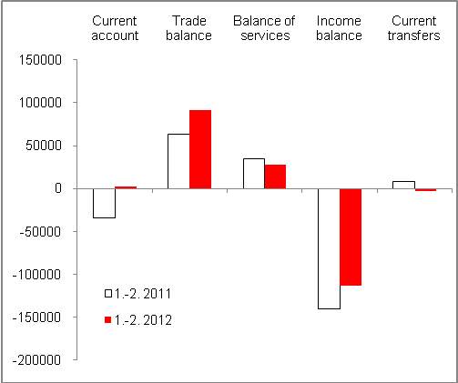 |  |  | 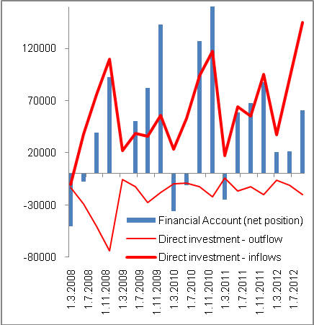
Source: ČNB

National approach (under the principle of the change in ownership), exports in FOB prices, imports in CIF prices.

