13 May 2024

Development of international trade in goods price indices in the Q1 2024

In the Q1 2024, compared to the Q4 2023, export prices increased by 1.7%. In the year-on-year (y-o-y) comparison, export prices increased by 0.7% in the Q1 2024. Import prices increased by 0.1% in the Q1 2024 compared to the Q4 2023. In the y-o-y comparison, import prices decreased by 1.7% in the Q1 2024. The terms of trade reached the value of 101.6% in the Q1 2024 compared to the Q4 2023. In the year-on-year comparison, the terms of trade reached the value of 102.5% in the Q1 2024.

**Export prices**

**Quarter-on-quarter** (q-o-q; in the Q1 2024 compared to the Q4 2023), they increased by 1.7%. The following increased the most: prices of waste collection, treatment and disposal services; materials recovery services by 10.1%, furniture by 8.3%, and products of forestry, logging and related services by 8.2%. The most considerable decreases were in prices of electricity, gas, steam and air conditioning by 11.1%, leather and related products by 4.0%, textiles by 2.1%, and products of agriculture, hunting and related services by 2.0%.

**Year-on-year**, in the Q1 2024, they increased by 0.7% (in the Q4 2023 they decreased by 2.2%). Prices of the following considerably increased: other transport equipment by 17.1%, furniture by 14.1%, and prices of motor vehicles, trailers and semi-trailers by 8.3%. Mainly prices of the following decreased: electricity, gas, steam and air conditioning by 29.1%, products of forestry, logging and related services by 15.5%, and products of agriculture, hunting and related services by 15.2%.

**Import prices**

**Quarter-on-quarter** (in the Q1 2024 compared to the Q4 2023), they increased by 0.1%. The following increased the most: prices of other manufactured goods by 3.2%, machinery and equipment n.e.c. by 3.1%, beverages by 3.0%, and food products by 2.9%. Mainly the following prices decreased: electricity, gas, steam and air conditioning by 16.2%, crude petroleum and natural gas by 6.9%, and prices of leather and related products by 5.1%.

**Year-on-year**, in the Q1 2024, they decreased by 1.7% (in the Q4 2023 by 6.1%). The biggest price decreases were in electricity, gas, steam and air conditioning by 38.4%, crude petroleum and natural gas by 21.8%, paper and paper products by 8.6%, and prices of chemicals and chemical products by 7.6%. Significant price increases were in other transport equipment by 12.1%, motor vehicles, trailers and semi-trailers by 6.5%, and prices of beverages by 5.7%.

**The terms of trade**

**Quarter-on-quarter** (in the Q1 2024 compared to the Q4 2023), they reached the value of 101.6%. A significant positive value was reached by electricity, gas, steam and air conditioning (106.1%), a negative value by fabricated metal products, except machinery and equipment (98.6%).

**Year-on-year**, in the Q1 2024, they increased to the value of 102.5% (in the Q4 2023 the value was 104.2%) and for the fifth quarter they remained in the positive values – see the Chart No 2. A significant positive value was recorded by electricity, gas, steam and air conditioning (115.1%) and a negative value by fabricated metal products, except machinery and equipment (94.5%).

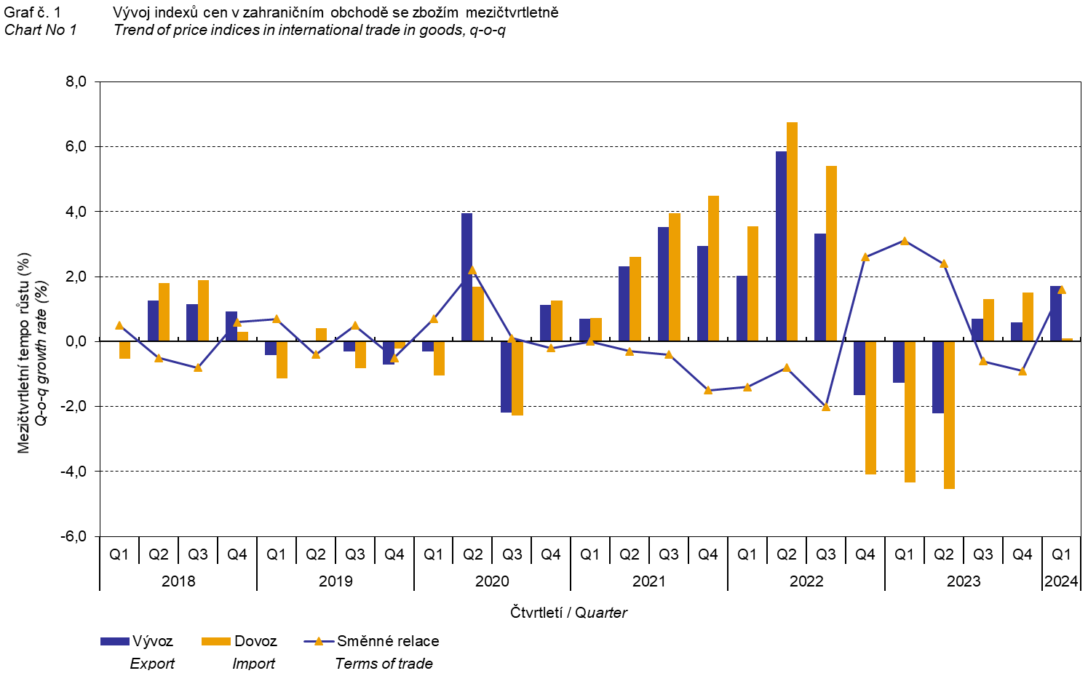

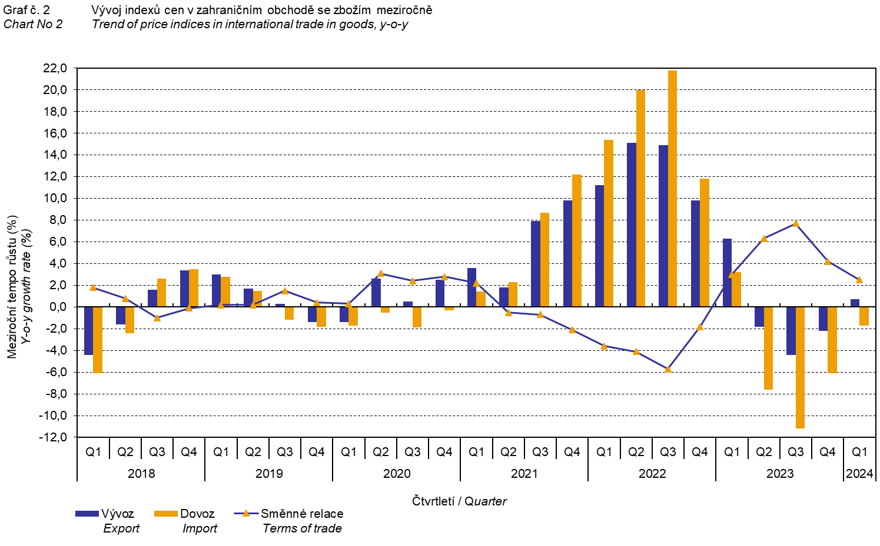

The international trade in goods (change of ownership) price development was also significantly influenced by the CZK exchange rate to the major foreign currencies. All monitored foreign currencies have been included in the **quarter-on-quarter** **exchange rate** **index**. Q-o-q indices of the CZK exchange rate to these currencies were weighted by the respective weight, which pertains to those foreign currencies in the export price index and in the import price index (before the Q3 2023, only two most important currencies, i.e. EUR and USD, have been included; as of the Q3 2023, the calculation was refined by inclusion of all currencies and it was calculated backwards to the year 2021).

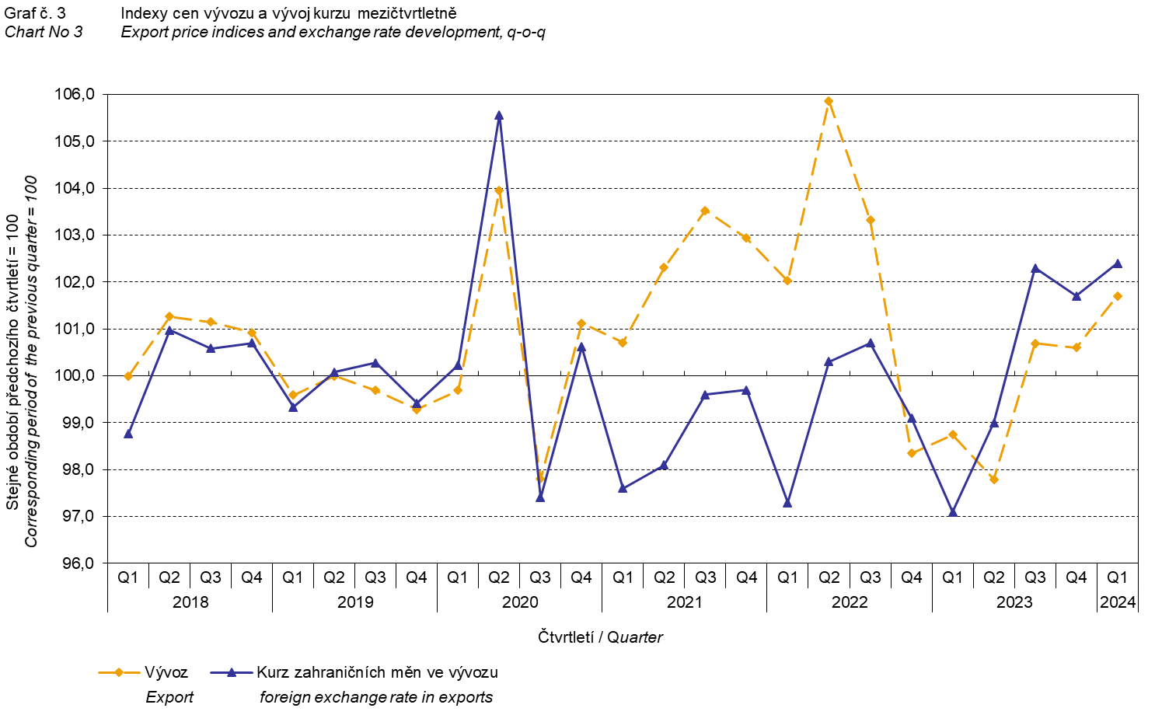

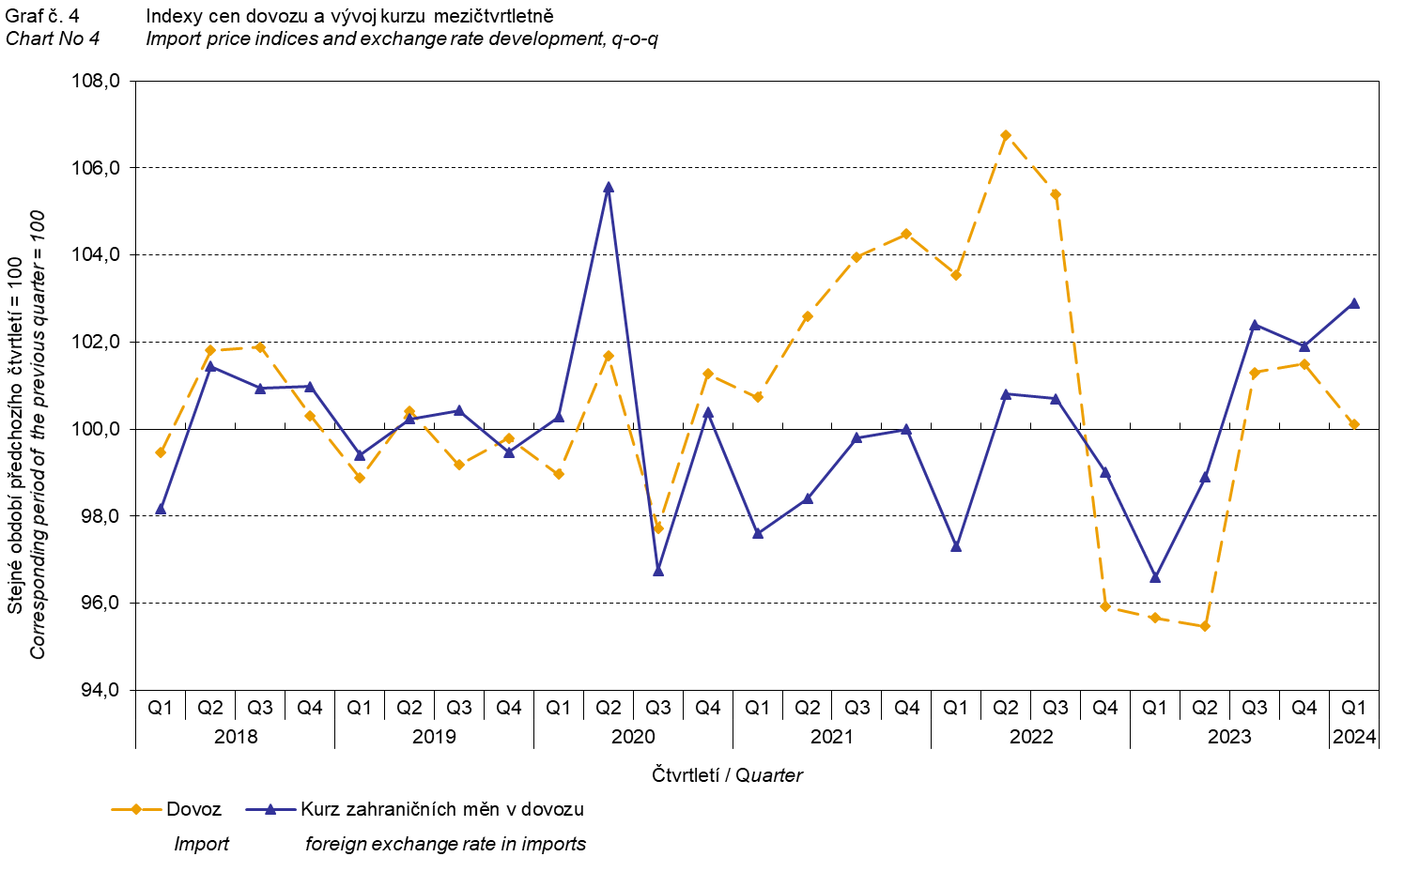

It is apparent from the Chart No 3 and the Chart No 4 above that in both exports and imports, international trade in goods prices have a relation to exchange rate effects. Contracts with foreign entities are usually concluded for a longer period of time and the longer the contract period is, the stronger the relation to exchange rates is.

# International trade in goods price indices, year-on-year, adjusted for exchange rate influence

The Czech Statistical Office (CZSO) also calculates year-on-year international trade in goods price indices adjusted for exchange rate effects. It is carried out as follows: prices in foreign currencies reported in the current month are **converted** to Czech crowns **by the exchange rate** of the same month **of the previous year**. Afterwards, they are used for the weighted mean calculation together with prices reported in CZK. This exchange rate adjusted base price index of a month is related to the non-adjusted base price index of the corresponding month of the previous year and thus the year-on-year adjusted price index for a month is calculated.

Since 2017, adjusted quarter-on-quarter price indices have been calculated similarly, too. **Differences between adjusted and non-adjusted price indices may be considerable**. They are obvious in the Chart No 6 and the Chart No 7, for example, in the Q1 2018 and in the Q2 2021.

The method employed does not enable to make a 100% exchange rate adjustment because not all trade transactions made in foreign currencies are also reported in foreign currencies; the proportion does not exceed 30%. From the aforementioned it follows that **at the full exchange rate adjustment, differences** between the published price indices and the exchange rate adjusted price indices **would** probably further **increase**.

The exchange rate adjusted indices described above can also be used to make the exchange rate adjusted breakdown of increments of price indices. The Table 1 gives the **published and exchange rate adjusted breakdown of increments** of export and import price indices. The breakdown illustrates well how many percentage points each of the groups “exchange rate contributed” to the index.

# It is generally true that the exchange rate effect decreases the value of price indices in international trade in goods if CZK is strengthening to foreign currencies in total. Conversely, the exchange rate effect pushes the price indices up if CZK is weakening to foreign currencies in total.

The Chart No 5 below illustrates the CZK exchange rate to the two most important foreign currencies, i.e. to EUR and USD.

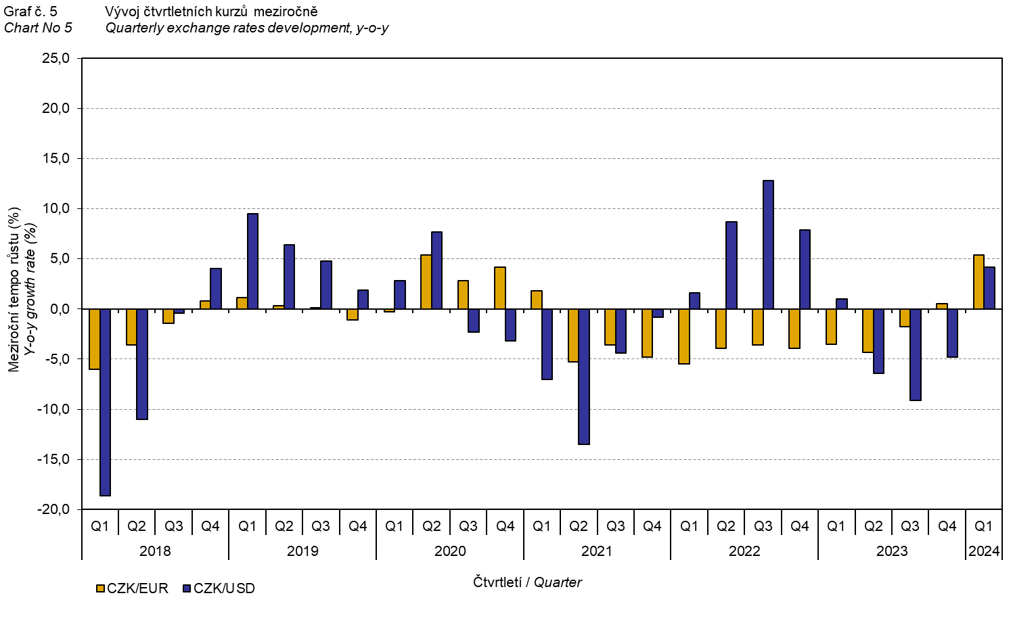

It is apparent from the Chart No 6 and the Chart No 7 below how significant the exchange rate influence of all monitored foreign currencies on the value of the export and import price indices was.

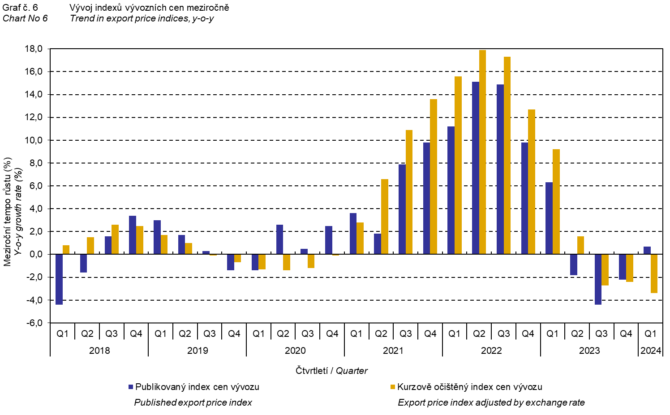

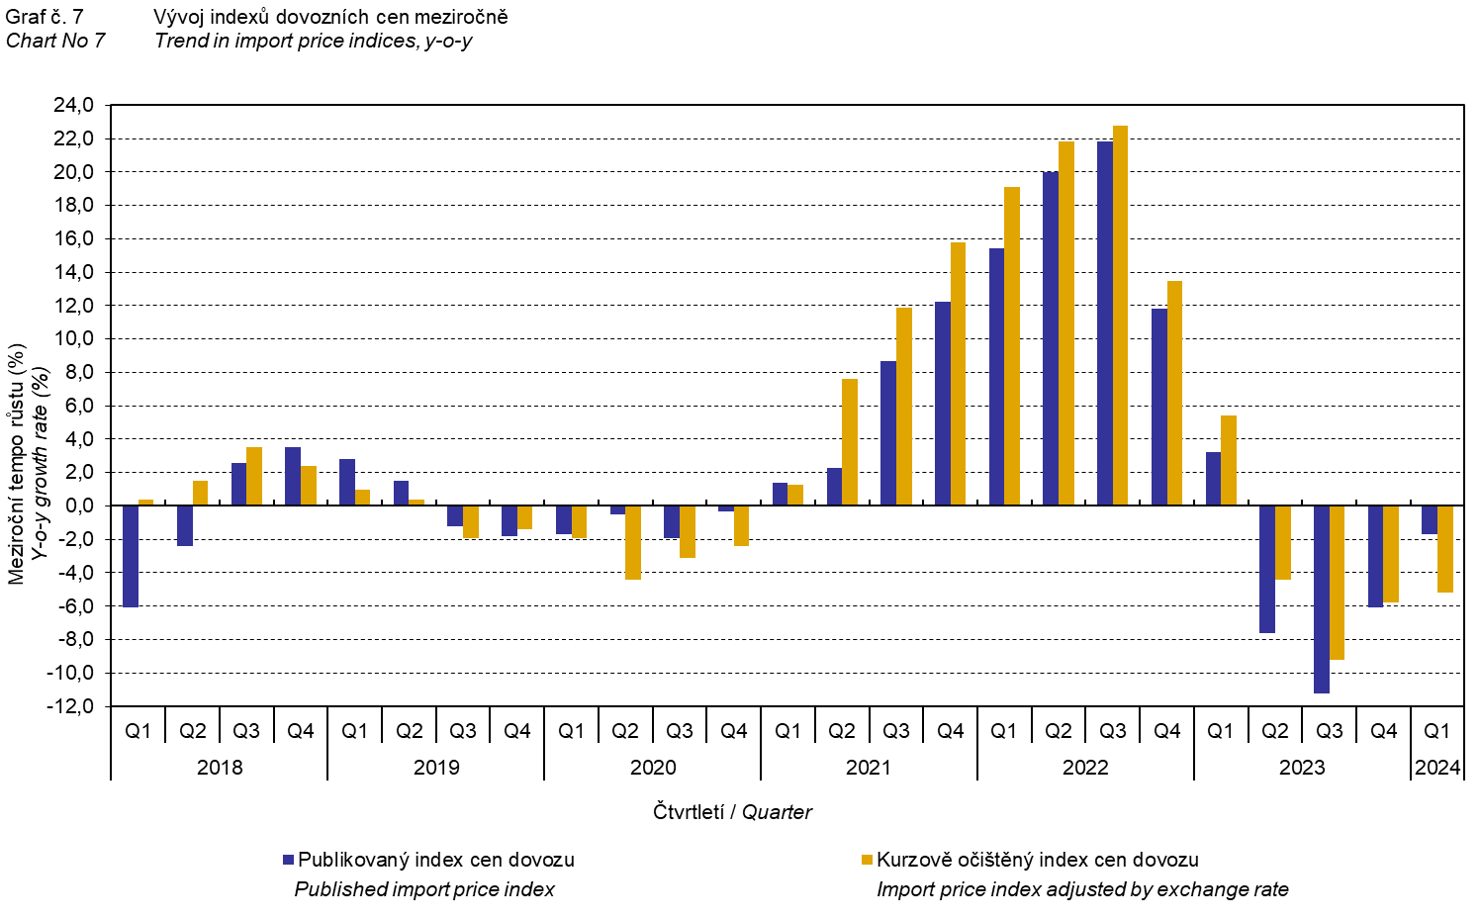

The Chart No 8 shows the exchange rate influence on the value of the year-on-year terms of trade.

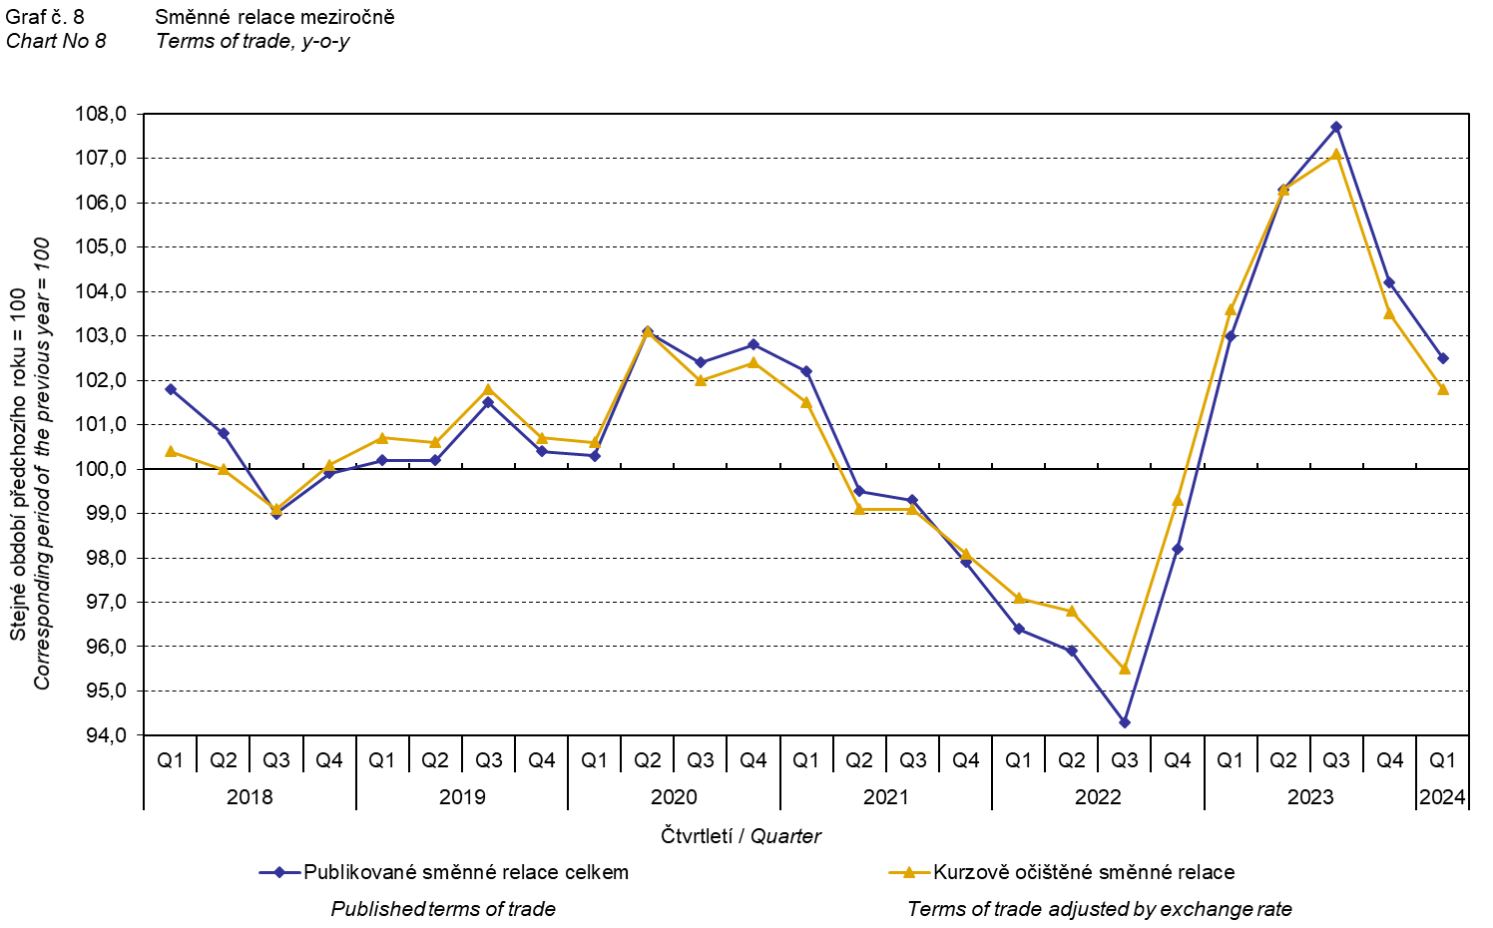

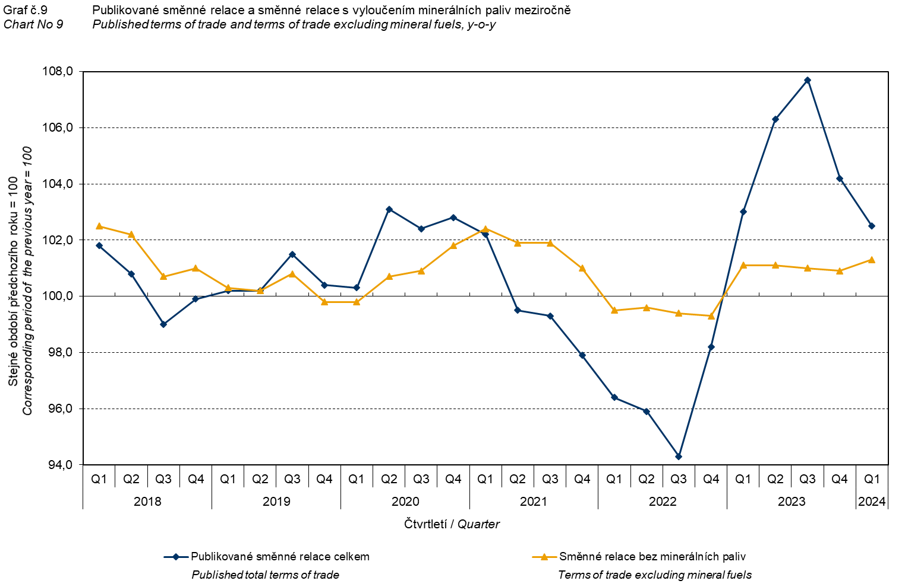

The Chart No 9 shows the development of the value of the terms of trade when mineral fuels are excluded, i.e. two-digit divisions 05, 06, 19, and 35 of the CPA classification (which correspond to the ‘mineral fuels, lubricants and related materials’ = the SITC 3 section). In this chart, the effect of mineral fuels can be observed; it has an influence on the total value of the y-o-y terms of trade. Since the Q1 2021, mineral fuels were decreasing the value of the terms of trade; however, in the Q1 2023, there was a turnabout and mineral fuels started to increase the value of the terms of trade. Naturally, it is related to the world market price development, especially as for petroleum prices. Import prices, which, compared to export prices, have a higher proportion of crude materials, respond in a more sensitive way to price turbulences. Therefore, the terms of trade are usually increasing when prices of crude materials are decreasing, and, vice versa, when prices of crude materials are increasing, the terms of trade are decreasing.

# Final summary

In the Q1 2024, the exchange rate effect increased, **year-on-year**, the export price index and attenuated a decrease of import prices. While export prices were increasing, import prices decreased; therefore, the terms of trade reached positive values, **year-on-year**. After elimination of the exchange rate effect, the terms of trade were lower than the published terms of trade. Values free of the exchange rate effect correspond to the exchange rate adjusted indices – see the Charts Nos. 6, 7, and 8.



The closing table gives published **non-adjusted** international trade in goods price indices.



*Note: For internal reasons, the Czech decimal comma is used instead of the English decimal point as a decimal separator in tables and charts of this analysis.*

**Elaborated by:** Hana Lapáčková, Prices Statistics Department

phone number: (+420) 274 052 709, e-mail: [hana.lapackova@czso.cz](mailto:hana.lapackova@czso.cz)