2. Agricultural holdings in IFS 2023 broken down by quartile

Agricultural holdings in quartiles by utilised agricultural area
If we divide the agricultural holdings participating in the Integrated Farm Survey 2023 into quartiles according to their utilised agricultural area, there are approximately 8 290 holdings in each quartile. Their average area accounts for 1.6 ha in the first quartile, 8.4 ha in the second quartile, 29.7 ha in the third quartile and 384.9 ha in the fourth quartile.
Holdings in the first quartile utilise only 0.4% of agricultural area, 0.2% of arable land, and 0.4% of permanent grassland; none of them grow hop-gardens. They reach larger shares of the total area in the case of vineyards (14.3%) and orchards (7.1%). On the contrary, holdings in the fourth quartile utilise 90.7% of agricultural area, 94.1% of arable land, 94.7% of hop-gardens, and 83.0% of permanent grassland, while their shares of vineyards and orchards are 55.4% and 58.7% respectively. For all the crops mentioned, those in the third quartile always have the second highest share of the total and those in the second quartile the third highest; the only exception to this rule are vineyards, which are three percentage points lower in the second quartile than in the first quartile.

Graph 18: Shares of land use types by quartile – agricultural holdings, total
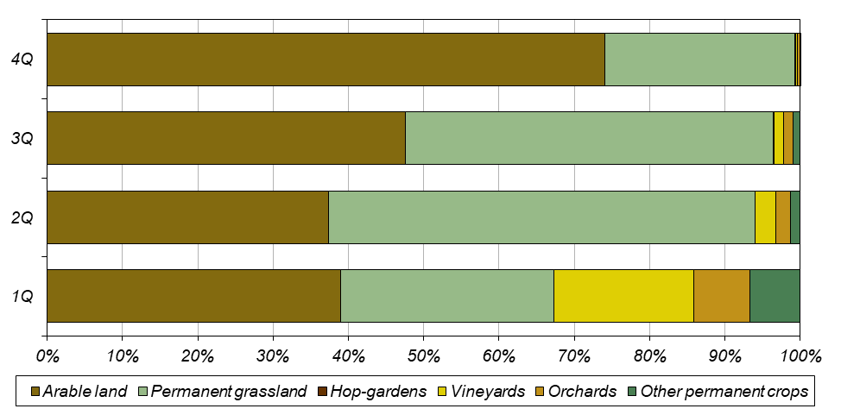
For selected crops on arable land applies that their share of total area is the lowest in the first quartile and increases towards the fourth quartile. However, the shares of area of potatoes and vegetables in the first three quartiles are higher than the corresponding shares of arable land; therefore, it can be said that smaller holdings are dealing with their growing more than with other types of crops.
The cattle numbers in each quartile correspond significantly to the above distribution of utilised agricultural area. Holdings in the first quartile account for 1.3% of total cattle numbers, 0.2% of dairy cows, and 0.8% of other cows. In contrast, the fourth quartile accounts for 90.6% of cattle, 98.4% of dairy cows, and 83.9% for other cows. The same is true for sheep, which account for 6.7% in the first quartile and 40.7% in the fourth quartile. For both cattle and sheep, holdings in the third quartile are again at the second position and the holdings in the second quartile at the third position, although as for raising of sheep, the third quartile differs from the fourth quartile only by seven percent. The situation is somewhat different in raising of goats as they are more concentrated in small holdings and the proportions of their numbers in the quartiles are more even than for other livestock species. Holdings in the first quartile keep 21.4% of the goats, those in the fourth quartile 22.6%, and the highest proportion, 32.4%, was recorded in the third quartile.
The situation is quite different in raising of pigs and poultry, where holdings with no agricultural land, and therefore those in the first quartile, make a major contribution. Although most pigs (43.3%) are kept by holdings in the fourth quartile, holdings in the first quartile account for 34.2 %. Similarly, the largest number of sows is kept by holdings in the fourth quartile (44.0%), followed by holdings in the first quartile (34.4%). In poultry farming, the holdings in the first quartile (59.2% of the poultry numbers) distinctly outnumber the holdings in the fourth quartile (25.1%). For hens, the proportions are 60.6% of stocks in the first quartile and only 18.2% in the fourth quartile; for broilers, 53.9% of the stocks are kept in holdings from the first quartile and 31.8% in holdings from the fourth quartile.

Graph 19: Livestock in quartiles – agricultural holdings, total
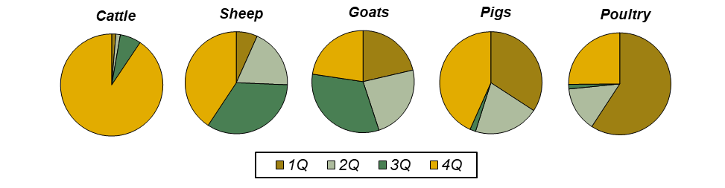
Unsurprisingly, agricultural workers are concentrated the most in the fourth quartile (61.1% of persons), with the first quartile is at the second position (14.5%). Similar proportions apply to both the regularly employed workers (56.0% in the fourth quartile and 16.5% in the first quartile) and the irregularly employed workers (76.6% in the fourth quartile and 9.1% in the first quartile). The share of regularly employed workers in the total is the highest in the second quartile (84.8%) and the lowest in the fourth quartile (67.7%).

Holdings of natural persons in quartiles by utilised agricultural area
There are approximately 7 010 holdings of natural person per quartile by area of utilised agricultural area surveyed in IFS 2023. Holdings in the first quartile have an average area of 0.8 ha, those in the second quartile 4.7 ha, those in the third quartile 13.9 ha, and those in the fourth quartile 80.6 ha.
Holdings in the first quartile utilise only 0.8% of agricultural area, 0.5% of arable land, and 0.6% of permanent grassland; none of them grow hop-gardens. Their orchards (10.9 %) account for a larger share of the total area and their vineyards (32.0%) account for the largest share of the total area of all quartiles. In contrast, holdings in the fourth quartile utilise 80.6% of agricultural land, 86.0% of arable land, 74.1% of permanent grassland, and 80.7% of hop-gardens, while their shares of orchards and vineyards are 42.9% and 23.7%, respectively. For all the crops mentioned, those in the third quartile always have the second highest share of the total and those in the second quartile the third highest; the only exception to this rule are vineyards, which are concentrated the most in the first quartile followed by the second one and least numerous in the third quartile.

Graph 20: Shares of land use types by quartile – holdings of natural persons
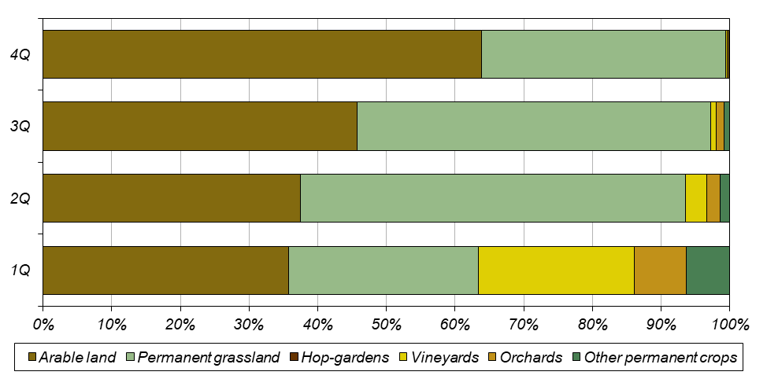
Again, for selected arable crops applies that their share of total area is the lowest in the first quartile and increases towards the fourth quartile. Only in the case of medicinal, aromatic and spice plants, the shares in the first and second quartiles are equal (0.2%). The shares of areas of potatoes and vegetables in the first three quartiles are higher than the corresponding shares of arable land and it can therefore be said that smaller holdings are dealing with their growing more than with other types of crops.
The cattle numbers in each quartile correspond significantly to the above distribution of utilised agricultural area. The first quartile accounts for 1.7% of total cattle, 1.2% of dairy cows, and 1.0% of other cows. In contrast, the fourth quartile accounts for 78.7% of the cattle, with 90.0% for dairy cows and 80.0% for other cows.
A similar situation was recorded for sheep, of which 5.4% are kept by holdings in the first quartile and 46.5% by holdings in the fourth quartile. For both cattle and sheep, holdings in the third quartile are again at the second position and holdings in the second quartile at the third position. The situation is somewhat different in raising of goats, which is more concentrated in smaller holdings, and the proportions of their numbers in the quartiles are more even. Holdings in the first quartile keep 15.9 % of the goats, those in the fourth quartile 23.9%, and those in the second quartile the most, 30.9 %.
The largest proportion of pigs (61.3%) is kept by holdings in the fourth quartile, with the second largest proportion (17.0%) being kept by holdings in the first quartile, i.e. mainly those farming without land; these holdings keep 16.6% of pigs.. Similarly, the largest number of sows are kept in holdings in the fourth quartile (61.8%), followed by those in the first quartile (16.4%). In poultry farming, holdings in the first quartile (64.9% of the stock) outnumber holdings in the fourth quartile (17.3%). For hens, however, the proportions are 27.8% of the numbers for holdings in the first quartile and 45.5% for holdings in the fourth quartile. As for broilers, 75.8% of the numbers are concentrated in holdings in the first quartile and 11.8% in holdings in the third quartile.

Graph 21: Livestock in quartiles – holdings of natural persons
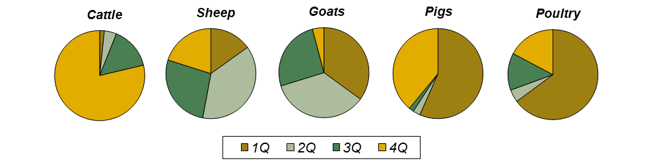
Agricultural workers, again, are mostly concentrated in the fourth quartile (33.9% of persons) and their shares are fairly even in the other quartiles. The share of persons regularly employed shows a similar trend (30.2% in the fourth quartile), while the share of irregularly employed persons increases with the size of the holding (from 6.4% in the first quartile to 67.5% in the fourth quartile). The share of regularly employed workers in the total number of workers is the highest in the first quartile (97.6%) and the lowest in the fourth quartile (80.1%).

Holdings of legal persons in quartiles by utilised agricultural area
There are approximately 1 282 holdings of legal persons in each quartile by utilised agricultural area. Holdings in the first quartile have an average area of 6.7 ha, those in the second quartile 62.6 ha, those in the third quartile 329.3 ha, and those in the fourth quartile 1 504.2 ha.
Holdings in the first quartile utilise only 0.4% of the agricultural area, 0.1% of arable land, 0.7% of permanent grassland, and no hop-garden. They have a slightly larger share of the total area in the case of orchards (7.1%) and vineyards (7.6%). In contrast, holdings in the fourth quartile utilise 79.1% of agricultural area, 83.8% of arable land, 64.9% of permanent grassland and 72.0% of hop-gardens; their shares of orchards and vineyards are 36.2% and 24.2%, respectively. For all the crops mentioned, except vineyards and orchards, those in the third quartile always have the second highest share of the total and those in the second quartile the third highest share; those in the third quartile have the largest shares of vineyards and those in the second quartile grow more orchards than those in the third quartile.

Graph 22: Shares of land use types by quartile – holdings of legal persons
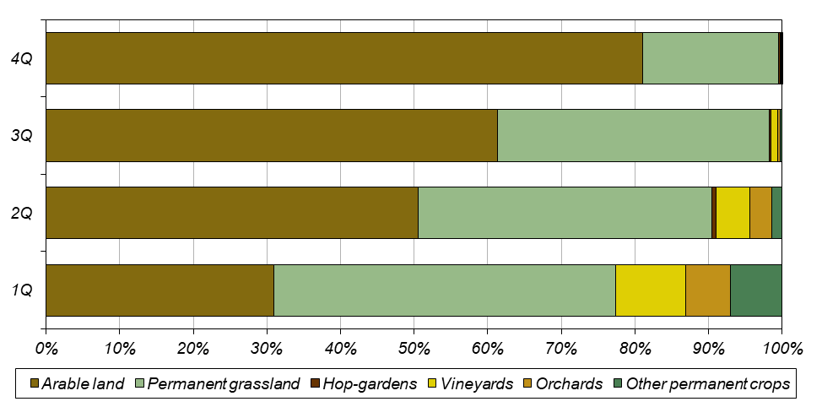
Again, the shares of selected arable crops are the lowest in the first quartile and increase towards the fourth quartile. Similarly to holdings of natural persons, the shares of vegetable areas are higher than the corresponding shares of arable land in the first three quartiles. However, in contrast to holdings of natural persons, similar results were recorded also for aromatic, medicinal, and culinary plants, while this trend is not so clear for potatoes.
Cattle numbers in each quartile again follow the distribution of utilised agricultural area. The first quartile accounts for 1.1% of cattle totals, 0.1% of dairy cows and 0.6% of other cows. In contrast, holdings in the fourth quartile keep 82.7% of cattle, 93.9% of dairy cows and 57.3% of other cows. Both sheep and goats are reared mostly by holdings from the second quartile (37.8% of sheep and 35.2% of goats). The lowest proportion of sheep (15.1%) was recorded in the first quartile and the lowest proportion of goats (4.1%) in the fourth quartile.
The importance of holdings with no agricultural land, i.e. those belonging to the first quartile, is crucial for pig and poultry farming. The largest proportion of pigs (56.6%) is kept by holdings in the first quartile, and the second largest proportion is kept by holdings in the fourth quartile (39.0%). Similarly, the largest number of sows was found in the first quartile (56.1%), followed by the fourth quartile (40.0%). In poultry farming, the first quartile (74.2% of the numbers) again completely outweighs the fourth quartile (20.8%); for hens, the shares are 82.3% of the numbers in the first quartile and 9.1% in the fourth quartile, and for broilers 66.8% of the holdings in the in the first quartile and 30.0% in the fourth quartile.

Graph 23: Livestock in quartiles – holdings of legal persons
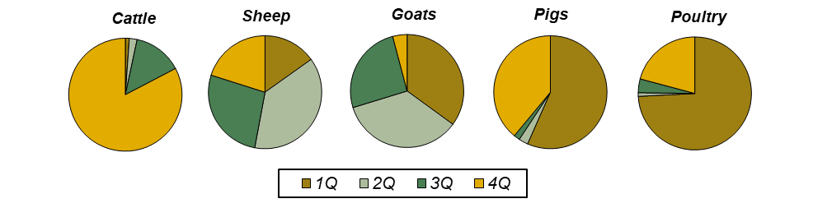
Workers in agriculture are concentrated the most in the fourth quartile (62.4% of persons), with the fewest in the second quartile (9.4%). The same is true for both the regularly employed workers (65.6% in the fourth quartile and 12.7% in the second quartile) and the irregularly employed workers (57.8% in the fourth quartile and 16.3% in the second quartile). The share of regularly employed workers in the total is the highest in the fourth quartile (67.4%) and the lowest in the second quartile (56.8%).

