- Imbalances

Odd movements in economic growth may knock an economy off balance. The out-of-balance states can be observed from both inside and outside in transactions with foreign countries. Fiscal disproportion is a typical example of an internal imbalance, that is, a proportion between income and expenditure of the government sector, imbalance between the demand and supply in the labour market or between savings and investments. A particularly good example is too high unfavourable negative balance of payments current account in relation to the performance of the economy or a disproportion of coverage for deficits and surpluses of individual components of the balance of payments. In this analysis, the focus is on the internal imbalance measured by the deficit and debt of the government sector, while the external imbalance is measured by the development of the balance of payments current account of the Czech Republic. The fiscal problem is again assessed in the European context.

  - Internal imbalance

    - Government sector deficit

- Debt by government sector deficit decreased in 2011… | The government sector deficit of the Czech Republic – defined as central government institution (state budget), local government institutions (budgets of municipalities, towns and regions) and social security funds – decreased in 2011. Its reduction was both nominal and in relation to GDP at current prices.  Following dramatic cuts in the state budget, the deficit has been on decline from the record value of CZK 218.3 billion in the crisis year of 2009 to 182.7 billion in 2010 and to 117.9 billion with the economy recovering in 2011, when such a hard budget restriction contributed decisively to the loss of the pace of economic growth in the CR.

Chart No. 16 | Budget deficit of the government sector in relation to nominal GDP (in %) | Chart No. 17 | Y-o-y changes of government sector deficit and GDP (in mil. CZK)
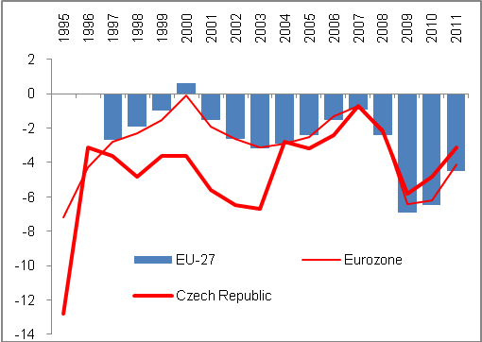 |  | 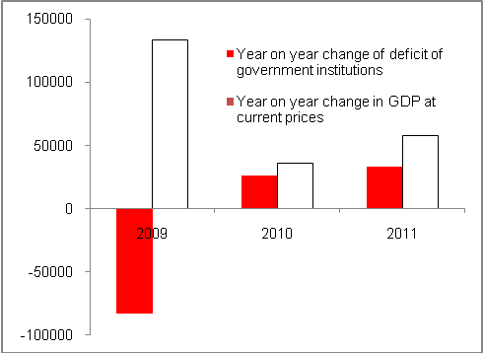
Source: CZSO

- … at the expense of the pace of GDP growth | The gradual reduction of the annual deficit of the government sector in the Czech Republic since 2009 from 5.8% of nominal GDP to 4.8% in 2010 and down to 3.1% in 2011 is a positive trend with regard to the paradigm of the adopted economic policy preferring only the reduction of deficits. However, this has been achieved at the expense of future weak growth impulses for the economy, where measures reducing the effective demand of Czech households and also the slump of large investments financed from public sources have the most negative impact.

- Significant drops of government sector investments in an effort to reduce deficits… |  | The government sector seeks to reduce deficits by lower investments. In 2011, the gross formation of fixed capital was lower for the second consecutive year. While in 2009 the investments of the government sector were CZK 15.7 billon higher than in 2008 and reached CZK 191 billion – which at that time worked to reduce the drop in the economy under the crisis – the next two years were impacted by restrictions in this regard. In 2010, the formation of gross fixed capital fell year on year almost by 28 billion and in 2011 for another CZK 25 billion. Compared to 2009, the investments of the government sector were CZK 53 billion lower in 2011. This development was reflected in the transport infrastructure.
- … contributed to growth inhibition |  | Therefore, it is clear that the government sector did not participate in the growth of the economy in the year of economic recovery (2010) as far as investments are concerned. Subsequently, by forming less gross fixed capital the government further deepened the slowdown of the economy in 2011.
- In the European context, there was a strong long-term level of investments of the government sector of CR with a drop in 2011 |  | However, surprisingly enough, the proportion of investment to nominal GDP in the Czech Republic is, in the European context, among the highest, even from a long-term perspective. In 2001–2011 the annual average of this indicator stood at 4.3%, which was the third highest relative proportion of government investment in GDP in the EU after Bulgaria and Estonia (4.7 and 4.5%). For the EU-27, it was 2.5%; the least investments in relation to GDP were provided by Denmark and the UK (1.9% of GDP), followed by Germany and Belgium (1.6%) and particularly Austria (1.2%). The difference cannot be attributed to the organisation of individual countries (federal countries in Germany or Austria), as the indicator is consolidated for the entire government sector. Therefore, a more significant share of private investments in the development of these countries can be assumed.  As late as in 2009, the Czech Republic ranked in the third place in the EU in the amount of government sector investments in relation to GDP with 5.1% after Romania and Poland, but the Czech Republic dropped to seventh place in 2011 with 3.6%. The decrease of the investment ratio was characteristic for the whole of the EU-27 (from 2.9% to 2.5%) and can partially be explained by debt-related budget difficulties of the countries of Southern Europe, or countries providing aid respectively.
Chart No. 18 | Structure of government sector deficit (in million CZK) |  | Chart No. 19 | Structure of 2009 deficit (internal circle) and 2011 (external circle), in % of the total deficit of the Czech government sector
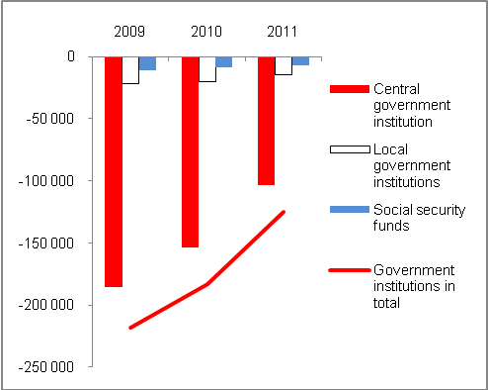 |  |  | 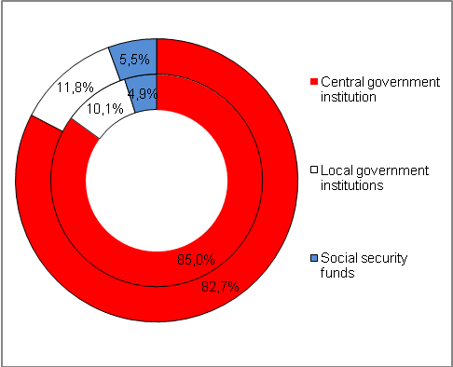
Source: CZSO

- European context | In the European context, the deficit of the government sector was fairly adequate in 2011 when it only slightly exceeded the Maastricht convergence criterion limit (3%) with 3.1% of nominal GDP. In the ranking of the EU-27, the CR was positioned in the second third of the ranking when three countries recorded an economic surplus in their government sectors (Sweden, Estonia and Hungary) as can be seen in Chart 20. Another seven countries had more favourable deficit than the Czech Republic (Malta, Austria, Bulgaria, Denmark, Germany, Luxembourg and Finland).  On the contrary, in 2011 the worst economic result was reported by Ireland where guarantees given by the Irish government for risk balances of banking sector entities were probably reflected in the result. On average, the government deficit for the EU-27 was 4.5% of the nominal GDP of the union, and 4.1% in the Eurozone. The deficit for both European groups posted significant year on year improvement (-6.5% and -6.2% respectively in 2010) particularly due to the reduction of the government sector deficit of the largest European economy – in 2011 the German deficit stood at only 1% of the German GDP in nominal terms and improved year on year by 3.3 p.p.
Chart No. 20: Government sector deficit of EU-27 countries in 2011 (in % of nominal GDP)

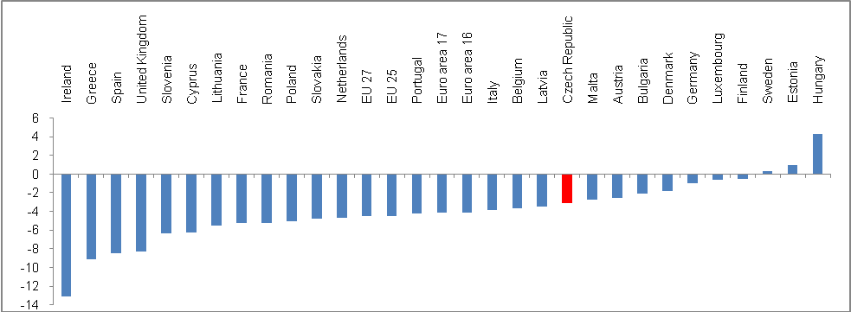
Source: Eurostat

    - Government gross consolidated debt

- Czech government sector debt is the highest in history in both nominal and real terms… |  | For the first time, the government gross consolidated debt of the Czech Republic exceeded the threshold of two fifths (41.9%) of nominal GDP in 2011 and in this relation was the highest since 1995. Against 2010, the consolidated debt increased by 3.1 p. p., which represented a year on year increase by billions of CZK. In 2000, the government sector debt of the Czech Republic was only 17.8% of nominal GDP, which represented the fourth lowest debt of all EU-27 countries (after Estonia, Luxembourg and Latvia).
- … but in the European context in relation to GDP, the Czech Republic is among the least indebted countries |  | However, in the context of the large relative debts of European countries, even in 2011 the Czech government debt represents the seventh best figure (after Estonia, Bulgaria, Luxembourg, Romania, Sweden and Lithuania). As is apparent from the list of the countries given above, Bulgaria and Sweden have significantly improved their relative indebtedness to 16.3% and 38.4% of GDP respectively, while in 2000 the debt of Bulgaria was 7.5% of its GDP back then and 53.9% in case of Sweden  However, the Czech government debt has been constantly increasing since 2009, following approximately the same trend as the gross debt of the EU-27.
- In the period of strong growths, the EU-27 as a whole reduced debt faster; the relative position of the Czech Republic in the ranking of the countries by indebtedness declined despite strong prosperity |  | If we examine the development of the relative debt of the Czech Republic (i.e. gross debt/GDP) by the place that the country occupied in the European ranking, it is clear that the strong prosperity of the Czech economy in 2005–2007 meant that the Czech Republic lost its position as one of the least indebted countries among the EU-27.  However, it also means that the majority of the EU countries managed to achieve better economic results in the period of strong growth – their governments reduced their deficits faster, at such a pace that in 2007 and 2008 only eight and nine countries of the EU respectively, had higher relative debt than that allowed by the Maastricht criterion. Although the situation was not as positive as in the beginning of the decade when only six EU countries had over-limit debt in 2000 and 2002, it was much better than in 2009–2011 when more than half of the EU countries reported higher debt than is permissible under the rules of the Maastricht Treaty. The position of the CR in the ranking improved with moderate worsening of the position in 2011.
Chart No. 21 | Gross consolidated debt of the government sector to nominal GDP (in %) |  | Chart No. 22 | Position of the Czech Republic regarding the debt of EU-27 countries EU-27 (by gross consolidated debt /GDP at c.p.)
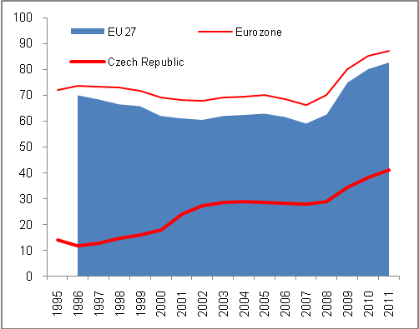 |  |  | 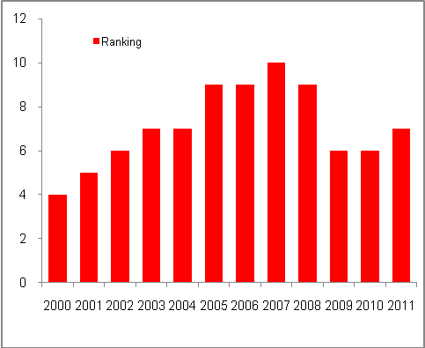
Source: Eurostat, own calculations

- Government sector debt of the Czech Republic rises irrespective of the movement of nominal GDP and in 2011 during nominal growth of economy by 0.9% the debt of the Czech Republic rose by 9.1% … | As shown in Chart 20, in 2008–2011 the government sector debt rose irrespective of the GDP development. Significant surge of the deficit increasing the debt was a logical result of the crisis development of the economy in 2009. However, the gross debt rose significantly even in 2010 and 2011, and in spite of moderate reduction of deficits; they were too high to reflect positively on the amount of gross debt of the CR.  The above-mentioned Chart 20 shows the development of GDP and the debt of the Czech government sector in nominal terms. The development in percentage increases then shows that during decline of the Czech economy in 2009 by GDP at c.p. by 2.8% the gross debt rose year on year by an extreme 16.4%. In 2010, during the post-crisis recovery (The nominal GDP rose by 1%) the dynamics of gross debt dropped to +11.7%, however this still represented very strong year on year growth of the government debt. When GDP at c.p. actually recorded a year on year stagnation in 2011 (+0.9%), the Czech government gross consolidated debt rose almost by one tenth (+9.1%).
- Gross government debt increased to CZK 156.8 billion in 2011, and 79% of the debt consists of securities with long-term maturity | The debt of the Czech Republic in form of a government gross consolidated debt rose by CZK 131.2 billion in 2011 and exceeded CZK 1.5 trillion (CZK 1567.8 billion), which is logically the highest debt in history of the country. However, as a result of harsh restrictions the increase of the debt stood lower than in 2010 (+151 billion Czech koruna) and even against 2009 (+181.2 billion Czech koruna). It goes without saying that the increase of government sector deficit reported record values in the crisis year of 2009. By vast majority, the debt consists of issued debt securities (CZK 1388.2 billion, that is from 89%), and bonds with long-term maturity (CZK 1243.8 billion), that formed 79% of the total government sector debt in 2011.

- Growth of the debt of central government and stagnation of the debt of local governments in the structure |  | The central government (state budget) has long significantly contributed to the aggregate of the government gross consolidated debt of the CR. According to the state budget current performance, the reduction of budget expenditures is accompanied by problems on the income side caused both cyclically and by structural balance. As opposed to central government debt, local government debts are much lower (CZK 98.9 billion in 2011 compared to CZK 1470.5 billion) and their debt shows only slight year on year changes (See Chart 25).
Chart No. 23 | Debt of selected countries (gross government debt (GDP at c.p., in%) |  | Chart No. 24 | Gross consolidated government debt of the CR and GDP (in million CZK)
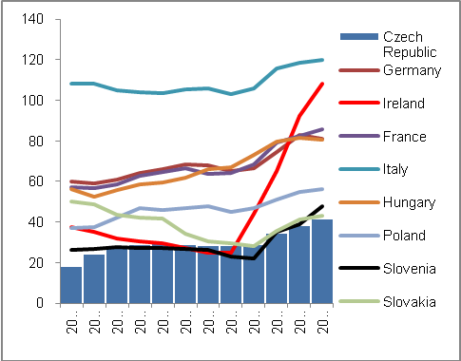 |  |  | 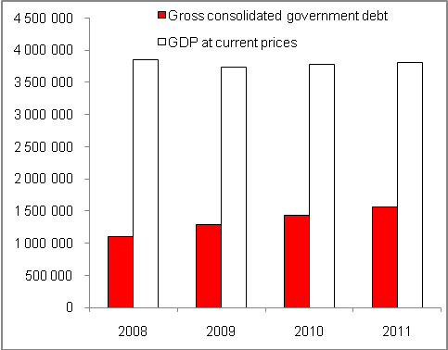
Source: CZSO

- Debt of the central government rose to CZK 1470.5 billion, the debt of local governments to CZK 98.9 billion | The central government gross consolidated debt rose by CZK 128 billion in 2011 and reached CZK 1470.5 billion. Despite the fact that it did not represent such a strong increase as in 2009 and 2010 (CZK +173.8 billion and 153.1 billion respectively), this increase rose the debt of the entire government sector decisively to CZK 1567.8 billion.  The contribution of local governments to the growth of the debt of the entire government sector was almost CZK 100 billion in 2011 (CZK 98.9 billion) and its amount rose by CZK 2.2 billion against 2010. On the contrary, in 2010 the debt of local governments dropped year on year by two billion, as in the crisis – with the need to pay more social benefits in the competence of municipalities – on the contrary the debt of local government rose year on year by 6.8 billion in 2009.  As opposed to government subsectors, the gross debt of social security funds is insignificant, in 2011 it was merely CZK 0.076 billion. While having been on decline in 2009 and 2010, the debt rose by CZK 0.052 billion in 2011 and contributed to the growth of the government gross consolidated debt of the Czech Republic already by CZK 52 million in total.
- Interest from gross government debt remained on the same level in 2011 as in 2010, i.e. CZK 53 billion and 1.4% of GDP | Debt service requirements can be described as the risk of the bonds issued related to their placement on the market (Apart from institutional investors, the Ministry of Finance started allowing purchase of government bonds also for individual investors in 2011), and also as the price that must be incurred in a form of interest costs to issues of securities by government sector.  In spite of high increase of the government sector debt of the Czech Republic, the issues of bonds were successfully placed both in 2010 and 2011 while being demanded by foreign investors mostly. The debt service in a form of consolidated interests remained practically on the same level (53 billion) in 2011 as in 2010 (53.1 billion Czech koruna). The ratio of interests in relation to GDP also remained the same (1.4%).

Chart No. 25 | Structure of the deficit (in billion CZK, in%); 2008 (internal circle) and 2011 (external circle) | Chart No. 26 | Development of the debt of Czech government sector units (in million CZK)
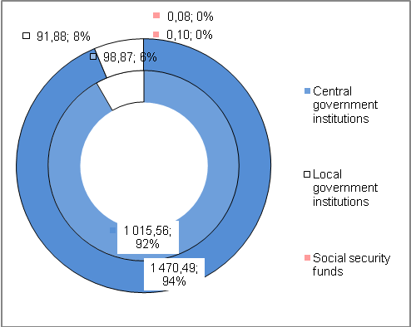 |  | 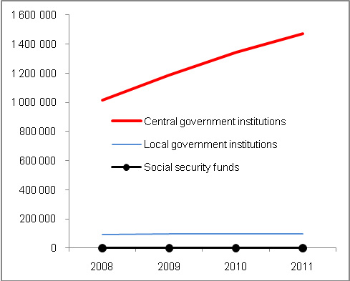
Source: CZSO

- Interest/deficit ratio |  | The interests paid from the government sector debt increased year on year from 40.4 to CZK 48.4 billion in 2009 and by another 4.7 billion to 53.1 CZK in 2010. If we compare the volume of these interests with the size of deficit in each of the years, they represented more than one fifth of the deficit (22.5%) in 2009, and almost one third (29%) in 2010 and almost one half (45%) of the government sector deficit in 2011. However, we should remember that the deficit has been on steady decline, but the debt has grown with debt service requirements, which were also naturally affected by the development of the above-mentioned interest/deficit ratio.
Chart No. 27 | Debt service costs and government sector deficit (in billion CZK) |  | Chart No. 28 | Interest to deficit and interest to nominal GDP ratios (v%)
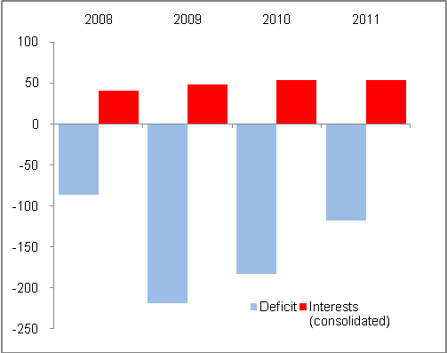 |  |  | 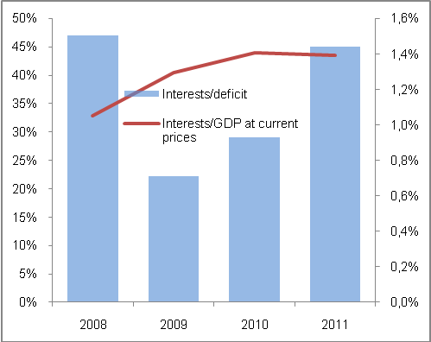
Source: CZSO, own calculations

    - Private debt, public tenders, state aid, guarantees and social benefits

In connection with internal imbalances related to government sector, there are also less frequent sectors generating these imbalances or contributing to their intensity. However, let us also compare the level and development of the debt of private entities that together with the gross debt and government sector deficit gives a picture of the country debt.

      - Private sector debt

- Private sector debt of the Czech Republic rose to the highest level in history in 2010… | The private sector debt may be defined as liabilities of other institutional (other than government) sectors, that is, of non-financial enterprises, households and non-profit organisations serving households. Based on the data of Eurostat comparing such debt in relation to nominal GDP, the private sector debt of the Czech Republic increased according to available data to 71.6% in 2010 and was the highest in time series since 2003, since when the data are published for the Czech Republic.
- … but in European context, it is practically the lowest of all countries | However, the private debt of the Czech Republic in relation to GDP (71.6%) belongs among – despite its growing share resulting from rapid surge of loans provided to households – the lowest in Europe. The only lower relative debt was reported by Slovakia (69%) in 2010 while Poland was practically on the same level (71.1%). In European context, these figures are extremely low (Please see Chart 29). For example, Ireland would need up to the three times value of its nominal GDP generated in 2010 to redeem its private debt. The same applies to Cyprus.  It is clear that reasons behind the high private sector debt in different countries may lie in loan expansion of countries that develop from lower costs (Bulgaria with corporate loans) or the other way around, in countries where households have accumulated debt over the last decades (In particular, the developed EU-15 countries states with a long tradition of taking loans). But e.g. the data concerning the private debt in the United Kingdom, where significant debt of households given the tradition of acquisition of houses through mortgages may be expected, are not available in Eurostat tables in the time series, while the above-mentioned thesis would be the most self-evident for this particular country.  In 2010, the Baltic states, Sweden, Belgium, Denmark or Germany managed to decrease the private sector debt. On the contrary, the Czech Republic belongs to countries whose private debt has increased and is growing over time (Chart 28).

Chart No. 29 | Private debt of selected countries (in % GDP in c.p.) | Chart No. 30 | Private debt of EU-27 countries in 2010 (in % GDP in c.p.)
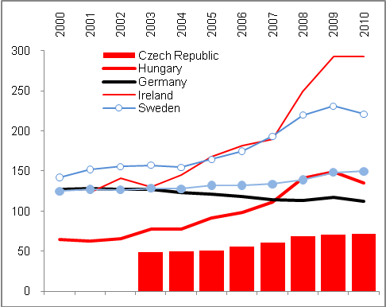 |  | 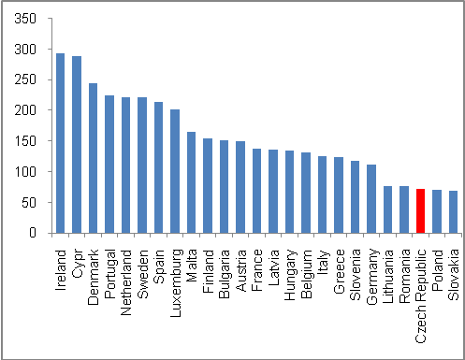
Source: Eurostat

- Causes of the growth of private sector debt in the Czech Republic | In the Czech Republic, the private sector debt grows predominantly as a result of debts of households that particularly in 2002–2008 used loans for housing on a massive scale. The debt of non-financial enterprises in the Czech Republic has not developed expansively, both by effects of the economic cycle phase (however, even in years of strong prosperity the loans provided to business did not grow as fast as loans provided to households) and by alternative forms of financing that have developed extensively in the Czech Republic and that are mostly used by exporters.
- Relation of the government debt to private debt | There are countries with significant disproportion of government and private debt. In Sweden where the government debt in relation to GDP is very low (39.4% GDP) in the European context – when the country has one of the few reported surplus economic results of the government sector in the past decade – on the contrary in 2010 the private sector debt exceeded by 2.2 times the Swedish GDP level, which manifests intensive private sector debt. A similar situation can be found in Slovenia (Chart 30).
Chart No. 31: Gross consolidated government debt and consolidated private debt of EU-27 countries in 2010 (in % of nominal GDP)

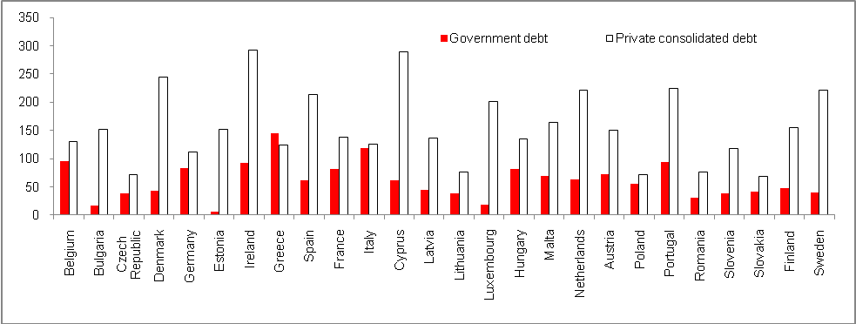
Source: Eurostat

- In 2010, the Czech government and private debt was the second lowest in Europe | When analysing the government debts and private debts, not only is there an issue of their mutual proportionality, but also an issue of the size (aggregate) of the total debt for both sectors. Regarding the combination of government sector debt and the debt of other (private) sectors, the Czech Republic is among the countries with the lowest “complex” debt in the European context. Its government and private debt made up only 109% of nominal GDP in 2010 (see Chart 31). The only lower debt in the EU-27 was reported by Romania (107.2%) and only Slovakia and Lithuania were within the same group, i.e. with government and private debt up to 110% GDP.  Ireland, having an extreme aggregate debt (385.3% GDP), is a high risk country with regard to a continuous recession it cannot escape and failing to either partially redeem the debt by faster growth or prevent its escalation. On the other hand, Greece and Italy – which have, as a result of the high debt of their governments, become a synonym for “European Sovereign Debt Crisis” confronting the Eurozone throughout 2011 – are in the ranking in the second quarter of the countries with the highest complex debt (with 269%, 244% GDP respectively). From this perspective, even Portugal has more debt (318% GDP).

- Very positive state of imbalance and growth | As far as imbalances are concerned, it can be said that the Czech growth is saturated by both government debts and private debts to a much smaller extent than in other EU-27 countries.

Chart No. 32: “Complex” debt of EU-27 countries in 2010 (gross government debt plus consolidated private debt; in % of nominal GDP)

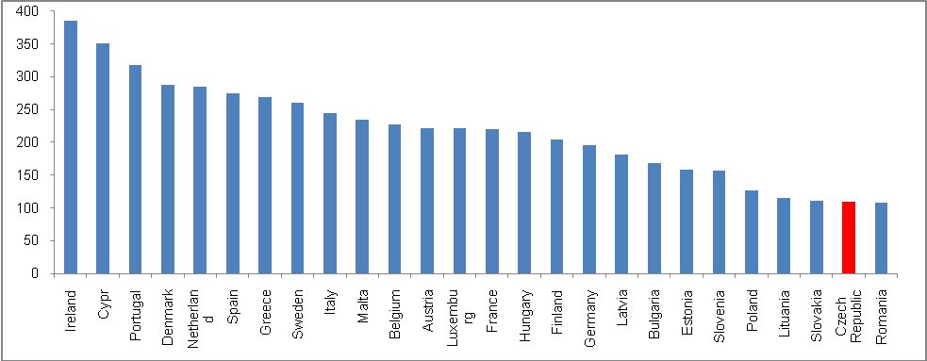
Source: Eurostat, own calculations

3.1.3.2. Public tenders
- Value of the Czech public tenders announced in relation to GDP higher than in EU-27…, |  | In 2011, the value of public tenders that were publicly announced stood at 5.6% of the nominal GDP in the Czech Republic. This was more than the EU-27 average (3.6%). This proportion was very low in 2004 and 2005 (0.4%, and 2.7% of GDP), which was less than the above-mentioned European average (2.6% in 2005, in the EU-15 as little as 2.7% in 2004). However, from 2006 the value of public tenders started to rise rapidly, also with regard to the fact that GDP grew significantly as well, therefore the public tenders announced grew even faster.
Chart No. 33 | Value of public procurement (in % GDP at current prices) |  | Chart No. 34 | State aid in CR and EU-27(in % GDP at current prices)
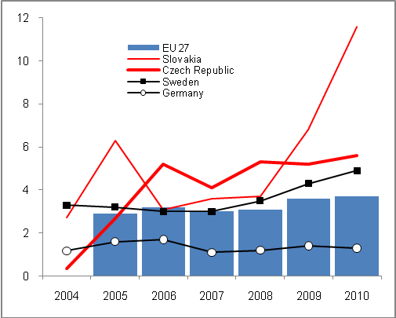 |  |  | 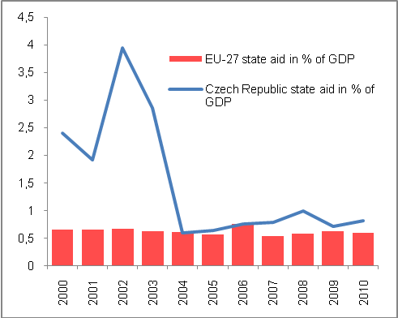
Source: Eurostat

- … but significantly lower than in fast-developing countries | This fact can partially be interpreted as follows: the government sector started to announce more and more new tenders, which could be understandable with regard to the boom in Europe. Moreover, in the European context their proportion to GDP was the highest in the countries whose economies were prosperous in 2010; the value of public tenders in Slovakia reached 11.6% of GDP in 2010, 10.4% in Estonia, 11.5% in Latvia and 8.5% in Poland.  On the other hand, in the long-term the value of public tenders in proportion to GDP is relatively low in Germany (in 2010 it was 1.3%, the lowest figure in the EU-27).  On the contrary, the value of public procurement in proportion to GDP is surprisingly high in the UK in the long-term (from 1993 to 2010 this relationship had been at 4.3% annually, 6.2% in the crisis year of 2009 and 6.5% in 2010). This policy is a result of an effort to stimulate the economy through investments financed by the government sector.
      - State aid

- Average expenditures for state aid in 2000–2010 higher than for EU-27… | The state aid item that can be found in the Eurostat statistics concerns the government sector deficit, as it is one of the factors increasing expenditures. As shown in Chart 34, the Czech Republic was among countries with a relatively high share in relation to GDP in 2000–2010 (1.37%). It was approximately 2.5 times more than the average for the EU-27 in this period. Costly state aid after the catastrophic flooding in 2002 significantly contributed to this figure.  However, after 2002 the share of state aid in relation to GDP has been declining significantly, and until 2010 the Czech Republic had spent on state aid from the government sector relatively the same amount as the EU-27 in aggregate (Chart 33). It is also clear from Chart 34 that there was a change concerning state aid in relation to GDP in 2010 against the average share in 2000–2010.
- … in 2010 significantly under the EU-27 average | In the long run, the Czech Republic has been one of the countries with a high share of state aid in relation to GDP (1.37%), but at the same time according to data for 2010, it is among those states whose aid was relatively significantly under their long-term averages in 2010 (0.82% GDP). In the Czech circumstances, this came about by budget restrictions, which were in a year on year comparison significant particularly in 2010. On the contrary, the EU-27 as a whole reported slightly higher state aid in relation to GDP than the long-term average in 2010.

Chart No. 35: State aid in relation to nominal GDP (EU-27 countries, in %)

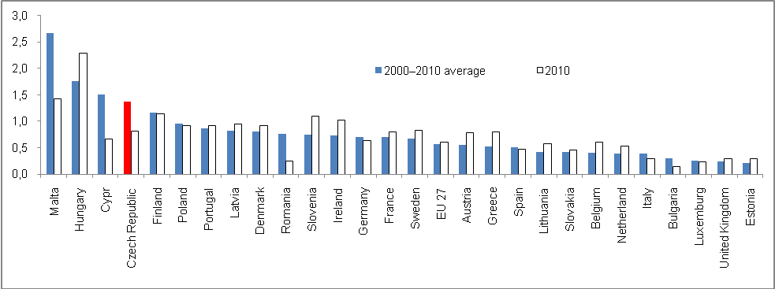
Source: Eurostat
      - Guarantees

- Guarantees provided by the government of CR are among the highest in the EU | Although data concerning the volume of guarantees of the government sector in relation to GDP are not available for all countries in the European context, it follows from the accessible sample that the government sector of the Czech Republic provided guarantees of 8.2% of nominal GDP in 2010. Since 2008, this ratio has increased in the Czech Republic (from 5.4% in 2008 to over 6.6% in 2009). In 2006, the guarantees of the government sector were 6.6% of nominal GDP.  There was a rapid increase of government-provided guarantees in e.g. Belgium (from 1.8% of GDP in 2006, when Eurostat data became available, to 21.3% in 2010), which was possibly a result of guarantees provided to banks in this country. The Czech Republic did not have to prop up healthy and well-capitalized banks in the country from government sector funds, but the amount of guarantees provided has been relatively high in the entire period – already in 2006 their volume was 6.6% of GDP and, as mentioned above, this was the second highest relationship after Malta (11.5%). Also in 2010, the Czech Republic was among the countries with the highest relative share of government-provided guarantees after Malta and Belgium. The governments of Slovakia and Estonia with the lowest volume of state guarantees in relation to GDP applied a different “guarantee” strategy (0.1% and 0.2% respectively).

      - Social benefits

- The amount of social benefits in relation to GDP paid in the Czech Republic is below both the EU and Eurozone average | The relative amount of social benefits in the Czech Republic, i.e. the amount paid in relation to nominal GDP, is below average in the European context – in 2011 it was 14% in the Czech Republic, while it stood at 16.7% in the EU-27 and 17.4% in the Eurozone. This has been the case for the whole period since 2000 (Chart 36). The same logic is followed by their decrease or their significantly lower dynamics respectively, pursued as part of restrictive measures by the Czech government aimed at further enlargement of the gap as opposed to the development in the EU.  Chart 36 also shows that social benefits in Greece, which had followed the same dynamics in relation to GDP as in the EU-27 until 2004, saw a rapid change in pace following this year and were the highest in Europe in 2011. There was a year on year increase despite harsh budget restrictions dictated by the European Commission, the reason being that Greek GDP dropped sharply, which also changed the relevant proportion of social benefits.

Chart No. 36 | Guarantees provided in relation to nominal GDP (in %) | Chart No. 37 | Social benefits paid in proportion to nominal GDP (in %)
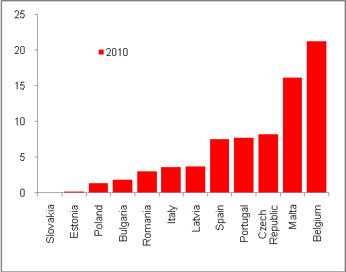 |  | 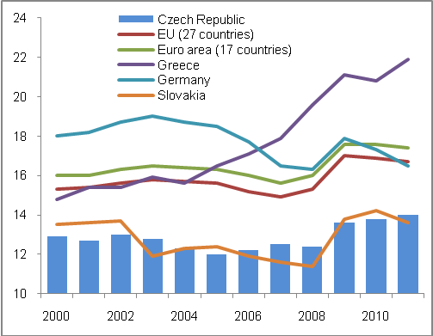
Source: Eurostat

    - Imbalances with institutional sectors

- Sector surpluses and deficits | Surpluses and deficits of individual institutional sectors are a result of the relationship between their source and utilization in a given year (the situation in the Czech government sector was discussed earlier in this chapter).
- Significant worsening of government deficits due to the sovereign debt crisis in the Eurozone | In the time series of 2000–2010, the government sector of EU-27 and Eurozone reported a deficit in their economic results in each year. In 2008, only six, mostly Scandinavian countries, posted surpluses. In 2010, a moderate surplus was reported only by Estonia. A sharp drop into deficit was recorded by Germany in 2010, which reported a deficit of a mere 1.4 billion euro in 2008. However, in 2009 Germany reported a deficit of as much as 76.1 billion euro and in 2010, when the debt-related problems of the Southern countries of Europe began and subsequently support from other countries in the Eurozone was provided, the German deficit exceeded the threshold of 1 hundred billion euro (106 billion).
- Deficit follows the same trend as the rest of Europe | The economic results of the Czech government sector showed a sharper drop than in Hungary or Slovakia, but lower than in Austria, which is a member of Eurozone and is affected by the requested support (contributions to EFSM, a fund ready to saturate the budgets of the most jeopardized countries).
- Surplus in the sector of non-financial enterprises and reasons behind it | Following the permanent deficit of the sector of non-financial enterprises, which can be understood as the “standard” position of the sector given the character of its activities (it uses third party lending sources), the sector reported in both the crisis year of 2009 and the post-crisis year of 2010 a surplus in its economic result. The same situation occurred in the non-financial enterprises sector in the European context.  While under usual circumstances a business uses working capital and makes investments, in periods of depression or slump of activities, this “normal” use of resources undergoes some changes. In the Czech Republic, the sharp drop of foreign demand particularly in the last quarter of 2008 and subsequently in 2009, was responsible for the decline in industry and later also for stagnation of services. Businesses did not need as much working capital as during periods of strong prosperity and, fearing future developments, they stopped making investments. This resulted in the surplus of resources that would have been used (invested) under different circumstances.  The fact that this situation lasted also into 2010 can be evidenced by yet another surplus reported, despite the fact that it stood at 2/3 of the figure for 2009. On the contrary, in the EU-27 the surplus of the sector of non-financial enterprises posted a year on year growth. This can be explained by the significantly greater uncertainty of the European economy, particularly the economy of the Eurozone shaken by fiscal problems arising from the debt situation. In the sector of non-financial enterprises, this crisis was reflected in the surplus reported.
- Financial institutions of the Czech Republic in surplus for the entire period of 2001–2010, although moderate in 2009 and 2010 | The economic result of the financial institutions sector in the Czech Republic has been positive for the entire monitored period. The recorded surpluses of resources over their use were highest in the first years of the last decade, in the period that saw the so-called credit-crunch that dampened the volume of client loans provided. In the Czech Republic, significantly higher surpluses were achieved by financial institutions in the period of subsequent boom. This can be explained by the saturation of the economy by financial resources with regard to the sector and their utilization.  Consequently, the crisis period in 2009 resulted in the decrease of surpluses. Even with a lower volume of client credit (the loans provided to non-enterprises even recorded a year on year drop), the financial institutions in the Czech Republic had enough opportunities to place their funds, particularly by purchasing securities issued by the Czech state to cover its high deficit.  Even during the financial crisis, the financial institutions of the EU-27 countries reported on the whole economic results with a surplus of resources that was even higher than before the crisis. This can again possibly be explained by the fewer opportunities for risk-free placement of these resources.

Chart No. 38 | Surpluses and deficits of the institutional sectors in the CR (net loans (+)/net borrowings in million CZK) | Chart No. 39 | Deficits in total economy (in billion EUR, net lending(+)/net borrowing (-))
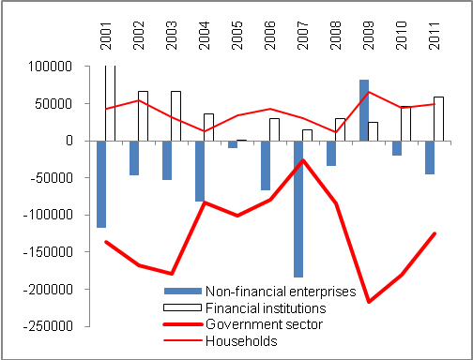 |  | 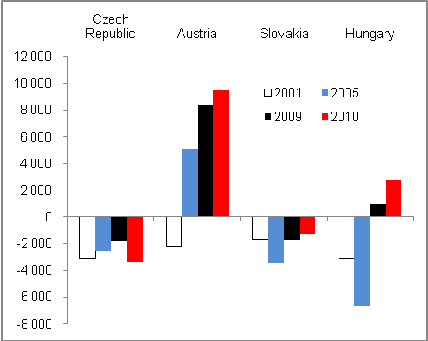
Source: Eurostat

- The surplus of households was influenced by legislative changes in the crisis year of 2009 | According to the revised time series, households posted surpluses for the entire monitored period, despite the fact that by massive purchasing of non-financial activities, mostly by investments into housing, the level of their liabilities was increased. In spite of this, the growth of components of their gross disposable income, i.e. particularly salaries and wages, but also net income from ownership, gross operating surplus and mixed income of entrepreneurs, income and balance from redistribution, managed to exceed the use of these resources. In 2009, the surplus of the household sector was the highest since 2000 as a result of legislative changes (introduction of equal tax, changes in tax-deductible fixed expense for entrepreneurs and so on), particularly in the sphere of redistribution which allowed households to dispose of more money (that is, changes in their income and expenses in relation to the government sector).  In the European context, there is generally rather an excess of resources over their utilisation, despite the fact that six countries of EU-27 reported a deficit in 2010 and four countries in 2009. In the long-term, deficits have been reported by households of poorer EU countries (Romania, Bulgaria, Lithuania), but also by households in Finland, the Netherlands and Greece.
- Mutual ability to finance | In aggregate, in the long-term the financial institutions and households have been able to finance by their surpluses those sectors, which recorded deficits in their economic results in the monitored period (government sector) or at least for many years in the times series of 2000–2010. The crisis of 2009 and continuing uncertainty in 2010 were responsible for surplus in the sector of non-financial enterprises.

  - External imbalance

External balance or imbalance of the economy is caused by the combination of inbound and outbound cash flow combinations. The statistics given in the balance of payments provide such information. The parameter to assess whether or not the country is deviating from an external balance, and to what extent, is a proportional indicator of the balance of payments current account and nominal GDP. The second parameter is a mutual comparison of results (balances) of the most important components of the balance of payments and the ability to compensate deficits by surpluses achieved.

    - Deficit of the current account of balance of payments

- Imbalance improved in 2011 | The external imbalance of the Czech economy measured by the deficit of the balance of payments current account to nominal GDP improved in 2011. This ratio reached 2.9% of GDP at c.p., which was less than the average for the previous five years (3.1%) and even for the period of 2000–2011 (3.7%). There was also a year-to-year improvement, as the current account reached 3.9% of nominal GDP in 2011.
- Unfavourable development of external relationships in the beginning of the last decade, i.e. in 2000–2004… | When looking at the development of external imbalance in the last decade including 2011, it is clear that the ratio of current account deficit to GDP at c.p. was less favourable in 2000–2004 when it was mainly affected by a negative trade balance. Its development was influenced by massive imports of investments in connection with the development of foreign-controlledforeign-controlled. These equipped their newly acquired capacities with technologies, and a transition to a strong expert orientation was achieved through them affecting the structure of economy – either by establishment and the strong impact of foreign-controlledforeign-controlled in the Czech economy, and by new ties to domestic suppliers, or by their increasing intensity respectively.
- … was replaced by improvement following the accession to the EU and high export orientation of companies led by foreign investors in the Czech Republic | For the above-mentioned reasons, a significant deviation from the external balance of the Czech economy occurred in 2000–2004 when on average the balance of payments current account deficits reached 5.2% of nominal GDP in annual average.  Subsequently, there were several influences at work, which gradually improved the external balance. The entry of the country into the EU and the sharp increase of mutual ties, especially trading and related ones, resulted in a gradual improvement of trade balance. This was also achieved as a result of transformation movements with businesses under foreign control from the previous era. These, when the strongest wave of foreign imports wore off, started production mostly for export. To achieve this, they also used their ties to their parent companies based in countries from which these direct investments were made, or the global reach of some foreign investors respectively.

Chart No. 40 | Deficit of the balance of payments current account to GDP at c.p. (in %) | Chart No. 41 | Structure of the balance of payments current account (in billion CZK)
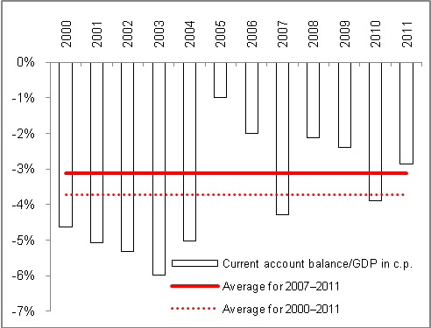 |  | 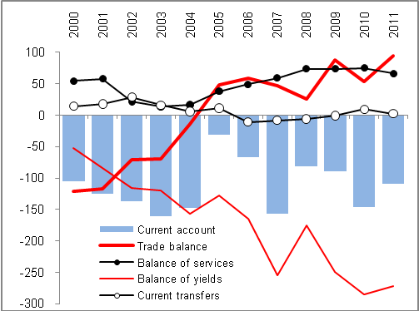
Source: CNB, own calculations

- Even in the “strong” year of 2007 the external balance worsened as a result of high repatriated income | In addition, it is clear from the time series that the external balance of the Czech economy worsened even in the year of the strong boom – in 2007 there was a slump in balance of payments resulting from an extreme balance of yields (Chart 39) caused predominantly by cash outflow in the form of repatriated income of businesses under foreign control operating in the Czech Republic. However, this was not caused by fear of upcoming risks related to the global financial crisis – as these dominated two quarters later – but rather by “pulling off” of high income generated in the Czech Republic in the year of peaking economic growth (in 2006, GDP grew year on year in real terms by 7%).
- In 2011, the yield net outflow was not less than in the record year of 2010…, | In 2011, the cash net outflow in the form of yields (CZK 271.9 billion) was not as significant as in 2010 (CZK 285 billion) when it reached the record level. Clearly enough, there was a classic cycle of direct investments in the Czech Republic. Until 2003, the reinvested income of foreign-controlled prevailed over the amount of dividend paid to foreign owners; in 2004 and 2005 their proportion was roughly equal. After that, investors started to transfer a higher share of their income to the parent countries.
- … but the outflow of the dividend itself was historically highest | If it were not for the increase of the surplus in the merchandise trading balance, undoubtedly this historically highest outflow of the dividend itself – although in aggregate the balance of yields was lower as a result of more favourable development with regard to employee compensations (foreigners working in the Czech Republic), the deficit of which was more moderate – would deepen the balance of payments current account of the Czech Republic also in 2011.

Chart No. 42 | Current account balance and its long-term average (in % of GDP at current prices) | Chart No. 43 | Contribution of current account components in the final balance  (in billion CZK)
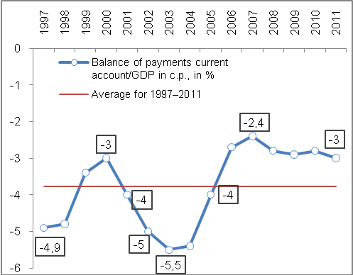 |  | 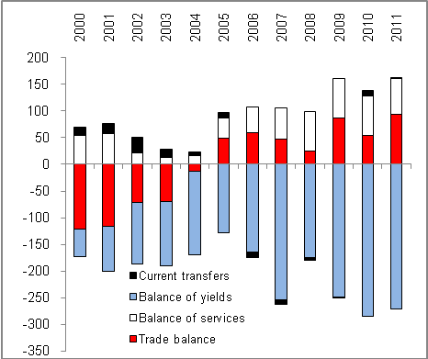
Source: ČNB

- In the long-term, the prevailing outflow of cash over the inflow despite relatively positive relative balance | The relationship of the Czech Republic towards foreign countries records deficit in the long-term, every year the outflow of cash from the country is higher than its inflow. This imbalance was first generated by merchandise-related trade balance deficits, and later – as the country was passing through the individual phases of the direct foreign investments cycle – particularly by outflow of cash in the form of dividend from income of companies of foreign owners achieved by their operation in the Czech Republic.  Contributions of each of the components of the balance of payments current account in the amount of deficit in 2000–2011 are illustrated by Chart 42. At the same time, the development of deficit of some current account components can be seen in the Chart as well, with their amount in relation to GDP being in aggregate – and the size of external imbalance of the Czech economy – relatively positive in the entire period.
- Against the countries compared, the external imbalance of the Czech Republic is stable, but it has not improved against Hungary, Slovakia and Slovenia | The ambivalence of the external relationships of the Czech Republic is not too high against some countries that it is traditionally compared with. As opposed to surpluses of the balance of payments current account to nominal GDP, which have not been achieved under Chart 43 by the Czech Republic like Germany or Austria, these relative deficits of the current account are less volatile than in Slovenia or Hungary, which managed to leave the negative zone in 2011 for the first time. As opposed to the Czech Republic, notably Slovakia has recorded a deeper external imbalance over the last 15 years. However, since 2007 Slovakia has been making gradual progress in this regard. (In 2011, the measured condition of external economic relationships in Slovakia was even better than in the Czech Republic, while Poland posted slightly worse results.)

Chart No. 44: Comparison of the external imbalance of selected countries (current account balance to GDP at c.p. in %)

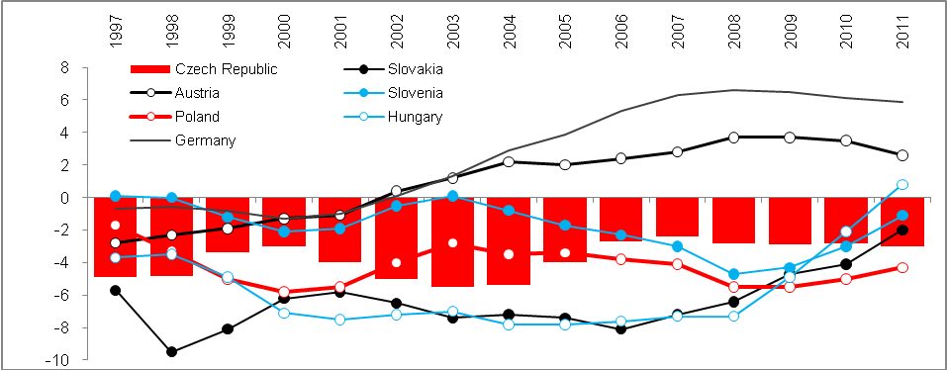
Source: Eurostat

The Czech government sector consists of organisational units of the state, territorial self-governing units, selected allowance organisations, state and other non-budgetary funds (Land fund, Supporting and guarantee forestry and farming fund, Winemakers’ funds and so on), Railway infrastructure administration, the transformation institution Prisko, PPP Centrum, public universities, public research institutions, health insurance companies, the association and union of health insurance companies and the Centre for International Reimbursements. Since 2010, several public non-financial enterprises have been, based on a test, transferred to the government institution sector, while at the same time some selected allowance organisations were transferred to sectors of non-financial enterprises and government institutions.
Regarding the instruments, securities other than stock are included in the private debt (Item F. 3 in the national accounting) and loans (F. 4), i.e. without other instruments. These are given on consolidated bases, which means that they do not include transactions in the framework of one institutional sector.
This comprises both regular aid in the form of e.g. farming subsidies and ad hoc help during natural disasters. Apart from that, it is also a support of the state in ensuring its long-term objectives (e.g. support of research and development, protection of the environment, energy savings, support of small and medium enterprises, creation of jobs and positions, support of education and regional development aid).
In the form of net lending to or borrowing by the sector.
In the time series since 2005, there has been a methodical influence when the reporting of export and import of goods and services is carried out by the so-called national approach, i.e. not by cross-border statistics of these flows, but according to the ownership.
From this perspective, other components of the balance of yields are relatively insignificant – while in 2007, CZK 281.4 billion were drawn from the Czech Republic as a net yield from direct investments, the net outflow in the form of work abroad (i.e. the wages of or allowances for employees/residents working outside the Czech Republic) stood at CZK 5 billion. The yields from portfolio investments and yields from other investments posted a positive net result (in total, a yield of almost CZK 23 billion).
For more see Dubská, D. [2011] Firmy se zahraniční majetkovou účastí v ekonomice ČR: oslabily nebo dále sílí? Praha, Český statistický úřad. 2012. http://czso.cz/csu/2011edicniplan.nsf/publ/1158-11-n_2011
According to ČNB, in 2008 CZK 183 billion were drawn and only 41 billion were left for reinvestments. In the same year, 74 billion were drawn from the manufacturing industry and 28 billion from the finance industry.

