CROSS-THEMATIC INFORMATION

 | Year 2013
Comprehensive information |  | Prague, 6th September 2013
Publication code: a-1111-13 |  | Reference No.: 40/2014–01

Tendencies and Factors of Macroeconomic Development and Quality of Life in the Czech Republic in 2012

Prepared by: | Cross-Thematic Analyses Unit
Authors of publication:: | Ing. Drahomíra Dubská, CSc., Bc. Jiří Kamenický, Mgr. Iva Kohoutová,  Ing. Lukáš Kučera
Contact person: | Ing. Drahomíra Dubská, CSc.
Phone number: | 274 054 041
E-mail: | drahomira.dubska@czso.cz

Czech Statistical Office
Year 2013
Are you interested in the latest data connected with inflation, GDP, population, average wages and much more? You can find them on the CZSO web page: www.czso.cz

Team of authors:

Ing. Drahomíra Dubská, CSc. (Introduction, Summary, Chap. 3, 5, 6, 7)
Bc. Jiří Kamenický (Chap. 2)
Mgr. Iva Kohoutová (Chap. 8).
Ing. Lukáš Kučera (Chap. 1 and 4)

ISBN
© Czech Statistical Office, Prague 2013

Contents

Summary 5
1. Overall Economic Performance 8
1.1 Gross domestic product 8
1.1.1 Expenditure side of GDP 9
1.1.2 Supply side of GDP 14
1.2 Sources of long-term growth of GDP 16
2. Production Performance of Industries in the Economy 19
2.1 Basic characteristics of the businesses (in the view of institutional sectors or industrial branches) 19
2.2 Performance of non-financial corporations in the CR 23
2.2.1 Investment rate 28
2.2.2 Debt ratio 29
2.2.3 Loans in default 31
3. Internal and External Imbalance 35
3.1 Deficit and debt of the government sector 35
3.1.1 Deficit of government institutions 35
3.1.2 Gross consolidated debt of the government institutions 37
3.2 Private debt 39
3.3 Indebtedness of the CR – private debt and debt of government institutions 40
3.4 External imbalance 40
3.5 Labour market imbalance 42
3.6 Labour productivity and real wage development 42
4. Price development 44
4.1 Consumer prices 45
4.2 Producer prices 47
4.3 Prices in the foreign trade 49
5. Selected factors of competitiveness 51
5.1 Change of share of the CR in the world exports 51
5.2 Cost competitiveness based on real unit labour cost 52
5.3 Support of sophisticated activities 53
6. Real and nominal convergence 57
6.1 Changes in the relative position of the CR in the economic development compared to the EU 57
6.1.1 Factors influencing the loss of performance of the Czech economy 60
6.1.1.1 Domestic demand 60
6.1.1.2 Foreign demand 61
6.2 Fulfilment of the Maastricht criteria of nominal convergence 64
7. Regions of the CR according to the level of economic advancement and selection of social statistics 66
7.1 Gross domestic product per capita 66
7.2 Income per capita in the CR regions 67
7.3 Risk of poverty or social exclusion 70
7.4 Share of people living in households with very low intensity of work 72
8. Demographic development in the CR in the European Context 74
8.1 Life expectancy at birth and other characteristics of demographic reproduction 75
8.2 Immigration and illegal immigration 79
8.3 Population Aging 81
8.3.1 Economic dependency ratio 81

Introduction

Regular CZSO publication titled Tendencies and Factors of Macroeconomic Development and Quality of Life in the Czech Republic in 2012 focuses in the breakdown of year 2012 on its results monitored in the medium- and long time horizon. Special attention is practically in all chapters devoted to the post-crisis period in the CR, i.e. the development after 2009. International comparisons are also performed where possible with regards to data accessibility.

Content of the analysis are chapters included regularly as well as themes new or included irregularly. To the areas analysed every year belong also in this elaborate areas related to the overall economic performance, price development and in the last two years also included results of the Czech Republic in real and nominal convergence and selected factors of competitiveness. Apart from these, the analysis focuses also on more detailed view of the demographic development in the CR and international comparison in all its important parameters including the ratio of economically active and economically inactive population, i.e. the index of economic dependency. This chapter contains among other also the international comparison of migration including illegal immigration.

Completely new is the chapter monitoring the business sector from the view of its profitability, indebtedness and investment rate related to the performance of the economy as a whole. A deeper analysis is here performed also for businesses in individual institutional sectors with a special focus on foreign controlled non-financial corporations. The question of real convergence of the CR to the average level of economic and currency union in Europe is in this work enriched by the view on a relative position of GDP per capita in the purchasing power parity (units of PPS) per regions of the Czech Republic, resp. size of GDP per capita in crowns in regions and its comparison in time. Assessed is also the position and changes in the economic advancement of regions (NUTS 2) in the CR compared to regions in the European countries.

Social statistics are in this analysis covered by newly included analysis of household incomes according to the changes in the size of their disposable income, even also according to the regions of the Czech Republic. Final picture is depicted by the help of results of the survey Statistics on Income and Living Conditions (SILC) regarding the development in the CR according to the households at risk of income poverty or social exclusion. The development of share of population endangered by material hardship is also stated as well as households with very low intensity of work.

CZSO by a gradual extension of this regular yearly publication - in preceding years of mostly economic character – pursues an effort for statistically detectable and appraisable data regarding the quality of life of people, by providing still wider and statistically precise picture of the development in the Czech Republic.

Summary

- Year 2012 presented for the Czech Republic a continuation of the economic recession phase, which began already in the last quarter of 2011. With an average growth of the Czech economy during the period 2003-2011 in real terms by 3.4 % annually – but also with an average growth per years 2010-2011 by 2.2 % -, contrasted its year-on-year fall in 2012 by 1.2 %. All expenditure components of GDP were decreasing, except for results of flows of goods and services with abroad. Net disposable income of households, as a source of their consumption expenditure – which is a main expenditure component of GDP -, although growing in nominal terms as opposed to year 2011, in real terms its fall in 2012 further deepened to -2.4 % from -1.3 % in 2010 and -2.1 % in year 2011. Proportion of population at risk of income poverty was however in 2012 year-on-year mildly lower, when there existed 9.6 % of the CR population at risk of income poverty compared to 9.8 % in 2011.

- In light of the long-term view, during the 2003-2012 decade, the main sources of GDP growth were intensive growth factors, according to the analysis of contribution of the total productivity of production factors. They played the main role also in the development of the CR GDP in 2012 – contribution of the labour productivity fell to zero and the productivity of capital contributed to the decrease of GDP by a negative 1.5 percentage point (p.p.). Lowering of the stock of labour the slump of GDP in 2012 deepened, the growth of stock of capital subdued it.

- Recession of the Czech economy in 2012 was the main cause of continuation of divergence of the CR from the average economic and currency Union in Europe, which commenced in 2010. GDP per capita in purchasing power parity (units of PPS) reached in 2012 in the CR according to the Eurostat data 79 % of EU 27 average and 72.5 % of the group of „old“ Union countries average (EU 15). Moving away from the average economic development of the EU recorded for years 2010-2012 apart from the CR also Slovenia, Netherlands and six countries of South Europe. In nominal convergence, i.e. the fulfilment of criteria set by the Maastricht Treaty, the CR in 2012 in comparison to the previous years worsened, when it did not succeed in reaching the limit for two criteria – required size of government sector deficit to GDP (4.4 % against the limit of 3 %) and also the inflation criterion.

- Regions of the CR in the aggregate without the capital city Prague converged during the years 2002-2011 to the average level of EU 27 – GDP per capita in PPS rose by 7.1 p.p. to 69 % of EU average, in Prague then by 24 p.p. to 169 % of EU average, with Prague starting to divert already from year 2009 (from 175 % in 2008). Significant disproportion between the development of Prague and other regions as a whole weakened.

- Incomes per capita (based on net disposable income of households) in nominal terms were hit by the post-crisis development more strongly, in comparison to the development of the whole economy. However, during the period 2002-2011 they increased by 43 % (in years 1995-2011 by 134 %), in Prague by 33 % and 154 % resp. The strongest growth of these incomes was thus observable in the second half of 90s. The highest additions were in years 2002-2011 recorded in the Moravian-Silesian region and Central Bohemia. In 2010 these incomes fell in nine regions of the CR, in 2011 in further four regions. The decrease avoided in both years only the Pilsen region.

- There was in 2011 15.3 % of the CR population at risk of income poverty or social exclusion – the income poverty itself 9.8 % -, i.e. the least out of EU countries. Values in Prague and Central Bohemia (9.1 % and 9.6 % resp.) were completely the lowest among NUTS 2 regions in the whole EU. Even the highest values in the CR (Northwest 24.6 %, Moravia-Silesia 22 %) were however more favourable compared to for example data for the whole Italy or Ireland. Materially deprived according to the SILC parameters were in 2011 in the CR 6.1 % of population (12th place in the EU ranking), people living in households with low intensity of work 6.6 % (3rd place in the EU).

- Explanation of lower endangerment of income poverty in 2012 for the CR as a whole (9.6 % of population) compared to year 2011 (9.8 %) lies in the seemingly small changes in the area of social and tax system, which had however a large impact on the income distribution of households in the CR and consequently also on the development of the rate of at risk of income poverty (adjustment of pensions to 1st January 2011 shifted households of non-working retirees in the income distribution closer to the median value), from the opposite side of the income spectrum then had an effect the so-called „flood taxes“ in the form of lowering of tax discount per taxpayer – it concerned the most working persons of the so-called „middle class“ with incomes close to the median value, whose incomes did not grow as much.

- Aggregate price level in the economy in 2012 increased year-on-year by 1.4 % especially due to the VAT increase and continuing growth of import prices. Consumer prices (in the form of harmonised index of consumer prices) climbed up in 2012 by 3.5 %, which represented the fifth highest growth of prices in the whole EU. Still, the price stability in the CR was during the period 2003-2012 more favourable in comparison to the EU as a whole.

- Macroeconomic balance was characterised in 2012 by worsening of the government institution sector deficit to 4.4 % of nominal GDP (from 3.3 % in 2011). Disregarding the exceptional impact of returning of property to the Church the deficit would have amounted to 2.5 % of GDP, i.e. less than the limit of convergence criterion. Gross consolidated debt of the government sector rose year-on-year by 5 p.p. to 45.8 % of GDP and was the eighth lowest in the EU. When including the private debt (loans to firms and households), the indebtedness of the CR arrived in 2012 at 119 % of GDP, which was the third best ratio in the EU. Results of the economic relations of the CR with abroad improved already second year in a row and the deficit of the current account of balance of payment (2.5 % of GDP) was more favourable compared to the average of years 2003-2012. Regarding the balance of productivity and real wage development, in 2012 there was in both cases obvious a year-on-year decrease by 0.6 %. Deep imbalance on the labour market, characterised by the low number of jobs accompanied by a strong demand according to the number of job applicants, existing roughly since the half of 2009, continued also in 2012. In this year still, in spite of the recession grew the employment rate, mainly due to the higher use of part-time employment.

- Nonfinancial corporations – composing nearly two thirds of value added as well as investment in the Czech economy and providing jobs nearly to three fifths of employed persons – developed between years 2010-2012 more favourably than other institutional sectors of the CR economy. Their share on the aggregate value of fixed investment, on creation of savings and net worth of Czech economy increased. For the cost of labour their share remained on the level of year 2008, the level of value added of this year however this sector in 2012 did not reach. Its growth is pushed in the long-term mostly by the manufacturing industry (with the exception of the end of 90s, year 2001 and year 2012). Industry and services displayed in years 2009-2011 deepening of differences in the individual branches in the value of labour productivity.
- Crisis in 2009 hit the sector of non-financial corporations in the CR by the full force – gross value added fell year-on-year the most among all sectors (-6.3 %). Slump was compensated by the decrease of employment (-4 %), by one sixth lower fixed investment; stocks of inventories decreased by record 41 bn crowns. Also in years 2010-2012 the businesses faced a falling margin rate, size of cost of wages, halting of investment. However, they managed to repay the previous loans and somewhat lower the share of loans in default. In the period of post-crises stabilisation, the rate of indebtedness of these businesses did not grow. In the long-term the dominant position of foreign controlled corporations prevails (one third of jobs, higher rate of return, profitability, productivity and lower cost of labour). Given phase of foreign direct investment cycle however at the same time also means a strong repatriation of profits.
- According to the selected factors of competitiveness the position of the CR in 2012 worsened due to the fall of proportion of exports of goods and services on the world exports (for the first time since the start of monitoring in 1994). Growth of real unit labour cost in 2012 compared year 2003 was the fifth fastest in the EU, which indicates a not very favourable development of cost competitiveness. In the support of sophisticated activities however, the CR accelerated the convergence to the EU average, if we consider relation of expenditure on research and development to GDP (1.84 % against 2.03 % in the EU in 2012, 1.15 % in the CR against 1.88 % in the EU in 2002).

- Analysis of the demographic development in the CR showed, that despite increasing the life expectancy at birth in the CR still does not reach the average European level. We also belong among countries with low fertility according to the indicator of total fertility rate of 1.45 child per one woman against 1.57 in EU average, where the indicator is being pushed up mostly by the states of West and North Europe (approximately two children are on average born to women in Sweden, Great Britain, on Iceland and the most in Ireland).

- In line with the European trend occurs in the CR the increase in the age of mother at the time of birth of the first child and on the other also to the growth of share of children born outside marriage (39.5 % on average for EU in year 2011 against 41.8 % in the CR, in 2012 already 43.4 %). Similar to majority of states of Europe is in the CR also the trend of lowering of the number of entered marriages and their postponement until later years of age (in the CR started only after year 1990, in North and West Europe already in the 70s). Until year 2008 was the crude marriage rate in the CR higher compared to the EU, afterwards decreased to the European average. To the historically lowest value fell the so called first marriage rate – while still in the 80s would until their 50 years of age marry at least once approximately 90 % of males and 96 % of females (and in the preceding decades even more), in 2012 would it be under current conditions remaining unchanged (giving the current level of nuptiality, death rate and migration) already only 53 % of males and 61 % of females.

- Overall population growth in the CR significantly slows down from year 2008 and in 2012 was sustained only thanks to migration (number of live births only very slightly exceeded the number of deaths). In years 2007-2010 was in the CR the rate of natural increase of population approximately the same as in the EU, i.e. +1 ‰, but it 2011 fell to 0.2 ‰. Share of foreigners on the CR population since year 1998 doubled to 4 % in 2012. The most foreigners in the CR come from Ukraine (28 %), Slovakia (19 %) and Vietnam (14 %). In 2012 had the CR the highest migration balance with Slovakia, although the highest number of immigrants arrived from Ukraine. Czech citizens moving abroad were more than those who returned. Illegal stays of citizens of countries outside the EU remain in the CR from year 2008 with respect to number of persons approximately the same (around three thousand), while in 2012 nearly one third of such immigrants came from Ukraine.

- Population of Europe as well as the CR ages – age median in 2012 was in the EU 41.8 years of age, in the CR 40.1 years of age -, because the share of children on total population is falling (in the CR 14.7 %, in the EU 15.6 %) and simultaneously increases the share of persons at the age above 65 years (in the CR 16.2 %, EU 17.8 %). Relation of economically active and economically inactive population was in 2012 in the CR relatively favourable (100:45 based on index of economic dependency, in the EU 100:50). Low level of fertility will however this share significantly worsen in the future (in 2060 in the CR approximately to 100:79, in the EU to 100:78) and multiplies thus among other also the issue with the sustainability of public finances.

Overall Economic Performance
Economy of the Czech Republic returned in 2012 back into recession. Gross domestic product fell in real terms by 1.2 %, which presented one of the largest decreases of performance in the whole European Union. On this participated weak investment activity in the long-term, but also already for a third year the ongoing fiscal restriction limiting both the investment expenditure and the provision of public services. Consolidation of public budgets adversely affected both expenditures and incomes of the household sector – which together with deepening anxiety regarding the future economic development limited their consumption in year 2012. Deeper fall of GDP, than the observed result, was prevented only by the foreign trade, which managed even in this year - strongly affected by the consequences of debt crisis - to show surplus.

Gross domestic product
Czech Republic given the growth of GDP in years 2003-2012 took the eighth place in the current EU… |  | For years 2003-2012 the GDP of the Czech Republic grew by one third, which placed it in the EU (growth by 12.4 %) on solid eighth position. First three places were taken by the countries of former Eastern Bloc (Slovakia with the growth of 55.5 %, Poland 51.9 % and Lithuania 47.7 %). The reason was obvious – these economies disposed of low volumes of GDP, presenting a high growth potential. Developed economies such as Sweden (24.6 %), Austria (17.5 %) or Germany (12.7 %) stood in the context of long-term growth during years 2003-2012 behind the CR. There were also however countries in the European Union, which in the given period did not grow, but even worse – fell. Among these economies were Portugal (-0.7 %), Italy (-0.8 %) or Greece (-1.2 %).
…and increase of the performance in years 2008-2012 was in the CR the tenth highest |  | In the medium-term view (2008-2012) the CR slightly worsened, with the growth of +1.5 % compared to year 2007 it took the overall tenth place among the countries of the European Union. Still, it represented an above-average growth, since totally the European Union for the period 2008-2012 fell by 0.7 %, Euro Area also  (-1.2 %). This significantly worsened economic development of the EU was caused by the economic difficulties during 2008-2009 flowing from the consequences of mortgage crisis in the USA – adversely affecting the foreign trade followed by the decrease of the investment activity -, but also a later government cost-cutting measures introduced as a reaction to the consequences of the debt crisis.
However, the slump in the CR in 2012 was the eighth deepest |  | In 2012 the GDP of the Czech Republic fell by 1.2 %, which placed the domestic economy on the overall eighth worst position in the European Union (decrease of 0.3 %). Behind the CR ended the countries of the south wing such as Greece  (-6.4 %), Portugal (-3.2 %), Italy (-2.4 %), Cyprus (-2.4 %) and Spain (-1.4 %), which were heavily hit by the consequences of the debt crisis. Among remaining economies showed higher fall than the CR only Slovenia (-2.3 %) facing considerable growth of government indebtedness after 2008 as a result of a markedly worsened state of the domestic economy and troubles in the banking sector, but also Hungary (-1.7 %).
Among countries from the 2004 wave, apart from the CR was in 2012 decreasing only Cyprus, Slovenia and Hungary… |  | Among countries accessing the European Union in year 2004, the GDP fell in 2012 apart from Czech Republic in the mentioned Cyprus (by 2.4 %), in Slovenia (-2.3 %) and Hungary (by 1.7 %). Other countries from the 2004 wave despite the adverse situation in Europe as well as not very positive anticipations regarding the future development their economic level not only increased, but also reached in 2012 the highest growths in the whole EU 27.
…and Baltic states accrued the highest growths in the whole European Union |  | In Malta, the GDP increased by one percentage point. Poland gained a year-on-year growth of GDP in the amount of 1.9 %, Slovakia even a growth higher by one tenth of p.p.. First three positions were then seized by the Baltic states, which unequivocally stood out by the reached values in the context of the whole EU (Estonia 3.2 %, Lithuania 3.7 % and Latvia 5.6 %). Reasons behind the very high growths of these three countries were twofold – they were growing out of low basis, since all in 2009 faced double-digit slumps of GDP (largest slumps in the whole EU), nevertheless the growth was also caused by the executed reforms of public finances. It is also certainly worth mentioning the countries accessing the EU in 2007, i.e. Romania (+0.7 %) and Bulgaria (+0.8 %) - also these countries thus exceeded the development of the CR economy in 2012.
The largest economies in the EU softened the fall of GDP in the European Union in 2012 |  | Out of three largest economies of the European Union (based on GDP) slightly grew the GDP in 2012 in the United Kingdom (by 0.2 %) and Germany (by 0.7 %). France kept the original value of GDP from year 2011. Thus these economies at least partially compensated the lowering of performance, facing in 2012 several other European economies, in the forefront with the countries of the South wing. These rather positive results were helped by the opposite strategy to that employed by a number of other EU countries including the Czech Republic – governments of the United Kingdom, Germany and France in the unfavourable period increased their final consumption expenditure compared to year 2011 and thus fought against the adverse development in the remaining part of the economy.

Chart 1 | GDP in the CR, European Union and the euro area (constant prices, y/y in %)
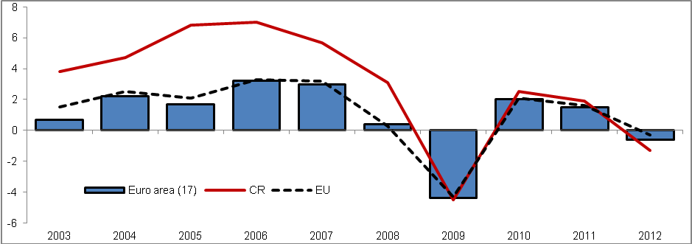
Source: Eurostat

Chart 2 | GDP in the CR and selected countries (constant prices, y/y in %)
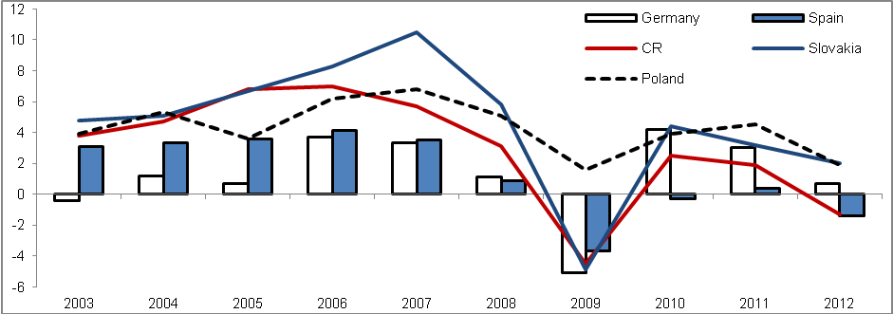
Source: Eurostat

Expenditure side of GDP
The long-term growth of GDP of the CR was caused mostly by the net exports… |  | The moving force of the development of GDP in real terms was in the CR in the long-term especially the net exports, which participated on its growth in years 2003-2012 from 47.3 %. It acquired a significance already in 2004, when thanks to the increase of the exports volume resulting from the accession of the CR to the EU, the foreign trade balance gained a surplus in current prices – in constant prices the foreign trade still remained in deficit (constant prices did not consider the positive aspect of the terms of trade). Since that year, the foreign trade balance has never decreased into deficit anymore (neither in current prices nor in real terms).
…compared to the European Union was its impact on the GDP growth more than twice as high... |  | The comparison with the whole EU (21.3 %) confirms the above average effect of the foreign trade on the growth of GDP in this time period – it was more than twice as high. To the significant share of the foreign trade on the GDP growth surely contributed also a continuing inflow of foreign direct investment into the Czech Republic, which positively contributed to the increase in the competitiveness of the domestic producers on the foreign market.
…still it faced fluctuations similarly to the other GDP components – year-on-year decrease of the net exports lowered the performance of the domestic economy in the form of GDP in 2007 |  | Still the component of net exports since 2005 (in constant prices) did not contribute to the growth of GDP absolutely – in 2007 a situation occurred, when the increase of imports (12.8 %) exceeded the growth of exports of goods and services from the Czech Republic (11.2 %). The unusually high growth of imports (it reached higher rate of growth only in 2010 – mainly due to the low comparative basis of the preceding year) was the result of a strong domestic demand affected by a notable performance of the domestic economy – the interest in foreign products for consumption as well as further production grew. Lower rate of growth of exports against imports then led to the drop of net exports by 10.9 %.
In 2012 the net exports as the only expenditure component halted a larger fall of GDP – still its increase was below the average compared to year 2011… |  | Increase in the net exports in 2012 by 19.7 % averted a more marked fall of GDP. This increase resulted from the higher growth of exports (4.0 %) compared to imports (2.3 %) - foreign demand thus year-on-year grew more strongly than the foreign supply. Still it represented a significant slowdown in comparison to 2011, when the net exports climbed up by 39.3 % – the rate of growth of foreign exchange of goods and services decreased as a consequence of weakened performance of nearly the whole EU facing the impact of the debt crisis.
…the growth of net exports in the CR in 2012 was below average also compared to the EU |  | Rate of growth of net exports of the Czech Republic was in 2012 below average even in comparison with the EU (increase by 47.9 %) - exports from the CR in 2012 increased compared to EU by 1.7 percentage point more notably, imports even by 2.5 percentage point – as a result of a higher rate of growth of imports in the CR against the EU compared to the exports then the CR recorded also a lower increase of the net exports. However even in the European Union compared to 2011  (+74.9 %) eventuated a significant lowering of the foreign trade balance dynamics.
Still the growth of foreign trade balance ended more notable compared to years 2009 or 2010 |  | The increase in the net exports of the domestic economy in 2012 was however higher compared to 2010 (15.9 %) and notably higher compared to 2009 (5.5 %). If in 2009 the economic troubles of Czech foreign partners pushed down the domestic exports by 10.9 %, a notable interconnection of exports and imports (Czech producers-exporters to a large extent use also the imported products as an input for their production) pressed also the imports down (-12.1 %). On the contrary in 2010 occurred a high growth of exports by 15.4 %, the same rate of growth however showed also the imports – large growths were given mostly by the low comparative bases of 2009.
The second most significant source of GDP growth was the final consumption expenditure of households – compared to the EU however, its share on the growth was below-average |  | The second most significant expenditure item from the view of long-term growth of GDP in the CR was the final consumption expenditure of households, which contributed to the increase of GDP in years 2003-2012 by 36.0 %. Even despite a notable share on the growth of performance, this component ended below average, when we compare the development with the EU (47.2 %) – domestic household consumption was in comparison to the European Union still relatively low – in 2012 the share of household consumption accounted in the EU for 55.7 % GDP, in the CR only for 46.9 %. No matter how the household consumption following the transition to the market economy after year 1989 expanded by high rates of growth – especially due to the not-saturated consumption – it still has not managed to reach the comparable level to the EU.
In 2012 the household sector decreased its expenditure aimed for consumption – it occurred for the fist time in years 2003-2012 |  | Adverse development of the household sector consumption dynamics in years 2009-2011 resulted in 2012 even in the decline – by 2.7 %. Lowering of this component was extraordinary, in years 2003-2012 it did not happen even once. Its share on this slump had most probably a marked deepening of the anxiety of households regarding the coming economic development in connection to the real fall of the disposable income.
Anxiety of domestic households regarding the future was in 2012 most likely higher than in the EU... |  | It seems that the anxiety of Czech households was in 2012 much higher to the corresponding average of the EU, where the final consumption expenditure of households fell only by 0.7 %. The rising worries of the Czech households related to the future development were also confirmed by the consumer confidence indicator, which was in 2012 the lowest since 1999.
... which was also reflected in the sharp growth of savings in the nominal terms... |  | Lowering of the household consumption was also partially reflected in the growth of their net savings (in current prices). If in years 2010 and 2011 the net savings decreased – by 8.3 % and 17.3 % - in 2012 the willingness of households to save again enlarged markedly – net savings expanded by 23.3 %. The impact had also a development of household net disposable income (including the adjustments for the change in net equity of households in pension funds reserves) in 2012, which increased year-on-year in nominal terms by 0.8 %. In the period 2003-2012 it grew on average by +4 % annually, in the second half of this time period however the rate of growth notably fell to year-on-year +2.2 %.
... while the households net disposable income again fell in real terms |  | Net disposable income of households in real terms was falling already for a third year with an increasing rate of fall – from -1.3 % in 2010 via -2.1 % in 2011 down to – 2.4 % in 2012 (the rate of growth of consumer prices was increasing).
Slump in the rates of growth of household consumption was however observed in the Czech Republic already since 2009 |  | Issues with the household consumption dynamics were however observed already since 2009, when its rate of growth declined to 0.2 %. In years 2010-2011 the growth of consumption was still negligible (1 % in 2010 and 0.5 % in 2011).
In 2003-2012 the household consumption grew on average by 2.1 % per year, in the second half of this period already only by 0.4 % |  | If we compare the average rate of growth of final consumption expenditure of households during the period 2003-2012 (+2.1 %) with years 2008-2012 (+0.4 %), there is obvious a large change. Apart from the reduction following 2008 the reversal was affected also by high growths of consumption in years 2003-2008, which except for year 2005 (2.9 %) did not fall below three percent. The household sector profited from the mentioned accession to the EU in 2004 – it launched a growth of significance of the foreign trade for the CR, which benefited in the form of increase of the disposable income just also the households.

Chart 3 | Exports, imports and GDP (constant prices, y/y in %) | Chart 4 | Final consumption expenditure, gross capital formation and GDP (const. prices, y/y in %)
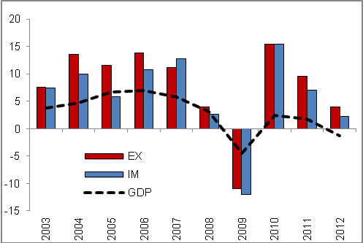 |  | 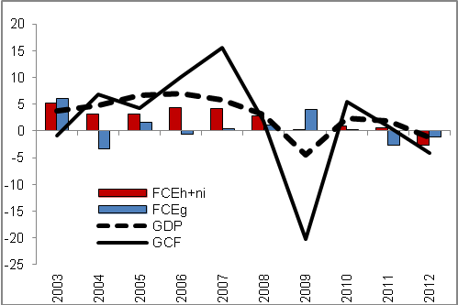
Source: Eurostat

Growth aspect of final consumption expenditure of government was in the CR below the EU average in the long-term |  | Minor effect on the long-term growth of the economic performance of the domestic economy in years 2003-2012 in the form of GDP had the final consumption expenditure of government (4.0 %) - in comparison to the European Union (26 %) nearly one seventh. So it was valid, that mostly the public services were in the CR provided to a lower extent to the rate corresponding to the EU average.
2010, 2011, 2012 – gradual cuts of the government consumption resulting from the saving measures… |  | From the strong growth of the government consumption in 2009, when its consumption increased as a result of the effort to limit the adverse economic development in the CR by unusual 4 %, a notable restrictions occurred. Already in 2010 the rate of growth of government consumption fell to mere two tenth of percentage. In the following year, the consumption was even decreased (-2.7 %) and the unfavourable development continued also in 2012 (-1.2 %). These three years of limited consumption of government institutions corresponded to the government cuts, which took place in a large extent both on the expenditure side and the revenue side. Reasons can be found in the effort to halt the increase of the government debt, which would thwart its financing with low interest rates (resulting from the loss of credibility on the part of the financial market) – in a way gradually observed mostly in countries of so called South wing in years 2010-2012.
…which were markedly higher compared to the European Union |  | Consequences of the fiscal consolidation in the CR – which in terms of the rate of growth of government consumption lasted in 2012 already for a third year – were more notable to those in the EU. In 2010 the government sector consumption in the EU still grew by 0.7 %, in 2011 it declined by 0.2 %, in 2012 already the level of its consumption stagnated. Thus it held true, that in all three years, the government consumption cuts in the CR were larger. It lowered the performance in the form of GDP in the given year, however the reforms should bring positive effects in the future both in the form of preserving the low rates of state debt financing and maintaining or even increasing the attractiveness of the CR as a promising investment locality for foreign investors.

Chart 5 | Consumer confidence indicator (2005=100, left axis) and final consumption expenditure of households (constant prices, y/y in %, right axis) | Chart 6 | Gross fixed capital formation of individual institutional sectors (current prices, in mil. crowns)
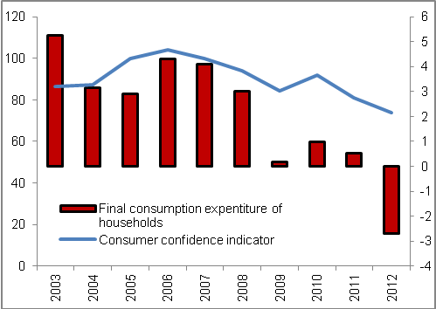 |  | 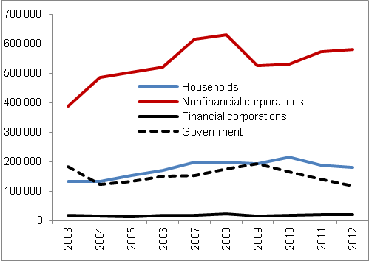
Source: CZSO, Eurostat

In 2012 the volume of gross capital formation also fell – both as a result of the limitation of investment and lowering of the stock of inventories |  |  | In 2012 the gross capital formation in the CR experienced also a negative development – the volume of this component fell by 4.1 %. If the gross fixed capital formation (investment) lowered by 2.7 %, the inventories must have also shared in its fall. The development from 2009 was thus repeated, when the investment fell by 11 %, gross capital formation however by larger 20.2 %. Higher fall of the gross capital formation compared to investment was in 2012 recorded also in the European Union. The decline in the stock of inventories could have been interpreted in a way, that on the part of producers a marked change in the demand was not expected – they believed that they can cover its potential increase from the regular production.
Gross fixed capital formation decreased in years 2009-2012 already twice |  |  | Lowering of the gross capital formation in 2012 reached one fifth of the fall in 2009, of the gross fixed capital formation one quarter. The volume of investment thus in years 2009-2012 decreased already twice – gross fixed capital formation in years 2010 and 2011 grew by 1 % and 0.4 %. Gross capital formation decreased in years 2009-2012 also for the second time.
Strong years of 2005-2007 increased the average rate of growth for the whole decade 2003-2012 to 1.9 % - however in years 2008-2012 the investment fell on average by 1.8 % per year |  |  | For the whole decade 2003-2012 the volume of gross fixed capital grew on average by 1.9 %. In years 2008-2012 however the rate of growth decreased significantly and achieved negative 1.8 %. Apart from the fall of investment in years 2009 and 2012 the notable development change affected the strong years 2005-2007, when a marked investment into own housing by households and increase in capital stock by firms occurred. Gross fixed capital formation grew by 6 % in 2005, in 2006 by 5.8 %. The largest increase of investment was then recorded in 2007 – it increased by a notable 13.2 %. Out of investment significant by volume in this year increased the investment into buildings by 6.4 %, into civil engineering buildings by 15.7 %, into machinery and equipment even by one third.
Limitation of investment in 2012 on the part of individual institutional sectors differed from 2009… |  |  | In 2009 the fall of gross fixed capital formation was observed mostly for companies (nonfinancial corporations by 16.6 %, financial corporations less significant by volume even by 34.4 %), which as a result of downswing of the foreign trade limited spending of the resources on further investment. The households also contributed to the fall of investment in 2009 (-3.5 %), which was the effect of the high demand for own housing before year 2008, which led even towards the overheating of the real estate market. On the contrary in 2012 the investment fell mostly on the side of government institutions.
…in 2012 the most markedly fell the gross fixed capital formation of the government institutions… |  |  | While in 2009 the government sector moderated the slump of the economy by an increase of new investment by 8.9 % (for instance total investment into the civil engineering buildings in the CR grew by 4.8 %), in 2010 it decreased it by 14.5 %, in the following year by 14.6 %. The slump of investment in 2012 was however the deepest – by 15.2 %. The consolidation of public finances taking place from 2010 inhibited the value of new investment in the economy still to a larger and larger extent.
…but even the household sector did not increase the volume of new investment |  |  | In 2012 the volume of gross fixed capital formation of households kept falling  (-4.1 %). Still compared to the previous year (-12.8 %) there was an improvement. On the contrary as a continuation of the adverse development can be year 2012 seen with respect to years 2008-2012, when the growth of investment in the household sector eventuated only in year 2010 (by 12.5 %), year 2008 can be considered rather as a year of stagnation (+0.2 %).
The lowering of the gross fixed capital formation in the CR in 2012 was also caused by the drop of investment into the solar panels… |  |  | On the drop of the gross fixed capital formation in 2012 had also an effect the subsiding positive influence of investment into the solar panels, which had been affecting the total investment in the economy already since year 2009 – then they only prevented the gross fixed capital formation from deeper decrease, they gained significance especially in 2010 and 2011, when it contributed to the growth of total investment in the economy by 1 % and 0.4 %.
…nonfinancial corporations thus increased the gross fixed capital formation in 2012 only by 1.6 % - compared to the previous year by mere one fifth of the percentage addition |  |  | It can be assumed, that the investment into solar panels was executed mostly by the sector of nonfinancial corporations. Subsiding of these investments in 2012 then caused the drop of the rate of growth of gross fixed capital formation in this sector from 8% in 2011 to mere 1.6 %. However, it is necessary to add, that the limitation of nonfinancial corporation investment was also caused by a lower rate of growth of goods and services exchange with abroad, as well as the weak household consumption – businesses thus changed the expectations regarding the future economic development and moderated their investment formation.
Still the gross capital formation participated on the long-term growth of GDP in the CR more than in the EU |  |  | Despite the adverse development of gross capital formation in 2012, it can still be considered as a more significant source of long-term GDP growth compared to the case of the EU. This component participated on the growth of GDP in years 2003-2012 from 13.7 %, which was roughly three times more compared to the EU as a whole (growth of GDP was affected only from 4.6 %). Main reasons of this growth can be seen in a gradual increase of the capital stock – the domestic economy was in comparison to the EU underinvested for a long-term – to the increase of the capital stock also contributed to a great extent the visions of profit opportunities on the part of foreign direct investors, who invested significantly in the CR.
Table 1 | Gross capital formation (GCF) and gross fixed capital formation (GFCF) in the CR and in the EU (constant prices, y/y in %)
GCF | 2003 | 2004 | 2005 | 2006 | 2007 | 2008 | 2009 | 2010 | 2011 | 2012
EU | 1,9 | 4,1 | 2,4 | 7,2 | 7,9 | -2,1 | -17,6 | 4,3 | 3,0 | -5,5
CR | -0,9 | 6,8 | 4,3 | 10,2 | 15,5 | 1,9 | -20,2 | 5,4 | 0,8 | -4,1
GFCF | 2003 | 2004 | 2005 | 2006 | 2007 | 2008 | 2009 | 2010 | 2011 | 2012
EU | 1,1 | 3,0 | 3,5 | 6,3 | 6,3 | -1,1 | -13,0 | 0,0 | 1,4 | -3,0
CR | 0,6 | 3,0 | 6,0 | 5,8 | 13,2 | 4,1 | -11,0 | 1,0 | 0,4 | -2,7

Source: Eurostat

The fall of GDP in 2012 was to the highest extent affected by the household and non-profit institutions consumption expenditure  (-1.3 p.p.)… |  | In the view of contributions of individual expenditure components on the fall of GDP in 2012 in the Czech Republic participated to the highest rate the final consumption expenditure of households and non-profit institutions (-1.3 p.p.). Despite the gross capital formation was falling faster compared to the households and non-profit institutions consumption, it contributed to the fall by less notable -1 p.p. – this is given by its lower share on the GDP (24.3 % in 2012) than in case of final consumption expenditure of households and non-profit institutions (in 2012 47.6%). Similarly, final consumption expenditure of government also contributed to the fall of GDP (-0.2 p.p.). The impact of unexplained discrepancy resulting from using the data in constant prices was in the amount of -0.3 p.p.
…net exports softened the drop of performance with its contribution in the amount of +1.6 p.p. |  | The growth of net exports then softened the adverse development in 2012 only to a limited extent, specifically by +1.6 p.p. It is evident, that despite the CR is a very open economy exposed to notable fluctuations on the part of the foreign trade, in 2012 the slump of GDP was caused by a lowered household and government consumption as well as dampened investment activity – all components of the domestic demand played a part in the decrease.

Chart 7 | Contributions to GDP growth in the CR  (constant prices, in p.p.) |  |  | Chart 8 | Contributions to GDP growth in the EU  (constant prices, in p.p.)
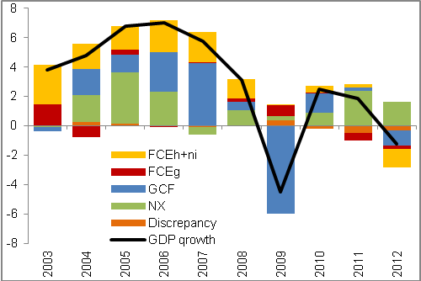 |  |  |  | 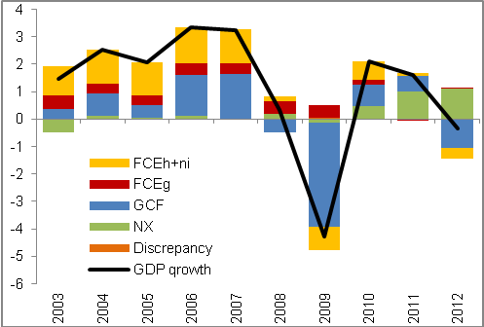
Source: Eurostat, own calculations

Supply side of GDP
Gross value added decreased in 2012 for four fifths of all industries |  |  | In 2012 the gross value added decreased by one percentage – thus after a two years' growth of 3.1 % in 2010 and 1.8 % in 2011 the gross value added of the economy again decreased. In comparison to the slump in 2009 (-5.2 %) it represented a roughly one fifth fall. The magnitude of the 2012 decrease can be however seen in a different aspect to the depth of its decrease. If in 2009 decreased the gross value added in 14 out of 20 industries, in 2012 it was already 16 of these. The main reason can be assigned to the fact, that the economic troubles in 2012 were caused both by the lowering of the rate of growth of the foreign demand (from 9.5 % to 4 %) and especially by a lower domestic demand – opposed to this in 2009 the foreign demand and the domestic investment activity decreased – final consumption expenditure softened the fall. Thus in 2012 the economic complications were related to a wider spectrum of expenditure activities compared to 2009.
The manufacturing industry, most significant by volume, faced a decrease, in comparison to slump of 2009 however it was a decrease rather negligible |  |  | Manufacturing industry most significant by volume (in 2012 it represented already 31.6 % of total gross value added in the economy) recorded in 2012 a reduction of value added by 0.4 %. Although it seems as a negligible decrease, it presented a lowering of value added by 4.4 bn crowns. Still compared to the drop by 15.4 % in 2009 (for the reason of weakened foreign demand as well as lower domestic investment activity) it was a decrease rather negligible – comparable values of year 2008 achieved the manufactory industry only in 2011.
…especially due to a continuing increase of the foreign exchange |  |  | Opposed to this in 2012 the lowering of gross value added in the manufacturing industry could be seen mostly in the lower domestic consumption, the investment activity was restricted to a much lesser extent. However more importantly – the fall in the foreign demand did not eventuate, only a lowering of the rate of growth – manufacturing industry is sensitive to the changes in the foreign trade dynamics.
Weak household consumption and a lower rate of growth of exports in 2012 adversely affected also the wholesale and retail trade |  |  | Second most significant industry in the Czech Republic economy by volume is the wholesale and retail trade. Its gross value added decreased in 2009 as well, however by much lower 3.7 % - this industry is usually less sensible to changes in foreign demand compared to the manufacturing industry. In years 2010 and 2011 the gross value added increased as a result of the exchange recovery of production with abroad but also a weak improvement of the household consumption – by 5.5 % and 8.1 %. Considerable fall in the household consumption in connection to the weaker rate of growth of foreign exchange however the increase of value added in 2012 halted – gross value added of wholesale and retail trade fell by 1.7 %.
Gross value added of construction was in 2012 lowered already for the second year in a row – it fell to the level of 2005 |  |  | Construction faced prolonged troubles. Restricted demand for housing on the part of households, lower investment activity of companies and also a considerable limitation of gross fixed capital formation of the government institutions (already since 2010) resulting from a notable reduction of the number of public procurements (their number fell in 2012 by 11.3 %, however they had already been cut for a fourth year in a row) decreased the gross value added in construction already for a second year. If in 2011 the gross value added in construction fell by 5.2 %, in 2012 then already by 5.4 %. The value of gross value added in 2012 thus reached the level of 2005. Still it is necessary to note, that construction has been facing troubles for a much longer time period – out of years 2008-2012 the gross value added fell already in four of them.
Saving measures of the government sector restricted the gross value added of public administration and defence, education as well as health and social work activities |  |  | For a second year the gross value added of the public administration and defence fell by a fast rate of growths as well. If still in 2010 the value added of this industry rose by 0.9 %, in 2011 it decreased by 2.4 %, in 2012 even by one tenth of percentage point more. With the fall of half a percentage in 2010 fought also the education. Long-term drop of performance (already since 2006) continued in the health and social work activities. Because these are the sectors with a considerable weight of the public sector, it is possible to assume, that the lowering of their gross value added was a consequence of the several times mentioned government saving measures.
Industry of arts, entertainment and recreation less significant by volume faced a decrease of gross value added by 5.8 bn crowns, that is more than the manufacturing industry… |  |  | Even if the industry of arts, entertainment and recreation forms only approximately one percentage of total value added in the economy, in 2012 as a result of notable weakening of demand after services of this industry the gross value added fell by high 17.8 %, which represented 5.8 bn crowns. Main role in this fall played the lowered household consumption – they in the complicated economic situation preferred to consume only essential products and services, which does not include the production of this industry.
…still the highest decrease in monetary terms was observed in financial and insurance activities |  |  | The highest decrease of gross value added in 2012 in monetary terms occurred in financial and insurance activities – by 10.9 bn crowns (-7.8 %). In years 2003 to 2012 the drop in this industry occurred only for the third time (in 2005 by 8.9 %, in 2010 by 3 %). Slump in 2012 can be ascribed to the lower interest in financial services on the part of business clients as well as physical persons, which in hard times searched for savings also in used services of this industry. The decrease was also caused by the already relatively high competition between individual institutions, which were forced to limit or completely eliminate payments for certain services – for instance in the form of fees.
The growth of proportion of alternative employment types had a positive effect on the gross value added creation in real estate activities… |  |  | Growth of gross value added in 2012 was on the contrary observed for real estate activities (by 3.3 %). Considerable share on this growth had the increase in employment in number of persons by 6.1 %. Less notable was however the increase in employment in number of hours worked (by 5.8 %) - thus it can be assumed, that in this industry there was an increase in the alternative employment types and trade license work. Total increase of gross value added in this industry created further 7.5 bn crowns against year 2011, which is nearly the double compared to the loss of manufacturing industry most significant by volume.
…and record net exports of electricity in connection to the marked share of electricity production from solar panels increased the gross value added in the energy industry by 14 % |  |  | Notable increase of the gross value added was recorded also in the energy industry (by 14 %) - the highest growth since 2008 (16.6 %). It is necessary to note that due to this increase in the value added the energy industry returned to the level comparable to 2009, because following the stated growth in 2008 the gross value added kept falling. The considerable rate of growth of value added of this industry was in 2012 most likely also influenced by the record net exports of electricity from the CR, as well as the high share of electricity production out of solar panels, which create energy out of de facto „nothing“.
Growth of share of alternative employment types probably increased the gross value added also in administrative and support service activities and professional, scientific and technical activities |  |  | Third industry, which managed in 2012 to increase the gross value added produced were the administrative and support service activities – by 6.2 %, which amounted to 3.5 bn crowns, the last one was then the professional, scientific and technical activities – by 5.8 % and 8.2 bn crowns. Similarly to the case of real estate activities had on the growth of gross value added of this two industries a marked share the growth of employment in number of persons by 2.3 %, in number of hours worked only by 1.2 %. Thus it can be again assumed, that in these industries the share of alternative employment types increased.

Chart 9 | Gross value added of sectors in the CR (constant prices, in bn crowns, pr. sector on the right axis) |  |  | Chart 10 | Contributions to gross value added change (constant prices, in p.p.)
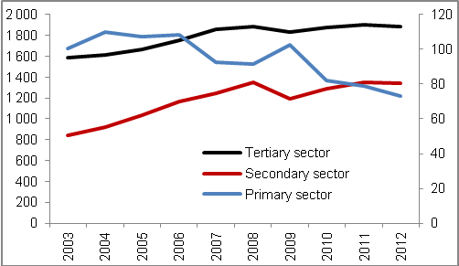 |  |  |  | 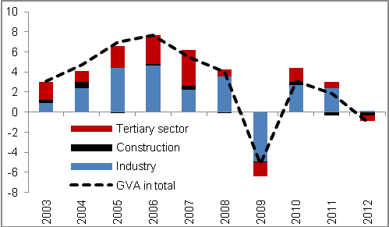
Source: CZSO, own calculations

Sources of long-term growth of GDP
Capital stock in the Czech Republic in years 2013-2012 was continually increasing and thus supported the growth of GDP in a stable way |  |  | Capital stock (gross stocks of fixed assets) was in the Czech Republic for a long-term a stable source of GDP growth, in the period of 2003 to 2012 showed constant growth on average of 2.4 % and shared in the growth of GDP with an average contribution in the amount of +1.0 p.p. Even in times of GDP decrease in 2009 was the fall softened by the growth of this quantity (+1.0 p.p.). We attribute the causes of this constant increase of capital stock to the underinvestment of the domestic economy – even despite the fact, that in two out of last four years (2009 and 2012) the gross fixed capital formation year-on-year decreased.
On the other hand the labour stock in the number of hours worked fluctuated and reacted to the given development of GDP – it was decreasing both in years 2009 and 2012 |  |  | The labour stock, on the other hand, could not be considered as stable (employment- in number of hours worked), since its value quite fluctuated through time – this development flows from the nature of this quantity itself, as the amount of labour stock is possible to relatively easily adjust to the actual economic situation, which was noticeable both in years 2009 (-3.0 %) and 2012 (-1.1 %), when the stock of labour fell considerably. Contribution of the stock of labour to GDP growth between years 2003 and 2012 reached an average of +0.1p.p. The contribution gained the highest value in year 2008 (+1.6 p.p.), i.e. in the period, when the growth of GDP already slowed down, the lowest value then in the mentioned year 2009 (contribution gained -1.8 percentage point) – stock of labour deepened the slump of GDP.
In years 2003 to 2012 the main sources of long-term GDP growth were the intensive factors… |  |  | In total these extensive sources from year 2003 to 2012 contributed by an average amount +1.1 p.p. and affected the growth of GDP by 39 %. Still the main factors in the GDP growth were in the monitored period the intensive sources, that is the labour productivity (based on the number of hours worked) and capital productivity. Together they shared on the growth of GDP between year 2003 and 2012 on average +1.8 p.p. (in the form of total factor productivity contribution). Intensive sources thus affected the GDP out of 62 %.
…while the labour productivity played the main role |  |  | Contribution of the labour productivity was acquiring positive values in the long-term – the exception was year 2009, when it reached -0.9 p.p. In the whole decade, the contributions amounted to on average +1.6 p.p. This development was given by the higher growth of GDP to employment, which subsequently implied a higher labour productivity. Contribution of the capital productivity achieved in the last ten years an average of +0.2 p.p. As a consequence of constant growth of capital stock and GDP decrease in years 2009 and 2012 the capital productivity was in these years decreasing and the contributions to the growth of GDP were negative. Due to the higher rate of growth of capital stock in 2011 over GDP, there was a negative contribution on the side of capital productivity also in this year. Out of last four years (2009-2012) was thus the contribution of the capital productivity negative in three of them.
Fall of GDP in 2012 was caused especially by the lowering of capital productivity… |  |  | The fall of GDP in 2012 was the effect especially of the intensive sources, concretely with the contribution of -1.5 p.p. GDP fell in nearly the same size as the number of hours worked, and the contribution on the side of labour productivity was nearly zero. On the other hand following the decrease of GDP and further growth of capital stock, there arose a fall of the capital productivity, which subsequently contributed to the fall of GDP -1.5 p.p.
…the fall was however also influenced by the decline of the stock of labour, growth of capital stock on the contrary the fall of GDP slowed down |  |  | Extensive sources as a whole softened the fall of GDP, by positive 0.3 percentage points. With respect to the decline of stock of labour, this source contributed to development of GDP -0.7 percentage points and thus deepened the fall of GDP. On the other hand the capital stock thus had to work against the lowering of GDP – it contributed to the development +1.0 p.p.

Chart 11 | Sources of long-term growth of GDP in the CR (constant prices, 2003=100)
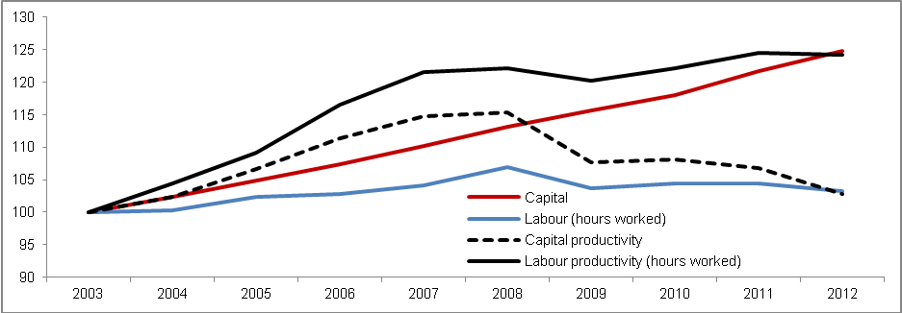
Source: CZSO, own calculations

Chart 12 | Contributions of sources of long-term growth of GDP in the CR (constant prices, in p.p.)
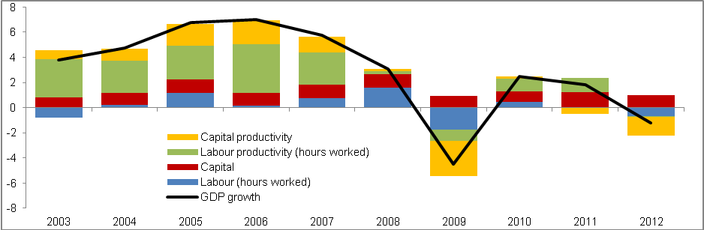
Source: CZSO, own calculations

Production Performance of Industries in the Economy
It is possible to view the business or corporations from two angles. Through the individual industries or as a one of main institutional sectors. The advantage of using institutional sectors lies in the fact, that these sectors join units with a similar economic behaviour. In case of business sector (in the institutional view categorised as non-financial corporations) it is mostly the significant role as a producer, investor and also employer. For assessment of the long-term dynamics of the performance of the businesses in the CR the data from the national accounts were primarily used.

Basic characteristics of the businesses (in the view of institutional sectors or industrial branches)
Key influence of non-financial corporations on the creation of gross value added of the national economy was interrupted by the onset of recession in 2009…  …contrary to growth rates in the following years their share has not even in 2012 reached the pre-crisis level |  | Non-financial corporations in the CR represent a key sector of the economy in the view of gross value added creation. The role of this sector has been increasing in the long-term. It was strengthened by the processes of economic integration (mostly the accession of the CR into the EU), which markedly expanded the export potential of domestic (mostly industrial) companies. Between years 2003 and 2008 the proportion of non-financial businesses on the gross value added creation in the whole national economy increased by nearly 5 p.p. Non-financial corporations sector was however also the most hit (out of all sectors in the CR) by the deep recession of 2009. Although the non-financial corporations generate since that time value added by year-on-year higher rates in comparison to other sectors of the economy, they remained also in 2012 below the level of the peak boom (in 2008 they created nearly two thirds of gross value added of the national economy). Mirror picture of the development of non-financial corporations represents the sector of households (mostly small entrepreneurs). At the beginning of the 90s households generated one quarter of value added of the whole economy, in 2012 its weight decreased to one sixth. Entrepreneurs felt the negative effect of recession mostly in years 2011 and 2012, specifically in construction as well as wide spectrum of services (mostly in food service activities). Sector of government institutions participated on the value added of the national economy in the long-term without higher fluctuations by one eighth. Adopted saving measures between years 2009 and 2012 led to the lowering of the weight of this sector by 0.5 p.p. At time of economic recession the influence of financial institutions in the Czech economy strengthened, their share on the total value added reached the highest value from the half of 90s. Mildly, but steadily strengthens its weight the so far peripheral sector of non-profit institutions.
At times of prevailing boom increased their share of gross value added in the economy especially the manufacturing industry and progressive services… |  | More significant structural changes in terms of gross value added creation can be observed in individual industries. High dynamics of the growth of value added of non-financial corporations in the long-term, mostly boom period (from half of 90s till year 2008). was dragged mostly by the manufacturing industry, in smaller part by some dynamic services industries (e.g. information activities or professional, scientific and technical activities). In this period on the contrary lowered their share on the value added of the whole economy the construction, energy industry as well as mining (in all cases due to the adverse development in the second half of 90s) and also already in the half of 90s relatively modest primary sector.

Chart 13 | Share of institutional sectors on gross value added creation^{*)} in the total economy and real growth of GDP | Chart 14 | Share of groups of industries on gross value added creation^{*)} in the total economy
^{*)} in basic prices (i.e. without taxes lowered by subsidies on products). Source: CZSO (national accounts)

…since the burst of recession have been relatively successful the financial services |  |  |  | In the subsequent period (2009-2012) marked by a deep recession the most decreased their share mainly the manufacturing industry and also in the group of services (trade, transportation, accommodation and food service activities). Relatively successful during recession were on the other hand energy industry, real estate activities, public services and mostly financial and insurance activities, which increased their share on the gross value added in the national economy in four years nearly by one half (from 3.4 % to 4.9 %)
Chart 15 |  | Share of main groups of industries on the growth of gross value added of the Czech economy^{*)} (y/y in %) |  |  | Chart 16 |  |  | Share of branches of services on the growth of gross value added of the Czech economy^{*)} (y/y in %)
^{*)} in basic prices (i.e. without taxes lowered by subsidies on products).
Note.: Calculated on seasonally adjusted data Source: CZSO (national accounts)
During boom in half of 90s as well as one decade later the manufacturing industry contributed to the year-on-year growth of value added in the CR economy markedly more compared to the services sector total |  |  |  | Data combining dynamics of growth of individual sectors as well as their total size (from the view of gross value added production) are mirrored in the contributions of partial industries to year-on-year growth of real gross value added of the national economy. With respect to the size of industries it is not surprising, that in the long-term the manufacturing industry contributed the most to the growth of value added. During period 1996-2008 it lost its dominant position only twice, to the benefit of financial services (1998) and to a cluster of selected services - trade, transportation, food service activities and accommodation (2001) resp. In most years of this period were the contributions of the manufacturing industry even notably higher compared to the whole tertiary sector. Within the services framework, the most contributes to the growth of value added in the whole economy in the long-term the cluster of services (trade, transportation and warehousing, food service activities and accommodation), which also as one of the first segment within services experienced the worsening of economic performance already during the year 2008. Within services, its position gradually improved the public services as well as professional, scientific, technical and administrative services, which still by the end of 90s influenced the growth of value added in the economy negatively, while throughout the most of the subsequent decade, their contribution was visibly positive (in years 2007-2008 secured one seventh of the growth of value added of the whole economy). The same can be within the secondary sector framework stated regarding the energy industry and construction.
Key meaning of the manufacturing industry for changes in dynamics of value added of the whole economy lasted also in year of deep recession and following two years of mild recovery  Weakening of year-on-year dynamics of gross value added during 2012 was felt the most in export oriented branches of the manufacturing industry |  |  |  | Key meaning of the manufacturing industry for the year-on-year dynamics of gross value added of the whole CR economy was further enhanced during the recession. In 2009 it shared in nearly three quarters on the sharp fall of the value added (-5 %). In the following two years it managed to easily compensate the year-on-year falls of the gross value added in the energy industry, construction or public services. For the whole year 2012 (with the minimal influence of manufacturing industry) on 1% year-on-year drop of the value added of the whole economy participated to the comparable extent most of other industries, in primary, secondary (especially construction) as well as tertiary sector (financial services, public services, trade as well as transportation, food service activities). The most significant feature of 2012 was gradual weakening of the year-on-year dynamics of the produced value added visible in most key industries during the year. The most for the production of transportation vehicles, negatively affected by the weakening of foreign demand. Growth of value added on the contrary did not stop in some smaller sections of services (real estate activities and employment activities) and thanks to a favourable development in first three quarters of 2012 also in the energy industry.
Chart 17 | Employment structure^{*)} based on subsectors of non-financial corporations in the CR (in %) |  |  |  |  | Chart 18 | Relative change of number of employed^{*)} based on institutional sectors in the CR  (Average year-on-year change in %)
^{*)} recalculated jobs to full-time equivalents Source: CZSO (national accounts)

Non-financial corporations in the CR concentrate nearly three fifths of jobs |  | Sector of non-financial corporations is generally considered to be not only a significant producer of value added, but it also enjoys a key role on the labour market. In 2011 this sector provided jobs to 59 % of employed persons in the CR (jobs recalculated to full-time employment). The weight of the non-financial corporations on the total employment is tightly connected to the change of the inner structure of employment in this sector.
Restructuralisation waves in the agriculture and industry in the 90s markedly decreased employment in public non-financial corporations as well as whole business sphere  Growth of weight of foreign controlled corporations was supported by strong growth of foreign direct investment (mainly from the break of millennium) continued also in the period of boom |  | Throughout the whole 90s and also in the first years after year 2000 faced this sector a fall of job vacancies (the strongest apart from the beginning of 90s in periods 1998-2000 and in 2003 – with year-on-year losses of jobs -3 to -4 %). These losses were connected with the restructuralisation waves in the primary and later mostly in the secondary sector, as well as with the shifts in the ownership structure of businesses (privatization of state companies and eventually also the entry of foreign owners). While the long-term fall of the share of public companies in the total employment in the whole non-financial corporations sector practically halted in 2013, the growth of employment in the foreign controlled private corporations continued also in the later boom years. It was possible thanks to still strong entry of the foreign capital into the domestic businesses, as well as the expansion of current production capacities of businesses under foreign control, which benefited from the dynamic development of exports. Between years 2003 and 2009 increased in the businesses the share of those under foreign control from 21 to 29 % (for industry), from 15 % to 25 % resp. (for market services). At the end of boom the foreign capital controlled 4 out of 10 corporations¹⁷ in market services with headquarters in Prague, and nearly 45 % of industrial corporations¹⁷ located in the Pilsen region. In the period 2009-2011 the proportions between individual subsectors of non-financial corporations remained without significant changes – public businesses employed one tenth of employees of the whole non-financial corporations sector, businesses with the prevailing foreign capital one third and national private businesses near 55 %. Weight of the foreign controlled corporations in years 2010 and 2011 slightly lowered, mostly in industry.
Portion of jobs spills over between non-financial corporations and the sector of small entrepreneurs in connection with the business cycle |  | In the successful period between years 2004-2008 the non-financial corporations belonged (next to the small segment of non-profit organisations) to the sector with the fastest growing employment (year-on-year on average by 3 %). Portion of jobs most likely spilled into the non-financial corporations in the time of boom (also thanks to the higher dynamics of wage growth) from the household sector (i.e. small entrepreneurs). Opposite phenomenon then occurred besides other things also for the reason of rationalisation of the operating costs of businesses after year 2009. In the 2009-2011 period the employment in the non-financial corporations sector as well as in government sector decreased by similar dynamics. While for the non-financial corporations it arrived in the form of one-off deeper fall in 2009 (-4%), in case of government sector it was a more gradual reduction spread throughout the whole period.

Chart 19 | Gross value added per employed person (in thousand crowns, constant prices, differences based on branches main groupings) | Chart 20 | Gross value added per employed person (non-financial corporations total*=100;  selected divisions of industry classification NACE*)
* Based on (74) divisions of industrial branches with prevailing non-financial corporations
Note.: Branches with prevailing non-financial corporations include all divisions of classification of economic activities (CZ-NACE) apart from financial and insurance activities (64-66), predominantly public services (84-91, 94) and households (97-98)
Employed persons = recalculated jobs on full time equivalents Source: CZSO (national accounts)

Long-term lag in the productivity in the primary sector and construction, favourable development in industry |  |  | One of the basic feature of the long-term productivity development (expressed as a ratio of gross value added to employed person) can be considered the development of inter-industry differentiation. It is obvious already from an approximate comparison of the main sectors of the economy. While in 1993 the productivity in the primary sector laid one seventh below the level of all industries (including all branches with prevailing of non-financial corporations), in 2011 it was lower nearly by one third (opposed to long-term fall of employment and strong year-on-year growth of gross value added against year 2010). In construction the productivity in the long-term oscillates between 70-75 % of level of all industries. Thanks to the growing weight of export oriented corporations under foreign control there was a convergence for the manufacturing industry, especially in the second half of the 90s. Above average growth of productivity in the whole secondary sector was ensured a decade later also by a favourable development in industries with high productivity – energy industry and mining industry. During recession on the contrary decreased the advance of the whole tertiary industry (without financial and public services) over other industries.
Growth of the inter-branch differences in productivity between years 1998 and 2005 and also during the recession |  |  | At the level of division (74) of the industry classification is for the last two decades apparent an increase of the frequency of partial industries, whose productivity does not reach 70 % of the level of all branches, as well as industrial divisions with a very high productivity (extraction of crude petroleum and natural gas; production and distribution of electricity, gas, steam and air conditioning; manufacture of tobacco products). The value of variation coefficient, which summarizes the relative differences between all assessed divisions, expressed a relatively sharp growth of differences in productivity between years 1998-2005. In spite of short-time slight convergence of industry productivities on the peak of boom the size of relative disparities between individual divisions in 2011 was the second highest in history.
Chart 21 | Gross value added per employed person* (in thous. crowns, cur.p., selected industry divisions) |  |  | Chart 22 | Gross value added per employed person (in thous. crowns, cur.p., selected services divisions*)
* Selected divisions of economic branches with prevailing non-financial corporations
Note.: employed persons = recalculated jobs to full-time equivalents Source: CZSO (national accounts)

Performance of non-financial corporations in the CR
More detailed analysis of the economic behaviour of the non-financial corporations in the CR is enabled by the time series of the sector accounts |  |  | Transformations of the economic behaviour of the sector of non-financial corporations can be relatively comprehensively characterised by a set of basic indicators derived from the national accounts tables. In the long-term view, it is apparent that the non-financial corporations in the CR similarly to most developed countries show financial need – i.e. net borrowing (their creditor is usually the financial sector). This was the case of the national private non-financial corporations mainly in the 90s, when the businesses as a result of the need to renew the production base invested massively. Still in the period 1998-2002 their investment rate moved around 35 % and it was the highest among all institutional sectors of the Czech economy (in the earlier part of the 90s it was exceeded only by the financial sector).
Chart 23 | Selected relative indicators of performance of non-financial corporations in the CR
Notes to the calculation of relative indicators:
- Rate of gross margin = gross operating surplus (B.2g) / gross value added (B.1g) * 100
- Rage of gross savings = gross savings (B.8g) / gross value added (B.1g) * 100
- Rate of gross investment = gross fixed capital formation (P.51) / gross value added (B.1g) * 100
- Rate of self-financing (narrow concept) = gross savings (B.8g) / gross fixed capital formation (P.51) *100
- Rate of self-financing (wider concept) = (gross savings /B.8g/ + capital transfer balance /D.9rec- D.9pay /) / (gross fixed capital formation /P.51/ + changes in inventories /P.52 /+ acquisitions less disposals of valuables /P.53/ + acquisitions less disposals of non-financial non-produced assets /K.2/) * 100
- Net profit rate = net operating surplus (B.2n) / total production (P.1) * 100
Source: CZSO (national accounts)

In the second half of 90s the strongly indebted non-financial corporations did not create enough of own resources for their strong investment need and had to take further debt mostly in the form of loans |  |  | Causes of the deep deficits (net borrowing) of the non-financial corporations in the second half of 90s laid among other things in the relatively lower rates of gross margins (beside other things as a result of mild recession in the economy), high debt (and subsequently higher need for repayments) and gradual deepening of the balance of owner income due to the higher outflow of dividends to foreign owners. Businesses could not earn enough resources, resp. savings (gross savings rate fell in 1997 to 20 %) to cover own high investment needs (during 1995-97 they managed to cover from own resources less than two thirds of investment).
During boom also increased the margin rate as well as the profitability of businesses…  …however businesses kept a significant financing need due to the growing outflow of dividends to the foreign shareholders and also by the contribution of growing stock of inventories |  |  | After 2001 the net borrowing as well as the rate of self-financing of non-financial corporations markedly improved. The rate of gross investment fell to the level of the whole national economy and the higher rate of gross margins enabled not only the strengthening of the dividend outflow mainly to the foreign owners, but also a relatively higher savings creation. In year of the peak boom (2007) achieved the non-financial corporations sector with the historically so far highest rate of gross margins (49 %) also a record financial deficit. The reason behind a seeming inconsistency was both the deep fall of the owner income balance (outflow of dividends but also a reinvested profits from foreign direct investment) and the high rate of investment mostly (esp. historically highest increase in inventories: year-on-year by total 100 bn crowns). Sharp improvement of the net lending/net borrowing of non-financial corporations in the year 2008, which experienced in its second half a notable signals of upcoming recession mostly in industry, was facilitated by a marked growth of savings (in absolute terms they even more than twice exceeded the value of savings in the household sector). The important role was played also by a mild fall of the investment rate as well as a lower increase of the stock of inventories and also the exceptionally positive balance of the non-financial corporations sector from the reinvested profits from foreign direct investment.
Businesses reacted to the year of deep recession by lowering of employment or investment and marked year-on-year fall of stock of inventories |  |  | Economic recession fell in 2009 on the sector of non-financial corporations in the CR by a full force. Gross value added here year-on-year fell the most out of all sectors (nominally by 6.3 %). This slump was partially compensated by the decrease of employment (-4 %), businesses however cut mostly the investment (gross fixed capital formation decreased by one sixth) and the stocks of inventories declined year-on-year by record 41 bn crowns. Year-on-year fall of inventories (however by a grade lower) recorded non-financial corporations only in the economically weak end of 90s.

Table 2 |  | Weight of non-financial corporations sector on national economy (%)  (selected aggregates of national accounts sets)
¹⁾ In 1997 acquired for non-financial corporations negative values, in the aggregate national economy were in the whole monitored period only positive.
²⁾ For the whole period was the balance for the whole national economy negative, for non-financial corporations acquired the balance of financial management the positive values only in years 1993 and 2009.
³⁾ Sum of financial liabilities in the final balance sheet: Securities other than interests (AF.3), Loans (AF.4), Other liabilities (AF.7)
⁴⁾ Balance sheet at the end of period, expresses the difference between the level of (financial and non-financial) assets and financial liabilities.
Source: CZSO (national accounts)

In times of „post-crisis“ stabilization businesses fought with the decreasing margin rate, prudent costs on labour force, as well as the investment area; they managed to keep repaying former loans |  |  |  | During 2010-2012 the businesses managed to renew a mild nominal growth of gross value added (ranging 1-2 %) and to stabilize the total employment (accompanied by a mild growth of paid compensations to employees – in 2012 +1.6 %). On the contrary they did not achieve to stop the falling gross margin rate, which gradually moved down to the level of half of 90s. Businesses were however successful in repaying the former loans (interest balance lowered from -50 bn crowns in 2010 to -7 bn crowns two years later) and also the long-term growth of outflow of dividends mostly to foreign owners ceased. Very careful was the growth of investment rate, as well as the year-on-year additions to the inventory balance. This behaviour in summary suggests that the non-financial corporations sector in the CR did not expect in the near future any substantial recovery of the economy. Thanks to the prudent attitude towards investment reached the non-financial corporations a high rate of self-financing, both from own savings (90 %) and all accumulation sources (nearly 100 %) and low deficit of the financial results.
Non-financial corporations in the CR in the long-term strengthen their influence on the performance of the whole economy  Recession of the beginning of year 2009 in the CR strongly affected first the non-financial corporations sector, later the government sector and households  The share of non-financial corporations on the whole economy exceeded in year 2012 the pre-crisis level especially for investment, savings and production, not yet the value added |  |  |  | From the perspective of the last two decades there is an obvious total favourable development for all important macro indicators (see table 2) of non-financial corporations in the CR in relation to other institutional sectors, especially after year 2000. Corporations were due to their marked exports orientations the first of all sectors of the CR economy hit by the economic recession. Its signals emerged in the business sector already in 2008 with a year-on-year decrease of the share of production and net operating surplus of non-financial corporations in total national economy.  Recession in this sector fully manifested in 2009 by a deep fall of the weight of non-financial corporations on investments and net operational surplus of the whole economy (in a lesser extent for value added and production). In the subsequent years the non-financial sector tried to utilize the short-term recovery of economies of the main exports destinations, while the consequences of recession fully manifested in other sectors of the CR economy – mostly the government sector and households. The result was a gradual growth of weight of performance indicators of the non-financial corporations sector on the whole CR economy. „Pre-crisis“ weight on the whole economy reached in 2012 the non-financial corporations in the CR in case of production, employee compensations (despite the fall of employment exceeding the level of most other sectors), creation of savings (among other also due to the impact of notable worsening of the performance of the government sector) and fixed investment. The proportion of net value added produced by the non-financial corporations on the total economy (opposed to production) in four years decreased by 1 p.p. It was the result of both higher dynamics of fixed capital consumption and costs within the production process (intermediate consumption).
Weight of foreign controlled corporations in the Czech economy strengthens in the long-term and significantly affects performance of the whole non-financial corporations sector |  |  |  | Performance of the whole non-financial corporations sector is influenced by its partial subsectors, whose behaviour is determined also by the completely different ownership structure. Non-financial corporations can be by ownership (resp. property control) divided into public (under state control), national private (in private ownership of entities of the given state) and under foreign control (remaining businesses, whose behaviour is decided by non-residents).
Chart 24 | Cost of labour of non-financial corporations (share of employee compensations (D1) in net value added (B.1n);  subsectors of non-financial corporations |  |  |  | Chart 25 |  | Rate of return of non-financial corporations (ratio of net entrepreneurial income (B.4n )* and assets (AN+AF);  subsectors of non-financial businesses
^{*)} Net entrepreneurial income (B.4n ) is the balancing item of the business income accounts, i.e. balancing item corresponding to the concept of profit before distribution and tax on income, as used in the business accounting.
Rate of return of non-financial corporations = B.4n / (AN+AF) * 100 Source: CZSO (national accounts)
Labour costs swallow two thirds of produced net value added of businesses…  …recession of the economy launched regardless of the ownership structure of businesses a mild increase of their share; companies attempt to sustain qualified employees |  |  |  | In case of the CR includes the subsector of corporations under foreign controls all branches, subsidiaries and places of business (of non-residential businesses) on the CR territory. Share of individual subsectors of non-financial businesses markedly changed mostly in the 90s and following period of boom, as evidenced by the above-mentioned significant shifts of employment between subsectors.  Significant part of produced net value added is in the non-financial corporations sector immediately used to cover the operational costs, mostly the compensations to employees. These include mostly the gross wages and salaries (incl. benefits in kind) and also all social contributions paid by the employer. In the view of employer thus represent complete costs of employing labour force. Share of compensations paid to employees in net value added decreased in the circumstances of the business sphere in the CR mostly in years of boom, a turn occurred in year 2008 (for public non-financial corporations only in 2010), since that time the labour force costs cut higher and higher share of the net value added produced by businesses.  Businesses in times of recession attempted to sustain the qualified labour force (in the anticipation of future growth of orders) and searched the needing savings of costs in other areas than the expenditure on labour force. Sharp growth of the rate of labour force cost emerging in public non-financial corporations after 2000 is linked to the more extensive transformation of the ownership structure of businesses in the period of strong inflow of foreign direct investment directed mostly to the more perspective businesses.
Dominant position of businesses under foreign control did not majorly affected even the recession…  …their rate of returns exceeds the level of private domestic businesses still more than one half |  |  |  | The mirror picture of the development of rate of costs of labour force provides the development of the rate of return of businesses. Since the second half of the 90s is obvious the dominant position of foreign controlled corporations (at times when the majority of net entrepreneurial income was still generated by firms controlled by the national private capital. Only in years 2000-2002 produced the firms with foreign owners a half of entrepreneurial income of all non-financial corporations in the CR, in 2009 it was just under two thirds. Deep recession of the economy adversely affected the rate of return of businesses regardless of the owner. However the most were hit (due to the fall of demand in exports destinations) the foreign controlled corporations, still compared to the national private corporations they sustained the relative rate of return on the double level.
Chart 26 | Property income balance  (main types of incomes for sector of of non-financial corporations) |  |  |  |  | Chart 27 |  | Property income balance (D4)  (comparison of subsectors of non-financial corporations)
Source: CZSO (national accounts)

In the 90s the high investment need of the businesses in the CR was mostly covered by loans from domestic banks, in the subsequent decade mostly by foreign capital  Recession halted the growth of outflow of dividends from the non-financial corporations sector in the CR, but businesses better repay the loans |  | Non-financial corporations in the CR lost in the process of primary redistribution of income in years 2010-2012 until now record two thirds (in absolute terms yearly more than 350 bn crowns) of produced net operational surplus. Notable impact of owner income deficit is however for businesses in the CR a long-time phenomenon. Since 1995 the businesses have lost in the primary redistribution less than half of net operation surplus only twice (in 2005 and 2008). While in the 90s the under-capitalised domestic businesses searched sources of necessary investments mostly in the bank loans, in the later years they stemmed mostly from the massive inflow of foreign direct investment (mostly from period 1999-2002). High interest rates as well as the indebtedness of businesses were in the 90s the causes of deep negative balance from interests (in times of recession of years 1997-1998 paid the non-financial corporations for interest by 105-115 bn crowns more compared to their income from deposits).  Since year 2001 the negative balance from redistributed income of corporations (mostly in form of dividends) exceeds over the size of negative balance flowing from interests. Gradual deepening of the negative balance of owner income temporarily stopped for corporations in 2008 due to the marked strengthening of income (for national private corporations) from reinvested profits from foreign direct investment and from simultaneously sharp decline of transferred operation surpluses from foreign investment (for foreign controlled corporations). In times of recession the slump of the dividend balance for the non-financial corporations in the CR halted (mostly due to the influence of businesses under foreign control) and at the same time the businesses manage to be repaying loans (interest balance lowered between years 2010 and 2012 in the whole non-financial corporations sector from -50 bn crowns to -7 bn crowns).

Chart 28 | Share of net operational surplus (B.2n) on total production (P.1) of non-financial businesses (comparison of subsectors of non-financial corporations in the CR) | Chart 29 | Net operational surplus per 1 employed person (in thous. crowns)  (comparison of subsectors of non-financial corporations in the CR)
^{*)} recalculated jobs to full-time equivalent Source: CZSO (national accounts)

Differences in the profitability rate for businesses by their ownership structure deepened during the boom, in recession convergent tendencies were apparent  Varying dynamics as well as timing of reduction of total employment among subsectors of business in times of recession |  |  |  | Differences between subsectors of non-financial corporations in the long-time development of rate of profit, alternatively produced operational surplus per employed person give in the basic features a similar picture of business sphere in the CR as in case of its rate of return. The scissors open among businesses based on the type of prevailing owner especially at times of boom (among other also due to the larger changes of the ownership structure resulting from the inflow of foreign direct investment), in times of recession (second half of 90s, decade later resp.) there were apparent convergent tendencies (mostly for the profitability rate). Negative rate of profit of public non-financial corporations in 2001 was the result of deep year-on-year fall of gross value added in the group of these businesses accompanied by a stagnation of total costs per labour force. Negative impacts of the current recession put a mark on profitability but as well as on productivity. Productivity was also affected by a varying dynamics of employment in the different groups of businesses. Between years 2008 and 2011 the total employment decreased in foreign controlled corporations by 6.8 %, in private companies with prevailing domestic capital by 2.5 %, for businesses controlled by the public sector by 4.8 % (where opposed to the previous categories occurred the largest year-on-year decrease not until 2011).

Investment rate

Differences in the investment rate between the subsectors of the non-financial corporations lower than for profits or productivity  Long-term differences of businesses in the structure of gross fixed capital formation |  |  |  | Opposed to indicators covering other aspects of the performance of businesses (labour costs, rate of return, profitability, productivity) in case of investment activity (expressed by rate of gross investment) there are no differences between the assessed group of businesses so significant (which is valid especially for businesses with the prevailing private capital). With respect to size still less and less significant subsector of public non-financial corporations holds within the business sphere in the long-term the highest rate of investment. Exception was only the period of first half of 90s and year 2003 (when the value of acquiring tangible fixed assets was likely negatively influenced by higher sale of state property). Individual subsectors of businesses slightly differ in the long-time in the structure of gross fixed capital formation. Foreign controlled corporations still more often invest into acquiring of non-tangible fixed assets (e.g. SW, database, cultural and art works, geological exploration) and also prefer more the investments into new assets as opposed to the already used.
Chart 30 |  | Rate of gross investment﻿ of non-financial corporations in the CR (subsectors of non-financial corporations) |  |  |  |  | Chart 31 |  | Rate of gross investment of institutional sectors in the CR  (in % GVA of the given sector)
^{*)} Investment rate in more narrow conception i.e. gross fixed capital formation (P.51)/ gross value added (B.1g) * 100
Source: CZSO (national accounts)

Narrow and wider conception of investment; part of investment of businesses included in their intermediate consumption |  |  |  |  |  | Investments can be understood also in a wider conception (investment to inventories, acquiring of valuables or to land). When included also these items the excess of rate of investment of foreign controlled corporation over other businesses in the 90s is even more highlighted, the rate of investment of public non-financial corporations after 2008 also increases. However not even this conception can completely capture the investment behaviour of businesses. It does not involve e.g. the expenditures on research, education or marketing activities (these items can be found in total intermediate consumption and cannot be individually analysed by means of national accounts).
Differences in the rate of investment of various subsectors of non-financial corporations in the shadow of significant differences between various sectors of national economy |  |  |  |  |  | Differences in the rate of investment between various subsectors of businesses in the CR are in the long-term in the shadow of much more significant differences in the investment activity of different sectors of the national economy. The investment rate in the non-financial corporations sector fell slightly below the level of the whole economy only in the short time period, when these businesses in the CR were most hit by recession. On the contrary through the whole 90s and also the half of subsequent decade they belonged to the sectors with the highest investment activity. Significant contribution of inflow of foreign direct investment as well as processes of economic integration also played its role. In times of boom the highest rates of investment were reached by the government sector, whose investment activity was however significantly restricted by the saving measures in year s 2010-2012. Despite of this government investment rate still however by the end of period maintained the level of the non-financial corporations.

Debt ratio
Indebtedness in relation to non-financial businesses assets |  |  |  |  |  | Apart from the common transactions and accumulation of non-financial assets (capital) the performance of businesses is affected also by the accumulation of financial property (incl. the changes of property and liabilities resulting from random and formal influences and also due to the movement of prices). Important indicator derived from the relation between the property and liabilities balance of the non-financial corporations is the debt ratio.
Chart 32 | Rate of debt of non-financial corporations in the CR, share of selected liabilities on total assets (financial and non-financial)* |  |  |  |  |  |  | Chart 33 |  | Share of institutional sectors on total debt* of the CR
^{*)}Sum of financial liabilities in the closing balance sheet: Securities other than shares (AF.3) + Loans (AF.4) + Other liabilities (AF.7) divided by sum of financial (AF) and non-financial (AN) assts Source: CZSO (national accounts)

Opposed to the gradual fall of the debt ratio the non-financial corporations sector still holds the first place of the relatively most indebted sector of the Czech economy  Current recession has not led so far for non-financial corporations thanks to their prudential behaviour to a larger increase in the debt ratio |  | The size of indebtedness reaches (in relation to the value of all assets) for the non-financial corporation sector the highest values of all institutional sectors in the CR. A high debt ratio was typical of businesses practically through the whole 90s, both for national private businesses as well as businesses under foreign control. While for national private businesses the debt ratio started to gradually fall down in the second half of 90s, for companies directed by foreign owners it fluctuated around a high level (50 %) until year 2002. Since 2005 the debt ratio for both groups of private businesses does not significantly differ and the indebtedness of the whole business sector stagnated since then.  Compared to other sectors (mostly the government) the businesses were negatively influenced by the deep recession, to which they managed to flexibly react (high creation of savings in 2008, major lowering of costs as well as investment in 2009 and successful repayments of loans in the subsequent years). Despite this their debt ratio remained in 2011 the largest from all sectors (30 %), followed by the government sector (25.5 %), financial sector and households (similarly 15.5 %) and the least indebted non-profit sector (6.5 %).
Lower debt ratio of public firms affected also by a high value of their property |  | Debt ratio of companies shows a significant connection to the investment need of companies realised in the preceding years, it is also however affected by the size of the assets. In this sense can be partially explained the lower indebtedness of the public non-financial companies in the long-term featuring a relatively high value of their property (e.g. buildings, land). Value of non-financial assets of public firms shared at the end of 2012 on the aggregate value of these assets in the whole non-financial corporations sector by a complete one quarter.
High dynamics of the growth of indebtedness of individual sectors situated in different periods |  | Individual sectors differed also by a varying course of the debt dynamics. In the period of subsiding boom as well as mild recession (1995-1998) the most grew the debt (in relation to total assets) in the financial sector, in the period 1999-2003 for government institutions, in years of culminating boom (2004-2007) for households (including households as consumers as well as small entrepreneurs), which from year 2008 the government sector again took the leading position in debt dynamics.
Businesses saturated a high investment need by the bank loans mostly in the 90s, later it was replaced by a foreign capital … |  | With the debt ratio of businesses is also connected the volume of loans acquired in the past. Loans of financial institutions active in the CR were the key source of funds covering the high investment need of businesses mostly in the 90s, afterwards their significance started gradually falling, which is apparent from the view of banks themselves as well. While still at the end of 2002, the loans to non-financial corporations formed a half of the value of all client loans provided by commercial banks in the CR, at the end of boom period they fell to 40 % and in the half of 2013 they reached only a one third share.
…and since 2009 the businesses lost the position of dominant loan client of banks (to the benefit of households) |  | Mostly with the expansion of the mortgage market households assumed the role of the dominant client (as consumers). From May 2009 the volume of loans provided to households overtook the loans to non-financial corporations. From the half of 2010 the strong growth of loans provided to households slowed down and the division of loans between institutional sectors did not change to a large extent in the subsequent period any more.

Loans in default
The growth of loans in default as one of the signals of coming recession turned up firstly for businesses, later for small entrepreneurs and roughly with a year's lag also for households |  | Financial health of businesses is reflected also in the frequency of loans, which are paid off with a longer delay (loans in default, resp. non-performing loans). Long-term development of year-on-year changes of the volume of loans evidences a narrow connection with the business cycle – mostly for non-financial corporations and small entrepreneurs. At the same time there is obvious a different onset of first impacts of strong economic weakening during year 2008. In the business sector the size of loans in default increased already at the beginning of Q3 2008, for small entrepreneurs it eventuated only in the last two months of the same year. In case of households (population) the dynamics of the value of problematic loans started to accelerate since the second half of 2009 (signs of prudential behaviour of households occurred by the end of 2008 by the decrease of year-on-year dynamics of the consumer credit).

Chart 34 | Dynamics of non-performing clients loans (in total loans) of the selected institutional sectors of the CR economy (year-on-year change in %)
^{*)} Other sectors include: government and non-profit institutions and also non-residents
Note: In financial institutions are not from year 2008 included saving and credit institutions. Source: CNB

Continuous year-on-year growth of the size of loans in default in the last decade only in the household sector |  |  | Households as the only institutional sector of the economy kept at least a mild growth of the size of troubled loans throughout the whole last decade (while at times of boom these were sustained by the high dynamics of all closed consumer credit, in years 2011-2012 they were more affected by the undiminishing volume of loans for housing). On the contrary in the non-financial corporations sector the volume of troubled loans started since the second half of 2011 year-on-year slightly fall. It was due to the more prudent approach of businesses as well as banks themselves when concluding new loan contracts.
 |  |  | We gain even more precise information regarding the payment ability in the individual sectors of the economy, when we compare the size of loans in default with the aggregate balance of loans in these sectors. The share of troubled (non-performing) loans reached for all sectors a long-time minimum (data are available since 2002) at the break of years 2007 and 2008. In this period, it was also achieved a minimal difference in the share of loans in default between two main segments of the loan market – non-financial corporations (2.9 %) and households (2.8 %).
Chart 35 | Share of non-performing clients loans (in total loans) of institutional sectors of the CR economy
Source: CNB

Growth of share of loans in default was in crisis year 2009 for the non-financial corporations the sharpest among all sectors of the economy…  …mild improvement in the subsequent two years resulted from a prudent investment policy of businesses together with more strict set up of loan terms of banks  Adverse development of the weight of problematic loans in the sector of small entrepreneurs since the beginning of recession still continues  Proportion of loans in default since 2005 the highest in restaurants, accommodation and food service activities;  adverse development launched with recession lasts also in construction, on the contrary improvement in trade and manufacturing industry |  |  | Crisis year 2009 was reflected in all institutional sectors in marked increase of the proportion of problematic loans. In business sphere this process started the first (in half of 2008), was the most dynamic (during crisis year the share of loans in default increased from 4.4 % to 8.0 %), but it also reached the first its peak up-to-date (9.0 % at the end of Q3 2010). Favourable development in the business sphere halted at the end of 2012. The share of troubled loans of businesses increased during the first half of 2013 by 0.2 p.p. and remained one quarter above the level of whole economy. Relatively favourable development for businesses in the last two years can be explained by the above mentioned factors – tightening of the terms of loan providers (as a reaction to sharp growth of troubled loans in 2009) and also a more responsible behaviour of companies (repaying the former loans and very cautious growth of the investment rate).  On the contrary, the share of loans in defaulted of small entrepreneurs most likely has not peaked yet, with its growth lasting for already more than four years and during 2013 exceeding the 14% boundary. It is probably the effect of long-term unfavourable development in certain industries hit mostly by the drop of private consumption (construction, trade, food service activities etc.). In the view of banks themselves, the sector of small entrepreneurs however composes in comparison to the business sector and population a relatively small segment of the loan market – it shared on the problematic loans of all sectors below 3.5 % in the half of 2013.  Ongoing economic recession led among others also to a marked differentiation of industries according to the proportion of troubled loans. While the manufacturing industry (represented especially by the non-financial corporations) managed to improve its payment morals towards banks already during 2010, in case of constructions the signs of improvement can be traced only to the beginning of 2013. Unfortunately, the extent to what the sector of small entrepreneurs shares on the adverse result of loans in construction cannot be from the commonly available data discerned, which is anyway valid also in case of trade, whose development was however between years 2010 and 2012 notably more favourable.
Chart 36 | Share of non-performing clients loans (in total loans) of the selected industries of the CR
^{*)} Includes all codes of economic activities classification (CZ-NACE) apart from financial and insurance activities (64-66), predominantly public services (84-91, 94) and households (97-98) Source: CNB

In small segments of the market – energy industry, mining industry and primary sector – the proportion of troubled loans significantly below the level of whole economy |  |  | Recession on the contrary did not influence the payment morals towards banks of economic entities with predominating focus on primary sector much. If we omit the loan specific industries (financial sector an d public services), then it was just the primary sector, which as the only industry decrease the share of its loans in default between years 2005 and 2013. Relatively small segment with respect to size the accommodation, restaurants and food service activities records up to year 2005 the highest share of loans in default, in fact continuously (only in 2010 it was exceeded with a worse payment morals by construction and for a short time also by manufacturing industry). Out of industries with a prevailing non-financial businesses display a good payment morals in the long-terms the energy industry and mining industry.
Chart 37 | Share of non-performing clients loans (in total loans) and its change in main industries of the CR economy (between 31 December of 2007 and 31 December of 2012)
Source: CNB

Manufacturing industry contributed between years 2007 and 2012 to the growth of size of non-performing loans of all industries (with the prevailing non-financial corporations) by one third |  | In times of recession the payment morals towards banks worsened the most in construction and the accommodation, restaurants and food service activities. However these industries participated on the size of loans in default of all industries with a prevailing non-financial business in the half of 2013 still only by one seventh. Key manufacturing industry in the last five years due to the impact of very adverse development in 2009 also considerably increased its size of loans in default. Because of its large weight (also on the loan market) contributed this industry to the increase of the total volume of loans in default (of all industries with prevailing non-financial businesses) between years 2007 and 2012 by one third.
Significant differences in the representation of loans in default between branches are also conditioned by structural differences |  | Large inter-branch differences in the representation of loans in default in the last years are not only the result of the current economic situation in individual branches. They also reflect the different investment need given by the nature of various branches or the investment policy in the 90s. Significant role is most likely played by the ownership structure (public businesses, private businesses national and under foreign control), as well as differences in size of entities in individual branches (large companies, small and medium enterprises, small entrepreneurs). Preference for other financial sources apart from bank loans must also be mentioned (non-bank intermediaries, investment subsidies from public sources etc.).

Internal and External Imbalance
Departion of the Czech economy from balance was not apparent in 2012 despite the country being in recession. Internal imbalance according to the size of relative deficit of the public finances improved as well as the external imbalance according to the deficit of current account of balance of payments. Among other significant imbalances on the macroeconomic level further deepened the disproportion between supply and demand on the labour market, relation between development of real wage and labour productivities also transformed.

Deficit and debt of the government sector
Debt crisis, which Greece entered already during 2010 and which also subsequently hit some other countries of the South Europe, impacted also on the other countries of the euro area due to the need to share the „rehabilitation of losses“. The CR according to the Eurostat data fared in this period very well and its government institutions deficits as well as their projections into the development of gross consolidated debt of the government sector did not presented any marked worsening of the relative position in the European context. Also the private debt in the CR in relation to GDP belongs to the lowest in the EU.

Deficit of government institutions
Extraordinary influences significantly affected the year-on-year worsening of the government sector deficit in the CR to 169 bn in 2012 from 124.9 bn in 2011… |  |  | Government sector in the CR ended in 2012 in deficit, which amounted to 169.003 bn crowns against 124.943 bn crowns in 2011. The worsening was caused based on the notification submitted by CZSO to the European Commission „inclusion of financial compensations linked to the restitution of church property in the amount of 59 bn crowns and the correction of EU subsidies pre-financed from the state budget (returned funds in the amount of 12 bn crowns). With both influences the government sector deficit would reach the size of 2.5% of GDP.
… i.e. 4.4 % of nominal GDP from 3.3 % in 2011 |  |  | Following the year-on-year improvement of the government sector deficit in the CR in years 2010 (by 35.6 bn crowns) and 2011 (by 57.8 bn crowns) thus the shown deficit in 2012 worsened year-on-year by 44.1 bn crowns, which represented 4.4 % of nominal GDP (4.8 % in 2010 and 3.3 % in 2011).
Chart 38 | Government sector deficit  (in % of nominal GDP) |  |  | Chart 39 | Gross consolidated government sector debt (in % of nominal GDP)
 |  |  |  | 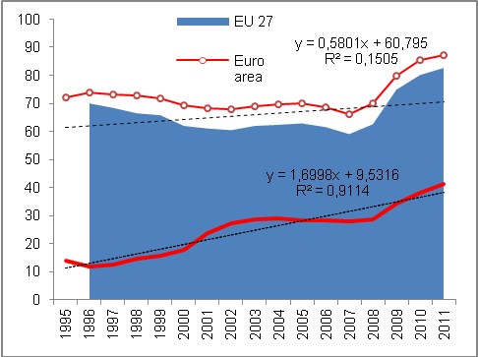
Source: Eurostat, own calculations

Worse deficit of central government institutions, better of local government institutions and effectively the same of social security funds  The only EU country with a government sector surplus in 2012 was Germany |  | On the size of government sector deficit in the CR in the amount of 169 bn in 2012 shared the government institutions by their deficit in the amount of 160 bn crowns expanded against year 2011 by 56.8 bn crowns. On the contrary, improved budget presented the local government institutions, which reduced the 2011 deficit (14.7 bn) to 2.2 bn crowns. They restricted their deficits also in years 2010 (by 1.7 bn) and 2011 (5.6 bn crowns). On the contrary, the deficit of social security funds remained nearly the same (6.8 bn crowns against 6.9 bn in 2011).  Practically whole government sector deficit in the CR in 2012 represented the deficit of state finances (central government), i.e. 95 % of government deficit (in 2011 it was 83 % and in 2010 84 % of total deficit).  In the view of international comparison the only country of the EU, whose government sector budget ended in 2012 with an excess of revenues over outlays was Germany (chart 40). Even here however the surplus was only small, arriving at 0.2 % of German GDP. All other countries of the Union were with their government sectors in deficits.
Chart 40 Government sector deficit (in % of nominal GDP, EU countries, EU 27 average)
Source: Eurostat
Chart 41 Government sector deficit of South Europe countries (in% of nominal GDP, EU countries,
EU 27 average)
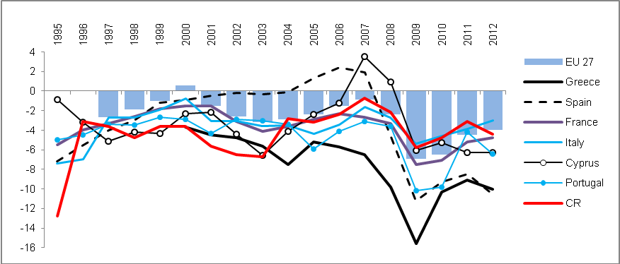
Source: Eurostat
In 2012 in deficits even the traditionally the „budget successful“ countries of North Europe |  | Year 2012 was not successful for government sectors practically of all European countries. Even states showing surpluses in past occurred in 2012 in deficits – e.g. the long-time in surplus North of Europe – in Sweden (-0.5 % of GDP) the deficit showed similarly to crisis year 2009, it strongly deepened in Denmark (from -1.8 % to -4 % of GDP, i.e. to European average), slightly less then in Finland (from -0.8 % to -1.9 %). Improvement of a not very good situation of the government sector budget recorded Netherlands (from -4.5 % to -4.1 % of GDP).  Excellent result on the contrary most likely sustained Norway, standing outside the European Union. According to the latest available data for year 2011 amounted their surplus of the government sector to 13.6 % of GDP, year earlier then to 11.2 %.
Mild improvement of deficits in Poland and Slovakia, out of troubled countries also Italy and France |  | To improve the results of government sector budgets managed out of the „economically related countries“ to the Czech Republic in Poland (-3.9 % of GDP), Slovakia -4.3 %) %), Slovenia (-4 %), distinctive development occurred also in Ireland (from -13.4 % in 2011 to -7.6 % in 2012), which in the previous period provided guarantees to its collapsing bank sector. In troubled countries of South Europe (chart 41) further increased the year-on-year mildly deep deficits of Greece (-10 %) and Spain (-10.6 %), faster the in comparison so far smaller deficit of Portugal (-6.4 %). On the contrary the deficit of France (-4.8 % of GDP) and Italy (-3 %) improved.

Gross consolidated debt of the government institutions
Gross consolidated debt of the government institutions in the CR increased in 2012 to 1758.8 bn crowns, i.e. year-on-year growth of  12.1 % |  | Government sector in the CR was by the end of 2012 indebted in the amount of  1 758.872 bn crowns. Nominal value of this gross consolidated debt of government institutions was compared to 2011 higher by 189.9 bn crowns, i.e. by 12.1 %. It represented a faster year-on-year growth compared to years 2010 (+11.7 %) and 2011 (+9.2 %). In the European context was then the relative size of this debt to GDP in 2012 despite the significant increase still only the roughly a half level in comparison to the relative debt of the government sector for the EU 27 %.  In the view of financial instruments this debt was focused mostly into long-term bonds (1390.8 bn crowns the balance as of the end of 2012), which also dominated its yearly addition (147 bn crowns).
Interest cost on gross consolidated debt of the government sector increased in 2012 to 57 bn crowns |  | Servicing the gross consolidated debt in 2012 required to pay out on interest 57 bn crowns (interests based on ESA 95, consolidated). These interest costs grow in time (from 52.5 bn in 2011 and 51.1 bn crowns in 2010, when they for the first time exceeded the fifty billion boundary).
Debt of local government institutions only 6.2 % of total gross debt of government institutions in the CR in 2012 |  | Similarly to deficit, on the government sector debt also participates the indebtedness of central government institutions from 1652.9 bn crowns based on the balance as of the end of 2012 with the growth against the year 2011 by 12.4 %. The debt of local government institutions represented 109.4 bn crowns (year-on-year growth by 9.6 %) and the debt of social security funds  172 mil crowns with a year-on-year change of -9.5 %).

Chart 42 | Gross consolidated debt of the government sector for year 2012 (in % nom. GDP) | Chart 43 | CR ranking among EU 27 according to the government sector debt (debt/nom. GDP, in %)
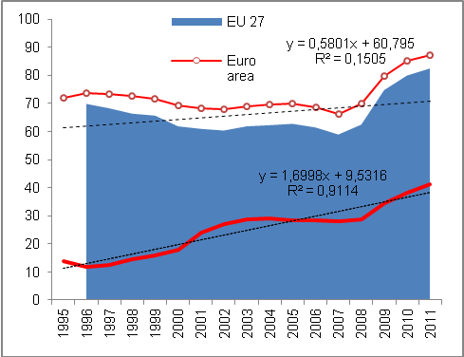
Source: Eurostat, own calculations

Debt/GDP in the CR in 2012 45.8 %, in the EU 27 on average 85.3 % |  | Czech Republic from the position of the seventh least indebted country of the EU 27 in 2011 with 40.8 % of gross consolidated debt of the government sector in relation to the nominal GDP shifted in 2012 to the eight position with the relation of debt to GDP in the size of 45.8 %.
The speed of indebtedness in 2012 the highest in Portugal, Cyprus and Ireland, in the CR in the view of the EU rather medium |  | Even though the speed of the relative indebtedness of the government sector in the CR is often highlighted as the highest risk for its public finances, development in 2012 shows, that year-on-year increase by 5 percentage points was in the context of the EU 27 countries rather lower.  The government sector debt grew in 2012 the most in Portugal, by 15.3 p.p. to 123.6 % of GDP, in Spain by 14.9 p.p. to 84.2 %, in Cyprus by 14.7 p.p. to 85.8 % and in Ireland by 11.2 p.p. to 117.6 % of GDP of these countries. These are mostly the countries having faced the debt crisis already before the year 2012 and its solving is as can be seen from the speed of debt growth still an issue.
Year-on-year growth of relative indebtedness in the CR in 2012 in percentage points roughly the same as in Netherlands or United Kingdom |  | In the CR, as noted before, the relative debt of the government sector increased in 2012 by 5 p.p., which was approximately the same as in the Netherlands (+5.7 p.p.) or in the United Kingdom (+4.5 p.p.). Both countries were however in 2012 in relation to GDP considerably more indebted (71.2 % and 90 % of GDP resp.) compared to the CR (45.8 % of GDP). In this sense roughly comparable countries, i.e. by the relative debt of the government sectors, as Denmark, Latvia and Lithuania (45.8 %, 40,7 % and 40,7 % of GDP) nevertheless managed in 2012 to guard its growth better, since the year-on-year additions of this indebtedness were compared to the CR lower or the relative debt even decreased (Denmark -0.6 p.p., Latvia -1.2 p.p. and Lithuania +2.2 p.p.).
Countries with favourable relations of government debt to GDP – Estonia, Bulgaria, Luxembourg |  | The least indebted country of EU 27, with regards to the government sector debt to GDP was in 2012 Estonia, whose debt represented a mere one tenth of the nominal GDP (10.1 %). However, even in this case the year-on-year increase amounted to 3.9 p.p., which is with respect to the size of the debt in 2011 (6.2 % HDP) a rather high increase.  Among other countries with favourable relation of gross consolidated debt of the government sector to GDP were in 2012 in the EU 27 apart from Estonia also Bulgaria, Luxembourg, Romania and Sweden except for already mentioned Latvia and Lithuania (chart 44). In these countries the relative indebtedness was in comparison to the CR in 2012 lower. Its year-on-year worsening occurred only in case of Bulgaria, Romania, Luxembourg and Lithuania, mostly no more than only by 2.5 p.p. In the remaining part of this group of lowly indebted countries of the Union, the government sector debt compared to 2011 decreased.
Chart 44 Gross consolidated debt of the government sector in 2012 (in % of nominal GDP)
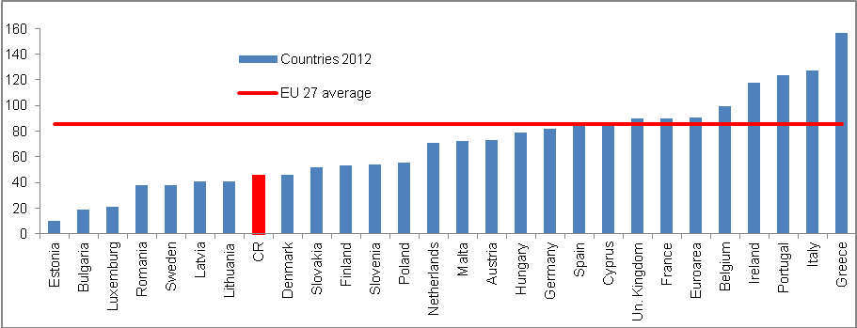
Source: Eurostat 2012

Private debt
Apart from the government sector, other institutional sectors of countries have also other liabilities. If we sum up the indebtedness of companies (non-financial businesses), households and non-profit institutions serving households, we acquire a so called private debt of a given country. The balance of this debt in relation to GDP can supplement the view on the liabilities of the government sector and formulate the indebtedness in the given country more completely.

Private debt in the CR gauged at 78.6 % of GDP in 2011 was in the EU 27 benchmark the fourth lowest |  | Private debt involving the debt balances of non-financial businesses, households and institutions serving households in the Czech Republic amounted according to the latest Eurostat data in 2011 in total to 78.6 % of nominal GDP. It was the fourth lowest private debt in this relative expression out of all countries of the union (chart 45). Lower debt reported in this year only Lithuania (70.1 %), Rumunsko (71.8 %) and Slovakia (76.3 % of nominal GDP). Against 2010 the CR kept this position (then the better relative result reached apart from Romania and Slovakia also Poland).
Long-term accrual of this relative private debt for years 2003-2011 by 22.8 percentage points was after Netherlands (+22 p.p.) and fall of private debt in Germany (-19.6 p.p.) the lowest in the EU 27 despite a sharp increase of household debt in this period |  | In light of years 2003-2011 the accruals of private debt increased the most in countries now facing also immense complications with the debts of their government sectors – in Ireland the private debt increased for the given period by 153 p.p. to 309.5 % of GDP, in Cyprus by 124 p.p. to 289.4 % of GDP. Somewhat lower accruals for years 2003-2011 are obvious for the private debt of Italy and Greece (+35.2 p.p. and +58 p.p. resp.), but still considering a hypothetical comparison, these countries would need more than whole annual GDP of year 2011 to amortize the balance of their debt (128.6 % of GDP and 130 % of GDP resp.).  On the contrary, the Czech Republic recorded a very low accrual of private debt for the period 2003-2011, which is surprising, since the major growth of household debt falls just into this time period, mainly in years 2004-2008. People borrowed especially to acquire their own housing – more than three quarters of household debts consisted of and consist also in 2013 – just the mortgages and loans from building societies. Year-on-year rates of growth of mortgages exceeded in this period of ongoing boom 30 %. Also in 2012, when the significant slump of the household loans from commercial banks continued, the year-on-year addition remained positive.  Role when assessing the low growth of private debt in the Czech Republic however most likely plays the fact, that the crisis of year 2009 markedly lowered the rate of lending to firms and after a relatively long time period, the loans to firms year-on-year declined.

Chart 45 | Private debt* - CR ranking in EU 27  (in % of nom. GDP) | Chart 46 | Development of relation private debt/nom. GDP in the CR and selected countries (in %)
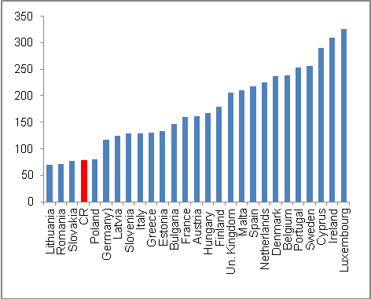

*Debt of non-financial businesses and households inc. non-profit institutions serving households
Source: Eurostat

Relative private debt fell for years 2003-2011 out of EU 27 countries only in Germany |  | For years 2003-2011 increased in the EU 27 relative private debt less than in case of the Czech Republic (+22.8 p.p..) only in Netherlands (+22 p.p.), its decline recorded as the only one EU 27 country only Germany (-19.6 p.p.).

Indebtedness of the CR – private debt and debt of government institutions
Indebtedness of the Czech Republic according to private debt and government sector debt together amounted to 119.4 % of nominal GDP in 2011, which was the third best result among the EU 27 countries following Romania and Lithuania |  | If we aggregate the debt of the government sector and the private debt – both in the relative expression to nominal GDP – the position of the Czech Republic is on the EU 27 countries ranks even better compared to individual rankings (chart 47).  As stated, according to the relative size of the gross consolidated debt of the government sector was the CR in eight and in 2011 it was placed seventh among the EU 27 countries. In case of private debt again relative to GDP, it ranked then in both years the fourth. Thus if we calculate the relative position of the CR in the indebtedness according to the government as well as private debt, we arrive at the conclusion, that in the EU 27 there are only two countries indebted less than the Czech Republic (Romania with 106.5 % of these debts in relation to GDP and Lithuania with 108.6 %).  Debt in the CR in 2011 according to the private debt together with the debt of the government sector represented 119.4 % of nominal GDP, which was only negligibly more compared to this way defined debt of Slovakia (119.6 % of GDP).
The most indebted was in 2011 Ireland with 416 % of GDP of private and government debt together |  | The highest debt recorded in year 2011 Ireland (chart 47), where the private debt and the debt of government sector represented together 415.9 % of GDP. On this participated from three quarters the relative private debt (309.5 % of GDP), and from the remaining part also in the European context very high debt of the government sector (109.5 % of GDP).
Chart 47 Gross consolidated debt of the government sector incl. private debt (in % of nominal GDP)
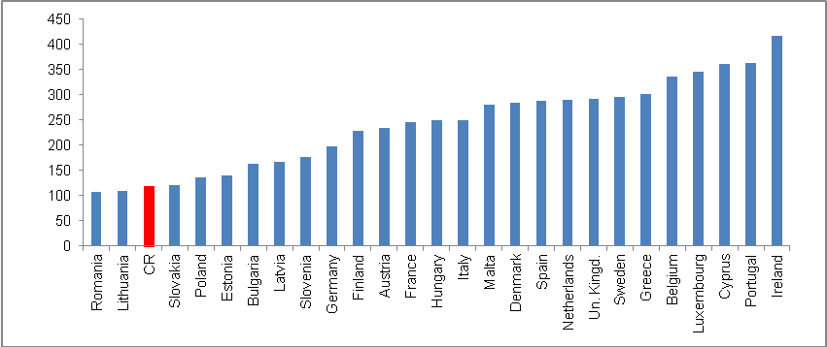
Source: Eurostat, own calculations

External imbalance
The extent of external imbalance of the Czech economy given by the balance of the current account of the balance of payments determines the ability of the performance balance to create surpluses and on the contrary, the intensity of the income balance deficits increases.

For the whole decade 2003-2012 the relatively favourable external imbalance at the size of average deficit of current account of 3.2 % of nominal GDP |  |  | For the decade of 2003-2012 the deficit of the current account of the balance of payments as one the basic measures of the external imbalance moved in the CR on average around an annual 3.2 % of the nominal GDP. Before the accession to the EU, when the Czech economy regularly recorded the deficits in the foreign trade with goods, the current account deficit occurred in 2003 on 6 % of GDP. However, after that already in 2005 due to the marked dynamism of exports following the elimination of administrative barriers for the penetration on the European markets, it fell thanks to the trade balance surplus to mere one percentage of the nominal GDP (chart 48). However, it was also the best result of the monitored period 2003-2012.
Fluctuation of the imbalance towards its lowering |  |  | Certain instability of the external imbalance according to the current account deficit was characteristic for the observed period. Still the trend of its gradual improvement roughly since 2006 can be observed. In years 2011 and 2012, the deficit of the current account moved to an improved level (-2.7 % and -2.5 % of nominal GDP resp.) compared to the long-time average (-3.2 % in years 2003-2012).
In the CR, the imbalance in the economic relations „paradoxically“ reduced in times of crises and recessions – due to the higher surpluses of the trade balance; this was confirmed also in 2012  In 2012 came to the CR direct investment from abroad in the amount of 207.4 bn crowns, in that 57 % constituted the reinvested profits … |  |  | It is typical for the Czech economy that in times of economic slowdown, respectively recessions or crises, the result of the foreign trade with goods improves even given the notable loss of the rate of growth of the goods flows. In the 2009 crisis, when the exports from the CR were falling for several months year-on-year roughly by one quarter, the trade balance reached high positive values. Similarly, although to a lesser extent, worked the situation in 2012. It can be most likely explained by high export-import interconnectedness of the Czech economy, the structure of exports, changed foreign demand and also the fact, that the trade balance is improved by weak imports into the CR. In addition, in recession in case it has a more global character, the prices of crude petroleum fall and thus so does imports. It was typically for year 2012 mostly for the reason, that domestic demand was very weak and the drop on foreign markets arrived only approximately in the last quarter.  Balance of the financial account of the balance of payments, whose positive result can compensate a deficit current account is in case of the Czech Republic in the long-time view markedly influenced by the intensity of the foreign direct investment inflow.  In 2012, the CR recorded the third highest inflow of foreign direct investment for the whole period 2002-2012 (chart 49) in the amount of 207.4 bn crowns (compared to 277.7 bn crowns in 2002 and 279.2 bn crowns in 2005). In that 118.3 bn crowns constituted the profits reinvested back into the Czech economy. Capital inputs as such represented 63.5 bn crowns and the rest, i.e. 25.6 bn crowns presented the other capital.
Chart 48 | Current account of balance of payments deficit (in % nominal GDP) |  |  | Chart 49 | Inflow of foreign direct investment into CR and sale of state shares (in bn crowns)
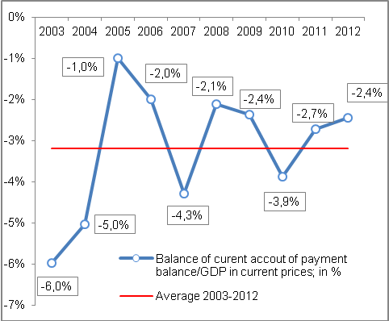 |  |  |  | 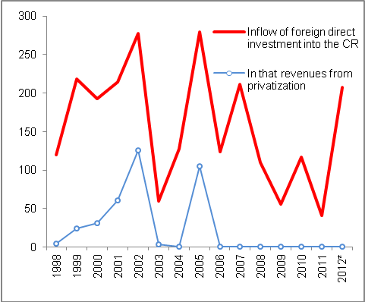
*Preliminary data Source: CNB, own calculations

… and 31 % of direct investment constituted the direct inputs into the equity of companies – privatizations do not play any role already since 2006 |  | While in the first half of the past decade had a role in the inflow of direct investment the sales of state shares in companies to the hands of foreign investors, starting 2008 the factor of privatization practically disappeared (chart 49). Last sale of state property to foreign hands eventuated in 2005.
Investment of Czech entities abroad amount annually on average for years 2002-2012 just under mere one eighth of foreign direct investment |  | With respect to the investment of domestic entities abroad, there is for the whole period obvious – in fact since the beginning of independent Czech Republic – a marked disproportion compared to the flows of foreign investment into the CR. For the period 2002-2012 were arriving into the CR annually on average directed investment in the value of 146.5 bn crowns, but investment of domestic entities abroad amounted only to 21.7 bn crowns annually on average, i.e. something below 15 %. In 2012 the direct investors from the CR invested abroad 26.2 bn crowns, in years 2005 and 2011 they reduced their investments (returned flow of funds into the CR).

Labour market imbalance
Very favourable imbalance of the supply and demand on the labour market in the CR in the finishing boom of 2008… |  | High imbalance on the Czech Republic labour marked has been already lasting longer than three years. At the end of boom of the Czech economy, i.e. approximately in the half of 2008, there was a relatively favourable imbalance on the labour market. Numbers of vacancies in some months of the first half year of 2008 exceeded 150 thousand of offers and the number of job applicants progressed below the boundary of 300 thousand persons.
…replaced by a sharp fall of vacancies, when the numbers of job applicants were rising since 2009 |  | In 2010 the numbers of job applicants registered by the employment offices overtook the boundary of half a million persons (in chart 50 the seasonal fluctuations of this indicator in individual years is shown, their numbers were falling in the summer months, when the opportunities of seasonal employment are growing).
Stagnation of the number of job vacancies from September 2009 till March 2012 between 30-40 thousand |  | On the contrary, the business sector did not create job vacancies, pressure on the labour market presented also the laying off the persons employed in the public sector resulting from the government saving measures. Practically since the second half of 2009 the number of offered vacant positions stagnates between 30-40 thousand.
Very mild recovery of supply of vacancies from April to October 2012, afterwards the number of job applicants again higher than half a million persons |  | Very mild recovery was in this direction apparent in 2012 from April till October, when the numbers of supply of vacant positions exceeded 40 thousand, however in the last two months of the year, the supply again decreased. There were again more than half a million job applicants (509 thousand persons in November and 545 thousand persons in December 2012).

Chart 50 | Supply of vacant positions and numbers of job applicants (in thous. of persons) | Chart 51 | Unemployment rate* (according to ILO, in %) and changes of economic activity  (in percentage points)

*Since 2009 the average rate of unemployment not seasonally adjusted; additions/reductions in the rate of economic activity year-on-year for Q4
Source: CNB, own calculations

Labour productivity and real wage development
During years 2004-2007 faster growth of labour productivity over real wage... |  |  | Following the strong growths of the labour productivity in the Czech economy in years 2004-2007, when its rate of growth markedly overtook the growth of the real wage and the character of the Czech economy thus could have been titled as intensive, the subsequent period proved to be considerably less favourable.
…and different development in the subsequent years |  |  | Year-on-year fall of the labour productivity in 2009 was linked to the slump of the economic performance – the gross value added declined year-on-year more (-2.4 %) than the employment (-1.8 %). Returned growth of the labour productivity in years 2010 and 2010 was caused by the fact, that the labour market reacted with a lag and the number of employed persons was decreasing in both years (-1.2 % and -0.03 % resp.). The created gross value added however already mildly grew (by the same number of 0.7 % in both years 2010 and 2011).  In 2010 an atypical phenomenon occurred, when the growth of employed persons (year-on-year by +0.4 %) was accompanied by a decrease of the economy (-0.2 % according to the gross value added). The cause lied in the specific changes on the Czech labour market with the growth of till that time limitedly used part-time employment.
Chart 52 | Relation of labour productivity and real wage dynamics (y/y in %) |  |  | Chart 53 | Labour productivity and average wage (increases against 2002)

Source: CZSO, own calculations

Lead of the year-on-year rates of growth of real wage before the rates of growth of the labour productivity only in 2003 and 2009; in 2012 decrease in both cases |  | Faster growth of the real wage compared to the labour productivity in the decade of 2003-2012 occurred only in 2003 (+5.7 % year-on-year against +5.6 % year-on-year for the labour productivity) and in 2009 (+2.3 % against -0.6 %). In 2012 fell both the real wage and the labour productivity (similarly by -0.6 %). The fall of real wage eventuated in 2012 in the CR for the first time and was to a considerable extent influenced by a high rate of inflation (+3.3 %), as the average nominal monthly wage increased in comparison to year 2011 by 2.7 %.  Roughly from year 2008 the economy already lost the intensive growth character. As can bee seen in chart 53, „the opening scissors“between the rate of growth of labour productivity and the growth of real wage ceased to be visible since year 2009.

Price development
Even despite a relatively unfavourable situation in the CR economy in 2012, the prices grew. The increase was caused both by the growth of import prices and the increase of VAT in January of this year. Prices for consumers increase the most for years 2009-2012. As a consequence of adverse climatic conditions and continuing lowering of animal production in agriculture eventuated further growth of prices of this industry. Growth of imports prices increased the prices of industrial production. On the contrary, the adverse situation in construction produced further decrease of construction works prices, mild lowering was also observed in market services. Also thanks to a weaker crown against both the two major world currencies in comparison to year 2011, the prices of exports and imports markedly increased, domestic economy however still faced losses flowing from the adverse development of terms of trade.

Aggregate price level in the economy in 2012 again increased |  | Following two years of fall (2010 by 1.6 %, 2011 by 0.9 %) the general prices grew in 2012 from the point of view of implicit GDP deflator by 1.4 %. In the context of years 2003-2012 the increase of the price level was above average (average growth by 1.1 %). With respect to the development in the pre-crisis period – in 2007 in the amount of 3.3 %, in 2008 1.9 %, even in 2009 the price level still grew by a notable rate of growth of 2.3 % - it was still however a relatively weak growth.
Pressure on the fall of the price level from the side of foreign trade subsided, domestic economy however still showed losses from the terms of trade effect |  | In the view of individual deflators of the expenditure items the growth was observed especially for exports and imports. Exports deflator pointed to the growth of price level of 3.1 % (the highest dynamics since year 1997), for imports even by 3.6 % (the fastest growth since 2000). Evident higher increase of the imports prices signifies a worsening terms of trade. However, what was important, the drop of terms of trade flowing from these deflators showed a slowdown and the pressure on the overall price level lowering was in 2012 lower compared to the preceding two years. Domestic economy thus gradually decreased the loss resulting from the terms of trade effect – nevertheless a profit was last reached in 2009.
Within the final consumption expenditure frame, the price level grew the fastest for households, the slowest for the non-profit institutions |  | Deflator of total final consumption expenditure in 2012 signalled an increase in the price level by 2.1 %. The highest rate of growth recorded the price level for final consumption expenditure of households (2.3 %), the lowest the prices of final consumption expenditure of non-profit institutions (0.7 %). Deflator of final consumption expenditure of government institutions amounted to 1.6 %. Price level of consumption expenditure thus in all three institutional sectors, which consume in the economy, grew. It was not prevented even by the suppressed consumption of the household and government institutions sectors. Main role in the price increase in 2012 played most likely the rise of VAT and continuing increase of the import prices.
Following two years fall the price level grew also in the context of gross capital formation… |  | Deflator of the gross capital formation added among the individual aggregates the lowest, but still positive value of 0.5 %. Following a two years fall of prices of gross capital formation (2010 -0.6 %, in 2011 -1.1 %) their mild growth again contributed to the growth of the overall price level in the economy.
…the same was valid for investment |  | Very similarly oscillated also the prices of gross fixed capital formation – in 2010 they fell by 0.5 %, in 2011 by 1.2 %. In 2012 their price level increased by 0.5 %. On the repeated growth of prices of gross fixed capital formation most likely participated the changing structure of this component. If we assume, that large investment of the government sector are relatively cheaper compared to the investment of other sectors, then with their limitation on the part of government institutions occurred falls of the share of investment of government institutions on total investment in the economy, whose price subsequently increased.

Table No. 3 | Deflators (y/y in %)
 | GDP | FCE | GCF | Exports | Imports
2008 | 1,9 | 4,4 | 0,1 | -4,5 | -3,1
2009 | 2,3 | 1,3 | 0,9 | 0,3 | -1,7
2010 | -1,6 | -0,2 | -0,6 | -1,3 | 0,6
2011 | -0,9 | 0,6 | -1,1 | 0,8 | 2,5
2012 | 1,4 | 2,1 | 0,5 | 3,1 | 3,6

Source: CZSO

Consumer prices
Consumer price index grew in years 2003-2012 continuously |  | Consumer price index (CPI) in years 2003 to 2012 displayed relatively stable growth by an average year-on-year rate of growth of 2.4 %. Still, the development of CPI can be in this period divided in two parts according to the rates of growth dynamics. The first is a gradual increase in the rate of growth beginning year 2003 until 2008, influenced especially by a high economic performance positively affected by the accession to the European Union, fall of the rate of unemployment linked to the growth of nominal wages and subsequent growth of consumer demand for goods and services – strong demand then pushed on the price increases. In 2008 the increase of VAT also affected the inflation.
After lowering of the rate of growth of consumer prices in 2009 the growth again gained pace… |  | As a consequence of significant increase of the rate of unemployment in 2009 (from 4.4 % to 6.7 % according to the ILO methodology) following the economic slowdown, the demand for goods and services fell. Year-on-year change of CPI plunged to mere 1 %. To this decrease contributed also a lowering of the imports prices, which also consequently manifested in the prices for consumers. Nevertheless, in years 2010-2012 the rates of growth of consumer prices for the reason of gradual increase of the imports prices regained pace (even despite remaining unemployment). Period 2009-2012 thus can be with respect to a gradual growth of prices for consumers labelled as the second cycle.
…in 2012 the rate of growth of consumer prices compared to 2011 nearly doubled |  | In 2012 eventuated an above average growth of the consumer prices, specifically by 3.3 %. The rate of growth thus showed acceleration already third year in a row and in comparison to year 2011 nearly doubled (growth in 2011 reached 1.9 %). Still the prices in 2012 increased much less than in 2008 (by 6.3 %).
Significant share on inflation had the increase of the lower VAT already in January 2012 |  | To the high growth of consumer prices in 2012 contributed also the increase of the lower VAT rate from 10 % to 14 % valid from January 2012. This change had an immediate impact on the price level of goods and services for consumers – consumer price index increased in January 2012 against December 2011 significantly by 1.8 %. It is obvious that this growth was affected also by other factors, such as season. Still it can be assumed that the impact of VAT rate increase was high – it confirms also the analysis of the consumer price index addition, when the tax amendments themselves caused an increase of prices compared to the previous month by 1.1 %.
Apart from VAT change also other artificial interventions stood behind the CPI dynamics in 2012… |  | In the view of individual product groups in the consumer basked grew the fastest in 2012 the prices for goods included in the division health by 9.4 %, which was influenced by exclusion of a number of medication from the list of those paid for by the insurance companies. The rate of growth of prices of food and non-alcoholic beverages (+7.0 %) recorded acceleration in the past 3 years, prices of possessions within housing, water, energy and fuels (+ 5.0 %) grow practically continuously. It seems that the prices of these products convert to the level common in the EU.
…divisions such as clothing and footwear or post and telecommunication put the brakes on the year-on-year inflation… |  | On the contrary, inflation was pressed down by the decrease of prices in the division of clothing and footwear (-3.0 %), whose prices were falling already thirteenth year in a row – on the price fall participated apart from a considerable competition most likely also the fact, that this goods is for a high part produced in countries with low cost of labour. Prices of post and telecommunication were decreasing (-2.4 %) for the reason of long-time strengthening competition also on the market of telephone services and appliances (prices of post and telecommunication were falling already fifth year in a row). Prices of furnishing, housholds equipment and maintenance decreased year-on-year by 1.1 %.
…as well as the recreation and culture |  | Fourth year in a row was also observed the fall of prices in the area of recreation and culture (-0.2 %) – specifically the prices were by 8.1 % lowered for „technology used in recreation“(for instance cameras, video cameras etc.), but also for other products of long-term consumption for recreation and culture  (-2.1 %). The fall of prices in this area was most likely influenced by the decreased demand from consumers, who already owned the stated products and in the adverse period did not find it necessary to purchase new appliances.
In the long-term view the price stability of the CR was above-average, growth of price in 2012 was however the fifth highest among the EU countries |  | Harmonised index of consumer prices (HICP) increased in the CR during period 2003-2012 by 25.2 %, which placed the CR on the ninth position from the point of view of stability of prices in the whole EU. With respect to the growth of HICP in the EU by 26.6 % it was a placing mildly above average. Considerable growth of HICP in 2012 by 3.5 % however moved the Czech Republic to the fifth worst position. Comparable dynamics reached the prices in Slovakia and Poland, where the growth amounted to 3.7 %, or Romania with an increase of prices by 3.4 %.
Price development of individual segments of the harmonised index of consumer prices was in the CR markedly different from the EU |  | Given the structure of HICP growth existed between the development of prices in the CR and EU considerable differences. While in the CR in years 2003-2012 markedly grew the prices of expenditure on health (on average by 6.3 %) or housing, water, energies and fuels (on average by 5.6 %), in the EU the average growth of prices corresponded only by 2.6 % and 3.9 % respectively. So it is obvious, that in these areas the CR converted to the average price level in the EU. On the contrary, while prices of other groups of products in the EU grew, in the CR they on average decreased – clothing and footwear -3.3 %, in the EU prices stagnated; prices of furnishing, housholds equipment and maintenance in the CR were declining on average by 1.1 %, in the EU they were on the contrary increasing by 1.3 %.

Chart 54 | CPI in the CR (2003=100, left axis; y/y change in %, right axis) | Chart 55 | HICP in the CR and EU (2003=100, left axis; y/y change in %, right axis)
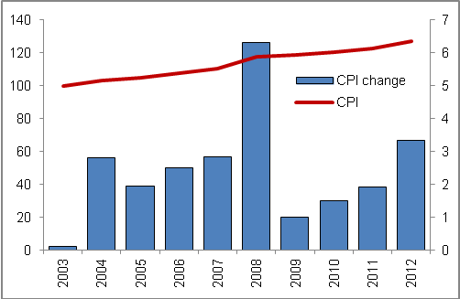 |  | 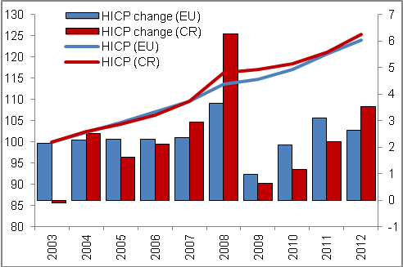
Source: CZSO Source: Eurostat

Chart 56 | Average year-on-year change of prices in individual divisions of consumer price index (y/y in %)
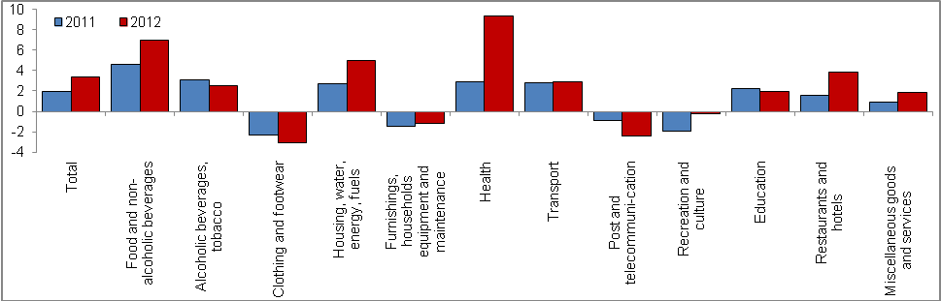
Source: CZSO

Chart 57 | HICP growth in countries accessing the EU in 2004 (horizontal axis - HICP y/y in % in 2012, vertical axis - average HICP y/y in % in years 2003-2012)
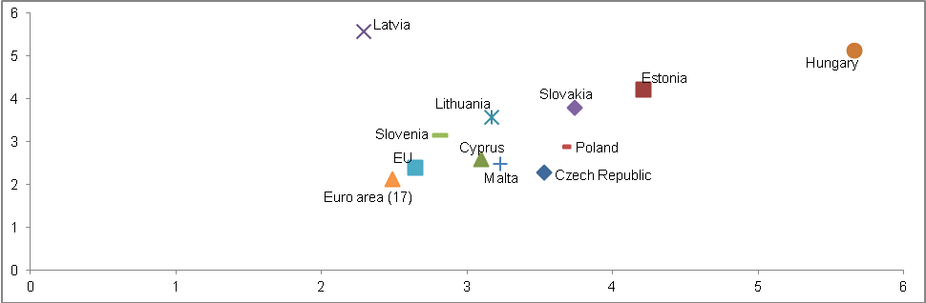
Source: Eurostat

Producer prices
Prices of agricultural producers grew already third year in a row, year-on-year increase in 2012 however markedly shrank |  | Prices of agricultural producers grew in years 2006 till 2012 by relatively high year-on-year rate of growth on average by 3.9 %, while these rates of growth showed very high variability. Marked changes in the prices of agricultural products have their justification especially in the prices of crop production – prices change as a result of varying harvests in individual years. Year 2012 was characterised by mildly below-average year-on-year growth of prices of agricultural producers by 3.8 % - after considerable growth in 2011 (by 21.2 %) given mostly by high prices on the world commodity markets thus the rate of growth was slowing down, however it remained positive already third year in a row.
Source of price growth in agriculture was in 2012 especially the animal production (+5.4 %) |  | In half of 2012 eventuated in the world for the reason of insufficient harvest a repeated increase of prices, for example the price of wheat increased from approximately 600 USD above 900 USD. Adverse climatic conditions decreased the harvest in the CR as well – still the prices of cereals increased by a notably lower proportion 4.4 %, compared to the world markets. Due to the opposite development of prices in the vegetable segment (-10.6 %) and potatoes (-20.5 %) the prices of aggregate crop production increased only by 2.7 %. Increase of the agricultural producer price index was pushed mostly by the area of animal production (+5.4 %) – it can be assumed, that the growth of prices was affected by a growing demand for quality products on the part of consumers, but also the effort to support local producers. On the other hand the domestic animal production has been falling already for a long-term, which led to the limitation of domestic supply.
 |  | Let us compare the stabilization of prices in individual areas of agricultural production. If the price of cereals increased in 2011 by 47.1 %, in 2012 already only by mentioned 4.4 %. The growth of prices of industrial crops also slowed down – from 32.8 % (the high growth of prices of industrial crops in 2011 was influenced mostly by rape) to 6.0 %.
Eggs – extreme growth of prices by tenths of percentage as a result of the EU legislative change |  | Among extreme price fluctuations in 2012 of individual agricultural products we can name for instance an increase of price of eggs by 53.6 %, which had its foundation in the EU directive related to the more stricter conditions for the breeding of hens. It is also worth to mention the development of prices of potatoes, which grew in 2011 by 3.6 %, in 2012 however slumped by 20.5 % and thus contributed to the lowering of the rate of growth of the crop production. The fall of prices in 2012 was most likely affected also by the high harvest in 2011 and subsequent sale of remaining potatoes for lower prices in 2012.
Growth of prices slowed down also in the industry – in years 2003-2012 below-average development, slowdown also with respect to 2011 |  | Industrial producer price index recorded from year 2003 till 2012 a growing trend with an average rate of growth of 2.4 % - compared to the prices of agricultural production a markedly lower variation of year-on-year changes. Year 2012 was in the context of development of this price index mildly below-average, since the increase of prices arrived at 2.1 %. As a fall of rate of growth of prices in the industrial producer sector can be year 2012 understood in comparison to the previous year, when the prices increased by notable 5.6 %.
Highest increase of prices in the area of water supply; sewerage, waste management… |  | Given the individual areas, the prices grew for water supply; sewerage, waste management (by 8.1 %) - these prices increase continuously and in the long-term have a considerable effect on the prices for consumers. Prices in this industry grow for the reason of the effort to protect the environment and thus the necessity to modernise the sewage disposal plants as well as the fact, that this industry is strongly monopolistic. Further the growth of prices in 2012 was affected by the products and services in the manufacturing industry (+2.3 %), which following a marked slump in 2009 (-5.6 %) grew already third year in a row – to this increase contributed long-term growing import prices of products used as an input for further production. Prices increased also in the energy industry, concretely by 1.7 %. Prices in the energy industry grew already for the second year, despite the fact that the prices of electricity on the world marked were gradually falling since the second half of 2011.
…prices fell in the mining and quarrying |  | On the contrary, the growth of the industrial producer index was pushed down by the development of prices in mining and quarrying, which following the growth in 2011 (+6.9 %) in 2012 year-on-year fell by 1.9 %. Price lowering was however significantly lower compared to 2009 (-3.9 %). The drop of prices was most likely influenced by the weaker demand for materials for further processing. Interesting fact was, that in 2012 the fastest grew the prices of crude petroleum and natural gas, specifically by 14.8 %. On this development participated the weaker crown (especially against USD) in 2012 compared to 2011 (producers could increase prices on the domestic market, since it was possible to sell abroad relatively at a higher price). On the contrary prices of black and brown coal and lignite fell (by 5.2 %), one of the main inputs for further production in industry.
Overheating of the construction sector in strong years had consequences also in 2012… |  | Lowering of prices in the construction industry since 2010 inclusive can be ascribed to a very strong demand for products of this branch (especially as a result of acquiring of own housing) in the pre-crisis period. Beginning year 2002 till year 2007 the gross value added in the construction continuously grew (with the exception of a very mild drop by 0.4 % in 2005), which subsequently led to the overheating of the market. In 2008 the gross value added in construction as a result of market saturation slumped for the fist time, specifically by 0.9 %, however year-on-year fall continued also in 2009. The growth of gross value added in the amount of 5.3 % in 2010 was quickly nullified by the fall in the subsequent years (-5.2 % and -5.4 %).
…prices of construction works were falling already third year in a row, their fall was however still steeper |  | To this adverse development corresponded also the prices, which were year-on-year falling. The rate of fall however kept deepening – in 2010 the prices in construction fell by 0.3 %, in 2011 by 0.4 %, in 2012 already by seven tenth of percentage.
In 2012 fell the prices of all registered construction works |  | If in 2011 out of construction works the prices were raised only for long-distance electricity lines (+0.4 %) and public entertainment buildings (+0.1 %), in 2012 prices of all construction works were reduced. The highest decrease of prices faced bridges and elevated highways (-1.7 %) – it is obvious, that as a result of ongoing fiscal restriction the large construction orders were being limited and this type of construction works belongs here. On the contrary, the lowest decrease of prices was found for local water pipelines (-0.2 %) – the cause can be most likely seen in the necessity of continuous renovation of the state of water pipeline regardless of the state of the economy and thus also a lower decline of demand.
Further lowering of prices of construction works is possible only with immense difficulties |  | Important finding – an unfavourable one – is, that also the prices declined in reaction to the market situation of all types of construction works, their fall was not marked – most prices were reduced by less than one percentage point. It proves that the prices of the construction sector production are already very low and further very difficult adaptation of prices to a potential lower demand.

Chart 58 | Prices of agricultural and industrial producers (2003=100 indus. producers, l. axis; 2005=100 agric. producers, l. axis; y/y change in %, right axis) | Chart 59 | Prices of construction works and market services (2003=100, l. axis; y/y change in %, right axis)
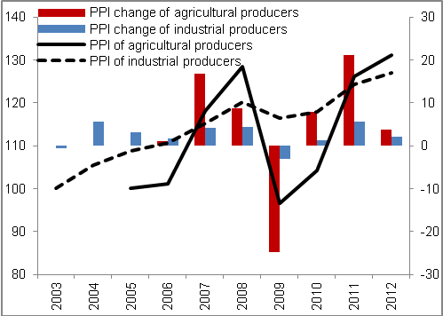 |  | 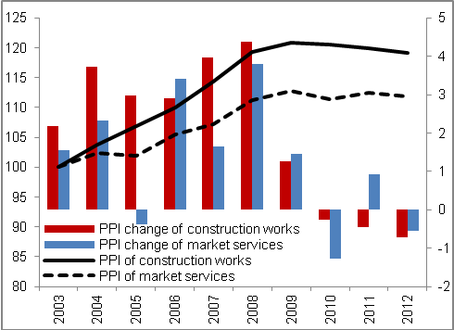
Source: CZSO

Mild year-on-year decrease of prices was after a year's pause apparent also in market services… |  | Prices of market services following a mild year-on-year increase in 2011 (by 0.9 %) again decreased, specifically by 0.6 %. Still it represented a decrease roughly halved in comparison to year 2010.
…weak demand lowered prices of services in the area of employment and advertising services... |  | The most significantly decreased the prices for water transportation (by 9.5 %), which were after considerable growth in 2011 (by 49.2 %) slightly corrected by this decrease. Out of market services were further falling the prices of services in the area of employment (-7.5 %) or prices of advertising and market research services (by 3.1 %). It is apparent, that these types of market services are in times of economic slowdown required on the part of firms less- companies reduce costs and search employees on their own and restrict also the expenses for advertising. Lower demand then reduces prices of these services. The reduction of prices occurred as a result of low construction activity also in architectural and engineering services (by 2.6 %).
…however it missed the prices of financial services, which seem to be rather resilient towards the fluctuations of the economic performance |  | Out of market services on the contrary were raised the prices of financial services apart from insurance industry and pension financing (by 2.4 %), that is especially banks. Prices of their services seem to be immune towards the external influences, since they grow practical constantly regardless of the state of the economy. It is likely that even despite considerable competition between financial institutions thus arises the increase of margins (assuming constant costs per unit of production, which can be considered in this sector).
Advertising in TV and radio causes long-time and significant seasonal fluctuation of prices of market services |  | Interesting is also the notable seasonal nature of prices of market services, which fall regularly in summer months (especially in June and July) and in winter months (mostly in November, December and January) – in other months they display a tendency to grow. This seasonal nature of the index of prices of market services is fundamentally influenced by the area of advertising agencies selling time on TV or in radio. The reason can be seen in lower viewer ratings in summer and winter months.

Prices in the foreign trade
Prices in the foreign trade in 2012 grew very notably – export prices however sill lagged behind import prices |  | Dynamic development continued for the prices of foreign trade. In 2012 increased the export prices by 2.8 %, import by 4.3 %. Export prices increased second year in a row, prices of imports already third year. Export prices however still lagged behind import prices. Export price index rose in 2012 the fastest since year 2004, import prices grew by comparable rates of growth to year 2011.
With respect to year 2011 CZK depreciated against EUR and caused especially the rise of export prices. CZK depreciated also against USD, which strongly affected the prices of import mineral fuels and lubricants |  | Rate of CZK against EUR mildly devalued in Q4 2011, in 2012 it kept its value slightly above 25 CZK/EUR (rate was in 2012 on average by 2.2 % weaker then in 2011). This development on the foreign exchange market supported especially the growth of prices of Czech Republic exports, for the reason that large part of production ends in EMU – to euro area was exported in 2012 64 % of total value of exported goods, the proportion of imports from the euro area constituted only 51 % of total volume of imported goods. Rate of CZK weakened also against USD – it was on average in 2012 by 10.7 % weaker than in 2011. Weakening of CZK against USD pushed especially on the growth of import prices with the emphasis on the prices of mineral fuels and lubricants.
Export prices of beverages and tobacco grew in year 2012 already fourth year in a row, more significant price growth was observed also for chemicals and miscellaneous manufactured articles |  | Above average growth achieved the export prices in the area of beverages and tobacco (5.1 %), which were put up by still strong demand – prices of this good have grown already fourth year in a row. Increase of prices was observed also for chemicals (by 4.8 %) and miscellaneous manufactured articles (4.0 %). On the contrary a fall was faced by mineral fuels and lubricants (-2.5 %) – the fall was assisted by declining prices of electricity on the world market. Prices of the most significant by volume machinery and transport equipment after two-year fall in 2012 again increased (+2.8 %) – this price development favourably affected also the domestic segment of motor vehicle industry.
Significant growth continued for the import prices of mineral fuels and lubricants… |  | Continued double digit rise of the import prices of mineral fuels and lubricants (by 15.7 %), concretely for an already third year in a row. The decrease was not realised even with the help of temporary slump of prices of crude petroleum in the half of 2012 from the values of 126 USD/barrel to 89 USD/barrel – the prices were pushed up by weaker CZK against USD.
…the only group facing decrease of import prices were crude materials except fuels |  | Import prices of beverages and tobacco (9.9 %) and food and live animals (6.7 %) were significantly raised up. After two-years fall in years 2010 and 2011 grew also the import prices of machinery and transport equipment (2.7 %) and miscellaneous manufactured articles (2.6 %). Reasons for growth of import prices can be seen in high prices of crude petroleum, which are reflected in the prices of nearly all products. Their increase was also contributed by weak exchange rate of crown. Weak demand pressed against the rise of prices (not only domestic, but especially demand of large economies) – its decrease however did not manage to fully manifest in the import prices. The only group of products, whose prices in 2012 fell, were crude materials except fuels (-2.5 %) – the factor of weakened demand most likely prevailed.
Terms of trade fell already third year in a row |  | For the reason of higher growth of import prices fell in year 2012 the terms of trade – by 1.4 %. Worsening of the terms of trade thus continued already third year in a row and the last year, when they improved, remained year 2009 (+3.9 %). One of the main roles in this development played the prices of crude petroleum, which were since the dramatic fall in the second half of 2008 from value above 140 USD/barrel to 40 USD/barrel going up. As the CR is a net importer of crude petroleum, its gradual increase of its price was reflected on the part of import prices. Still the rate of fall of terms of trade gradually slowed down (2010 -3.0 %, 2011 -2.3 %), nevertheless it remained negative.

Chart 60 | Terms of trade, export and import prices  (2003=100, left axis; growth of prices and change in terms of trade y/y in %, right axis)
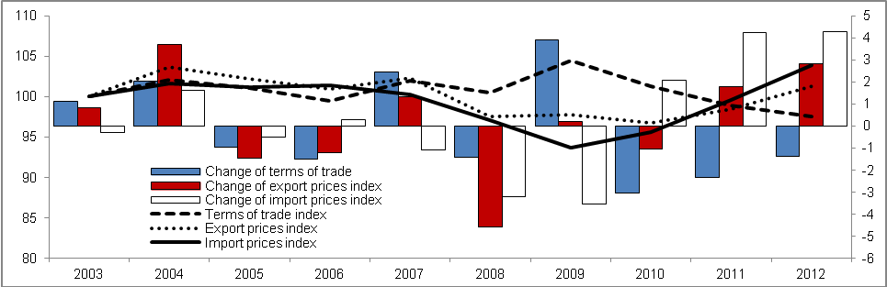
Source: CZSO

Selected factors of competitiveness
The ability of given country to compete on international markets influence price and non-price factors. Following selection is focused on the change of the share on the world exports of goods and services, competitiveness with respect to the development of unit labour costs and also the intensity the country is able to exert for support of sophisticated activities.

Change of share of the CR in the world exports
Benefits and risk of openness of the economy |  | Openness of the economy, regarding the strength of the flows of goods and services with abroad, represent for a given country ambivalent effects – on one hand it provides evident benefits in the possibilities to use national work on foreign markets, on the other hand then the risks connected to the dependency on these markets in times of economic slowdowns and slumps.
Share of the CR on the world exports of goods and services in 2012 in the amount of 0.72 % for the first time since the beginning of monitoring fell |  | Open Czech economy exported in 2012 goods, which represented in value 0.721 % of world exports of goods, and services in worth 0.528 % of world exports of services. In both cases the year 2012 was year, when continued the lowering of share of the CR in world exports of goods as well as world exports of services (chart 61).
The highest share of exports of goods in the crisis year 2009... |  | Share of the CR on the world exports of goods was the highest in the crisis year 2009, which can be to a large extent attribute to the enormous slump of the world goods exchange - the CR in that time benefited from the specific conditions given by the structure of its exports and opportunities it provided (introduction of measure to support demand in several countries, where the exports of motor vehicles from the CR headed, i.e. so called „scrappage allowance“). After the crisis then the share of exports of goods from the CR on the world exports mildly fell.

Chart 61 | Share of exports of goods and services from the CR in flows on a global scale (in %) | Chart 62 | Change of share of exports of goods and services on global exports (year y/y-5, in %)
Source: Eurostat

…in exports of services already in year 2008 |  | Also the exports of services recorded a loss of competitiveness in the form of lowering of the share on the world exports of services. Unlike the exports of goods however the share was the highest already in year 2008 (chart 61) – it follows that crisis year 2009 hit more, with respect to foreign export destinations, just the services. Its role could also play the slump of international transport services, associated with the lower exchange of goods.
Drops of shares typical also for other European exporting countries, Slovakia and Poland for now only with a lowering additions of these shares |  | Year-on-year change of proportions is for the assessment of the competitiveness of a country in exports a too short period. If we compare however the shares of the given year with the shares five years back, it is visible from chart 62, that in 2012 in this notion for the first time declined the share of aggregate exports of goods and services from the CR on the world exports of goods and services.  This issue for now did not strike Slovakia, which fared for the whole monitored period 2003-2012 better in contrast to the CR and so far not also Poland, where the same occurred. On the contrary due to the strong Asian competition, Germany has been losing its share already since year 2009 (chart 62).
Decrease of competitiveness of exports for the CR in year 2012 milder in contrast to most EU 27 countries |  | Despite for the first time arising negative shift of the share of the CR in 2012 compared to year 2007 and subsequent drop of competitiveness, the Czech Republic enjoys in the ranks of EU 27 countries a relative good position (chart 63) – most European countries recorded in 2012 substantially higher losses of competitiveness of their exports of goods and services compared to the CR.
Chart 63 The CR position in competitiveness based on change of share of exports of goods and services on their world exports (in %)

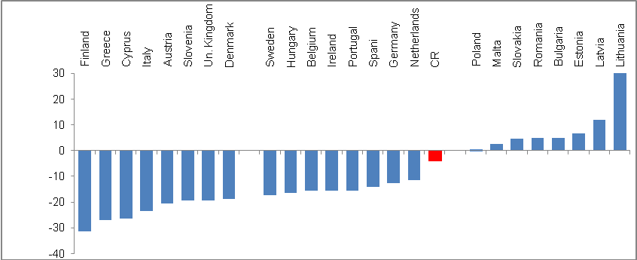
Source: Eurostat

Cost competitiveness based on real unit labour cost
Meaning of the labour factor in relation to the economic performance |  | Cost (price) competitiveness of economies in the international comparison is expressed by the unit labour costs. The aim of the indicator of unit labour costs is to express the dynamics of the production factor labour participating on the overall economic performance.
For years 1995-2011 growth of real unit labour costs in the CR the highest among the EU 27 countries |  | While in 2011 belonged the CR in the European comparison of increases of unit labour costs to the top among other countries for the period 1995-2011 – it means, that labour in relation to the performance of the economy raised its price in the CR for that time period the most -, from the comparison of shorter time period is apparent, that this growth of unit labour costs occurred mostly in the second half of the 90s.
Labour in relation to economic performance raised its price in the CR for period 2003-2012 by 3.4 %, which was the fifth highest increase of real unit labour costs in the EU 27 |  | If we compare the position of the CR from years 1995-2011 and a shorter period, i.e. decade 2003-2012, from chart 64 can be seen, that real unit labour costs recalculated to the base of year 2003 show an increase in the CR of 3.4 %, which was the fifth highest increase in the EU 27. Price of labour „increased more“ only in Finland (growth of real unit labour costs from period 2003-2001 by 8 %, in Ireland by 7.9 %, Estonia by 6.4 % and Slovenia by 4.5 %.  On average for the whole EU 27 however occurred in the CR in 2012 against year 2003 to the lowering of real unit labour cost by 1.5 %, while milder was this drop in „old“ Union countries (EU 15), i.e. -0.3 % and in the euro area, with -0.5 %. Competitiveness here thus increased.

Chart 64 Real unit labour costs (index 2003=100)

*Poland 2004=100, **Romania 2005=100 Source: Eurostat

Support of sophisticated activities
Future multiplications effects of the support of research and development |  |  | Expenditure on research and development belong to the investment into sophisticated activities with potential multiplication effects in the labour productivity and generally to developed predominantly economic activities, resp. possibilities of improving the quality of life.
Financing of sophisticated activities |  |  | Research and development is financed both from the public sources and private sources, is being performed on workplaces of various nature (universities, special research institutions, firms etc.). Its character is also given by the area of research execution (natural sciences, technical sciences etc.). Data provided in charts are based on total expenditure of the given country on research and development, i.e. money spent from the public budgets as well as funds from companies and other sources.
Expenditure on research and development relative to GDP in the CR in years 2002-2011 rose and amounted to on average 1.41 % of GDP… |  |  | Advancement of a country and effort for its future competitiveness is often gauged by the proportion of money, which are expended on research and development. The Czech Republic belongs among countries, where in the last decade during years 2002-2006 share of these expenditures in relation to GDP grew (chart 65), in years of strong boom then it mildly decreased (also due to the impact of mathematic relationship of the high value of GDP as a denominator). Afterwards in crisis year 2009 most likely again also due to this effect the ratio of expenditure on research to development to GDP rose and in years 2010 and 2011 continued increasing (1.55 %, resp. 1.84 %).
… growth of this share was however lower than for the EU 27 (1.91 %) and EU 15 (1.99 %) |  |  | This positive development of strengthening investment on research and development in relation to income of a country however in the international comparison shows, that the rate of growth was not in contrast to the EU average (1.91 %) and especially ratio for „old EU countries“ (1.99 %) adequate (chart 65). Convergence of the ratios occurred only in years 2010 and 2011.
Chart 65 | Expenditure on research and development in relation to nominal GDP (in %) |  |  | Chart 66 | Expenditure on research and development (in euros/inhabitant)
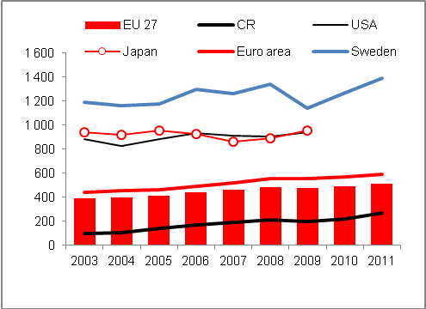
Source: Eurostat

Ability of rich countries of the North of Europe to finance sophisticated activities |  |  | On the contrary a strong support of sophisticated activities is traditionally recorded on the North of Europe, where the potentially technologically leading countries of Europe come from. It can be assumed, that the ability to finance their social states is connected just to the building up of the competitiveness through the support of research and development. The opposite direction is also valid, i.e. that their wealth enables them to expend money in this extent.
Finland the world power in relative expenditures on research and development… |  |  | The highest expenditure on research and development in relation to GDP records in the long-term with more than three percent of GDP Finland (3.78% in 2011), Sweden (3.37 %) and Denmark (3.09 %). For the 2002-2011 decade arrived the ratio of expenditures on research and development to GDP in case of Denmark annually to 2.73 %, Sweden 3.21 % and Finland even 3.60 %, which contrasts with the number for the Czech Republic in the amount of 1.41 % of GDP annually on average.
…with larger relative investments into research and development than in the USA, Japan or South Korea |  |  | Countries, where the data for year 2011 are not available at time of preparing this analysis, recorded according to data for year 2009 expenditures on research and development in relation to GDP in case of South Korea 3.57 %, Japan 3.36 % and USA 2.87 %. Investment into research and development achieved in China in year 2009 relatively high 1.7 % of GDP, which was more than in the CR in the given year (1.47 % of GDP).  Also on a global scale thus according to data captured in the Eurostat tables is the country with the highest expended investments in relation to income of a country Finland. Here in 2009 constituted the mentioned ratio 3.94 % of GDP, which was the most also from all countries monitored according to the relative expenditures on research and development in the whole time series from year 2002.
Slovakia in the long-term invests very little from its GDP into research and development |  |  | For instance Slovakia, with impressive rates of growth in time of European boom in the last decade as well as after crisis in 2009, which were in the European context very high and also higher than for the Czech Republic, expended very low share of its GDP on research and development. In 2011 it belonged in the ranking of EU countries with 0.68 % of GDP as far as the fourth place from end before Bulgaria, Cyprus and Romania.
In 2011 the CR with the highest share from new countries after Slovenia and Estonia |  |  | In 2011 invested the CR into research and development in relation to GDP (1.84 %) the most out of all new EU countries after Slovenia (2.47 %) and Estonia (2.38 %) and in the ranking of EU countries was placed on the eleventh position.

Chart 67 Expenditures on research and development as % of nominal GDP in year 2011

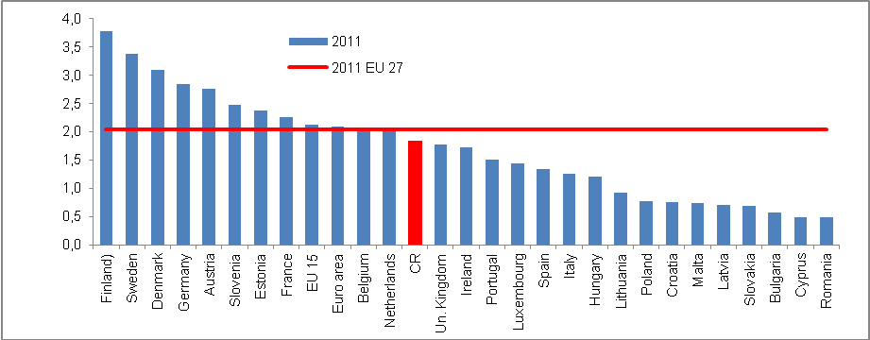
Source: Eurostat

The CR in 2011 on 11th place in the EU based on expenditure on research and development relative to GDP… |  | While in 2011 was the Czech Republic placed in the context of the EU 27 countries according to the expenditures on research and development to GDP close below the average for this group (1.84 % against 2.03 % in the EU 27) and tightly behind was placed the United Kingdom and Ireland, look on the recalculation of these expenditures per inhabitant shifts the Czech Republic on back places.
…but as far as 17th place in the EU with respect to recalculation of expenditures on research and development on one inhabitant |  | Expenditures on research and development, which Eurostat calculates for individual countries in euros per capita, reached in 2011 in the CR only 273 eur per one inhabitant. Average for the EU 27 came to 510.5 eur/inhabitant, which means the CR expended in this recalculation only about a half (53.5 %) than the EU on average (chart 68). In 2002 it was only 24.2 % of the European average in eur per capita.  In the last available data arrived this ratio in the USA to 937 eur/inhabitant, in Japan 951 eur. In Denmark, Luxembourg and Finland it was in 2011 more than 1200 eur/inhabitant and to this amount was close also Sweden with 1137 eur per one inhabitant invested into research and development. On the contrary less than 100 eur per capita invested into research and development in 2011 in Croatia, Poland, Slovakia and also in Turkey, which in this indicator overtook Latvia, Romania and Bulgaria.
Considerable reserves in the support of sophisticated activities in the CR and consequently also a potential growth of competitiveness |  | CR despite the growth of expenditures on research and development, both in relation to GDP and recalculated per one inhabitant, so far is not even nearing the limit, which was in directions of the so call Lisbon strategy (previous aims of the document Europe 2020) set at 3 % of GDP. However, troubles to reach it have most European countries. Apart from the three named Scandinavian states has got close to it in 2011 Germany (2.84 % of GDP), Austria (2.75 %) and from new Union countries also Slovenia (2.47 %).  A certain issue remains to present the fact, that majority of these expenditures represent funds heading into the technical research, mostly in the motor vehicle industry. Financing of other areas, where given the nature of things participates mostly the state, were in the previous years limited by the restriction of budget funds, even with respect to the common state expenditures and even more so of the expenditures on development , which do not have a mandatory character.

Chart 68 Expenditure on research and development (recalculation in euros per capita; Europe and selected world countries)

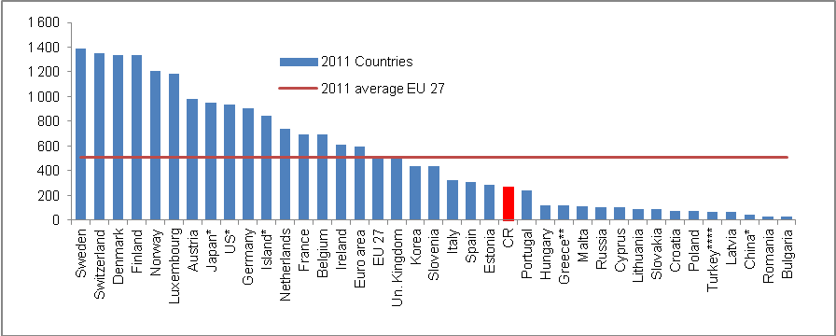
Source: Eurostat
*2009, **2007, ***2008, ****2010

Real and nominal convergence

The ability of a country to near by the rate of growth of performance of its economy to the level of economic and currency union in Europe, i.e. converge in real terms to this level, is in this chapter examined through the development of shifts in the relative position of the Czech republic economy according to GDP per capita in purchasing power parity (in PPS) to the EU average, resp. in some cases to the average of their most developed countries, which consist of so called old EU countries, that is the EU 15 group (does not include states, which became a member of the Union in the accession wage from May 2004 and later). Fulfilment of the Maastricht criteria is then assessed further as a nominal convergence.

Changes in the relative position of the CR in the economic development compared to the EU
Economic advancement of a country gauged by the gross domestic product per one inhabitant expressed in the purchasing power parity (units of PPS) in case of the Czech Republic from year 2010 in relation to the average level of economic and currency union in Europe worsens. Real convergence thus switched to a mild real divergence.

GDP per capita in PPS fell in the CR in 2012 to 79 % of the EU 27 average… |  |  |  |  | Mostly due to the fall of GDP of the CR in 2012 compared to 2011 by 1.2 %, which was – after five European countries with the highest debt of the government sector and also Hungary – the seventh deepest drop in the EU 27, eventuated further worsening of the relative position of the CR in measuring the economic advancement. GDP per capita in purchasing power parity (PPS) fell according to Eurostat data to 79 % of the EU 27 average. In years 2010 and 2011 arrived according to this source at 80 % of the average level of the union (chart 69).
… and 72.5 % of the „old“ Union countries level |  |  |  |  | If we however relate this development to the idea, that convergence is a desirable especially towards the very advanced European countries, this view shows the intensity of approaching mostly to the EU 15 group, which involves so called „old“ EU countries, i.e. the union before the May 2004 accession wave.  Convergence of the CR to the EU 15 groups halted similarly as in the relation to the average of EU 27 in 2009, when GDP per capita amounted to 75.5 % of the economic level of these old EU countries. In 2012 fell this ratio to 72.5 %. Worsening, i.e. a divergence relative to the average level of the EU 15 group (chart 69) was thus more marked than the worsening towards the average of the whole union (EU 27).
Chart 69 | Gross Domestic Product per capita v PPS (constant prices, seasonally adjusted, y/y in %) |  |  |  |  | Chart 70 | GDP (in cur.p., y/y in %) and confidence indicators based on CZSO Business Cycle Surveys
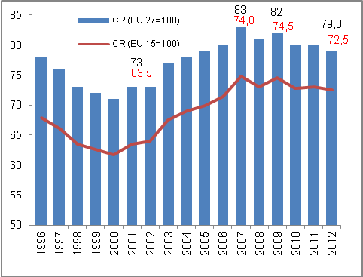 |  |  |  |  |  | 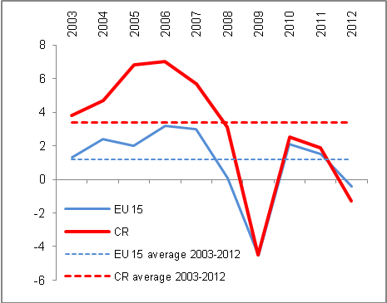
 |  |  |  |  |  | Source: Eurostat, own calculations
Effect of the GDP drop by 1.2 % in 2012, but also in years 2010 and 2011 was the GDP growth of the CR against the usually compared neighbour central European countries weaker  Despite the fall of relative position of GDP per capita in PPS for Greece and Portugal the Czech Republic in 2012 in the ranking of countries sustained its position… |  |  |  | Significant effect on worsening of this relative position of the Czech Republic had the adverse development of GDP in 2012, since in the post crisis year 2010 GDP in the CR increased in real terms year-on-year by 2.5 %, which was mildly more than for EU 27 (+2.1 %) and in this view was relatively favourable also year 2011 (+1.8 % against 1.6 % in the EU 27). For comparison, Slovakian economy however in these years grew year-on-year by 4.4 % and 3.2 % resp., Polish by 3.9 % and 4.5 % resp., Austrian by 2.1 % and 2.7 % resp.  If in years of boom and when including the crisis year 2009 (i.e. period 2004-2009) grew the CR economy on average by 3.8 % annually and the EU 27 economy by 1.2 % and the strength of convergence of the CR towards the average economic level of the union was with this more than triple growth very high, then in the post crisis period, i.e. 2010 till 2012 presented weak, but still a divergence – GDP in the CR grew for that period on average annually by 1 %, while the economy of the EU 27 by 1.1 %. Development of GDP of „old“ EU countries against the CR presents the chart 69.  In the ranking of countries based on GDP per capita in PPS did not occur in 2012 from the point of view of the Czech Republic any substantial changes. Its position (16th place in the ranking of EU countries) did not affect nor the marked worsening of the relative position of Portugal to 75 % of the EU 27 average from 78 % in 2011, neither the worsening in case of Greece (according to preliminary data also to 75 % of the EU 27 average from 79 % in 2011), since these countries were behind the CR already in 2011.
… on the 16th place in the EU 27 and when including the European countries outside union then on the 20th place |  |  |  | If we include also the European countries standing outside the EU, i.e. states with a very high GDP per capita in PPS, the Czech Republic shifts to the 20th position in Europe (this indicator amounted to in 2012 in case of Iceland to 110% of the EU average, Switzerland 160 % and in Norway the GDP per capita in PPS was in comparison to the EU 27 average even nearly double with 195 % of the union level.
GDP per capita in PPS fell in the CR in year 2012 to 79 % of the EU 27 average and 72.5% of „old“ Union countries average |  |  |  | Mostly due to the effect of GDP fall in the Czech Republic in 2012 in comparison to 2011 by 1.2 %, which was – after five European countries with the highest debt of the government sector and also Hungary – the seventh deepest decrease in the EU 27, eventuated a further worsening of the relative position of the CR in the measurement of the economic development. GDP per capita in the purchasing power parity (PPS) fell according to the Eurostat data to 79 % of the EU 27 average. In years 2010 and 2011 it amounted to 80 % of the average Union level according to this data source. Relative position of the CR on the scale of European countries can be discerned from chart 71.
Chart 71 Ranking of countries in GDP per capita in PPS in year 2012 (EU 15=100)
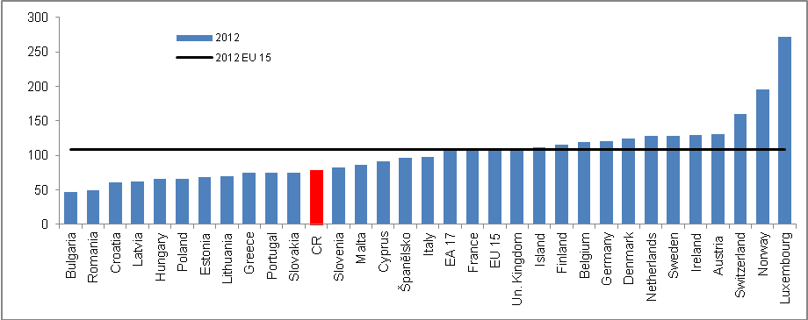
Source: Eurostat

Significant influence of the rate of growth of economies on the size of GDP per capita |  |  | Worsening of the indicator GDP per capita in PPS in case of the CR was caused mostly by the loss of the pace of performance of its economy (a role in this complex indicator however play also other factors). As can be seen from chart 72, countries where was this indicator improving in time, i.e. mostly Slovakia and Poland (but also very mildly Hungary) recorded especially after crisis a significantly higher growth of economy compared to the Czech Republic. Mainly due to the fall of GDP of the Czech Republic in 2012 against year 2011 by 1.2 %, 2011 totalled according to this source 79 % of average union level.
Very low growth of GDP per capita in PPS in the CR for years 2003-2012 |  |  | Even though in comparing the GDP per capita in PPS level against its change for selected countries (chart 73) plays a role the methodological change in case of the CR, which can distort the position, the fact remains, that the growth of this indicator for the whole decade of 2003-2012 is in case of the CR only very mild.
Three out of four largest European economies recorded a fall of GDP per capita in PPS in 2012 against year 2003 - Italy under European average, strengthening of prosperity in Germany |  |  | Debt crisis in large European economies, such as for example Italy, affected likely indirectly also the decrease of its economic level according to GDP per capita in PPS in 2012 in comparison to the level of year 2003 – from 112 % of the EU 27 average to 98 % in 2012, which means that this fourth largest European economy got with respect to advancement according to the monitored indicator, below the EU level.  Worsening was recorded among four largest European economies also in France (from 116 % in 2003 to 108 % EU 27 average in 2012), whose government sector also worsened its budget. In losses was also the United Kingdom (from 120 % to 110 % of average GDP per capita in the EU 27).  As the only one from large economies manage to increase its economic prosperity according to GDP per capita in PPS Germany (from 115 % to 121 % of the EU 27 average). It thus reaffirms the role it plays in the European economy also for economically connected countries via the imports of their goods and services, resp. capital interconnectedness via subsidiaries in these countries. Its prosperity is for them from the view of development of their economies very important.
Norwegian GDP per capita increased from very high 145 % against the EU 27 average in 2003 to 195 % in 2012… |  |  | From other European economies accelerated the most the prosperity of Norway standing outside the EU – its very high level of GDP per capita in 2003 (155 % of the EU 27 average) further markedly increased to 195 % in 2012. It is a country very little hit by the crisis in 2009 (GDP fell in real terms year-on-year by less than two percent) and in 2012 was its growth against other Scandinavian countries the highest.
…Slovakia also strengthened significantly its prosperity from 55 % to 75 % in 2012 compared to the CR, where GDP per capita rose from 77 % of the Union average in 2003 in ten years to 79 % |  |  | Among small European countries managed to increase during years 2003-2012 it’s GDP per capita in PPS Slovakia (from 55 % to 75 % of the EU 27 average). It thus neared relatively close the level of the Czech Republic (79 %). Its negligible increase of this indicator for the decade of 2003-2012 had comparison only with the development of Hungary (from 63 % to 66 % of the EU 27 average). Lower GDP per capita in PPS shown for the monitored years Slovenia, which used to have traditionally the best result among the usually compared countries of the accession wave of year 2004. Worsening of this indicator to 82 % in 2012 from 84 % in 2003 was in the percentage points lower compared to case of Portugal, which was till year 2004 according to this prosperity measure in front of the Czech Republic. After the relatively long and strong boom of the Czech economy however Portugal moved below the level of the CR.
Chart 72 | GDP per capita in PPS, selected countries in the decade 2003-2012 (EU 27=100) |  |  | Chart 73 | GDP per capita in PPS in year 2003 and 2012 (selected countries, EU 27=100)
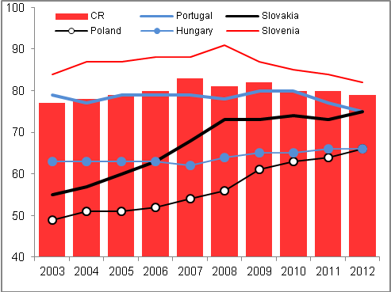 |  |  |  | 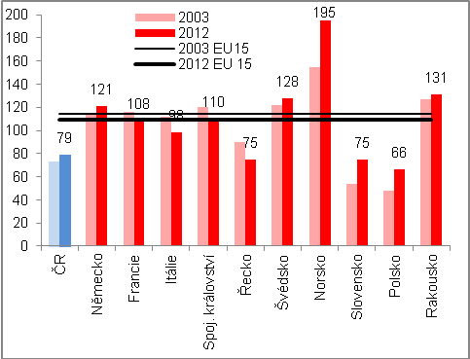
Source: Eurostat, own calculations

Comparison of the CR and EU 27 in years 2003-2007 and post crisis in the basic structure of GDP… |  | Structure of growth according to the development of individual expenditure components of GDP in the CR compared to the EU 27 and also the development of the supply side of economies (tab. 4) depicts in more detail, how in the periods – most interesting in the economic view – of decade 2003-2011 differed the dynamics of these components in the Union economy as a whole against the Czech Republic.
… confirmed for one thing markedly better development of most components in the CR during period 2003-2007 (but stagnation of consumption of government sector in the CR compared to its growth in the EU), on the contrary for years 2010-2012 worse development apart from foreign trade |  | While for years 2003-2007, when the European economy as well as economy of the CR enjoyed the boom phase, increased in comparison to the EU 27 more significantly the Czech foreign trade, investment as well as household consumption – however not the expenditure on final consumption of the government sector – in the post-crisis year 2010-2012 this was already valid only for foreign trade. Other components fared in the CR worse.  The year 2012 then only confirmed the significantly worse development of final consumption expenditure of both households and government sector against their development in the European Union as a whole. The slump of investment was in this comparison smaller, however the fall of gross value added more than triple compared to EU 27.
Table 4 Increments/reductions of basic GDP components in the medium- and long term horizon (in real terms, in %, year 2012 year-on-year in %)

 | 2003-2007 |  | 2010-2012 |  | 2012/2011
 | CR | EU 27 | CR | EU 27 | CR | EU 27
Household consumption | 17.5 | 8.3 | -2.2 | -0.5* | -2.7 | -0.8
Government consumption | -0.5 | 13.5 | -3.9 | 0.0** | -1.2 | 0.1
Investment | 17.4 | -0.2 | -3.4 | -3.1 | -4.1 | -5.5
Exports of goods and services | 95.5 | 43.2 | 14.0 | 8.9 | 4.0 | 2.4
Imports of goods and services | 66.0 | 34.9 | 9.4 | 3.8 | 2.3 | 0.3
Domestic demand | 13.4 | 7.6 | -2.8 | -0.9 | -2.7 | -1.5
Gross value added | 30.6 | 11.6 | 0.8 | 1.6 | -1.0 | -0.3
Gross domestic product | 28l4 | 10.8 | 0.6 | 1.3 | -1.2 | -0.4
* E.g. Germany +2.5 %, Slovakia -1.1 %, Poland +3.5 %, Estonia +8.3 %.
** E.g. Germany +2.2 %, France +1.9 %, Greece -9.2 %, Slovakia -4.9 %. Source: Eurostat

Factors influencing the loss of performance of the Czech economy

Domestic demand
Strongly worked also the domestic influences, especially falls of final consumption expenditures and even more also the lack of investment |  |  | Internal economic development of the CR stood for the prevailing part of year 2012 behind its weaker performance compared to the results of the EU 27 economy (chart 74). Significant was especially the factor of household consumption, which in both the nominal and real expression shared roughly by one half on total expenditures on GDP in the CR.  While till year 2009 increased the household final consumption expenditures in the CR in real terms markedly faster than for households for EU 27 average (e.g. in 2003 by 5.3 % year-on-year against +1 % in EU 27), and after crisis their year-on-year increase was in 2010 approximately the same, i.e. +1 % in the CR against +1.1 % in the EU), year 2012 already showed a notable imbalance to the detriment of the CR (-2.7 % year-on-year against -0.7 % in the EU).
Chart 74 | GDP dynamics (real, y/y in %) |  |  | Chart 75 | Domestic demand (real, y/y in %)
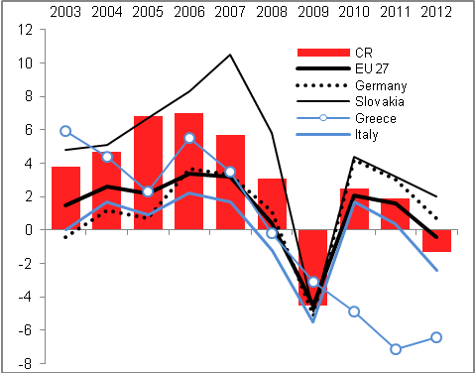
Source: Eurostat, own calculations

Development of domestic demand in the CR was thus in years 2011 and 2012 compared to the EU 27 development unfavourable |  | In years 2011 and 2012 was already significantly falling also the rate of growth of imports in reaction to the weak domestic market, even though a fall below the level of the preceding year did not eventuate, in contrast to the development of investment (gross fixed capital formation), as can be seen from chart 75. Domestic demand in the CR in total decreased in 2012 year-on-year by 2.7 %, while in the EU by 1.5 %. Difference to the detriment of the CR was apparent already in year 2011 (-0.1 % against +0.7 % in the EU) and especially in 2009 (-5.4 % against  -4.4 %). In all other years of the period 2003-2012 increased the domestic demand in the CR faster compared to the EU 27.

Foreign demand
Countries of the largest business partners such as Slovakia and Germany as well as the EU as a whole did not record significant slump of GDP, resp. its decline until Q4 2012 |  | The unfavourable change for the CR on foreign markets, lying in the decline of demand after exported goods and services due to the fall of GDP (chart 76), did not start to appear in 2012 until approximately Q3 (mostly in August and September). However, it strengthened significantly only in the last quarter of the year. Result of the foreign business exchange, as the only factor working from the half of year 2011 in the positive direction on the GDP development thus also started to lose dynamics (in Q4 2012 was its effect however null, for the whole year 2012 arrived the contribution of the foreign trade with goods and services balance +1.4 p.p. thanks to high contributions in Q1 and Q3).
Decline of the rate of growth of exports of goods and services from the CR in real expression from +6.3 % year-on-year in Q1 to +2.4 % in Q4 2012; comparably for imports from +3.6 % to + 2.6 % |  | For the whole year 2012 was sustained both the imports and exports expressed in the nominal terms (according to CZ-CPA in the national conception) in year-on-year growths (chart 77).  In real terms then increased the total exports of goods and services compared to year 2011 by 4.2 % (exports of goods by 4.6 %, exports of services by 2.2 %). In individual quarters the decrease was recorded only in Q2 for exports of services (year-on-year by -2 %). Comparably the total imports of goods and services in 2012 increased by 2.5 % (imports of goods by 1.7 %, imports of services by 7.3 %), the fall eventuated in Q3 for imports of services.  Also these proportions of the rates of growth of imports and exports reflect in the annual view a weaker domestic demand compared to foreign demand.

Chart 76 | GDP dynamics in countries of largest business partners (real terms, y/y in %) | Chart 77 | Foreign trade (according to CZ-CPA data in national conception, y/y in %)
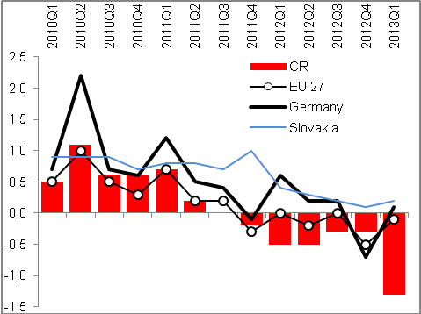 |  | 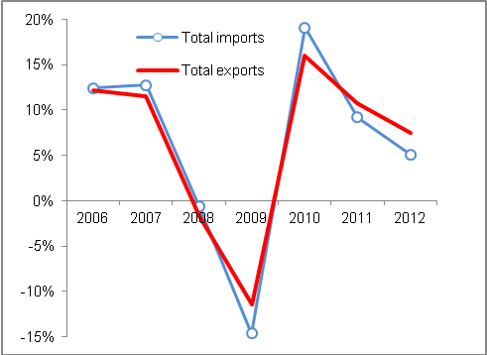
Source: Eurostat Source: CZSO

Exports of motor vehicles out of the CR after year-on-year growth by strong 17.6 % in Q1 2012 in the last quarter fell by 1.6 % and thus set also the lowering of rate of growth of total CZ exports; in Q1 2013 already sharp year-on-year fall of motor vehicle exports by -11.6 % |  | Cyclical industries producing main export items of goods from the CR suffered in 2012 by a gradual loss of pace of these exports (chart 78). In data related to foreign trade based on national conception (CZ-CPA) is apparent a very sharp year-on-year fall of exports of motor vehicle out of the CR in individual quarters – from +17.6 % in Q1 to -1.6 % in the last quarter of year 2012. This development was for the dynamics of the total exports of goods from the CR determining.  In Q1 2013 already occurred a sharp fall of the motor vehicle exports from the Czech Republic by 11.6 % against the same period of 2012, which was however partially influenced also by the statistical basis.
Following a weak year-on-year growth of exports of computers and electrical appliances from the CR by 1.5 %, their exports fell in Q1 2013 by 12 % |  | Also another significant item, exports of computers and electronic appliances, which in years of boom similarly to the case of motor vehicles put dynamics into the total exports from the CR, progressed in 2012 unfavourably with respect to the year-on-year dynamics quarter by quarter – after year-on-year addition in Q1 2012 by +7.7 % their export fell in the last three months by 0.9 %.  In Q1 2013 the exports of computers and electronic appliances from the CR lowered compared to the same period of 2012 by strong 12 %.
Chart 78 Exports of selected commodities (motor vehicles, computers and electronic appliances) and aggregate exports from the CR (y/y in %, CZ CPA, national conception)

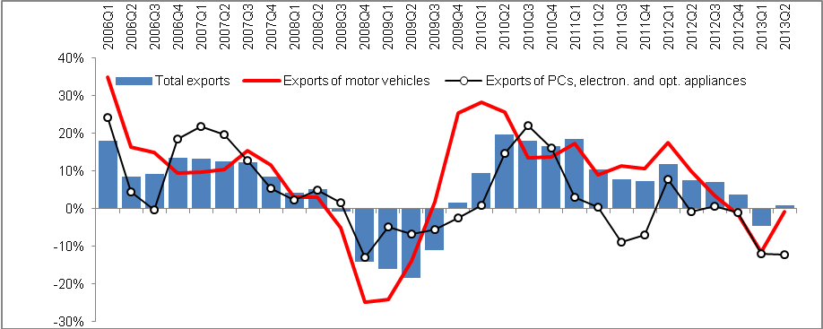
Source: CZSO

Positive outlook only for two countries in Europe, for „countries at risk“ identified Germany and Slovakia, the largest business partners of the CR – for the whole remaining part of the EU 27 indicated for 2013 a recession |  |  | Outlook for 2013 does not bring from the point of view of foreign demand for the CR for now a turn for better, this is expected as far as 2014. As can be seen from chart 79 (a map) processed by the rating agency Moody´s in May 2013, recession is anticipated for year 2013 in the majority of monitored countries (red field). Recovery is predicted by the Moody´s agency in Austria, as economies „at risk“ are according to this source marked Germany and Slovakia, i.e. the largest customers for goods from the CR. In this view is this way identified development for the exports from the Czech Republic more favourable, than in the majority of other European destinations.  Prediction of „expansion“, or economic growth limited the Moody´s agency in their prediction from May 2013 to only two countries of Europe – Norway and Poland.
Eurostat is also positive regarding Germany and Slovakia; recession for year 2013 predicts apart from seven countries of south Europe only to Netherlands, Slovenia and the Czech Republic |  |  | Also the prediction of Eurostat for years 2013 and 2014 counts with the recovery only in 2014. GDP of the EU 27 in real terms according to this estimate shall in 2013 in fact stagnate (-0.1 %), drop of 0.2 % is indicated for old union countries (EU 15), deeper for the euro area as a whole (-0.4 %). Also Eurostat is in case of Germany and Slovakia more optimistic and forecasts the growth of their GDP in 2013. It again suggests from the view of Czech exports a favourable anticipations.
Apart from seven countries of south Europe predict Eurostat recession in 2013 already only to Netherlands, Slovenia and the CR  GDP per capita in PPS fell in the CR in “Union country“  Relatively fast diversification of the Czech exports on markets outside EU 27 – fall of share of union on total exports from the CR from 87.3 % in 2003 to 83 % in 2011 and 80.8 % in 2012 |  |  | From other EU 27 countries Eurostat forecasts for year 2013 a recession to seven states of South Europe (Greece, Spain, France, Italy, Cyprus, Croatia and Portugal) and apart from them only to Netherlands, Slovenia and the Czech Republic.  In the global outlook processed in May 2013 by Moody´s Analytics the growth is anticipated only in Russia, China, several countries of southeast Asia, in Australia and the Pacific region and smaller countries of central and South America. As economies at risk signs this outlook the economies of USA, India, Argentina, Bolivia and South Africa. From largest fast growing economies labelled as the BRIC group thus apart from growth in Russia and China shall revive the Brazilian economy and somewhat lower outlook has India.  Czech exports is still more and more diversified with respect to group of countries BRIC, especially in the direction of Russia, where the dynamics increases year-on-year the fastest. Still in year 2012 represented the exports into these four large countries only 5.7 % of total exports from the CR, while into the EU 27 countries headed 80.8 % of aggregate exports.  With respect to the European recession is thus favourable, that the share of EU 27 countries falls 87.3 % in 2003 via 83 % in 2011 until the mentioned approximately four fifths in 2012.
Chart 79 | Outlook for the European economy (Moody´s, prepared in May 2013) |  |  | Chart 80 | Eurostat Expectations for years 2013 and 2014 (real GDP, y/y in %)
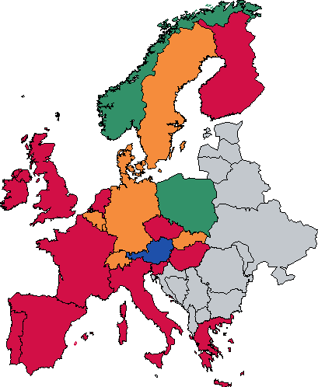 |  |  |  | 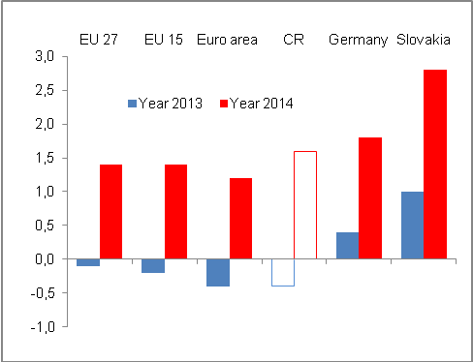
Source: Moody´s Analytics Source: Eurostat
Note to coloured fields of the map:
Green „expansion“, blue „recovery“, yellow „economy at risk“, red „recession“

Chart 81 Outlook for the world economy (prepared in May 2013)
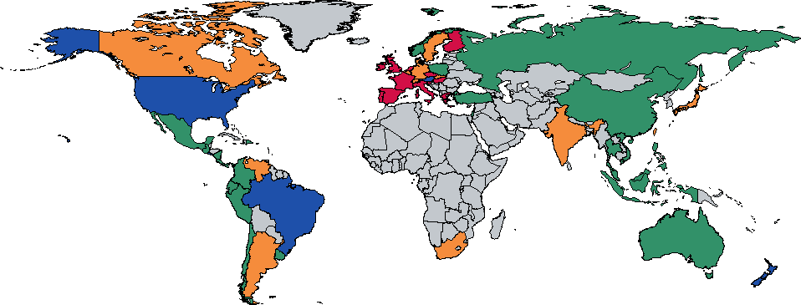
Source: Moody´s Analytics
Note to coloured fields of the map:
Green „expansion“, blue „recovery“, yellow „economy at risk“, red „recession“

Fulfilment of the Maastricht criteria of nominal convergence
Even after the 2009 crisis the CR fulfilled the given convergence criteria with the exception of government sector deficit to nominal GDP |  | Maastricht agreement criteria regarding the nominal convergence of countries to the average level of currency and economic union in Europe, the CR filled through the prevailing part of the last decade without relatively large troubles (in years 2004 and 2006-2007 it was possible thanks to strong growth of economy also to reach the prescribed government sector deficit in relation to nominal GDP). Not even after the crisis of year 2009 did this fulfilment not worsen somehow more significantly – from year 2009 till year 2011 the CR fulfilled the convergion criteria with the exception of the limit for the size of the government sector deficit in relation to nominal GDP, where its relative size did not fall below 3 % of GDP. However the criterion of gross consolidated debt of the CR to GDP with limit of 60 % was filled with reserve (more to the fiscal criterion in the analysis in chapter 5 about imbalances).  Criterion prescribed above of long-term nominal interest rates of the government bonds denominated in the national currency the Czech Republic fulfils in the long-term similarly with a marked reserve. Last prescribed condition of a convergence, the criterion of exchange rate stability of the national currency, is not possible from the point of view of the CR without the membership in the ER II system to assess. Volatility of the crown exchange rate according to the development on the exchange rate market is not however a significant issue of the Czech crown.
In 2012 were not kept two of the limits, apart from prescribed relation of the government sector deficit to GDP also the inflation criterion – it meant the least favourable result of the criteria of nominal convergence fulfilment in the last five years |  | Not very positive post-crisis development, which halted in years 2010-2012 the real convergence, but until year 2011 did not worsen the fulfilment of Maastricht criteria, impacted in 2012 the ability of the CR to keep the inflation criterion. Growth of harmonised index of consumer prices (HICP) by 3.5 % was above the limit of 2.8 % valid for year 2012.  The CR thus in 2012 did not meet two of the convergence criteria, which was the least favourable result in the last five years.

Table 5 Nominal convergence of the CR – fulfilment of the Maastricht criteria (values in %)

 | 2008 | 2009 | 2010 | 2011 | 2012
Inflation criterion (HICP) in % | 6,3 | 0,6 | 1,2 | 2,1 | 3,5
Inflation criterion (HICP) in % | No | Yes | Yes | Yes | No
Fiscal criteria
deficit  (< 3 % GDP in cur.p.) | -2,2 | -5,8 | -4,8 | -3,3 | -4,4
deficit  (< 3 % GDP in cur.p.) | Yes | No | No | No | No
debt  (< 60 % GDP in cur.p.) | 28,7 | 34,2 | 37,8 | 40,8 | 45,8
debt  (< 60 % GDP in cur.p.) | Yes | Yes | Yes | Yes | Yes
Stability criteria
Interest rates in % | 4,6 | 4,8 | 3,9 | 3,7 | 2,8
Interest rates in % | Yes | Yes | Yes | Yes | Yes
Exchange rate | CR is not part of the ERM II system.

Source: Eurostat, own calculations

Regions of the CR according to the level of economic advancement and selection of social statistics
For economic development in the Czech Republic was in the last nearly two decades characteristic strongly accelerated growth of GDP per capita in PPS in the capital city Prague and compared to this considerably weaker development in the regions of the country. From year 2008 however, the relative position of Prague in this indicator does not improve any more.

Gross domestic product per capita
In the period 1992-2002 the regions of the CR excluding Prague in total diverged from the average level of the GDP per capita in PPS in the EU 27 |  |  |  | Differing development of the size of GDP per capita in PPS as a measure of economic advancement was in the CR apparent between the regions in the group as a whole on one side and Prague on the other side especially in the period 1995-2002. At that time very markedly increased this indicator for the capital city Prague from 123.1 % of the EU 27 average in 1995 to 145 % in 2002. Regions of the CR as a whole on the contrary diverged, when the GDP per capita in PPS fell from the two third level of the EU 27 average (i.e. 66.6 %) in 1995 to 60.7 % in 2002 (chart 83).
From year 2003 relatively strong convergence of the “rest of the CR“ to the EU 27 average |  |  |  | Strong and relatively long boom of the Czech economy on the break of the half of the last decade caused the disproportion between GDP per capita in PPS between Prague and the rest of the CR to further increase (in Prague it grew up from 2003 even until the crisis year 2009 from 153.3 % to 175.5 % and in the remaining part of the CR from 62.8 % to 69.7 %), and convergence of the regions towards the EU 27 was relatively strong, at least the trend was compared to the last period significantly positive (chart 83).
Chart 82 | GDP per capita in crowns |  |  |  |  | Chart 83 | GDP/per cap. in PPS in Prague, in the CR apart from Prague and total in the CR (EU 27=100)
Source: CZSO
Prague ranking eighth among NUTS 2 regions of the EU 27 based on level of GDP per capita in PPS in 2010 with 172 % of the EU 27 average behind Bratislava (176 %) |  |  |  |  | Difference between the capital city and other regions is typical for a number of another EU countries. According to Eurostat data based on data available so far in NUTS 2 regions placed in 2010 on first ten places according to the higher GDP per capita in PPS a total of eight capitals – Prague took the eighth place with 172 % of the EU 27 average level behind Bratislava (176 %), but before Stockholm (168 %) and Wien (165 %).  First three places were occupied by London with a high concentration of financial services, which shared to a large extent on the fact, that in the British metropolis arrived the GDP per capita in PPS for year 2010 328 % of the EU 27 average. It was followed by Luxembourg (266 %) and Brussels (223 %). Even though the capital cities of France or Netherlands in the ranking of Top 10 did not place, French region Ile de France and Dutch Groningen occupied in the ranking of European regions according to advancement 5th and 6th position.
On top of regions London, Luxembourg and Brussels, at the end two Polish regions |  |  |  |  | On the opposite pole, i.e. in the last ten positions in the ranking of NUTS regions in the EU, ended in 2010 five Polish regions, three Hungarian and two Romanian. Region with the lowest GDP per capita in PPS in 2010 was the Polish Swietokrzyskie with 47 % of the EU average.
In the CR on the 2nd position in GDP per capita in PPS against the EU 27 average appeared in 2010 the Southeast region, already then the Central Bohemia… |  |  |  |  | Stratification of the GDP per capita in PPS of the NUTS 2 regions compared to average level of the EU oscillated in 2010 in the Czech Republic from 172 % in case of Prague to 63 % in the Northwest region. Somewhat surprisingly did not remained on the second position the Central Bohemia (70 % of EU 27 average), but Southeast region, which can be attributed to the high economic advancement of the South Moravian region and also the city Brno.  Out of other NUTS 2 regions in the Czech Republic was the fourth most advanced region in the country the Southwest (69 % of EU 27 average in 2010) and on the fifth place then Moravia-Silesian region (67 %). Evidently the role plays here the performance of large industrial companies. On the contrary, the last threesome involved Northeast (65 % of the EU 27 average), Central Moravia (64 %) and with 63 % of EU 27 average in the indicator of GDP per capita in PPS of NUTS 2 regions then Northwest.
… regarding the size of the indicator comparability to Greece |  |  |  |  | With regard to the level of stratification were NUTS 2 regions in the CR in 2010 according to Eurostat similarly advanced to regions in Greece.

Income per capita in the CR regions
The GDP per capita itself is the indicator suggesting the advancement of a country or region according to the economic performance, i.e. according to those GDP components, which affect the (material) level of the people's life only indirectly. Better is from the view of this level to monitor for example development of their incomes. In the next part is used the indicator of net disposable income of households as an aggregate not only of their incomes from wages and salaries, but also the size of the gross operational surplus and mixed income, income on property balance, resp. balance from redistribution.

Until 1997 in total four regions incl. Prague exceeded the average republic level of gross household disposable income recalculated per one inhabitant |  | In 1995 were above the average level of household net disposable income recalculated per one inhabitant of the Czech Republic in the amount of 81.3 thousand crowns apart from capital city Prague (98.3 thousand crowns) also three more regions – Central Bohemian (83.5 thous.) Kralovehradecky (82.2 tis.) and Pilsen region (81.6 thous. crowns). Starting year 1998 it was not however valid anymore for the Pilsen region and from year 2002 also for the Královehradecky region.  In 1995 to three regions with the lowest household net disposable income per capita belonged the Pardubicky region (76.1 thous. Crowns). Olomoucky (75.8 thus.) and with a certain distance then Vysocina region with 72.7 thousand crowns per one inhabitant (chart 84).
Chart 84 Net disposable income per capita in crowns in regions of the Czech Republic and in the CR in total (selected years of period 1995-2011)

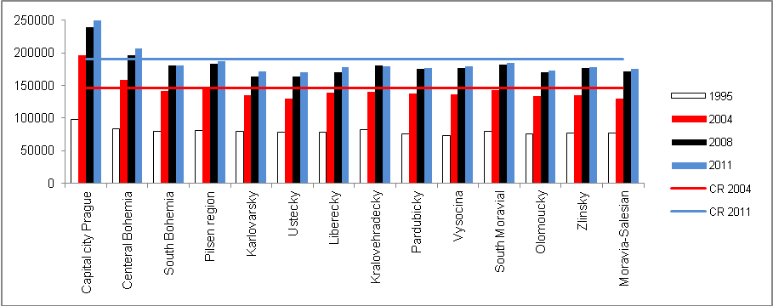
Source: CSZO

For the period of boom 2004-2008 increased the incomes per capita in the form of household net disposable income by more than one quarter (+26.7 %), GDP per capita increased for that time period more (+28.6 %) |  | At the beginning of boom in the Czech economy in 2004 already increased the household net disposable income per capita against year 1995 by nearly four fifths (+79.5 %) to 145.9 thousand crowns. This average of incomes exceeded apart from the Prague inhabitants (196.3 thousand crowns per capita) also people in the Central Bohemia (158.2 thous. crowns) and the Pilsen region (146.1 thous. crowns per one inhabitant). In year, when strong boom in the CR peaked (2008) already remained above the CR average with respect to incomes in the form of household net disposable income per capita (185 thous. Crowns) apart from Prague (239.8 thousand crowns) only Central Bohemia region (196.2 thousand crowns).  In 2008 were thus this way defined incomes per capita by more than one quarter higher (+26.7 %) than in 2004 at the beginning of boom. The addition however included the already high previous basis.
Adverse post crisis development – in years 2010 and 2011 net disposable income of households per capita stagnated, despite the economy growing in nominal terms |  | Post crisis development reduced the subsequent additions to incomes, when in 2011 exceeded the household net disposable income per capita the level of year 2008 only by mere 2.9 % in nominal terms. In years 2010 and 2011 did not eventuate any year-on-year additions (chart 86). At the same time, nominal GDP grew by 0.6 % year-on-year, resp. 1.1 % (in real terms however +1.8 %, -1.2 %).  It means that the post crisis development affected the nominal incomes of households (their net disposable income) recalculated per capita more significantly, that would correspond to the development of the economy.
Crisis development also worsened the ranking of five regions in the rankings according to the size of income per capita… |  | Crisis more significantly worsened the position of the Pilsen and Moravia-Silesian region, mildly then the regions South Bohemian, Zlinsky and Ustecky, whose position in the ranking of regions according to incomes (household net disposable income) per capita in 2009 against year 2008 decreased. Without change remained the position of capital city Prague, Central Bohemian region and Vysocina region. Other regions were „helped“ by the development in 2009 to a better placing.
… in aggregate also in 2009 year-on-year nominal growth of household net disposable income per capita by 3 % |  | Still also in 2009 against year 2008 the nominal incomes per capita in all regions increased, on average for the CR by 3 %. Reason was the impact of legislative changes (effect of the equal tax and other changes), through which effect remained to households more funds, which would be under previous conditions part of the budget revenues. For public finances it was so unfavourable, that in crisis year it was necessary to strengthen the transfers to households (unemployment benefits, material hardship benefits and other connected benefits). This also in the overall view strengthened the sources of households, which were receivers of these transfers.
V roce krize byl nejvyšší růst příjmů na hlavu zaznamenán v Karlovarském a Ústeckém kraji… |  | The logics of this consideration is supported by the fact, that in percentage the most increased in the crisis year 2009 compared to year of finishing boom (2008) incomes per capita in Karlovarsky region (+5.6 %) and Ustecky regions (+4.7 %). The role played of course also a low absolute basis of these incomes in the form of net disposable income and local situation on the labour market.
…on the contrary low in the Zlinsky and South Bohemian region |  | The least increased in 2009 year-on-year the incomes per capita in the South Bohemian and Zlinsky region (+1.4 %, resp. 1.3 %).

Chart 85 | Increase in income per capita in years 2002-2011 (net disposable income of households/per cap.; in %) | Chart 86 | Development of nominal y-o-y change of income per capita (net disposable income of households/per cap.; y/y in %)
Source: CZSO

Moravia-Silesian region with the highest increase of incomes per capita for the decade of 2002-2011… |  | For the whole decade of 2002-2011 increased the most incomes per capita in the form of household net disposable incomes per capita in the Moravia-Silesian region, specifically by nearly one half (+46.6 %), while on average for the CR by 42.6 %. From chart 85 is further apparent, that higher than average incomes recorded also further six regions.  Out of these two, Pardubicky and Ustecky, however in year 2011 despite this long time higher than average growth of incomes per capita occupied with 177.1 thousand, 170.9 thousand crowns resp. of household net disposable income per capita a position in the lower part of rankings of the CR regions (incomes in the Ustecky region were the lowest similarly to year 2009, in year 2010 it was in the Olomoucky region).
… the lowest increment in Karlovarsky and Kralovehradecky region |  | Compared to other regions and average for the CR in years 2002-2011 increased the least, roughly by one third, the incomes to people in Karlovarsky and Kralovehradecky region (+35.9 %, 34.3 % resp.). The relativism of the income dynamics view as a key parameter of satisfaction with life can be proved by the fact, that according to the surveys from the commercial sector it is just the Kralovehradecky region, where people state based on selected indicators of other than economic character a high level of satisfaction with their lives.
In 2011 were incomes per capita in the CR against year 2002 higher by 43 %, compared to year 1995 by 134 % |  | If we compare the additions to household net disposable income per capita in years 2002-2011 on one hand and even longer period 1995-2011 on the other hand, it can be seen from chart 87, that the highest growths of income occurred in the second half of 90s. Even here however works the effect of the preceding low comparative basis. In 2011 were in the CR this way defined incomes per capita by 42.6 % higher compared to 2002 and against year 1995 increased by 134.2 %.

Chart 87 Increases of incomes (household net disposable income/capita) in regions for years 2002-2011 and 1995-2011 (in %)
Source: CZSO, own calculations

Risk of poverty or social exclusion
Survey of living conditions of households, performed in the European context, produces after assessment the indicators of a various type: the share of population at risk of poverty or social exclusion on total population of households, various social characteristics of households – health, working conditions, housing, childcare etc. The area mapping material deprivation works with nine items related to the material hardship.

Very low share of population at risk of income poverty was in the CR recorded already since the beginning of survey in 2005… |  |  | The Czech Republic occupies from the beginning of the survey of living conditions of households in the European countries one of the best placing in the ranking of EU 27 countries, with respect to their population being at risk of so called income poverty and also in the indicator of poverty or social exclusion.  In 2005, since when the data for the CR are being recorded, was the country according to share of the population at risk of income poverty 10.4 % of total population of households compared to 16.4 % for the EU 27 as a whole (it was the least after Sweden with 9.7 %). In 2006 fell the proportion of population in the CR at risk of poverty below the ten percentage boundary (9.9 %), while a lower share had at that time only Netherlands (9.7 %) and average for EU 27 mildly increased to 16.5 %.
... and since year 2007 is the share of people living in households at risk of income poverty in the CR annually the lowest from all EU 27 countries |  |  | Lowering of the share of persons at risk of income poverty was visible since the beginning of introduction of the survey in 2005 till year 2009. Also in this crisis year their share fell, even to mere 8.6 % of population. Not only it was the lowest share of all EU 27 countries, but against the aggregate for union countries (16.3 %) it was only roughly one half.
Mild increase in the share to 9 % and 9.8 %of population at risk of income poverty in years 2010 and 2011 |  |  | Subsequently however in years 2010 and 2011 increased the share of people at risk of income poverty in the CR to 9 %, resp. 9.8 % of population. Here was likely reflected the effect of „lagging“ impact of economic crisis, when in 2009 could households „benefit“ from the effect of legislative changes introduced already since the beginning of year 2008 and post-crisis measurers.
Increase of the threshold limit above 60 % of the median of incomes would increase the numbers of persons in the CR endangered by the income poverty by tens of thousand pensioners with the pension as the only source of income |  |  | Threshold limit, under which the people are „included“ into the category of at risk of income poverty, i.e. 60 % of the median of the equalised income, is in the CR really „threshold“ in that sense, that many inhabitants, mostly dependent of the income paid from the retirement benefits, finds themselves tightly above this limit. It follows from the data that by shifting this threshold to 70 % of the median of incomes would put at risk of income poverty further more than 200 thousand not-working retirees.  In the CR lives in the long-term (survey started for the first time for year 2005) only around 9-10 % people in the population of households, which are at risk of income poverty. In 2011, when the complete Eurostat table is available, in the CR lived at risk of income poverty 9.8 % of population, while on average for EU 27 countries was at risk of income poverty endangered 16.9 % of population
Chart 88 | At risk of income poverty or social exclusion (share of population in % of total population) |  |  | Chart 89 | Share of population at risk of poverty or social exclusion (in %, years 2005 and 2011)
Source: Eurostat

By income poverty or social exclusion endangered in the CR in 2011 only 15.3 % of population |  | According to the SILC survey was in the CR endangered by the poverty or income exclusion in 2011, for which a completed table of countries is available for comparison, in total 15.3 % of population. For example in Belgium it was 21%, in Denmark 18.9 % and in Germany 19.9 %. High risk of income poverty or social exclusion was apparent in Bulgaria, where was in 2011 at this risk nearly half of population (49.1 %).  Results depict the Czech Republic as a country with a very favourable position with respect to the risk of income poverty of its population and also the risk of social exclusion.  The rate of risk of income poverty can however serve more to the comparison of standards of living of various group of persons within the given country, rather than for international comparison of quality of life, since it reflects especially the differentiation of incomes, which is in the CR still low. That is why also the level of income poverty is here low and it is the same also for most other central European countries of the former eastern bloc. This indicator by itself is not adequate for the assessment of living conditions. To compare how people live in individual countries is necessary to also contemplate the real level of incomes (from which is calculated the poverty threshold) and what can people purchase for these incomes in various countries.
Regional view on the risk of poverty and social exclusion in the CR |  | From the regional view was in 2011 in the Cr higher risk of income poverty or social exclusion especially in three NUTS 2 regions – the Northwest, the Central Moravia and in Moravia-Silesia. Compared to year 2005 this list has not changed.
Chart 90 Regions of the CR according to NUTS 2 – risk of poverty or social exclusion (in % of population)
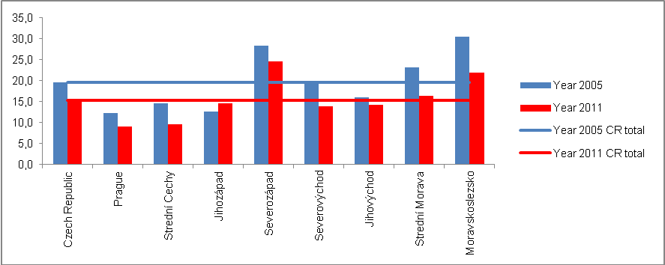
Source: Eurostat
Risk of material deprivation in the CR in the share of population lower compared to income poverty, in the EU 27 rankings however the CR only in the second third |  | Materially deprived, i.e. people in material deprivation, as signs the gauged group the European survey SILC, represented in 2011 in the CR 6.1 % of population it means the same share as in „old“Union countries (EU 15). On the rankings of EU 27 countries it was the 12th place (chart 91).  In 2005 was however the share of materially deprived on total number of population in the CR nearly double (11.8 %) compared to year 2011 (6.1 %).

Chart 91 People in material deprivation (according to definition of material hardship SILC, year 2011, in % of population)
Source: Eurostat

Share of people living in households with very low intensity of work
Crisis and partially also the post-crisis impact on the employment rate in the CR in trend approximately the same as in the EU 27 |  | Rate of employment in the CR observed in the decade 2003-2012 approximately the same trend as employment in the EU (chart 92). Curve captures the crisis as well as post crisis divergence commencing in year 2009, when the employment rate in the CR – defined for employed people of the age group 20-64 years in percentage of population of this age group – it lowered to 70.9 % from 72.4 % in 2008, i.e. -1.5 p.p. The drop of the employment rate in the EU 27 arrived at 1.3 p.p. (to 69 % from 70.3 % in year 2008).
The rate of employment of persons at the age of 20-64 in the CR in the long-term higher compared to EU 27 average, in 2012 in the CR against the EU increased due to the higher usage of part-time jobs |  | In the Czech Republic has a job in relation to the overall population of the age category 20-64 years higher number of people compared to the same ratio in the EU 27 (chart 93). In 2012 reached this rate of employment in the CR 71.5 %, in the EU 27 68.5 %. Simultaneously, the trend diverged more notably – in the CR the rate of employment year-on-year considerably increased (from 70.9 % in 2011), in total for the EU 27 it slightly decreased (from 68.6 % in 2011).  Paradoxical growth of employment in the CR, when its economy was experiencing a recession, can be explained by the specific changes, mostly growing part-time jobs.
In the CR a low share of persons living in households with very low intensity of work |  | Surveys in European households, monitoring their living conditions, enables to assess also the fact, which percentage of people live in households with very low intensity of work. According to relevant definition, it is a household, where adults work less than the fifth of their potential working hours (which they spent at work in the preceding year). Results of the survey provided in the Eurostat tables show, that there was living in 2011 in the CR such people at the age until 60 years only 6.6 % of population of this age group.  In the European context low share of persons living in the CR in households with very low intensity of work even lowered in years 2005-2011 (from 8.8 % in 2005) while the EU 27 average grew up to 10.2 % in 2011 (especially from year 2009 with 9 %). It shows the troubles of the European labour market especially in the South countries.

Chart 92 | Rate of employment at the age group 20-64 let (employed in % of relev. population) | Chart 93 | People living in households with very low intensity of work (in % of given population)
Source: Eurostat

Demographic development in the CR in the European Context
Year 2012 continued in long-time trends for a number of demographic processes – again improved the mortality conditions, which was reflected in the lengthening of life expectancy at birth and drop of infant mortality, still occurs the postponement of parenthood and entry into marriage until later age, the intensity of marriage rate also falls and the share of children born outside marriage grows. With respect to the increasing life expectancy at birth and low fertility the age median further grows and thus continues the process of aging of population. As positive, even though these are for now rather short-term changes, can be perceived mild year-on-year increase of total fertility rate, near stagnation of aggregate abortion rate and also further fall of total divorce rate, which occurred already in year 2011. On the contrary, adverse is the continued increase of the economic dependency index, i.e. the number of persons at the economically inactive age (0-14 and 65 and more years) per population at the economically active age (15-64 years), which started in year 2009.

The population growth, sustained only due to migration, slows down |  | Overall number of the Czech Republic population has been increasing for several years, both thanks to the positive migration balance (since 1990 the negative migration balance occurred only in 2001) and the natural change of population, which progressed into positive numbers in 2006 (for the first time since 1993). This population growth however significantly slows down since 2008 and was kept in 2012 especially due to the positive migration balance, since the number of live births only mildly exceeded the number of deaths (by 387 persons). Fall of the natural increase was thus caused mainly by the increase of the number of deaths, which was not adequately compensated by live births, whose number year-on-year decreased.

Chart 94 Development of crude rate of the natural and population change in the Czech Republic and the European Union, 1990-2012
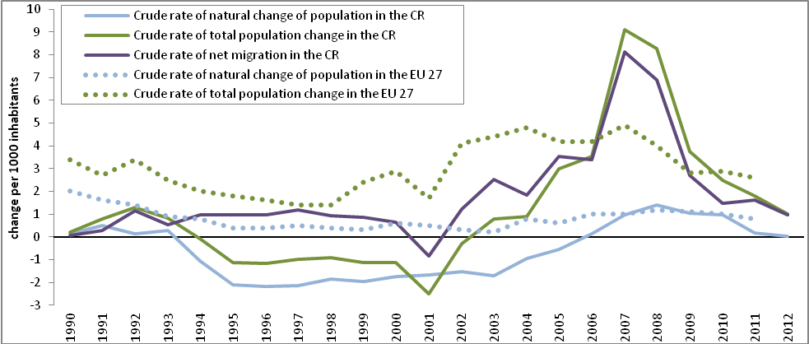
Source: CZSO, Eurostat

In period 2007-2010 crude rate of natural increase in the CR copies the development in the European Union, since 2011 it again fell below the European average |  | Since 2007 the value of crude rate of natural increase in the Czech Republic copies the average for states of the European Union, which fluctuates around 1 ‰, but in 2011 we experienced a more marked decrease to 0.2 ‰ from 1 ‰ in 2010. In 2011 experienced a similar rate of natural increase as in the Czech Republic also Poland and Austria. The highest values in the long-time achieve Ireland and Iceland, further then France, Netherlands or Norway, that is states with the highest level of fertility and the best mortality conditions. On the contrary, the lowest growth of the natural increase occurs in the post-soviet states and states of former eastern bloc, such as Bulgaria, Ukraine, Belarus and the Pobalt states, where the population decreases since the 90s of the last century.

Life expectancy at birth and other characteristics of demographic reproduction

Life expectancy at birth in the Czechia grows, however still does not reach the average value for the EU |  | Life conditions, gauged by the life expectancy at birth in the Czech Republic improve in the long-time (between years 1990 and 2012 increased the life expectancy at birth from 68 years for males and 75 years for females to 75 and 81 years resp.), but even though the situation here is the second best immediately after Slovenia compared to other post-communistic states, we still lag behind the European Union average. The difference between the average life expectancy for the European twenty seven and the Czech Republic moves from year 2002 around 2.5 years for males and 2 years for females. Most probably, a move closer to the European average cannot be anticipated in the nearest future, since the difference in the life expectancy at birth has not changed significantly since 2008 and it has even started to slightly increase.
Chart 95 Life expectancy at birth in states of Europe, 2011
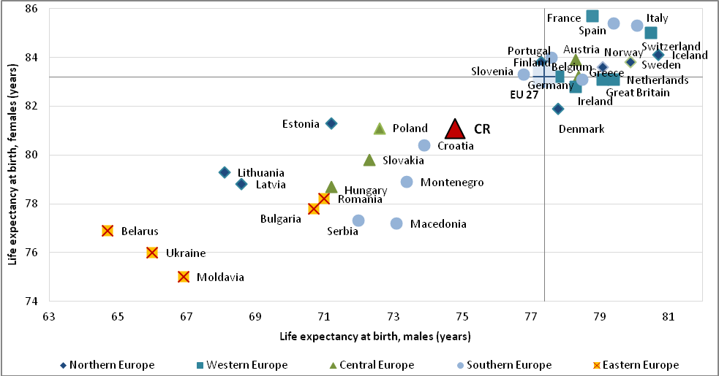
Source: Eurostat

The highest differences in life expectancy at birth between university graduates and males with primary education within Europe occur among Czech males |  | Eurostat data enable to analyze the life expectancy not only according to the age and sex, but also according to the educational attainment. Data are not however available for all European statesand further time periods (available only 2007−2010). Generally, it can be stated, that the differences in the life expectancy at birth between persons with primary and university educations are for males higher than for females. According to the available data education a significant factor for the length of life expectancy at 30 years is in the Czech republic – while males with university education shall have in 2010 before them on average 51 years, males with primary education only 34 years. This difference was the largest among the European countries, where the data were available. On the contrary, the lowest difference between these education categories was in Portugal (3 years). The highest differences in the life expectancy according to the male education are for states of former eastern bloc, such as Czech Republic, Hungary, Bulgaria or Estonia. These are also the states with a high proportion of people employed in industry (r_{s}=0.829) , where can be expected a higher share of persons with a lower grade of completed education, and where also exist a physically demanding jobs with adverse working conditions. For females then were the highest differences in the life expectancy according to education in Estonia (8.5 years) and lowest again in Portugal (1 year), in the Czech Republic then the difference arrived at 4.6 years. For females however are not the differences between individual states as marked as for males.
On the contrary our infant mortality is in the long-time one of the lowest |  | On the other hand in the long-time we belong among states with the lowest birth mortality not only in Europe, but also in the world. As can be seen in chart 96 in 2011 we achieve similar values to developed countries of north Europe, such as Norway, Sweden or Finland and the European average was in comparison to us by 0.12 p.p. higher. In 2012 then we experienced further mild decrease down to the value of 2.6 ‰.
Chart 96 Infant mortality rate and legally induced abortions ratio in states of Europe, 2011
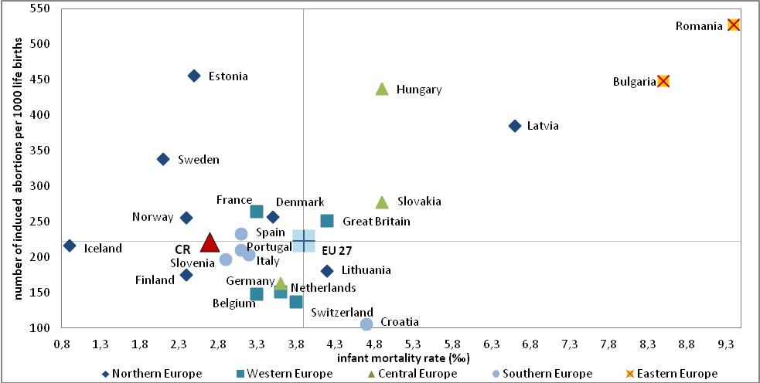
Source: Eurostat, WHO

The index of legally induced abortions decreases in most states of Europe …  … and in our country reaches the historically lowest values since year 2002 |  | During the 90s occurred in the countries of former eastern bloc a marked fall of the index of legally induced abortions and approaching of the values of other European states, where there were never performed more legally induced abortions (LIA) over the number of births. Long-term highest index of legally induced abortions in the European Union occurs in Romania, where is currently approximately one LIA per two live born children, but in 1990 it was more than three LIAs per one live born child. In the CR, the number of LIAs never exceeded the number of live births, but on the break of 80s and 90s it was approaching this limit (in 1989 there were 87 LIAs per 100 live born). Since then however the index of legally induced abortions falls and since year 2002 its value fell below the level from year 1958, when it was for the first time permitted by law to perform the induced abortion even for other than health reasons and the abortion index achieved value of 34.6 LIAs per 100 live births. From year 2006 then the index of induced abortions stays below the EU average.  Indicators depicted in chart 96 can also serve as indicators of the advancement level of individual states. The value of infant mortality rate signals the quality of health facilities and overall health care for the mother and newborn. Index of induced abortions can then also reflect the social and economic climate in the society, which can considerably influence the ability and will of a female or couple to take care of the child in the given conditions.
In the Czech Republic is the total fertility rate in the long-time below the average for the whole European Union  In the whole Europe the average age of mother at the birth of the first child increases… |  | In 2008 the slight increase of the total fertility rate ceased to grow and in 2011 there was again recorded a negligible decrease of the average value for the whole European Union to 1.57 child per one woman from value 1.6 in 2010. Similar trend portrayed the development of fertility in most states of Europe. As can be seen from chart 97, the Czech Republic together with the states of south and central Europe belongs among countries with rather low fertility as opposed to the west and north Europe, where for instance Ireland, Iceland or France reach in the long-term the highest values of total fertility, which currently oscillates around two children per one woman. Based on the available data from Eurostat the Czech Republic had in the period between years 1999 and 2003, when the total fertility rate does not reach even the value 1.2 child per one woman, the lowest fertility in Europe. Situation started improving from year 2004, but still with the current value of 1.45 from year 2012 we do not reach the European average.  In all states of Europe occurs the postponement of parenthood until a later age. Similarly also in the CR, where the average age of mother at the birth of the first child increased from 22,5 years in 1990 to 27.9 years in 2012. It is visible in chart 97, that the postponement of parenting however does not need to means also a decrease of the fertility level. For example in Sweden or Great Britain, where there are on average two children per one women, the average age at the first birth reaches a value of more than 30 years.
Chart 97 Total fertility rate and mean age of woman at birth of first child in states of Europe, 2011
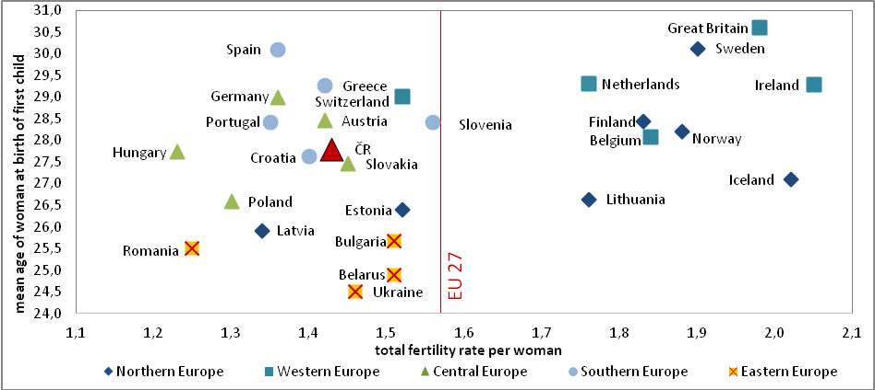
Note: value of mean age of mother relates in Great Britain to year 2010 and for Belgium to year 2009
Source: Eurostat

… and in the long-time occurs an increase of the share of children born outside marriage |  | Nearly in all states of Europe increases the share of children born outside marriage, which is a result of both the drop of intensity of nuptiality and the postponement of marriage until later age. In most states then, similarly to the Czech Republic, the mean age at first marriage for females exceeds the mean age at birth of first child (on the basis of UNECE data). Thus on average women have the first child, before they get married for the first time. In the Scandinavian countries is this gap even several years, it is the highest in Iceland, where it exceeds 5 years. The only state, when on the contrary the share of children born to unmarried women mildly falls in the long-term, specifically from year 2004, is Sweden. In 2011 the share of live born children outside marriage on average for the whole European Union reached the value of 39.5 %, which is by 2.3 percentage points less than for the CR, where until 2012 the proportion of born to unmarried women even increased to 43.4 %. The most children were in 2011 born outside marriage on the already mention Iceland (65 %), within the European Union then in Estonia (59.7 %) and more than half of children are born outside marriage also in Bulgaria, Belgium, France, Slovenia, Sweden or Norway. On the contrary, completely the least then in Greece (7.4 %), Macedonia (11.6 %) and Croatia (14 %).
In most states of Europe less people are getting married and entry into marriage is postponed until later age, the same situation is also in the Czech Republic  The Czech Republic was among countries with rather higher nuptiality, in the last years however the level fell to the average for the whole EU |  | As already stated, in Europe occurs in the long-term a shift in the nuptiality behaviour, only its timing differs in the individual states – while in the states of North and West Europe already since the 70s of the last century, in the Czech Republic only after year 1990. These changes lie mostly in the fall of the value of crude marriage rate and the growth of the mean age at time of first marriage, which in the most states of North and West Europe surpasses already 30 years even for females (in 2010 it was the highest in Sweden – 32.9 years for females and 35.5 years for males, in the Czech Republic then it reached the value of 29.4 years for females and 32.2 years for males). The size of average age when entering into first marriage is then according to data available for 31 European states connected with the intensity of nuptiality – correlation analysis show the medium strong statistically significant negative correlation between these two indicators of nuptiality (r_{s}=-0.482). It means, that the European states, where the first marriage is being postponed until later age, also report a lower value of the crude marriage rate.  In comparison to year 1990 only in Sweden, Finland and Iceland occurred the increase of the crude nuptiality rate, otherwise in all other countries the intensity of nuptiality gauged by this indicator decreased, even despite the fact, that in some countries eventuated a mild growth from year 2005. The average value of crude rate of nuptiality for the European Union from year 1990 was continuously falling down to 4.4 of marriages per 1000 population. Apart from year 2003 the CR reached higher values compared to the EU average. The difference however started to gradually shrink and from year 2008 is the rate of crude nuptiality in the Czech Republic nearly similar to the European average (in 2012 was here entered into 4.3 marriages per 1000 inhabitants, the same as in the previous year).
Chart 98 Crude marriage and divorce rates in the states of Europe, 2011
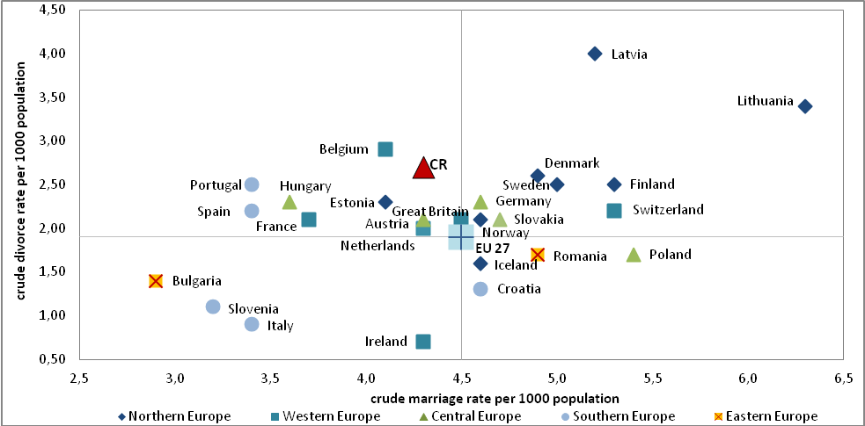
Note: values for the European Union relate to year 2009
Source: Eurostat

Total first marriage rate in the CR reaches the historically lowest values  In most countries of Europe the crude divorce rate grows  Czechia has been and still is among countries with the highest total divorce rate |  | To assess the development of the intensity of the marriage rate would be useful to use also other more precise indicators, such as for example total first marriage rate gauging the share of persons, who enter into the first marriage until they reach age of 50 provided the unchangeable nuptiality, mortality and migration conditions of a given year. Such data are not available for most European states and so it is not possible to exercise the international comparison. Based on data on total first marriage rate would in the CR in the 80s until 50 years of age married around 90 % of males and 96 % of females. In the preceding decades this share was even higher. This situation changes substantially after year 1990, when the total first marriage rate started to decrease and according to the level of marriage rate from 2012 would then in their life under the current conditions remaining unchanged marry at least once only 53 % of males and 61 % of females.  Most European countries experienced between years 1990 and 2011 an increase of crude divorce rate. For the whole period the Czech Republic reached higher crude divorce rates, compared to the average for the whole European Union and in 2009, when are available the latest data for the European average, exceeded the rate by 0.9 percentage points. Together with the northern states we belong to countries with the highest crude divorce rate in Europe. Crude rate is however not the most suitable indicator for the assessment of development. Unfortunately the latest data regarding the total divorce rate, which relate divorces to the original marriages are not available for most states and thus an up-to-date international comparison cannot be performed. Thanks to the PPD database, international data from year 1960 are available, however only until year 2003. For the whole of this period, the Czech Republic stays together with the states of northern Europe on the imaginary front place. For comparison – states with the lowest total divorce rate in 2003 achieved values around 20 % (Croatia – 17 %, Poland – 20 %, Romania – 21 %, Slovakia – 24 %) compared to 48 % in the Czech Republic. Total divorce rate in the Czechia in 1990 amounted to 38 % in 2010 it then reached its historical peak - 50 %. Until year 2012 nevertheless the value fell again to current 44.5 %.

Immigration and illegal immigration
In most states of Europe occurs an increase in the number of immigrants  The number of immigrants in the CR increased year-on-year, however the migration balance on the contrary fell |  | In most states of Europe occurs since the end of 90s the increase in the number of immigrants. A more substantial long-term decreased was recorded only in Germany, Portugal and Croatia (here the fall was the most significant – nearly by 84 %). However, starting in year 2007 the decrease of immigration experienced also Spain, Iceland and Italy. In 2011 most immigrants into countries, where the data are available, arrived from other European countries. Only in Spain immigrants from other continents constituted more than half of all immigrants (they represented more than 30 % of immigrants also in Italy, Sweden and Belgium).  In 2012, there were 30 298 persons moving into the Czech Republic, which is by nearly 8 thousand more than in the previous year. At the same time nevertheless also more people moved out of Czechia and the net foreign migration thus between years 2011 and 2012 fell by more than 6 thousand. The highest positive net migration the Czech Republic recorded in year 2012 with Slovakia and Slovaks constituted 15.9 % of all immigrants from abroad. The highest share of all immigrants could be ascribed to citizens of Ukraine (19.5 %), however a high number of Ukrainians simultaneously left the CR and the net migration thus reached negative values. Russians represented the third most numerous groups of immigrants (10.6 %) with the second highest net migration. Back to homeland then returned in 2012 less Czech citizens compared to those moving abroad.

Chart 99 Share of foreigners on population in European countries, 1. 1. 2012
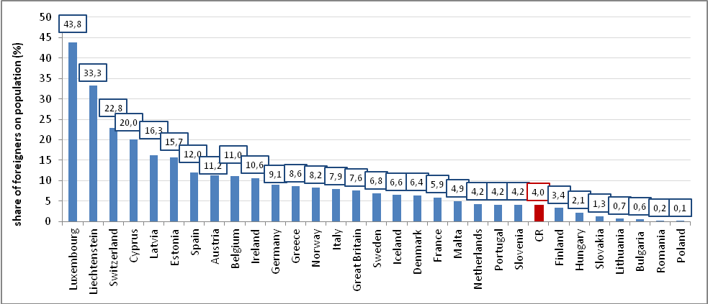
Source: Eurostat, own calculations

The share of foreigners on total population also grows in Europe  In the Czech Republic grows both the share of foreigners on total population and the newborn foreigners |  | In most countries of Europe since the end of 90s of the last century occurs a growth of share of foreigners on total population. The exception is Estonia and Latvia, where the share of foreigners falls in the long-term. The most increase between years 1998 and 2012 recorded Spain, where occurred nearly eightime increase of the share of foreigners per population despite the fact, that from year 2010 is here being recorded a slow decrease. In the long-time the most foreigners within the total population are in Luxembourg, where at the beginning of 2012 represented nearly 44 % of population, which is most likely caused by the number of international institutions, which has a headquarters here. A large share of foreigners records also Lichtenstein (33 %) or Switzerland (23 %). On the contrary, relatively fewer foreigners lived in Romania and Poland, where their share in population did not reach even 0.2 %. Correlation analysis confirmed a medium strong positive linear relationship between the size of GDP and the share of foreigners in the population (r_{s}=0.43). Thus it could be stated, that in Europe is to some extent valid – the more developed the state (measured by GDP), the higher share of foreigners on population.  In the Czech Republic the share of foreigners from year 1998 nearly doubled to current 4 % of total population and this value place us among states with the lowest share of foreigners in Europe. The highest share of foreigners has been recorded since year 2000 to citizens of Ukraine (25.7 % from foreigners at the end of 2012), further then Slovakia (19.6 %) and the third most numbered group are the citizens of Vietnam (13.1 %). The share of live births with foreign citizenship also grows. In 1998 constituted foreigners 1 % of newborns and until year 2011 this share increased to 2.7 %. The most frequent nationality among the newborns were citizens of Vietnam (30.2 %), on the second place then Ukraine (24.7 %), whose share on foreigners born in the Czech Republic from year 1995 increased nearly fivefold and in 1998 then for the first time exceeded the share of Slovakians, which are the third most frequent citizenship for newborn foreigners with 14 % in 2011. The fastest increase of the share of newborn foreigners recorded citizens of Mongolia – in 1995 constituted only 0.1 %, but until 2011 this share increased 28times to current 4.1 % of live born.
More than 400 thousand citizens of third countries were staying in the states of the European Union illegally |  | Eurostat publishes since year 2008 also the statistics of citizens of third countries on the territory of member states, when it was found that they are staying in the given state illegally. In absolute numbers, the most illegal immigrants were gauged in 2012 in Greece (72 thousand) and Germany (64 thousand). There were in total for all states of the European Union 427 195 persons staying illegally. If we however relate illegal immigrants to the total number of citizens of third countries in the given state, relative the highest number would be in Poland – per 1000 persons with citizenship outside the European Union would be 209 illegal immigrants (opposed to this, in Greece it was 88 and in Germany only 14). It was ascertained in the Czech Republic, that in 2012 were staying here illegally 3 315 of citizens of third countries and from year 2008 this number has not any significantly changed. The most illegal immigrants in our country in 2012 came from Ukraine (32.1 %), Russia (12.7 %) and Vietnam (11.5 %).

Population Aging
European population is aging… |  | As a consequence of low fertility and prolongation of the life duration changes also the age structure of the population. Population aging occurs in the long-time across the whole Europe. In the EU the age median between years 1990 and 2012 rose by 6.3 years to current 41.5 years. For the Czech Republic the age median was at the beginning of year 2012 lower – 40.1 years.

Chart 100 Share of age groups 0-14 and 65+ in total population in states of Europe, 2012
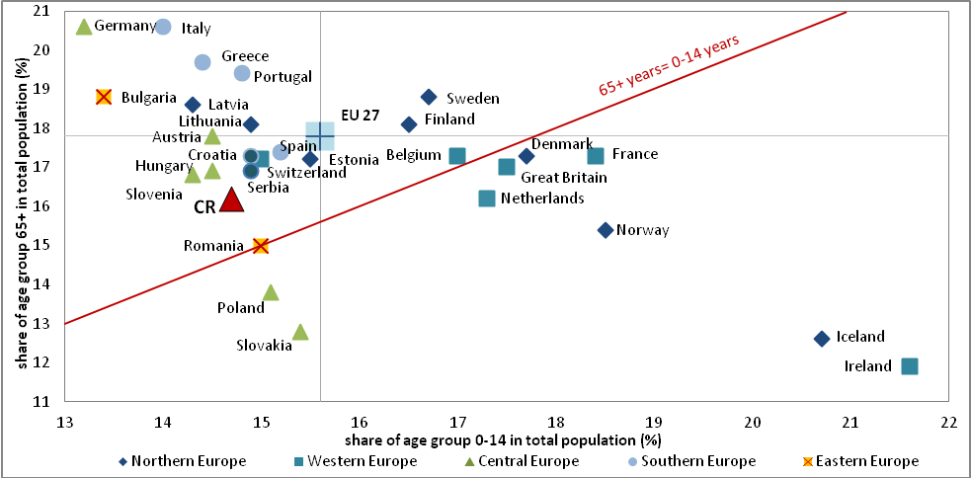
Source: Eurostat

…thanks to the drop of share of the child population…  … and simultaneously increase in the share of persons older 65 years of age… |  | Both in Europe and the Czech Republic in the long term increases the share of persons at the age of 65 years and more and on the contrary falls the share of child segment of the population (0-14 years), although in the several past years this fall halted and this share mildly increased as a result of increased natality. Currently the highest share of child population is found in Ireland and Iceland (21.6 % and 20.7 % resp.), that is states with the highest total fertility rate. On the contrary, the least number of children until the age of 14 years can be found in Germany and Bulgaria, in both countries around 13 %. The Czech Republic reaches in the long time lower values in comparison the average for the European Union, behind which lags with the current 14.7 % by 0.9 percentage points.  Share of persons older 65 years is then the highest in Germany and Italy, where it reached in 2012 value of similarly 20.6 % out of total population. On the contrary the lowest share is in Macedonia, Ireland and Iceland, around 12 %. The fastest rate of increase of the share of this age category occurs in Lithuania, Latvia and Malta, where it increased since year 1990 roughly by 60 %. In the CR this share increased nearly by 30 % and with the value 16.2 % we still reach below average values when compared to the European Union, where in 2012 the persons older 65 years constituted on average 17.8 % of population.
… and this trend shall continue from now on according to projection |  | Population projection of Eurostat supposes the continuation of current trends, which is mild decrease of child population and relatively high growth of share of persons older 65 years. Until year 2060 should in the European Union children until 14 years of age on average constitute 14 % of total population and persons in the post productive age 30 %. Czech Republic should reach similar values to the European average. Within the segment of population at the economically inactive age should then occur the highest increase for persons older 85 years, which should be between years 2015 and 2060 for example in Slovakia and Romania nearly fivefold, in the Czech Republic nearly fourfold. On average this population group should in the European Union in year 2060 constitute 7 % of total population, in the Czech Republic then 6 %.

Economic dependency ratio
Economic dependency ratio for CR is in comparison to other states rather lower – 45 persons |  | Thanks to relatively low share of child and post productive segments of population the economic dependency index was in the CR in 2012 relatively low – there were per 100 persons at the economically active age (15-64) 45 persons at the economically inactive age (65 and more years and 0-14 years of age) and lower values are reached only in Romania, Slovakia, Poland and Ukraine. The question however remains, whether will the relatively favourable relation of population at the economically active age adequately reproduce in the future in given to the low fertility level.

Chart 101 Economic dependency ratio in selected European states, 1990-2060
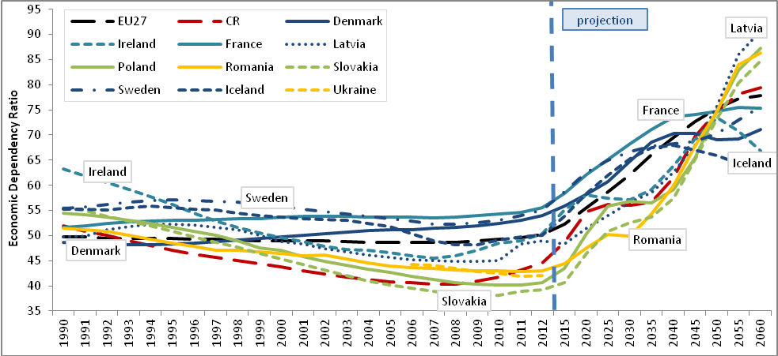
Source: Eurostat, own calculations

Since 2009 the economic dependency ratio in the CR has grown and based on projection, this trend will continue both at home and in other European countries |  | The decreasing trend of the economic dependency ratio, which lasted already since the 80s of the last century, was interrupted in 2009 and since this years its values on the contrary grow, as the economically active age starts to include less numerous generations from the second half of 90s and according to the projection, this trend will continue even from this point on. From chart 101 is then apparent, that other states, which in 2012 had a favourable value of the economic dependency index, will be in year 2060 on the contrary reaching very high values. Economic dependency index for the whole European Union in 2012 attained 50 persons, but for example in France or Sweden value of 55 persons. Until year 2060 should in the European Union be allotted to 100 persons at the economically active age already 78 persons at the economically not active age and in the Czech Republic by one person more, that is 79 persons, so we would reach higher values compared to states with the least favourable economic dependency index in 2012, such as France, Sweden or Denmark.

European survey of living conditions in households.
Eurostat data, constant prices (unless stated otherwise).
European Union with 27 member countries (unless stated otherwise).
Euro area with 17 member countries (unless stated otherwise).
Eurostat data, in constant prices – unless stated otherwise. For the reason of using data in constant prices arises the discrepancy (unexplained diference between GDP and expenditure components caused by chaining of the values from current prices to constant prices).
EX – exports, IM - imports
FCEh+ni – final consumption expenditure of households and non-profit institutions, FCEg – final consumption expenditure of government institutions, GCF – gross capital formation
Commodity structure of the gross fixed capital formation – in current prices, data of the CZSO national accounts.
Gross fixed capital formation of invididual institucional sectors – in current prices, data of the CZSO national accounts.
In constant prices. Data of CZSO annual national accounts.
Unavailable information about the 21st branch „Activities of extraterritorial organisations and bodies“.
Primary sector = agriculture, forestry and fishing + mining and quarrying. Secondary sector = manufacturing industry + energy + water supplies and activities connected to the waste waters + construction. Terciary sector = other branches (services).
This chapter is based on the CZSO national accounts. Value of the capital stock (gross stocks of fixed assets) for year 2012 was due to the absence of data in the national accounts estimated. For the reason of comparability of data are based on national accounts also the values for labour stock (employment). GDP and capital stock in constant prices.
The sum does not have to correspond for the reason of operations with average values and rounding.
Dynamics of the performance of individua branches (from the view of value added, sales, closed orders or employment) is assessed in more detail in regular (quarterly, annual) reports regarding the development of the CR economcy, e.g. http://www.czso.cz/csu/2012edicniplan.nsf/publ/1109-12-q4_2012http://www.czso.cz/csu/2012edicniplan.nsf/publ/1109-12-q4_2012
Non-financial corporations include institutional units, whose main function is to produce goods and non-financial market services and which have the nature of market producers. Both private and public companies, enterprises, cooperatives as well as some non-profit institutions serving corporations belong here, as well as some significant units, which are not independent legal person (so called quasicompanies) belong here.
With 20 and more employees at the end of respective year.
By the control of the company are meant the decisions regarding its economic behaviour due to the holding of more than one half of shares, resp. control via a packet of shares of more than one half of votes belonging to shareholders.
This share can be with a small simplification interpreted also as an inverse value of net margin rate of businesses (i.e. the share of net operational surplus on net value added).
The total debt does not include the value of interests (AF.5 – shares and other securities). Their proportion on total liabilities of non-financial corporations in the CR oscillates in the long-term near 50 %.
Include loans, whose repayments of interest or principal are delayed by 90 days or more, or repayments of interest for 90 days or more were capitalised, refinanced or postponed based on agreement, or repayments exceeded the deadline by less than 90 days, but exist other good reasons (such as debtors announcement of bankruptcy) leasing to doubts, that repayments will be executed in full amount.
Government sector of the CR, i.e. sector of government institutions constitutes organizational state bodies, municipalities, selected state-funded institutions, state and other extra-budgetary funds (Estate fund, Support and warranting forest and agrarian fund, Wine fund and others), Railway infrastructure administration, transformation institution Prisko, PPP Centrum, public universities, public research institutions, health insurance companies, associations and unions of health insurers and Centrum of interstate payments. From year 2010 was based on the repeated test transferred several public non-financial businesses into the sector of government institutions, transferred were also selected state-funded institutions between sectors of non-financial businesses and government institutions.
Notification of the deficit and government debt from April http://www.czso.cz/csu/redakce.nsf/i/notifikace_vladniho_deficitu_a_dluhu_20130422.
In constant prices (unless stated otherwise).
Imbalance between the Eurostat and CZSO data is given by the methodology. Following the extraordinary revision of the national accounts arose the increase of the GDP level of the Czech Republic from year 2008 (mostly due to the inclusion of the imputed rents). Eurostat recognises this methodology, however given the inconsistence of the time series of coefficients of purchasing power parities until year 2007 (Eurostat did not recalculate this series retrospectively even after a repeated request from CZSO). On the contrary, national accounting of the CZSO keeps a consistent time series of these parities, however on the other hand does not consider the change given by the extraordinary revision. According to the opinion of employees from the section of CZSO macroeconomic analyse, this version provides a more precise picture of the development in contrast to the Eurostat version.
This takes into account, whether its price development in the sphere of consumer prices does not divert to a significant extent from the price development according to the quantified data for the EU 27 development. It further considers, whether country in similar comparison does not show a marked imbalance in the government sector deficit and its gross consolidated debt in relation to nominal GDP. Maastricht stability criteria determine also the limits for the development of long-term nominal interest rates and volatility of the exchange rate.
People who cannot afford at lest four out of nine defined things: pay bills for rent and services, heating in the housing, eat meat every second day, face unexpected outlays, weeks holiday outsider of home, car, automatic washing machine, colour TV, telephone.
Threshold for determining the risk of income poverty is 60 % of the median of equalised income per consumption unit for every country (indicator takes into account in equalisation so called savings from the number more numerous households, i.e. savings on cost on things and services, which serve more members of household).
Indicator represents a share of persons endangered by income poverty, materially deprived or living in households with low working intensity. For households with low working intensity are considered such households, which have work intensity lower than 0.20. Coefficient of work intensity of household is calculated for members of household aged 18 to 59 years with the exception of studying persons aged 18 to 24 years. Working intensity is calculated as a share of number of months, when such defined persons were working, and the number of months of their presence in the household in total.
Aggregate fertility represents a number of children, which would be live born to every woman throughout her whole reproduction period (for which is considered the age span 15-49 years), if during this reproduction period the rate of fertility of females did not change and remained on the level of the year, when is the aggregate fertility calculated.
Available for Bulgaria, CR, Denmark, Estonia, Croatia, Italy, Hungary, Malta, Poland, Portugal, Romania, Slovenia, Finland, Sweden, Norway, Macedonia.
Correlation between the share of persons employed in industry and the diference between the life expectancy of males with primary and university education.
United Nations Economic Commision for Europe (UNECE): http://w3.unece.org/pxweb/database/STAT/30-GE/02-Families_households/?lang=1
The Population and Policy Database (PPD): http://www.demogr.mpg.de/cgi-bin/databases/PPD/index.pli
Analysis performed for the European states, where the needed data were available, but with the exception of Luxembourg.
Analysis processed on the basis of Eurostat data, data always to 1/1 of the given year
Three states were selected, which reached in 2012 and 2060 the highest and three states, which reached on the contrary the lowest values

