Prices

Growth of aggregate price level at the turn of the years 2012 and 2013 led year-on-year to higher prices in the first half of 2013,… |  |  | Aggregate price level in the economy (according to the implicit GDP deflator) in Q1 2013 increased year-on-year by 1.4 %, the same rate of growth of prices was also observed in Q2. On this growth participated the price increases between the last quarter of 2012 and first quarter of 2013 by 1.3 %. In Q2 2013 the price level compared to Q1 2013 remained the same.
…the main role in the price increases played the improvement of terms of trade between last quarter of 2012 and first quarter of 2013 |  |  | To the growth of price level between Q4 2012 and Q1 2013 contributed mostly a higher increase in the prices of exports (1.8 %) compared to imports (0.4 %). Quarter-on-quarter stagnation of the price level in Q2 2013 was given by the mild increase in the prices of final consumption expenditure (by 0.8 %), which was however fully compensated by a price decrease for gross capital formation in connection with the repeated worsening of the terms of trade in the foreign trade.
Prices for consumers in H1 2013 were determined especially by the increase of VAT in January 2013 |  |  | In January 2013 the prices for consumers increased compared to the last month of the previous year by 1.3 %. This relatively high growth was caused especially by the increase of both rates of VAT by one percentage point – total tax impact increased the price level by 0.8 p.p., the other influences consisted of 0.5 p.p. contribution. The price dynamics in the following months nevertheless markedly alleviated – prices for consumers were thus at the end of first half of the year only by 0.4 % higher than in January. Year-on-year the index of consumer prices climbed in Q1 2013 by 1.8 %, in Q2 by 1.5 %. The households of pensioners felt the effect of price increases stronger – their costs of living rose by 0.6 and 0.8 p.p. more notably compared to all households – products and services, affected by the growth of VAT the most, share higher proportion in the households of pensioners a larger part of total expenses compared to all households.
In the consumer basket compared to the same period of previous year the most grew the prices of food and non-alcoholic beverages, the deepest slump was faced by prices of postal services and telecommunications |  |  | Prices of housing, water, energy and fuels – the most significant items of consumer basket by volume – grew year-on-year in Q1 and Q2 2013 by 2.6 % and 2 %. Compared to the growth of prices in the same period of the previous year (by 5.6 % and 5.4 %) it represented a reduction of rates of growth to less than one half. The largest increase in the price level out of all products of the consumer basket was in both quarters visible for food and non-alcoholic beverages – by 4.9 % and 5.4 %, still it represented compared to Q1 and Q2 2012 a milder increase (+7.5 % and +6.8 %). Opposite development eventuated for the prices of transportation, which were falling already for second quarter in a row – by 0.8 % in Q1 with acceleration to 1.2 % in the second. This price development was unusual; year-on-year fall of prices in transportation was not observed as far as half of 2009. The main role represented the lower prices of motor vehicles, motorcycles and bicycles determined by the still weakening consumer demand together with the lower prices of oil on the world market reducing the prices of fuels. Still the largest fall among all products contained in the consumer basket the most fell the prices of postal services and telecommunications (by 4.9 % and 9.5 %), which were set by the massive reduction of prices of the telecommunication services in H1 2013. Competition contest however pushed down these prices already for a sixth year.
Year-on-year rate of growth of industrial producer prices continued weakening. Low domestic demand in Q2 2013 even decreased the prices of manufacturers. |  |  | Year-on-year rates of growth of prices in industry kept further weakening. Given that in the second half of 2012 prices grew year-on-year by 1.7 % and 1.6 %, in the first half of 2013 the rates of growth further weakened to 1.2 % and 0.5 % – lowering of rates of growth was already long-term and lasted since Q3 2011. In the provided rates of growth the main role played the prices of manufacturers – rates of growth of prices in the manufacturing industry gradually fell to 0.8 % in Q1 2013, weakened domestic demand even decreased the prices in Q2 2013 by 0.2 %. „Deflation“ development in the manufacturing industry was not prevented even by the still growing prices of manufacturers of food, beverages and tobacco.
 |  |  | Mild price increase was in Q2 2013 – following four quarters lasting year-on-year fall – apparent in the mining and quarrying (+0.4 %). Compared to first half of 2012 the prices in energy industry also rose by an above average pace, less markedly then in the supply of water.
Year-on-year rate of growth of prices in agriculture in Q2 2013 weakened due to the quarter-on-quarter drop of prices of plant production |  |  | For prices of agricultural producers, the prices grew year-on-year especially at the turn of years 2012/2013 – given the prices in total increased in the last quarter of 2012 approximately by 14 %, the same increase was notable also in Q1 2013 and the rate of growth slackened only in Q2 2013 (9.3 %). Quarter-on-quarter the prices in agriculture presented in Q2 2013 even a decrease (-2.2 %). The halting or prices in agriculture in Q2 2013 was influenced by the decrease of prices of plant production (quarter-on-quarter by 5.2 %) linked to the prices of animal production remaining the same (quarter-on-quarter by -0.4 %).
Prices of construction works kept falling – however they were falling faster compared to costs of construction production and the mark-up of construction companies further fell |  |  | Prices of construction works kept sinking. If in the last quarter of 2012 the prices year-on-year fell by 0.8 %, in Q1 2013 the fall deepened to one percentage point. However, deepening of the falls continued – in Q2 2013 the prices of construction works fell already by 1.3 %. Even though the prices of construction works were decreasing across the whole year 2012, the lowering was always less than one percentage point – thus the year-on-year decreases in first two quarters of 2013 not only continued, but markedly deepened. Only the price development by itself proved the adverse state of the domestic construction. The fact that in Q1 and Q2 2013 occurred a year-on-year stagnation respectively fall of costs of construction production only by 0.6 % (prices of construction works fell by 1 p.p. deeper in Q1 and by 0.7 p.p. more in Q2) was the evidence of continued lowering of construction firms mark-up.
Prices of market services were year-on-year lowered by a significant reduction of prices of telecommunication services but also a weak demand for warehousing and transportation |  |  | Prices of market services accelerated its fall in Q2 2013 from year-on-year 0.5 % to 1.7 %. The already mentioned competition contest on the market of telecommunication services contributed significantly to this fact, leading to a marked deepening of the year-on-year fall of prices from one percentage in Q1 2013 to a marked 14.8 % in the second. Deepening of the decrease of prices of market services as a whole was also caused by prices of warehousing and supportive services in transportation (year-on-year by -3.5 % and -8.8 %) but also prices of ground and pipe transportation (-1.5 % and -2.1 %), which are lowered in the long-term by weaker demand for products to be processed in industry and construction and thus also a lower demand for their warehousing or transportation.
Exports prices continued growing year-on-year, prices of imports were in H1 2013 falling… |  |  | Prices of exports of goods continued in H1 2013 in their year-on-year growth – prices were in Q1 by 0.9 % higher compared to the same period of the previous year, in Q2 by 0.6 %. The growth of export prices was affected also by a weaker crown against euro (year-on-year by 1.9 % and 2.3 %). Opposed to this, the import prices were in H1 2013 year-on-year by 0.3 % and 0.7 % lower – as a consequence of lowered import prices in H2 2012.
…which led to an improvement in the terms of trade |  |  | Lasting year-on-year growth of prices of exports of goods together with the drop of import prices led to an improvement of the terms of trade in comparison to the same period of the preceding year – in Q1 2013 by 1.2 %, in Q2 by 1.3 %.
Year-on-year lowering of the import prices in both quarters of 2013 was determined by a weak demand for raw materials in the world |  |  | On the side of exports eventuated a year-on-year increase in prices of the most significant by volume machinery and transportation vehicles (in both quarters by 1.6 %), on the part of exports then for the same group only by 0.5 % and 0.9 %. Higher growth of export prices of machinery and transportation vehicles then led to a profit from the terms of trade with these goods. Decrease of import prices in both quarters of 2013 was determined by the lowering of import prices of other raw materials (year-on-year by 7.6 % and 6.5 %), especially then by the lower prices of imported mineral fuels and grease (by 4 % and 7.7 %). Decrease of the import prices of these raw materials was given the mild depreciation of crown against the dollar caused by the weakening demand for raw materials to be processed in the world.
Chart 11 | Growth of consumer prices based on individual types of households  (y/y in %) |  |  | Chart 12 | Growth of prices in selected divisions of CPI (y/y in %)
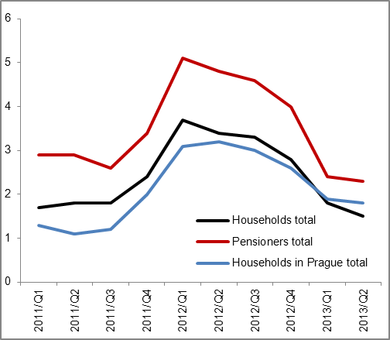 |  |  |  | 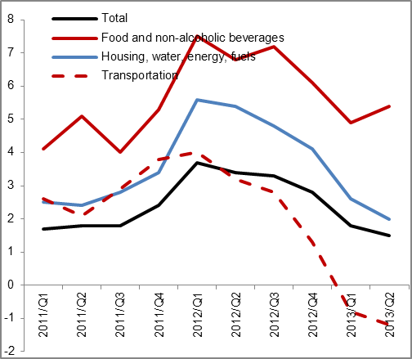
Source: CZSO

Chart 13 | Deflators (y/y in %) | Chart 14 | Producer prices (y/y in %, prices in agriculture on the right axis, others on the left axis)
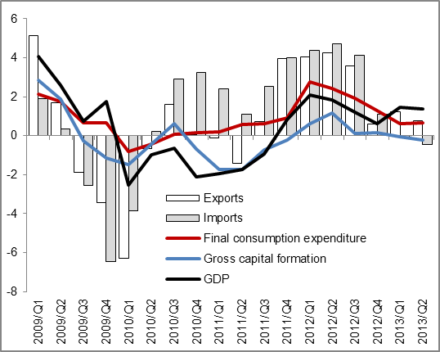 |  | 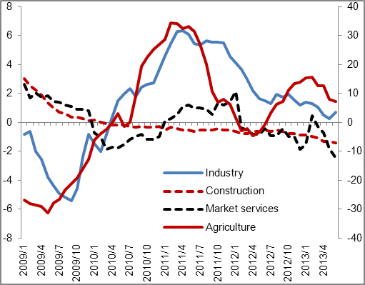
Source: CZSO

